Create connection



Database using java



Table creation

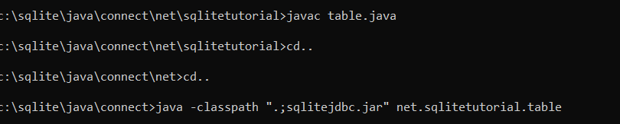

Insert value

Select all data

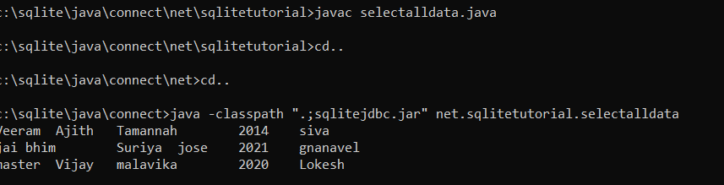

Select particular data

