LAB Logbook
Lab 1
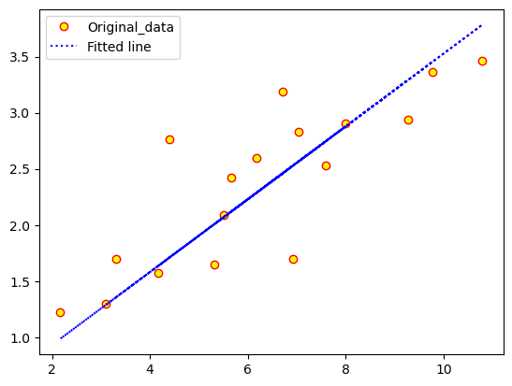

Lab 2

Task 1:

Task2:
Ans: output 1: 0.8284
output 2: 0.8284

Lab 3

Lab 4:

Lab 5

Optimal number of epoch = 7

Lab 6

Optimal number of epoch = 6

Lab 7:
vgg16
Optimal number of epoch: 40
VGG19
Optimal no of epoch : 3

Extra inception v3:

Lab 8

Lab 9

Lab 10

Lab 11

