Voyage Vista: Illuminating Insights from Uber Expeditionary Analysis

1. Introduction:
   1. overview

Uber is a multinational transportation network company that operates a ride-hailing platform. It was founded in 2009 by Garrett Camp and Travis Kalanick and is based in San Francisco, California. Uber provides a convenient way for individuals to request rides from drivers who use their own personal vehicles. Uber Driver Analysis refers to the Analyzing the number of trips taken by Uber drivers can provide insights into their overall activity and the demand for rides in specific areas. Daily, Weekly, or Monthly Analysis: Uber's data can be analyzed on a daily, weekly, monthly basis to understand the trends and patterns of trip volumes. This analysis can help identify peak hours or days of high demand and optimize driver availability during those times. Trips can be analyzed based on geographic regions or specific cities to identify areas with higher demand. This analysis can help Uber drivers decide where to focus their driving efforts for maximum efficiency and profitability. The Major of our project is to use data Analyzing techniques to find unknown patterns in the Uber Drives dataset. The research is carried out on Uber drives data collected from the year 2016.

* 1. PURPOSE

**Understanding Driver Activity**: Analyze and gain insights into the activities of Uber drivers, particularly focusing on the number of trips taken and their patterns.

1. **Identifying Demand Patterns**: Determine trends and patterns in trip volumes by conducting daily, weekly, and monthly analyses. This information can help identify peak hours, days, and regions of high demand for Uber rides.
2. **Optimizing Driver Availability**: Use the insights from the analysis to optimize driver availability. This involves recommending specific times and locations for drivers to maximize their efficiency and profitability.
3. **Geospatial Insights**: Analyze the data to identify regions or cities with higher demand for Uber rides. This information can help drivers make informed decisions about where to focus their efforts.
4. **Data Pattern Discovery**: Employ data analysis techniques to uncover previously unknown or hidden patterns in the Uber driver dataset. This may include identifying factors contributing to increased demand or other interesting correlations.
5. In summary, the primary purpose of the project is to use data analysis to provide valuable insights and recommendations for Uber drivers, helping them make informed decisions about when and where to operate, ultimately improving their earnings and efficiency in the ride-sharing platform.

2.Problem statement & Design thinking

1) Identify peak demand :

understanding when& where there is the

highest demand for Uber rides to help drivers be

available during those time & in those areas.

2) Optimizing driver allocation :

determining how to allocate drivers

effectively to meet demand without oversaturating

any one area or time period

3)Choosing profitable locations:

Identifying specific geographic regions or

cities with consistently high demand to help drivers

focus their efforts where they are most likely to earn

more

3) Uncovering unknown pattens :

using data analysis techniques to discover hidden

patterns or trends in the dataset that might not be

immediately apparent, which could lead to new

strategies for drivers optimization.

2.1 EMPATHY MAP :

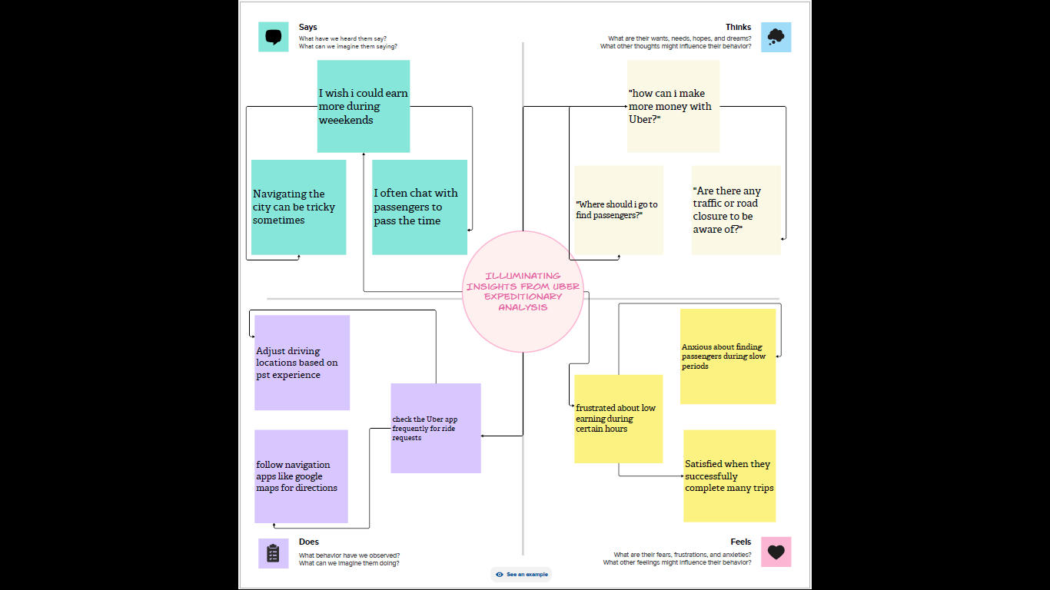

2.2 Ideation & Brainstorming map :

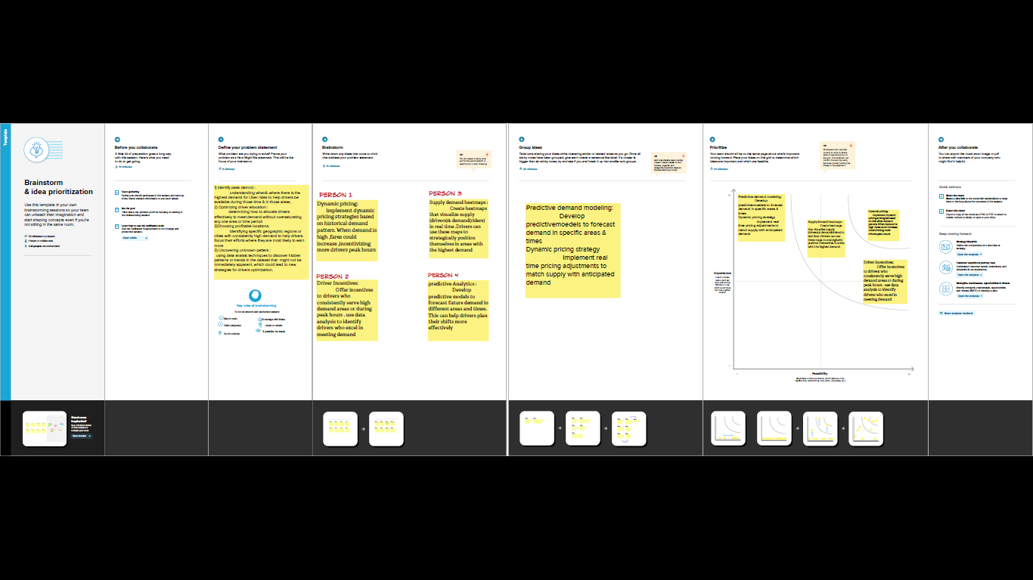

3.RESULTS :

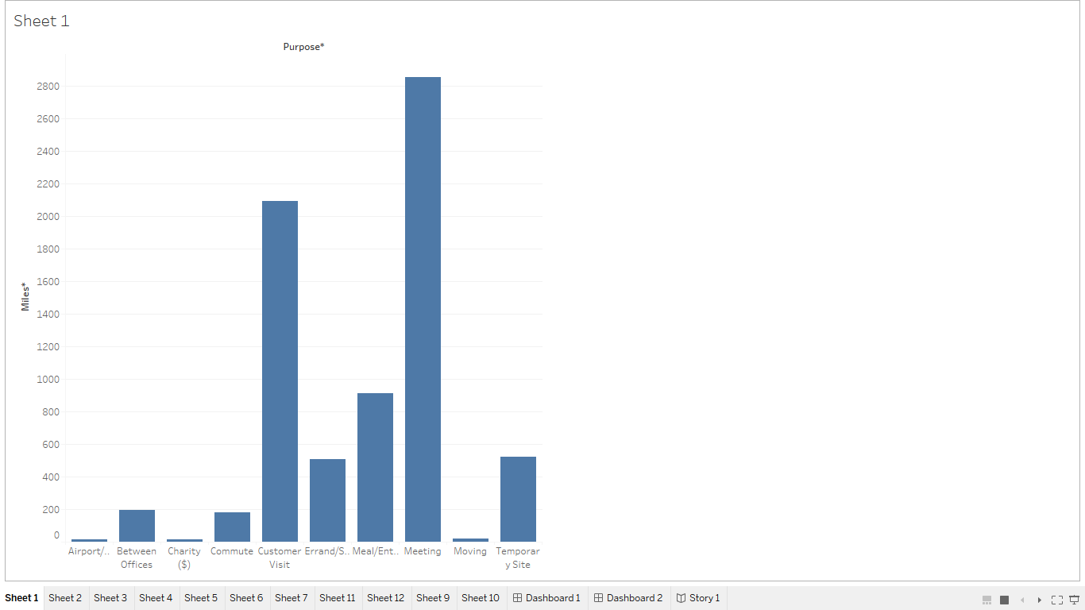

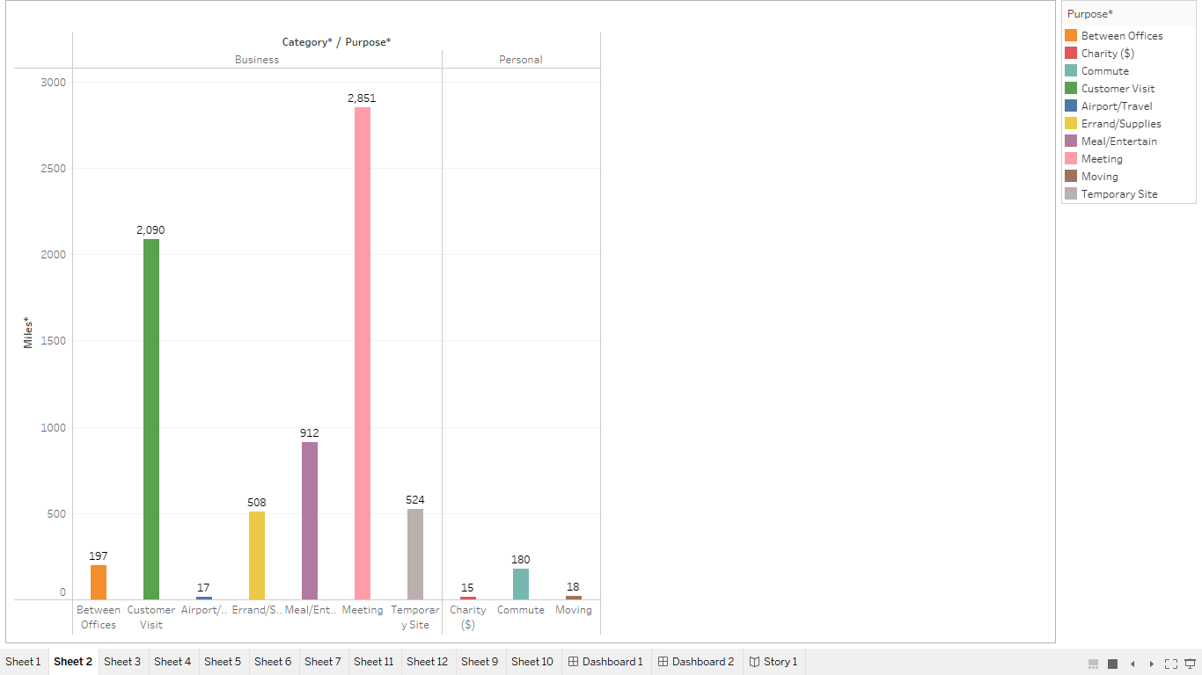

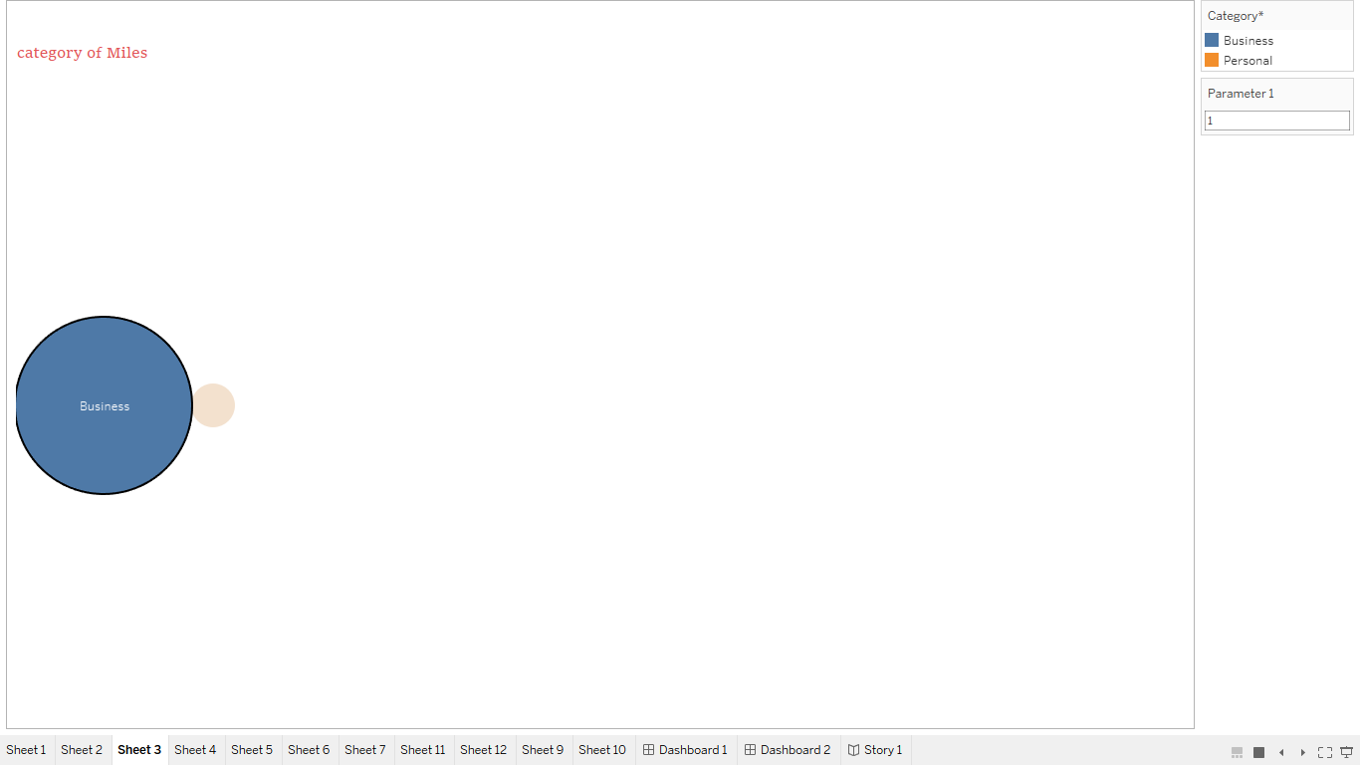

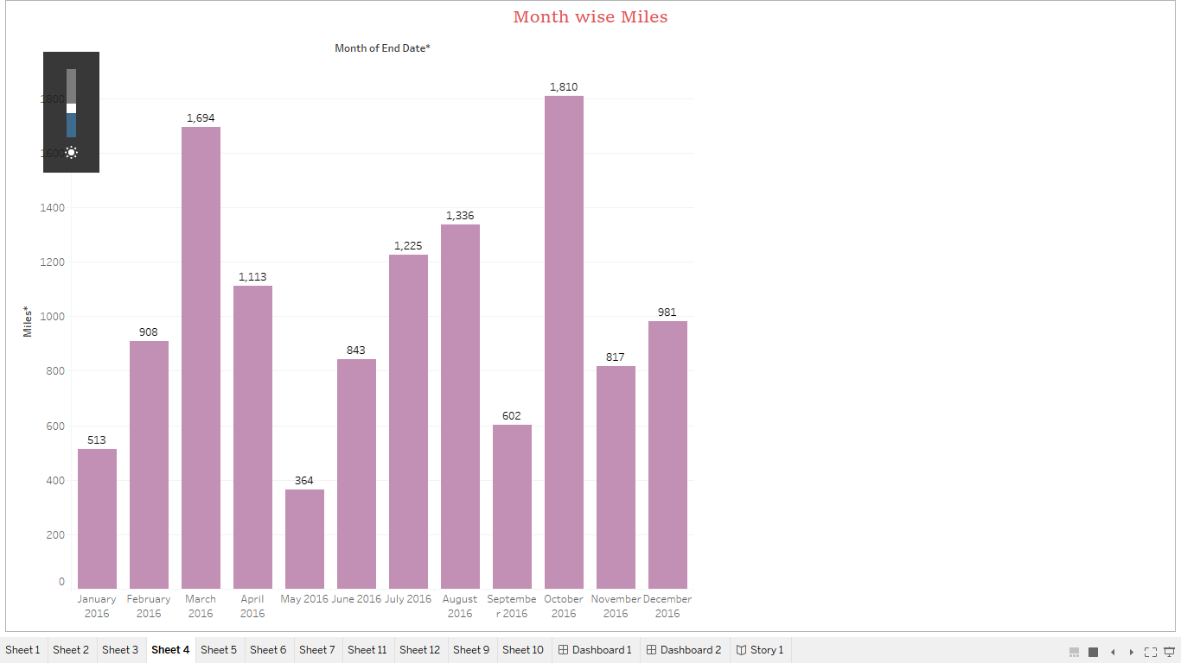

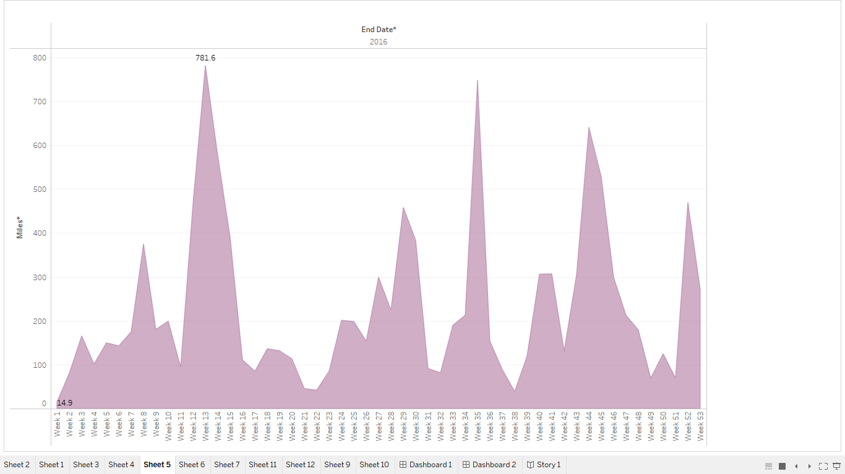

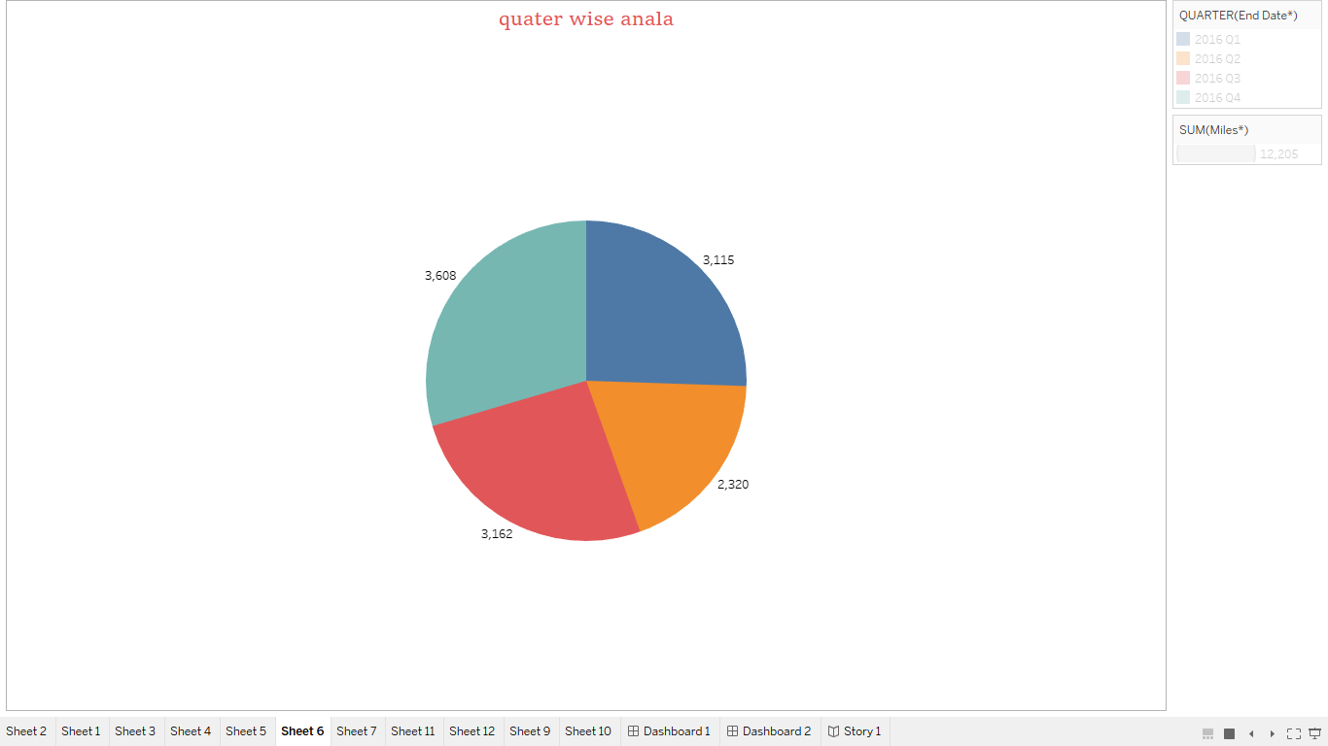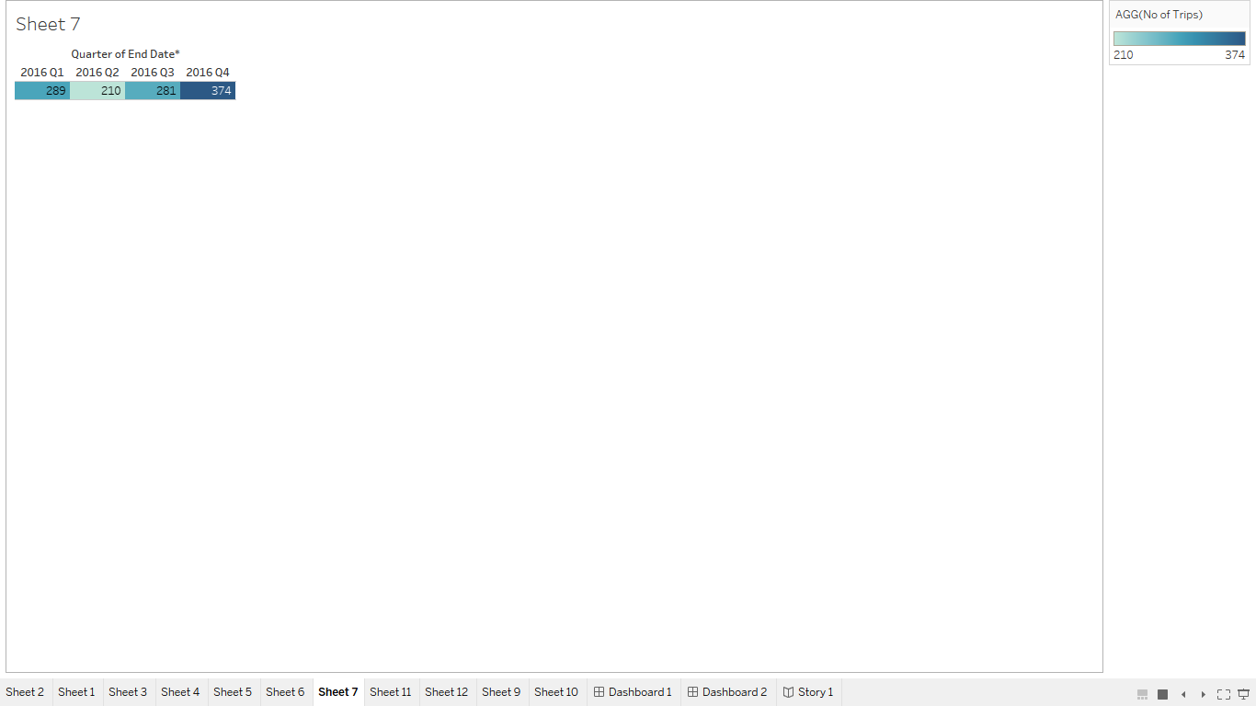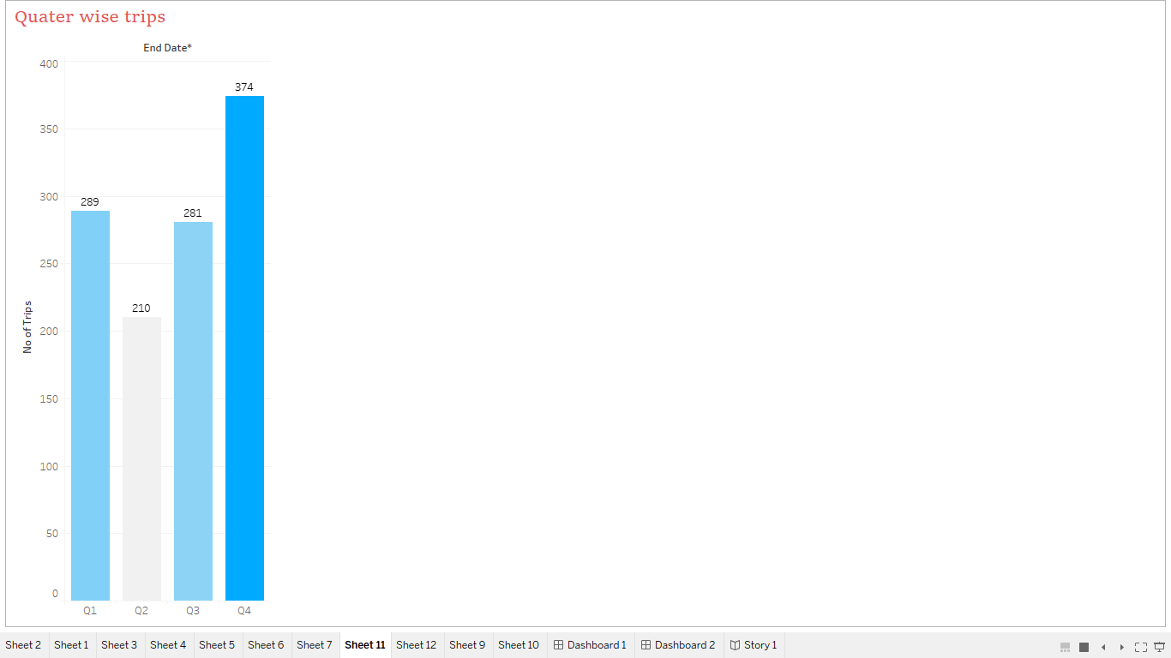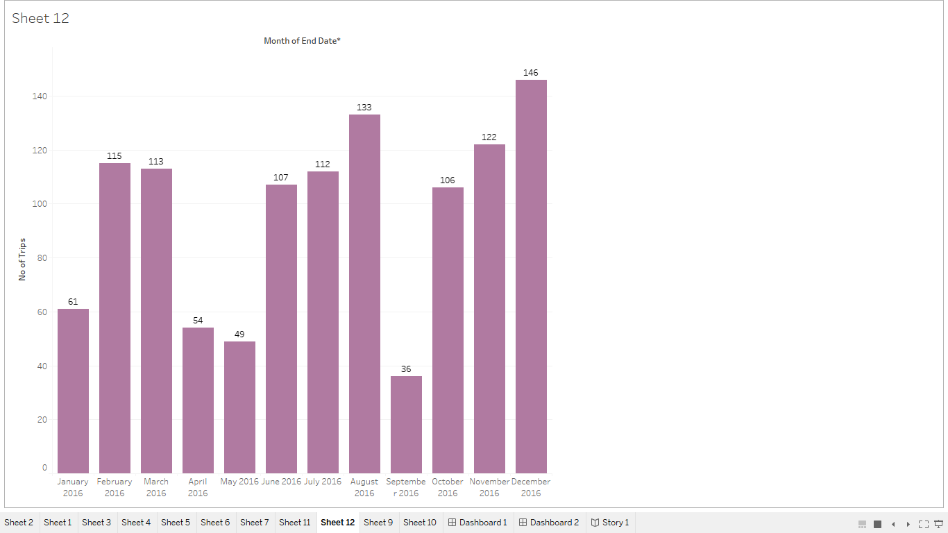

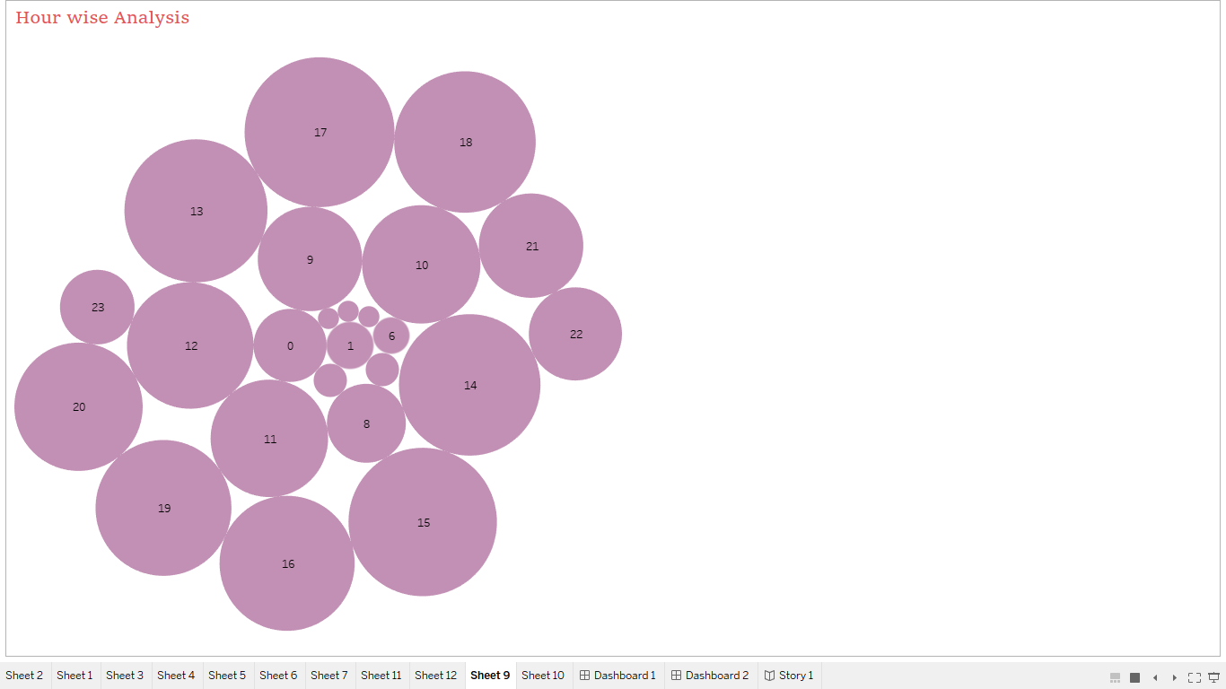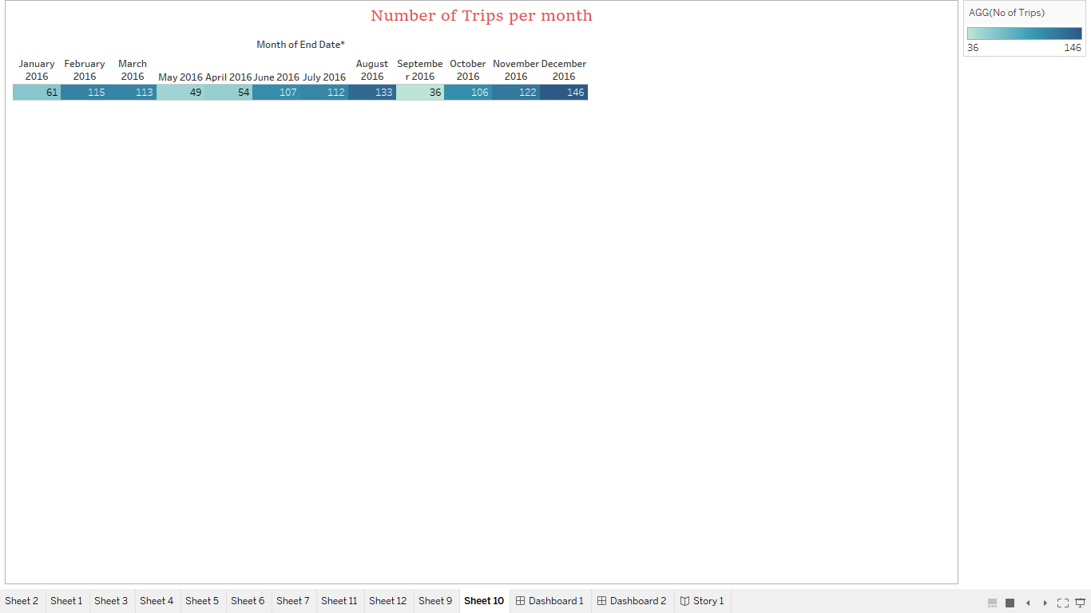

DASHBOARDS :

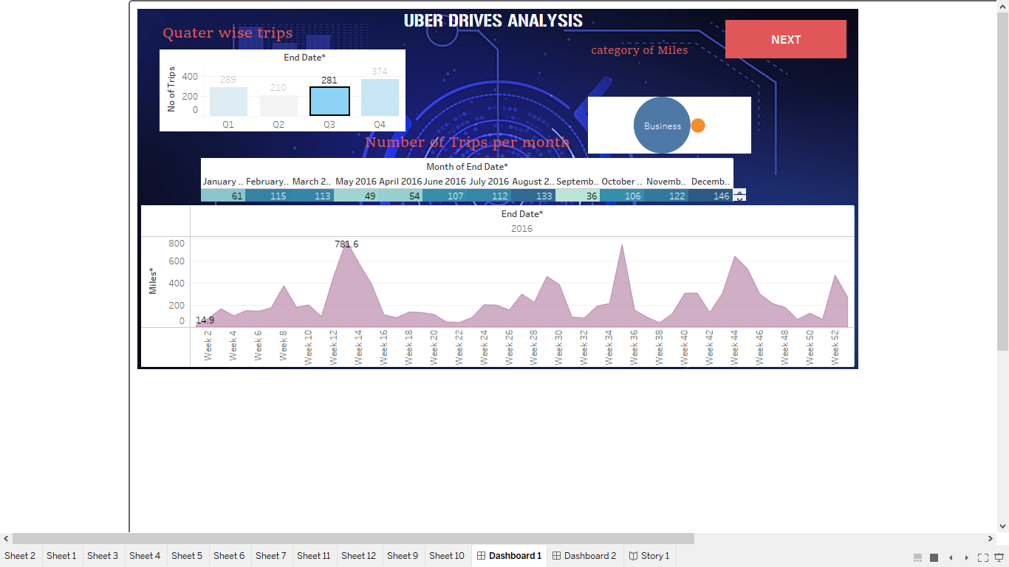

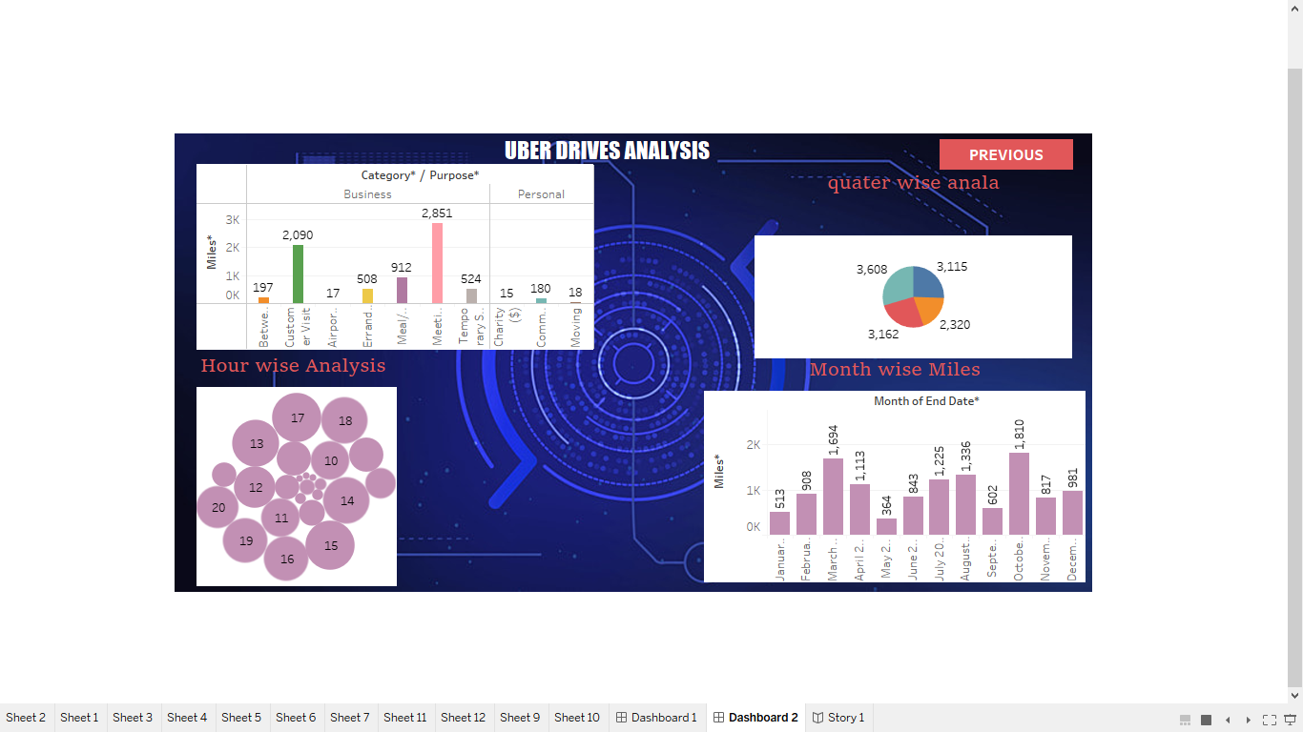

STORY :

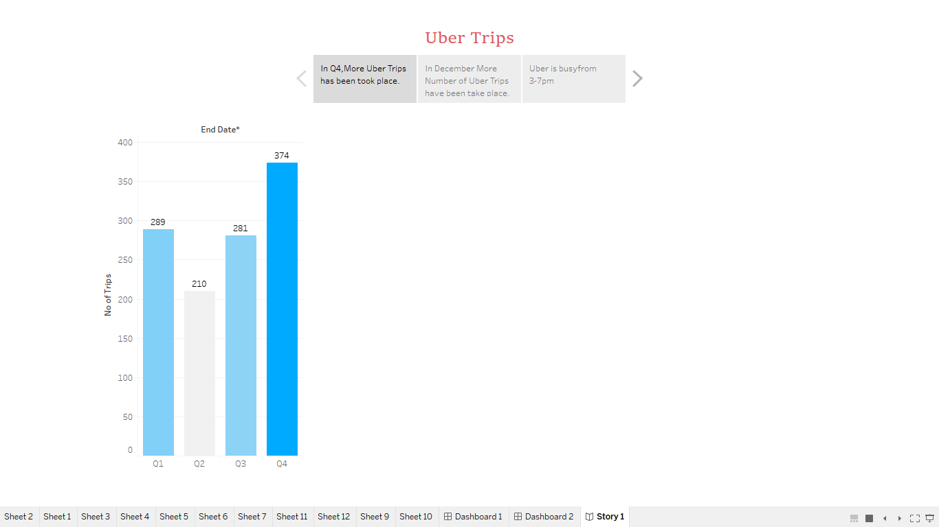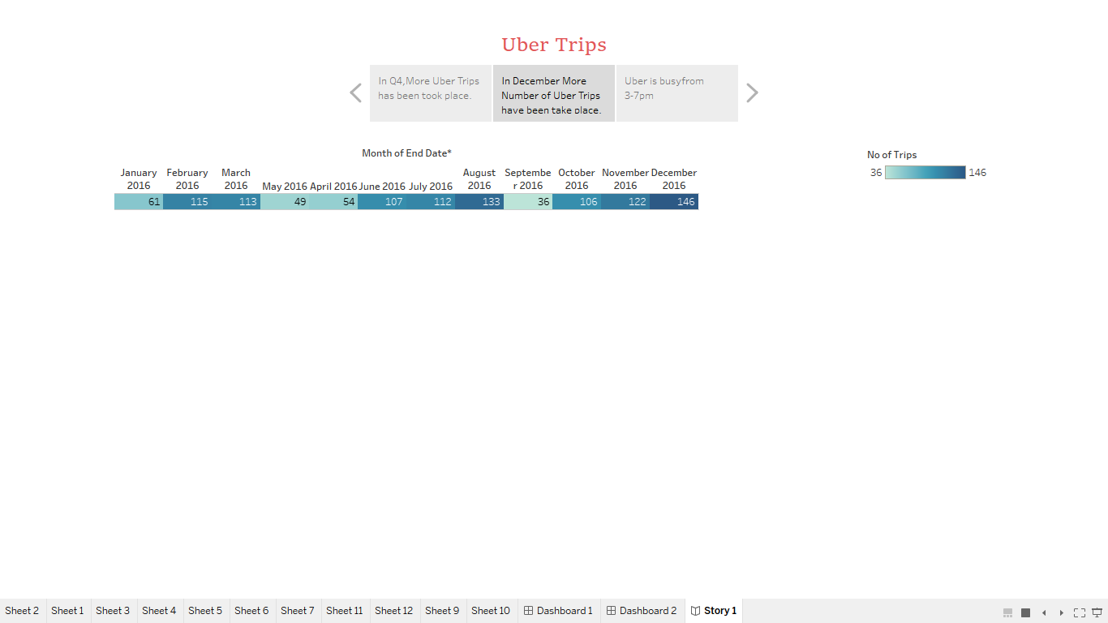

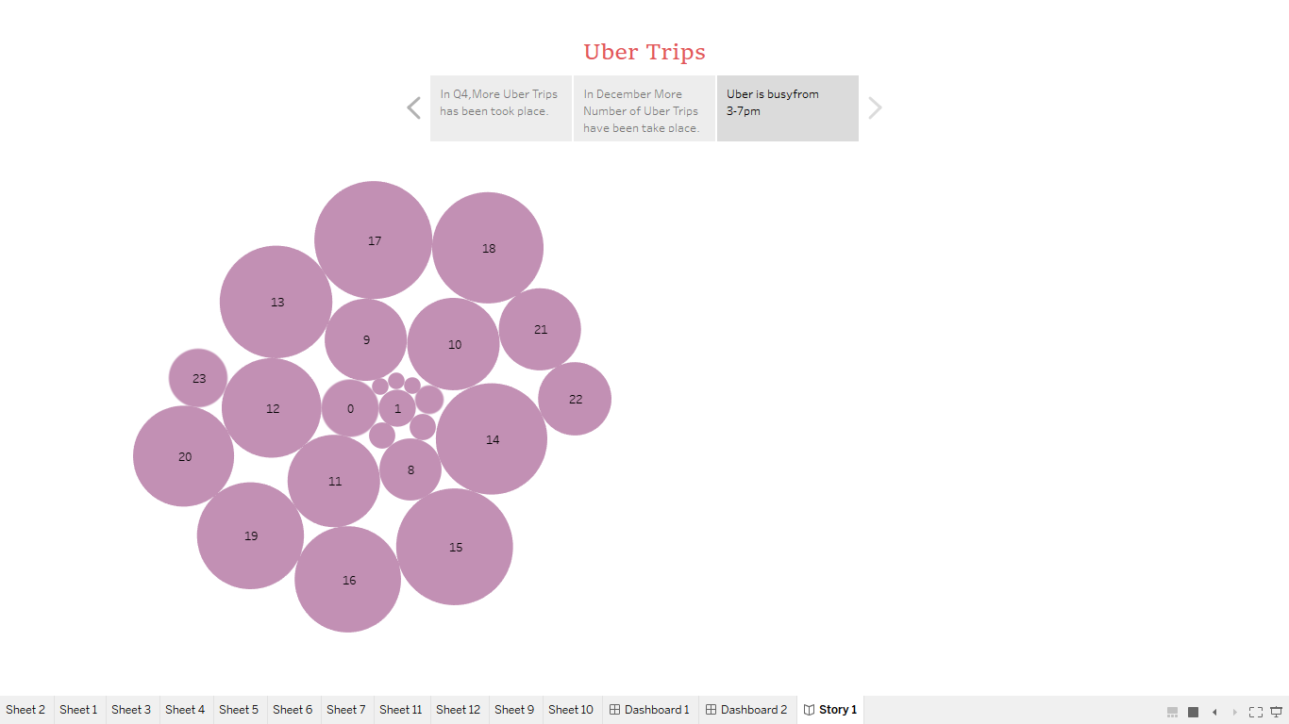

Advantages :

1. **Increased Driver Earnings**: The project helps drivers optimize their work hours, leading to higher earnings. This is a significant benefit as it directly impacts the livelihoods of Uber drivers.
2. **Improved Rider Experience**: By ensuring that drivers are available during peak demand periods, riders experience shorter wait times and faster pick-ups, enhancing their overall satisfaction with the service.
3. **Efficient Resource Allocation**: Uber can allocate its resources more efficiently, which can lead to cost savings and increased profitability. This is essential for the sustainability of the ride-sharing platform.
4. **Data-Driven Decision-Making**: The project promotes a data-driven culture, enabling both drivers and Uber to make informed decisions, which can lead to more effective operations and a competitive edge in the industry.
5. **Safety and Reliability**: Through improved driver availability in high-demand areas, Uber can enhance the safety and reliability of its service, ensuring that riders can rely on the platform when they need it most. This contributes to the long-term success of the business.

**DISADVANTAGES** :

1. **Data Privacy Concerns**: Analyzing Uber driver data involves handling personal and sensitive information. Ensuring the privacy and security of this data is a critical concern, and any mishandling could lead to privacy breaches and legal issues.
2. **Data Accuracy and Quality**: The analysis heavily relies on the accuracy and quality of the data collected. Inaccurate or incomplete data can lead to misleading conclusions and ineffective recommendations.
3. **Ethical Considerations**: Data analysis, especially in a commercial context, raises ethical questions. Ensuring that the project respects ethical standards and guidelines is essential to avoid harm to drivers or riders.
4. **Over-Reliance on Data**: There's a risk of over-reliance on data-driven decisions. Sometimes, qualitative factors and human judgment are crucial and can't be entirely replaced by data analysis.
5. **Driver and Rider Resistance**: Some drivers and riders may be resistant to the changes suggested by the project's recommendations. Drivers may feel they are being micromanaged, and riders may not like potential changes in pricing or availability

Top of Form

APPLICATION :

1. **Driver Earnings Optimization**: Uber drivers can use the insights to maximize their earnings by strategically choosing when and where to operate, ensuring they are on the road during peak demand periods.
2. **Enhanced Rider Experience**: The analysis allows Uber to improve the rider experience by ensuring that drivers are available when demand is high, reducing wait times and providing faster service.
3. **Operational Efficiency**: Uber can efficiently allocate its driver resources, reducing costs and enhancing profitability through data-driven decision-making.
4. **Safety and Reliability**: By deploying drivers to high-demand areas during peak times, Uber can enhance the safety and reliability of the service, ensuring riders can rely on the platform when they need it most.
5. **Market Expansion**: Uber can use the analysis to identify underserved areas with high demand, allowing the company to expand its services into new markets and grow its customer base.

CONCLUSION :

In conclusion, the "Uber Driver Analysis" project presents a valuable opportunity to leverage data analysis techniques for the benefit of Uber drivers, riders, and the company itself. By systematically examining Uber driver data collected from 2016, this project has provided actionable insights and recommendations that can significantly impact the operation of the ride-sharing platform. Key takeaways from the project include:

1. **Earnings Optimization**: The project has revealed opportunities for Uber drivers to optimize their earnings by strategically planning their work hours, particularly during peak demand periods. This not only benefits drivers by increasing their income but also leads to a more efficient use of resources within the Uber ecosystem.
2. **Enhanced Rider Experience**: Improved driver availability during peak hours and high-demand areas ensures that riders experience shorter wait times and faster pick-ups. This enhances the overall rider experience and contributes to customer satisfaction and loyalty.

FUTURE SCOPE :

1. **Advanced Machine Learning**: Future iterations of the project can incorporate advanced machine learning and predictive modeling techniques to create more accurate forecasts of driver demand. This would enable Uber to proactively manage driver availability based on historical data and real-time factors.
2. **Real-Time Analysis**: Expanding the project to include real-time analysis of data would allow Uber to respond dynamically to changing demand patterns and optimize driver allocation on a minute-by-minute basis.
3. **Enhanced Driver Incentives**: The project's scope can be broadened to include the analysis of driver incentive programs, allowing Uber to tailor and adjust incentives to align with demand patterns and driver preferences.
4. **Integration of Other Data Sources**: Future iterations can integrate external data sources, such as traffic patterns, weather conditions, and events data, to provide a more comprehensive understanding of demand. This would enable Uber to adapt to external factors that influence rider demand.
5. **Multi-City and Global Application**: Expanding the project's scope to multiple cities or on a global scale would provide valuable insights into regional and international variations in demand patterns, optimizing Uber's services on a broader scale.

By embracing these future directions, the "Uber Driver Analysis" project can become a more powerful and dynamic tool for Uber, contributing to even greater efficiency, profitability, and service quality within the ride-sharing industry.

Top of Form

1. Top of Form