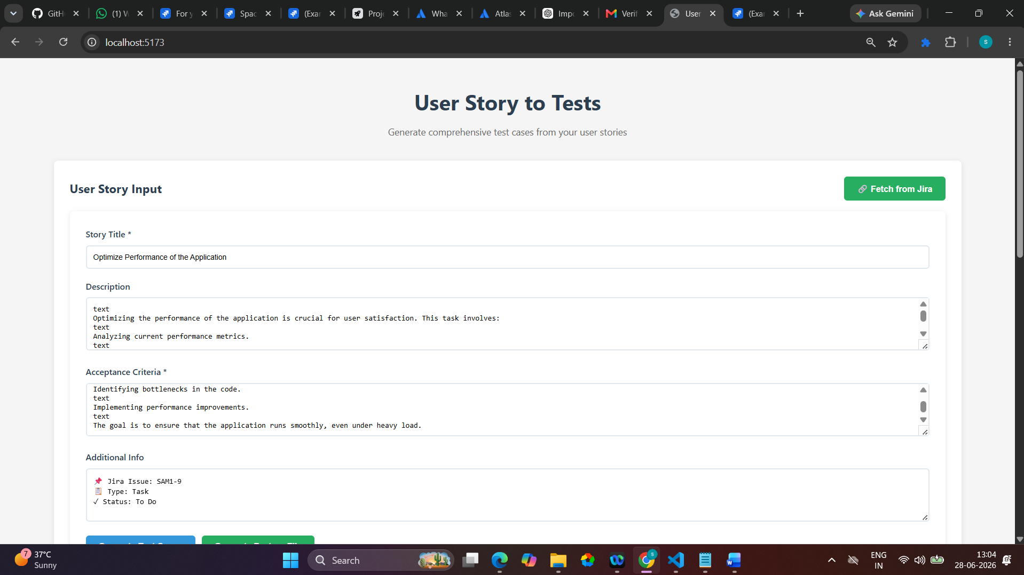

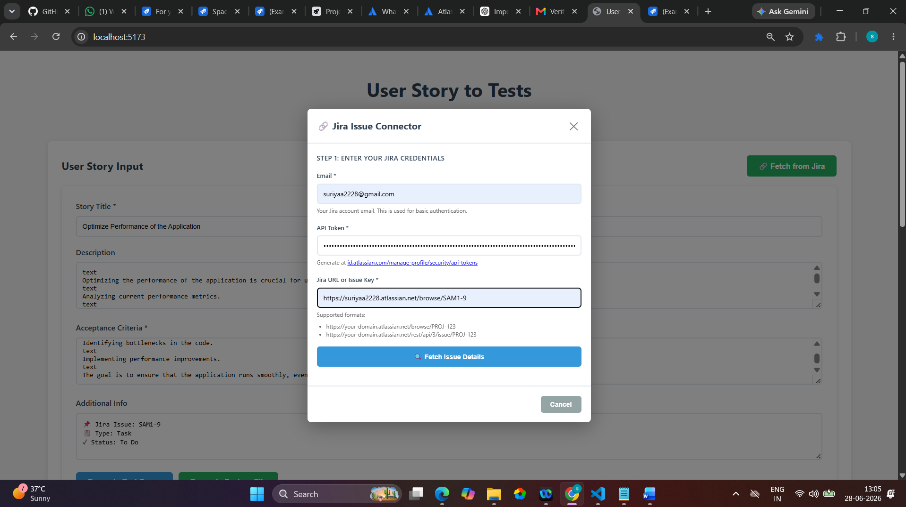

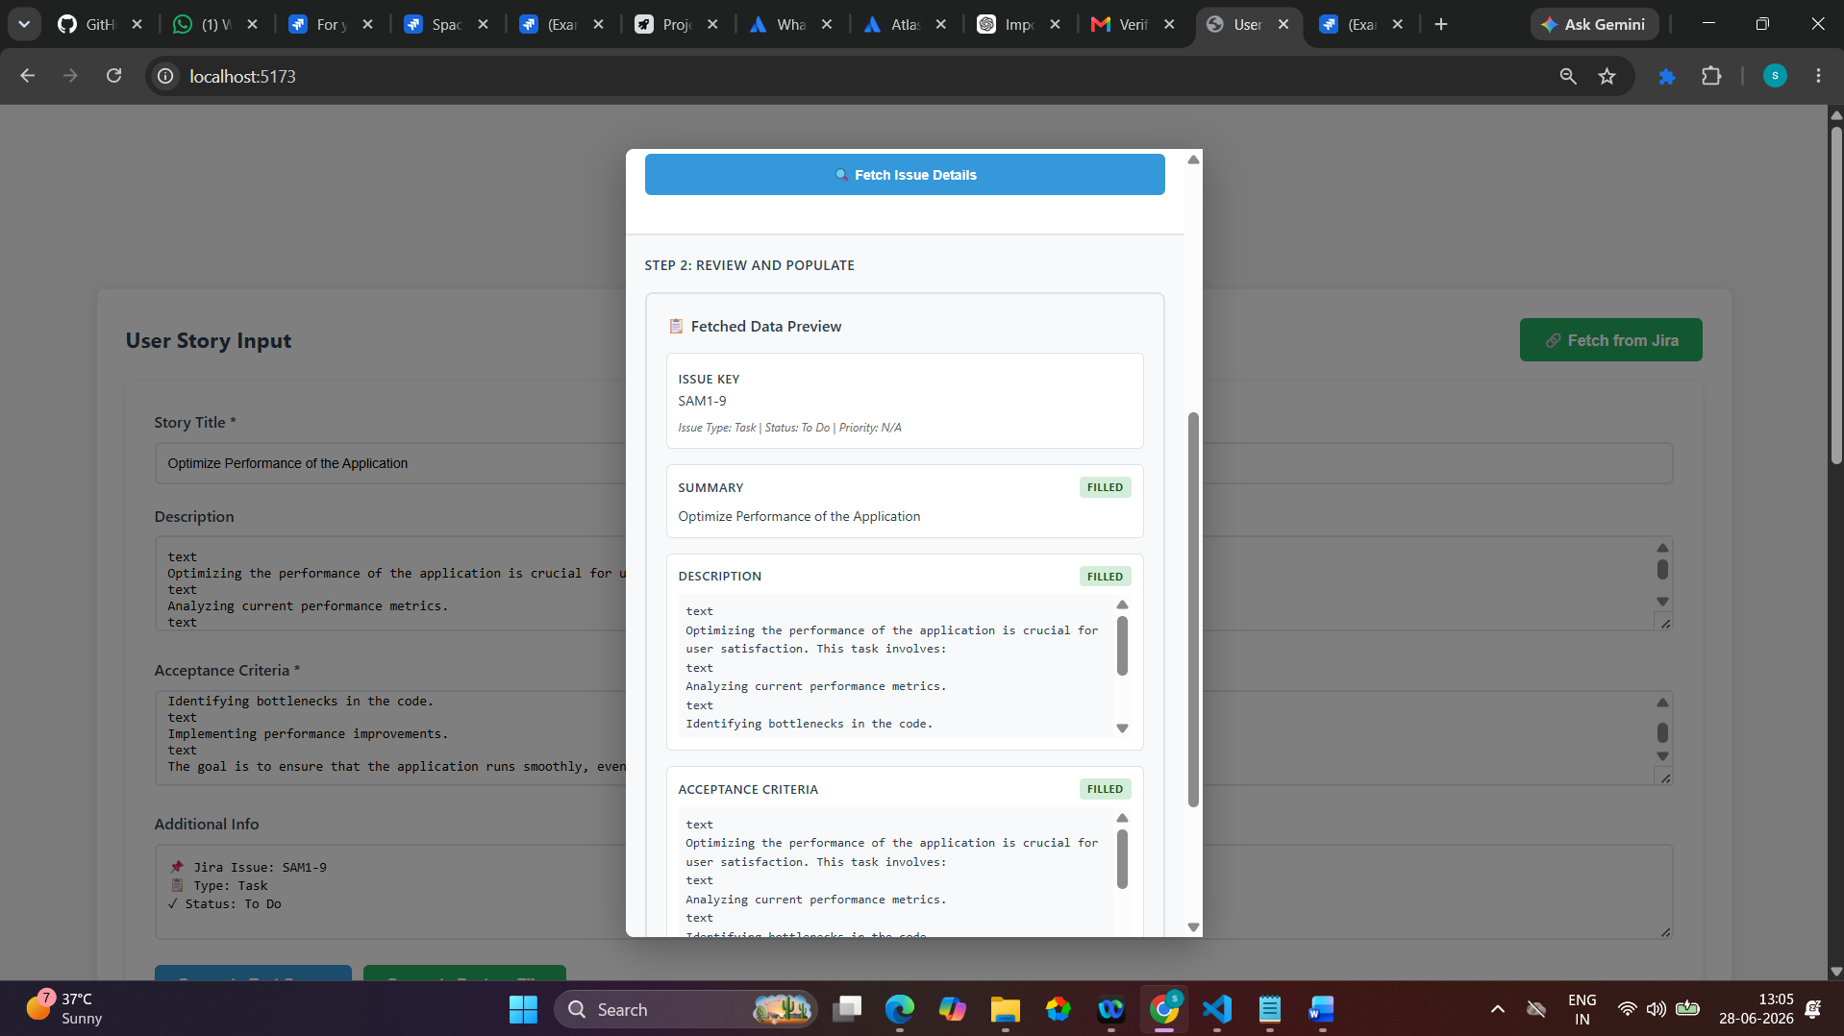

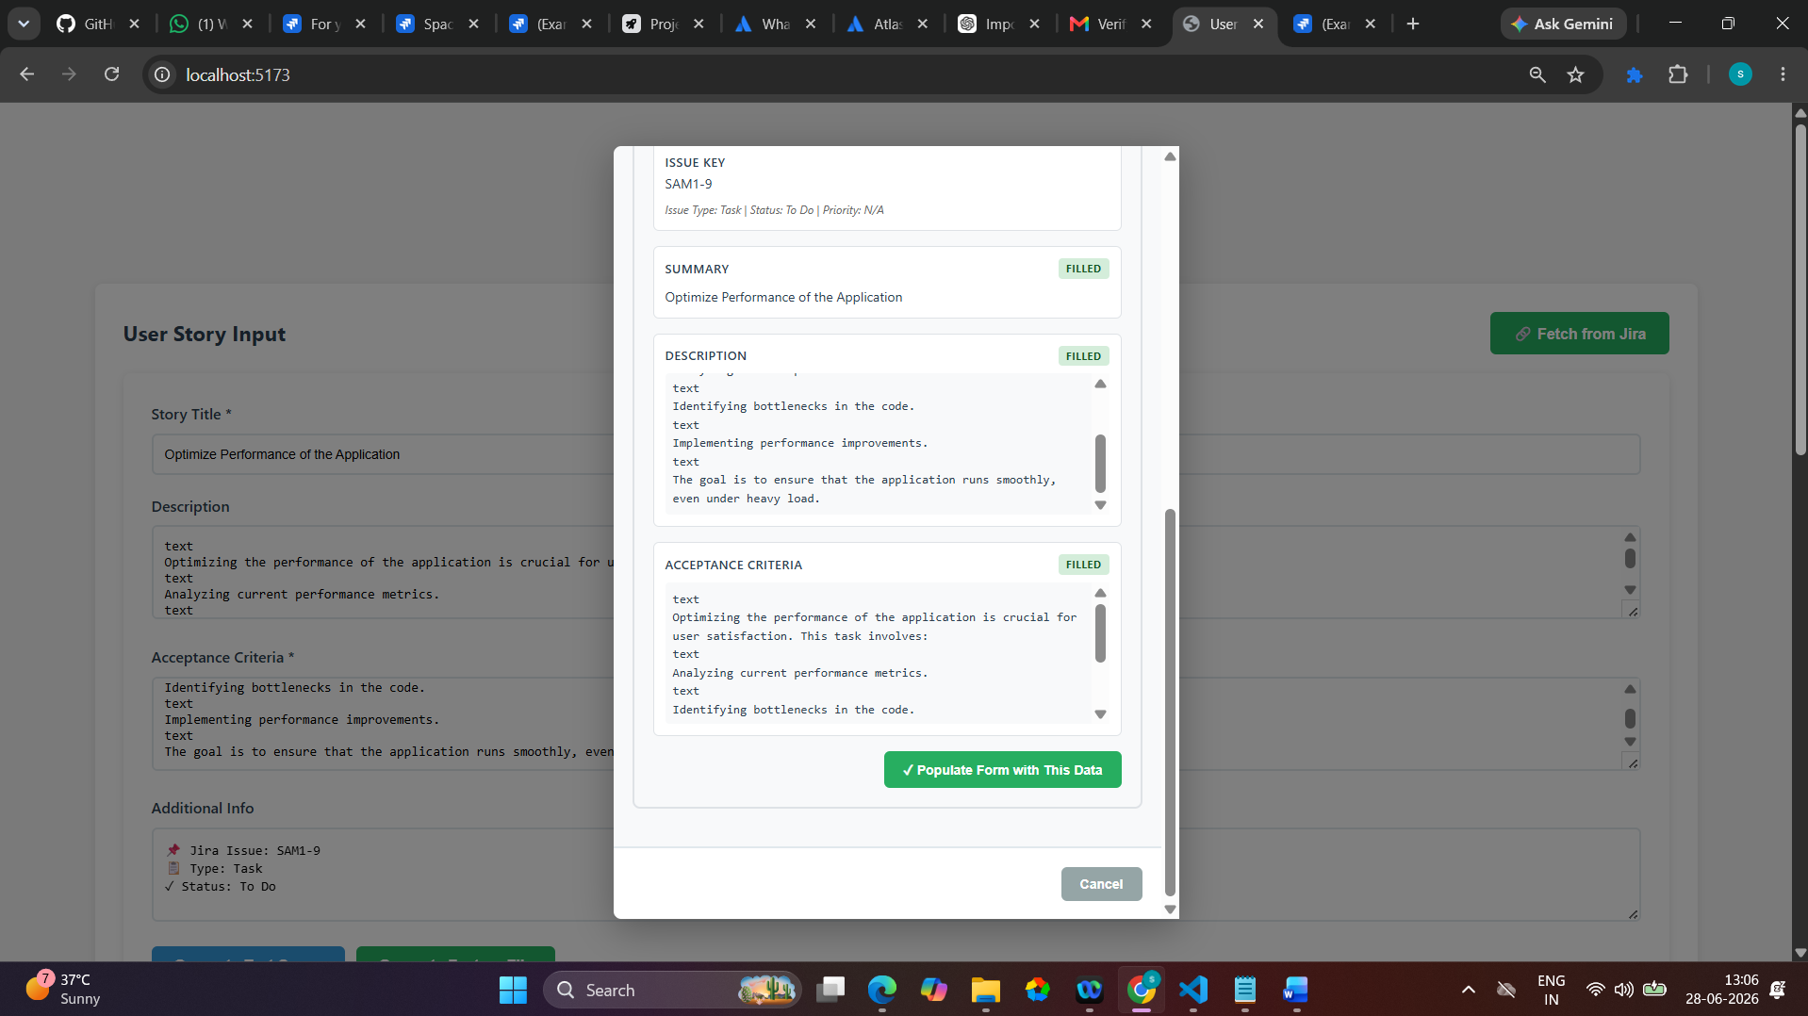

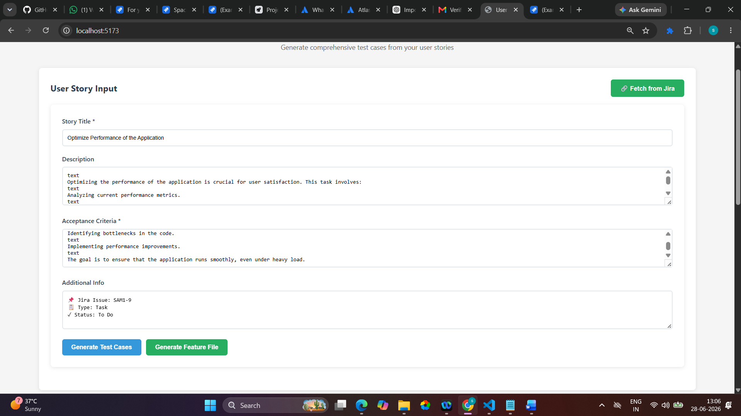

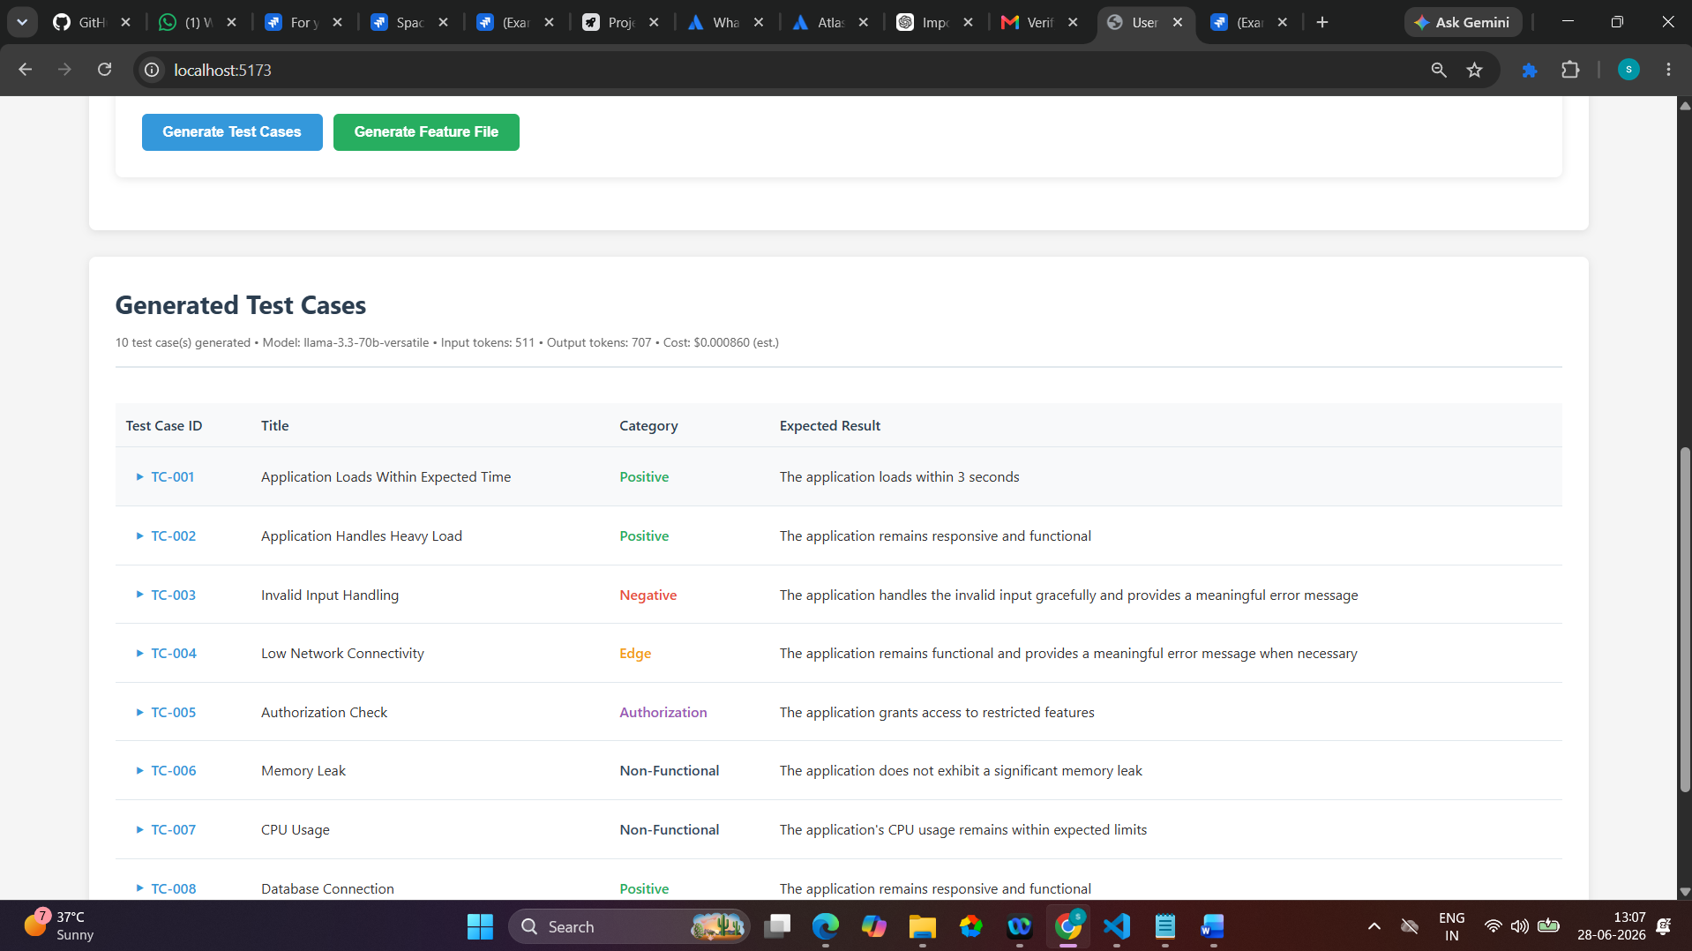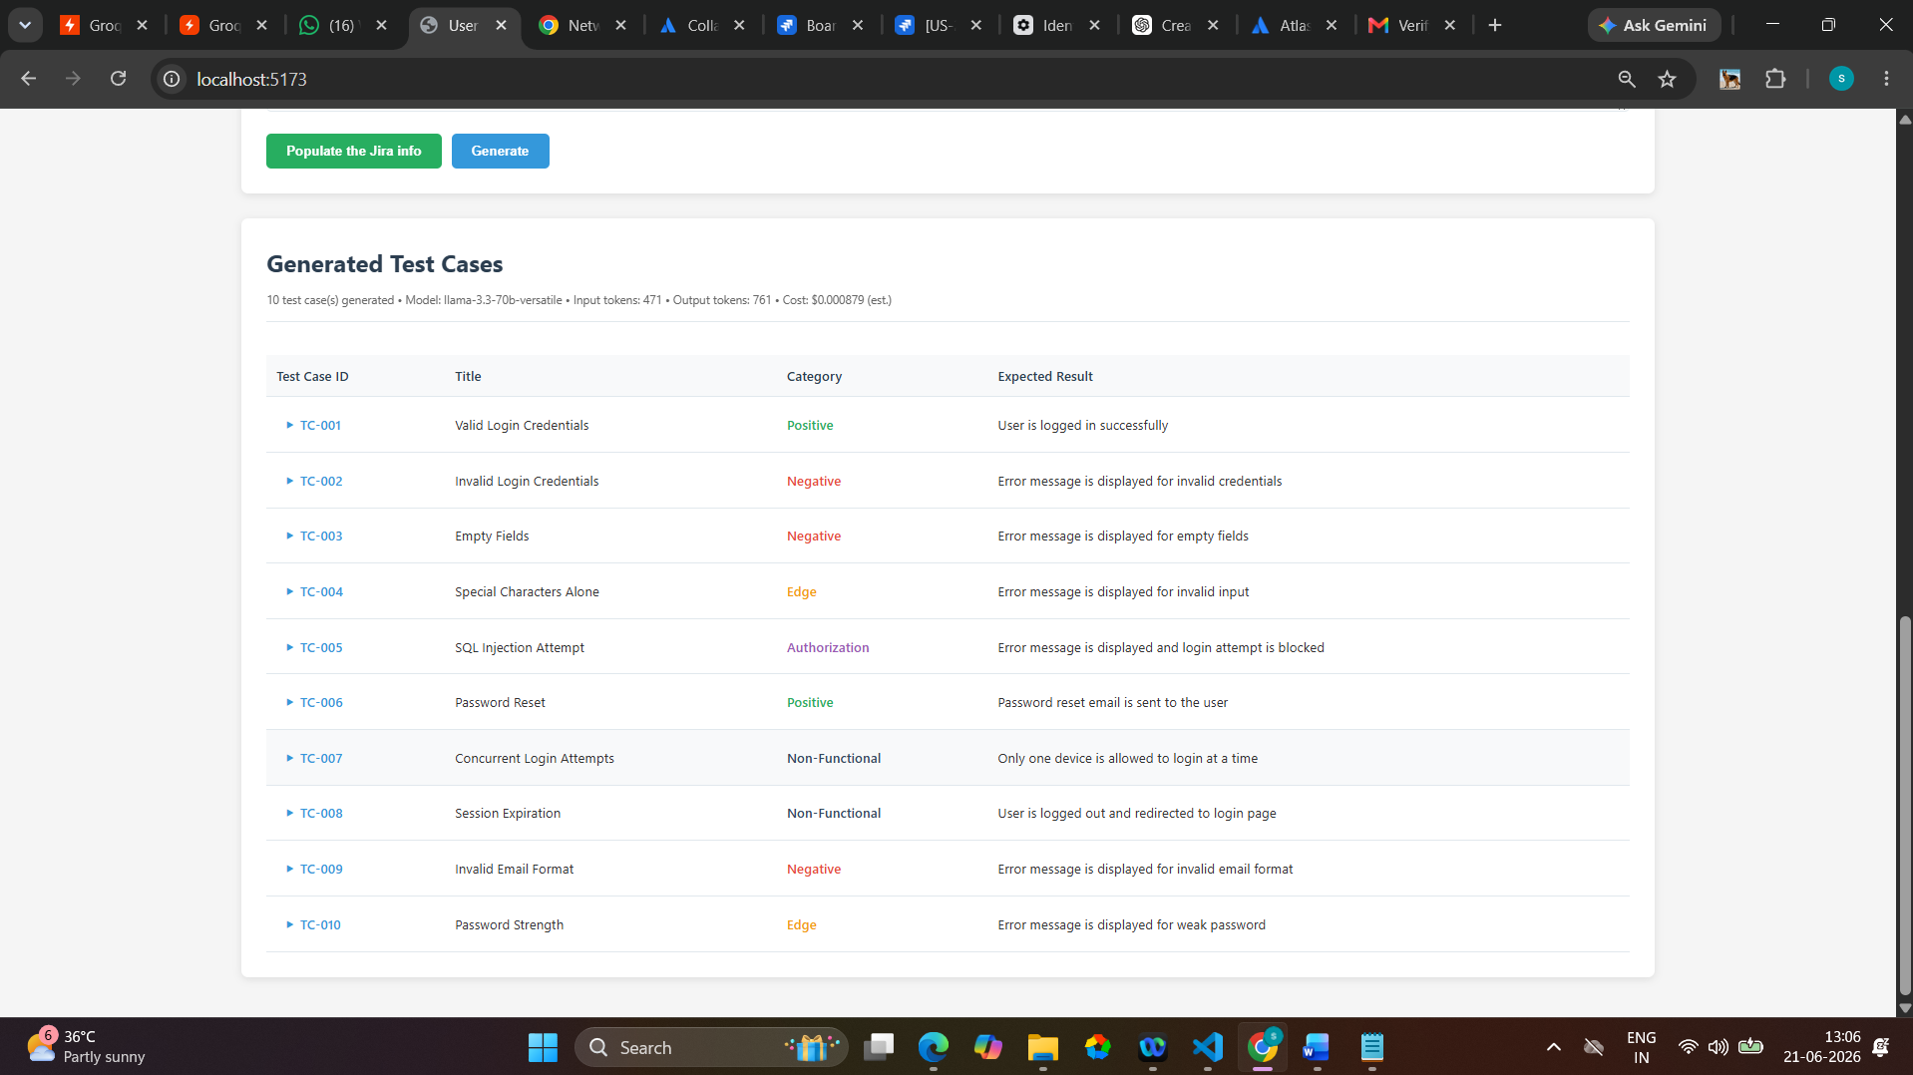

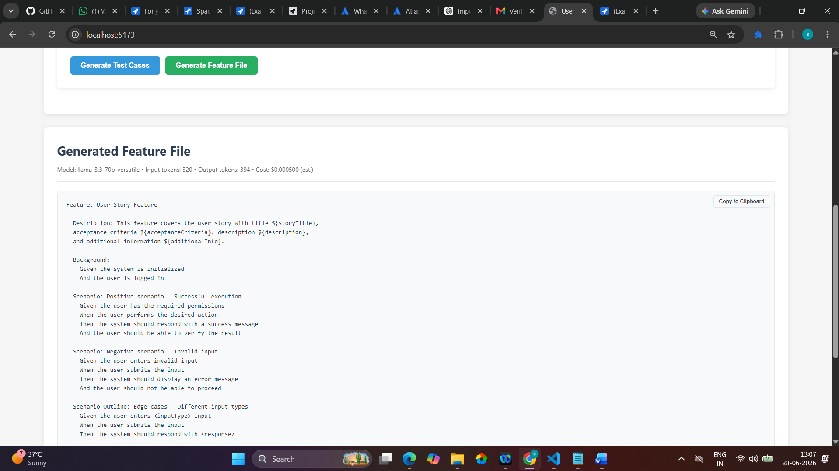

Feature: User Story Feature

Description: This feature covers the user story with title ${storyTitle},
acceptance criteria ${acceptanceCriteria}, description ${description},
and additional information ${additionalInfo}.

Background:
Given the system is initialized
And the user is logged in

Scenario: Positive scenario - Successful execution
Given the user has the required permissions
When the user performs the desired action
Then the system should respond with a success message
And the user should be able to verify the result

Scenario: Negative scenario - Invalid input
Given the user enters invalid input
When the user submits the input
Then the system should display an error message
And the user should not be able to proceed

Scenario Outline: Edge cases - Different input types
Given the user enters <inputType> input
When the user submits the input
Then the system should respond with <response>

Examples:
| inputType | response |
| valid | success message |
| invalid | error message |
| empty | error message |

Scenario: Authorization - Permission check
Given the user does not have the required permissions
When the user attempts to perform the action
Then the system should display an authorization error
And the user should not be able to proceed

Scenario: Non-functional requirement - Performance
Given the system is under heavy load
When the user performs the action
Then the system should respond within the expected time limit
And the user should be able to verify the result

