S01
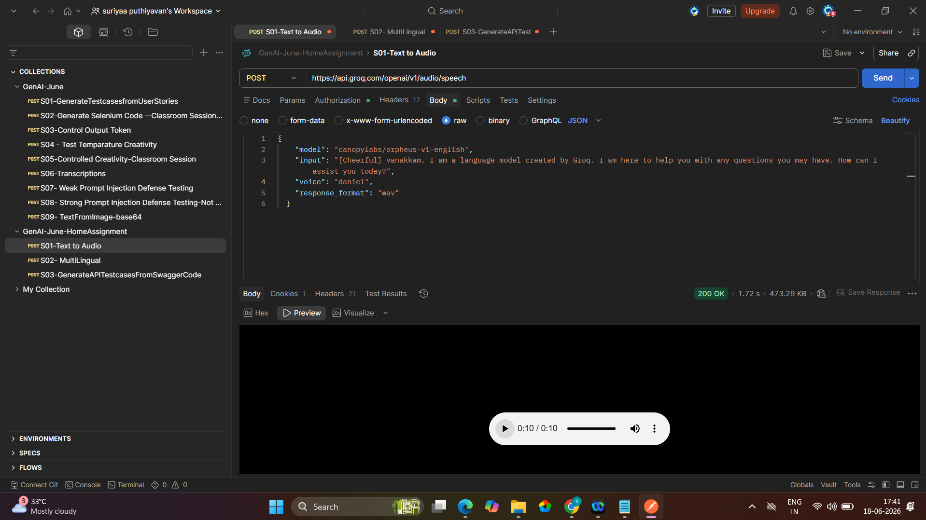

S02
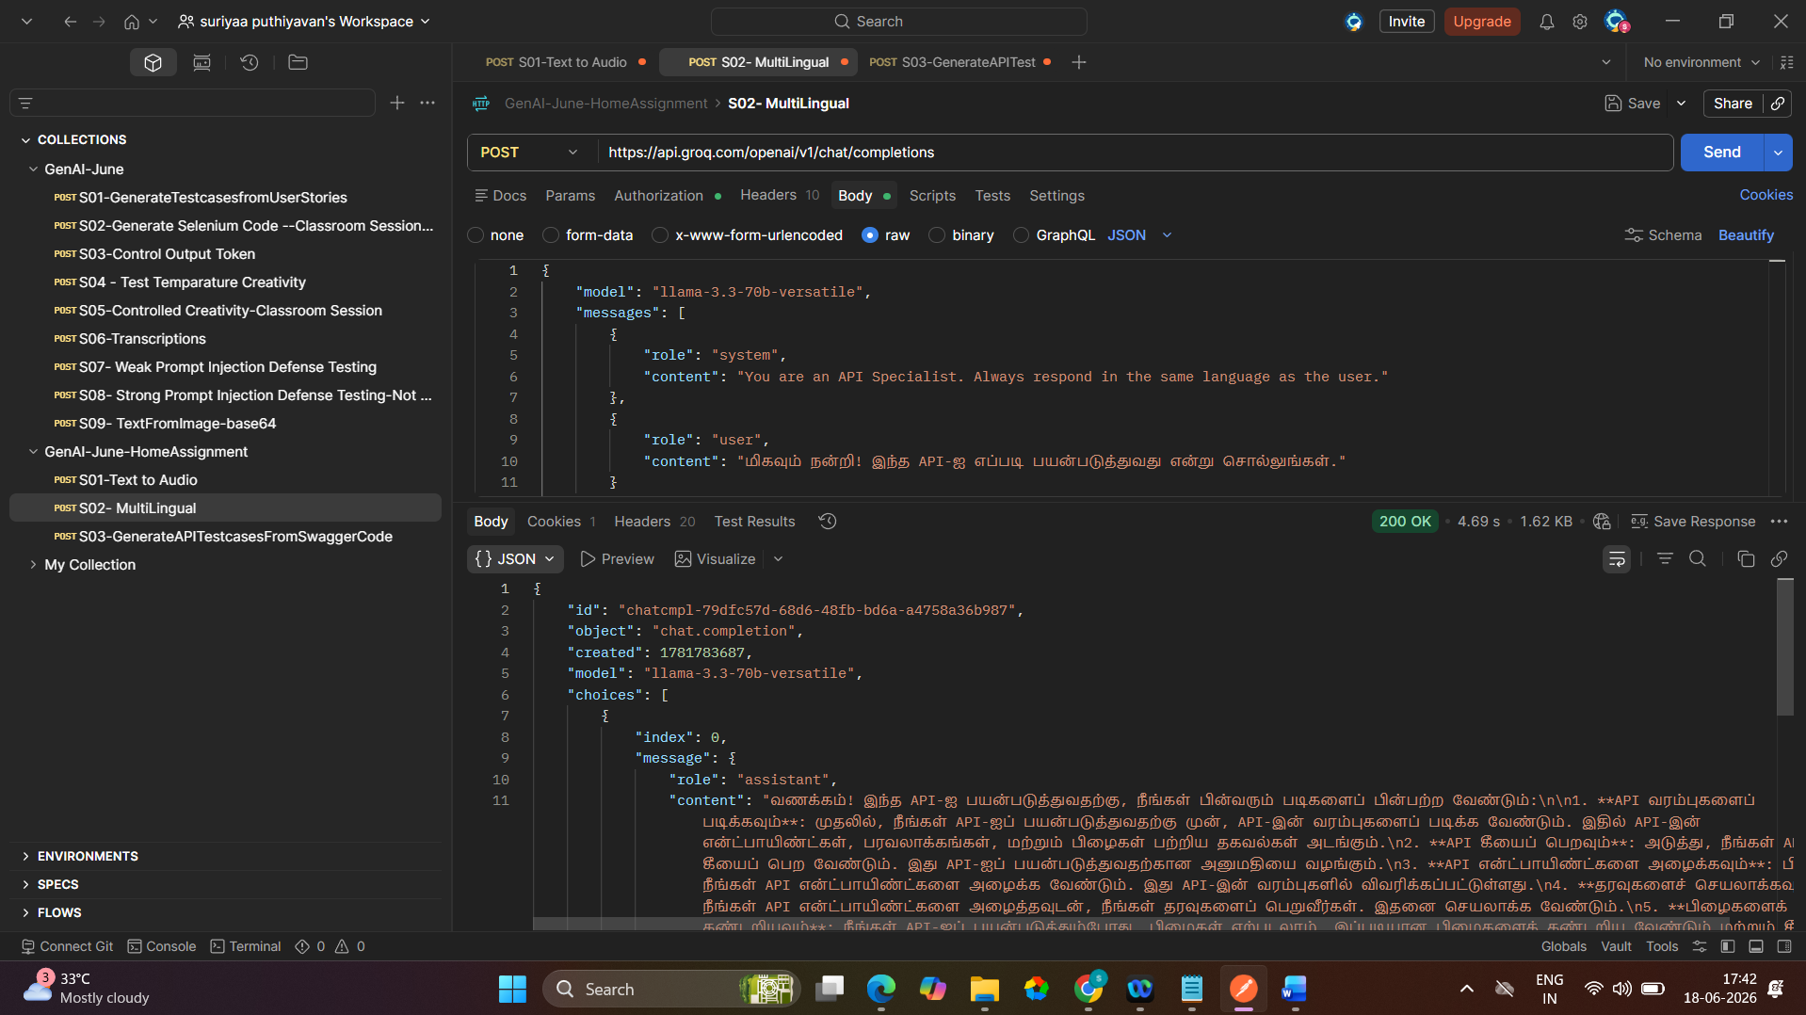

S03
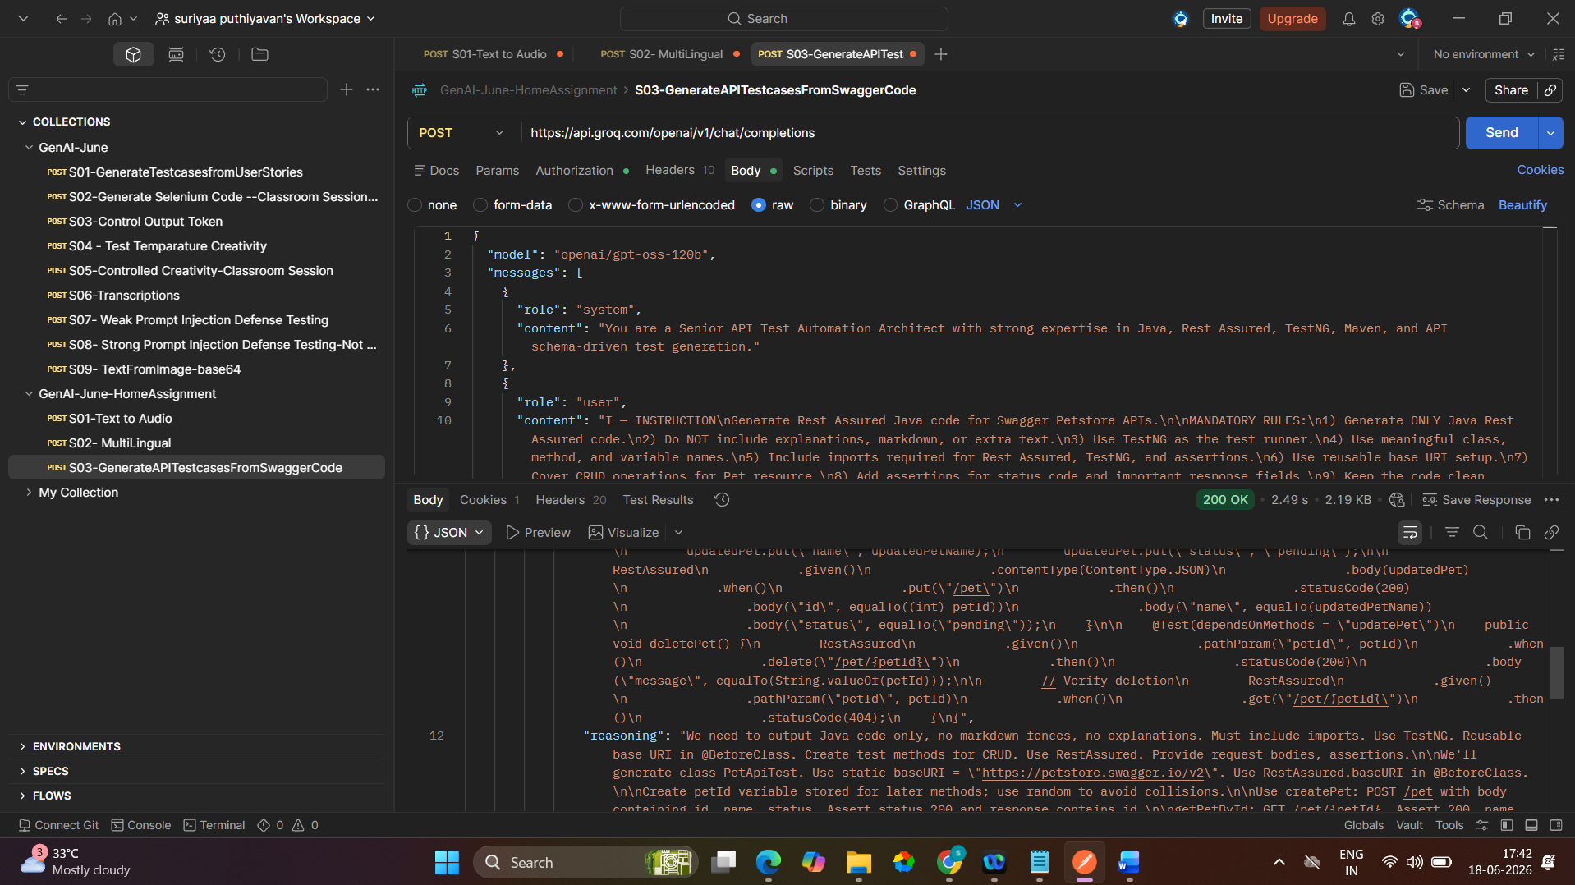
id: chatcmpl-eab80fd5-667e-423b-a571-00cd4839c79c

object: chat.completion

created: 1781783819

model: openai/gpt-oss-120b

choices:
index: 0

message:
role: assistant

content: import io.restassured.RestAssured;
import io.restassured.http.ContentType;
import io.restassured.response.Response;
import org.testng.annotations.BeforeClass;
import org.testng.annotations.Test;
import java.util.HashMap;
import java.util.Map;
import static org.hamcrest.Matchers.*;

public class PetApiTest {

private static final String BASE_URI = "https://petstore.swagger.io/v2";
private long petId;
private final String initialPetName = "TestPet";
private final String updatedPetName = "UpdatedPet";

@BeforeClass
public void setUp() {
RestAssured.baseURI = BASE_URI;
petId = System.currentTimeMillis();
}

@Test
public void createPet() {
Map<String, Object> pet = new HashMap<>();
pet.put("id", petId);
pet.put("name", initialPetName);
pet.put("status", "available");

RestAssured
.given()
.contentType(ContentType.JSON)
.body(pet)
.when()
.post("/pet")
.then()
.statusCode(200)
.body("id", equalTo((int) petId))
.body("name", equalTo(initialPetName))
.body("status", equalTo("available"));
}

@Test(dependsOnMethods = "createPet")
public void getPetById() {
RestAssured
.given()
.pathParam("petId", petId)
.when()
.get("/pet/{petId}")
.then()
.statusCode(200)
.body("id", equalTo((int) petId))
.body("name", equalTo(initialPetName))
.body("status", equalTo("available"));
}

@Test(dependsOnMethods = "getPetById")
public void updatePet() {
Map<String, Object> updatedPet = new HashMap<>();
updatedPet.put("id", petId);
updatedPet.put("name", updatedPetName);
updatedPet.put("status", "pending");

RestAssured
.given()
.contentType(ContentType.JSON)
.body(updatedPet)
.when()
.put("/pet")
.then()
.statusCode(200)
.body("id", equalTo((int) petId))
.body("name", equalTo(updatedPetName))
.body("status", equalTo("pending"));
}

@Test(dependsOnMethods = "updatePet")
public void deletePet() {
RestAssured
.given()
.pathParam("petId", petId)
.when()
.delete("/pet/{petId}")
.then()
.statusCode(200)
.body("message", equalTo(String.valueOf(petId)));

// Verify deletion
RestAssured
.given()
.pathParam("petId", petId)
.when()
.get("/pet/{petId}")
.then()
.statusCode(404);
}
}

reasoning: We need to output Java code only, no markdown fences, no explanations. Must include imports. Use TestNG. Reusable base URI in @BeforeClass. Create test methods for CRUD. Use RestAssured. Provide request bodies, assertions.

We'll generate class PetApiTest. Use static baseURI = "https://petstore.swagger.io/v2". Use RestAssured.baseURI in @BeforeClass.

Create petId variable stored for later methods; use random to avoid collisions.

Use createPet: POST /pet with body containing id, name, status. Assert status 200 and response contains id.

getPetById: GET /pet/{petId}. Assert 200, name matches.

updatePet: PUT /pet with changed name or status. Assert 200 and updated field.

deletePet: DELETE /pet/{petId}. Assert 200 and then GET returns 404.

Make methods dependOnMethods appropriately.

Use TestNG annotations.

Add import static io.restassured.RestAssured.*; import static org.hamcrest.Matchers.*;

We'll also need JsonObject or Map for body. Use HashMap.

Implement.

Now produce code.

logprobs:

finish_reason: stop

usage:
queue_time: 0.287111261

prompt_tokens: 396

prompt_time: 0.020414458

completion_tokens: 899

completion_time: 1.911126817

total_tokens: 1295

total_time: 1.9315412749999998

completion_tokens_details:
reasoning_tokens: 231

usage_breakdown:

system_fingerprint: fp_c800245357

x_groq:
id: req_01kvd9ev0meetsjx9j1rwganb2

seed: 109825974

service_tier: on_demand

