

A Project Report On

**Online Book Store**

**By**

**Batch:** 2021– 6518

**Center:Chennai**

Under the Guidance of,

**Chittaranjan Ghosh.**

**Technical Trainer**

**EduBridge**

(School of coding)

## Introduction:

Online Book store is an online web application where the customer can purchase books online. Through a web browser the customers can search for a book by its title or author, later can add to the shopping cart and finally purchase using credit card transaction. The user can login using his account details or new customers can set up an account very quickly. They should give the details of their name, contact number and shipping address. The user can also give feedback to a book by giving ratings on a score of five. The books are divided into many categories based on subject like Software, Database, English, Architecture etc. The Online Book Store Website provides customers with online shopping through a web browser. A customer can, create, sign in to his account, place items into a shopping cart and purchase using his credit card details. The Administrator will have additional functionalities when compared to the common user. He can add, delete and update the book details, book categories, member information and also confirm a placed order.

.**Modules:-**

* Admin
* User

I have developed this Application in **Java,** It’s a web-based projects so I have used **MySQL.**

**Software Requirements:**

**Front end:** Java

**Back end**: MySQL workbench 8.0 CE.

**Middleware/Server:** JAVA,MySQL.

**Browser:** Best result on Google Chrome

**Operating System:** Window

# Data Dictionary:

* Admin login:

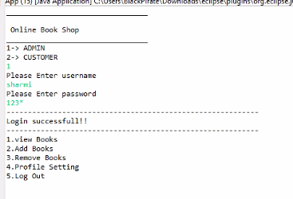

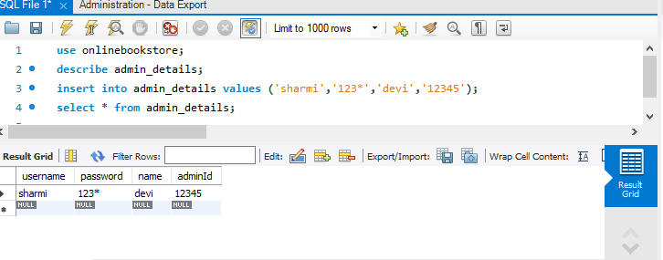

* Admin View Book:

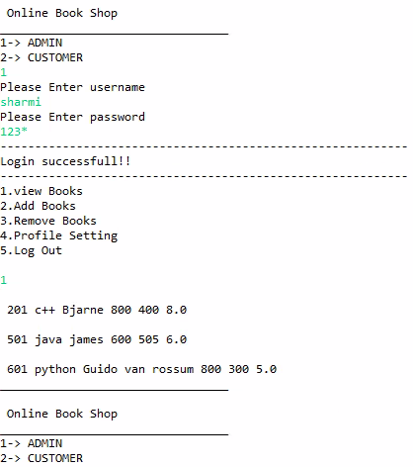

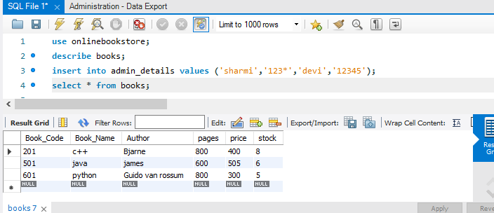

* Admin Add Book:

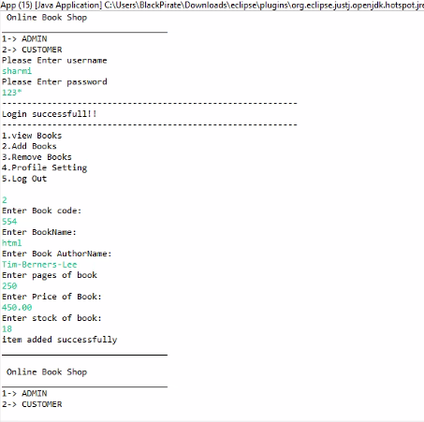

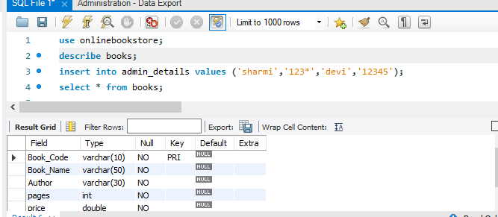

* Remove Book :

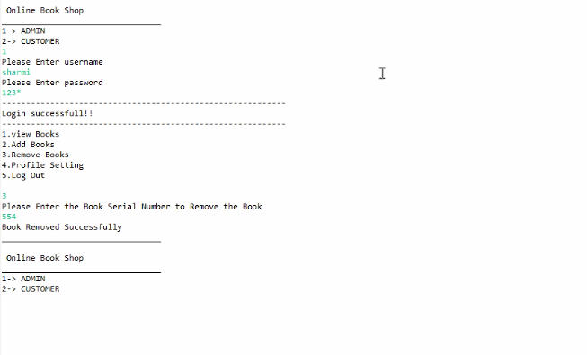

* Admin Profile:

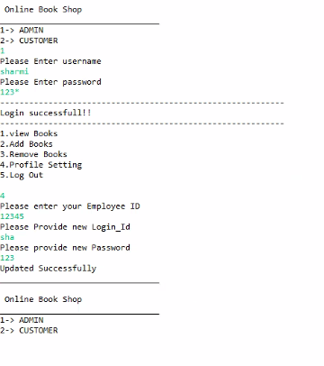

* Admin Logout:

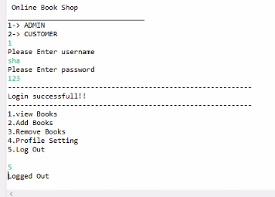

* Customer login :

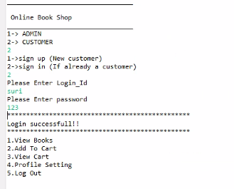

* New Customer:

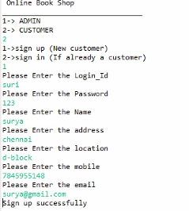

* Already Customer:

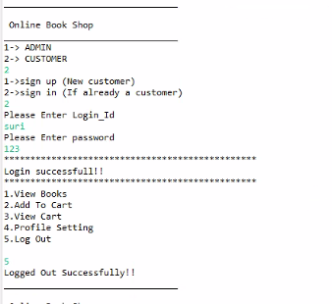

* Customer View Book:

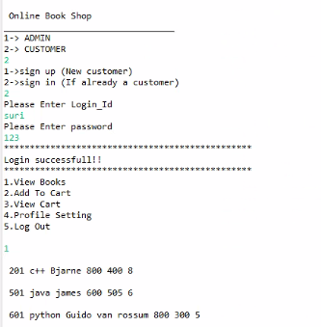

* Customer Profile:

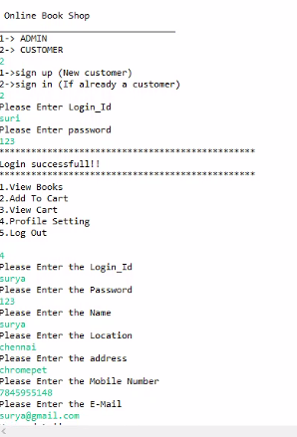

**Thank you…..**

**Suggestions?......**