DIGITAL ACQUISITION
Landing Page Optimisation
What it is, how it works, and what data it needs
With two real examples · Capital One and the insurance industry

An introduction for anyone who needs to understand this topic without a technical background.

1. What is landing page optimisation?
A landing page is the first page someone sees after clicking an advert, an email or a search result. It usually asks them to do one thing — get a quote, open an account, start an application.
Landing page optimisation is simply the work of making that page better at turning visitors into customers.

How it is done today
In most organisations it works like this. Someone reviews the analytics. They form a theory — perhaps a shorter form would help. They build two versions of the page and split the traffic between them. Three weeks later they see which won, and that version becomes the page everyone sees.
This is called A/B testing. It works, and it is a perfectly respectable way to improve a page. But it has three limits.
Limit | What it means in practice
It is slow | Each test takes weeks and teaches you one thing. Your list of ideas is far longer than the number of tests you can run.
It ignores differences | The winning version is the one that worked best on average. Visitors who are not average get a page that suits them less well.
It goes stale | A page that won last year may be losing today, because offers, competitors and customers have all changed. Nothing tells you.

What closed-loop optimisation changes
Closed-loop optimisation does the same job, but automatically and continuously. Instead of a person testing two versions and choosing a winner every few weeks, the system chooses what to show each visitor, watches what happens, and adjusts.
A simple way to picture it
Think of two shop assistants.
The first greets every customer with exactly the same sentence, all day, every day. Once a month the manager tries a new sentence and keeps whichever sold more.
The second notices what you are looking at, adjusts what they say, sees whether it worked, and does better with the next customer. By the end of the week they have learned more than the first will learn in a year.
The second assistant is a closed loop.

2. How it works
The system runs a cycle with six steps. It repeats for every visitor.
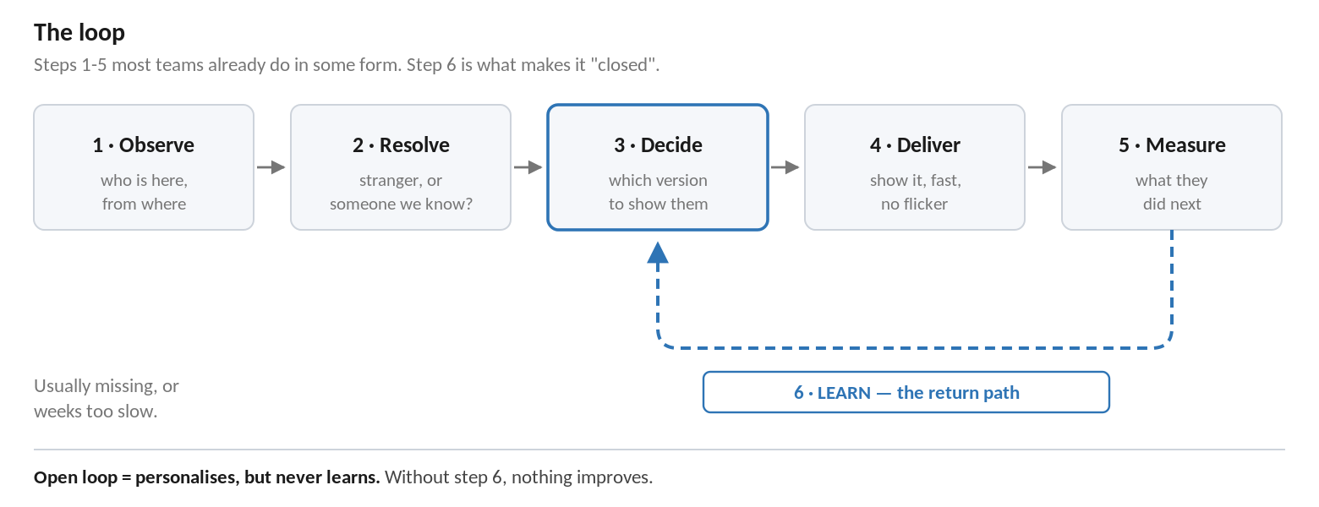
Step | What happens
1. Observe | The system notices things about the visitor — which advert they clicked, where they are, what device they are using.
2. Resolve | It works out whether this is a stranger or somebody it already knows.
3. Decide | It chooses which version of the page to show them.
4. Deliver | It shows that version, quickly enough that the visitor notices nothing.
5. Measure | It records what the visitor did next.
6. Learn | It feeds that result back, so the next decision is better informed.

Step 6 is the important one
Most organisations already do steps 1 to 5 in some form. They have analytics, they have logins, they have a testing tool, they have reports.
What is usually missing is step 6 — the automatic return path. Results land in a report that somebody reads on Tuesday. That is an open loop: the page may be personalised, but the system never learns from what it did. Closing that loop is the whole idea.

Three levels, not two
It helps to separate three different things that often get called "personalisation".
 | Who decides what a visitor sees | What happens when it stops working
No data | Nobody. One page for everyone. | Nothing. You never find out.
Data plus rules | A person, once, when the rule was written. | Nothing. The rule quietly goes stale.
Data plus closed loop | The system, continuously, from real results. | It notices and changes its mind.
The third row is what this work is about. The second row is much cheaper and much easier, and is often what people picture when they hear the word personalisation.

3. Two real examples
Both are financial services businesses. One sells credit cards, one sells insurance. Both run this today.

Example 1 — Capital One built a bank on it
In the late 1980s every credit card customer was offered much the same card at much the same price. That meant good customers were overcharged and risky customers were underpriced, and nobody could tell them apart at the point of sale.
Capital One was founded on a different idea: run the whole business as a continuous experiment. Instead of one offer for everyone, test large numbers of offer variations against different groups of customers, see which combinations produce profitable accounts, and feed that back into who gets offered what next.
How big | Around 14,000 tests in 1997, rising to roughly 45,000 by 2000, with far higher numbers reported since
How it decides | Which offer, rate and credit limit to put in front of which customer
What it learns from | Whether the account turned out profitable over its life — not whether somebody replied
Why that matters | Rewarding replies would attract people who cannot get credit elsewhere. Rewarding profit attracts customers worth having.
What that discipline found
Because they measured profit rather than replies, Capital One noticed something no competitor had priced: people who transfer a balance from another card are, on average, lower risk than people who do not.
That let them offer good balance transfer deals to customers the rest of the market was mispricing — profitably, for years.
It could never have been found by counting replies. It needed a system connected to whether people actually repaid, long after the advert.
One honest note: Capital One started this with posted mail, not websites. The technology has changed completely. The loop has not — and the hardest part is still the same one, which is connecting what a customer eventually did back to the offer that reached them.
The lesson: the system becomes very good at whatever you reward it for. Choosing what to reward matters more than choosing the technology.

Example 2 — Insurance
Insurance is a useful example because the money is real and the rules are strict. Two things are happening in the industry.
First, quote journeys are being built as closed loops from the start.
Lemonade, a listed insurer, replaced the traditional long form with an onboarding assistant that asks questions one at a time and decides what to ask next based on the answers so far, while pricing models run in the background. The page is effectively assembled for each customer.
Their published results for the fourth quarter of 2024 show why this is interesting:
Premium | Up 26% on the year
Loss ratio (12 months) | Improved by 12 percentage points
Those two normally move in opposite directions. The easy way to sell more insurance is to sell it to riskier customers. Growing and improving risk quality at the same time only happens if the system is learning from whether policies turn out well — not from how many quotes were completed.
Second, insurers are recognising visitors and branching the experience.
A top-ten US property and casualty insurer set out to identify anonymous website visitors so it could tailor what they saw. It identified 50% more previously unknown visitors, and its systems returned a recognised profile in under 100 milliseconds — fast enough to personalise the page before it appeared.
One important limit in insurance
Regulators have looked closely at this. In the UK, charging existing customers more than equivalent new customers — known as price walking — is banned.
So the line insurers draw is: personalise the experience, never the price. Which headline, which images, which questions, which help text — all fine. Which price, which terms, which eligibility — off limits.
This is a sensible line for any regulated business to adopt from the start.

4. What data is needed
The technology is widely available and well proven. Data is what decides whether it works. There are five things the system needs.
What | Examples | Where it usually comes from
1. Who is here | Which advert they clicked, their location, device, whether they have visited before, whether they are already a customer | Web analytics, tag manager, customer data platform
2. What we showed them | Which version of the page and which content each visitor actually saw | Testing or personalisation tool
3. What they did | Pages viewed, how far they scrolled, which fields they filled in, where they gave up | Web analytics, behavioural analytics
4. What happened in the end | Whether the application was approved, whether the customer activated and stayed | Origination, fulfilment and servicing systems
5. What we are allowed to do | What each visitor has consented to, and when | Consent management platform

The two that are usually missing
Most organisations have items 1, 3 and 5 in reasonable shape. Items 2 and 4 are the ones that tend to be missing, and they are the two that matter most.
- The link between page and outcome. The system must be able to say: this visitor saw version B, and eleven days later became an approved, active customer. If that link is broken, the loop cannot learn.
- The real outcome, not the easy one. Most analytics stops at "application submitted". But an application is not revenue. If the system is rewarded for applications it will produce more applications — including from people who will not qualify.
The single most important point in this document
A closed-loop system becomes very good at whatever you reward it for.
Reward it for form submissions and you will get more form submissions, more declines, more processing cost — and no more revenue. Every report will show a success.
Reward it for approved, active, retained customers and it will find the pages that attract those people.
The difference between those two outcomes is not the platform you buy. It is whether outcome data can travel back from your fulfilment systems to your website.

The good news
Not all personalisation needs a big data platform. Some of it is already sitting in the visitor's request and costs nothing to use.
Available immediately, no platform needed | Needs identity and outcome data
Headline matched to the advert they clicked | Recognising an existing customer
Local currency, language or branch details | Pre-filling a form from records you hold
Layout suited to their device | Recommending the right product for them
Recognising a returning visitor from a cookie | Learning which version genuinely works
Starting with the left-hand column is a sensible way to show value early while the harder foundations are being built.

5. Where to start
- Find out whether the loop can close. Take one journey and ask a simple question: can we tell which version of the page a customer saw, and can we find out what eventually happened to them? Everything else depends on the answer.
- Agree what a conversion is worth. Ask Finance for a value per customer. Without it, no benefit can be proved later.
- Choose the right thing to measure. Decide now that success means approved and active customers, not submitted applications.
- Agree what must never change. Prices, eligibility rules and regulated wording should be fixed. Settle this with Risk and Compliance before anything is built.
- Start small and measure honestly. One journey, a proper comparison group, and a result agreed in advance — before choosing any platform.

In one paragraph
Landing page optimisation means making the first page a customer sees better at converting them. Today that is done manually and slowly. A closed-loop system does it automatically and continuously, choosing what each visitor sees and learning from what happens next. Capital One built a bank on this idea, and insurers are running it today. The technology is proven and available. What decides whether it works here is whether our data can tell the system which page a customer saw and whether that customer turned out to be a good one.

Sources
Clemons and Thatcher, "Capital One: exploiting an information-based strategy", Hawaii International Conference on System Sciences; Harvard Business School teaching material and published coverage of Capital One's Information-Based Strategy. Lemonade Inc. shareholder letter, Q4 2024. Merkle case study on identity resolution with a top-ten US property and casualty insurer. Financial Conduct Authority policy statement PS21/5 on general insurance pricing practices.

