DIGITAL ACQUISITION · INDUSTRY CASE STUDY
Closed-Loop Optimization in Insurance
The hardest version of the problem — and the clearest illustration of why data readiness decides it

1. Why insurance is the most instructive industry to study
Insurance is worth examining not because it is the most advanced adopter, but because it is the most demanding environment in which this technique has been deployed. Three characteristics make it so, and all three apply in some form to our own journeys.
Characteristic | Why it makes closed-loop optimization harder
The true outcome is years away | A conversion is a quote. The commercial result is a policy that is bound, retained, and does not generate disproportionate claims. Loss experience emerges over 12 to 24 months.
Converting the wrong customer destroys value | In most industries a poorly targeted conversion is merely unprofitable. In insurance it can be actively loss-making, because the customer brings risk with them.
Pricing personalization is regulated | What may be varied by customer is constrained by conduct regulation in a way that does not apply to retail or media.
The consequence is that insurance forces the discipline that other industries can defer. An insurer that optimises its quote funnel on quote volume will discover, eventually and expensively, that it has bought growth with underwriting quality. That is the same failure mode we face on our own acquisition journeys — insurance simply makes it impossible to ignore.

2. Where personalization applies in an insurance journey
The insurance acquisition funnel is long, form-heavy and abandonment-prone, which gives it unusually large optimization surface.
Stage | What can be personalized in real time | Signal required
Landing page | Headline and cover type emphasis matched to the search term; local pricing and trust signals; device-appropriate layout | Ad keyword, referrer, IP geolocation, user agent — all available at page load
Quote form | Question order and count; pre-filled fields for known customers; progressive disclosure rather than a single long form | Existing customer record, prior partial quote, session behaviour
Mid-form recovery | Simplify or explain a field where hesitation is detected; surface help; adjust the next question based on prior answers | In-session behavioural signal — dwell time, field re-entry, abandonment patterns
Quote presentation | Which cover options are shown first; how excess and add-on choices are framed; comparison emphasis | Quoted premium, risk segment, inferred price sensitivity
Abandonment return | Resume the saved quote; adjust the proposition; change the channel of follow-up | Persisted partial quote, identity resolution across sessions
Note that the first row requires no customer data platform at all, while the last three depend entirely on identity resolution and session persistence. This is the same ladder identified in the management briefing.

3. Case study: Lemonade
Lemonade is a US-listed insurer built around exactly this model. It is worth studying because the closed loop is not an addition to a legacy journey — it is the journey. Its results are reported quarterly to public markets, which makes the figures unusually well-attested for this subject.

3.1 What actually happens on the page
The customer does not meet a static form. They meet an onboarding agent, Maya, which asks questions conversationally and one at a time, while machine learning models run in the background assessing risk and constructing a quote. What is asked next depends on what has been answered so far and on what the models currently need to know.
This is a landing page that changes dynamically based on user data, in the strictest sense. The page composition is generated per customer rather than selected from a fixed set of variants. The design rationale is simple and worth quoting in our own report: friction reduces conversion, and every additional step in a quote process loses customers. The system is therefore optimising the number and order of questions against both conversion and underwriting need simultaneously.

3.2 Reported performance
Figures below are taken from Lemonade's published shareholder letter for Q4 2024 unless otherwise noted.
Measure | Reported result
In Force Premium | $944 million, up 26% year on year — fifth consecutive quarter of accelerating growth
Revenue growth | 29% year on year
Gross loss ratio (Q4) | 63% — their best quarterly result reported to that point
Gross loss ratio (trailing twelve months) | 73%, improved 12 points year on year; sixth consecutive quarter of sequential improvement
Gross profit | Up 90% year on year to $64 million; full year 2024 gross profit up 98% to $167 million
Adjusted free cash flow | $27 million in the quarter; $48 million for the full year — first full year positive
The number that matters is the loss ratio, not the growth
Growing premium 26% while improving the trailing loss ratio by 12 points is the specific combination that proves the loop is closed correctly.
A funnel optimised purely for conversion would have grown premium and worsened the loss ratio, because the easiest way to sell more policies is to sell them to worse risks at inadequate prices.
Doing both at once means the system is learning from an outcome signal connected to underwriting reality — not from quote counts. That is the entire lesson of this case study, expressed in two numbers on a public earnings statement.
Other reported detail, drawn from company statements and secondary coverage and therefore less firmly attested: the great majority of policies are sold without human intervention; telematics data acquired through the Metromile transaction is used to improve pricing segmentation; and lifecycle targeting is used to cross-sell renters converting to homeowners. These are directionally useful but should be cited with that caveat.

4. The reward horizon — the central problem
Insurance exposes the reward problem more starkly than any other sector. The signal we can measure immediately is almost worthless; the signal that reflects commercial truth arrives far too late to learn from.
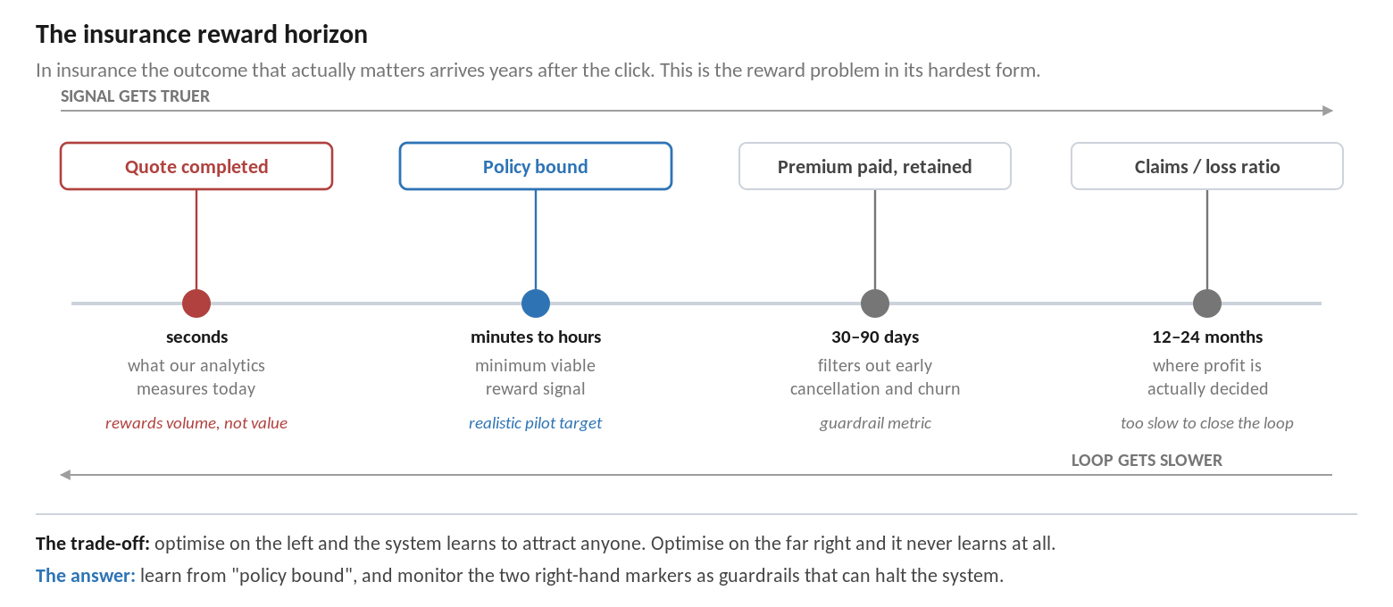

4.1 How to resolve it
The resolution is not to pick one marker. It is to learn from an intermediate signal while monitoring the distant ones as guardrails with authority to stop the system.
- Learn from the nearest signal that reflects genuine commitment — a bound policy, not a completed quote. It arrives quickly enough to train on and is materially harder to game than quote volume.
- Monitor retention at 30 and 90 days as a quality guardrail. A rising bind rate with falling 90-day retention is the system learning to attract customers who should not have been attracted.
- Review loss ratio by acquisition cohort periodically. Too slow to be a reward signal, but essential as a periodic audit that the loop has not drifted into buying poor risk.
- Give the guardrails teeth. A guardrail that cannot halt the system is a report, not a control.
The same structure applies directly to our own journeys. Substitute "application submitted" for quote, "approved and activated" for bound policy, and "arrears or early attrition" for loss ratio, and the architecture is identical.

5. The regulatory boundary
Insurance is instructive on governance because conduct regulators have already intervened directly in personalization of price. The distinction that emerges is one we should adopt in our own design.

5.1 What UK regulation established
- Price walking is prohibited. Following the FCA's general insurance pricing practices market study (PS21/5, with rules taking effect for renewals from January 2022), insurers may not charge existing customers more at renewal than an equivalent new customer would pay. A personalization system that learned "this customer is unlikely to switch, so charge more" would be implementing a banned practice.
- Fair value must be demonstrated. Product governance rules require firms to assess whether a product delivers fair value to the target market and continues to do so, using a prescribed approach to assessing whether price has been fairly set.
- Barriers to switching are constrained. Rules address auto-renewal practices and impose reporting requirements in home and motor insurance.

5.2 The principle worth borrowing
Personalize the experience. Do not personalize the price or the terms.
Which headline, which imagery, which explanation, which question order, which help content, which reassurance — all of these can vary by customer, and varying them well is where the conversion benefit sits.
Which price, which eligibility criteria, which regulated disclosure, which product terms — none of these should be inside the set of things an optimization system is permitted to vary.
Drawing this line explicitly at design time is what makes the capability approvable. Insurers that did not draw it had it drawn for them by their regulator.
A second, subtler requirement follows. Because the system is choosing what each customer sees, the firm must be able to reconstruct after the fact what any given customer was shown and why. Auditability is not an optional feature of the platform; it is a condition of deploying it in a regulated journey.

6. What transfers to our acquisition journeys
Insurance element | Our equivalent | Status for us
Quote completed | Application submitted | Measured today — and the wrong reward
Policy bound | Application approved and activated | The correct pilot reward; not currently linked to the page variant
90-day retention | Product still active after 90 days | Guardrail; available but not joined to acquisition data
Loss ratio by cohort | Arrears, early attrition or claims by acquisition cohort | Periodic audit; requires cohort tagging at acquisition
Price walking prohibition | Fair treatment and consistent pricing obligations | Pricing must be excluded from the variable set
Fair value assessment | Product governance and target market assessment | Automated variation must not undermine the target market conclusion
Dynamic question ordering | Progressive disclosure in the application form | High-value, low-regulatory-risk starting point

6.1 Three practical recommendations from this case
- Adopt the bound-policy equivalent as the pilot's primary metric from the outset. Approved and activated, not submitted. This single decision determines whether the pilot measures anything real.
- Start with form and question-order personalization rather than proposition personalization. It carries the lowest regulatory exposure, it addresses the largest measurable drop-off, and it requires no pricing change — which means it can be approved quickly.
- Write the exclusion list before selecting a platform. Pricing, eligibility, regulated disclosures and terms are outside the variable set. Agreeing this with Risk and Compliance early converts them from a late obstacle into an early ally.

7. What this case does and does not prove
It does show | It does not show
That a fully closed-loop acquisition journey can be operated profitably at scale in a regulated financial services market | That a traditional insurer or bank can retrofit this onto legacy journeys as easily — Lemonade was built this way from inception
That growth and underwriting quality can improve together when the loop learns from the right signal | That the same result is achievable without the underlying data architecture that makes it possible
That regulators will engage directly with personalization of price, and that the experience/price distinction is the workable boundary | That our own regulatory position is identical — this must be confirmed with Risk and Compliance

Conclusion
Insurance demonstrates the technique working in a regulated financial services setting, judged against a commercial outcome rather than a click.
It also demonstrates, more clearly than any other industry, that the value depends entirely on which signal the system learns from. Lemonade grew premium and improved loss ratio simultaneously because its loop is connected to underwriting reality.
Our loop is currently connected to application submissions. Until that changes, the capability cannot deliver the outcome this business case is being asked to justify.

Sources
- Lemonade, Inc., Shareholder Letter Q4 2024 — In Force Premium, loss ratio, gross profit and cash flow figures.
- Lemonade investor relations material and company statements on AI onboarding, telematics and underwriting automation.
- Financial Conduct Authority, PS21/5, General insurance pricing practices market study — final rules, and PS21/11 amendments.
- Legal and industry commentary on the FCA general insurance pricing practices rules (Herbert Smith Freehills, Latham & Watkins, Bryan Cave Leighton Paisner).

Figures attributed to Lemonade's Q4 2024 shareholder letter are drawn from that primary document. Claims described in this document as less firmly attested come from secondary coverage and are labelled accordingly. Regulatory summaries are indicative and must be confirmed with Risk and Compliance before being relied upon.

