DIGITAL ACQUISITION · DETAILED CASE STUDY
Artwork Personalization at Netflix
A closed loop running in production at scale — and what it teaches us about ours

1. Why this case
This is the most completely documented closed-loop personalization system in the public domain. Netflix published the mechanism at the ACM Conference on Recommender Systems in 2018 and in its engineering literature — including the parts that did not work, the measurement problems they hit, and the guardrails they had to design. Almost every other case study in this space is a vendor summary with a headline number.
It is a media company, not a bank. That does not weaken it. Every hard problem they solved is a problem we will face — choosing what to reward, attributing an outcome to a variant, keeping the learning honest, and preventing the system from optimising itself into a bad place. Section 7 maps each one onto our acquisition journey.
What it is, in one paragraph
Netflix holds several candidate images for each title. Rather than choosing one for everybody, it selects a different image per member, in real time, using a contextual bandit that learns continuously from what each member does next. A member with a history of romantic films might see Matt Damon and Minnie Driver on Good Will Hunting; a member who watches comedies might see Robin Williams. Same title, same page, different image, chosen by the system and improved by the outcome.
It runs across roughly 130 million members and handles over 20 million personalized image requests per second at peak.

2. The business problem they were solving
The artwork is the first and often only thing a member evaluates before deciding whether to engage with a title. Netflix framed the objective precisely: recommend imagery that helps a member decide whether they will actually enjoy the title.
They defined four properties of a good image, and the list is instructive because two of them are constraints rather than goals:
Property | What it means
Representative | It must honestly reflect the title. Explicitly, no clickbait.
Engaging | It should draw the eye and communicate tone.
Informative | It should tell the member something true about what the title is.
Differential | It should distinguish this title from the others on screen.
"Representative — no clickbait" is a business rule written into the objective before any algorithm was built. They understood in advance that a system rewarded on attention alone would learn to mislead. This is the single most transferable lesson in the case and it is the subject of Section 4.

3. How the loop actually works
For every member-and-title request, the system faces a decision with a known set of options and an uncertain payoff. That is precisely the structure a contextual bandit is designed for.
Element | In Netflix's system | Why it is set up this way
Context | The member — viewing history, inferred taste, device, country, time | The best image is not universal; it depends who is looking
Actions | The candidate images available for that title | A modest, bounded choice set — far easier than ranking a whole catalogue
Reward | Minutes played following that impression | Deliberately not clicks. See Section 4.
Policy | A contextual bandit — epsilon-greedy, Thompson Sampling and upper confidence bound approaches were used | Balances using what is known against discovering what is not

3.1 The explore–exploit trade-off, concretely
If the system always shows the image it currently believes is best, it stops learning — it can never discover that a rarely shown image would have performed better. If it shows images at random, it learns quickly but delivers a poor experience. Bandit algorithms manage this tension explicitly.
Under Thompson Sampling, the system does not hold a single estimate of how good each image is. It holds a probability distribution. A narrow distribution means high confidence; a wide one means the image has not been shown often enough to know. For each request it draws a sample from each image's distribution and shows whichever draws highest. A promising but unproven image therefore gets shown sometimes — exploration emerges naturally from the maths rather than being bolted on.

3.2 Keeping the training data honest
A system that only ever learns from its own choices will reinforce its own biases — it never observes what would have happened had it chosen differently. Netflix addressed this by deliberately injecting controlled randomness, including maintaining a slice of traffic where images are served entirely at random.
That randomised slice costs money. It knowingly delivers a worse experience to a small fraction of members. Netflix accepts that cost because it is the only way to obtain unbiased data to learn from. Any credible closed-loop proposal here must include the equivalent — a permanent holdout — and leadership must understand at the outset that it is a deliberate investment, not an inefficiency to be optimised away.

3.3 Testing before going live
Before exposing members to a new policy, Netflix evaluates it offline using replay against previously logged randomised data — asking what the new policy would have done in situations already observed. Only policies that survive that test are put in front of members. This is a materially cheaper way to fail, and it is a practice we should adopt rather than reinvent.

4. The decision that matters most: what to reward
Netflix could have rewarded clicks. Clicks are abundant, immediate, easy to attribute and trivially available. They chose minutes played instead — a slower, messier, harder-to-attribute signal.
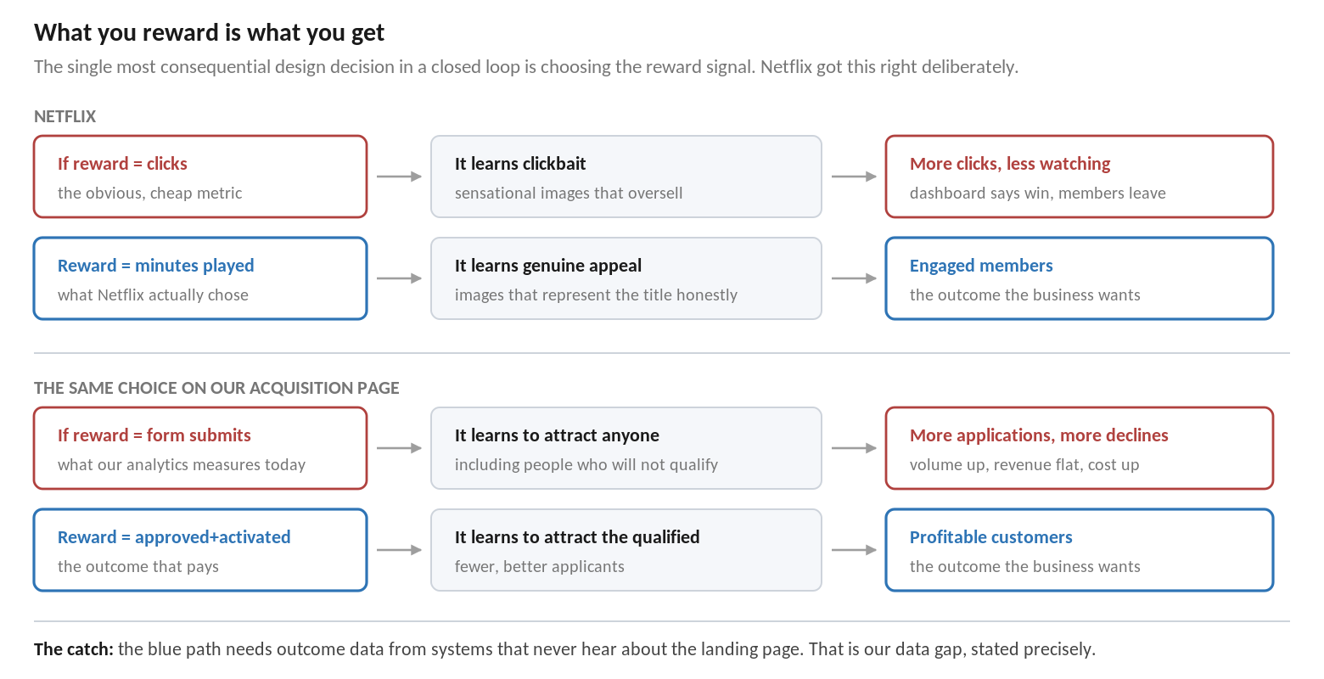
The reasoning is straightforward once stated. A system rewarded on clicks will find the images that generate clicks. The most reliable way to generate a click is to overpromise. Netflix would have built, at enormous expense, an industrial-scale clickbait generator with excellent reported metrics and declining member satisfaction.
This is the same decision we face, and we are currently on the wrong side of it
Our acquisition analytics measures application submissions. If we build a closed loop on that signal, it will optimise for application submissions — and it will succeed.
It will discover the propositions and page treatments that attract the widest possible pool of applicants, including those who will not qualify. Application volume rises. Decline rates rise. Processing cost rises. Revenue does not move. Every dashboard reports a success.
The correct reward is a downstream outcome — approved, activated, and still held after a defined period. That data lives in origination and servicing systems that currently have no knowledge of which landing page variant the customer saw.
Closing that gap is the central technical task of this initiative. It is not a reporting improvement; it is the precondition for the system learning anything worth learning.

5. The measurement problem they had to solve
Netflix hit an attribution problem that maps directly onto ours. A member watches a title. Was that because the recommendation system surfaced it, because the artwork appealed, or both? The image is one influence among several, and its incremental contribution is not directly observable.
There is a second-order version of the same problem. If the artwork for a title changes frequently, it becomes unclear which image was responsible for eventual engagement — the signal is smeared across several variants.

5.1 How they handled it
- Constrain how often the variant changes. Netflix controls exploration so that artwork selections do not change too often for a given member. Stability is traded for attributable measurement. This is a deliberate design choice, not a limitation.
- Isolate the incremental effect. The question is framed as the effect of the image on top of the existing recommender, rather than the total effect — which keeps the claim honest and modest.
- Use randomised data as the reference point. The exploration slice provides the counterfactual that makes incremental measurement possible at all.

5.2 Our equivalent
Netflix's problem | Our version of it
Did the member watch because of the image or the recommendation? | Did she apply because of the page variant, the offer, the ad that brought her, or the rate we advertised?
Frequent artwork changes smear attribution | Concurrent tests, campaign changes and pricing changes on the same journey smear attribution
Incremental effect on top of the recommender | Incremental effect on top of the existing page and the existing offer
The practical consequence for our pilot: choose a single-session, single-device journey, hold the offer and the pricing steady for the duration, give one person ownership of the test calendar, and keep a permanent holdout. Without those four constraints we will produce numbers we cannot defend.

6. What it takes to run
Dimension | Reality
Scale | Over 20 million personalized image requests per second at peak
Reach | Deployed across roughly 130 million members
Latency | The decision must be made within the page render budget, every time
Fallback | A default image must always be available if the decision service is slow or unavailable
Data | Continuous logging of context, the action taken, the randomisation applied, and the eventual reward
Team | Dedicated research and engineering capability, sustained over years
Two observations for our own planning. First, the latency and fallback requirements are architectural, not optional — a personalization decision that arrives late is worse than no personalization, because it produces visible flicker and contaminates measurement. Second, the logging requirement is more demanding than conventional analytics: the system must record not just what happened but what it chose and how randomised that choice was, or the data cannot be used for learning.
The reported benefit is described as a significant lift to core metrics, and notably as effective for the discovery of lesser-known titles — the system helped surface content that would otherwise have been overlooked. That secondary effect is worth noting: personalization often creates more value in the long tail than at the head.

7. Translating this to our acquisition journey
The mechanism maps across cleanly. This table is the practical output of the case study.
Loop element | Netflix | Our credit card acquisition page
Context | Viewing history, taste profile, device, country | Ad keyword, referrer, geography, device, returning-visitor status, existing relationship, propensity score
Actions | Candidate images for a title | Candidate headlines, hero treatments, offer emphasis, form lengths, CTA wording
Reward | Minutes played after the impression | Approved and activated customer — not application submitted
Guardrail | Representative imagery, no clickbait | No misleading rate or eligibility claims; regulated content held constant; fair treatment monitored across groups
Exploration | Randomised slice of traffic | Permanent holdout receiving the default page
Attribution control | Artwork changes limited in frequency | Single-session journey, offer and pricing held steady, one owner of the test calendar
Pre-launch check | Offline replay against logged randomised data | Power calculation and dry-run analysis before any variant goes live

7.1 What Netflix had that we must build
- A reward signal tied to real value, available with known latency. Ours sits in origination and servicing and does not currently flow back.
- A persistent identifier connecting the decision to the eventual outcome. Ours breaks when the applicant crosses into the fulfilment system.
- Logging of the decision itself — which variant, chosen by what, with how much randomisation. Conventional web analytics does not capture this.
- An accepted, permanent holdout, understood by leadership as the cost of knowing anything.
- Enough variants to choose between. A bandit with two options is an A/B test with extra steps.

7.2 What we should not copy
- The scale. Netflix operates at a volume that supports per-member learning. Our journey volumes will more likely support segment-level decisioning. That is a legitimate and useful place to land — the maturity model calls it Level 3, and it is where most well-run acquisition teams should aim.
- The in-house build. Netflix built its own platform with a standing research team. Commercial platforms now provide the equivalent capability. Building this ourselves is not warranted.
- The timeline. This capability was developed over years, on top of an existing mature experimentation and recommendation practice. Any plan implying we reach a comparable state in a quarter is not credible.

8. Six lessons for our feasibility assessment
 | Lesson | What it changes in our approach
1 | Choose the reward before choosing the platform | The primary metric for our pilot must be a downstream qualified outcome, agreed with Finance and Risk before anything is built
2 | Write the guardrails into the objective | Regulated content, rate claims and eligibility statements are excluded from variation from day one, not reviewed later
3 | Randomised exploration is a permanent cost | Budget for a holdout and defend it. Without it, we cannot measure and the models cannot learn
4 | Attribution is a design decision, not an analysis step | Constrain the pilot journey, the test calendar and the rate of change so results are attributable
5 | Log the decision, not just the outcome | Our event schema must capture which variant was served and how it was chosen — this is a data requirement, not a reporting one
6 | Bounded choice sets are what make this tractable | A handful of well-designed variants per element beats an unconstrained content problem

The conclusion this case supports
Netflix demonstrates that closed-loop optimization works, at scale, in production, and has done for years. The technology risk is genuinely low.
It also demonstrates that the difficulty was never the algorithm. It was choosing the right reward, obtaining it reliably, keeping attribution clean, and accepting the permanent cost of exploration.
Every one of those is a data and governance problem. Every one of them is unresolved for us today. That is precisely why the recommendation is to assess and remediate our data foundations before selecting a platform.

Sources
- Chandrashekar, Amat, Basilico & Jebara, "Artwork Personalization at Netflix", Netflix Technology Blog, 2017.
- Amat, Chandrashekar, Jebara & Basilico, "Artwork personalization at Netflix", Proceedings of the 12th ACM Conference on Recommender Systems (RecSys '18), pp. 487–488.
- Fernando Amat, "Artwork Personalization at Netflix", presentation, RecSys 2018.
- Netflix Technology Blog posts on contextual bandits, offline replay evaluation and explore–exploit strategies in recommendation.

All figures in this document are as published by Netflix. Descriptions of algorithmic approach are drawn from their published material and from the RecSys paper and presentation. Where this document draws inferences for our own context, they are labelled as such.

