DIGITAL ACQUISITION · BRIEFING FOR MANAGEMENT
Closed-Loop Landing Page Optimization
What it is, what it looks like, and who is already running it in production
This briefing supports the Loop Engineering feasibility study. It answers one question management asked directly: is this a proven capability that real organisations run today, or a concept?
The short answer
It is proven and in production — at Netflix, Booking.com, Spotify, Vodafone, and at banks including Axis Bank, TSB and U.S. Bank. This is established technology, not emerging technology.
But the published evidence also shows the value comes from disciplined experimentation built up over years. The algorithmic layer adds a modest increment on top of that foundation — it does not substitute for it.
The relevant question for us is therefore not "does this work?" It is "is our data and our operating capacity ready to make it work here?" That is what the feasibility study assesses.

1. What we are actually talking about
A closed loop is a system that observes a visitor, decides what to show them, shows it, measures what happened, and feeds that result back into the next decision — continuously and without a person in the middle.
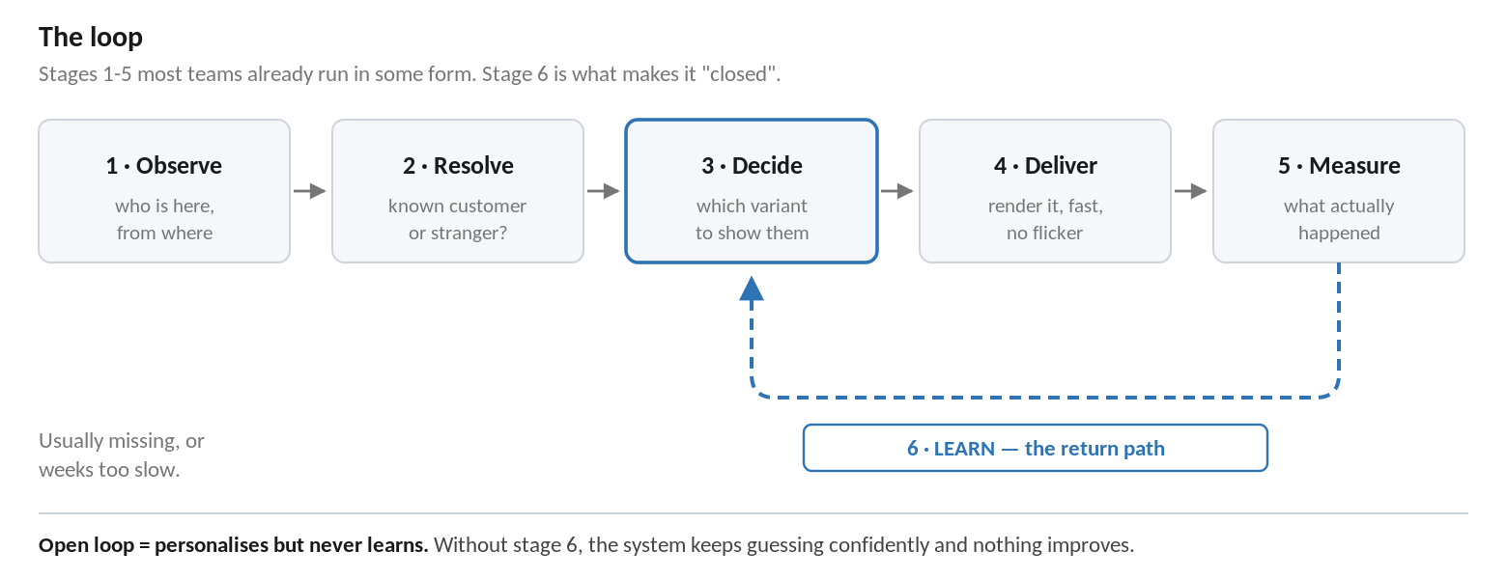
The six stages. Most organisations already operate stages 1 to 5 in some form.
The distinction that matters for this business case is between personalization and a closed loop. They are frequently confused, and they cost very different amounts.
 | Who decides what a visitor sees | What happens when it stops working
No data | Nobody — one page for everyone | Nothing. You never find out.
Data plus rules | A person, once, when the rule was written | Nothing. The rule quietly decays.
Data plus closed loop | The system, continuously, from measured results | It detects the decline and re-decides
The requirement we have been asked to assess is the third row. This is worth stating plainly, because "personalization" is usually heard as the second row — which is considerably cheaper, considerably easier, and not what was asked for.

2. What it looks like on the page
A single worked example. The same credit card acquisition page, seen by one visitor. She clicked an ad for a balance transfer, she is on mobile in Manchester, she started an application three days ago and abandoned it, and she already holds a current account with us.
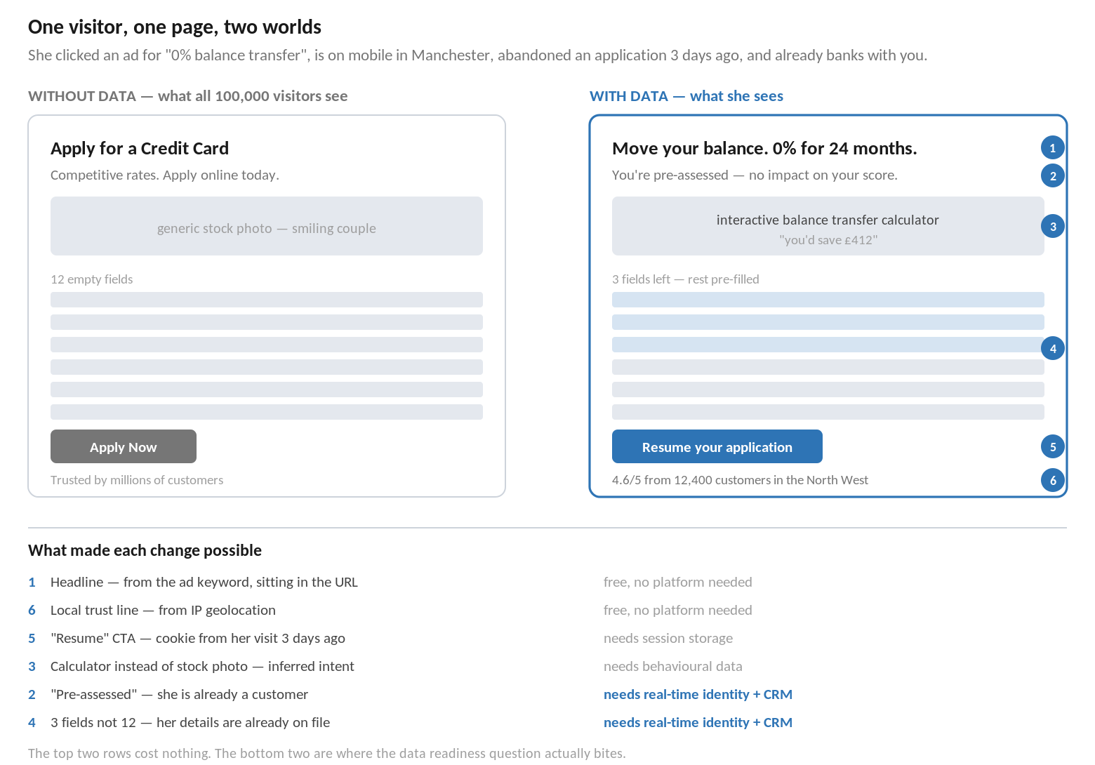

The point of this example
- The left-hand page is not badly designed. It is optimised for an average visitor who does not exist. Every element is a compromise across everyone who might arrive. That is the real cost of having no data — not poor design, but permanent mediocrity for every individual.
- The right-hand page is a ladder, not a switch. The ad keyword is already in the URL. Geography is in the IP address. Device is in the request header. Three of the six changes shown need no platform, no customer data platform and no budget.
- The expensive changes are the valuable ones. Recognising her as an existing customer — which pre-fills nine form fields and changes the entire proposition — requires knowing who she is in under a second. That is where our data readiness question actually bites.
- It must degrade gracefully. If she declines consent, or the identity lookup is slow, she must receive the left-hand page rather than a broken one. This is a hard design requirement, not a refinement.

3. Who is already running this in production
Organised by strength of evidence, because the difference matters when these figures are quoted back at us.

3.1 Published and independently verifiable
These organisations have published the mechanism in peer-reviewed papers or engineering literature. The numbers can be checked.
Organisation | What runs in production | Evidence
Netflix | Contextual bandit selecting which artwork each member sees for the same title. Deployed across roughly 130 million members, handling over 20 million personalized image requests per second at peak. | ACM RecSys 2018 paper and Netflix technology blog
Yahoo | Contextual bandit selecting front page news articles per visitor across 33 million events. Reported a 12.5% click lift over a non-contextual bandit. | Peer-reviewed, WWW 2010
Booking.com | More than 1,000 concurrent experiments running on the live booking flow at any moment, on an in-house platform built in the mid-2000s. | Widely documented, including their engineering blog
Stitch Fix | Multi-armed bandits built into their experimentation platform as a first-class capability, using Thompson sampling. | Engineering blog
Spotify | Bandit-based personalization, deliberately maintained on a separate technology stack from experimentation. | Engineering blog

3.2 Named enterprise adopters, vendor-published results
These are real production deployments at named organisations. The performance figures are supplied by the customer and published by the vendor, so they are evidence of adoption rather than independently verified measurement.
Organisation | Sector / platform | Published outcome
Axis Bank | Banking — Adobe Target | Personalized lending, account and credit card offers across web and app. See Section 4.
TSB | Banking — Adobe | Grew from roughly 250 personalization use cases to more than 1,000 over three years.
U.S. Bank | Banking — Adobe Target and Real-Time CDP | Audience-segmented personalization driven from high-traffic pages on usbank.com.
Vodafone | Telecoms — Tealium CDP | Real-time personalized availability check built on unified customer profiles; reported 10–30% conversion uplift against a control group.

4. The closest comparable: Axis Bank
Of all published cases, this is the one nearest to our own situation — a bank personalising credit card and loan acquisition journeys on its website and mobile app. Their published detail is worth reading closely.
Measure | Published figure
Scale | 15 million monthly website visits; 10 million monthly active mobile app users
Testing programme | Over 1,000 A/B tests across four years
Coverage | Personalization integrated with 60–65% of product landing pages
Testing outcome | 25% increase in lead capture; 15% reduction in bounce rate
Personalization outcome | 15–25% conversion rate uplift; 12–18% revenue uplift
App influence | 20–30% of new product applications influenced by app personalization
Algorithmic allocation ("Auto Allocate") | 3.2% higher click-through rate
Segment-level allocation ("Auto Target") | 12% higher conversion on targeted banners
The two figures at the bottom of that table are the most important in this document.
When Axis Bank switched on the algorithmic layer — the part that most resembles a closed loop — it delivered a 3.2% improvement in click-through. The segment-level allocation added 12% on targeted banners.
Single-digit and low-double-digit increments. Arriving on top of four years of work and more than a thousand experiments.
The large headline numbers — 12 to 18% revenue uplift — describe the whole personalization programme built over four years, not the algorithms. Conflating the two is the most likely way this business case gets oversold and then disappoints.

5. What the evidence actually tells us

5.1 The technology question is settled
No organisation now needs to prove that closed-loop optimization works. It is running at very large scale in media, travel, retail, telecoms and banking. Anyone arguing this is unproven technology is not reading the evidence.

5.2 Nobody started here
The sequence is consistent across every documented adopter. Netflix, Booking.com and Axis Bank all built substantial experimentation discipline first, over a period of years, and layered algorithmic decisioning on top of it afterwards. None of them began with a closed loop.
Our current position — manual analytics reviews, periodic A/B tests and agency-led content changes — is approximately where Axis Bank stood four years and one thousand experiments ago. That is a realistic and useful reference point for what a credible plan looks like.

5.3 What scaled was capacity, not technology
TSB's published story is a move from roughly 250 personalization use cases to over 1,000 in three years. What grew was not the sophistication of the platform but the number of things the organisation could run on it. That is an operating model outcome — people, content supply and governance — and it is the constraint most often underestimated in business cases of this type.

5.4 Treat the headline uplift figures with care
Vendor-published conversion figures are customer-supplied, self-selected for success, and rarely describe a control group. They are sound evidence that organisations are adopting this and believe it works. They are not a sound basis for forecasting what it would deliver here. Our own benefit estimate must be built from our own baseline traffic, conversion rate and Finance-agreed conversion value.

6. What this means for us
 | Finding | Implication
1 | The capability is proven in production, including at directly comparable banks | Technical feasibility is not the open question. We should stop debating whether it works.
2 | Every adopter built experimentation discipline first | A credible plan starts with testing capability and data foundations, not with platform selection.
3 | The algorithmic layer delivered single-digit incremental gains | Expectations must be set accordingly. This is a compounding capability, not a step change.
4 | What scaled at TSB was operating capacity | Content supply and clear ownership need to be resourced explicitly, or the capability will sit idle.
5 | The valuable personalization depends on real-time identity | Our data readiness — specifically whether we can recognise a customer and link outcomes back to what we showed them — determines the ceiling.

6.1 What we are asking for
Nothing in this briefing changes the recommendation in the feasibility study. It supports it:
- Approve a short data readiness assessment on one high-volume acquisition journey.
- Nominate that journey and an accountable business owner.
- Agree a value per conversion with Finance, so any future benefit claim is auditable.
- Defer platform selection until we have measured evidence from our own traffic.

The evidence in this document tells us the destination is real and reachable. It does not tell us how far away we are. That is what the readiness assessment is for.

Sources and evidence quality
Published and peer-reviewed
- Chandrashekar, Amat, Basilico & Jebara, "Artwork Personalization at Netflix", ACM RecSys 2018; and the Netflix technology blog.
- Li, Chu, Langford & Schapire, "A Contextual-Bandit Approach to Personalized News Article Recommendation", WWW 2010.
- Stitch Fix and Spotify engineering blogs on bandits in production experimentation platforms.
Vendor-published customer stories — adoption evidence, self-reported figures
- Adobe customer success stories: Axis Bank (published October 2025), TSB, U.S. Bank.
- Tealium: Vodafone customer data platform use cases.

Every figure in this briefing is attributed to its source and labelled by evidence type. No figure here has been independently verified by us, and none should be used to forecast performance on our own journeys.

