Project Manager App

1. Application Structure
   1. Angular based UI, delivered as a ZIP file
   2. Spring Boot based API/Service, delivered as a ZIP file, docker image
2. GitHub – Code available in below repo
   1. UI: <https://github.com/suriyakalavathi/IIHT_PMAngular>
   2. API/Service: <https://github.com/suriyakalavathi/IIHT_PMSpringBoot_Service>
3. Run the application
   1. Start the MySQL Workbench
   2. Build the docker image of the API/Service (once)

Successfully tagged suriyakalavathi/IIHT_PMSpringBoot_Service -1.0:latest

* 1. Run the API/Service application and it will start in 8080.

2020-06-16 16:25:26.453 INFO USDC2P7Y2 --- [ restartedMain] o.a.c.h.Http11NioProtocol : Starting ProtocolHandler ["http-nio-8080"]

2020-06-16 16:25:26.534 INFO USDC2P7Y2 --- [ restartedMain] o.s.b.w.e.t.TomcatWebServer : Tomcat started on port(s): 8080 (http) with context path ''

2020-06-16 16:25:26.541 INFO USDC2P7Y2 --- [ restartedMain] h.c.p.ProjectManagerApplication : Started ProjectManagerApplication in 22.267 seconds **……………….**

* 1. Build the docker image of the UI (Once)

from Users\skalimuthu\Documents\Cognizant\IIHT\IIHT_PMAngular (master) docker build -t docker build -t suriyakalavathi/IIHT_PMAngular -1.0

* 1. Run the UI application
     1. from Visual Source Code - Terminal

ng serve

* 1. Access the app @ <http://localhost:4200/>

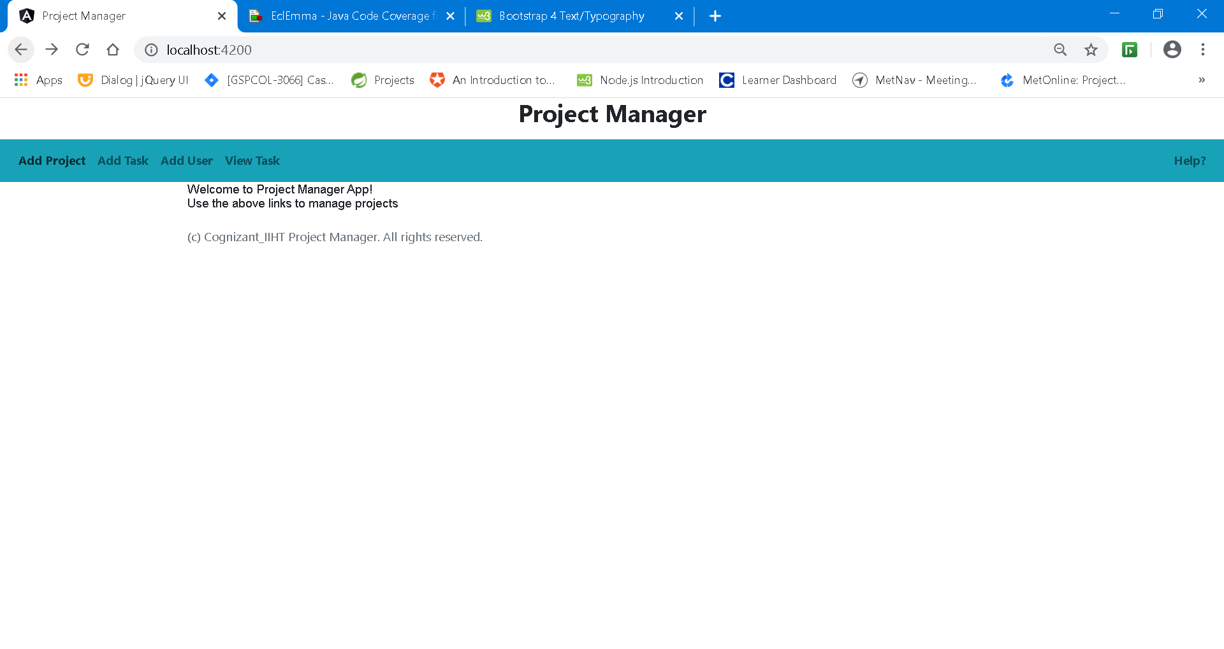

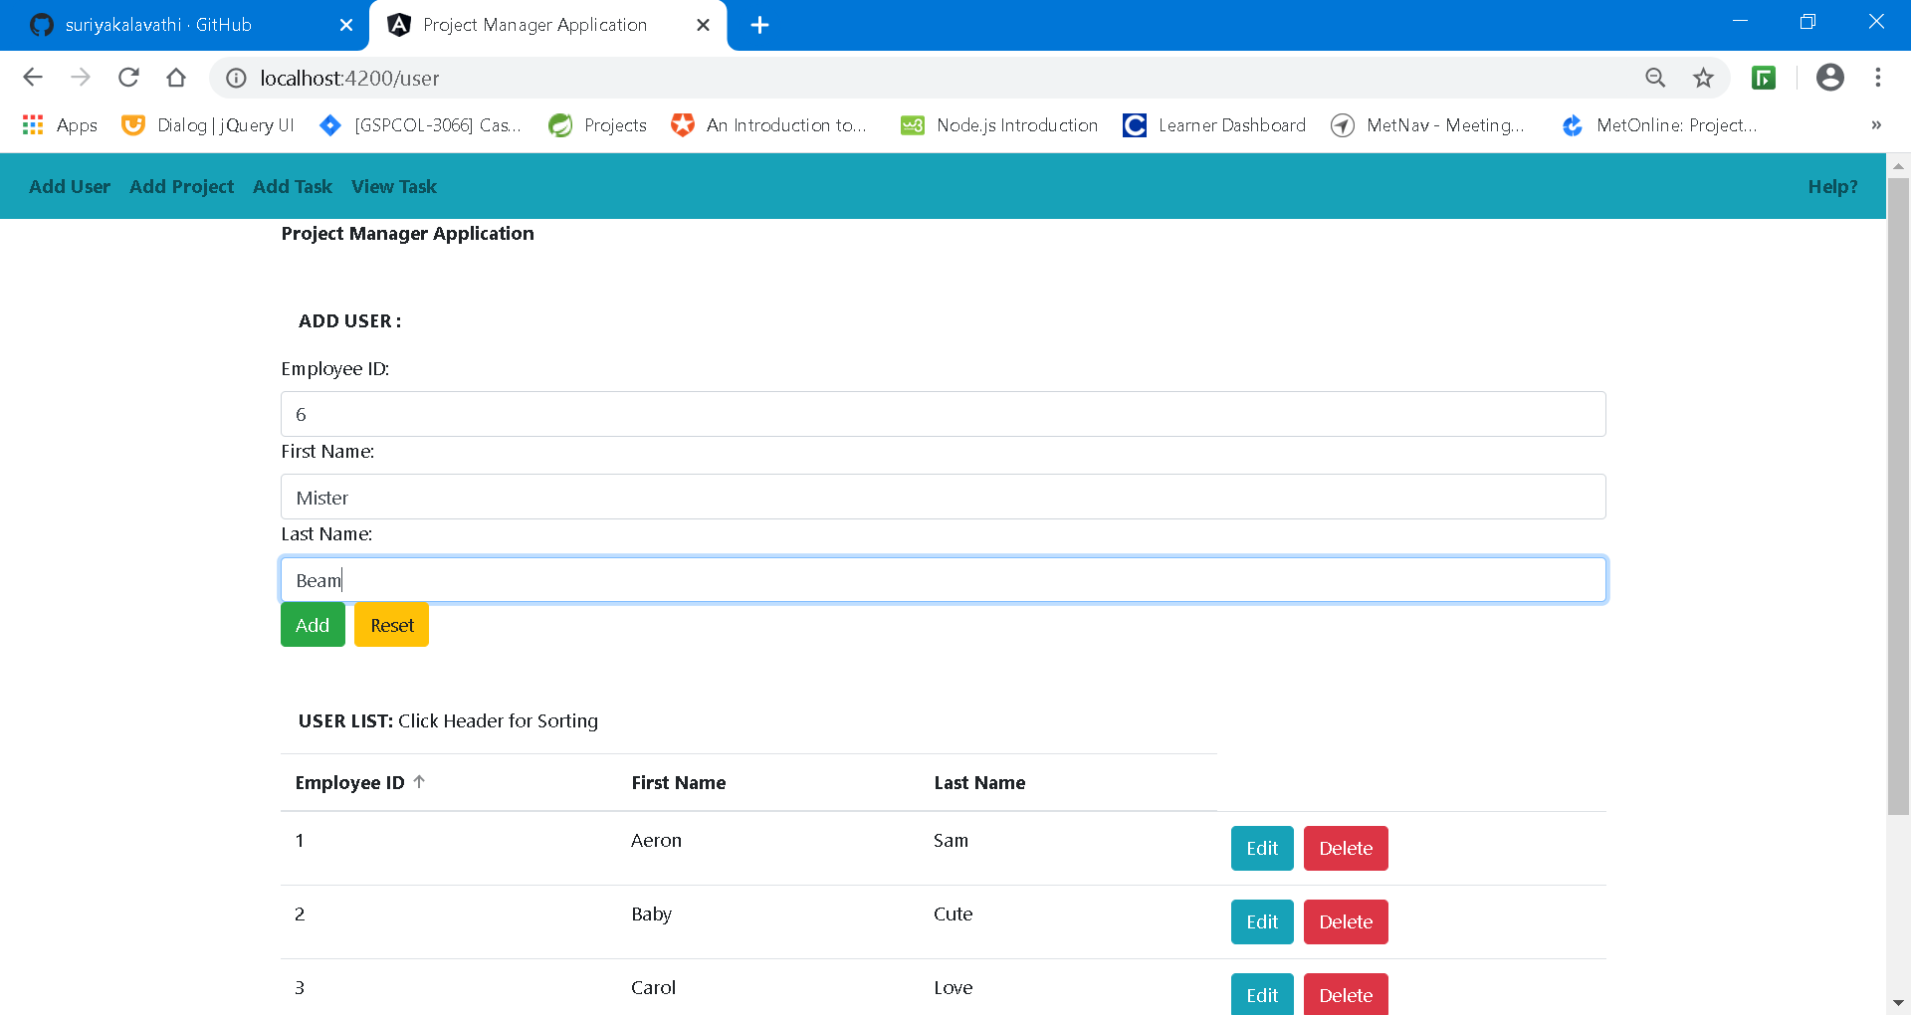

ADD Project:

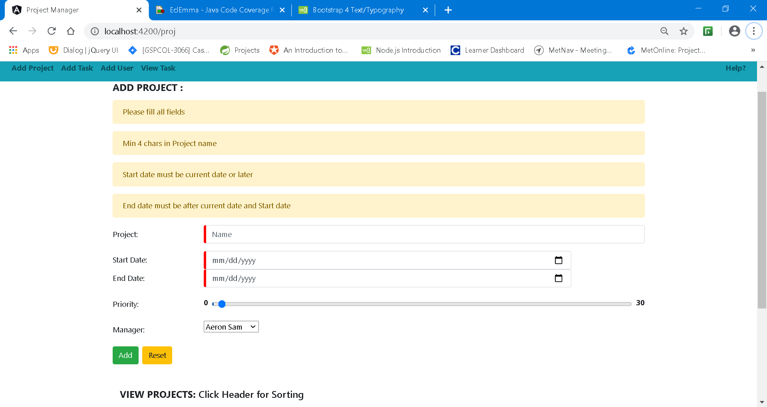

View Projects:

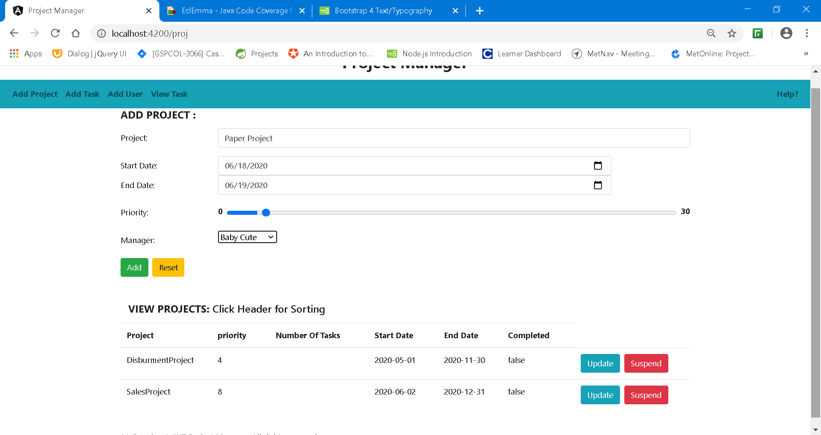

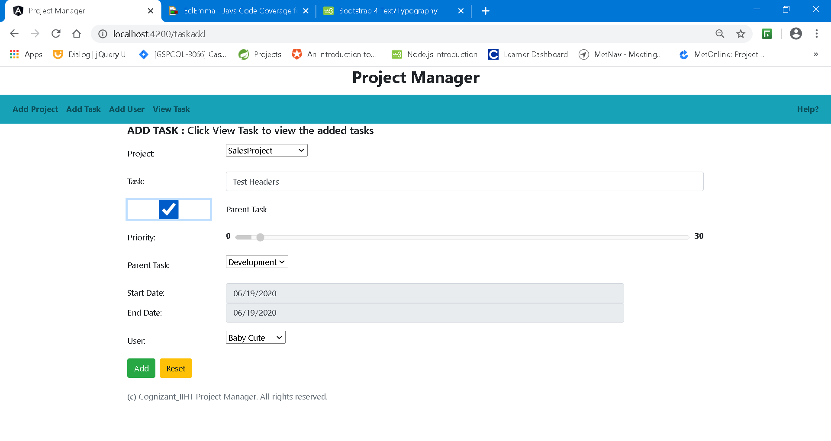

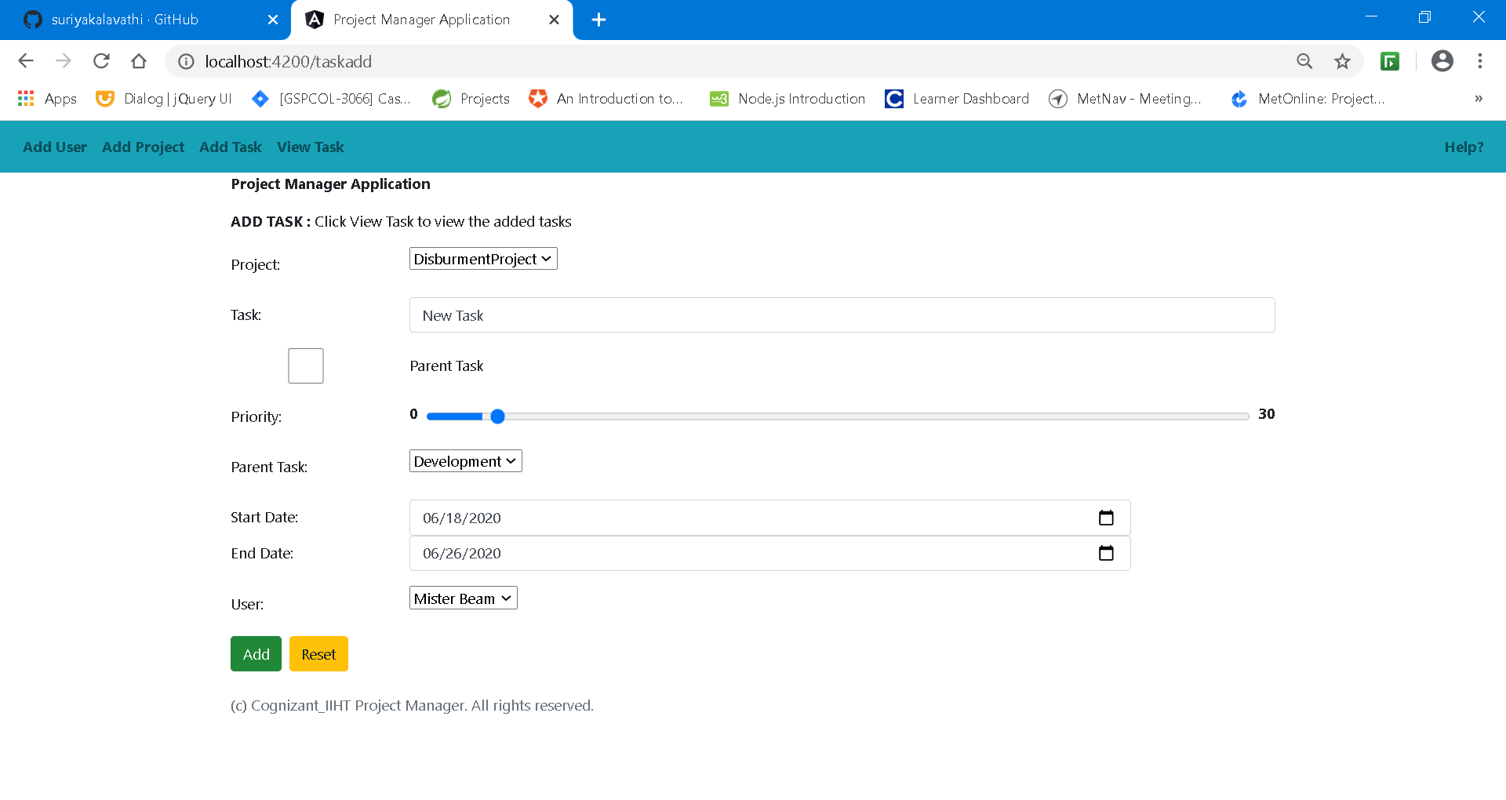

Add User

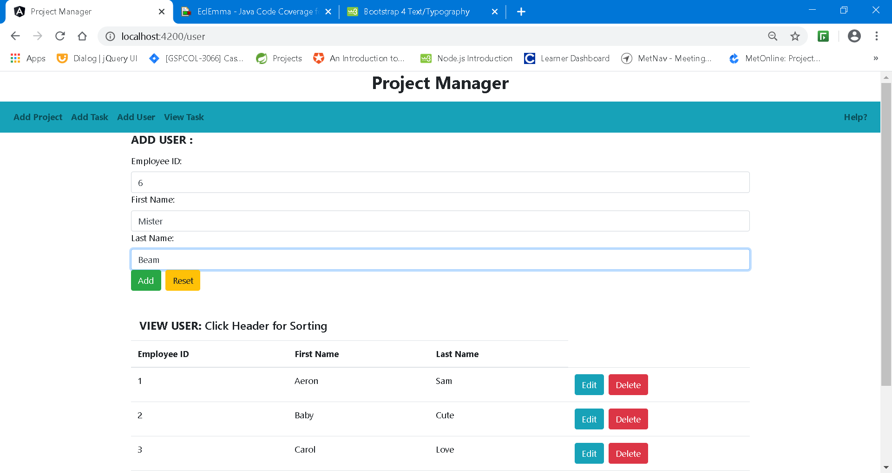

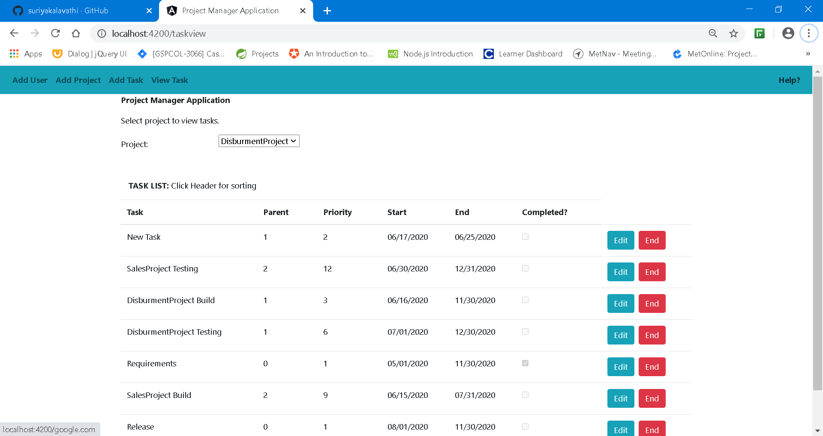

Swagger:

