VISTA
Virtual Suspension Test Bench
Technical Report — Semi-Active Suspension Control
Digital Control Architecture, Controller Design Studies, and Half-Car Dynamics
Project version: VISTA v1.30 · Stages 8–13
July 2026

Contents
1. Introduction and Project Vision
2. System Modeling
2.1 Quarter-Car Model
2.2 Semi-Active Damper Actuator Model
2.3 Half-Car Model (Stage 13)
3. Digital Control Architecture (VISTA v1.00)
3.1 The Sign-Convention Finding
3.2 Digital PID Results
4. Controller Design Studies (Stages 9–12)
4.1 Continuous Skyhook (Stage 9)
4.2 Groundhook (Stage 10): an Honest Negative Result
4.3 Hybrid Skyhook-Groundhook and the Pareto Front (Stage 11)
4.4 Clipped LQR (Stage 12)
5. Half-Car Model and Per-Corner Control (Stage 13)
6. Key Engineering Findings
7. Conclusions and Roadmap

1. Introduction and Project Vision
VISTA (Virtual Suspension Test Bench) is a Python-based virtual development platform for automotive suspension systems, built to mirror the early design and validation workflows used at vehicle OEMs and tier-one suppliers. The platform simulates, analyzes, and optimizes passive and semi-active suspensions, with an emphasis on physically correct actuator modeling and industrially representative control architecture.
This report documents the second major phase of the project: the digital control architecture introduced in VISTA v1.00 (Stage 8), the controller design studies of Stages 9 through 12 (continuous skyhook, groundhook, hybrid blending, and clipped LQR), and the extension to a four-degree-of-freedom half-car model in Stage 13 (VISTA v1.30). The first phase — passive quarter-car modeling, frequency-domain analysis, and two-state skyhook optimization — established the validated baseline that all results here are measured against.
A central theme throughout is that architecture matters more than tuning. The project's earlier continuous PID investigation (Stages 4–6) produced attractive comfort metrics that did not survive engineering scrutiny: the controller commanded a damping coefficient rather than a force, its derivative term was mathematically invalid inside a continuous ODE solver, and continuous dynamics were mixed with discrete control logic. Rather than continuing to tune a flawed architecture, the project was paused and redesigned. Every result in this report is produced by the corrected framework.

2. System Modeling

2.1 Quarter-Car Model
The quarter-car plant is a two-degree-of-freedom model with sprung mass, unsprung mass, suspension spring, semi-active damper, and tire stiffness. The plant exposes a force input interface: it receives a damper force at each instant and knows nothing about controllers. Model parameters follow the optimized passive baseline established in Stage 1.
Parameter | Symbol | Value
Sprung mass | m_s | 250 kg
Unsprung mass | m_u | 40 kg
Suspension stiffness | k_s | 10,000 N/m
Tire stiffness | k_t | 190,000 N/m
Passive damping (baseline) | c_s | 2,000 Ns/m
Body bounce frequency | f_1 | 0.98 Hz
Wheel-hop frequency | f_2 | 11.25 Hz

2.2 Semi-Active Damper Actuator Model
The damper is modeled as a physically constrained actuator rather than an ideal force source. Three constraints are enforced. First, passivity: a semi-active damper can only dissipate energy, so the achievable force always has the form F = c·v_rel with c bounded between c_min = 500 Ns/m and c_max = 3,000 Ns/m; force requests that would require energy injection fall back to the softest setting (the clipped-optimal law). Second, force saturation, implied by the coefficient envelope at the current relative velocity. Third, actuator bandwidth: the valve follows a first-order lag with a 15 ms time constant, representative of production continuously-variable dampers. Passivity clipping is treated as actuator saturation by the controllers, which matters for anti-windup design.

2.3 Half-Car Model (Stage 13)
The half-car extends the plant to the pitch plane: four degrees of freedom comprising body heave, body pitch, and front and rear unsprung masses. The body has 500 kg mass and 600 kg·m² pitch inertia, with the center of gravity 1.2 m behind the front axle and 1.4 m ahead of the rear axle. Each axle carries its own suspension, tire, and independent semi-active damper. The rear axle sees the same road profile as the front, delayed by the wheelbase travel time — 468 ms at 20 km/h — which turns a single speed bump into a two-impact event that excites the pitch mode. The resulting natural frequencies are 1.03 Hz in heave and 1.23 Hz in pitch.

3. Digital Control Architecture (VISTA v1.00)
The v1.00 architecture separates the system into the same layers found in a production vehicle. At every ECU sample (Ts = 1 ms), sensors are read, the controller firmware executes as a discrete difference equation, the resulting force request is translated by the damper model into a feasible valve command, and the command is held (zero-order hold) while the continuous plant is integrated between samples with fixed-step fourth-order Runge-Kutta. The plant never sees the controller; the controller never sees plant states directly, only the defined sensor set. All controllers implement a single interface — update(measurements, dt) returning a force request — so every control law in this report runs inside the identical loop.
The digital PID regulates sprung-mass velocity to zero and is implemented exactly as ECU firmware would be: proportional and integral terms as difference equations, the derivative acting on the low-pass-filtered measurement (Tf = 10 ms) to avoid derivative kick and noise amplification, and back-calculation anti-windup driven by the achieved force reported by the damper model, so that passivity clipping is correctly treated as saturation and the integrator never charges against a force the damper cannot deliver.

3.1 The Sign-Convention Finding
During v1.00 bring-up, an initial gain search reproduced the familiar failure signature of the earlier PID: excellent comfort figures with settling times above two seconds. Diagnosis traced the behavior to a sign-convention mismatch. The textbook PID computes a desired force acting on the body, while the damper interface uses the convention F = c·v_rel, which enters the sprung-mass equation with a negative sign. The controller was therefore unintentionally executing anti-skyhook logic: soft where it should have been firm. The correction lives explicitly at the actuator interface, where sign conventions belong. This episode is a concrete demonstration of why the force-based architecture matters — the bug was visible and diagnosable within minutes, whereas the earlier coefficient-based controller had concealed this entire class of error.

3.2 Digital PID Results
With the corrected convention, two independent multi-objective cost functions — one comfort-weighted, one weighted toward settling and travel — converged to the same tuning (Kp = 6000, Ki = 0, Kd = 20). The comfort-versus-control trade-off that invalidated the earlier PID no longer exists in the corrected architecture. The zero integral gain is the physically sensible result: a velocity regulation task has no steady-state error to integrate, and integral action buys nothing through a dissipative actuator.
Metric (speed bump, vs. passive) | Two-state Skyhook | Digital PID v1.00
RMS body acceleration | +8.4 % | +42.5 %
Peak body acceleration | −12.0 % (worse) | +52.7 %
Maximum suspension travel | −42.2 % | −42.2 %
Settling time | +0.6 % | −7.6 %

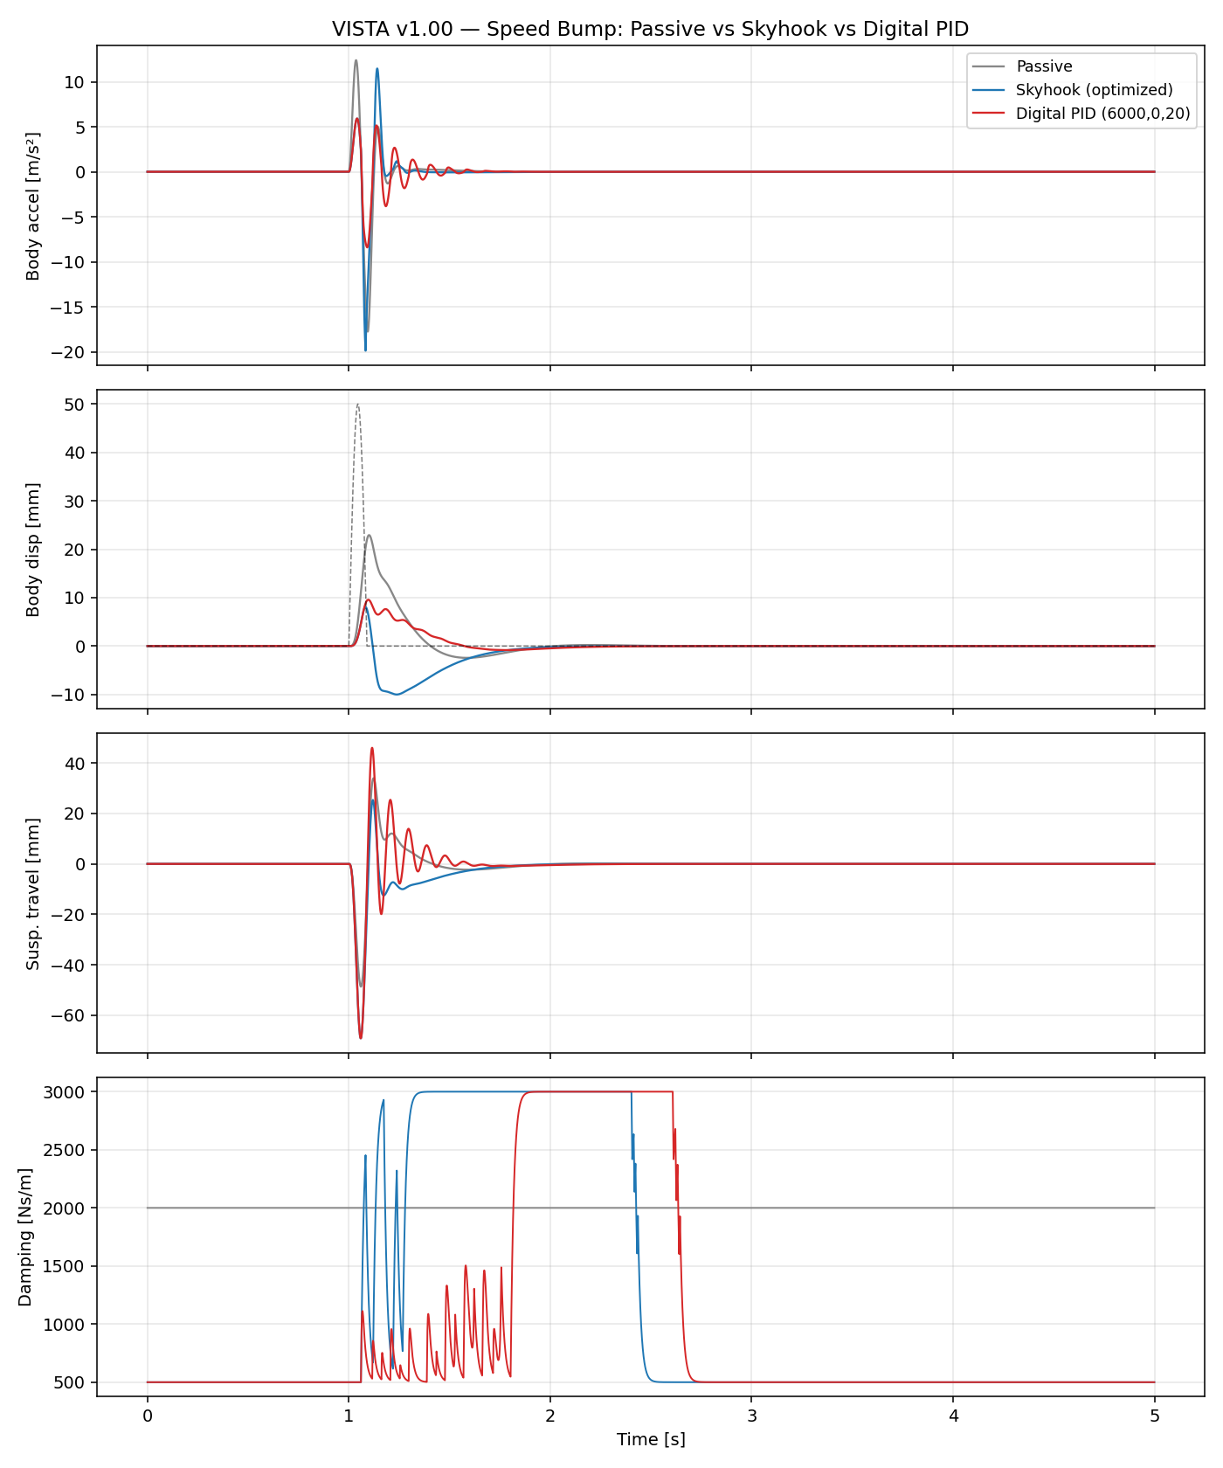
Figure 1 — Speed bump response: passive, two-state skyhook, and digital PID. The bottom panel shows the skyhook's bang-bang valve switching versus the PID's continuous modulation.
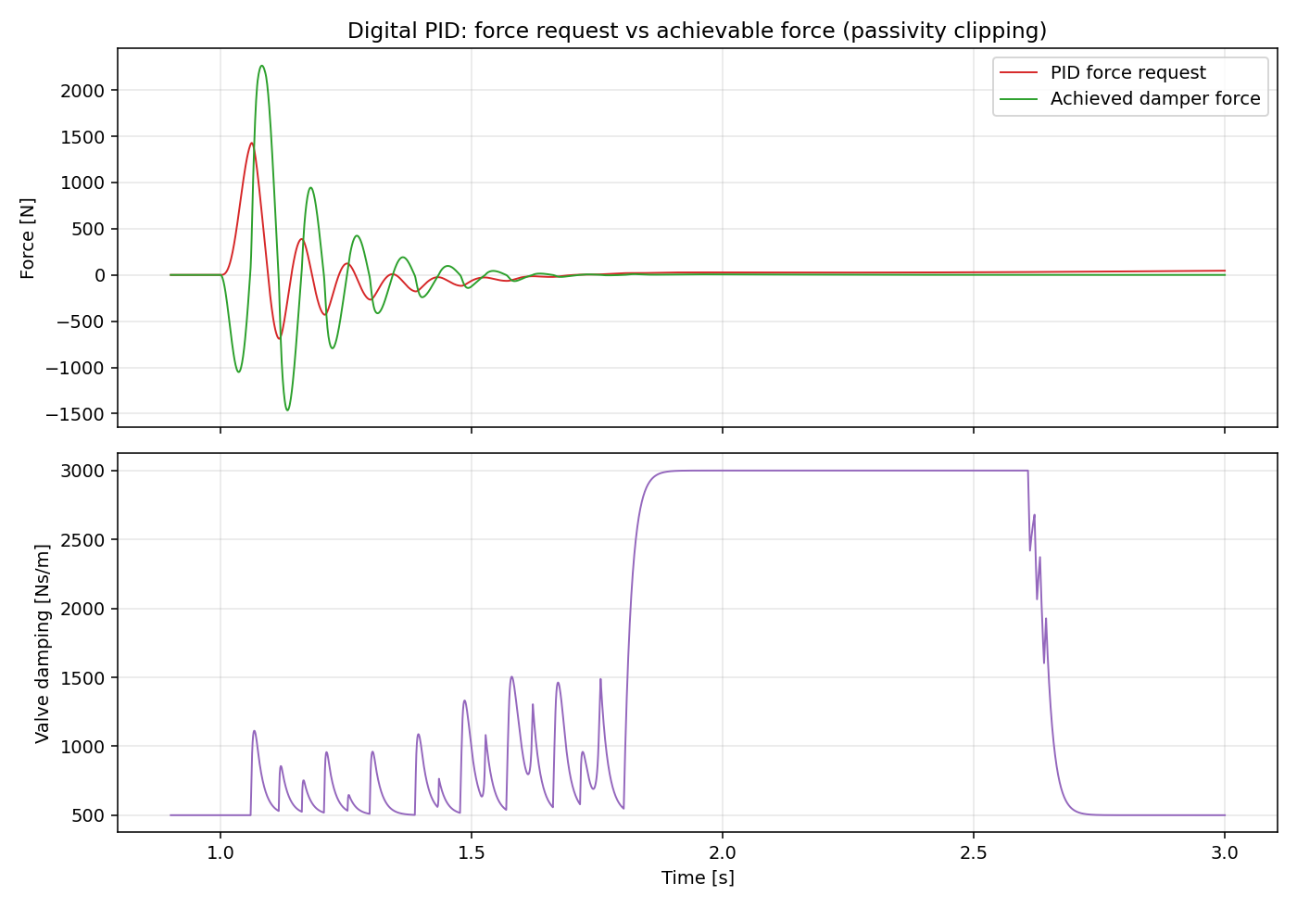
Figure 2 — PID force request versus achievable damper force, showing passivity clipping in action.
Multi-road validation confirmed robustness: RMS acceleration improved between 17 % and 43 % across smooth, medium, and rough random roads and the speed bump, with tire deflection degradation of 13 % to 48 % as the known and quantified cost of a comfort-oriented calibration.

4. Controller Design Studies (Stages 9–12)

4.1 Continuous Skyhook (Stage 9)
The continuous skyhook requests the force an imaginary damper suspended from an inertial reference would exert on the body, F = c_sky · v_body, leaving feasibility to the clipped-optimal damper layer. A sweep selected c_sky = 8,000 Ns/m. On the speed bump it nearly matches the digital PID (RMS +40.1 % versus +42.5 %; peak +50.7 % versus +52.7 %), confirming the prediction that the converged PID with zero integral gain is essentially a continuous skyhook with derivative refinement. Both controllers decisively outperform the two-state skyhook, whose valve switching produced acceleration peaks worse than the passive baseline.
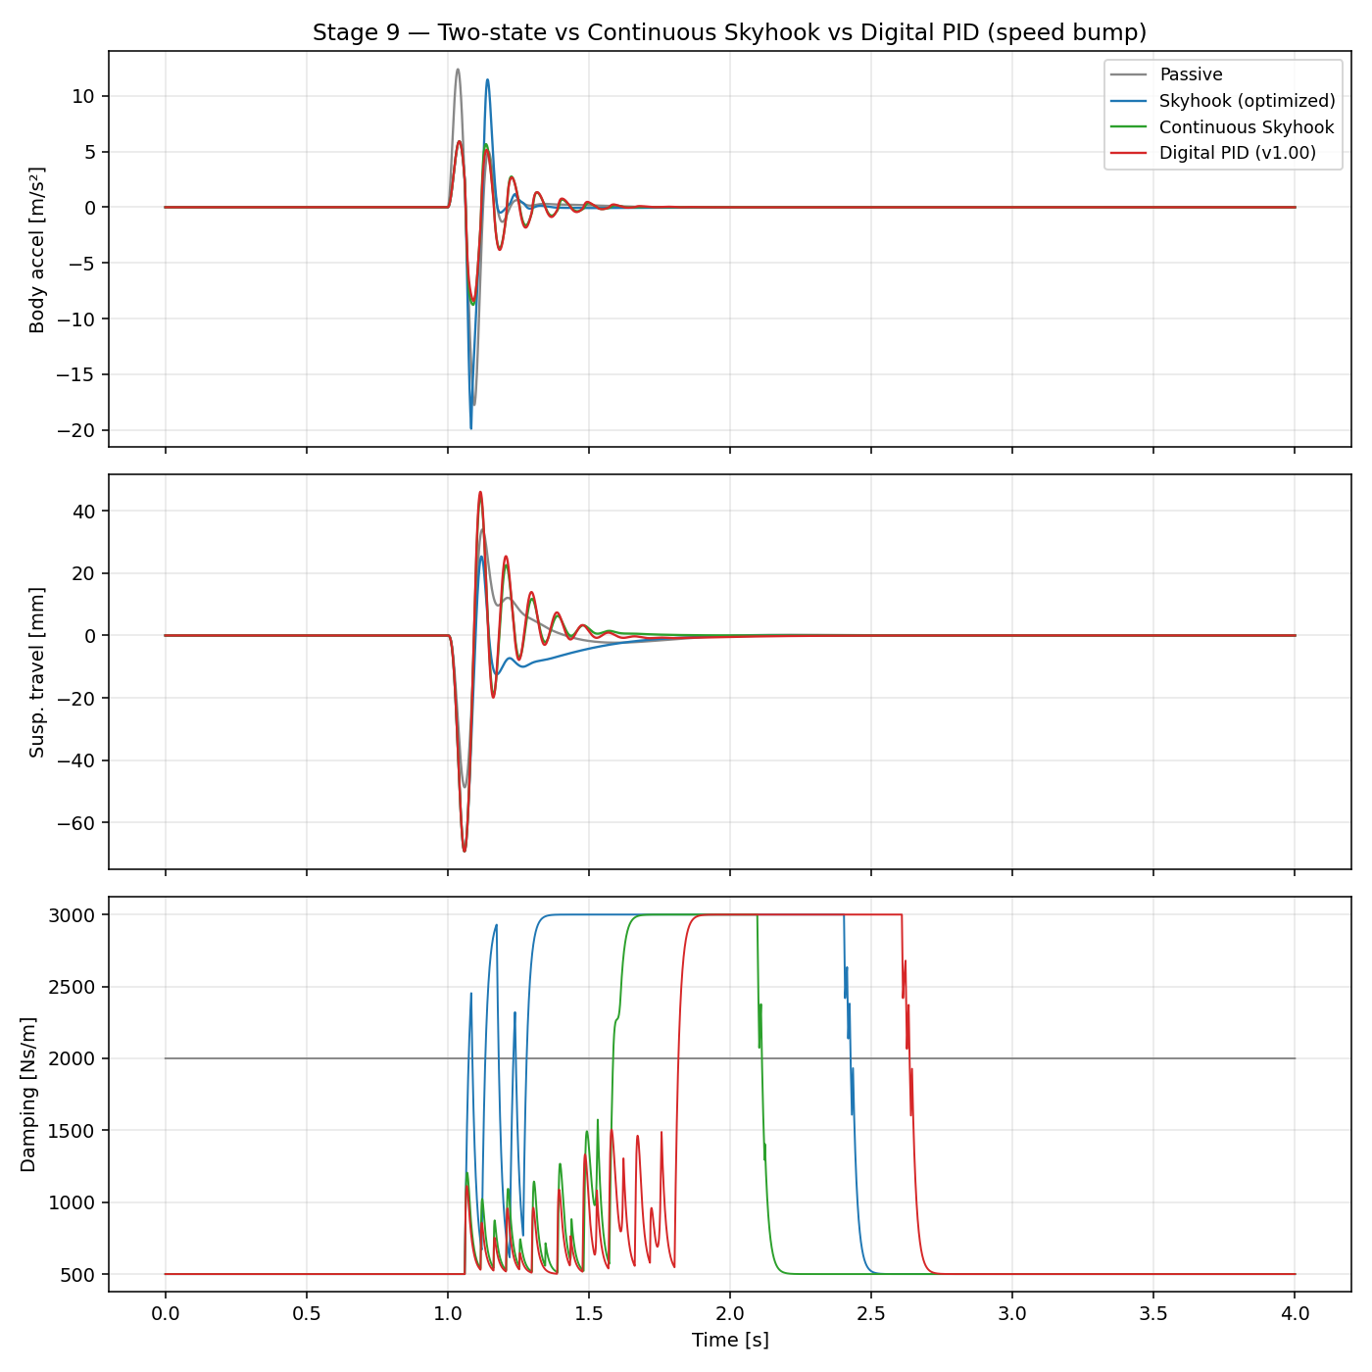
Figure 3 — Two-state skyhook versus continuous skyhook versus digital PID on the speed bump.

4.2 Groundhook (Stage 10): an Honest Negative Result
The groundhook mirrors the skyhook on the unsprung mass, targeting dynamic tire load. The result is negative and worth stating plainly: with the c_min = 500 / c_max = 3,000 Ns/m damper envelope, groundhook improves RMS tire deflection over the passive 2,000 Ns/m baseline by only about 1.5 % (at c_gnd = 4,000 Ns/m, chosen as the smallest gain within one percent of the optimum), while costing double-digit comfort. The passive damper is already near-optimal for road holding on this vehicle, and the soft floor of the semi-active envelope limits what any dissipative control law can add. This is consistent with the semi-active control literature; groundhook's practical value on this platform is as a blending ingredient rather than a standalone mode.

4.3 Hybrid Skyhook-Groundhook and the Pareto Front (Stage 11)
The hybrid controller blends the two force requests through a single calibration parameter: F = α·c_sky·v_body + (1−α)·(−c_gnd·v_unsprung). Sweeping α on a medium random road maps the comfort-versus-road-holding trade-off directly. A subtle result emerged: intermediate blends with α between 0.1 and 0.3 are dominated — the sky and ground force requests conflict, both clip toward the soft setting, and performance degrades on both axes simultaneously. After filtering to the true non-dominated set, the knee of the Pareto front lies at α = 0.70, delivering 15.0 % comfort improvement at only 9.9 % tire-deflection cost on the medium road. Validated on the speed bump, the same calibration improves RMS acceleration (+16.3 %), tire deflection (+2.0 %), and settling time (0.44 s versus 0.66 s passive) simultaneously — the only tuning in the study that wins on all three axes at once.
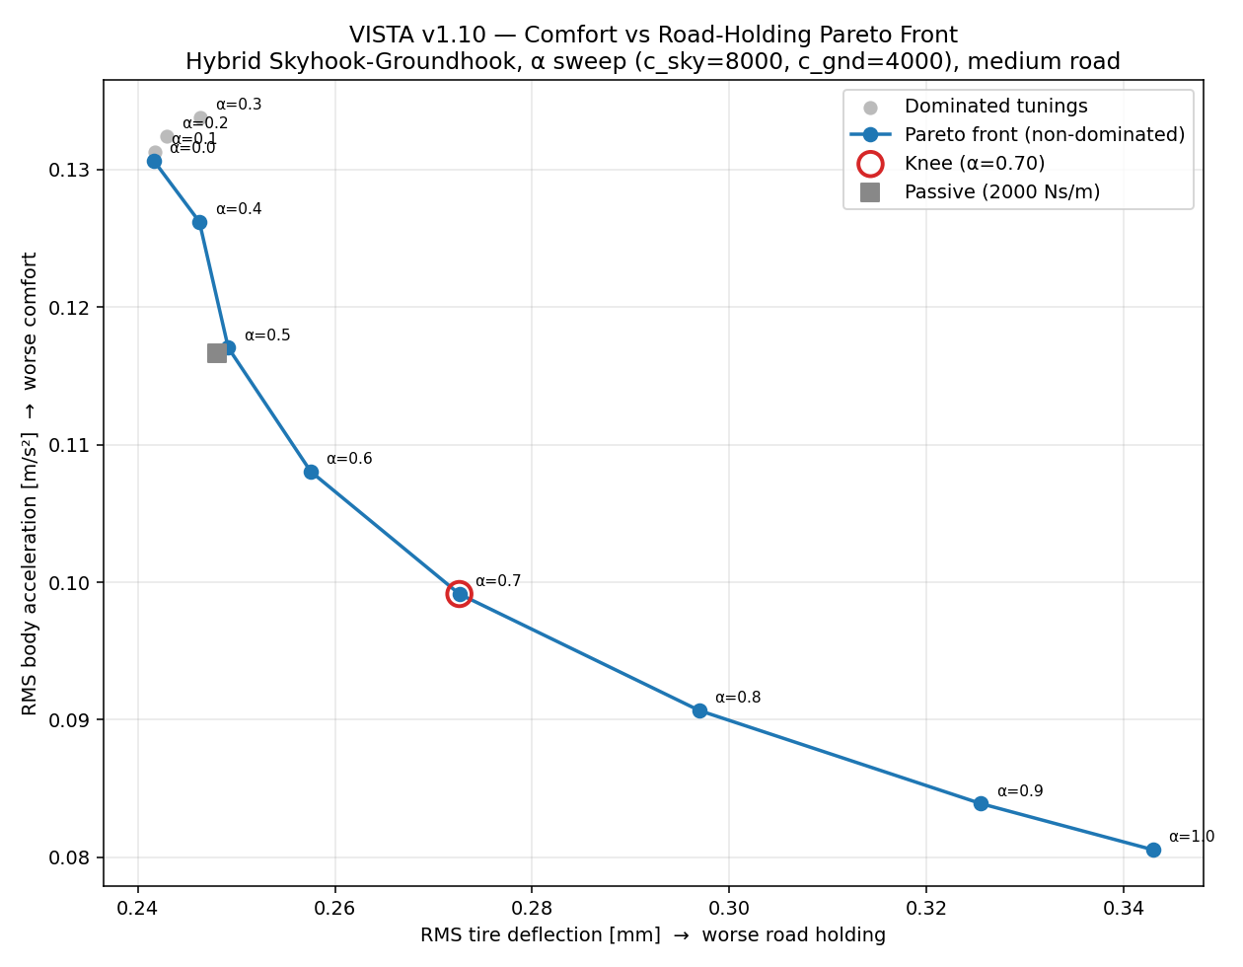
Figure 4 — Comfort versus road-holding Pareto front from the hybrid α sweep; dominated mid-range blends shown in grey, knee point at α = 0.70.

4.4 Clipped LQR (Stage 12)
The linear quadratic regulator was formulated on the standard suspension state vector (suspension travel, body velocity, tire deflection, wheel velocity) with the damper force as control input. The quadratic cost penalizes body acceleration, suspension travel, tire deflection, and control effort; because body acceleration depends on both state and input, the cost includes the proper cross-weight matrix. The Riccati equation is solved numerically, and the resulting full-state gain runs at 1 kHz behind the standard controller interface with its force request clipped by the same passivity-constrained damper — the clipped-LQR approach.
Two findings resulted. First, optimal control does not beat the tuned heuristic on this platform. Sweeping the tire-deflection weight traces LQR's own trade-off front; overlaid on the hybrid front under identical conditions, only one of eight hybrid non-dominated points is dominated by any LQR point. The fronts essentially coincide in the comfort region and the hybrid extends further toward road holding. The explanation is principled rather than accidental: LQR optimality is derived for a fully active actuator, passivity clipping voids the guarantee, and with this damper envelope the well-tuned skyhook-groundhook blend already operates at the achievable limit.
Second, the sensing gap is asymmetric. Full-state LQR uses tire deflection, which no production vehicle measures. Truncating that channel to the measurable sensor set costs nothing for comfort-weighted designs — the controller degenerates toward skyhook, which never needed tire information, and the measurable variant even edges out full state (+33.0 % versus +30.2 % RMS) — but it destroys road-holding-weighted designs, swinging performance by 27 percentage points (from +11.8 % to −15.6 %). The sensing limitation of production vehicles is therefore specifically a road-holding limitation, not a comfort limitation.
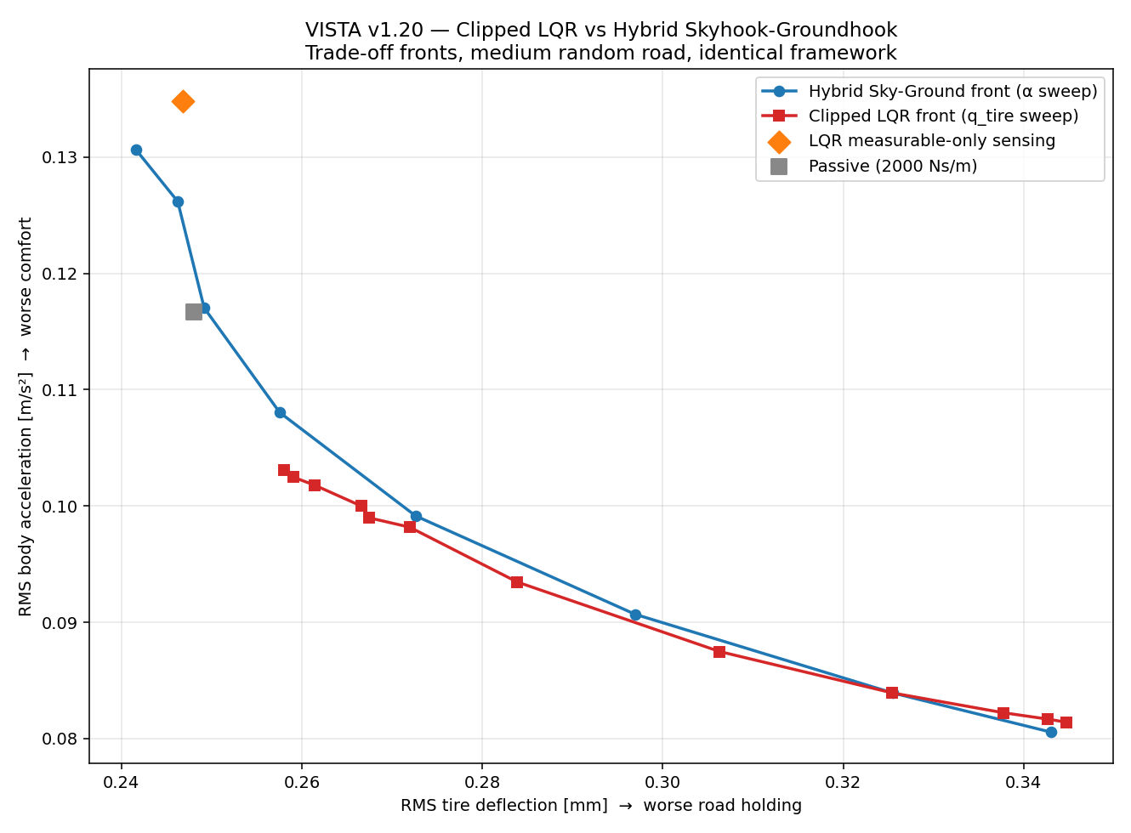
Figure 5 — Clipped LQR front versus hybrid front on the medium road. The orange diamond marks the road-holding-weighted LQR restricted to production-measurable sensing.

5. Half-Car Model and Per-Corner Control (Stage 13)
Stage 13 deploys the quarter-car controller library on the four-degree-of-freedom half-car without modification: each axle runs its own controller instance fed with corner-local measurements (corner heave velocity, relative velocity, unsprung velocity, travel), and each commands its own damper through the standard clipped interface. This is the direct payoff of the modular architecture — no controller code changed between vehicle models.
The wheelbase delay makes the speed bump a two-impact event: the front axle strikes at t = 1.0 s and the rear axle 468 ms later, exciting the 1.23 Hz pitch mode that no quarter-car model can represent. The results show that corner-local skyhook control damps pitch essentially for free: because pitch motion appears at each corner as heave velocity, the per-corner controllers suppress it without any dedicated pitch logic. Continuous skyhook improves RMS heave acceleration by 32.1 % and RMS pitch acceleration by 33.0 % on the bump, cutting peak pitch angle from 0.74° to 0.41°. The hybrid calibration retains its balanced character, improving both heave (+13.6 %) and pitch (+12.7 %) with roughly half the tire-deflection cost of the pure skyhook. Results on the medium random road follow the same pattern.
Speed bump (vs. passive) | Cont. Skyhook per corner | Hybrid α = 0.70 per corner
RMS heave acceleration | +32.1 % | +13.6 %
RMS pitch acceleration | +33.0 % | +12.7 %
Peak pitch angle | 0.41° (vs. 0.74°) | 0.51° (vs. 0.74°)
RMS tire deflection | −32.6 % (worse) | −9.2 % (worse)

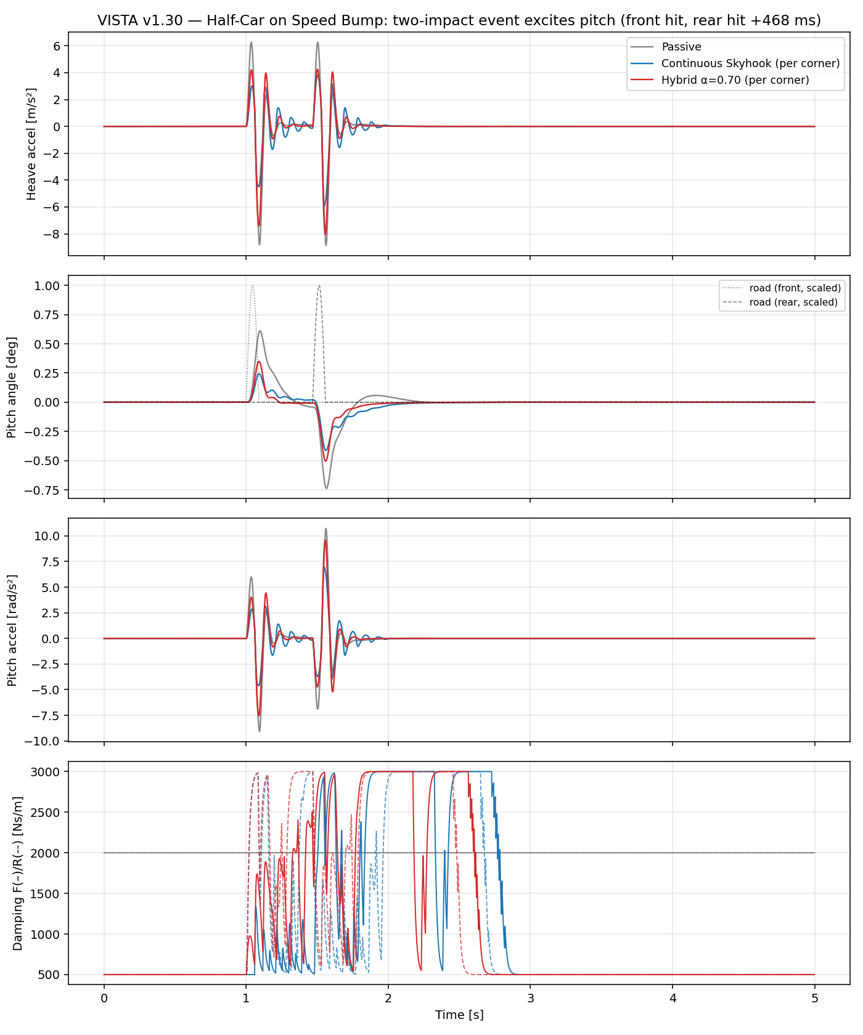
Figure 6 — Half-car speed bump response: the two-impact event (front hit, rear hit 468 ms later) excites pitch; per-corner semi-active control suppresses both heave and pitch.

6. Key Engineering Findings
First, control architecture dominates controller tuning. The Stage-5 PID and the initial v1.00 bring-up both produced attractive comfort metrics from structurally flawed implementations; in both cases the flaw, not the gains, was the story. A force-based actuator interface with explicit passivity clipping made the second flaw diagnosable in minutes.
Second, integral action is worthless in semi-active velocity regulation. Independent cost functions converged to Ki = 0: there is no steady-state error to integrate, and a dissipative actuator cannot realize the sustained forces an integrator requests.
Third, continuous force modulation beats switching logic. The two-state skyhook's valve slamming produced acceleration peaks worse than passive; continuous skyhook and PID eliminated them while improving every comfort metric.
Fourth, the damper envelope, not the control law, limits road holding. Groundhook added roughly 1.5 % over a well-chosen passive damper, and clipped LQR could not extend the hybrid's Pareto front. With c_min = 500 Ns/m, road-holding authority is bounded by hardware.
Fifth, production sensing limits road holding, not comfort. Removing the unmeasurable tire-deflection state is free for comfort-weighted LQR designs but catastrophic for road-holding-weighted ones — a 27-point performance swing.
Sixth, corner-local control scales to coupled body modes. Per-corner skyhook on the half-car damped pitch as effectively as heave with zero pitch-specific logic, because rigid-body pitch is observable in every corner's heave velocity.

7. Conclusions and Roadmap
The control-systems arc of VISTA is complete: digital PID, continuous skyhook, groundhook, hybrid blending, and clipped LQR, all implemented behind a single interface, all evaluated in one physically consistent sampled-data framework, and all benchmarked against a validated passive baseline on identical excitations. The project now carries a practical calibration menu — a comfort mode (digital PID or continuous skyhook), a balanced mode (hybrid at α = 0.70), and the quantified knowledge that further road-holding gains require a different damper envelope rather than a different control law.
The remaining roadmap proceeds from models to tooling: extension of the half-car to a full-car model with roll dynamics (Stage 14), an interactive dashboard for parameter studies (Stage 15), and the GitHub portfolio structuring with version history (Stage 17). Model-predictive control remains the stretch goal on the control side, attractive precisely because the constraint-handling that clipping performs implicitly is what MPC optimizes explicitly.

