**Suriya Latha A**

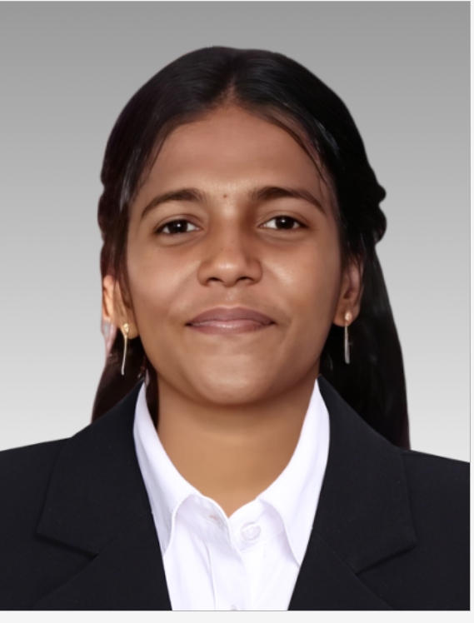

DOB: 01. 08. 2002

GitHub: https://suriyapravee.github.io/digital_portfolio/ c

Email Id: [praviya02@gmail.com](mailto:praviya02@gmail.com)

Mobile: 7358420683

Address: 5A, Pambukovil Santhai Road,Puliyankudi, Thenkasi,627855.

**Career Objective:** To work in an environment offering challenging career opportunities where I can apply and enhance my skills for solving diverse technical problems.

**Educational Qualification:**

|  |  |  |  |  |
| --- | --- | --- | --- | --- |
| **S. No** | **Qualification** | **Name of Institution** | **Year of Passing** | **Percentage/ CGPA** |
| 1 | MCA | Karpaga Vinayaga College of Engineering & Technology | 2026 | Pursuing |
| 2 | BCA | Arunachala Arts and Science College,Nagercoil | 2024 | 9.2% |
| 3 | Higher Secondary | H.N.U.C Hr. Sec school,Thenkasi | 2020 | 61% |
| 4 | SSLC | H.N.U.C Hr. Sec school,Thenkasi | 2018 | 85% |

**Technical Skills:**

* Python
* UI/UX
* HTML, CSS
* SQL
* R programming

**Certificate Courses:**

* Python with django
* TCS ION Career Edge-Young Professional

**Achievements:**

* First rank in BCA with Gold model [Manonmaniam Sundaranar University]
* Third Prize in District level Tamil Poem Writing Competition.

**Languages known:**

* Speak: English, Tamil
* Read & Write: English, Tamil

**Date:**25 /03/2025

**Place:** Thenkasi **Signature**