SSN College of Engineering
Department of Computer Science and Engineering

Subject: Internet Programming (UCS2601)

PROJECT REPORT
on

FinStud
A Personal Finance Management Web Application

Member | Name | Register Number
Member 1 | Sathish Kumar G | 3122235001118
Member 2 | J.P.Suriyaraj | 3122235001141
Member 3 | Suriyha M | 3122235001142

Academic Year | 2025 – 2026
Degree | B.E. Computer Science and Engineering
Submission Date | 10-04-2026

Abstract
FinStud is a full-stack personal finance management web application designed to help individuals track, manage, and understand their financial health. The application provides a comprehensive platform for recording income and expenses, managing assets and liabilities, setting financial goals, and tracking net worth over time through historical snapshots.
Built using a modern client-server architecture, the frontend is developed with plain HTML, CSS, and Vanilla JavaScript, while the backend is powered by Node.js and the Express.js framework, with data persisted in a MySQL relational database. The system uses JSON Web Tokens (JWT) for stateless authentication and integrates Google OAuth 2.0 for social login.
Users can register, verify their email, and access a feature-rich dashboard with real-time financial summaries and interactive charts rendered using Chart.js. The project demonstrates practical application of core Internet Programming concepts, including RESTful API design, CORS handling, secure password hashing, SMTP email integration, and responsive web design.

1. Introduction
Managing personal finances is a fundamental life skill, yet most individuals lack a structured way to track their income, expenses, assets, and overall wealth. Many existing financial tools are either too complex, too expensive, or lack the simplicity needed for everyday use by students and young professionals.
FinStud (Financial Student) is a web-based personal finance management system that bridges this gap. The project was developed as part of the Internet Programming course to demonstrate the construction of a full-stack web application from the ground up, combining both frontend and backend technologies in a practical, real-world scenario.
The application provides users with a clean, intuitive dashboard that gives a complete overview of their financial situation — including net worth, monthly income versus expenses, asset categories, financial goals, and historical net worth snapshots. All data is securely stored in a MySQL database and served through a RESTful API.

2. Problem Statement
Most students and young professionals have limited awareness of their own financial health. Without a structured tracking system, they often overspend, fail to save consistently, and struggle to plan for the future. There is a clear need for a simple, free, and web-based tool that consolidates all financial data — income, expenses, assets, liabilities, and goals — into a single unified platform.
FinStud addresses the following key problems:
- No centralised tool for students to track income and expenses in one place.
- Difficulty in calculating real-time net worth (total assets minus total liabilities).
- Lack of visual feedback on financial trends over time.
- No simple way to set and monitor progress toward financial goals.
- Manual spreadsheet tracking is error-prone and not user-friendly.

3. Objectives
The primary objectives of FinStud are:
- To design and develop a full-stack web application using Node.js, Express.js, and MySQL.
- To implement secure user authentication using JWT and Google OAuth 2.0.
- To provide a dashboard that displays net worth, income, expenses, and financial summaries at a glance.
- To enable users to add, edit, and delete assets, liabilities, income entries, and expenses.
- To allow users to create financial goals with target amounts and deadlines.
- To implement a net worth snapshot feature that records the user's financial state at any point in time.
- To support data import (bulk upload) and data export (JSON) for user convenience.
- To demonstrate key Internet Programming concepts such as REST APIs, CORS, SMTP email integration, and responsive web design.

4. Scope of the Project

4.1 In Scope
- User registration and login with email verification and password reset functionality.
- Google OAuth 2.0 social login integration.
- Dashboard with financial overview: net worth, income/expense totals, and asset distribution chart.
- Full CRUD operations for assets, liabilities, income, and expenses.
- Financial goals tracking with target amounts and deadline management.
- Net worth snapshots for historical tracking with a visual trend chart.
- User profile management, password change, and account deletion.
- Feedback submission module.
- Data export to JSON and bulk data import from JSON files.
- Responsive web design compatible with both desktop and mobile devices.

4.2 Out of Scope
- Real-time stock or cryptocurrency price integration.
- Bank account syncing or third-party financial API connections.
- Multi-currency conversion.
- Native mobile application (iOS or Android).

5. Tech Stack

5.1 Frontend
Technology | Purpose
HTML5 | Markup and page structure for all views
CSS3 | Custom styling, responsive layouts, and animations
Vanilla JavaScript (ES6+) | Client-side logic, API calls, and DOM manipulation
Chart.js 4.4.1 | Interactive charts for income/expense and net worth visualisation
Google Identity Services | Google Sign-In button and OAuth 2.0 token handling

5.2 Backend
Package / Library | Purpose
Node.js | JavaScript runtime environment for server-side execution
Express.js 4.x | Web framework for routing, middleware, and API handling
bcryptjs | Password hashing with salt rounds for secure storage
jsonwebtoken (JWT) | Stateless authentication token generation and verification
express-validator | Server-side request validation and input sanitisation
nodemailer | Email delivery for verification and password reset via SMTP
google-auth-library | Verifying Google OAuth ID tokens on the server side
dotenv | Environment variable management for secrets and configuration
cors | Cross-Origin Resource Sharing middleware
nodemon | Development server auto-restart on file changes

5.3 Database
Technology | Purpose
MySQL 8.x | Relational database for persistent data storage
mysql2 (Node.js driver) | Promise-based MySQL client for Node.js with connection pooling

5.4 Development Tools
Tool | Purpose
VS Code | Primary code editor
Postman | API testing and endpoint verification
Git | Version control
Live Server (VS Code Extension) | Frontend hot-reload during development

6. System Architecture
FinStud follows a classic three-tier architecture comprising the Presentation Layer (frontend), the Application Layer (backend REST API), and the Data Layer (MySQL database). The frontend and backend communicate exclusively through HTTP-based RESTful API calls, keeping each tier cleanly separated.

6.1 Architecture Overview
Layer | Description
Presentation Layer | HTML, CSS, and JavaScript files served as static assets from the Express server. The user interacts with the interface directly in the browser.
Application Layer | Node.js + Express.js REST API. Handles authentication, business logic, input validation, and returns JSON responses.
Data Layer | MySQL relational database that stores all persistent user data including credentials, financial records, goals, and snapshots.

Diagram: Three-Tier Architecture
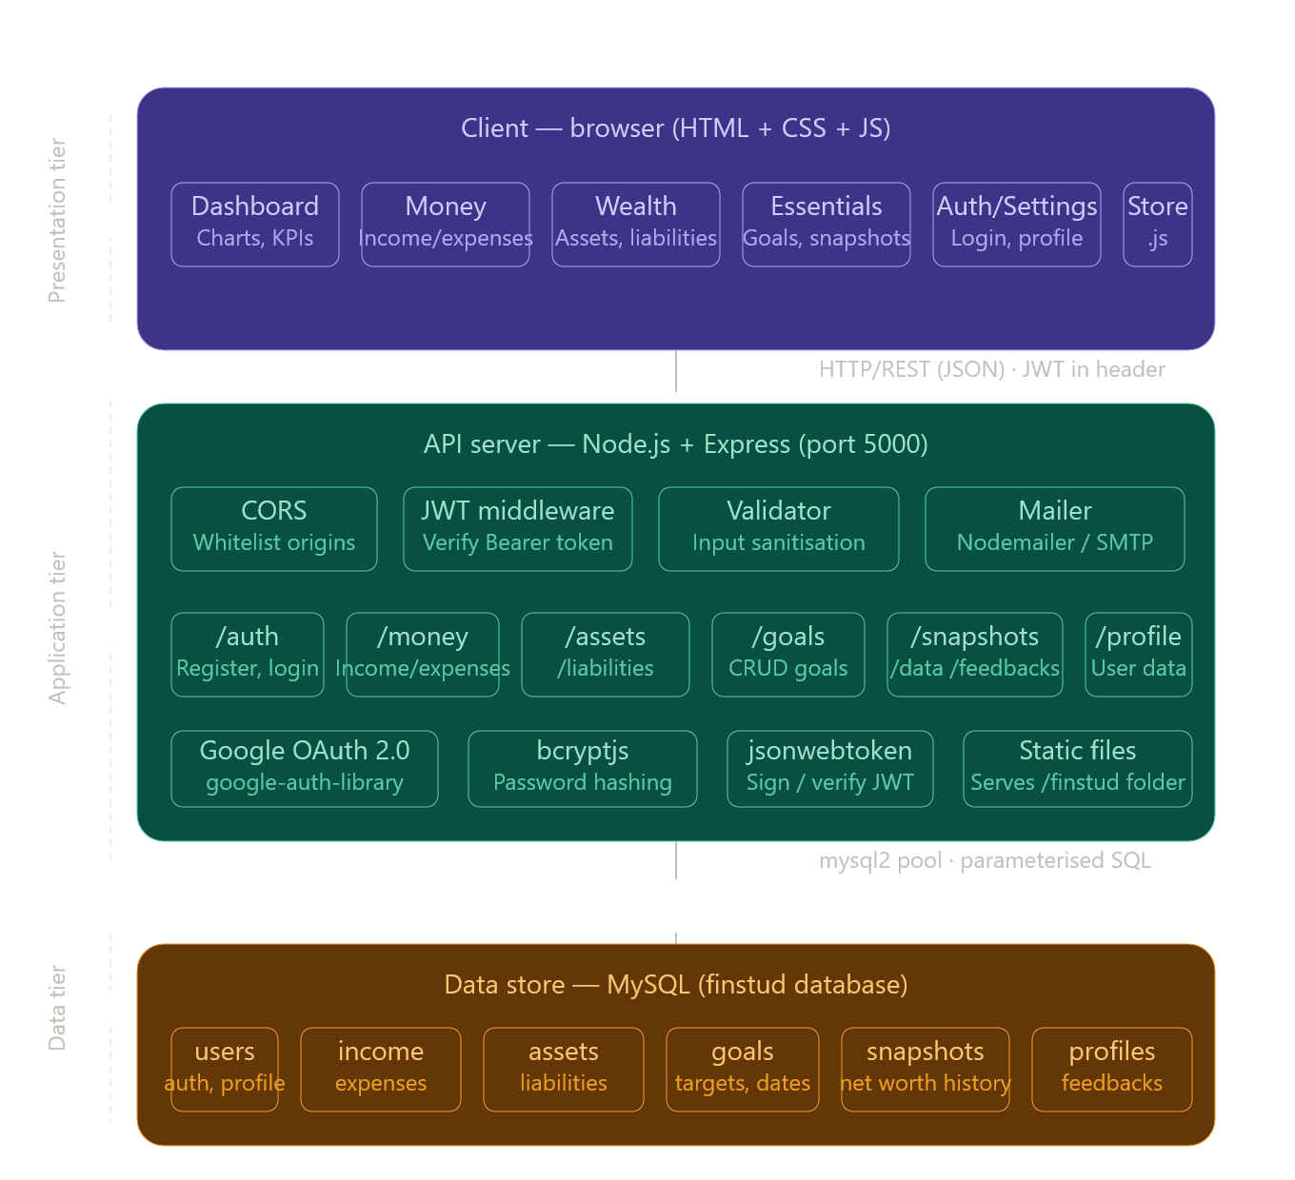

6.2 Component Interaction
The browser loads the static HTML, CSS, and JavaScript files from the Express server's static folder. The JavaScript in the browser (store.js) makes asynchronous fetch() calls to the REST API endpoints. The API server validates the request, verifies the JWT token from the Authorization header, queries the MySQL database, and returns a JSON response. The browser then updates the DOM dynamically based on the received data.

6.3 Authentication Flow
Authentication is handled using JSON Web Tokens (JWT). Upon successful login or registration, the server generates a signed JWT containing the user's ID, name, and email with a 7-day expiry. This token is stored in the browser's localStorage. Every subsequent protected API request includes this token in the Authorization: Bearer <token> header. The auth middleware on the server verifies and decodes the token before allowing access to any protected resource.

Diagram: Authentication Flow
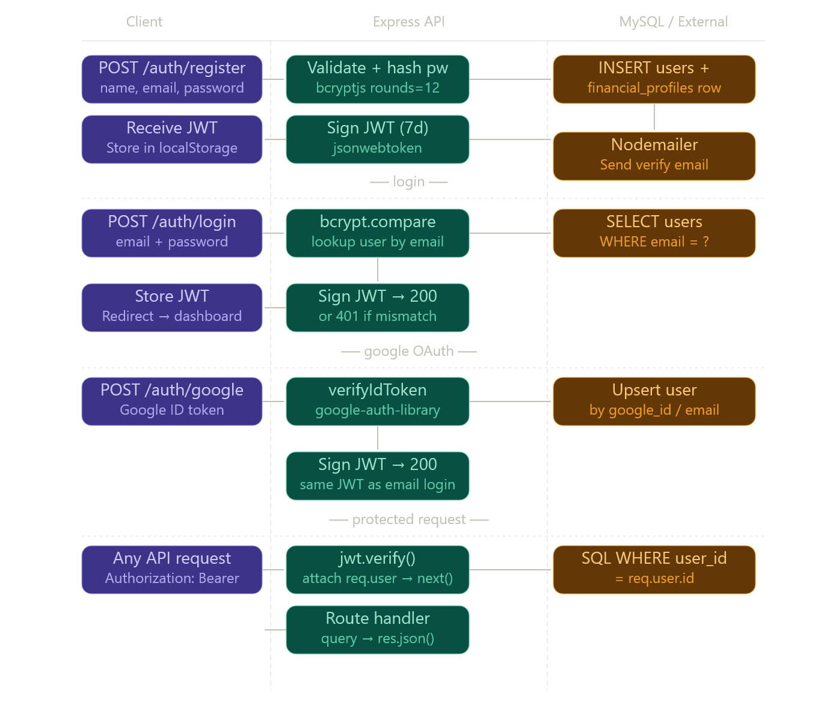

7. Module-wise Description

7.1 Authentication Module (routes/auth.js)
This module handles all user identity operations:
- POST /api/auth/register: Validates user input, hashes the password using bcryptjs (12 salt rounds), creates the user record, initialises an empty financial profile, generates a verification token, and sends a verification email via Nodemailer.
- POST /api/auth/login: Validates credentials, compares passwords using bcrypt.compare(), and returns a signed JWT on success.
- POST /api/auth/google: Verifies the Google ID token using the Google Auth Library, creates or links the user account, and returns a JWT.
- GET /api/auth/verify?token=: Verifies the user's email using the token sent via email and marks the account as verified.
- POST /api/auth/forgot-password and POST /api/auth/reset-password: Generates a time-limited (1-hour) reset token, emails the link to the user, and updates the password hash on a successful reset.
- POST /api/auth/change-password: Allows authenticated users to update their password after verifying the current one.
- DELETE /api/auth/delete-account: Deletes the user's account; all related data is cascade-deleted by MySQL foreign key constraints.

7.2 Assets Module (routes/assets.js)
Manages user assets such as savings, investments, real estate, and gold. Supports full CRUD: listing all assets sorted by value, adding a new asset with name, type, and value, partially updating existing assets (PATCH), and deleting an asset. All operations are protected by JWT middleware and are restricted to the authenticated user's own data.

7.3 Income and Expenses Module (routes/money.js)
Handles financial transaction tracking. Income and expense entries can be filtered by month and year. Supports bulk import of entries from an array and individual delete operations. This module powers the Money page, which displays monthly breakdowns with category-wise grouping.

7.4 Liabilities Module (routes/liabilities.js)
Records user debts and liabilities such as loans and credit card balances. Supports full CRUD. Liabilities are subtracted from total assets to compute the user's net worth.

7.5 Goals Module (routes/goals.js)
Allows users to define financial goals with a target amount and an optional target date. Goals can be updated when partially achieved or deleted when completed. The Essentials page displays all goals along with progress indicators.

7.6 Snapshots Module (routes/snapshots.js)
Records a point-in-time capture of the user's net worth, total assets, and total liabilities. Snapshots are displayed on the Wealth page as a historical trend chart, allowing users to track their financial progress over time.

7.7 Profile Module (routes/profile.js)
Manages the user's financial profile, including age, monthly income reference, monthly expense reference, and monthly savings target. This data supplements the summary cards shown on the dashboard.

7.8 Data Module (routes/data.js)
Provides data portability features. GET /api/data/export returns a consolidated JSON of all the user's financial data. DELETE /api/data/reset removes all financial records (income, expenses, assets, liabilities, goals, and snapshots) for the user without deleting the account itself.

7.9 Feedbacks Module (routes/feedbacks.js)
Allows users to submit categorised feedback messages (Bug, Feature Request, General, Other). Feedback is stored in the database and can be retrieved via the GET endpoint.

7.10 Frontend Pages
Page | Description
index.html | Public landing page with hero section, features, pricing tiers, and FAQ accordion
signup.html | Login and registration forms with Google Sign-In integration
onboarding.html | Post-registration setup page to capture initial financial profile data
dashboard.html | Main overview showing net worth, income/expense cards, and asset pie chart
wealth.html | Assets and liabilities management with net worth snapshot trend chart
money.html | Income and expense tracking with monthly filters and category charts
essentials.html | Financial goals tracking with progress bars and target dates
import.html | Bulk JSON import and full data export interface
settings.html | Account settings, profile management, password change, and data reset

Diagram: Module Structure
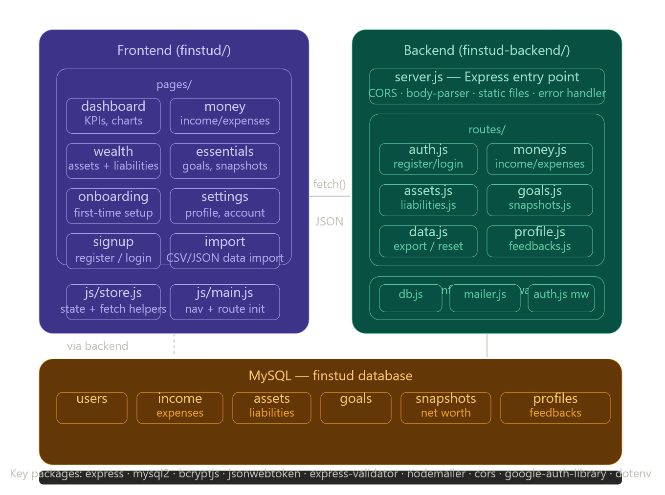

8. Working Flow

8.1 New User Registration Flow
- User visits index.html and clicks 'Get Started'.
- signup.html loads and presents the registration and login tabs.
- User fills in their name, email, and password; the form calls Store.register().
- The frontend sends POST /api/auth/register with the user's details.
- The backend validates the input, hashes the password, stores the user, and sends a verification email.
- The server returns a JWT token; the frontend stores it in localStorage.
- The user is redirected to onboarding.html to enter initial financial profile data.
- On completion, the user is redirected to dashboard.html.

8.2 Login Flow
- User enters email and password on signup.html.
- POST /api/auth/login is called; the backend verifies the password hash using bcrypt.compare().
- A JWT is issued and stored in localStorage under the key 'fs_token'.
- The user is redirected to dashboard.html; all subsequent API calls include the JWT.

8.3 Dashboard Data Load Flow
- dashboard.html loads and JavaScript calls multiple API endpoints in parallel.
- GET /api/assets, GET /api/money/income, GET /api/money/expenses, GET /api/liabilities, and GET /api/snapshots are fetched concurrently.
- Net worth is calculated on the client side: Total Assets - Total Liabilities.
- The income vs. expense bar chart and asset distribution pie chart are rendered using Chart.js.
- The latest snapshot date and value are displayed in the net worth banner.

9. Algorithms and Logic Used

9.1 Password Hashing (bcryptjs)
When a user registers, their plaintext password is hashed using the bcrypt algorithm with a cost factor of 12 (i.e., 2^12 = 4,096 iterations). During login, bcrypt.compare() securely checks the entered password against the stored hash without decrypting it. This approach makes brute-force attacks computationally expensive and ensures that plaintext passwords are never stored.

9.2 JWT Generation and Verification
Upon successful login, jwt.sign() is called with a payload of { id, name, email }, a secret key loaded from environment variables, and a 7-day expiry. The resulting token is a Base64-encoded string in three parts: Header.Payload.Signature. On every protected API request, the auth middleware calls jwt.verify() to validate the signature and check the expiry before allowing the request to proceed.

9.3 Net Worth Calculation
The net worth is computed on the frontend using the formula:
Net Worth = Sum(Asset Values) − Sum(Liability Values)
This is recalculated every time the dashboard loads by fetching the latest asset and liability records from the API.

9.4 Email Token Generation
Verification and password reset tokens are generated using Node.js's built-in crypto.randomBytes(32).toString('hex'), producing a 64-character cryptographically random hexadecimal string. Password reset tokens additionally store an expiry timestamp in the database, which is checked against the current server time on use.

9.5 Dynamic SQL Query Building (PATCH Operations)
For partial update operations (HTTP PATCH), the backend dynamically constructs the SQL UPDATE statement by building an array of fields and values only for the properties present in the request body. This prevents accidental overwrites of unchanged fields and keeps updates precise.

10. Database Design
The FinStud database is implemented in MySQL with the utf8mb4 character set to support all Unicode characters. The schema consists of nine tables with appropriate foreign key relationships and indexes for query performance.

10.1 Entity-Relationship Summary
Table | Description
users | Stores user credentials, Google OAuth info, and email verification state
financial_profiles | One-to-one with users; stores age and reference income, expense, and savings values
assets | Many-to-one with users; stores asset name, type, and value
liabilities | Many-to-one with users; stores liability name and amount
income | Many-to-one with users; stores income entries with date and category
expenses | Many-to-one with users; stores expense entries with date and category
goals | Many-to-one with users; stores goal name, target amount, and target date
snapshots | Many-to-one with users; stores net worth, assets, and liabilities at a point in time
feedbacks | Many-to-one with users; stores type and message of feedback submissions

10.2 Key Table Structures

users
Column | Type | Description
id | INT, PK, AUTO_INCREMENT | Primary key
name | VARCHAR(100) | User's full name
email | VARCHAR(150), UNIQUE | Login email address
password_hash | VARCHAR(255) | bcrypt-hashed password
google_id | VARCHAR(255), UNIQUE | Google OAuth subject ID
is_verified | TINYINT(1) | Email verification status
verify_token | VARCHAR(255) | Email verification token
reset_token | VARCHAR(255) | Password reset token
reset_expires | DATETIME | Expiry timestamp for reset token

assets
Column | Type | Description
id | INT, PK, AUTO_INCREMENT | Primary key
user_id | INT, FK → users.id | Owner of the asset
name | VARCHAR(200) | Asset description
asset_type | VARCHAR(100) | Category (e.g., Bank, Gold, Equity)
value | DECIMAL(15,2) | Current value of the asset

income / expenses
Column | Type | Description
id | INT, PK, AUTO_INCREMENT | Primary key
user_id | INT, FK → users.id | Owner of the entry
name | VARCHAR(200) | Description of the income/expense
amount | DECIMAL(15,2) | Monetary value
category | VARCHAR(100) | Category label (e.g., Salary, Rent)
entry_date | DATE | Date of the transaction

11. API Design
All API endpoints follow RESTful conventions. The base URL is /api/. Every protected endpoint requires a valid JWT in the Authorization: Bearer <token> header. The server responds with JSON for all routes.

Diagram: API Route Map
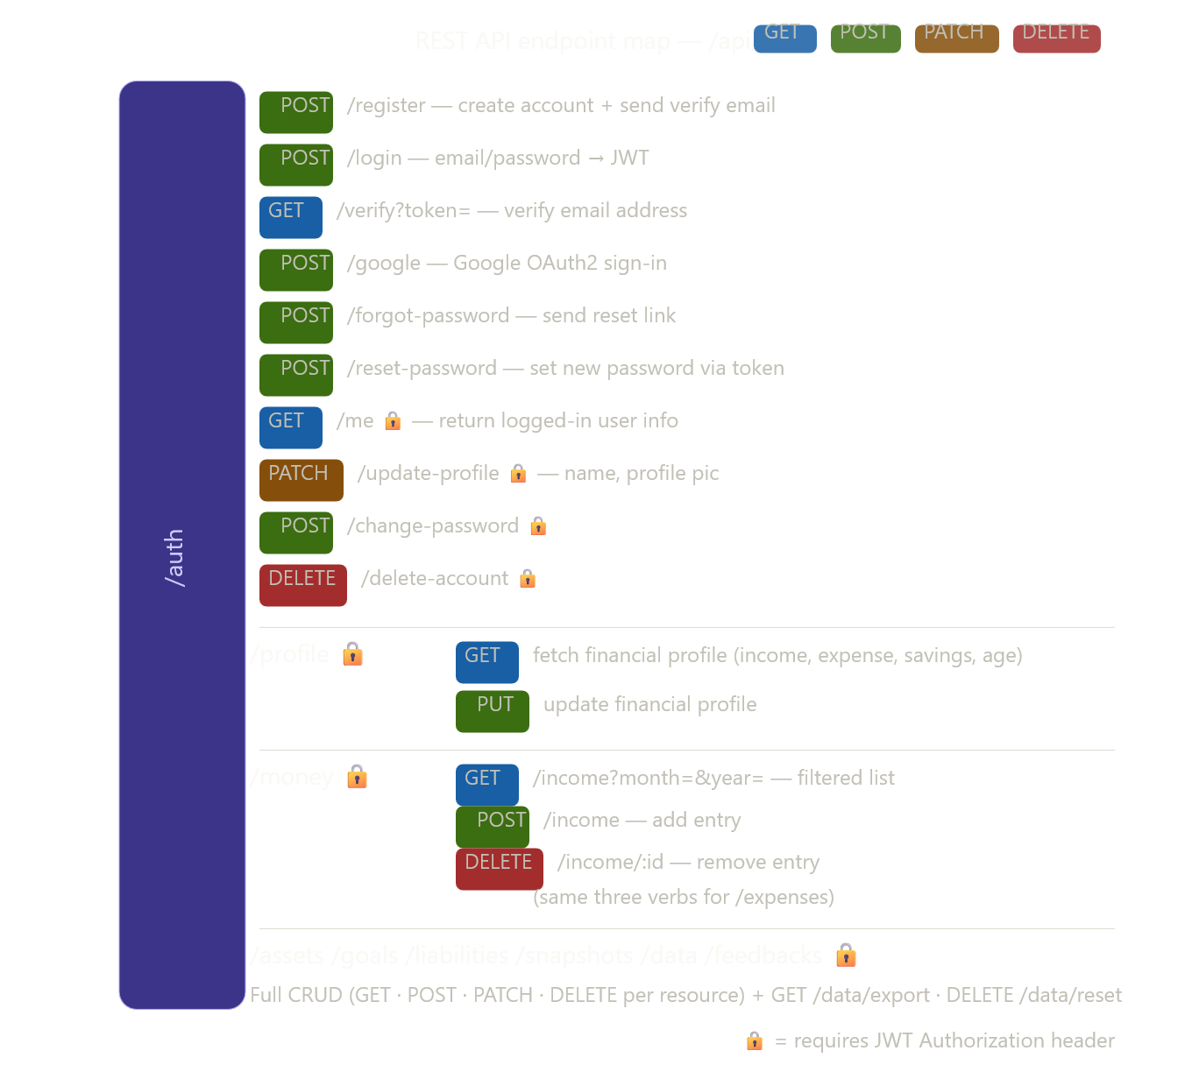

11.1 API Endpoint Summary
Resource | Available Endpoints
/auth | POST /register, POST /login, POST /google, GET /verify, POST /forgot-password, POST /reset-password, GET /me, PATCH /update-profile, POST /change-password, DELETE /delete-account
/profile | GET (fetch financial profile), PUT (update financial profile)
/assets | GET (list), POST (add), PATCH /:id (update), DELETE /:id (remove)
/liabilities | GET (list), POST (add), PATCH /:id (update), DELETE /:id (remove)
/money/income | GET (list, filterable by month/year), POST (add), DELETE /:id
/money/expenses | GET (list, filterable by month/year), POST (add), DELETE /:id
/goals | GET (list), POST (add), PATCH /:id (update), DELETE /:id (remove)
/snapshots | GET (list), POST (create new snapshot)
/data | GET /export (full data JSON), DELETE /reset (clear all records)
/feedbacks | GET (list all), POST (submit feedback)

12. Testing and Validation
The application was tested manually throughout development using the following approaches:

12.1 API Testing (Postman)
All REST API endpoints were tested individually using Postman. Test cases covered valid inputs, invalid inputs, missing fields, expired tokens, and unauthorised access attempts. The API returned appropriate HTTP status codes (200, 201, 400, 401, 404, 409, 500) for each scenario.

12.2 Frontend Testing
Each page was tested manually in Google Chrome and Mozilla Firefox. Test scenarios included form validation errors, successful data submission and UI updates, chart rendering with both empty and populated data, and responsive layout on mobile screen sizes.

12.3 Database Validation
MySQL constraints were verified: duplicate email registration correctly returns a 409 error, deleting a user triggers cascade deletion of all linked records, and indexed columns (user_id, entry_date) were confirmed to speed up filtered queries.

13. Limitations
The following limitations were identified during the development and testing of FinStud:
- The frontend uses plain HTML and JavaScript without a component-based framework like React or Vue, which may reduce code reusability as the application scales.
- There is no real-time update mechanism; the page must be refreshed or re-navigated to reflect changes made in another tab.
- The application currently supports only INR as the currency with no multi-currency capability.
- There is no role-based access control (RBAC); all users have the same level of permissions.
- The application has no automated test suite (unit or integration tests).
- Google OAuth requires a valid Internet connection and a configured Google Cloud project, which adds some complexity to the initial setup.

14. Future Enhancements
The following improvements are proposed for future iterations of FinStud:
- React or Vue.js Frontend: Refactor the frontend into a component-based SPA framework for better state management and maintainability.
- Real-time Updates with WebSockets: Provide live updates across multiple browser tabs or devices.
- Multi-currency Support: Allow users to record assets and transactions in different currencies with live exchange rate conversion.
- Budget Planner: Allow users to set monthly spending limits per category and receive alerts when they approach the limit.
- AI-Powered Insights: Integrate an AI module that analyses spending patterns and provides personalised financial advice.
- Recurring Transactions: Support automatic logging of monthly salary, rent, and utility payments.
- Mobile Application: Develop a React Native or Flutter app for native iOS and Android support.
- Bank Statement Import (CSV): Allow users to upload bank statements in CSV format for automatic transaction categorisation.
- Admin Panel: Provide an admin interface to manage users and view aggregated, anonymised usage analytics.
- Email Digests: Send users a weekly or monthly financial summary email automatically.

15. Conclusion
FinStud successfully demonstrates the development of a complete, production-ready personal finance management web application using the core technologies covered in the Internet Programming course. The project implements a RESTful backend API with Node.js and Express.js, a responsive frontend with HTML5, CSS3, and Vanilla JavaScript, and a relational MySQL database, resulting in a fully functional three-tier web application built from scratch.
The application addresses a real-world need for students and young professionals to understand and manage their financial health through an accessible, browser-based interface. Features such as JWT authentication, Google OAuth, SMTP-based email workflows, Chart.js data visualisations, and RESTful data management demonstrate a strong practical understanding of modern web development. The project serves as a meaningful reference for how internet technologies combine to deliver a secure, complete, and user-friendly web service.

16. Learning Outcomes
Through the development of FinStud, the following key learning outcomes were achieved:
- Understood the architecture and implementation of RESTful APIs using Express.js, and how HTTP methods (GET, POST, PATCH, DELETE) map to CRUD operations.
- Gained practical experience with JWT-based stateless authentication and the importance of secure token handling in web applications.
- Learned to integrate third-party OAuth providers (Google) using the Google Identity Services library and server-side token verification.
- Practised secure password management using bcrypt hashing and understood why plaintext passwords must never be stored.
- Acquired knowledge of MySQL schema design including relationships, foreign keys, indexes, and cascade operations.
- Applied CORS configuration to manage cross-origin requests between a frontend served on one port and a backend API on another.
- Implemented transactional email workflows using Nodemailer and SMTP for email verification and password reset.
- Developed interactive data visualisations using Chart.js for pie charts and bar/line charts.
- Understood environment-variable-based configuration management using dotenv for keeping secrets out of source code.
- Built a responsive multi-page web application with mobile-friendly navigation and adaptive layouts using CSS Grid and Flexbox.

17. Output Screenshots
The following section contains screenshots of all major pages and outputs of the FinStud application, demonstrating the working system and its features.

17.1 Landing Page
The public-facing landing page with hero section, feature highlights, pricing tiers, and FAQ accordion.
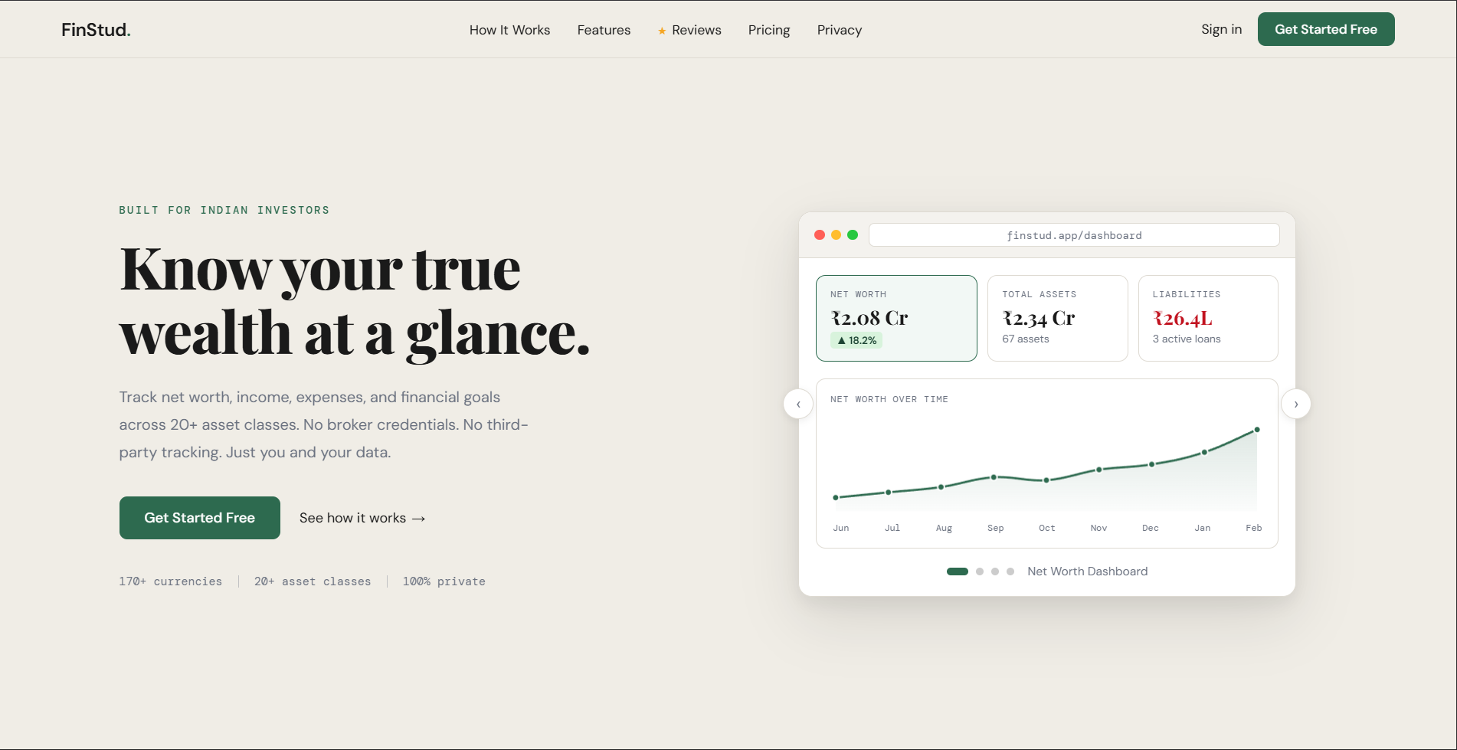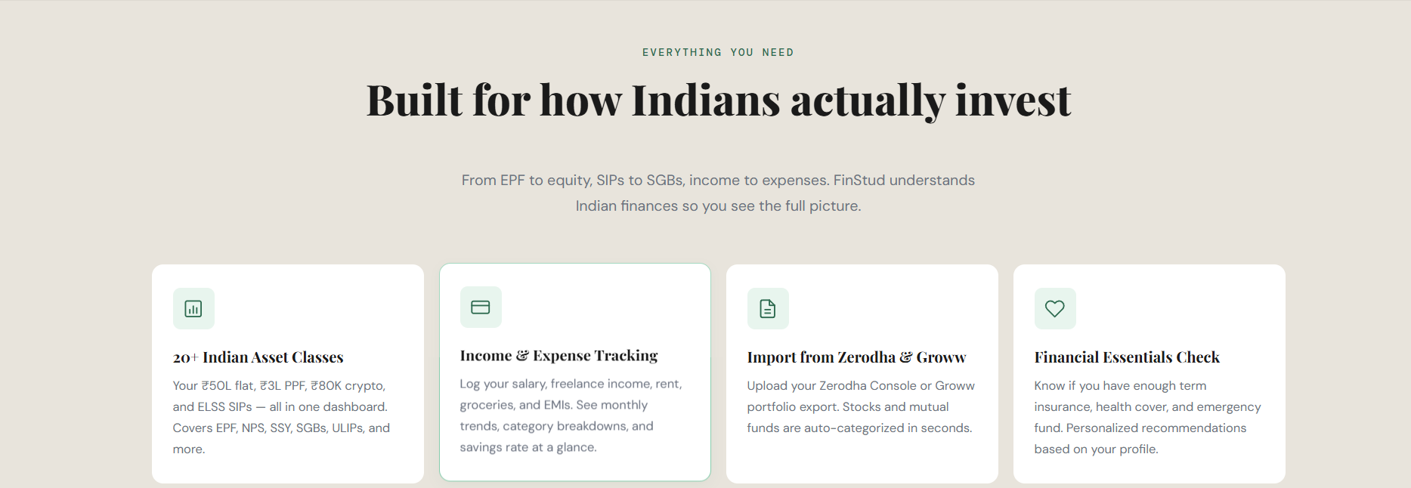

17.2 Sign Up / Login Page
The authentication page showing the registration and login form tabs, along with the Google Sign-In button.
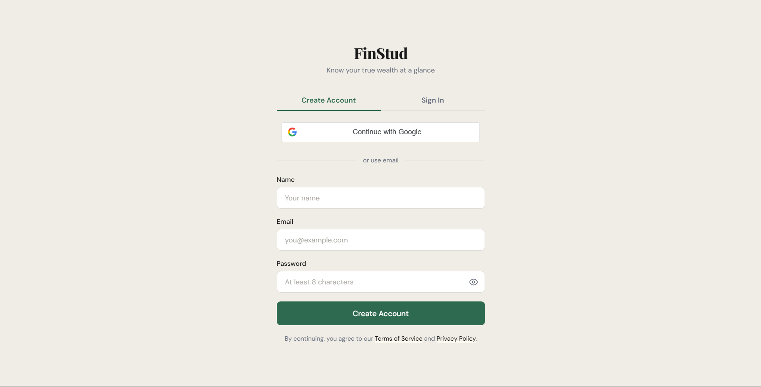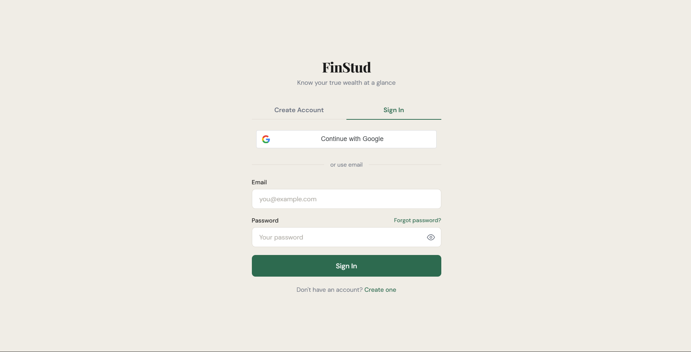

17.3 Dashboard / Overview Page
The main dashboard displaying the net worth banner, summary cards (income, expense, savings), asset pie chart, and income vs. expense bar chart.
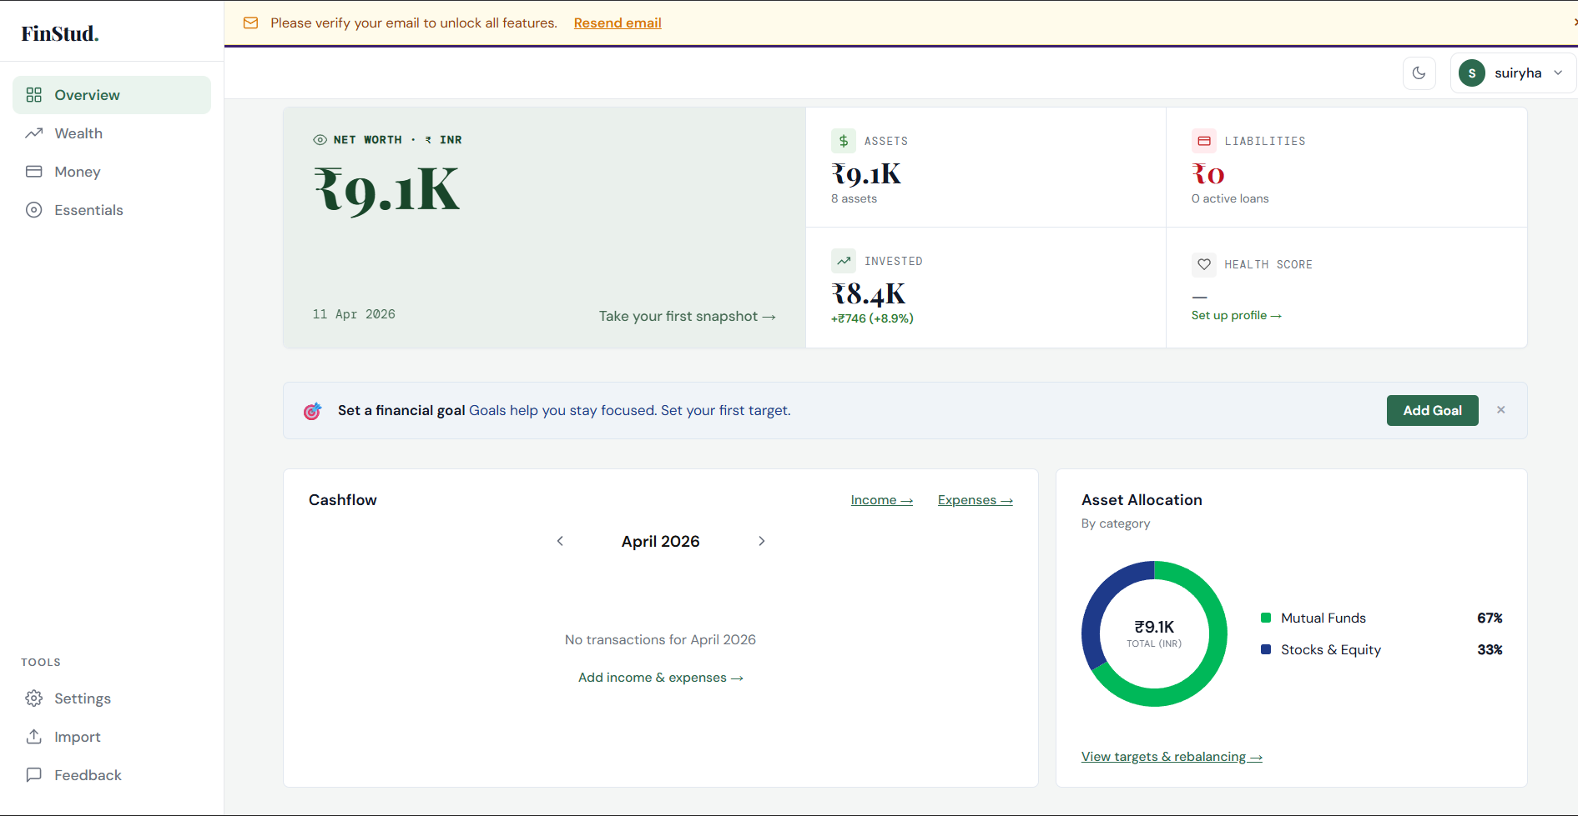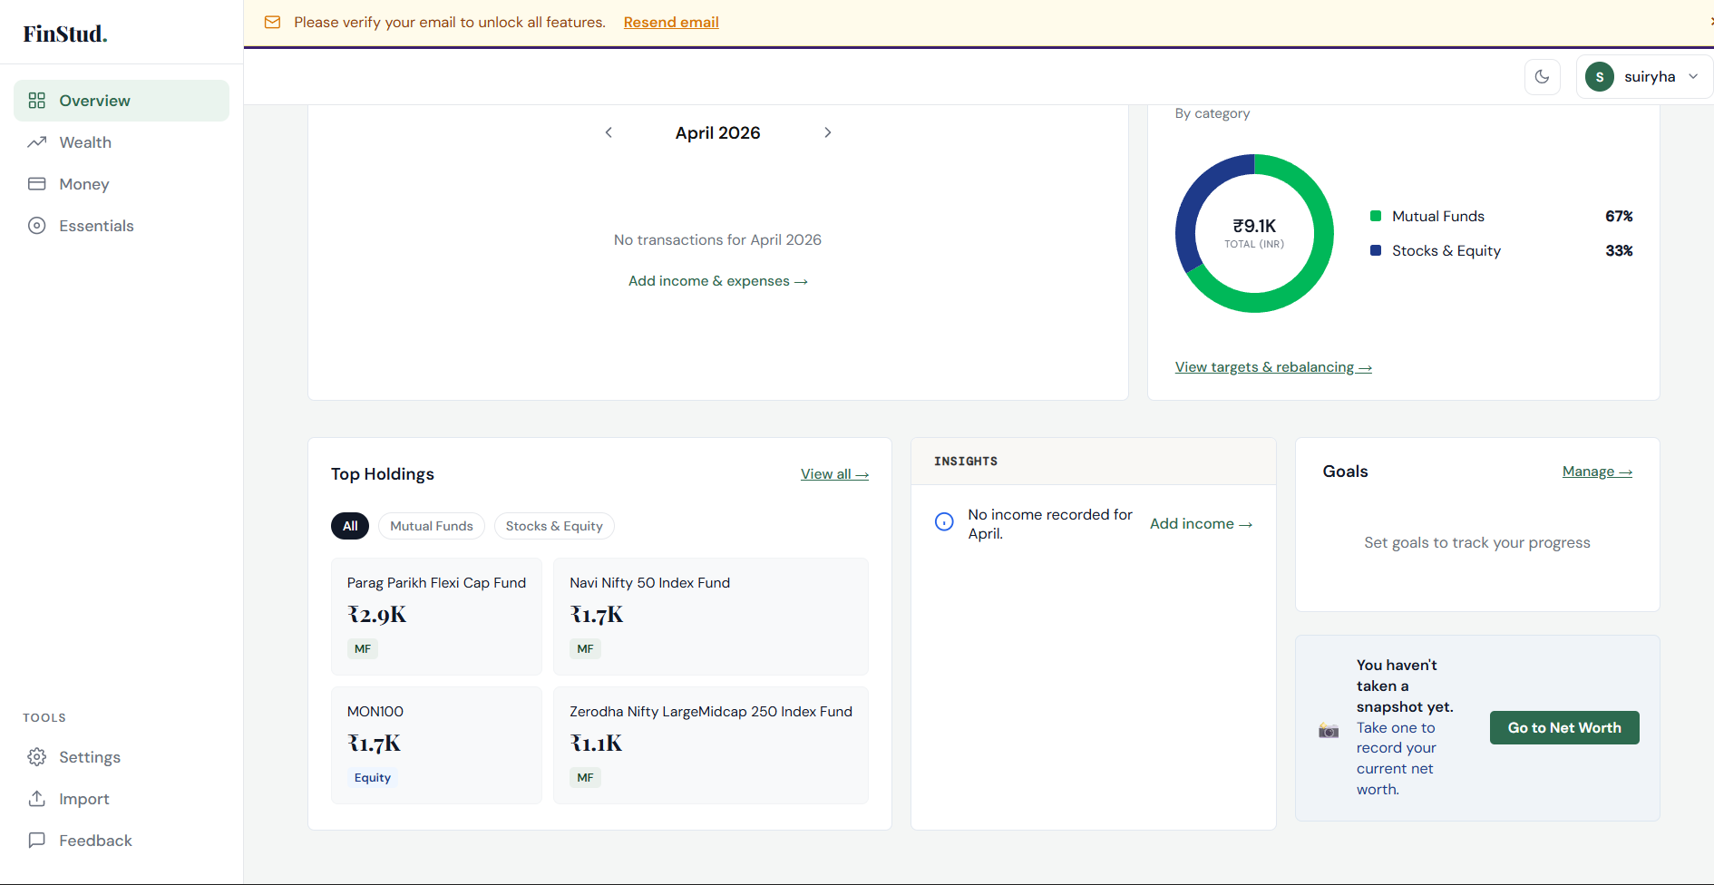

17.4 Wealth Page — Assets and Liabilities
The wealth management page showing categorised assets, liabilities, total net worth calculation, and the historical net worth trend chart from snapshots.
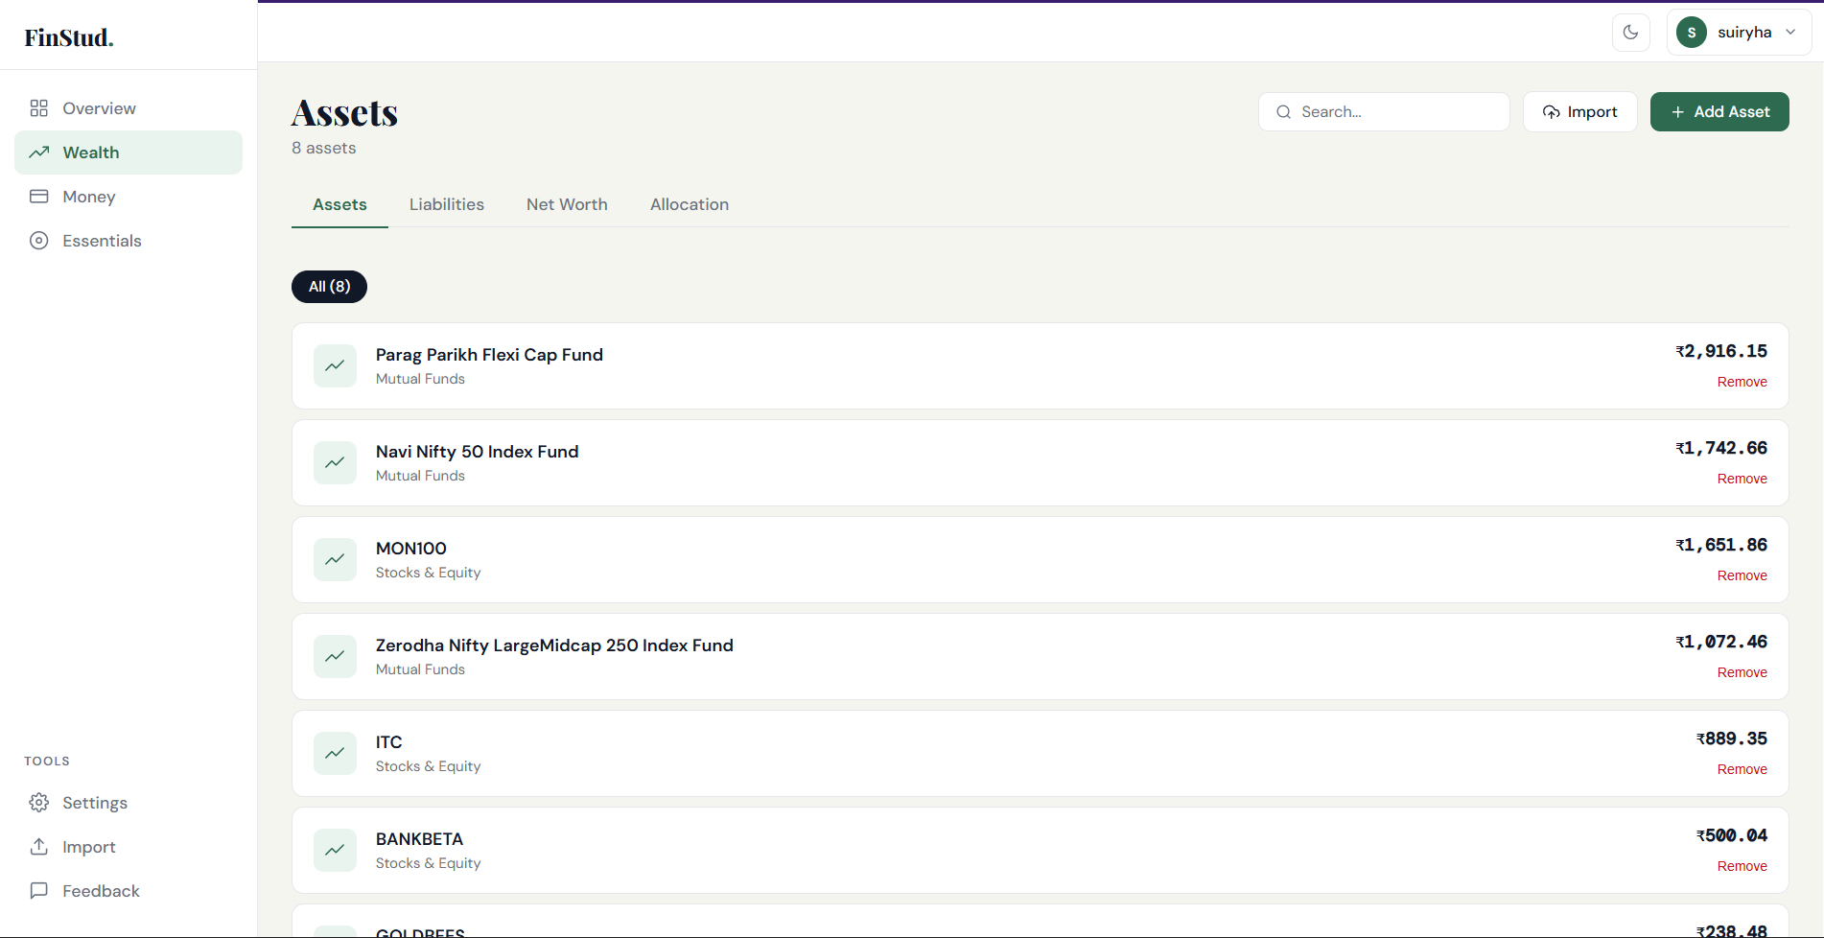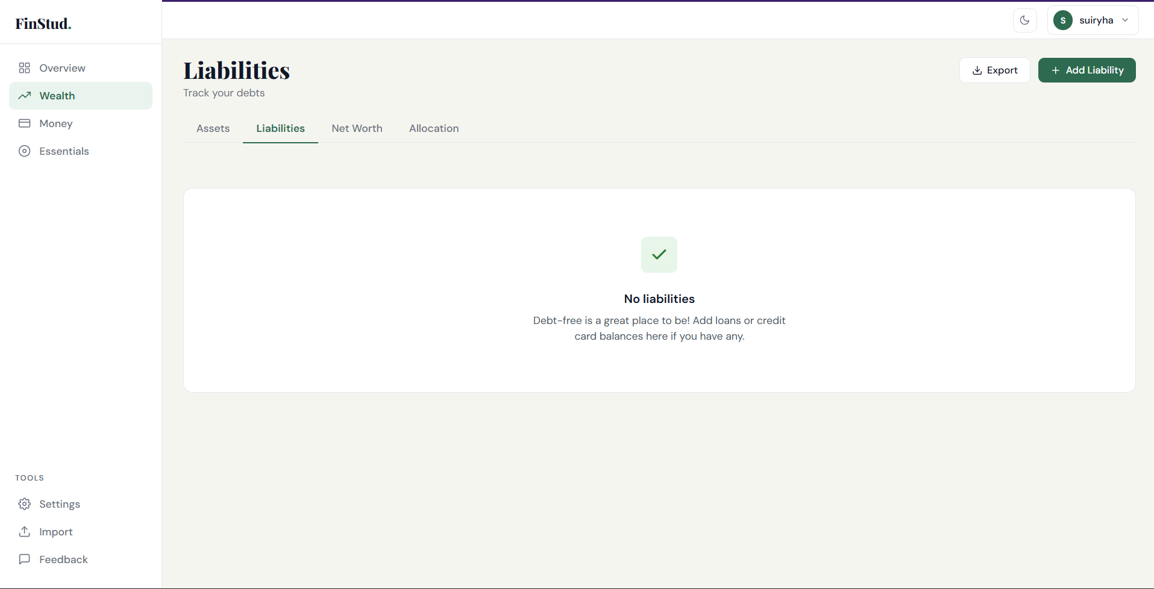

17.5 Money Page — Income and Expenses
The transaction tracking page with monthly filter, income and expense entry forms, and categorised summary charts.
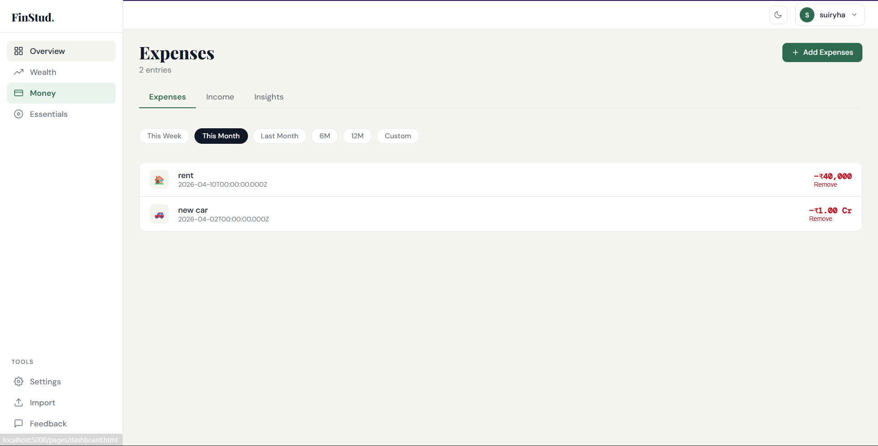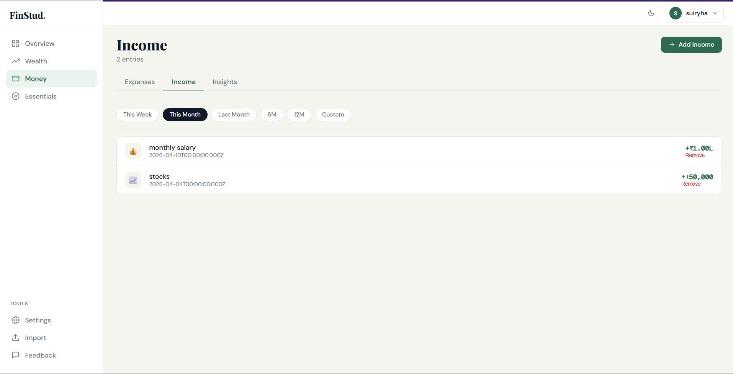

17.6 Essentials Page — Financial Goals
The goals tracking page showing all user-defined financial goals with target amounts, deadlines, and progress indicators.
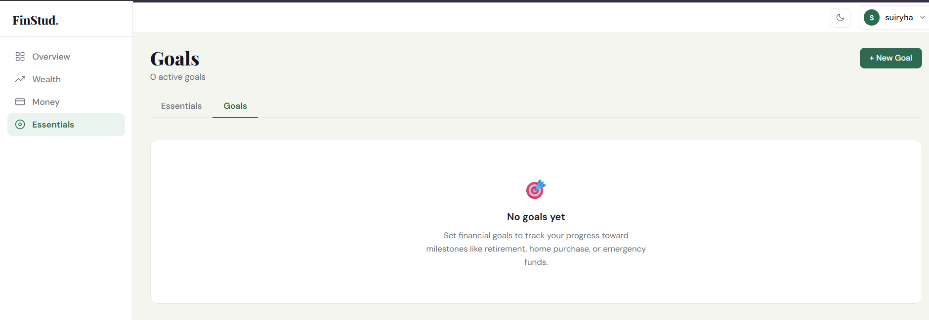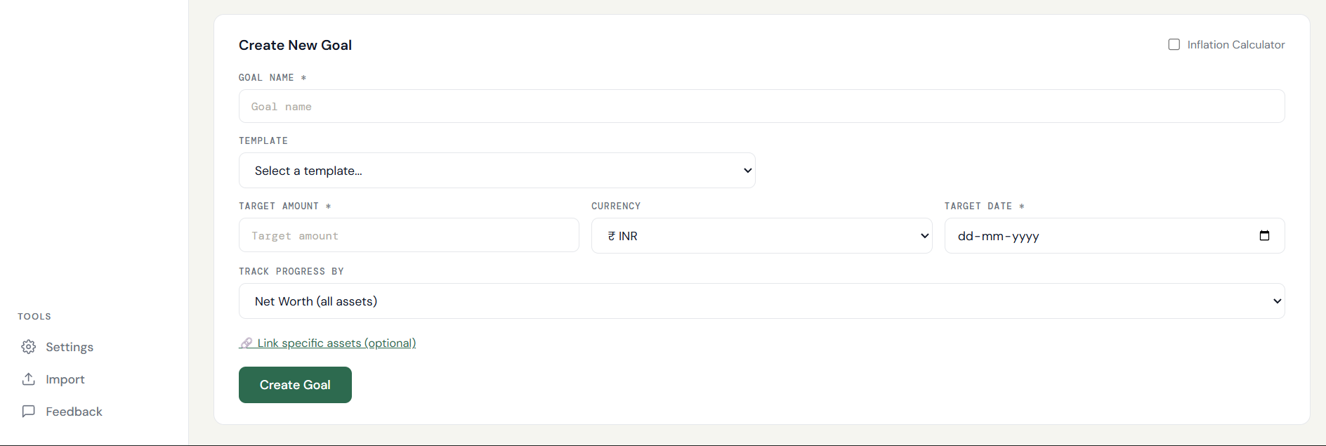

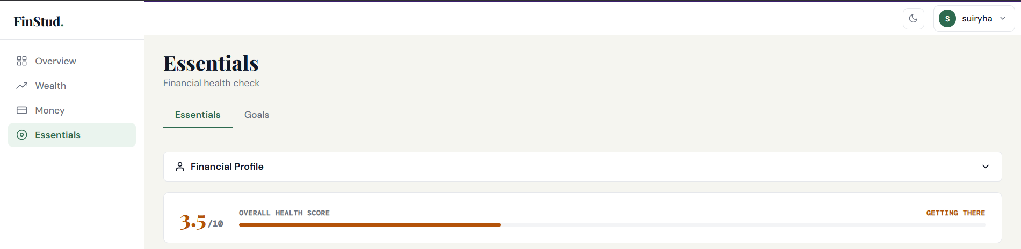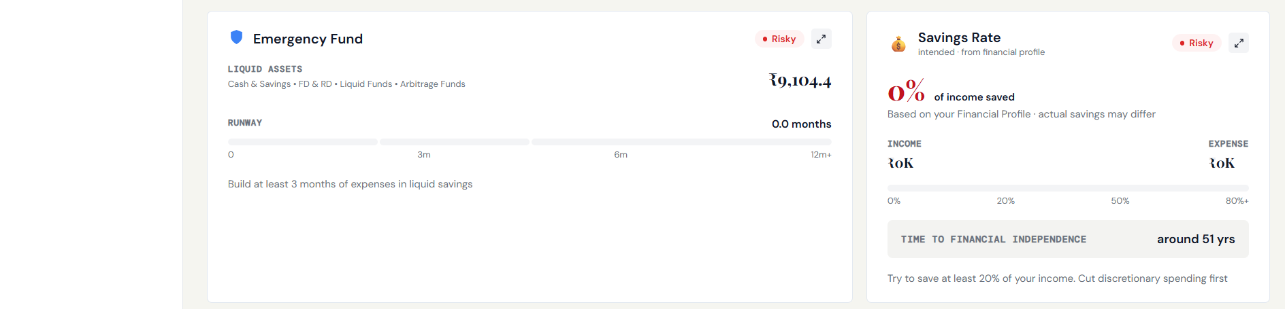

17.7 Settings Page
The account settings page for updating the profile name, changing the password, managing data (export/reset), and deleting the account.
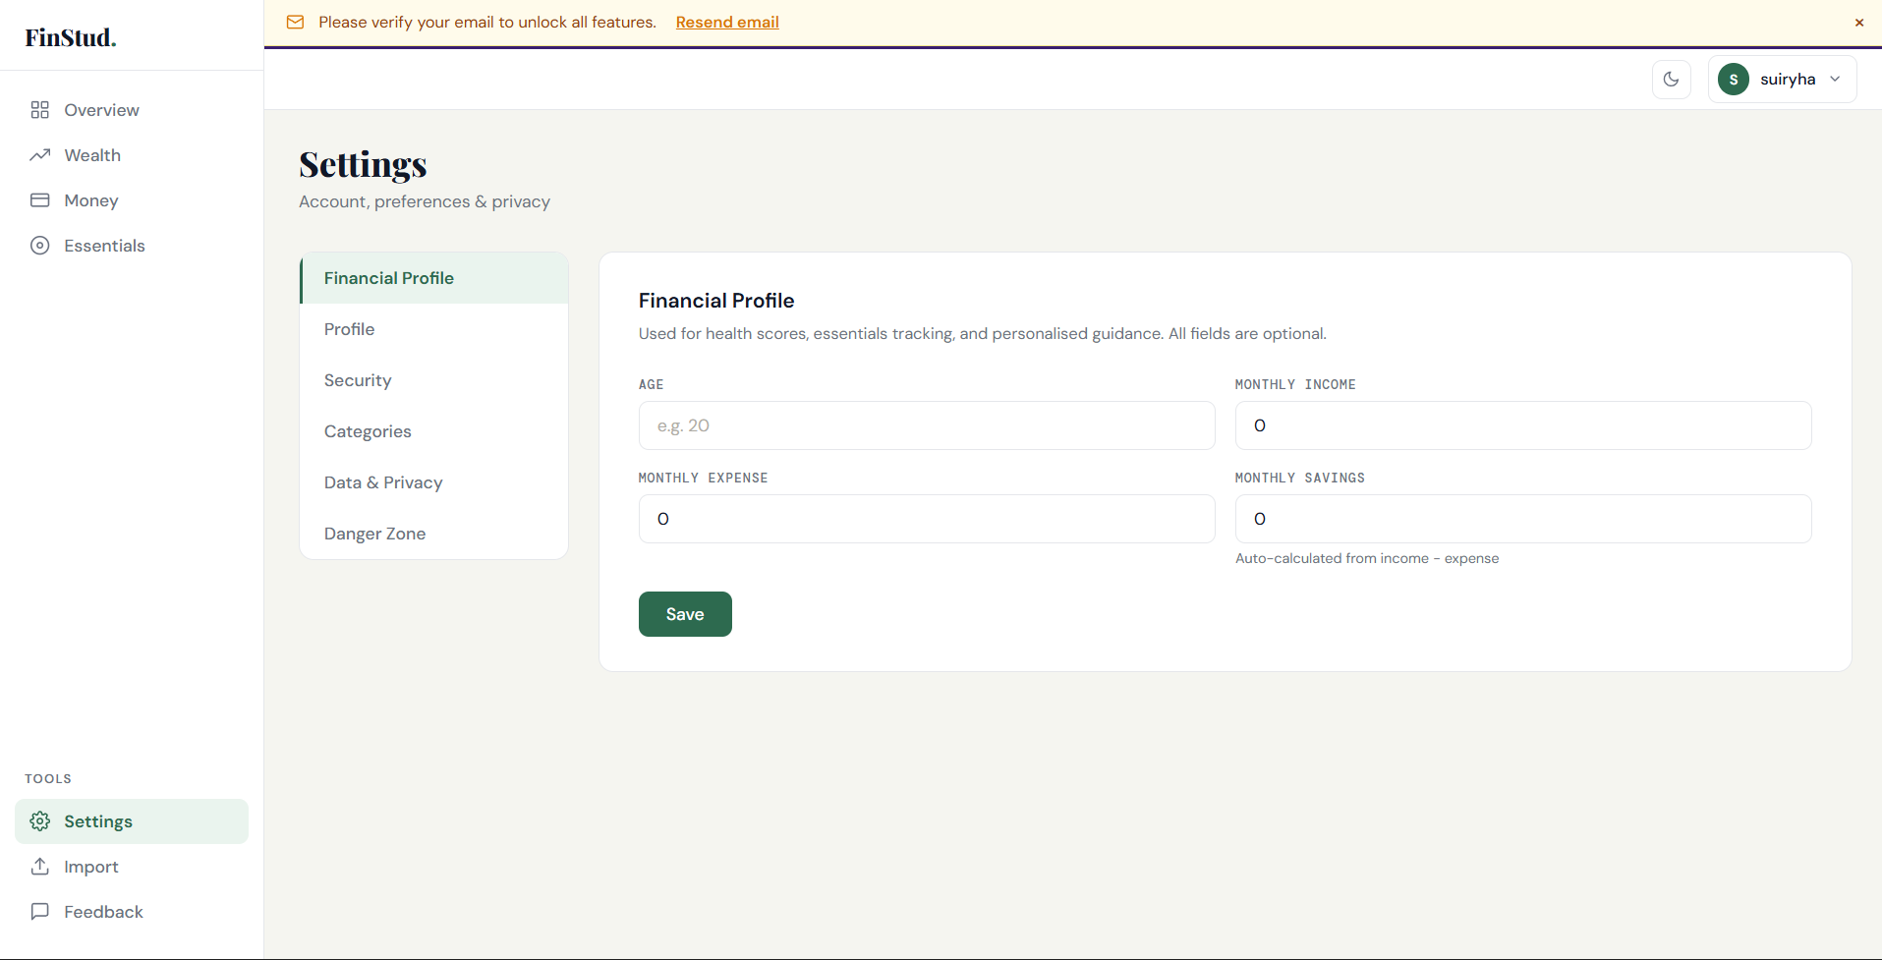

17.8 Import / Export Page
The data portability page where users can bulk-import financial records from a JSON file or export all their data as a downloadable JSON file.
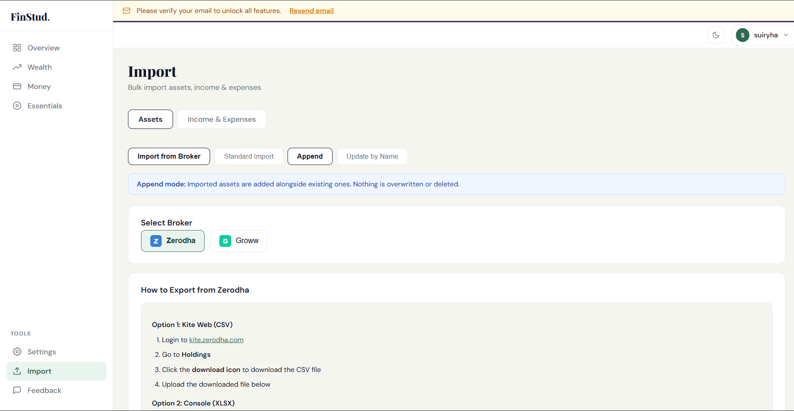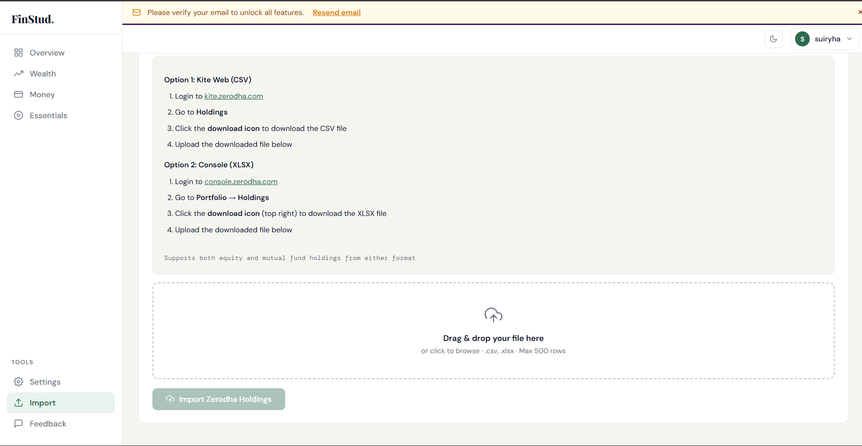

References
- Express.js Official Documentation — https://expressjs.com/
- Node.js Documentation — https://nodejs.org/en/docs/
- MySQL 8.0 Reference Manual — https://dev.mysql.com/doc/
- JSON Web Tokens (JWT) — https://jwt.io/introduction
- bcryptjs npm package — https://www.npmjs.com/package/bcryptjs
- Chart.js Documentation — https://www.chartjs.org/docs/
- Google Identity Services — https://developers.google.com/identity
- Nodemailer Documentation — https://nodemailer.com/
- MDN Web Docs (HTML, CSS, JavaScript) — https://developer.mozilla.org/
- OWASP Authentication Cheat Sheet — https://cheatsheetseries.owasp.org/

