TECHNICAL PROPOSAL ? VERSION 2.0
AI-Powered Reconciliation Break Management
Multi-Platform Implementation: TLM (85+ Recs) | DUCO (~10 Recs) | D3S (CEQ, LnD, MTN, OTC)
Accounting Control Team | March 2026 | CONFIDENTIAL

TLM  85+ Reconciliations | DUCO  ~10 Reconciliations | D3S  4 Asset Classes | 100+  Total Recs Covered

This document provides the specific technical implementation approach for the AI-powered break management system, tailored to your exact platform setup: TLM as the primary reconciliation engine (85+ recs), DUCO for a smaller subset of recs with API capability, and D3S generating separate break files for four distinct asset classes (CEQ, LnD, MTN, OTC) each requiring their own schema mapping and AI logic.

1. The Multi-Platform Challenge
The fundamental complexity of this implementation is that your 100+ reconciliations are spread across three platforms with fundamentally different data architectures, export formats, and operational characteristics. A single uniform AI approach will not work ? each platform requires its own ingestion strategy before a unified AI engine can be applied.

1.1 Platform Characteristics & Key Differences

Dimension | TLM (Primary) | DUCO
Rec Volume | ~85+ recs | ~10 recs
Break File Format | Structured bulk export ? consistent columns | REST API ? JSON response
Ingestion Method | SFTP daily file pull, cron job 07:00 | Direct API call ? real-time capable
Schema Consistency | High ? standard TLM export | High ? API contract
AI Complexity | Medium ? large volume, uniform structure | Low ? small volume, API-native
Threshold Basis | Per rec type, configurable | Per rec, API-driven
Real-Time Capable? | No ? file-based, daily | Yes ? API allows live query
Jira Epic Strategy | Rec-name based auto-assign | Rec-name based auto-assign

2. Platform Ingestion Layer ? Architecture
Before any AI processing can occur, all three platforms must feed into a single Unified Break Data Store with a consistent schema. The diagram below shows exactly how each platform is ingested and normalised.

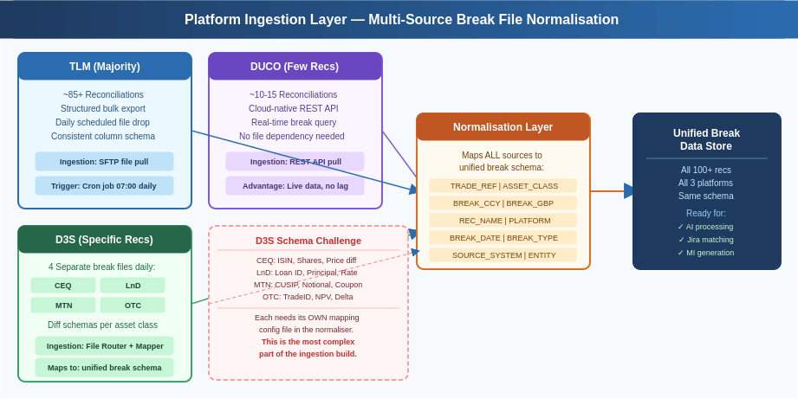

2.1 TLM Ingestion ? Standard Bulk Pull
TLM is the backbone of your rec estate. Its structured bulk export provides the most consistent data quality and is the easiest to automate. The ingestion approach:

- A scheduled Python script (cron job 07:00 each morning) connects via SFTP to the TLM break file drop location and pulls all rec files generated overnight.
- A single TLM schema mapping config converts the TLM export columns to the unified break schema. Since TLM is consistent across all 85+ recs, this mapping only needs to be built once.
- The SOURCE_SYSTEM field is stamped as 'TLM' on all records, and the REC_NAME field is populated from the filename, allowing AI rules to be applied per-rec later.
- Volume handling: TLM will contribute the vast majority of the 621,804 monthly rows. The pipeline is designed to handle this full volume in under 5 minutes.

2.2 DUCO Ingestion ? API-Native Advantage
DUCO's cloud-native REST API is a significant advantage for your ~10 DUCO recs. Unlike TLM and D3S which require file delivery, DUCO can be queried directly and in near-real-time:

- Python requests library calls the DUCO API endpoint: GET /v1/reconciliations/{rec_id}/breaks ? one call per rec, returns JSON.
- The JSON response is parsed and mapped to the unified schema. DUCO's API contract is stable, so the mapping is reliable without file format risk.
- DUCO enables intraday querying ? meaning for your highest-priority DUCO recs, breaks can be checked multiple times per day rather than waiting for a morning file.
- Recommended: flag your highest-risk DUCO recs for 3x daily API pull (08:00, 12:00, 16:00) to catch breaks before they age.

2.3 D3S Ingestion ? The Complex Case
D3S is the most architecturally challenging component because it generates four separate files (CEQ, LnD, MTN, OTC) with different schemas for each. This requires a dedicated File Router and four individual mapping configurations:

D3S File | Schema Key Fields
CEQ_breaks_YYYYMMDD.csv | ISIN, Shares_Diff, Price_Source, Price_System, MV_Break, Settlement_Date
LnD_breaks_YYYYMMDD.csv | Loan_ID, Principal_Balance, Rate_Source, Rate_System, Accrual_Break, Maturity
MTN_breaks_YYYYMMDD.csv | CUSIP, Notional_Face, Coupon_Source, Coupon_System, Day_Count, Amort_Break
OTC_breaks_YYYYMMDD.csv | TradeID, NPV_Source, NPV_System, Delta_Break, Margin_Call, Counterparty

The D3S File Router is the single most important engineering task in Phase 1. It detects the file prefix (CEQ/LnD/MTN/OTC), loads the correct YAML mapping config, and transforms each file into the unified schema. Without this, the four D3S asset classes cannot be processed uniformly by the AI engine downstream.

3. D3S Asset-Class Specific AI Logic
Each of the four D3S asset classes has fundamentally different break behaviour, risk profile, and escalation requirements. Applying a uniform AI model across all four would produce poor results. The diagram and table below define the specific AI logic for each.

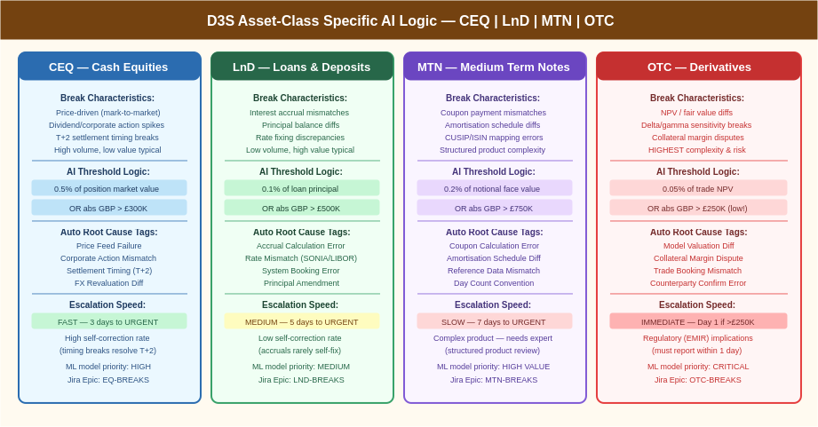

3.1 CEQ ? Cash Equities
Parameter | CEQ-Specific Logic
Break Driver | Primarily price-driven (mark-to-market) and settlement timing (T+2). High volume of breaks, most are timing-related and self-correct within 2 days.
AI Threshold | 0.5% of position market value OR absolute GBP > ?300K ? whichever is lower. This is deliberately tighter than the current static ?1M as small % breaks on large equity positions are material.
ML Model Feature | Corporate action calendar integration ? model learns that breaks spike on dividend ex-dates and record dates, and suppresses false escalation on those days.
Escalation SLA | 3 business days to URGENT. CEQ breaks self-correct faster than other classes. If still open on Day 3, it is a real break requiring investigation.
Root Cause Auto-Tags | Price Feed Failure | Corporate Action Mismatch | Settlement Timing (T+2) | FX Revaluation Diff | Custodian Reconciliation Gap
Jira Epic | EQ-BREAKS ? all CEQ breaks tagged to this Epic automatically

3.2 LnD ? Loans & Deposits
Parameter | LnD-Specific Logic
Break Driver | Interest accrual mismatches and principal balance discrepancies. Low volume but typically high value. Breaks rarely self-correct ? accrual errors require manual journal posting.
AI Threshold | 0.1% of loan principal OR absolute GBP > ?500K. Accrual breaks on a ?500M loan of even 0.05% = ?250K, which is material for this asset class.
ML Model Feature | Rate fixing calendar awareness ? model knows SONIA/SOFR fixing dates and flags accrual breaks arising on those dates as likely rate mismatch root cause.
Escalation SLA | 5 business days to URGENT. LnD breaks are complex to investigate. However, if growing in value, escalation is triggered earlier regardless of age.
Root Cause Auto-Tags | Accrual Calculation Error | Rate Mismatch (SONIA/SOFR) | System Booking Error | Principal Amendment Not Reflected | Day Count Convention Diff
Jira Epic | LND-BREAKS ? with sub-label for SONIA vs fixed rate loans

3.3 MTN ? Medium Term Notes
Parameter | MTN-Specific Logic
Break Driver | Coupon payment mismatches, amortisation schedule discrepancies, and CUSIP/ISIN reference data errors. These are structured products ? breaks can be complex to investigate.
AI Threshold | 0.2% of notional face value OR absolute GBP > ?750K. MTNs carry large notionals; percentage-based threshold prevents over-escalation on small basis point differences.
ML Model Feature | Amortisation schedule comparison ? model validates that the amortisation applied in both systems matches the term sheet schedule loaded in reference data.
Escalation SLA | 7 business days to URGENT. MTN breaks require specialist review (structured product knowledge). Longer SLA reflects investigation complexity, not lower priority.
Root Cause Auto-Tags | Coupon Calculation Error | Amortisation Schedule Mismatch | Reference Data Gap (CUSIP/ISIN) | Day Count Convention | Early Redemption Not Reflected
Jira Epic | MTN-BREAKS ? linked to relevant structured product trade IDs in Jira

3.4 OTC ? Derivatives (Highest Priority)
Parameter | OTC-Specific Logic
Break Driver | NPV/fair value differences (model vs counterparty), delta/gamma sensitivity breaks, collateral margin disputes. These carry regulatory implications under EMIR.
AI Threshold | 0.05% of trade NPV OR absolute GBP > ?250K ? the tightest threshold of all four classes. OTC derivatives are highly leveraged; small percentage differences represent significant risk.
ML Model Feature | Counterparty valuation model comparison ? model flags when NPV diff exceeds a configurable basis point tolerance per product type (IRS, CDS, FX Options, etc.).
Escalation SLA | IMMEDIATE on Day 1 if above threshold. EMIR Article 11 requires material valuation disputes to be resolved within 5 business days. Day 1 detection enables compliance.
Root Cause Auto-Tags | Model Valuation Difference | Collateral Margin Dispute | Trade Booking Mismatch | Counterparty Confirmation Error | Curve/Surface Data Diff | CSA Terms Mismatch
Jira Epic | OTC-BREAKS ? sub-labelled by product type (IRS/CDS/FXO/TRS etc.) for regulatory reporting linkage
Regulatory Flag | EMIR flag active ? OTC breaks >?250K and >5 days old auto-generate a regulatory tracking record for compliance team review

4. End-to-End AI Pipeline ? All Platforms to Month-End MI
The diagram below shows the complete flow from all three platform sources through the five-step AI engine to every output ? including the auto-generated month-end MI report that currently requires significant manual analyst effort.

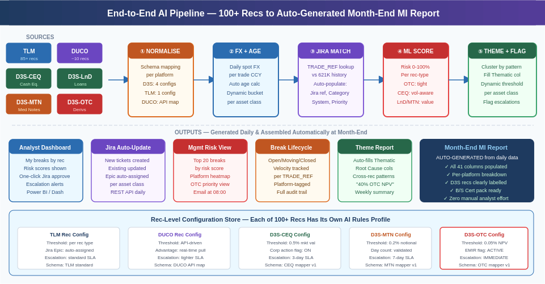

4.1 The Five AI Engine Steps in Detail

Step | What It Does ? Platform-Specific Detail
? NORMALISE | File Router detects source (TLM/DUCO/D3S-CEQ/D3S-LnD/D3S-MTN/D3S-OTC), applies the correct YAML mapping config, and outputs every break record in the unified 41-column schema. SOURCE_SYSTEM and ASSET_CLASS fields are auto-stamped. This is the foundation that makes steps 2-5 platform-agnostic.
? FX + AGE | Daily spot FX rates pulled from internal rate feed or Bloomberg API ? one rate per currency per day, stored in the FX Rate table. Each break converted using its trade-date currency. Age calculated as (today - first_seen_date). Bucket assigned per asset class rules: CEQ uses standard buckets, OTC uses tighter buckets (0-1d, 2-3d, 4-7d, 7d+) reflecting immediate escalation logic.
? JIRA MATCH | New daily breaks joined against the full 621K-row historical MI database on TRADE_REF + SOURCE_SYSTEM. Where a match is found (same trade, same platform), all historical tags are auto-populated: Jira Ref, JIRA DESC, Issue Category, Issue Category 2, Jira Priority, Epic, System to be Fixed, FIX REQUIRED. This eliminates the manual lookup entirely. For new breaks with no history, a draft Jira ticket is auto-created via the Jira REST API.
? ML SCORE | A Random Forest model trained on the 621K historical rows predicts the probability (0-100%) that each break will become material at month-end. The model is trained separately per asset class (CEQ model vs OTC model etc.) since the features driving materiality differ by product. Features: Asset Class, Break Type, Age Days, ABS GBP, Products Reconciled, Rec Name, Day of Month, Historical Resolution Rate for this trade.
? THEME + FLAG | K-Means clustering groups breaks by pattern across ALL recs and platforms ? identifying cross-platform themes (e.g., 'Bloomberg price feed affecting 23 TLM recs AND D3S-CEQ simultaneously'). This auto-populates the currently-empty Thematic and Type of Issue columns. Dynamic thresholds are applied per asset class configuration, and escalation flags are set based on age + risk score + threshold breach.

5. Rec-Level Configuration ? All 100+ Recs
A critical design principle is that every reconciliation has its own configuration profile in the system. This replaces the current one-size-fits-all static ?1M threshold with a configuration-driven approach that reflects the actual risk profile of each rec.

5.1 Configuration Profile Structure
Config Field | Description & Example Values
REC_ID | Unique identifier matching the rec name in TLM/DUCO/D3S. e.g., 'TLM_EQUITY_REC_001', 'DUCO_CREDIT_REC_003', 'D3S_OTC_REC_001'
SOURCE_PLATFORM | TLM | DUCO | D3S-CEQ | D3S-LnD | D3S-MTN | D3S-OTC ? drives schema mapper selection
ASSET_CLASS | Cash Equities | Loans & Deposits | Medium Term Notes | OTC Derivatives | Rates | FX | Credit ? drives threshold and escalation rules
THRESHOLD_TYPE | ABS_GBP | PCT_NOTIONAL | PCT_MARKET_VALUE | HYBRID (ABS + PCT, whichever lower)
THRESHOLD_VALUE | Numeric value for threshold. e.g., 300000 (for ABS_GBP) or 0.005 (for 0.5% PCT)
ESCALATION_SLA_DAYS | Days before WATCH status: CEQ=1, LnD=3, MTN=5, OTC=0 (immediate), TLM=configurable per rec
JIRA_EPIC | Auto-assigned Epic code. e.g., 'EQ-BREAKS', 'OTC-BREAKS', 'LND-BREAKS', 'MTN-BREAKS', 'TLM-[REC]-BREAKS'
EMIR_FLAG | TRUE for all OTC recs ? triggers regulatory tracking for breaks >5 days and >?250K
SELF_CORRECT_DAYS | Expected self-correction window for timing breaks. CEQ=2, LnD=0, OTC=0, TLM varies. Breaks within window suppressed from escalation.
ML_MODEL_ID | Which trained ML model to use for risk scoring. e.g., 'model_ceq_v2', 'model_otc_v1', 'model_tlm_generic_v3'

The rec-level config store is maintained as a YAML file or lightweight database table. Adding a new rec = adding one config entry. The AI engine picks up the config automatically ? no code changes required for new recs.

6. Jira Auto-Tagging ? Specific to Your 100+ Recs
The current process relies on analysts manually looking up historical Jira references for recurring breaks. With 50% of your 621,804 rows missing Jira references, this is the single highest-impact improvement the AI system delivers. Here is the exact logic:

6.1 The Jira Matching Algorithm
Scenario | AI Action
Trade Ref found in history ? same platform | Auto-populate: Jira Ref, JIRA DESC, Issue Category 1 & 2, Priority, Epic, System to be Fixed, FIX REQUIRED, Root Cause. Analyst sees pre-filled record and clicks 'Approve' ? 10 seconds of work.
Trade Ref found in history ? different platform | Flag as 'Cross-Platform Match' ? same trade seen on TLM previously, now appearing on DUCO. Auto-populate fields but with a 'Verify' flag. Analyst confirms whether same root cause applies.
Trade Ref NOT in history ? break type matches known pattern | ML classifier assigns predicted Issue Category and System to be Fixed based on Asset Class + Break Type + Rec Name pattern. Confidence score shown to analyst. Auto-creates draft Jira ticket.
Trade Ref NOT in history ? genuinely novel break | System creates a new Jira ticket with all structural fields pre-filled (Epic from asset class config, Priority from ML risk score). Analyst fills root cause narrative only ? 3 minutes vs 15 minutes today.
Same Trade Ref ? break reappears after being closed | System detects the prior resolution and flags as 'RECURRING BREAK'. Escalates to URGENT immediately. Jira ticket re-opened with prior history linked. Indicates a systemic fix did not hold.

6.2 Auto-Populate Coverage Target

Metric | Current State | Target State (Phase 3) | How Achieved
Jira Ref Coverage | ~50% (344,749 / 621,804) | ~95%+ | Historical match + new auto-create
Issue Category Coverage | ~44% (275,448 / 621,804) | ~90%+ | ML classifier + historical tag
Root Cause Identified | 0% (0 / 621,804) | ~75%+ | ML prediction + historical pattern
Thematic Column | 0% populated | ~100% | Clustering auto-populates all rows
B/S Cert Ready | 0% populated | ~100% | Auto-generated from break status

7. Month-End MI Report ? Auto-Generation
The ultimate goal is that the month-end MI report is produced automatically from the daily data accumulated throughout the month ? with no manual assembly by analysts. Given that your monthly MI has 621,804 rows and 41 columns, this is a significant time saving and quality improvement.

7.1 How Auto-Generation Works
- Step 1 ? Daily Accumulation: Throughout the month, every daily break file processed by the AI engine populates the persistent Break Ledger database with a record per break per day.
- Step 2 ? MI Assembly: At month-end (or on demand), the MI Generator queries the Break Ledger and aggregates: first seen date, last seen date, max/min break value, final status, all Jira tags, root cause, thematic cluster, and all 41 column values.
- Step 3 ? Validation: The generator applies the Period column (month number), stamps the Report Date, and validates that all mandatory columns are populated. Any remaining blanks are flagged for analyst review ? expected to be <5% of rows in Phase 3.
- Step 4 ? Output: The completed MI file is output in the same Excel/CSV format your current process produces ? but now with all 41 columns populated including the previously-empty Thematic, Root Cause, Type of Issue, Action, and B/S Cert columns.

7.2 Platform-Level MI Breakdown
A key improvement over the current MI is that the auto-generated report includes a platform-level breakdown ? allowing management to see whether breaks are concentrated in TLM recs, DUCO recs, or D3S asset classes:

MI Section | Content & Value
Platform Summary Tab | TLM vs DUCO vs D3S break count, total GBP exposure, age profile, and resolution rate. Identifies if one platform is driving disproportionate break volume.
D3S Asset Class Breakdown | Separate rows/sections for CEQ, LnD, MTN, OTC breaks ? including asset-class specific metrics (e.g., OTC: NPV break value and EMIR compliance status; CEQ: corporate action impact).
Rec-Level Heatmap | All 100+ recs ranked by: total break GBP, number of open breaks, average age, and % resolved within SLA. Instantly shows which recs need attention.
Theme Analysis | Auto-populated Thematic column summarised into a theme frequency table ? 'Price Feed: 847 breaks (?12.3M)', 'Settlement Timing: 1,203 breaks (self-correcting)', etc.
Jira Coverage Report | Shows Jira ref population rate per platform and per asset class ? tracks improvement from current ~50% toward the 95%+ target.
B/S Certification Pack | Balance sheet certification records auto-generated for all material breaks (>threshold) showing: break description, responsible team, resolution plan, and sign-off status.

8. Technology Stack & LLM Requirements

Core finding: No advanced LLM is required for the ingestion, AI scoring, auto-tagging, or MI auto-generation capabilities. Standard Python open-source libraries are sufficient for 90% of the solution. An LLM (Claude API) is optional for narrative generation only.

8.1 Component-Level Technology Mapping
Component | Technology
TLM/D3S file ingestion | Python: pandas, watchdog (file trigger), PyYAML (mapper config)
DUCO API integration | Python: requests library ? standard REST API calls
D3S File Router (4 asset classes) | Python: filename pattern match + YAML config loader
FX conversion (daily rates) | Python: Bloomberg BDH API or internal FX feed + pandas
Auto aging & dynamic bucketing | Python: pandas datetime diff + configurable cut function
Historical Jira matching | Python: pandas merge on TRADE_REF + SOURCE_SYSTEM
ML break risk scoring | Scikit-learn RandomForestClassifier ? one model per asset class
Thematic clustering | Scikit-learn KMeans ? auto-populates Thematic column
Dynamic threshold engine | Python: per-rec config file + pandas apply()
Jira REST API integration | Python: requests to Jira API v3 ? create/update tickets
Analyst & management dashboard | Power BI connected to Break Ledger database
Month-end MI auto-generation | Python: pandas aggregation + Excel writer (openpyxl)
Root cause narrative text | Claude API (claude-haiku-4-5) ? OPTIONAL enrichment
Jira DESC auto-writing | Claude API (claude-haiku-4-5) ? OPTIONAL enrichment
Audit query chatbot | Claude API with RAG on Break Ledger ? OPTIONAL Phase 4

9. Phased Implementation Roadmap

Phase | Scope
Phase 1 ? Foundation | Build TLM ingestion (SFTP pull, schema map). Build D3S File Router with 4 YAML mappers (CEQ/LnD/MTN/OTC). Basic FX conversion using daily rates. Auto age + bucket. Deploy to one pilot rec per platform to validate.
Phase 2 ? Jira Intelligence | Historical Jira matching engine (joins on TRADE_REF). Auto-populate all Jira fields from 621K history. DUCO REST API integration. Analyst dashboard v1 in Power BI showing break list with pre-filled tags for review.
Phase 3 ? ML & Scoring | Train ML risk scoring models per asset class (CEQ, LnD, MTN, OTC, TLM generic). Deploy thematic clustering. Dynamic thresholds replace static ?1M. Rec-level config store populated for all 100+ recs. Escalation email automation.
Phase 4 ? Daily Integration | Daily break file pipeline live for all 100+ recs. Break Ledger database capturing full lifecycle. Month-end MI auto-generation from daily data. EMIR tracking for OTC breaks. Management heatmap dashboard.
Phase 5 ? LLM Enrichment (Optional) | Claude API integration for root cause narratives, Jira DESC writing, and audit query chatbot. Targets the 5 currently-empty governance columns. B/S Cert pack automation. Regulatory reporting linkage for OTC/EMIR.
Phase 6 ? BAU & Governance | Model retraining schedule (quarterly). Config store governance for new recs. Threshold review framework. SLA reporting to management. Full handover documentation.

10. Recommended Next Steps
To validate the approach before committing to the full programme, the following proof-of-concept is recommended:

Recommended PoC (3 weeks): Select 1 TLM rec + 1 DUCO rec + the D3S-OTC rec. Build the normalisation layer for these 3 recs only. Run the Jira auto-matching against the 621K historical rows. Measure: (a) Jira coverage rate achieved, (b) analyst time saved per break, (c) D3S File Router accuracy for OTC file. This three-platform PoC will prove the ingestion architecture and demonstrate business value before full investment.

- Action 1: Define the pilot rec set (1x TLM, 1x DUCO, 1x D3S-OTC) and assign a developer for the Phase 1 build.
- Action 2: Extract the last 3 months of historical MI data (the full 621K+ rows) as the training and matching dataset for the Jira engine.
- Action 3: Document the D3S file schemas for all four asset classes (CEQ, LnD, MTN, OTC) ? the column names, data types, and trade reference format used in each file.
- Action 4: Obtain DUCO API credentials and test endpoint access for the pilot DUCO rec.
- Action 5: Review the rec-level config template and confirm threshold and escalation SLA values for the pilot recs with the relevant asset class owners.

CONFIDENTIAL ? For Internal Use Only | Investment Banking Middle Office | Accounting Control Team | TLM + DUCO + D3S Implementation | March 2026

