Steps to Configure the Proxy
A step-by-step guide to downloading, enabling, and disabling the proxy configuration script (proxy_linux.py) on a Linux system.

Step 1: Download the Script
Navigate to the repository and click on the Releases section. Download the proxy_linux.py file, and save it to a location that is easy to find, since you will need to navigate to this directory from the terminal later.
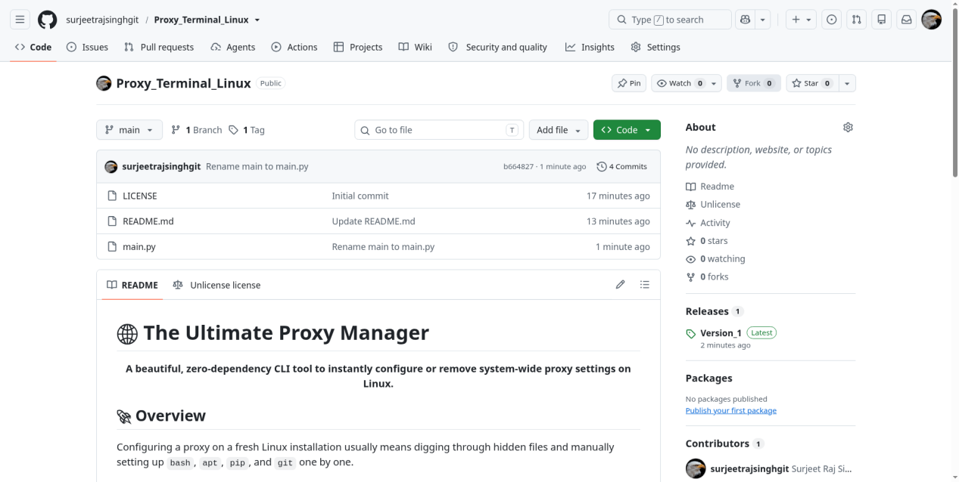
The GitHub repository page — open the Releases section to find the script.
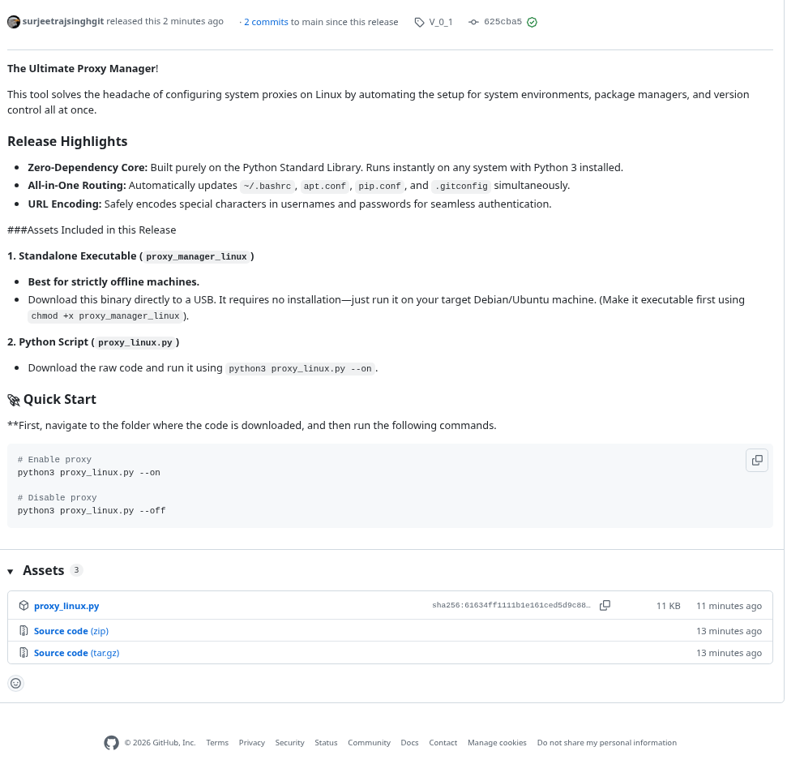
The Releases page — download the proxy_linux.py asset.

Step 2: Locate the Downloaded File
Open a terminal and use the cd command to navigate to the folder where the script was saved. For example:
cd /path/to/your/download/location
Running the script displays its usage and the available options:
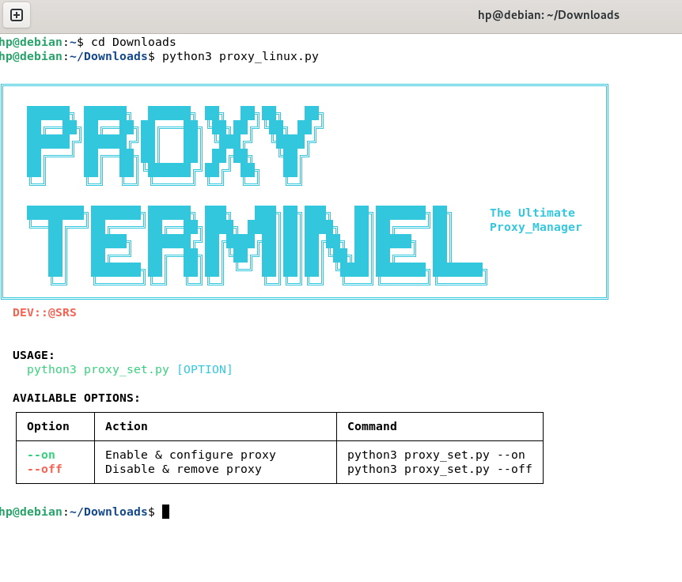
Usage information for proxy_linux.py, including the --on and --off options.

Step 3: Enable the Proxy
To enable and configure the proxy, run the following command:
python3 proxy_linux.py --on
This opens the setup prompt shown below:
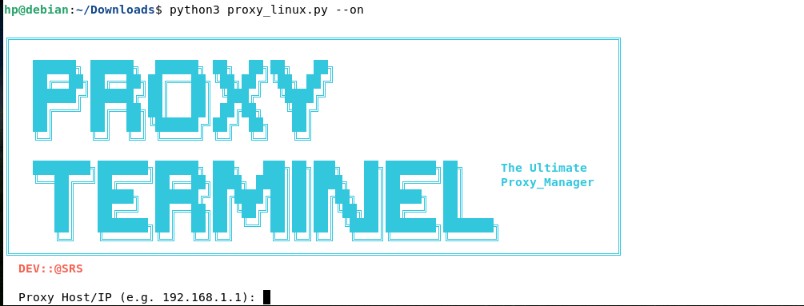
The proxy setup prompt after running the script with --on.
Enter the following details when prompted:
- Proxy Address — for example, 192.168.1.1
- Port — for example, 8080
- Username and password, if required by your network. Leave these blank and press Enter if no authentication is needed.
You will then be prompted to enter your root (sudo) password:
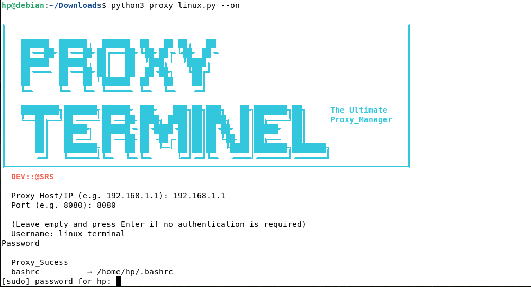
Entering the proxy details and root password.
Enter the password to complete the setup. The proxy will be enabled and configured automatically across the shell, apt, pip, and git configuration files.
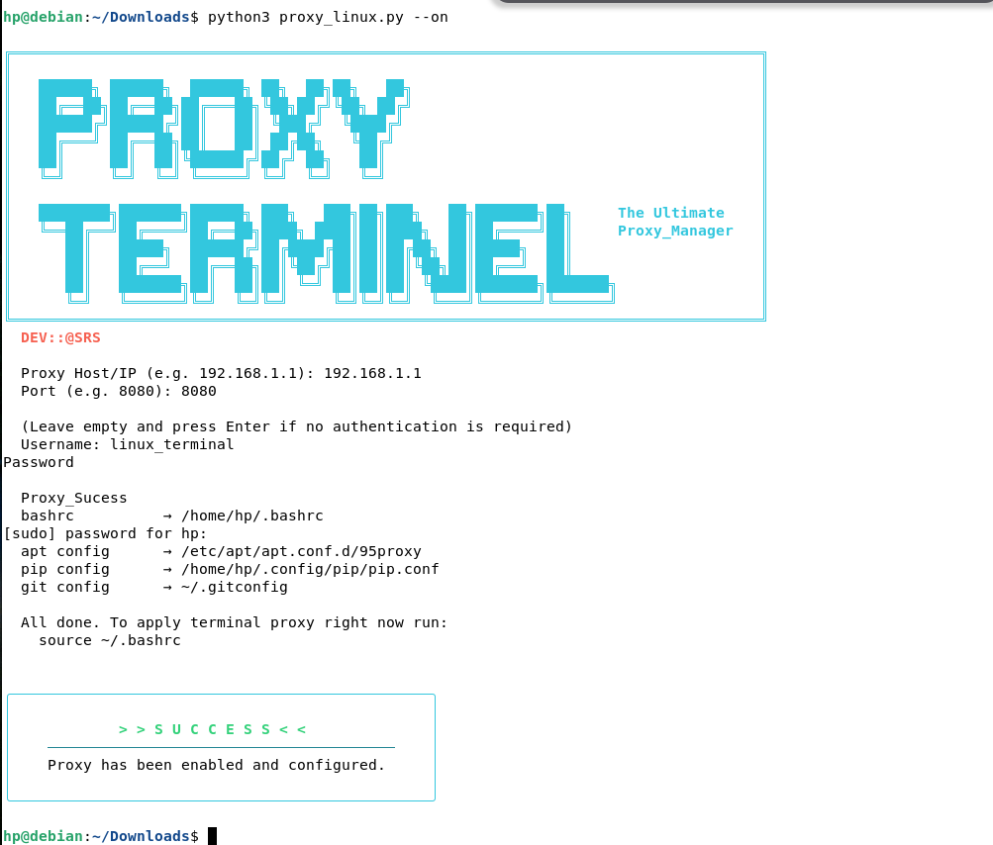
Confirmation that the proxy has been enabled and configured successfully.

Step 4: Remove the Proxy Configuration
To disable and remove the proxy configuration from the system, run:
python3 proxy_linux.py --off
You will be prompted to enter your root (sudo) password:
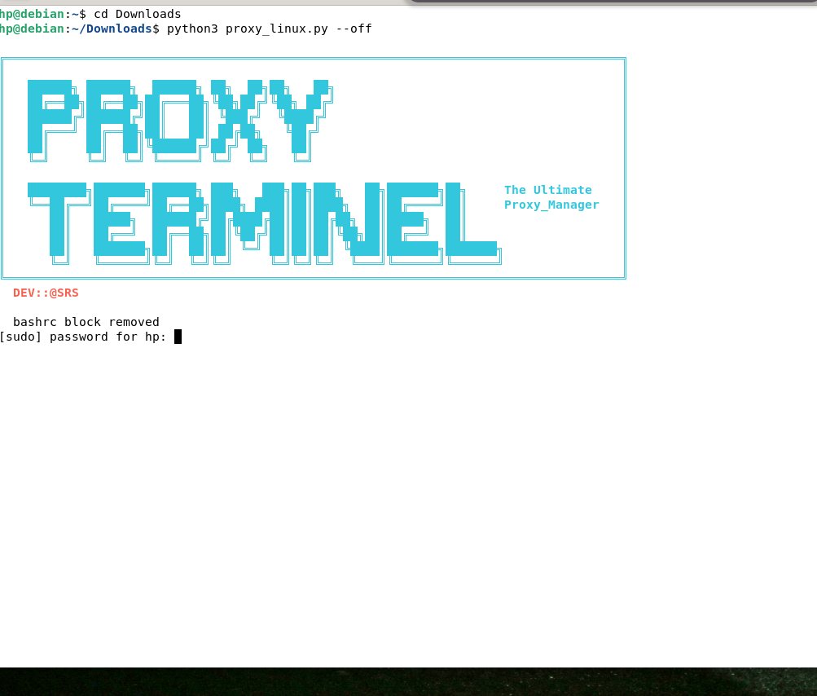
Removing the proxy configuration.
Once the password is entered, all proxy settings previously configured on the system will be removed.

