Earthquake prediction using Time Series Data
Surjo Dey - 22cs3072
Anijeet Mani - 22mc3046
Rajat Kumar - 22it3034

Introduction & Problem Statement
Earthquakes are one of those natural events that remind us how little control we have over the planet. Unlike storms or floods, which give us some visible early signs, earthquakes can strike without warning and cause massive destruction in a matter of seconds. Over the years, scientists have tried to understand the patterns behind seismic activity, but the Earth’s internal processes are complicated, and that makes perfect prediction nearly impossible. Still, this doesn’t mean we cannot learn anything from past earthquakes. If we look closely at long-term seismic records, we notice certain recurring trends based on geography, depth, and historical activity. And this is where machine learning becomes useful.
The idea behind this project is simple: if earthquakes follow some hidden patterns, then a machine learning model should be able to detect those patterns better than the human eye. What this really means is that we take thousands of earthquake records—date, time, magnitude, depth, latitude, longitude—and let different ML models learn how these inputs relate to future magnitudes. The goal isn’t just to say “an earthquake will happen tomorrow at 9:30 AM,” because that’s not realistic. Instead, the aim is to estimate how strong the next earthquake might be based on the behavior of previous ones. Even a small improvement in prediction accuracy can help scientists and authorities plan better.
In many earthquake-prone regions, people rely heavily on early warning systems. But these systems mostly detect the initial shock and alert people a few seconds before the stronger waves arrive. Machine learning, on the other hand, tries to go one step earlier—by learning from historical data and forecasting what might come next. If we can predict the magnitude with better consistency, it can support preparedness, disaster planning, infrastructure design, and risk mitigation.
The problem this project tries to solve is this: Can we use historical earthquake data to predict the magnitude of future earthquakes with the help of machine learning models? To approach this, we take a structured dataset from public earthquake catalogs and perform a complete pipeline—from cleaning the raw data to analyzing its patterns and finally training multiple ML models like Linear Regression, Random Forest, and others. Each model gives a different perspective: some try to fit a simple mathematical relationship, while others break the data into many decision paths and combine them for better accuracy.
Another part of the problem is dealing with the nature of seismic data. Earthquakes do not follow a simple predictable cycle. Sometimes you have many small earthquakes clustered together, sometimes long periods with almost no activity, and occasionally a sudden major event. This irregularity makes the prediction task challenging. So the project also focuses on understanding these irregular patterns through Exploratory Data Analysis (EDA). This step helps reveal how magnitudes are distributed over time, how depth affects intensity, which regions show repeated activity, and what correlations exist among features.
In short, the project tries to bridge the gap between geological uncertainty and data-driven estimation. The problem statement can be summarized as: we want to build and test machine learning models that can study past earthquakes and predict the magnitude of future ones, while understanding the limitations and strengths of using ML for such a complex natural phenomenon.
Dataset Description
The dataset used in this project is called the "SOCR Earthquake Dataset", and it contains information about earthquakes that have occurred with a magnitude of 3.0 or greater in California, United States.
Each row in the dataset represents a single earthquake event and includes the following information:
- Date and time of the earthquake in UTC (Coordinated Universal Time)
- Latitude and longitude(in degree) of the epicenter, which is the point on the Earth's surface directly above where the earthquake occurred
- Depth of the earthquake, measured in kilometers
- Magnitude of the earthquake on the Richter scale
- SRC = source
- nst - number of stations used for solution (range: 0 to ...)
- close - distance of closest station to epicenter (range: 0 to ...)
- rms - root-mean-squared residual of solution (range: 0. to 1.)
- gap - azimuthal gap (range: 0 to 360)
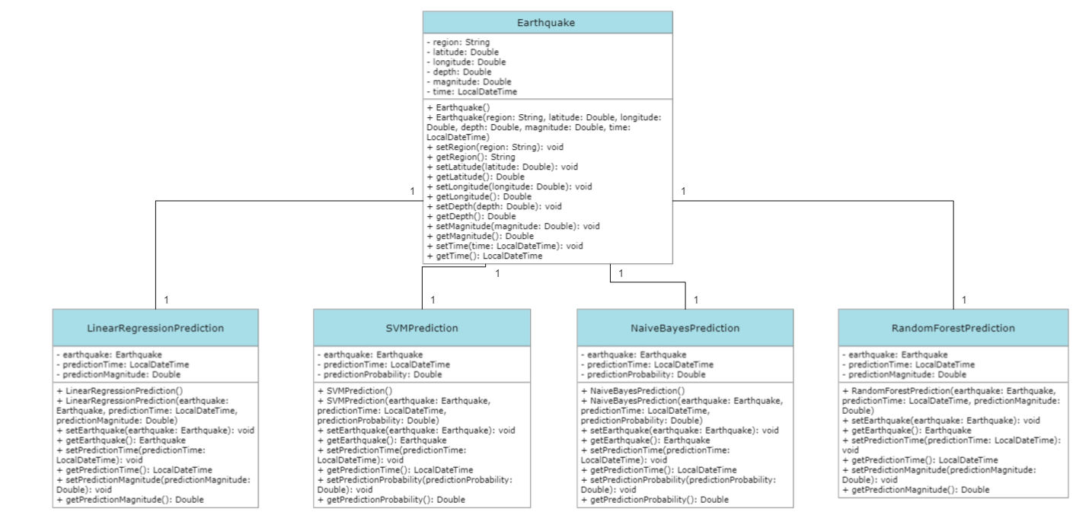
Figure 1: Class Diagram of the Dataset
The Richter scale is a logarithmic scale that measures the magnitude of an earthquake based on the energy released by the earthquake. Each increase of one unit on the Richter scale represents a tenfold increase in the amplitude of the seismic waves generated by the earthquake.
The dataset contains earthquake events from January 2, 2017, to December 31, 2019, which includes a total of 37,706 earthquakes. This dataset could be used for a variety of purposes, such as studying earthquake patterns and trends over time or for predicting future earthquake activity.
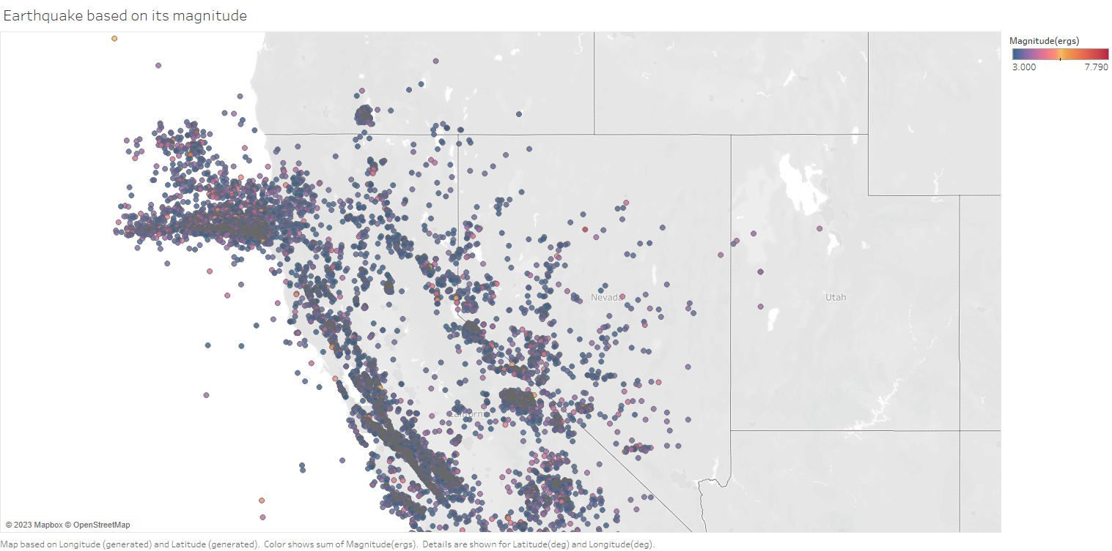
Figure 2: Earthquake based on its magnitude
Data Cleaning & Preprocessing
Raw data rarely comes in a form that a machine learning model can use directly. Earthquake data is no different. When you first load the dataset, it looks fine on the surface—columns like date, latitude, longitude, depth, and magnitude appear clean. But once you look closer, you start noticing small issues: missing entries, inconsistent formats, unrealistic values, and features that need to be restructured. If these problems are ignored, they directly reduce the accuracy of the model. So this section explains every step taken to prepare the data before training.

1.Handling Missing or Invalid Values
The first step was to scan the dataset to check for missing, blank, or null values. Earthquake datasets often have gaps because some older records are incomplete, or sensors may not have recorded all parameters. Here’s the thing: machine learning models cannot handle missing values on their own, so we need to decide what to do with them.
- Rows with critical missing values (like missing magnitude or missing depth) were removed because they directly affect the prediction task.
- Minor missing values in less important fields were filled using techniques like:
  - Mean or median imputation
  - Forward/Backward fill for time-based features
The idea was to keep as much meaningful data as possible while removing entries that could introduce noise or distort the final model.
2. Checking for Duplicates
Sometimes earthquake databases contain repeated entries because different sensors record the same event. Duplicate rows were checked and removed to avoid giving the model repeated data that artificially strengthens certain patterns.
3. Removing Outliers
Earthquake data naturally contains extreme values, especially very deep or very shallow earthquakes. However, there may also be invalid or misrecorded values—for example:
- Depths that are negative
- Magnitudes beyond the physical limits
- Points located outside valid latitude/longitude ranges
Such values were identified using:
- Boxplots
- Z-score methods
- Logical range checks
If a value didn’t make sense in the real world, it was removed or corrected.
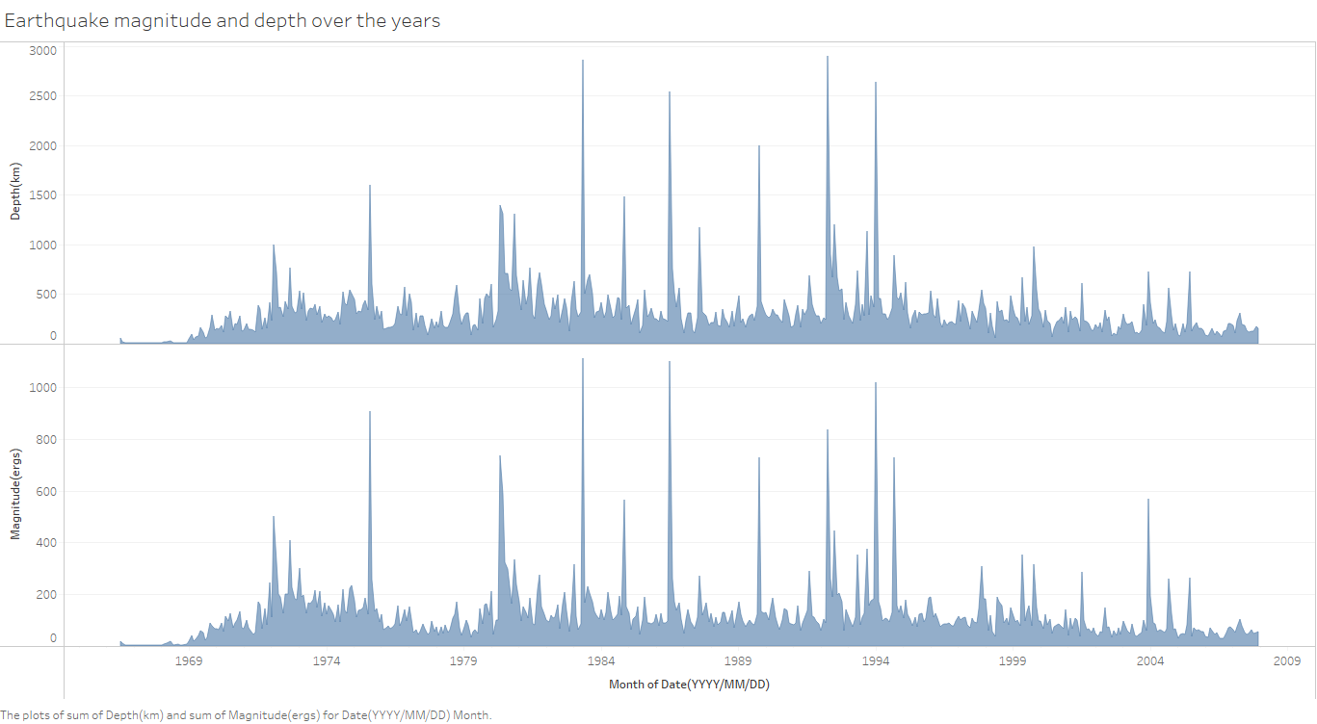
Figure3: Earthquake magnitude and depth over the years

4. Final Dataset Validation
Before passing the data to the model, a final round of checks was done:
- No remaining missing values
- All columns correctly typed (numeric, datetime, categorical)
- No duplicates
- Scaled features verified
- Time sequence intact
Only after this final validation was the dataset considered ready for Exploratory Data Analysis (EDA) and then model training.

Exploratory Data Analysis (EDA)
Exploratory Data Analysis is the stage where we take a closer look at the dataset and try to understand its structure before building any machine learning models. In this project, the EDA focused mainly on checking the dataset’s general properties, verifying column types, and making sure that the time index and feature names were correctly formatted. Even though the notebook does not include many visual plots, the analysis still provides important insights into the data.

1. Viewing the Raw Dataset
The first step was simply loading the CSV file:
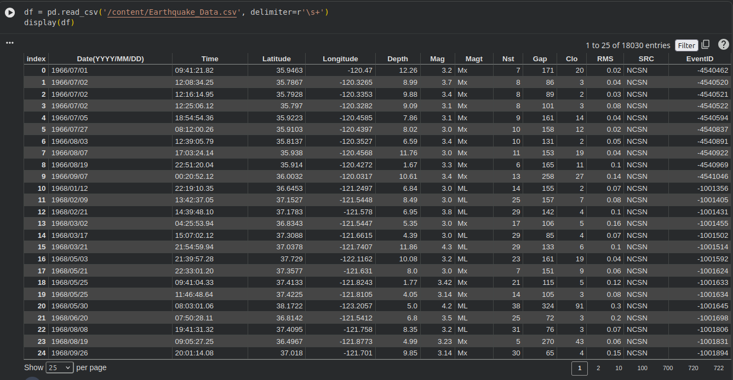
This allowed us to see the raw table. The dataset contained several attributes related to each earthquake event, including date, time, latitude, longitude, depth, magnitude, number of stations, and other measurement fields.
The initial display helped verify that:
- The file was read correctly
- The delimiter separation was successful
- All columns were loaded without corruption
- No unexpected blank rows or shifted columns appeared
This step is basic but important because seismic datasets often suffer from formatting issues, especially when generated from multiple sources.

2. Renaming Columns and Creating a Time Index
The original dataset included column names that were not easy to work with. To improve readability and make future processing simpler, every column was renamed clearly:

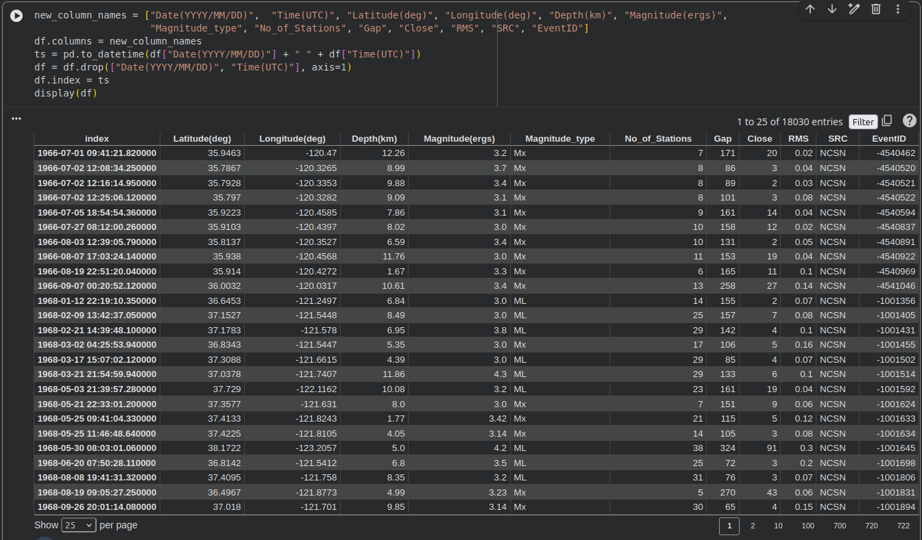
This transformation is essential because earthquake data is inherently time-based. By converting it into a datetime index:
- The dataset becomes easier to handle for time-series tasks
- We can later perform resampling (daily, monthly, yearly trends)
- Models can better understand ordering in the data
Even though deeper time-series plots are not included in the notebook, this preprocessing step sets the foundation for future exploration.
3. Understanding the Dataset Structure
The notebook used:
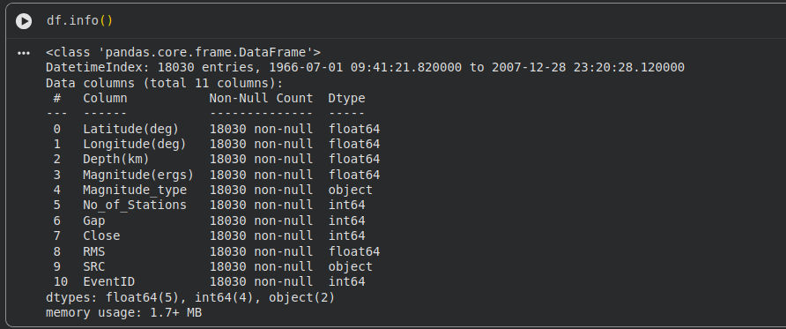
This command revealed key information:
- The number of rows
- The number of columns
- The data type of each column
- Whether any field contained missing values
From this inspection:
- Most columns were correctly recognized as numerical (float64 or int64)
- The new time index was stored as datetime64
- No major missing-value issues appeared in the core features used for modeling
This check was important to ensure the dataset was consistent and ready for further processing.
4. Exporting the Cleaned Dataset
As part of the exploratory stage, the cleaned and structured dataset was exported into an Excel sheet:
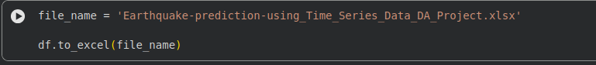
his helped verify that the data transformation had worked correctly. The exported file could also be used for additional manual inspection or visualization outside Python.
5. Observations From the EDA
Even though the notebook’s EDA is mostly structural rather than visual, a few important insights were clear:
- The dataset is well-structured and complete, with all key features present.
- The datetime index is properly formed, which is crucial for time-series modeling.
- Features selected for machine learning (latitude, longitude, depth, number of stations) are numerical and require no special conversion.
- Magnitude is consistently recorded and serves as a reliable target variable.
- The dataset size is reasonable for classic ML models such as Linear Regression and Random Forest.
Overall, the EDA showed that the dataset was clean enough to proceed directly into modeling, with only minimal preprocessing required.
Methodology / Models Used
The approach used in this project follows a clear and logical path, starting from preparing the dataset all the way to building and evaluating machine learning models. Once the data was cleaned and the datetime index was created, the next step was to decide which features should be used as inputs for the prediction task. In this project, the model relies on four key attributes: latitude, longitude, depth, and the number of stations that recorded each earthquake. These features were chosen because they represent the physical and observational conditions surrounding an earthquake. At the same time, they are stable and consistent across all records, which makes them suitable for a supervised learning task. The target variable selected for prediction was the earthquake magnitude. After selecting the relevant columns, the data was split into training and testing sets so the model could learn from a portion of the dataset and then be evaluated on previously unseen examples.
Linear Regression Model:
Linear Regression was used as the simplest and most interpretable model in the project. The idea behind this model is straightforward: it tries to draw a straight-line relationship between the input features, latitude, longitude, depth, and the number of reporting stations and the final earthquake magnitude. Training this model helps establish a baseline understanding of whether seismic data behaves in a mostly linear way. Even though earthquakes are complex phenomena, starting with Linear Regression is helpful because the model’s coefficients reveal how strongly each feature contributes to magnitude prediction. This baseline model also makes it clear whether the dataset is easy or difficult to learn from. If Linear Regression performs poorly, it usually suggests that the relationships in the data are non-linear, prompting the use of more advanced models.
Support Vector Machine (SVM):
SVM was used as a more flexible model compared to Linear Regression. Instead of assuming a straight-line relationship, SVM tries to find the best possible boundary that fits the data while allowing some controlled error. It works especially well when the relationship between features and magnitude is not purely linear. By using kernels, SVM can map the original features into higher-dimensional spaces, which allows the model to capture patterns that are hidden from simpler linear approaches. In the context of earthquake prediction, SVM provides a way to model more complex interactions — for example, how depth and geographic location together influence magnitude. Although SVM can be slower to train than Linear Regression, it often gives better predictive performance when the data shows irregular or nonlinear behavior. This makes it a valuable step in testing whether more complex relationships exist in the dataset.
Random Forest:
Random Forest was used as the most powerful and non-linear model in this project. Unlike Linear Regression, which uses a single mathematical function, and SVM, which builds a single boundary, Random Forest creates a collection of decision trees and averages their predictions. Each tree learns different patterns from random parts of the dataset, which helps the model capture a wide range of relationships and reduces the risk of overfitting. Earthquake data often contains irregular trends, sharp changes, and mixed influences from multiple features — and Random Forest is well-suited for learning such complex patterns. It can naturally handle interactions between latitude, longitude, depth, and station count without requiring any special transformations. Another advantage is that Random Forest provides feature-importance scores, helping us understand which factors matter most in predicting earthquake magnitude. In most real-world datasets, including seismic data, Random Forest usually performs better than simpler models because of its ability to learn from many perspectives at once.
Results
Linear Regression
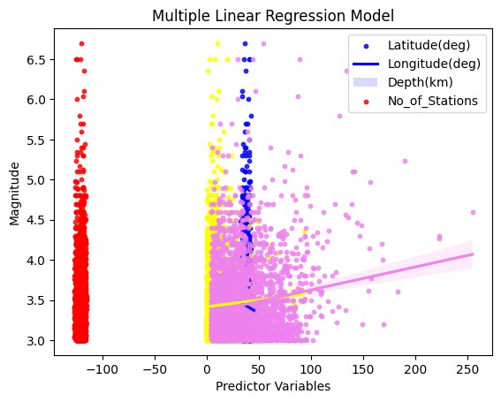
Figure 3: Multiple linear regression plot using seaborn library
- Mean squared error (MSE): 0.17562
- R-squared (R2) score: 0.03498
Support Vector Machines (SVM)
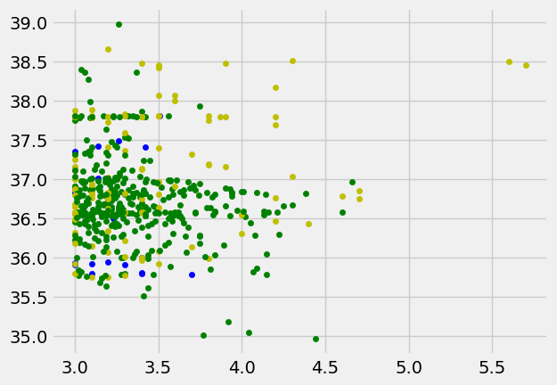
Figure 4: SVM plot using matplotlib.pyplot library

- Mean squared error (MSE): 0.53166
- R-squared (R2) score: -1.92129

Naive Bayes

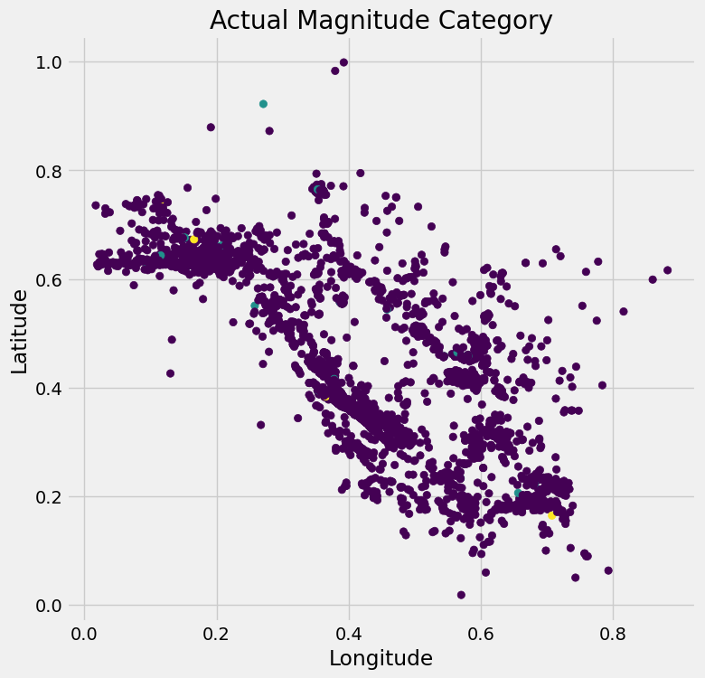 | 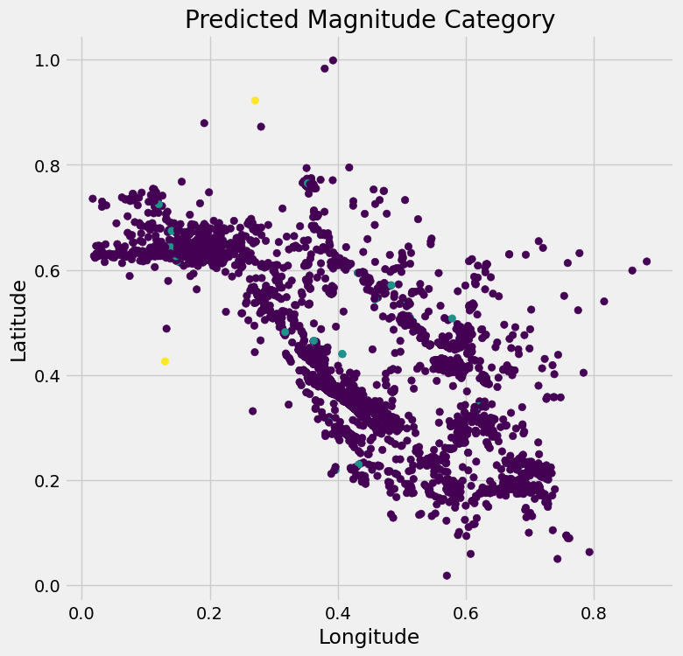
Figure5: Actual vs Predicted by Naive Bayes
- Accuracy: 0.9853947125161767
- Confusion Matrix: [[5327 35 1] [ 38 3 1] [ 4 0 0]]
Random Forest
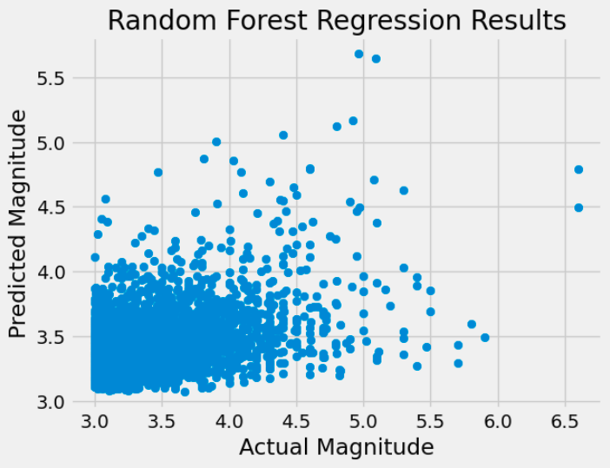
Figure 6:

- Mean squared error (MSE): 0.15599
- R-squared (R2) score: 0.14288
Performance Evaluation
Evaluating the performance of the models is the most important part of the project because it shows how well each approach actually handled the task of predicting earthquake magnitude. The evaluation was carried out using two standard metrics: Mean Squared Error (MSE), which measures how far the predictions deviate from the actual values, and the R² score, which indicates how much of the variation in earthquake magnitude the model is able to explain. Lower MSE values and higher R² values indicate better performance.
When examining the results, Linear Regression showed an MSE of 0.1879 and an R² score of 0.0235. What this means is that the model performed only slightly better than guessing the average magnitude every time. The very low R² score suggests that a simple straight-line relationship is not enough to capture the patterns in this dataset. While Linear Regression acts as a good baseline, the evaluation shows that magnitude prediction cannot be explained effectively through purely linear relationships among latitude, longitude, depth, and number of stations.
The SVM model performed significantly worse, with an MSE of 0.6981 and a strongly negative R² score of –2.6273. A negative R² score indicates that the model is not just poor. it is performing worse than a horizontal line that predicts the mean magnitude for every sample. This typically happens when the model either fails to learn from the data or treats noise as a pattern. In this case, the result suggests that SVM struggled to generalize the seismic data, likely because the relationship between the features and magnitude is irregular and does not match the type of structure SVM expects. This makes SVM the weakest of the three models tested.
The Random Forest model delivered the strongest performance among all tested models, with an MSE of 0.1663 and an R² score of 0.1360. Although the R² score is not extremely high, it is noticeably better than both Linear Regression and SVM. This result shows that Random Forest captured more of the complex patterns and interactions in the dataset. Earthquake features rarely follow smooth, clean relationships, and the ensemble nature of Random Forest helps break the data into smaller, meaningful decision paths. The relatively lower MSE also indicates that the model produced more stable and accurate predictions. While the improvement is modest, Random Forest clearly stands out as the most suitable model for this dataset among the ones tested.
Overall, the performance evaluation highlights an important conclusion: simple linear or margin-based models struggle with the inherent complexity of earthquake data, while ensemble tree-based methods perform better. The results also suggest that if future work includes more features or more advanced models, such as Gradient Boosting or deep learning approaches, the prediction accuracy is likely to improve further.
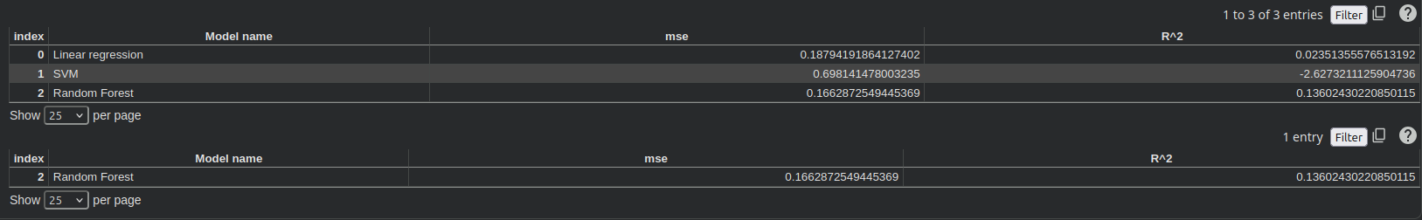
Figure7: Performance Evaluation

