**Problem No 01:**

**Problem Name: How to add two 8 bit data in assembly language?**

**Problem Objective:** This Program is about to Add Two 8 Bit Numbers in Assembly Language. Program should load data in registers AL and BL then add two Numbers.

**Source Code:**

.model small

.stack 100h

.data

a db "Enter The First Number : $"

b db 10,13,"Enter The Second Number : $"

c db 10,13,"The Summation is : $"

.code

main proc

mov ax,@data

mov ds,ax

mov ah,9

lea dx,a

int 21h

mov ah,1

int 21h

mov bl,al

mov ah,9

lea dx,b

int 21h

mov ah,1

int 21h

mov bh,al

mov ah,9

lea dx,c

int 21h

add bl,bh

sub bl,48

mov ah,2

mov dl,bl

int 21h

exit:

mov ah,4ch

int 21h

main endp

end main

**Input & Output:**

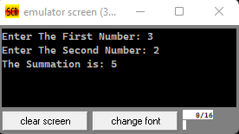

**Problem No 02:**

**Problem Name: How to subtract two 8 bit data in assembly language?**

**Problem Objective:** This Program is about to subtract Two 8 Bit Numbers in Assembly Language. Program should load data in registers AL and BL then subtract two Numbers.

**Source Code:**

.model small

.stack 100h

.data

a db "Enter The First Number : $"

b db 10,13,"Enter The Second Number : $"

c db 10,13,"The Subtraction is : $"

.code

main proc

mov ax,@data

mov ds,ax

mov ah,9

lea dx,a

int 21h

mov ah,1

int 21h

mov bl,al

mov ah,9

lea dx,b

int 21h

mov ah,1

int 21h

mov bh,al

mov ah,9

lea dx,c

int 21h

sub bl,bh

add bl,48

mov ah,2

mov dl,bl

int 21h

exit:

mov ah,4ch

int 21h

main endp

end main

**Input & Output :**

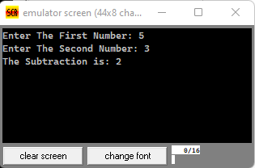

**Problem No 03:**

**Problem Name: How to multiply two 8 bit data in assembly language?**

**Problem Objective:** This Program is about to multiply Two 8 Bit Numbers in Assembly Language. Program should load data in registers then multiply two Numbers.

**Source Code:**

.model small

.stack 100h

.data

a db "Enter The First Number : $"

b db 10,13,"Enter The Second Number : $"

c db 10,13,"The Multiplication is : $"

num1 db ?

num2 db ?

.code

main proc

mov ax,@data

mov ds,ax

mov ah,9

lea dx,a

int 21h

mov ah,1

int 21h

mov num1,al

sub num1,48

mov ah,9

lea dx,b

int 21h

mov ah,1

int 21h

mov num2,al

sub num2,48

mov ah,9

lea dx,c

int 21h

mov al,num1

mul num2

add al,48

mov ah,2

mov dl,al

int 21h

exit:

mov ah,4ch

int 21h

main endp

end main

**Input & Output :**

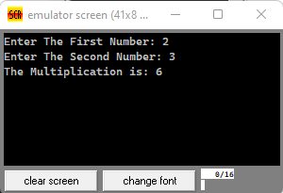

**Problem No 04:**

**Problem Name: How to convert upper case to lower case Alphabet?**

**Problem Objective:** This Program is about to convert a alphabet upper case to lower case.

**Source Code:**

.model small

.stack 100h

.data

a db "***Upper Case to lower Case $"

b db 10,13, "The upper Case input is : $"

c db 10,13, "The Lower Case is : $"

.code

main proc

mov ax,@data

mov ds,ax

mov ah,9

lea dx,a

int 21h

mov ah,9

lea dx,b

int 21h

mov ah,1

int 21h

mov bl,al

mov ah,9

lea dx,c

int 21h

mov ah,2

mov dl,bl

add dl,32

int 21h

exit:

mov ah,4ch

int 21h

main endp

end main

**Input & Output :**

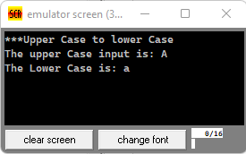

**Problem No 05:**

**Problem Name: How to find the biggest number between two values?**

**Problem Objective:** This Program is about to find the biggest number between two values.

**Source Code:**

.model small

.stack 100h

.data

a db "Enter The Two Values : $"

b db 10,13, "The Largest Number Is : $"

.code

main proc

mov ax,@data

mov ds,ax

mov ah,9

lea dx,a

int 21h

mov ah,1

int 21h

mov bl,al

mov ah,2

mov dl,10

int 21h

mov dl,13

int 21h

mov ah,1

int 21h

mov bh,al

biggest:

cmp bl,bh

jg l1

jmp l2

l2:

mov ah,9

lea dx,b

int 21h

mov ah,2

mov dl,bh

int 21h

jmp exit

l1:

mov ah,9

lea dx,b

int 21h

mov ah,2

mov dl,bl

int 21h

jmp exit

exit:

mov ah,4ch

int 21h

main endp

end main

**Input & Output :**

