HIPL: Agent and GUI developer documentation
Documentation for developers
about HIPL agent and GUI

Antti Partanen
2006-

Content of this document:
Chapter 1. Introduction
Chapter 2. Agent
Part 1. What is agent
Part 2. Daemon-agent -interface
Part 3. Agent-GUI -interface
Chapter 3. Database
Chapter 4. Graphical User Interface
Part 1. What is GUI

Chapter 1. Introduction

This document describes HIPL agent and GUI from developer point of view. Interface between agent and HIPL daemon is described in details, so is example GUI and database functionality.
Next is a simple diagram of agent/GUI:
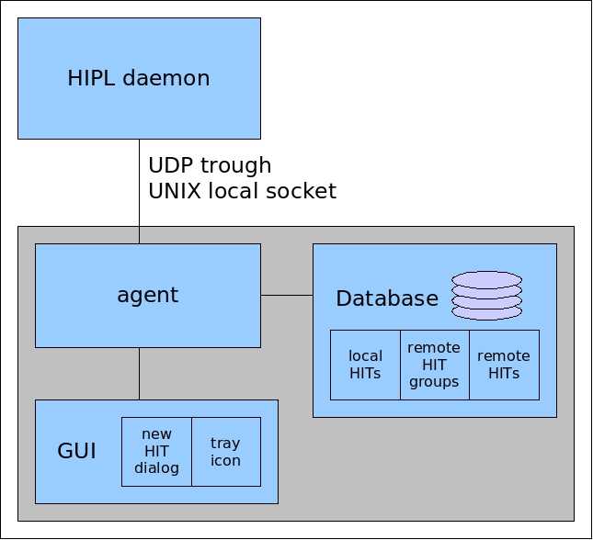

Chapter 2. Agent

Part 1. What is agent

Agent is the part, which handles database and communicates between daemon, database and GUI.

Part 3. Agent-GUI -interface

Agent uses following functions to manage GUI:

int gui_init(): Initialize GUI, build up necessary windows and so on. Return zero on success, usually -1 on errors.
int gui_main(): Run GUI. This function waits until GUI is finished. After this function, agent shuts down everything and exits.
void gui_quit(): Tell GUI to quit. If agent calls this function, GUI should shutdown and return from gui_main().

void gui_clear_hiu(): Clear ”HITs In Use”-list.
void gui_add_hiu(HIT_Remote *): Add remote HIT to ”HITs In Use”-list.
void gui_set_nof_hiu(int): Set number of ”HITs In Use”.

int gui_ask_new_hit(HIT_Remote *, int): Ask GUI whether or not to accept new remote HIT. First parameter is pointer to remote HIT struct and second pointer tells, whether the HIT is incoming or outgoing (only I1-packets are actually filtered trough GUI).

void gui_set_info(char *, ...): Set example status bar info to GUI. Must use printf()-style va_list for formatting the string. This function is optional, it must be declared, but doesn't need to do anything.

void gui_add_local_hit(HIT_Local *): Tell GUI to show new local HIT.
void gui_add_remote_hit(HIT_Remote *): Tell GUI to show new remote HIT.
void gui_add_rgroup(HIT_Group *): Tell GUI to show new remote group.

void gui_delete_local_hit(HIT_Local *): Tell GUI to delete local HIT. This is not in use and not needed to implement yet.
void gui_delete_remote_hit(HIT_Remote *): Tell GUI to delete remote HIT.
void gui_delete_rgroup(HIT_Group *): Tell GUI to delete remote group and HITs within it. This is not in use and not needed to implement yet.

