Introduction to Network Time Protocol
2002/12/18雷振

Content
- basic concepts of NTP
- Implementing and configuration
- Managing, and troubleshooting

References
- RFC-1305
- Using NTP to Control and Synchronize System Clocks(Sun BluePrints™)
- Xntpd Man page

Basic concepts of NTP

What is NTP?
- Control and Synchronize System Clocks among a set of distributed time servers and clients
- The standard of RFC1305

Why NTP?
- Inaccurate time: Electronic clocks in most servers and networking devices keep inaccurate time.
- The Need for Synchronized time: Every aspect of managing, securing, planning, and debugging a network involves determining when events happen.

Common UNIX Commands Related to Time
Command | Description
Date | Displays or sets the current system date and time
Rdate | Sets the current system time from a remote host using the date protocol (see RFC 868)
Adjtime() | Adjusts the system’s time of day clock gradually to a specified value
settimeofday() | Sets the system’s time of day clock instantly to a specified value
Ntpdate | Sets the current systems clock from a remote NTP server
Xntpd | NTP daemon

Other time protocols
- DTS or DTSS: Digital Time Service(for LAN evniroment)
- SNTP: Simple Network Time Protocol, is a lightweight variation of NTP, Wintel platform

NTP principles
- not based on the principles of synchronizing machines clock with each other.
- based on the principles of having all machines get as close as possible to the correct time, even in the presence of incorrect time sources, or when accurate time sources are temporarily unavailable

NTP Strata
- NTP works on a hierarchical model
- Clients can use time information from multiple servers to automatically determine the best source of time

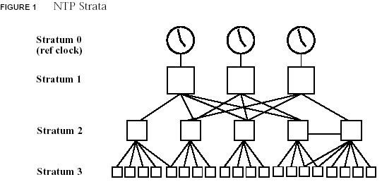

How to judge the accuracy of clocks
- how “close” a clock is to a reference clock—Stratum
- the network latency to the clock—delay
- the claimed accuracy of the clock—dispersion

NTP accuracy
- The maximum resolution of an NTP time stamp is about 200 picoseconds(10 ⁻¹²)
- Ultimate accuracy of NTP is limited by hardware and latency, rather than by the NTP protocol.
- Some environments accuracy
  - LAN: within a few milliseconds is normal.
  - WAN: within the range of 10-100 ms.
  - Internet: unpredictable

The ultimate source of NTP time
- Coordinated Universal Time(UTC),
- UTC evolved from Greenwich Mean Time (GMT)
- UTC is synchronized according to time zone

NTP uses the UDP protocol on port 123 to communicate between clients and servers.

Types of Clients and Servers
- Non-broadcast mode(LAN/WAN)
  - Server
  - Client
- Broadcast mode(LAN)
  - Broadcast/multicast server
  - Broadcast/multicast client
- Peer mode(same stratum)

NTP Algorithms
- Choose the best source from among several possible sources.(server) based on several factors, including:
  - the offset
  - the delay
  - an error factor.
- How NTP client adjusts the local clock
  - Slewing: gradual adjustment
  - Stepping: instant adjustment

Terms
- Offset: half the difference between the time it takes for the client/server query and the server/client response.
- delay: round-trip time for the client query to be received back by the client, the time the server spends processing the client query is subtracted
- error factor: represents errors related to clock reading times and frequency tolerance
- Dispersion: represented as half the delay plus the error
- Synchronization distance: dispersion plus one-half the absolute delay
- Illustration
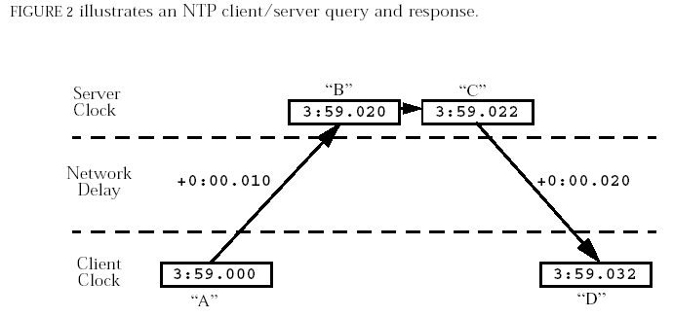
  - The offset is ((B-A)-(D-C))/2, or .005 seconds.
  - The delay is ((D-A)-(C-B)), or .03 seconds.

Resource Requirements
- NTP requires little resource overhead.
- A broadcast server sends out a packet about every 64 seconds.
- A non-broadcast client/server requires 2 packets per transaction. When first started, transactions occur about once per minute, increasing gradually to once per 17 minutes under normal conditions.

NTP components
- Xntpd: NTP daemon, used both for client and server and started automatically on OS startup
- /etc/inet/ntp.conf: config file which configures the NTP servers and clients. If the file exists, NTP daemon start, otherwise, not.
- ntpdate: fast initial synchronization before using xntpd,
- ntpq: querying the state of the NTP daemon on a local or remote machine.
- Xntpdc: querying the state of a local or remote NTP daemon, and making runtime configuration requests to a remote machine.
- Ntptrace: trace a chain of NTP hosts back to their master time source

Solaris NTP Versions
Solaris OE version | Approximate Open Source NTP version included
pre 2.5.1 | None
2.5.1 | NTP 3.2 (supported on Ultra Enterprise 10000 only)
2.6 | NTP 3.4y not including xntpdc
7 | NTP 3.4y not including xntpdc
8 | NTP 3-5.93e

Implementing and configuration (server/client/peer)

NTP server (stratum 0) setup

create /etc/inet/ntp.conf file
################################
server 127.127.1.0 prefer
fudge 127.127.1.0 stratum 0

driftfile /var/ntp/ntp.drift
statsdir /var/ntp/ntpstats/
filegen peerstats file peerstats type day enable
filegen loopstats file loopstats type day enable
filegen clockstats file clockstats type day enable
################################

Edit /etc/rc2.d/S74xntpd
add /usr/lib/inet/xntpd -l /var/ntp/ntp.log

Start xntpd daemon
/etc/rc2.d/S74xntpd start

Verify the server setup
# ntpq -p
remote refid st t when poll reach delay offset disp
=====================================================
*LOCAL(0) .LCL. 0 l 51 64 377 0.00 .000 10.03

NTP Client/Peer Setup

create /etc/inet/ntp.conf file
server 192.168.2.202 #### ip address of statum 1 server
peer 192.168.2.204 #### ip address of peer statum 2 server
driftfile /var/ntp/ntp.drift
statsdir /var/ntp/ntpstats/
filegen peerstats file peerstats type day enable
filegen loopstats file loopstats type day enable
filegen clockstats file clockstats type day enable

Edit /etc/rc2.d/S74xntpd
add /usr/lib/inet/xntpd -l /var/ntp/ntp.log

Start xntpd daemon
/etc/rc2.d/S74xntpd start

check to see if it is bound to a NTP server or not.
# ntpq -p
remote refid st t when poll reach delay offset disp
====================================================
*192.168.2.202 .LCL. 1 u 591 1024 377 0.66 0.086 0.14
+192.168.2.204 192.168.2.202 2 u 60 64 376 0.41 -0.077 0.52

Modify ntp.conf
- Modify /etc/inet/ntp.conf
- Stop xntpd: /etc/rc2.d/S74xntpd stop
- Restart xntpd: /etc/rc2.d/S74xntpd start
- Check with ntpq -d

Notice
- Use date, rdate or ntpdate to modify local date
- Use /etc/rc2.d/S74xntpd
- About 5 minutes for client to reach synchronization
- Each client uses numbers of independent servers
- NTP allows a server to lose connectivity for up to 24 hours and still provide NTP service to its clients.
- The calculated round trip delay and dispersion for server must be less than 16 seconds.
- The total delay and maximum error must be less than 16 seconds from the root clock.
- An NTP client can have a relationship with up to 64 servers, but only 10 of these can serve as potential synchronization sources.

Other issues
- ACL
- Authentication
- Broadcase/multicast configuration

Managing, and troubleshooting

log information
- /var/adm/messages
- command line option
/usr/lib/inet/xntpd -l /etc/inet/ntp.log
- config file
statsdir /var/ntp/ntpstats/
filegen peerstats file peerstats type day enable
filegen loopstats file loopstats type day enable
filegen clockstats file clockstats type day enable

ntpdate
- set the date and time by way of NTP
  - offset is more than 0.5 second: settimeofday()
  - offset is less than 0.t second: adjtime()
- # ntpdate server_name

debug output of xntpd
# /usr/lib/inet/xntpd -d

ntptrace
# ntptrace hostname
trace a chain of NTP hosts back to their master time source

Ntpq
- querying the state of the NTP daemon on a local or remote machine.
- Command line arguments mode or interactive mode

Peers: prints peers state
- Fields explanation
1 Each server for the current host is listed,
2 lists the servers’ current time source.
3 indicates the stratum of the server.
4 indicates the mode of the server.(l,u,b,m)
5 indicates the number of seconds since the given server was last reached
6 indicates the polling interval for a given host in seconds.
7 indicates the history of reachability. displayed in octal, 377, which indicates that the last 8 attempts were good.
8~10 estimated delay, offset, and dispersion in milliseconds..
- Flags: indicate how xntpd is using the listed server
  - a current synchronization source time
“*” or “o”
  - healthy peer servers
“-”: symmetric passive
“+”: symmetric active
“.”: culled from the end of the candidate 10 servers list
  - not synchronized
“x”: the servers clock is unsynchronized or set incorrectly.
Space: discarded due to high stratum and/or failed sanity checks
  - others
“#”: servers in the configuration are too far away to be useful.
“=”: means the remote server is being polled in client mode
“^”: sever is broadcasting to this address
“~”: the remote peer is sending broadcasts

associations: lists the status of the servers.
- Status fields explanation
- c/s synchronization status: 9614

host: select host

cooked; format output

debug; turn query program debugging on

clockvar: subcommand lists the type of clock used by a given server.

