In the Admin panel A ‘Friends’ tab is already there but needs to include ‘Friends of’ who they are ‘tied to’, so they are showing up together when you click on their name after they sign up. The same thing goes for a ‘User’ that can have Friends tied to them also

Finally I also need an ‘Appointments’ tab to work the same way, to keep track of the Clients that made appointments with the User.

I’m thinking these should be stored in the admin panel for 30 days even if the User or Friend deletes them. This also cannot have any effect on them if they want to replace a friend with another (they are limited to 2). This is only for the backend purposes

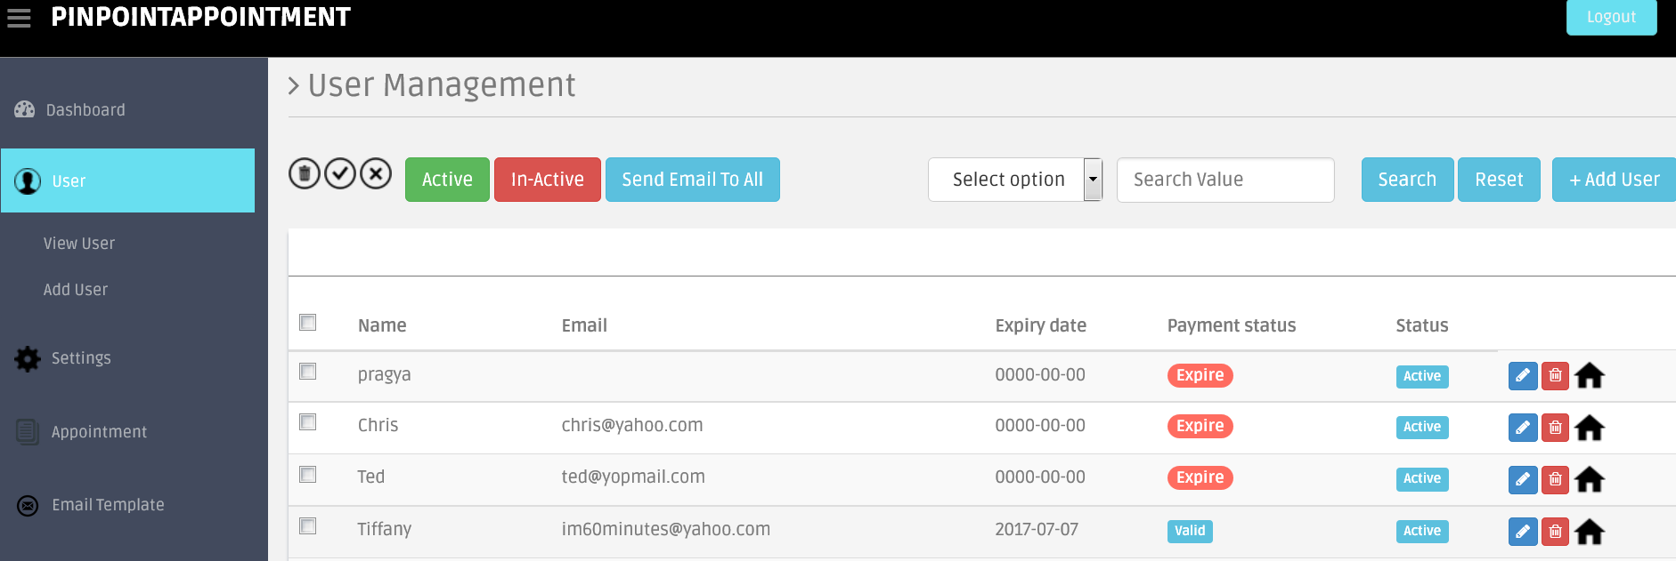

You can see that this was attempted by another developer as the friends/client appear on my own account, but it’s not working right



\*\*(I changed the days to 30)\*\*Also when I click on the black house and then see the address, I need to be able to click on it and be able to see all the people/leads who registered for that open house (even if deleted) and store them for 30 days along with the pictures could as they could use up a lot of space in the server, then auto deleted after 30 days.

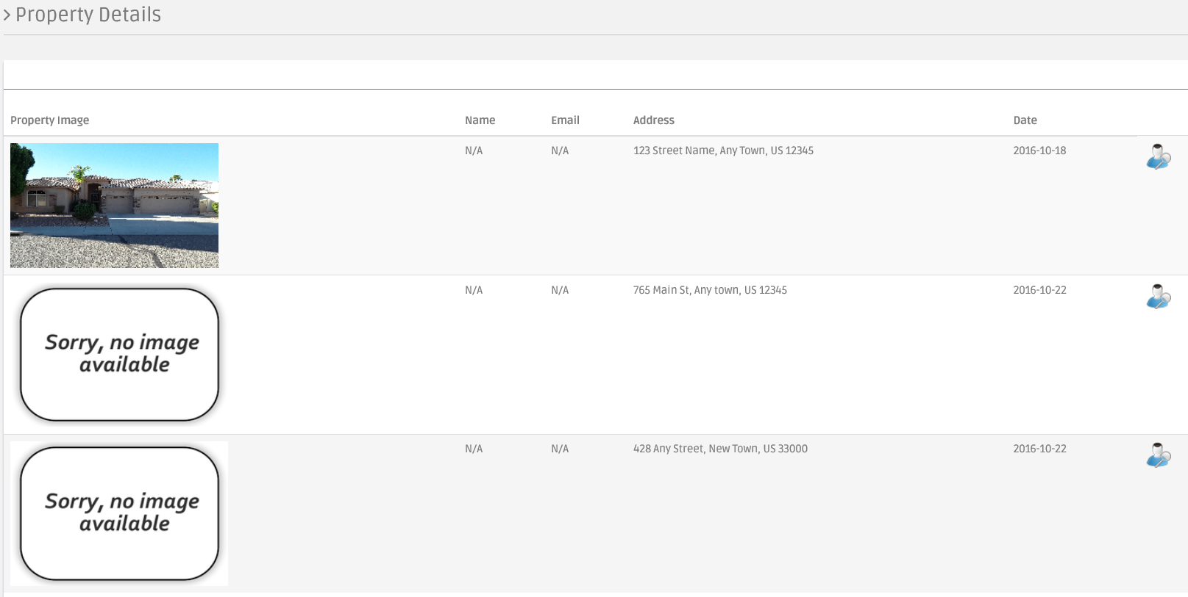

The is working in the tablet/ipad so I know they are there, but again the leads needs be brought into the admin panel. This is in case the tablet/ipad is stolen or somebody deletes an image of somebody on purpose (predator)

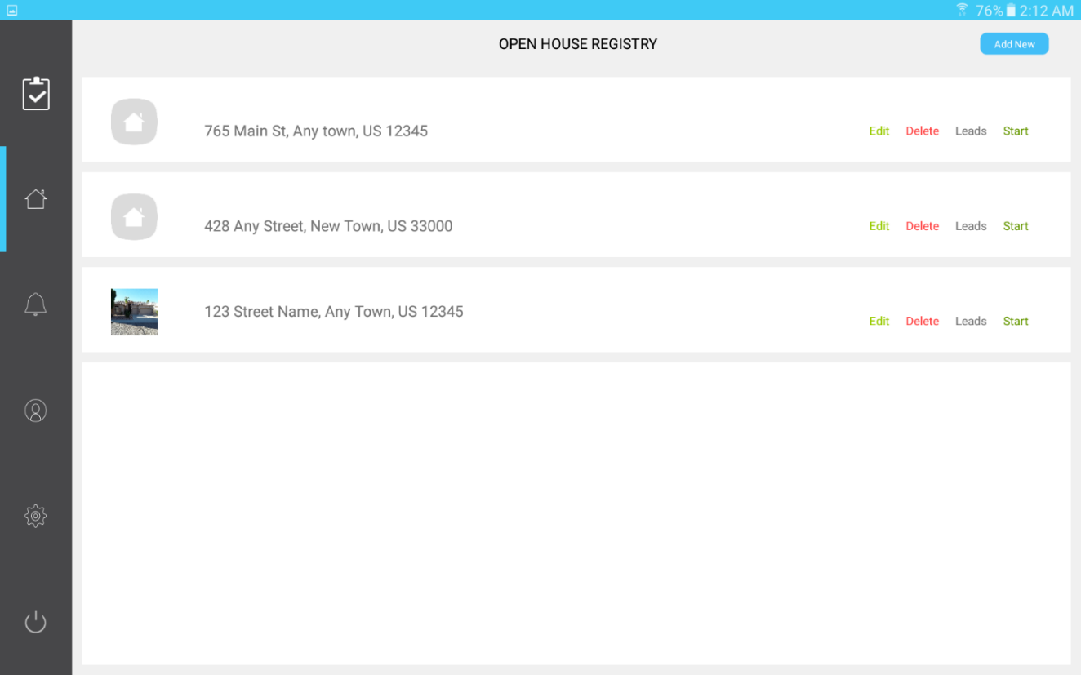

I am getting these messages every time there is a new sign up of a client or user. This can be turned off as I am really only interested when someone pays to purchase the app (User).

Hello Admin,

A new user has been registered to PinPointAppointment System.

Below is the details of the new user :

Name : Richelle  
Email : [rgriffin271@cox.net](mailto:rgriffin271@cox.net)  
Contact : +16027622004  
Device Type : IOS

These files are piling up and using up space. I need to have only 1 configured to do a backup once a day and replace the previous day. The others can be eliminated.

11.996 GiB /backup/cpbackup/monthly/pinpointappointm.tar.gz  
  
11.220 GiB /backup/cpbackup/weekly/pinpointappointm.tar.gz  
  
11.220 GiB /backup/cpbackup/daily/pinpointappointm.tar.gz