JavaWeb程序设计

题 目：_____搭建主从同步_____

专业班级：_____信计二班_________

姓 名：_____孙荣彪___________

学 号：_____2018591209_______

网上学子商城系统

1.
使用用户名和密码，登录学子商城，密码错误则显示错误信息，不能登录成功
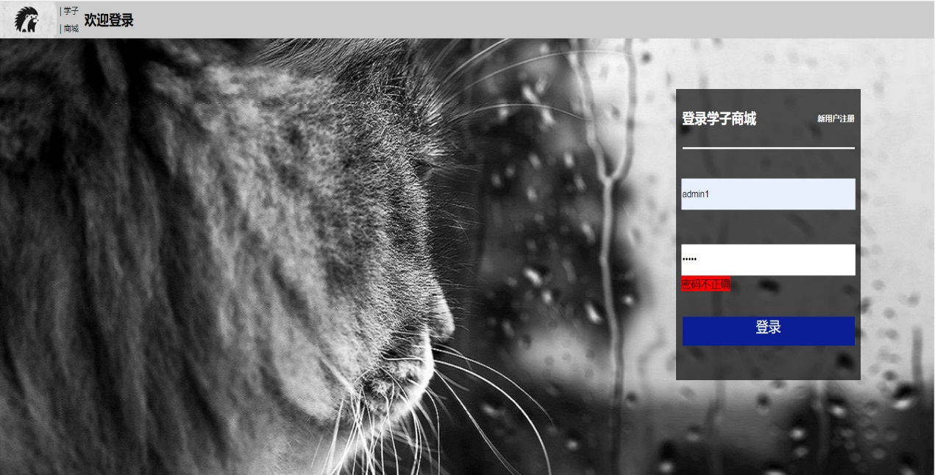

2.
用户名和密码皆错误则显示错误信息，不能登录成功，点击用户注册可以注册用户
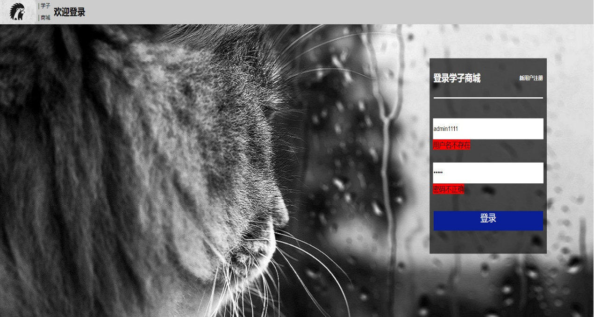

3.
使用admin2登录成功则进入首页，点击用户名进入我的信息
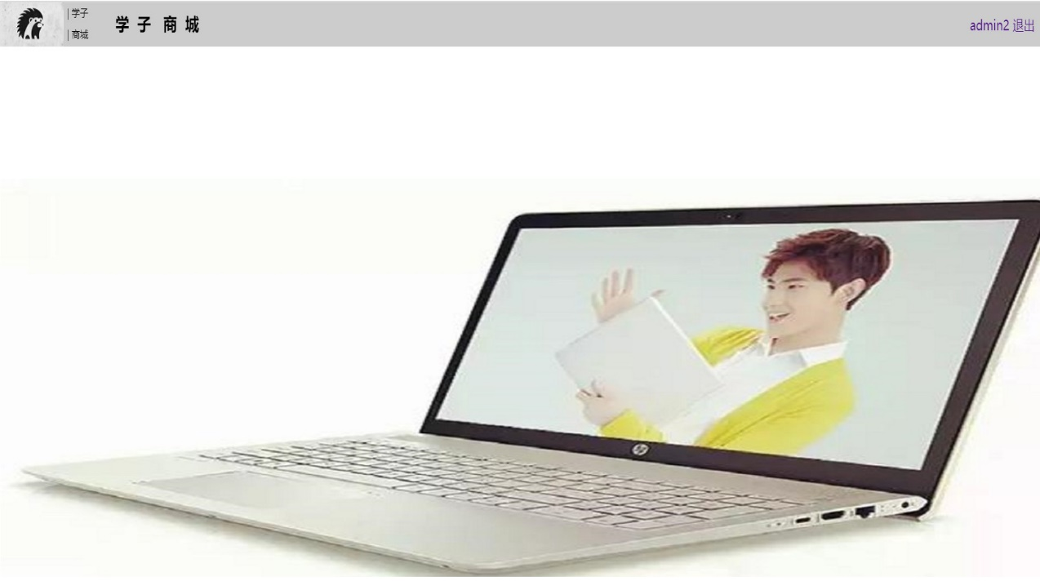

4.
打开数据库查看所有用户信息如下：
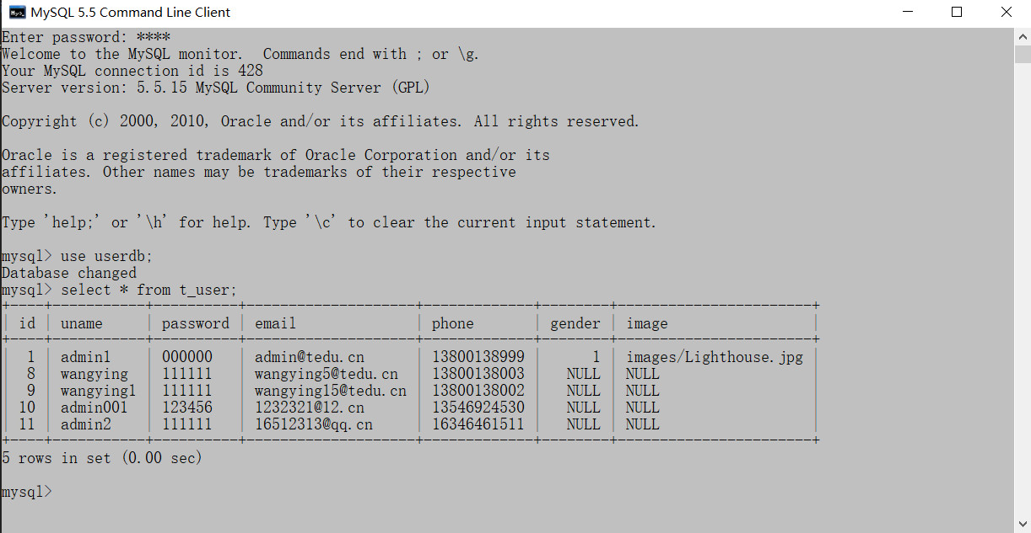

5.
在我的信息里面则可以更改详细信息，更改一部分信息进行数据库查看
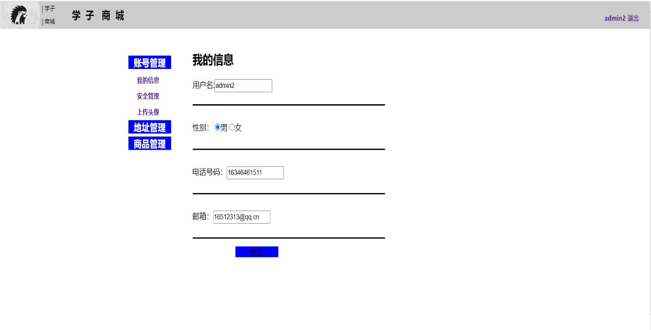6.
数据库查看，admin2的信息发生改变

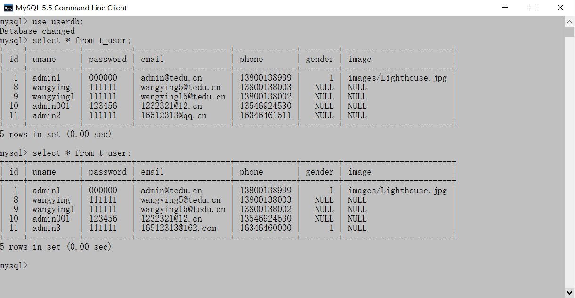

7.
进入安全管理更改密码，只有旧密码正确，新密码格式正确才可以修改
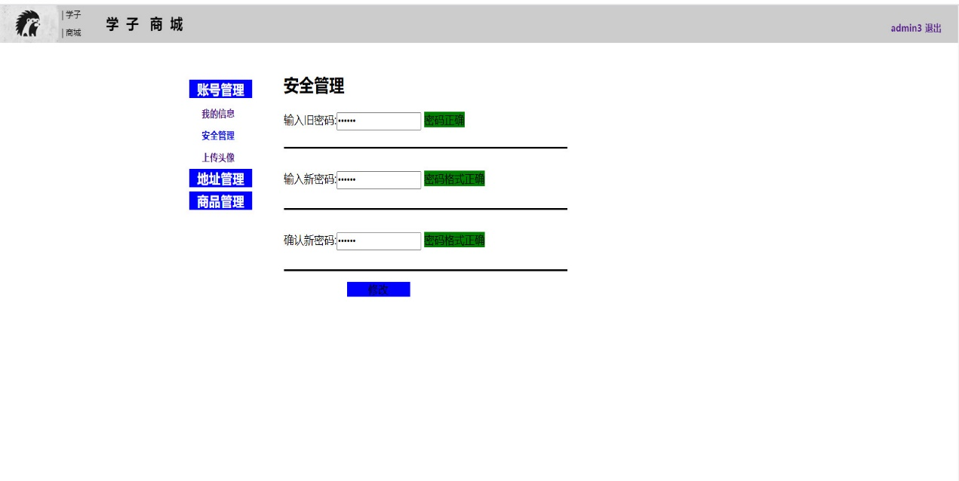
8.
数据库查看admin3的密码修改成功

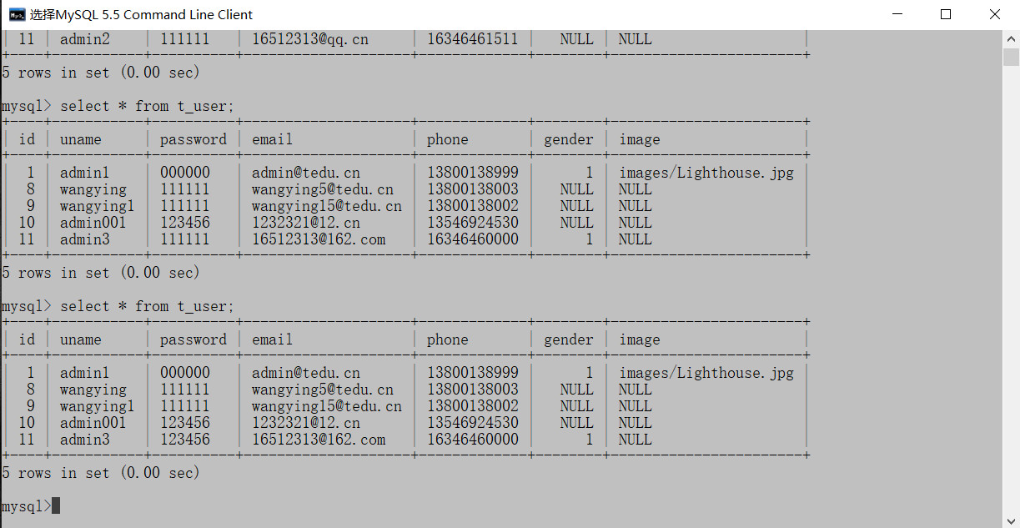

9.
退出进入首页，点击登录进入登录界面，然后跳转到注册界面


10.
注册用户各信息格式不正确则不可以注册

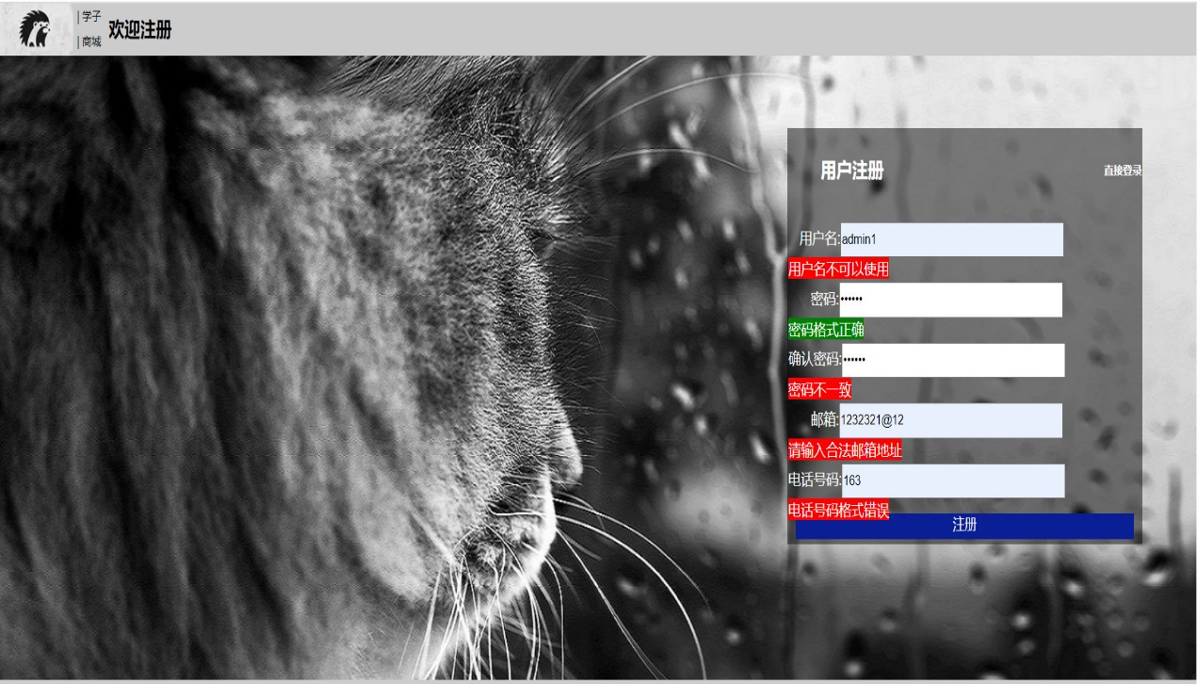

11.
格式正确点击注册按钮，跳转到登录界面
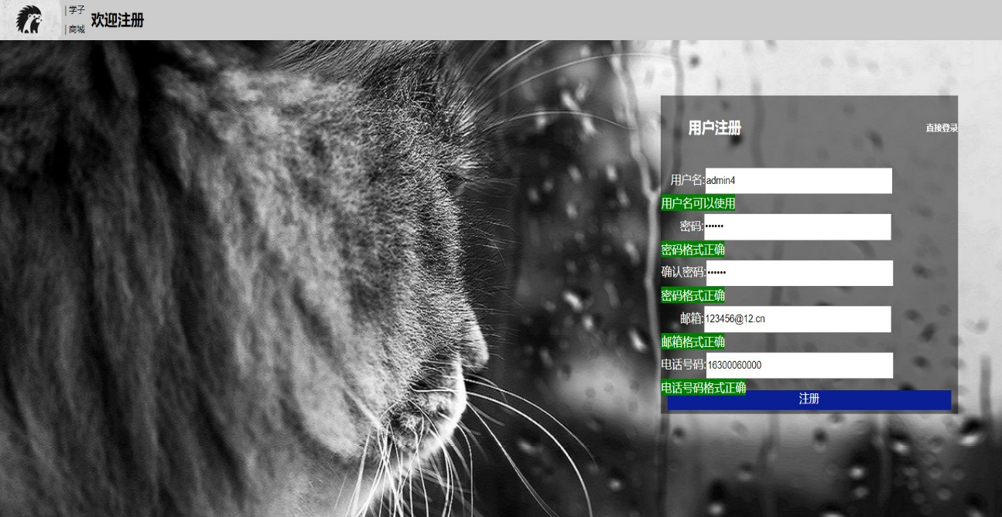

12.
查看数据库，admin4已经注册成功
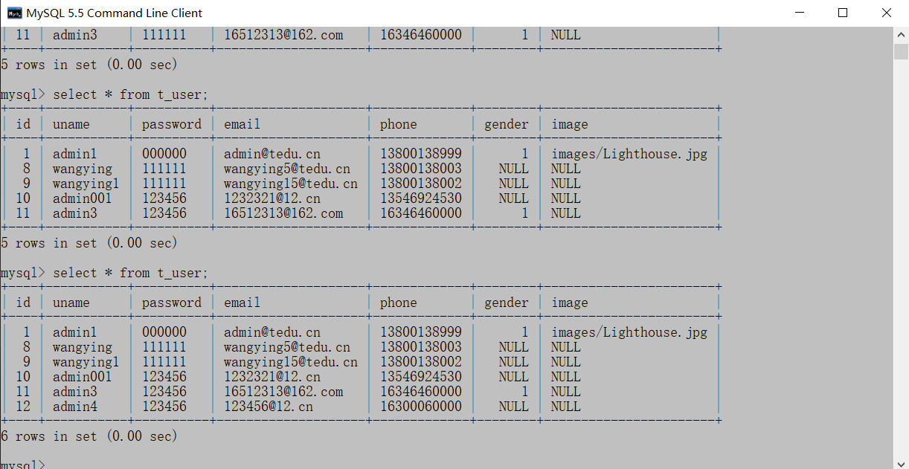

13.
商城界面流程运行结束

14.商城项目环境准备
1）新建demoWeb项目，在WebContent下创建js，css，images文件夹
2）上传jquery-3.1.1.min.js，使用jQuery框架
3）在Java文件夹下创建bean，util，web包
4）安装服务器
5）连接数据库

15.注册界面代码
1)register.html

<!DOCTYPE html>
<html>
<head>
<meta charset="UTF-8">
<title>register</title>
<link rel="stylesheet" href="css/register.css">
</head>
<body>
<div id="div1">
<div id="div2">
<div id="div3"></div>
<div id="div4"><p>|&nbsp;学子<br>|&nbsp;商城</p></div>
<div id="div5"><p>欢迎注册</p></div>
</div>
<div id="div6">
<form id="form" action="">
<div id="div7">
<p><a href="login.html" id="a">直接登录</a></p>
<div id="div8"></div>
<p id="p">用户注册</p>
</div>
<div id="div9">
&nbsp;&nbsp;
用户名:<input type="text" name="name" placeholder="请输入用户名" class="input" id="name1"><br>
<span id="nameSpan"></span></div>
<div id="div11">&nbsp;&nbsp;&nbsp;&nbsp;&nbsp;
密码:<input type="password" name="pwd" placeholder="请输入密码" class="input" id="pwd"><br>
<span id="pwdSpan"></span></div>
<div id="div12">
确认密码:<input type="password" name="pwd1" placeholder="请确认密码" class="input" id="pwd1"><br>
<span id="pwd1Span"></span></div>
<div id="div13">
&nbsp;&nbsp;&nbsp;&nbsp;&nbsp;
邮箱:<input type="email" name="email" placeholder="请输入邮箱" class="input" id="email"><br>
<span id="emailSpan"></span></div>
<div id="div14">
电话号码:<input type="text" name="phone" placeholder="请输入电话号码" class="input" id="phone"><br>
<span id="phoneSpan"></span></div>
<div id="div10">注册</div>
</form></div></div>
<script type="text/javascript" src="js/jquery-3.1.1.min.js"></script>
<script type="text/javascript" src="js/register.js"></script>
</body>
</html>

2) register.css
@CHARSET "UTF-8";
*{margin: 0px;padding: 0px;}
#div1{
width: 1600px;height: 750px;
background-color: #ccc;}
#div2{
width: 1600px;height: 50px;
background-color: #ccc;
position: fixed;}
#div3{
width: 93px;height: 50px;
background-image: url("../images/img02.jpg");
float: left;}
#div4{
width: 40px;height: 50px;
text-align: center;line-height: 24px;
font-size: 2px;
float: left;}
#div5{
width: 90px;height: 50px;
text-align: center;line-height: 50px;
font-size: 20px;;font-style: inherit;
font-weight: bold;float: left;}
#div6{
width: 1600px;height: 650px;
background-image: url("../images/img01.jpg");}
#form{
width: 450px;height: 400px;
position: relative;
top: 120px;
left: 1000px;
background-color: rgba(10,10,10,0.5); }
#div7{width: 450px;height: 50px;}
#p{
font-family: sans-serif;
color: #fff;
font-size: 20px;
font-weight: bold;
text-align: center;
line-height: 80px;
float: right;}
#a{
font-family: sans-serif;
color: #fff;
font-size: 10px;
font-weight: bold;
text-align: center;
line-height: 80px;
text-decoration: none;
float: right;}
#div8{width: 280px;height: 50px;float: right;}
#div9{
width: 450px;height: 38px;
margin: 30px 1px 0px;
color: #fff;}
#div11{
width: 450px;height: 38px;
margin: 20px 1px 0px;
color: #fff;}
#div12{
width: 450px;height: 38px;
margin: 20px 1px 0px;
color: #fff;}
#div13{
width: 450px;height: 38px;
margin: 20px 1px 0px;
color: #fff;}
#div14{
width: 450px;height: 38px;
margin: 20px 1px 0px;
color: #fff;}
.input{
width: 280px;height: 30px;
margin-top: 10px;}
#div10{
width: 430px;height: 25px;
font-size:15px;
text-align: center;
color: #fffffb;
background-color: rgb(10,30,150);
margin: 20px 10px 0px;}

3) register.js
name1.onfocus = function (){
nameSpan.innerHTML="用户名6-9位字符";
nameSpan.style.backgroundColor="#ccc";}
var name1count=0;
name1.onblur = function (){
var nameValue = name1.value;
var reg = /^[a-zA-Z0-9]{6,9}$/;
if(nameValue == ""){
name1count=0;
nameSpan.innerHTML="用户名不能为空";
nameSpan.style.backgroundColor="#ff0000";
}else if(!reg.test(nameValue)){
name1count=0;
nameSpan.innerHTML="用户名长度6-9之间";
nameSpan.style.backgroundColor="#ff0000";
}else{
nameSpan.innerHTML="用户名格式正确";
nameSpan.style.backgroundColor="#00ff00";
$.ajax({
url:"/demoWeb/CheckNameServlet",
type:"get",
data:"name="+$("#name1").val(),
dataType:"json",
success:function(obj){
nameSpan.innerHTML = obj.msg;
if(obj.state == 0){
name1count=0;
nameSpan.style.backgroundColor="#ff0000";
}else{
name1count=1;
nameSpan.style.backgroundColor="green";
}}});}}
pwd.onfocus = function (){
pwdSpan.innerHTML="密码6-12位字符";
pwdSpan.style.backgroundColor="#ccc";}
pwdcount = 0;
pwd.onblur = function(){
var pwdValue = pwd.value;
var reg = /^[a-zA-Z0-9]{6,12}$/;
if(pwdValue == ""){
pwdcount = 0;
pwdSpan.innerHTML="密码不能为空";
pwdSpan.style.backgroundColor="#ff0000";
}else if(!reg.test(pwdValue)){
pwdcount = 0;
pwdSpan.innerHTML="密码长度6-12之间";
pwdSpan.style.backgroundColor="#ff0000";
}else{
pwdcount = 1;
pwdSpan.innerHTML="密码格式正确";
pwdSpan.style.backgroundColor="green";}}
pwd1.onfocus = function (){
pwd1Span.innerHTML="密码6-12位字符";
pwd1Span.style.backgroundColor="#ccc";}
pwd1count = 0;
pwd1.onblur = function(){
var pwd1Value = pwd1.value;
var pwdValue = pwd.value;
var reg = /^[a-zA-Z0-9]{6,12}$/;
if(pwd1Value == ""){
pwd1count = 0;
pwd1Span.innerHTML="密码不能为空";
pwd1Span.style.backgroundColor="#ff0000";
}else if(!reg.test(pwd1Value)){
pwd1count = 0;
pwd1Span.innerHTML="密码长度6-12之间";
pwd1Span.style.backgroundColor="#ff0000";
}else if(pwd1Value != pwdValue){
pwd1count = 0;
pwd1Span.innerHTML="密码不一致";
pwd1Span.style.backgroundColor="#ff0000";
}else{
pwd1count = 1;
pwd1Span.innerHTML="密码格式正确";
pwd1Span.style.backgroundColor="green";}}
email.onfocus = function (){
emailSpan.innerHTML="请输入合法邮箱地址";
emailSpan.style.backgroundColor="#ccc";}
emailcount = 0;
email.onblur = function(){
var emailValue = email.value;
var reg = /^[a-zA-Z0-9]{1,}@[a-z0-9]{2,}\.[a-z]{2,}$/;
if(emailValue == ""){
emailcount = 0;
emailSpan.innerHTML="邮箱不能为空";
emailSpan.style.backgroundColor="#ff0000";
}else if(!reg.test(emailValue)){
emailcount = 0;
emailSpan.innerHTML="请输入合法邮箱地址";
emailSpan.style.backgroundColor="#ff0000";
}else{
emailcount = 1;
emailSpan.innerHTML="邮箱格式正确";
emailSpan.style.backgroundColor="green";}}
phone.onfocus = function (){
phoneSpan.innerHTML="请输入合法电话号码";
phoneSpan.style.backgroundColor="#ccc";}
var phonecount=0;
phone.onblur = function (){
var reg = /^1(3|4|5|6|7|8|9)[0-9]{9}$/;
var phoneValue = phone.value;
if(phoneValue == ""){
phonecount=0;
phoneSpan.innerHTML="电话号码不能为空";
phoneSpan.style.backgroundColor = "#ff0000";
}else if(reg.test(phoneValue)){
phonecount=1;
phoneSpan.innerHTML="电话号码格式正确";
phoneSpan.style.backgroundColor = "green";
}else{
phonecount=0;
phoneSpan.innerHTML="电话号码格式错误";
phoneSpan.style.backgroundColor = "#ff0000"; }}
div10.onclick = function (){
if(name1count==1 && pwdcount==1 && pwd1count==1 && emailcount==1 && phonecount==1){
$.ajax({
url:"/demoWeb/RegisterServlet",
type:"post",
data:$("form").serialize(),
dataType:"json",
success:function(obj){
location.href="/demoWeb/login.html";
}}); } }

4) RegisterServlet
package web;
import java.io.IOException;
import javax.servlet.ServletException;
import javax.servlet.annotation.WebServlet;
import javax.servlet.http.HttpServlet;
import javax.servlet.http.HttpServletRequest;
import javax.servlet.http.HttpServletResponse;
import com.google.gson.Gson;
import util.JDBCUtil;
import util.JsonUtil;
@WebServlet("/RegisterServlet")
public class RegisterServlet extends HttpServlet {
private static final long serialVersionUID = 1L;
protected void doGet(HttpServletRequest request, HttpServletResponse response) throws ServletException, IOException {
request.setCharacterEncoding("utf-8");
response.setCharacterEncoding("utf-8");
doPost(request, response);}
protected void doPost(HttpServletRequest request, HttpServletResponse response) throws ServletException, IOException {
String name = request.getParameter("name");
String pwd = request.getParameter("pwd");
String email = request.getParameter("email");
String phone = request.getParameter("phone");
System.out.println(name+","+pwd+","+email+","+phone);
String sql = "insert into t_user(uname,password,email,phone) value(?,?,?,?)";
JDBCUtil.executeSql(sql, new Object[]{name,pwd,email,phone});
JsonUtil util = new JsonUtil();
util.setState(1);
Gson gson = new Gson();
String str = gson.toJson(util);
response.getWriter().println(str);}}

