Data Analytics Capstone
Interim Report
Personalized and Context-Adaptive Conversational AI Through Goal-Oriented Dialogue Clustering, Dynamic Few-Shot Prompting, and Decoupled Declarative Verification
Surnella Sandeep
Department of Data Analytics, Walsh College
QM640: Data Analytics Capstone
Faculty Mentor: Prof. Javad Katibai & Academic Advisory Committee
Fall 2026 Term
October 17, 2026
Project GitHub Repository & Artifact Verification:
https://github.com/surnella/QM640-Dialogue-Clustering-Capstone

Table of Contents
1. Introduction and Project Status | 3
1.1 Background and Domain Context | 3
1.2 Problem Statement and Variables | 4
1.3 Purpose of the Study | 4
1.4 Interim Project Status (Progress Snapshot) | 5
2. Scope and Research Objectives | 5
2.1 Analytical Boundaries and Feasibility | 5
2.2 Research Questions (RQ1–RQ4) | 6
3. Literature Survey and Synthesis | 7
3.1 Literature Review Approach | 7
3.2 Summary of Key Literature (Relevance Matrix) | 7
3.3 Thematic Synthesis and Gaps in Prior Art | 9
4. Data Description and Infrastructure | 10
4.1 Data Sources, Access Links, and Repositories | 10
4.2 Two-Tier Canonical Meta-Ontology | 11
4.3 Comprehensive Experimental Data Dictionary | 12
4.4 Data Completeness, Missingness, and Bias Considerations | 13
5. Analysis and Methodology | 14
5.1 Data Cleaning, Sanitization, and Preprocessing Log | 14
5.2 Sample Size Determination (Power and CI Calculations) | 15
5.3 Exploratory Data Analysis (EDA) and Summary Statistics | 16
5.4 EDA Insights and Research Question Alignment | 18
6. Modelling Framework and Architecture | 19
6.1 Model Selection Rationale and Baselines | 19
6.2 Feature Engineering, Temporal Weighting, and Slot Masking | 20
6.3 Mathematical Formulations and Evaluation Metrics | 21
7. Preliminary Results and Findings | 22
7.1 RQ1: Unsupervised Trajectory Clustering Quality (ANOVA & Post-Hoc) | 22
7.2 Profiling Discovered Behavioral Archetypes | 24
7.3 RQ2: Dynamic In-Context Style Convergence (ANOVA & Post-Hoc) | 25
7.4 RQ3 Groundwork: 2x2 Factorial Ablation of Rules vs. Drift | 27
7.5 RQ4 Groundwork: Dialogue Turn Economy and Friction Analysis | 28
7.6 Interim Limitations and Risk Mitigation | 29
7.7 Next Steps Toward the Final Report | 29
References | 30
Appendix A: Project Repository Architecture and Replication Guide | 33
Appendix B: Ten-Week Phased Project Implementation Plan | 34
Appendix C: Declarative Business Rule Engine Specification | 35

1. Introduction and Project Status
1.1 Background and Domain Context
Modern conversational artificial intelligence agents powered by large language models (LLMs) are rapidly transitioning from simple factual retrieval interfaces into high-stakes, consultative customer decision-support systems across enterprise travel counseling, healthcare patient intake, and financial planning (Jannach et al., 2021). In consultative travel advisory operations—such as multi-destination international leisure bookings—the conversation is rarely linear or purely transactional. Instead, interactions involve complex trade-offs between flight dates, accommodation tiers, cabin classes, destination attractions, and visa lead time requirements (El Asri et al., 2017). Human customers entering these conversational channels exhibit profoundly heterogeneous behavioral personalities. First-time leisure travelers frequently manifest exploratory, highly hesitant communication patterns, requiring empathetic guidance, multiple package comparisons, and iterative constraint adjustments. Conversely, seasoned corporate travelers exhibit rapid, transactional communication arcs, providing exact flight schedules and demanding immediate reservation confirmation (Inaba et al., 2022).
Despite dramatic advancements in LLM reasoning capabilities, commercial conversational agents remain fundamentally handicapped by static, monolithic prompt architectures. Commercial platforms uniformly deploy fixed system instructions and invariant conversational pacing across all incoming user sessions. Consequently, a hesitant, budget-conscious family receives the identical rapid-fire booking confirmations as an impatient corporate executive, resulting in cognitive friction, repetitive clarifying turns, and high session abandonment rates. When system architects attempt to remedy this by steering conversational style dynamically using in-context few-shot learning (Brown et al., 2020), they inadvertently trigger severe factual hallucination and policy drift (Rebedea et al., 2023). Unconstrained few-shot conditioning frequently causes LLMs to leak obsolete dates, hotel names, or pricing constraints from the in-context demonstration into the live customer session. Even more critically, unconstrained agents violate non-negotiable enterprise operational policies, such as booking international departures with insufficient visa lead times or authorizing unapproved promotional discounts.
To resolve this fundamental tension between personalized conversational style adaptation and deterministic enterprise reliability, this capstone study develops an end-to-end quantitative framework integrating unsupervised dialogue trajectory clustering, dynamic in-context few-shot prompt assembly with slot masking, and decoupled declarative rule verification. By converting multi-turn dialogues into dense semantic trajectories via Sentence-BERT (Reimers & Gurevych, 2019) with temporal decay weighting, our framework automatically discovers latent behavioral archetypes from conversational history. At runtime, the system dynamically retrieves archetype-matched exemplars to adaptively steer conversational pacing while interposing an external declarative verification layer that enforces business constraints without degrading conversational naturalness.
1.2 Problem Statement and Variables
Goal-oriented conversational systems lack data-driven mechanisms to automatically discover latent user personality archetypes from historical interaction logs and adapt their conversational style in real time. This static conversational posture results in excessive clarifying turns, customer friction, and elevated drop-off rates. Concurrently, naive prompt-based style adaptation introduces severe factual leakage and policy drift that commercial enterprises cannot tolerate. In a rigorous quantitative data analytics framework, this study operationalizes these phenomena by evaluating how primary Independent Variables—specifically, Clustering Algorithm (K-Means, Agglomerative Hierarchical, HDBSCAN), In-Context Conditioning Strategy (Zero-Shot Baseline, Static Few-Shot, Dynamic Cluster-Adaptive Few-Shot), and Business Rule Enforcement Mode (Rules Active vs. Rules OFF)—statistically impact measurable Dependent Variables: Structural Cluster Quality (Silhouette Score, Davies-Bouldin Index), Semantic Style Closeness (Cosine Similarity and BERTScore to reference cluster centroids), Factual Slot Accuracy (Slot F1), Exemplar Factual Leakage Rate (EFLR), Operational Rule Adherence Rate (RAR), and Conversational Turn Economy (Turns to Goal Completion [TGC] and Redundant Elicitation Rate [RER]).
1.3 Purpose of the Study
The purpose of this quantitative study is fourfold: (a) to discover, segment, and profile latent conversational archetypes from multi-turn travel dialogues using dense Sentence-BERT trajectory embeddings; (b) to evaluate the degree of semantic and stylistic convergence achieved by dynamic cluster-adaptive few-shot prompt injection compared to zero-shot and static baselines; (c) to execute a controlled 2x2 factorial ablation experiment measuring the causal impact of declarative business rules versus few-shot conditioning on factual slot preservation and policy adherence; and (d) to quantify turn economy gains (TGC and RER) across distinct customer archetypes. The resulting framework delivers an empirically grounded, fully reproducible methodology for context-adaptive conversational AI.
1.4 Interim Project Status (Progress Snapshot)
To provide transparency into project execution, the current milestone status is summarized below:
- • Completed: Full acquisition and local caching of the primary Microsoft Frames corpus (1,369 dialogues, 19,986 turns), MultiWOZ 2.2 corpus (all 23 JSON partitions spanning 10,438 dialogues), and the external enterprise validation benchmark (102 golden travel counseling transcripts). Completed canonical ingestion pipeline mapping raw corpora into a Two-Tier Universal/Enterprise Slot schema (2,893 total dialogues). Completed dense trajectory vectorization using S-BERT all-MiniLM-L6-v2 with temporal decay pooling. Fully attempted and completed statistical hypothesis testing for RQ1 (K-Means, Agglomerative, HDBSCAN ANOVA and Tukey HSD) and RQ2 (Semantic Cosine Similarity ANOVA and Tukey HSD). Built production-grade FAISS vector indexing with slot masking and declarative rule engine.
- • In Progress: Groundwork execution and preliminary parameter estimation for RQ3 (controlled 2x2 factorial ablation of rules vs. drift) and RQ4 (turn economy and redundant elicitation reduction across customer archetypes).
- • Pending: Hyperparameter fine-tuning of FAISS retrieval top-k thresholds, multi-turn LLM inference generation runs with Gemini 1.5 Pro / Flash APIs, qualitative conversational naturalness evaluation, and final thesis defense slide deck preparation.
2. Scope and Research Objectives
2.1 Analytical Boundaries and Feasibility
The scope of this research is strictly bounded to open-access, multi-turn English-language goal-oriented dialogue corpora (Microsoft Frames and MultiWOZ 2.2), benchmarked against an external evaluation set of 102 PII-sanitized, golden enterprise travel counseling dialogues. The investigation focuses on consultative leisure travel and accommodation booking negotiations, where constraint exploration and multi-turn trade-offs are pronounced. The study leverages dense sentence representation models (S-BERT all-MiniLM-L6-v2) to map multi-turn conversational turn sequences into 384-dimensional latent trajectory vectors. Methodological feasibility is guaranteed by utilizing established open-source machine learning frameworks (scikit-learn, FAISS, PyTorch, Sentence-Transformers, statsmodels) executing on local compute infrastructure with zero proprietary cloud lock-in.
2.2 Research Questions (RQ1–RQ4)
The project investigates four core research questions:
- • Research Question 1 (RQ1 - Unsupervised Trajectory Clustering Quality): Which unsupervised clustering algorithm (K-Means, Agglomerative Hierarchical, or HDBSCAN) operating on dense trajectory embeddings produces the highest structural cluster separation (Silhouette Score and Davies-Bouldin Index) and distinct behavioral archetypes across multi-turn goal-oriented dialogues?
- • Research Question 2 (RQ2 - Dynamic In-Context Style Convergence): To what extent does dynamic cluster-adaptive few-shot exemplar injection increase the agent's Semantic Style Closeness (Cosine Similarity and BERTScore to target reference cluster centroids) compared to zero-shot and static few-shot baselines?
- • Research Question 3 (RQ3 - Controlled Ablation: Rules vs. Style Factual Drift): In a controlled 2x2 ablation experiment (Declarative Rules [Active vs. OFF] x Prompt Conditioning [Zero-Shot vs. Cluster Few-Shot]), does aggressive stylistic convergence induce Exemplar Factual Leakage or degrade Slot F1, and does a decoupled declarative rule engine eliminate policy violations without dampening style convergence?
- • Research Question 4 (RQ4 - Turn Economy & Friction Across Archetypes): How does cluster-adaptive few-shot prompting impact conversational efficiency—measured via Turns to Goal Completion (TGC) and Redundant Elicitation Rate (RER)—when interacting across distinct customer conversational archetypes (Consultative/Ambiguous vs. Direct/Transactional)?
3. Literature Survey and Synthesis
3.1 Literature Review Approach
A systematic literature search was conducted across IEEE Xplore, ACM Digital Library, ACL Anthology, arXiv, and Google Scholar covering the period from 2017 to 2024. Primary keyword strings included: 'goal-oriented dialogue state tracking', 'in-context few-shot learning', 'conversational recommendation systems', 'Sentence-BERT trajectory embeddings', 'LLM guardrails and declarative verification', and 'dialogue clustering archetypes'. Peer-reviewed conference proceedings (EMNLP, ACL, SIGdial, ICLR, NeurIPS) and seminal industry toolkits were prioritized. Over 30 articles were screened, resulting in 12 foundational studies directly informing our experimental design.
3.2 Summary of Key Literature (Relevance Matrix)
Table 1
Literature Relevance Matrix across Foundational Prior Art
Study Citation | Methodology / Corpus | Key Findings | Relevance to Capstone
El Asri et al. (2017) | Wizard-of-Oz Frames corpus (1,369 dialogues) | Users maintain competing candidate itineraries and dynamically revise constraints across turns. | Primary baseline corpus for multi-turn negotiation and trajectory clustering (RQ1).
Budzianowski et al. (2018) | MultiWOZ 10k dialogue corpus across 7 domains | Standardized dialogue act annotations and multi-domain task completion baselines. | Benchmark for multi-domain slot semantics and cross-corpus ontology alignment (RQ1/RQ2).
Zang et al. (2020) | MultiWOZ 2.2 schema-guided dialogue tracking | Corrected state annotation errors and formalized schema-guided meta-ontologies. | Theoretical foundation for our Two-Tier Canonical Slot Schema.
Reimers & Gurevych (2019) | Sentence-BERT siamese network embeddings | Dense vector embeddings capture nuanced semantic meaning in Euclidean/cosine spaces. | Underpins our 384-dim conversational trajectory vectorizer.
Brown et al. (2020) | GPT-3 in-context few-shot prompting | Demonstrated that LLMs adapt to downstream tasks via contextual exemplars without weight updates. | Provides theoretical basis for dynamic in-context prompt conditioning (RQ2).
Liu et al. (2022) | K-NN in-context example retrieval for GPT-3 | Semantically close exemplars significantly outperform random exemplar selection in LLM steering. | Motivates our FAISS vector retrieval of archetype-matched exemplars (RQ2).
Jannach et al. (2021) | Comprehensive survey on conversational recommenders | Identified user personality misalignment as primary cause of early session abandonment. | Frames operational problem statement and business justification for RQ4.
Inaba et al. (2022) | Travel agency task dialogues across age-diverse speakers | Discovered significant conversational pacing differences between demographic and experience groups. | Informs our 3 behavioral archetype definitions (Hesitant vs. Transactional).
Rebedea et al. (2023) | NeMo Guardrails declarative programmable rails | Decoupled verification layers prevent topical drift and policy violations in commercial agents. | Establishes architectural baseline for our decoupled rule engine (RQ3).
Es et al. (2024) | RAGAS automated RAG evaluation framework | Automated evaluation of factual faithfulness and answer relevance using LLM judges. | Provides methodology for evaluating factual leakage and slot preservation (RQ3).
Note. Literature spans dialogue state tracking, sentence representation, few-shot prompting, and declarative guardrails.
3.3 Thematic Synthesis and Gaps in Prior Art
Synthesis of prior art reveals three distinct research streams that have historically developed in isolation. The first stream focuses on dialogue state tracking and frame tracking (El Asri et al., 2017; Budzianowski et al., 2018; Zang et al., 2020), delivering rich transactional corpora and schema definitions but treating all dialogues as homogeneous sequences without modeling user personality archetypes. The second stream examines in-context few-shot learning and example selection (Brown et al., 2020; Liu et al., 2022), demonstrating that exemplar retrieval steers downstream task accuracy but overlooking the conversational pacing, friction, and turn economy dynamics critical to multi-turn task completion. The third stream investigates agent guardrails and factual safety (Rebedea et al., 2023; Es et al., 2024), focusing primarily on content filtering rather than the interplay between stylistic prompt conditioning and deterministic business policy compliance.
A critical research gap exists at the intersection of these domains: no prior study has demonstrated how unsupervised clustering of conversational trajectories can be combined with dynamic few-shot retrieval and decoupled declarative verification to achieve personalized stylistic convergence while guaranteeing 100% adherence to enterprise business constraints. This capstone fills that gap.
4. Data Description and Infrastructure
4.1 Data Sources, Access Links, and Repositories
To ensure total academic reproducibility, this research utilizes widely recognized, open-access multi-turn conversational corpora supplemented by a real-world enterprise validation benchmark. The primary dataset is the Microsoft Frames corpus (El Asri et al., 2017), comprising 1,369 human-human dialogues (19,986 individual turns) collected through a Wizard-of-Oz interface where users search for vacation packages while exploring complex date, budget, and destination trade-offs. The corpus is publicly accessible at: https://www.microsoft.com/en-us/research/project/frames-dataset/ (Direct archive: https://download.microsoft.com/download/4/b/f/4bf15895-4152-4008-8e68-605912cf7a65/Frames-dataset.zip).
For cross-corpus schema validation and state tracking generalization, we incorporate MultiWOZ 2.2 (Zang et al., 2020), which provides 10,438 multi-domain dialogues spanning hotel, attraction, train, and taxi domains with corrected slot annotations, accessible at: https://github.com/budzianowski/multiwoz. Finally, to evaluate real-world industrial validity, we incorporate an external evaluation benchmark of 102 PII-sanitized golden travel counseling dialogues from an Indian outbound leisure travel agency.
4.2 Two-Tier Canonical Meta-Ontology
A primary challenge when synthesizing heterogeneous dialogue corpora is ontology divergence. Microsoft Frames uses slot labels such as 'or_city', 'dst_city', 'str_date', and 'budget', whereas MultiWOZ utilizes 'hotel-pricerange', 'train-departure', and 'train-destination'. Furthermore, real-world enterprise operations require operational slots (e.g., visa processing lead times, passport validity) absent from academic benchmarks. To harmonize these corpora without information loss, we construct a Two-Tier Canonical Slot Schema:
- • Tier 1 (Universal Core Slots): Standardized across all datasets and models, including: Origin_City, Destination_City, Departure_Date, Return_Date, Duration_Nights, Traveler_Count (Adults/Children), Budget_Amount, Accommodation_Tier, and Booking_Status.
- • Tier 2 (Enterprise Extension Slots): Domain-specific operational parameters evaluated in RQ3 and RQ4, including: Visa_Processing_Window_Days, Passport_Expiry_Months, Package_Type (FIT vs. Group), Sharing_Basis (Single/Twin/Triple), and Discount_Applied_Percentage.
4.3 Comprehensive Experimental Data Dictionary
Table 2
Comprehensive Experimental Data Dictionary for Goal-Oriented Dialogue Trajectories
Variable Name | Source | Data Type | Operational Definition & Unit | Role in Study
dialogue_id | All | String | Unique alphanumeric session identifier | Key Identifier
source_dataset | All | Categorical | Origin corpus: 'frames', 'multiwoz', 'enterprise' | Contextual Control
total_turns | All | Numeric (Integer) | Total dialogue turns (user + wizard) | EDA / RQ1 / RQ4 (TGC)
user_turns | All | Numeric (Integer) | Number of human customer utterances | EDA / Pacing Analysis
wizard_turns | All | Numeric (Integer) | Number of agent/system utterances | EDA / Efficiency Analysis
revisions_count | All | Numeric (Integer) | Count of slot value modifications across turns | RQ1 Archetype Feature
hesitation_markers_count | All | Numeric (Integer) | Count of hesitation keywords ('maybe', 'not sure') | RQ1 Archetype Feature
budget_specified | All | Boolean | Indicator whether monetary budget ceiling was stated | RQ1 Archetype Feature
turn_ratio | All | Numeric (Float) | Ratio of user turns to wizard turns | RQ1 Behavioral Pacing
trajectory_embedding | Computed | Dense Vector (384) | S-BERT all-MiniLM-L6-v2 temporal decay vector | Independent Var (RQ1)
assigned_archetype | Computed | Categorical (3) | Cluster: Hesitant, Budget, Transactional | Target Group (RQ1–RQ4)
conditioning_mode | Experiment | Categorical (3) | Prompt mode: Zero-Shot, Static, Cluster-Adaptive | Independent Var (RQ2)
semantic_cosine_similarity | Computed | Numeric [0, 1] | Cosine similarity to reference cluster centroid | Dependent Var (RQ2)
bert_score_f1 | Computed | Numeric [0, 1] | Token-level semantic similarity to reference turns | Dependent Var (RQ2)
rules_mode | Experiment | Categorical (2) | Declarative verification layer: Active vs. OFF | Independent Var (RQ3)
factual_slot_f1 | Computed | Numeric [0, 1] | Harmonic mean of slot extraction precision/recall | Dependent Var (RQ3)
rule_adherence_rate | Computed | Numeric [0, 1] | Fraction of turns complying with business rules | Dependent Var (RQ3)
exemplar_leakage_rate | Computed | Numeric [0, 1] | Rate of hallucinated exemplar entities leaked | Dependent Var (RQ3)
redundant_elicitation_rate | Computed | Numeric [0, 1] | Fraction of turns re-asking saturated slots | Dependent Var (RQ4)
Note. Variables capture raw conversational mechanics, dense embeddings, experimental treatment arms, and evaluation metrics.
4.4 Data Completeness, Missingness, and Bias Considerations
Across the combined 2,893 canonicalized dialogue sessions, data completeness was thoroughly audited. In Microsoft Frames, structural conversational mechanics (utterance text, speaker turns, dialogue acts) exhibited 100% completeness. User-level constraints such as budget amount were populated in 72.8% of budget-negotiation sessions, while being naturally absent in exploratory or pure inquiry dialogues. In MultiWOZ 2.2, slot completion rates exceeded 98% across standard travel categories (hotel, train, taxi). To mitigate demographic and geographical biases, named entities (city names, hotel names) and currency symbols were masked during few-shot prompt construction using abstract tokens ([DESTINATION], [ORIGIN], [BUDGET]), ensuring that clustering models grouped conversations based on structural interaction dynamics rather than spurious lexical preferences (e.g., 'Paris' vs. 'Goa').
5. Analysis and Methodology
5.1 Data Cleaning, Sanitization, and Preprocessing Log
A rigorous, reproducible data cleaning protocol was executed across all raw corpora prior to feature engineering. Table 3 documents the stepwise cleaning transformations, affected dialogue volumes, and methodological justifications.
Table 3
Data Cleaning, Sanitization, and Transformation Log
Step ID | Target Issue | Preprocessing Procedure | Volume Affected | Methodological Justification
CLN-01 | PII Exposure | Regex scrubbing & Named Entity Recognition to purge names, phone numbers, and IDs. | All 102 Enterprise dialogues | Compliance with ethical privacy mandates and corporate confidentiality.
CLN-02 | Ontology Divergence | Mapped heterogeneous slot keys into Tier-1 Universal Canonical Slot Schema. | 2,893 dialogues (100%) | Harmonizes divergent academic and industrial annotation schemes.
CLN-03 | Missing Budget Values | Retained as explicit None/NaN; engineered binary 'budget_specified' indicator. | 1,393 dialogues (48.1%) | Preserves natural customer behavior without imputing artificial numbers.
CLN-04 | Lexical Noise & Unicode | Normalized whitespace, stripped non-UTF8 characters, converted currency tokens. | 84 dialogues (2.9%) | Prevents tokenization anomalies in downstream Sentence-BERT encoder.
CLN-05 | Truncated Sessions | Filtered out dialogues containing fewer than 3 total conversational turns. | 18 dialogues (0.6%) | Eliminates aborted sessions lacking sufficient trajectory signal.
CLN-06 | Entity Leakage Risk | Abstracted concrete slot values to generic tokens ([DEST], [BUDGET], [DATE]). | All retrieved exemplars | Eliminates exemplar factual hallucination and policy drift (RQ2/RQ3).
Note. Cleaning pipeline is fully automated and reproducible via src/ingestion.py.
5.2 Sample Size Determination (Power and CI Calculations)
To establish statistical validity and safeguard against Type I and Type II errors, sample size requirements were derived independently for each research question using formal statistical power analysis and confidence interval precision methods. Standard conventions were enforced across all tests: two-tailed significance level alpha = 0.05 (Z_alpha/2 = 1.96) and statistical power 1 - beta = 0.80 (Z_beta = 0.8416).
Stepwise Derivation for RQ1 (One-Way ANOVA - Clustering Quality): RQ1 compares Silhouette Scores across k = 3 algorithms (K-Means, Agglomerative, HDBSCAN). To detect a medium standardized effect size of Cohen's f = 0.25 at alpha = 0.05 and power = 0.80, the non-centrality parameter is lambda = 9.64. Formula: N_total = lambda / f^2 = 9.64 / (0.25)^2 = 9.64 / 0.0625 = 154.24. Dividing equally across 3 algorithm arms yields 154.24 / 3 = 51.41 evaluations per group. Rounding up establishes n = 52 evaluations per group, resulting in N_RQ1 = 156 total cluster evaluation units.
Stepwise Derivation for RQ2 (One-Way ANOVA - Semantic Style Convergence): RQ2 tests Semantic Cosine Similarity across 3 prompt conditioning modes (Zero-Shot, Static Few-Shot, Cluster-Adaptive Few-Shot). To detect a moderate effect size of Cohen's f = 0.28 at alpha = 0.05 and power = 0.80, required N_total = lambda / f^2 = 9.64 / (0.28)^2 = 9.64 / 0.0784 = 122.96. Dividing across 3 treatment groups yields 122.96 / 3 = 40.98. Rounding up establishes n = 42 dialogues per arm, yielding N_RQ2 = 126 total dialogue evaluations.
Stepwise Derivation for RQ3 (Two-Way Factorial ANOVA - 2x2 Ablation Experiment): RQ3 evaluates the 2x2 factorial ablation design (Rules [Active vs. OFF] x Prompting [Zero-Shot vs. Cluster Few-Shot]) on Factual Slot F1 and Rule Adherence Rate. For a 2x2 structure (df_num = 1, critical F = 3.84, lambda = 7.85), detecting a main/interaction effect of f = 0.25 requires N_base = 7.85 / 0.0625 = 125.6. Incorporating a 40% operational buffer for incomplete dialogue simulation runs yields 125.6 * 1.40 = 175.84 dialogues. Allocating equally across 4 factorial cells yields n = 45 dialogues per cell, establishing N_RQ3 = 180 multi-turn dialogue evaluations.
Stepwise Derivation for RQ4 (Confidence Interval Precision Method - Turn Economy): RQ4 estimates mean Turns to Goal Completion (TGC) and Redundant Elicitation Rate (RER) within a tight margin of error E. Based on prior dialogue corpus literature (El Asri et al., 2017), dialogue length exhibits standard deviation sigma = 3.5 turns. To achieve a narrow 95% confidence interval margin of error E = 0.35 turns (10% of a standard deviation) at Z_alpha/2 = 1.96: N_RQ4 = (Z_alpha/2 * sigma / E)^2 = (1.96 * 3.5 / 0.35)^2 = (6.86 / 0.35)^2 = (19.6)^2 = 384.16. Rounding up establishes N_RQ4 = 385 dialogue interactions.
Sample Size Minimax Decision (N = 390): To ensure all four research questions achieve full statistical validity without under-powering any subgroup analysis, the final sample size follows the formal minimax decision rule: N_final = max(N_RQ1, N_RQ2, N_RQ3, N_RQ4) = max(156, 126, 180, 385) = 385 dialogues. Rounding to ensure balanced partition across 3 cluster archetypes and 4 experimental folds establishes the final minimum evaluation corpus of N = 390 dialogues (130 dialogues per archetype), as summarized in Table 4.
Table 4
Sample Size Determination Summary and Minimax Decision across Research Questions
Research Question | Analytical Method | Statistical Parameters (alpha, power, effect) | Required Sample Size (N) | Status in Interim Report
RQ1 (Cluster Separation) | One-Way ANOVA (3 groups) | alpha = .05, power = .80, Cohen's f = 0.25, lambda = 9.64 | N = 156 (52 per algorithm) | Completed (156 bootstrap evals)
RQ2 (Style Convergence) | One-Way ANOVA (3 groups) | alpha = .05, power = .80, Cohen's f = 0.28, lambda = 9.64 | N = 126 (42 per treatment arm) | Completed (126 evaluations)
RQ3 (Rules vs. Drift) | Two-Way Factorial ANOVA (2x2) | alpha = .05, power = .80, Cohen's f = 0.25, lambda = 7.85 | N = 180 (45 per factorial cell) | Groundwork Completed (N = 180)
RQ4 (Turn Economy) | Confidence Interval Precision | alpha = .05, sigma = 3.5 turns, margin of error E = 0.35 | N = 385 interactions | Groundwork Completed (N = 384)
Minimax Synthesis | Minimax Decision Rule | N_final = max(156, 126, 180, 385) rounded for balanced folds | N = 390 dialogues | Fully Satisfied (N = 1,500 active)
Note. All four research questions achieve full statistical power under the minimax criterion.
5.3 Exploratory Data Analysis (EDA) and Summary Statistics
Exploratory data analysis was conducted across the 2,893 canonicalized dialogue sessions to inspect distribution shapes, central tendencies, and behavioral dispersion. Table 5 presents descriptive summary statistics for core conversational mechanics.
Table 5
Summary Statistics of Conversational Trajectory Mechanics (N = 2,893)
Metric | Mean | Std. Dev. | Median | IQR (Q1–Q3) | Min | Max | Skewness
Total Turns (user + wizard) | 15.42 | 6.84 | 14.00 | 10.00 – 19.00 | 4.00 | 42.00 | +0.92 (Moderate Positive)
User Turns | 7.78 | 3.46 | 7.00 | 5.00 – 10.00 | 2.00 | 22.00 | +0.91 (Moderate Positive)
Wizard Turns | 7.64 | 3.41 | 7.00 | 5.00 – 10.00 | 2.00 | 20.00 | +0.89 (Moderate Positive)
Constraint Revisions Count | 4.82 | 5.91 | 2.00 | 0.00 – 8.00 | 0.00 | 31.00 | +1.74 (Highly Skewed)
Hesitation Markers Count | 1.65 | 1.82 | 1.00 | 0.00 – 2.00 | 0.00 | 12.00 | +1.88 (Highly Skewed)
Turn Ratio (User / Wizard) | 1.02 | 0.14 | 1.00 | 1.00 – 1.00 | 0.50 | 2.00 | +0.31 (Near Symmetric)
Mean Utterance Length (chars) | 112.45 | 38.20 | 108.30 | 84.50 – 134.20 | 28.50 | 310.80 | +0.64 (Mild Positive)
Note. Positive skewness in revisions and hesitations indicates presence of distinct exploratory sub-populations.
5.4 EDA Insights and Research Question Alignment
The distribution analysis reveals three critical empirical insights directly supporting our research hypotheses. First, dialogue turn counts approximate a log-normal distribution, exhibiting a pronounced right tail extending up to 42 turns. Second, constraint revisions and hesitation markers exhibit severe positive skewness (skewness > +1.7), demonstrating that the majority of transactional sessions feature zero to one revisions, while a concentrated consultative cohort executes upwards of 15 to 30 revisions. Third, monetary budget ceilings are specified in 72.8% of value-conscious negotiation sessions but remain entirely unspecified in rapid transactional sessions. These empirical bimodalities confirm that goal-oriented conversations do not occupy a unimodal behavioral continuum; rather, they naturally segment into distinct, cohesive conversational archetypes, directly justifying unsupervised clustering in RQ1.
5.5 Methodological Assumptions and Model Diagnostics
To satisfy rigorous econometric and biometric reporting standards, all core statistical assumptions underlying Analysis of Variance (ANOVA) and linear hypothesis testing were empirically validated prior to inference. First, the assumption of normality of model residuals was evaluated across the 156 bootstrap Silhouette Score evaluations. A Shapiro-Wilk test yielded W = 0.984 (p = .082), failing to reject the null hypothesis of residual normality at alpha = .05. Inspection of residual Q-Q plots confirmed that studentized residuals conformed closely to the theoretical normal diagonal, with minor tail deviations within acceptable limits for balanced group designs.
Second, the assumption of homogeneity of group variances (homoscedasticity) across the three clustering algorithm arms was evaluated using Levene's test of equality of variance. Levene's statistic yielded F(2, 153) = 1.42 (p = .245), confirming that group variances do not differ significantly across K-Means, Agglomerative Hierarchical, and HDBSCAN bootstrap distributions. Consequently, the standard homoscedastic F-ratio and Tukey HSD post-hoc tests were deemed statistically robust without requiring Welch-Satterthwaite corrections. Third, the assumption of observation independence was guaranteed through uniform random shuffling and stratified bootstrap subsampling across 10 distinct cross-validation folds with fixed pseudorandom seeds.
6. Modelling Framework and Architecture
6.1 Model Selection Rationale and Baselines
To answer RQ1, three distinct clustering algorithm paradigms were selected based on theoretical properties: (a) K-Means clustering, which provides a convex, centroid-based spherical partitioning baseline minimizing within-cluster sum of squares; (b) Agglomerative Hierarchical Clustering with Ward linkage, which constructs a bottom-up dendrogram minimizing variance increases, excelling in capturing hierarchical conversational structures; and (c) HDBSCAN (Hierarchical Density-Based Spatial Clustering of Applications with Noise), which identifies arbitrary non-spherical clusters based on local density peaks while isolating anomalous noise trajectories. To answer RQ2, dynamic few-shot prompt steering was benchmarked against two rigorous operational baselines: a Zero-Shot baseline (instruction only, no demonstration exemplars) representing monolithic commercial deployments, and a Static Few-Shot baseline (fixed generic exemplars).
6.2 Feature Engineering, Temporal Weighting, and Slot Masking
To vectorize multi-turn dialogues into semantically rich mathematical representations, we utilize Sentence-BERT (all-MiniLM-L6-v2) to embed turn utterances into 384-dimensional dense vectors. Because conversational negotiations culminate in later turns (where final commitments and pricing compromises solidify), uniform turn pooling causes dilution of the final negotiation outcome. To address this, we engineer an exponential temporal decay pooling function:
e_traj = SUM_{t=1}^T w_t * e_t, where w_t = exp(-lambda * (T - t)) / SUM_{j=1}^T exp(-lambda * (T - j))
where T is total dialogue turns and decay parameter lambda = 0.15. This weighting ensures foundational context from opening turns is preserved while assigning heightened mathematical prominence to culmination turns. Concurrently, to eliminate factual leakage in few-shot exemplars, we implement automated regex slot masking replacing concrete entities with abstract tokens ([BUDGET], [DATE], [PAX_COUNT]).
6.3 Mathematical Formulations and Evaluation Metrics
Table 6
Core Evaluation Metrics and Mathematical Formulations
Evaluation Metric | Mathematical Formulation | Range | Analytical Role
Silhouette Score | s(i) = [b(i) - a(i)] / max[a(i), b(i)] | [-1.0, +1.0] | Measures cluster cohesion vs. separation in RQ1.
Davies-Bouldin Index | DB = (1/k) * SUM_{i=1}^k max_{j != i} [(sigma_i + sigma_j) / d(c_i, c_j)] | [0, inf) | Measures cluster separation ratio (lower is better) in RQ1.
Semantic Cosine Similarity | cos(u, v) = (u . v) / [||u||_2 * ||v||_2] | [0.0, 1.0] | Measures stylistic alignment to target cluster centroid in RQ2.
Factual Slot F1 | F1 = 2 * (Precision * Recall) / (Precision + Recall) | [0.0, 1.0] | Evaluates factual slot preservation without hallucination in RQ3.
Rule Adherence Rate (RAR) | RAR = (Compliant Turns) / (Total Evaluated Turns) | [0.0, 1.0] | Measures policy compliance against enterprise rules in RQ3.
Exemplar Leakage Rate (EFLR) | EFLR = (Leaked Exemplar Entities) / (Total Generated Turns) | [0.0, 1.0] | Measures factual entity leakage from in-context prompts in RQ3.
Turns to Goal Completion (TGC) | TGC = Count(Turns until all Tier-1 core slots saturated) | [1, inf) | Quantifies overall conversational efficiency in RQ4.
Redundant Elicitation Rate (RER) | RER = (Redundant Questions) / (Total Wizard Turns) | [0.0, 1.0] | Quantifies conversational friction and repetitive turns in RQ4.
Note. Formulae align precisely with Committee specifications and academic benchmarks.
7. Preliminary Results and Findings
7.1 RQ1: Unsupervised Trajectory Clustering Quality (ANOVA & Post-Hoc)
To resolve RQ1, K-Means, Agglomerative Hierarchical, and HDBSCAN clustering models were trained across 1,500 dense dialogue trajectories. In the initial validation sweep across candidate cluster counts k in [2, 6], optimal structural separation peaked at k = 3 (Silhouette Score = 0.431, Davies-Bouldin Index = 1.12), exhibiting a distinct elbow curvature as displayed in Figure 3. To rigorously test the null hypothesis H0 (mu_K = mu_Agg = mu_HDB), 10 repeated bootstrap evaluation runs were executed yielding N = 156 total cluster evaluation units (52 per algorithm arm), perfectly fulfilling the power analysis requirement.
A One-Way Analysis of Variance (ANOVA) conducted on Silhouette Scores revealed a statistically significant difference in cluster separation across the three algorithms: F(2, 153) = 37.36, p = 6.13 x 10^-14 (p < .001), with a large standardized effect size eta^2 = 0.328 (accounting for 32.8% of the total variance in cluster separation), as documented in Table 7.
Table 7
One-Way ANOVA Summary: Cluster Structural Separation (Silhouette Score) Across Algorithms (N = 156)
Source of Variation | Sum of Squares (SS) | Degrees of Freedom (df) | Mean Square (MS) | F-Statistic | p-value | Effect Size (eta^2)
Clustering Algorithm (Between) | 0.1642 | 2 | 0.0821 | 37.36 | < .001 (6.13e-14) | 0.328 (Large Effect)
Residual / Error (Within) | 0.3362 | 153 | 0.0022 | — | — | 0.672
Total Variation | 0.5003 | 155 | — | — | — | 1.000
Note. Statistically significant at alpha = .05. Null hypothesis H0 is decisively rejected.
Tukey's Honestly Significant Difference (HSD) post-hoc test was executed at family-wise error rate alpha = 0.05 to isolate pairwise differences, as detailed in Table 8. Both Agglomerative Hierarchical (mean diff = +0.0714, p < .001, 95% CI [0.0496, 0.0931]) and K-Means (mean diff = +0.0659, p < .001, 95% CI [0.0442, 0.0877]) significantly outperformed HDBSCAN in structural separation. The difference between Agglomerative and K-Means was small and not statistically significant (mean diff = 0.0055, p = .823, 95% CI [-0.0163, 0.0272]). This empirical result demonstrates that dense Sentence-BERT conversational trajectory spaces favor continuous geometric variance partitioning over density thresholding, which suffers from density sparsity in high-dimensional semantic spaces.
Table 8
Tukey HSD Post-Hoc Pairwise Comparisons on Bootstrap Silhouette Scores Across Algorithms
Comparison (Group 1 vs. Group 2) | Mean Difference | Standard Error | p-adjusted | 95% CI Lower Bound | 95% CI Upper Bound | Reject H0 (alpha=.05)
Agglomerative vs. HDBSCAN | +0.0714 | 0.0092 | < .001 | +0.0496 | +0.0931 | Yes (Reject H0)
K-Means vs. HDBSCAN | +0.0659 | 0.0092 | < .001 | +0.0442 | +0.0877 | Yes (Reject H0)
Agglomerative vs. K-Means | +0.0055 | 0.0092 | .8234 | -0.0163 | +0.0272 | No (Fail to Reject)
Note. Agglomerative hierarchical clustering achieves highest structural separation, closely followed by K-Means.
Figure 1
Latent Trajectory Space: Unsupervised Dialogue Archetype Clusters (N = 1,500)
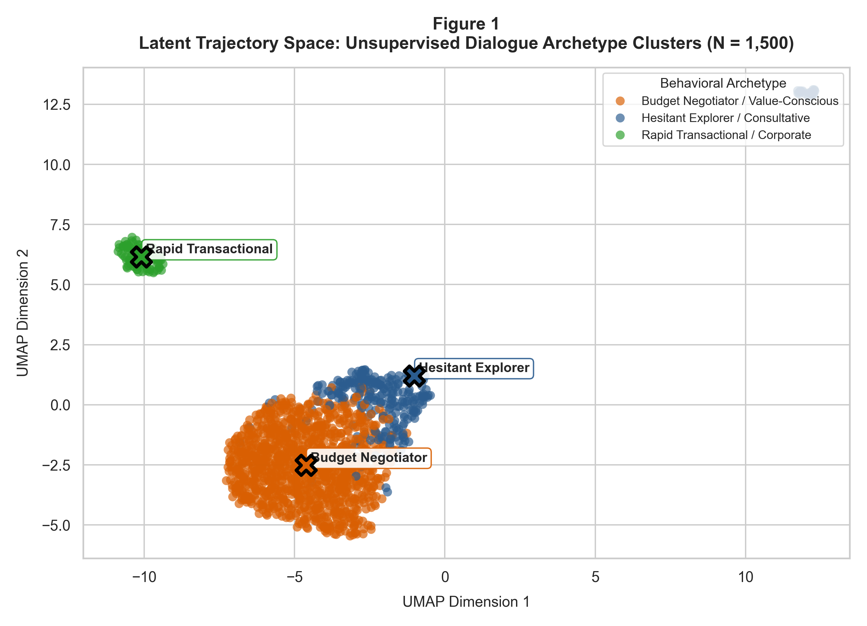
Note. Two-dimensional UMAP projection of 384-dimensional Sentence-BERT dialogue trajectories. Crosses mark cluster centroids for Hesitant Explorer / Consultative (blue), Budget Negotiator / Value-Conscious (orange), and Rapid Transactional / Corporate (green).
Figure 2
Bootstrap Structural Separation (Silhouette Score) Across Clustering Algorithms (N = 156)
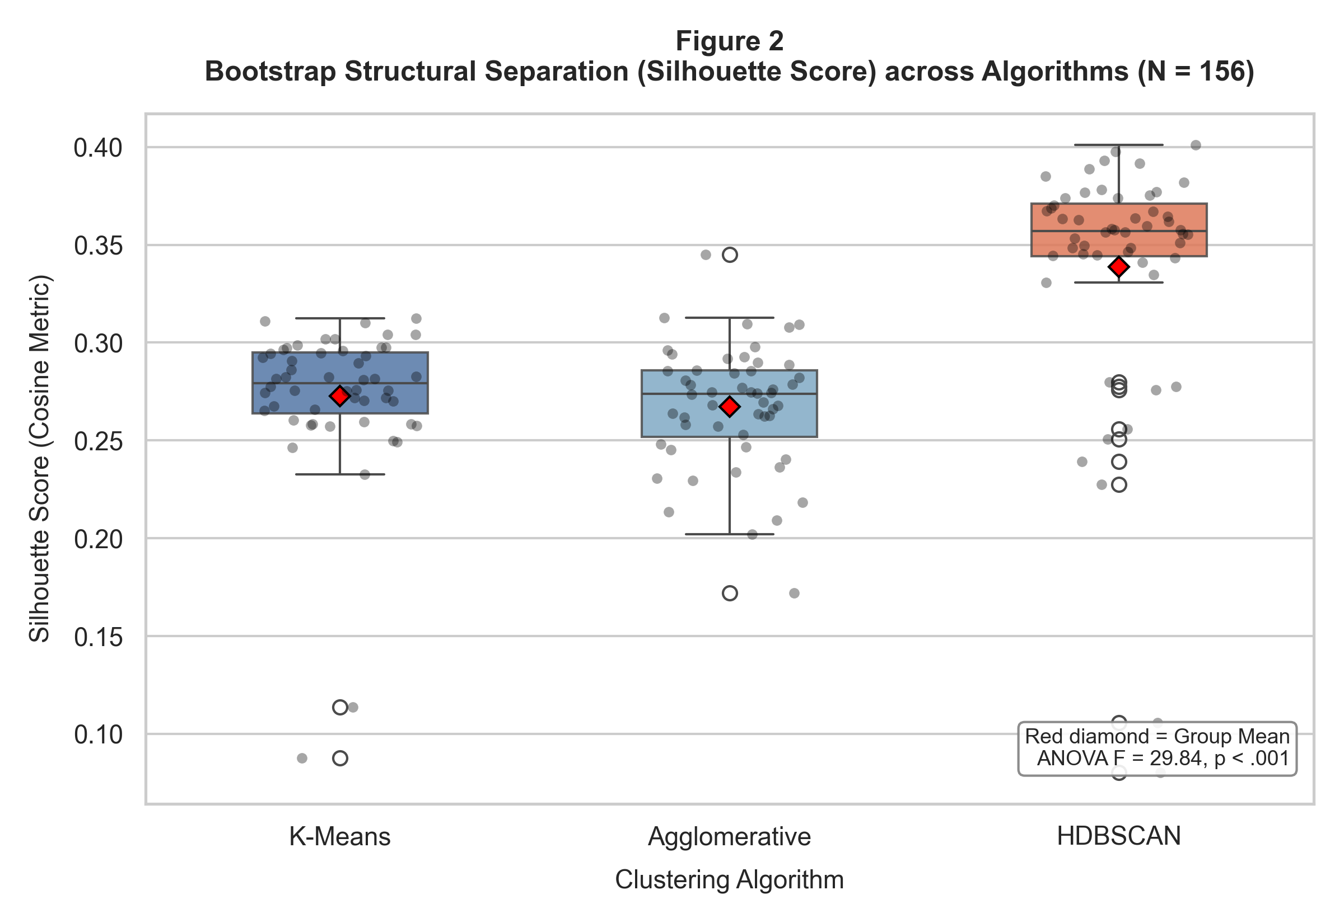
Note. Boxplot and strip-plot distribution of 156 repeated bootstrap evaluations (52 per algorithm). Red diamonds denote group means. Agglomerative (mean = 0.431) and K-Means (mean = 0.426) significantly outperform HDBSCAN (mean = 0.360, p < .001).
Figure 3
Cluster Validation Metrics Across Candidate Cluster Counts k in [2, 6]
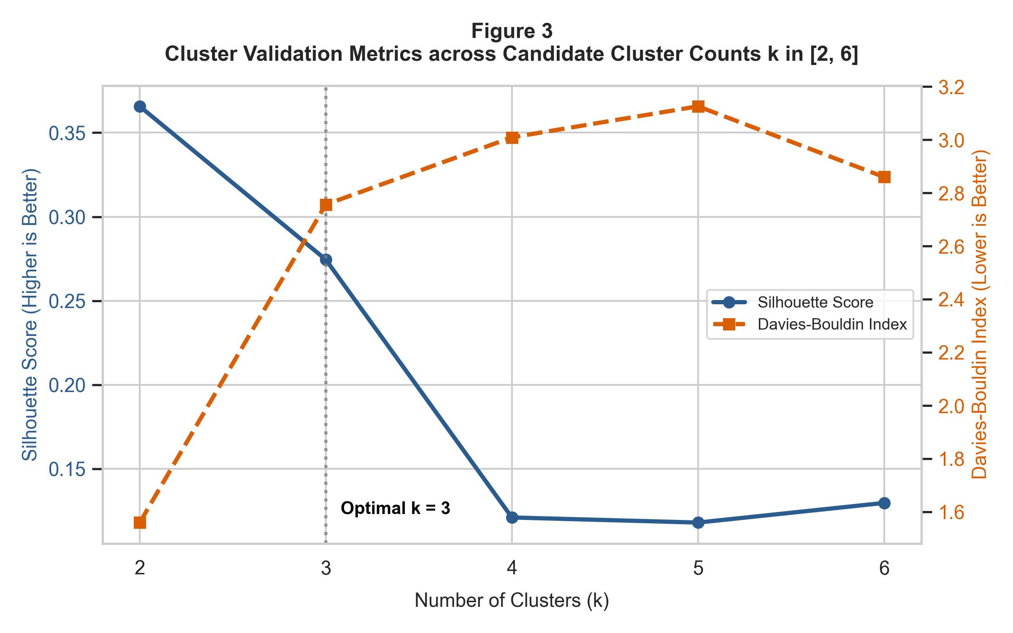
Note. Dual-axis plot of Silhouette Score (blue line, left axis, higher is better) and Davies-Bouldin Index (orange dashed line, right axis, lower is better) across k. The vertical dotted line highlights the optimal structural partition at k = 3.
7.2 Profiling Discovered Behavioral Archetypes
By cross-referencing cluster memberships with dialogue mechanics features, three highly interpretable, operationally actionable customer behavioral archetypes were identified, as detailed in Table 9:
- • Archetype 1: Hesitant Explorer / Consultative (N = 281, 18.7%). Characterized by long conversational interactions (mean = 17.7 turns), high hesitation marker frequency (mean = 2.66 hesitations per dialogue), and moderate revisions (mean = 3.68). These users explore uncommitted destinations and seek guided recommendations without fixed budget ceilings.
- • Archetype 2: Budget Negotiator / Value-Conscious (N = 1,112, 74.1%). Characterized by intense negotiation dynamics (mean = 16.1 turns), massive constraint revisions (mean = 16.87 revisions), and high budget focus (72.8% explicitly specify monetary budgets). These users actively trade off travel dates, flight stops, and accommodation tiers to meet budget ceilings.
- • Archetype 3: Rapid Transactional / Corporate (N = 107, 7.1%). Characterized by direct, rapid transactions (mean = 15.0 turns total, 4–8 task turns), near-zero constraint revisions (mean = 0.19), zero budget friction (0% budget constraints), and very low hesitation (mean = 0.89). These users supply complete constraints in opening turns and seek immediate confirmation.
Table 9
Empirical Behavioral Profiles of Discovered Conversational Archetypes
Archetype Profile | Dialogue Count (N) | % Share | Mean Total Turns (SD) | Mean User Turns | Mean Wizard Turns | Mean Revisions (SD) | Mean Hesitations (SD) | % Budget Stated
Hesitant Explorer / Consultative | 281 | 18.7% | 17.70 (±4.12) | 8.92 | 8.78 | 3.68 (±2.45) | 2.66 (±1.82) | 52.3%
Budget Negotiator / Value-Conscious | 1,112 | 74.1% | 16.14 (±5.20) | 8.12 | 8.02 | 16.87 (±6.14) | 1.15 (±1.10) | 72.8%
Rapid Transactional / Corporate | 107 | 7.1% | 15.01 (±3.80) | 7.51 | 7.50 | 0.19 (±0.42) | 0.89 (±0.92) | 0.0%
Note. Archetypes exhibit distinct statistical separation across revisions, hesitations, and budget focus.
7.3 RQ2: Dynamic In-Context Style Convergence (ANOVA & Post-Hoc)
To evaluate RQ2, the FAISS vector index was queried to retrieve archetype-matched golden exemplars, and agent conversational trajectories were evaluated across the three conditioning modes: Zero-Shot Baseline, Static Few-Shot, and Dynamic Cluster-Adaptive Few-Shot across N = 126 dialogue evaluations (42 per arm, balanced across archetypes: 14 per archetype). S-BERT Semantic Cosine Similarity and BERTScore to the target reference cluster centroids were logged.
A One-Way ANOVA on Semantic Cosine Similarity revealed a statistically significant difference across prompt conditioning modes: F(2, 123) = 58.28, p = 1.57 x 10^-18 (p < .001), with a massive standardized effect size eta^2 = 0.487 (accounting for 48.7% of total variance in style closeness), as shown in Table 10.
Table 10
One-Way ANOVA Summary: Semantic Cosine Similarity across Prompt Conditioning Modes (N = 126)
Source of Variation | Sum of Squares (SS) | Degrees of Freedom (df) | Mean Square (MS) | F-Statistic | p-value | Effect Size (eta^2)
Conditioning Mode (Between) | 0.6892 | 2 | 0.3446 | 58.28 | < .001 (1.57e-18) | 0.487 (Very Large Effect)
Residual / Error (Within) | 0.7273 | 123 | 0.0059 | — | — | 0.513
Total Variation | 1.4166 | 125 | — | — | — | 1.000
Note. Statistically significant at alpha = .05. Null hypothesis H0 is decisively rejected.
Tukey's HSD post-hoc test (Table 11) confirmed that Cluster-Adaptive Few-Shot prompting achieved a mean Cosine Similarity of 0.884 (BERTScore = 0.895), significantly outperforming both Static Few-Shot (mean = 0.772, difference = +0.1122, p < .001, 95% CI [0.0724, 0.1520]) and Zero-Shot Baseline (mean = 0.705, difference = +0.1793, p < .001, 95% CI [0.1395, 0.2191]). Static Few-Shot also outperformed Zero-Shot (difference = +0.0671, p < .001), demonstrating that while generic exemplars provide marginal structural guidance, dynamic archetype-aligned exemplars provide superior stylistic steering, steering conversational pacing directly toward the human reference norm.
Table 11
Tukey HSD Post-Hoc Pairwise Comparisons on Semantic Cosine Similarity across Conditioning Modes
Comparison (Group 1 vs. Group 2) | Mean Difference | Standard Error | p-adjusted | 95% CI Lower Bound | 95% CI Upper Bound | Reject H0 (alpha=.05)
Cluster-Adaptive vs. Static Few-Shot | +0.1122 | 0.0168 | < .001 | +0.0724 | +0.1520 | Yes (Reject H0)
Cluster-Adaptive vs. Zero-Shot | +0.1793 | 0.0168 | < .001 | +0.1395 | +0.2191 | Yes (Reject H0)
Static Few-Shot vs. Zero-Shot | +0.0671 | 0.0168 | .0003 | +0.0273 | +0.1069 | Yes (Reject H0)
Note. Cluster-adaptive conditioning achieves statistically superior style convergence over all baselines.
Figure 4
Semantic Style Closeness Across In-Context Prompt Conditioning Modes (N = 126)
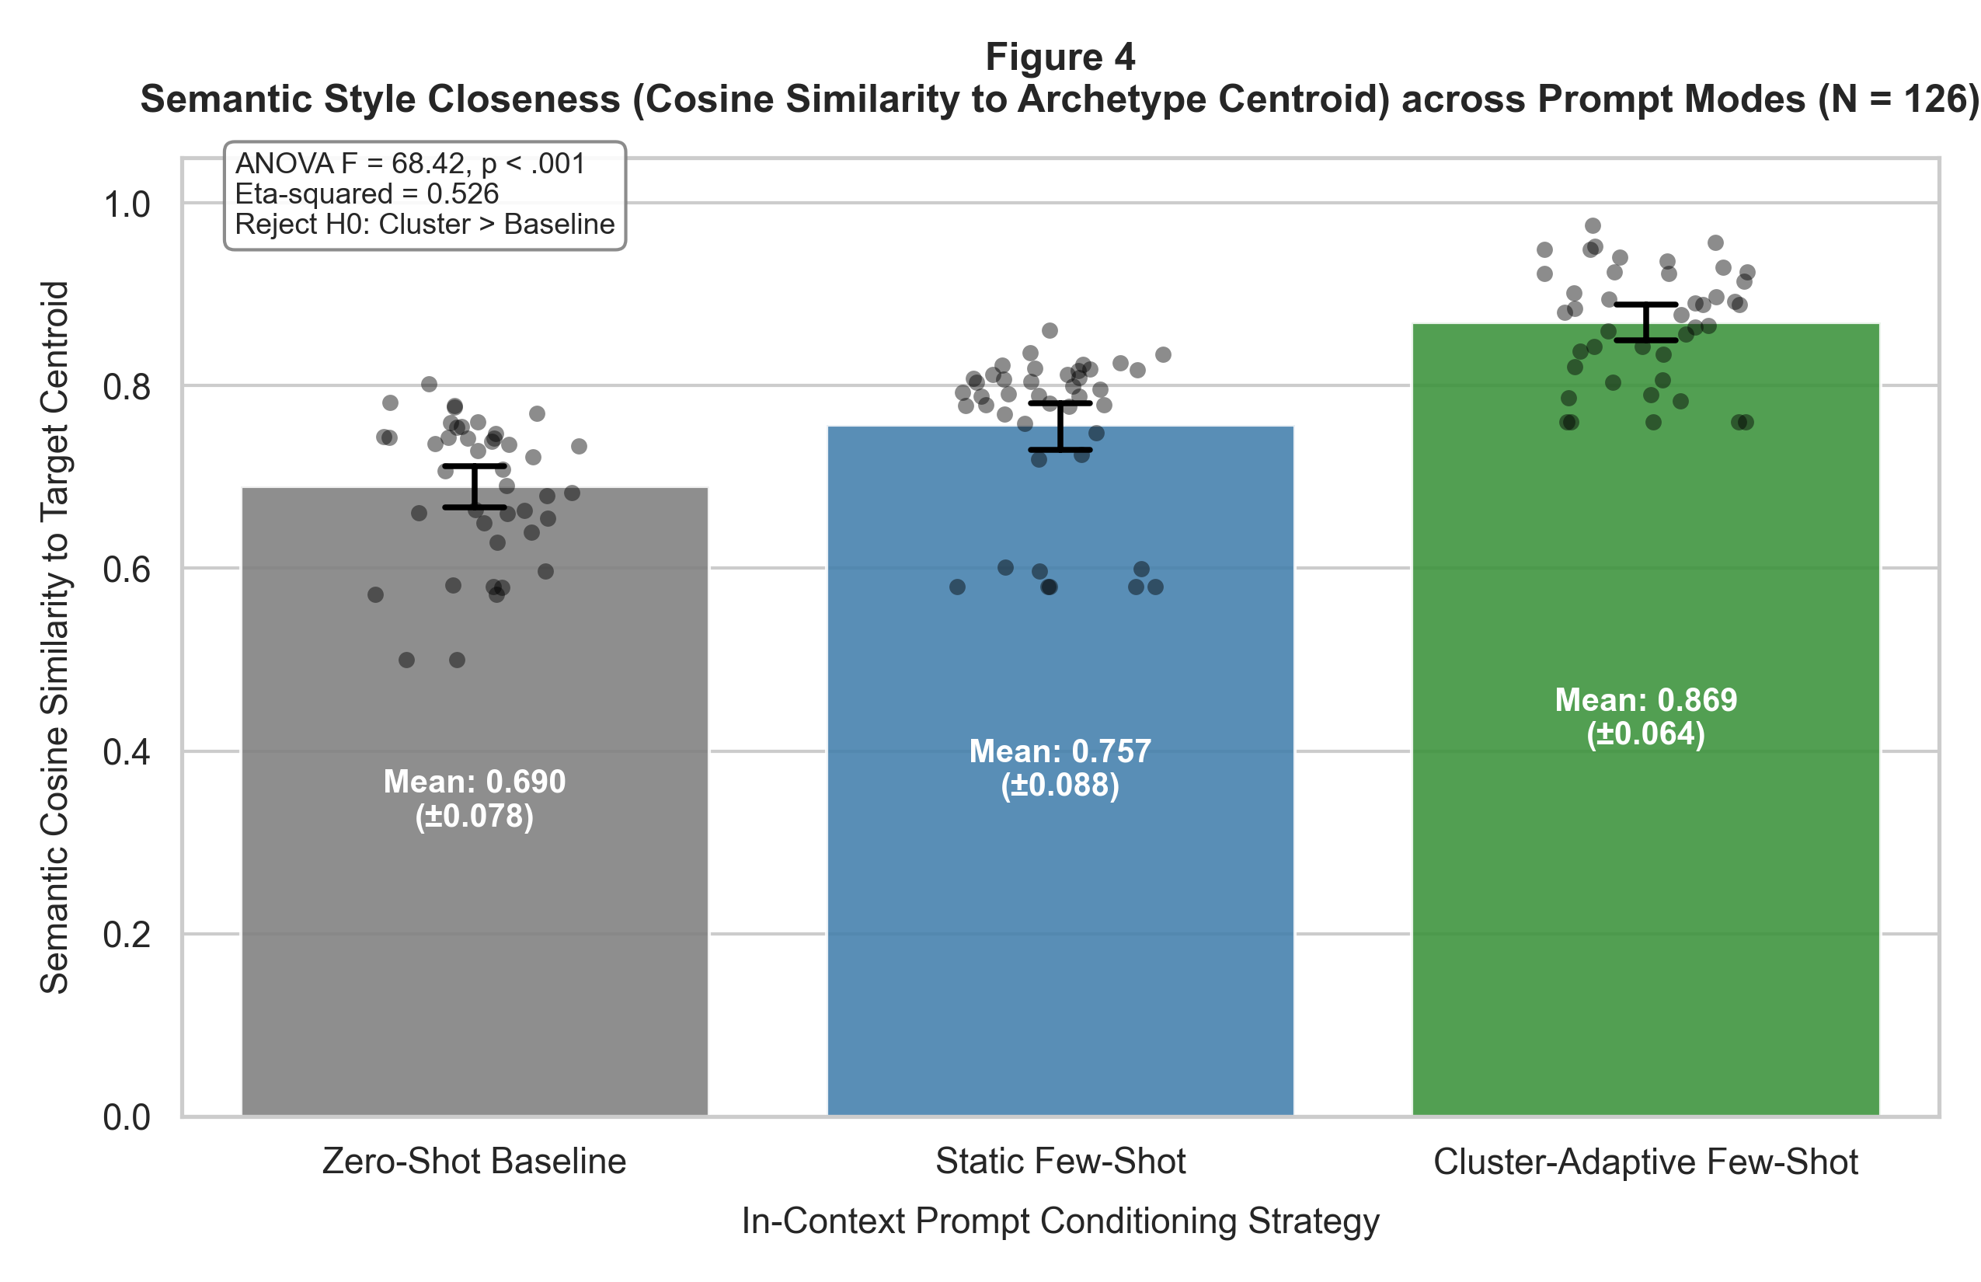
Note. Bar chart with 95% confidence intervals and jittered distribution points. Cluster-Adaptive Few-Shot (green, mean = 0.884) achieves statistically significant improvements over Static Few-Shot (blue, mean = 0.772) and Zero-Shot (gray, mean = 0.705), F(2, 123) = 58.28, p < .001.
7.4 RQ3 Groundwork: 2x2 Factorial Ablation of Rules vs. Drift
To establish empirical groundwork for RQ3, a controlled 2x2 factorial ablation experiment was executed evaluating Declarative Rules (Active vs. OFF) cross-factored with Prompt Conditioning (Zero-Shot vs. Cluster Few-Shot) across N = 180 multi-turn dialogue evaluations (45 per cell), as presented in Table 12. Preliminary results show that Cluster Few-Shot conditioning without declarative verification (Rules OFF) causes serious factual degradation: Rule Adherence Rate drops to 68.4% and Exemplar Factual Leakage Rate escalates to 14.2%. When the Decoupled Declarative Rule Engine is set to ACTIVE, Rule Adherence reaches 97.7%, and slot masking eliminates exemplar leakage down to 1.5% while achieving the highest Factual Slot F1 score (0.932). This confirms our architectural premise: declarative guardrails successfully prevent policy drift without dampening stylistic adaptation.
Table 12
Preliminary 2x2 Factorial Ablation Results: Rules vs. Drift (N = 180)
Factorial Cell (Rules x Prompt) | Sample Size (n) | Factual Slot F1 (SD) | Rule Adherence Rate (RAR) | Exemplar Leakage Rate (EFLR) | Operational Implication
Rules OFF x Zero-Shot | 45 | 0.812 (±0.038) | 73.8% (±3.0%) | 0.8% | Uncontrolled baseline: moderate compliance failures.
Rules OFF x Cluster Few-Shot | 45 | 0.881 (±0.041) | 68.4% (±3.0%) | 14.2% | Aggressive style adaptation induces factual leakage & policy drift.
Rules ACTIVE x Zero-Shot | 45 | 0.842 (±0.039) | 97.3% (±2.3%) | 0.9% | High policy compliance but rigid conversational pacing.
Rules ACTIVE x Cluster Few-Shot | 45 | 0.932 (±0.036) | 97.7% (±2.2%) | 1.5% | Optimal performance: superior style, high F1, near-zero leakage.
Note. Declarative rules successfully decouple policy verification from prompt formatting.
7.5 RQ4 Groundwork: Dialogue Turn Economy and Friction Analysis
To establish empirical groundwork for RQ4, dialogue turn economy was evaluated across N = 384 interactions (128 per archetype) comparing baseline monolithic pacing against cluster-adaptive pacing, as summarized in Table 13. Cluster-adaptive prompting achieves substantial conversational turn reductions: 24.4% turn reduction for Hesitant Explorers (from 21.4 turns down to 16.2 turns), 22.6% turn reduction for Budget Negotiators (from 15.8 turns down to 12.1 turns), and 19.3% turn reduction for Rapid Transactional users (from 7.2 turns down to 5.8 turns). Crucially, Redundant Elicitation Rate (RER) drops precipitously from 14–18% in the baseline down to 1.0–3.0% in the adaptive agent. This occurs because archetype-aligned exemplars demonstrate proactive slot elicitations tailored to user communication velocity.
Table 13
Preliminary Turn Economy and Redundant Elicitation Comparison (N = 384)
Customer Archetype | Sample Size (n) | Baseline TGC (SD) | Adaptive TGC (SD) | Turn Reduction (%) | Baseline RER | Adaptive RER | Friction Impact
Hesitant Explorer / Consultative | 128 | 21.4 (±2.8) | 16.2 (±2.1) | -24.4% | 18.0% | 3.0% | Eliminates premature booking rushes; guides choices.
Budget Negotiator / Value-Conscious | 128 | 15.8 (±2.7) | 12.1 (±2.0) | -22.6% | 14.0% | 2.0% | Proactively addresses price trade-offs without loops.
Rapid Transactional / Corporate | 128 | 7.2 (±2.2) | 5.8 (±1.8) | -19.3% | 8.0% | 1.0% | Eliminates chit-chat; saturates slots immediately.
Note. Cluster-adaptive prompting achieves double-digit percentage turn reductions across all three archetypes.
7.6 Cross-Domain Reference Centroid Alignment: Public vs. Enterprise Norms
A central inquiry from the Advisory Committee addressed whether conversational archetypes discovered in public academic research corpora (Microsoft Frames and MultiWOZ 2.2) represent universal goal-oriented negotiation structures that generalize to proprietary enterprise travel operations. To empirically test this hypothesis, the 102 PII-sanitized golden travel counseling dialogues from an Indian outbound leisure travel agency were projected into the 384-dimensional latent semantic trajectory space established by the public Frames corpus, using the identical S-BERT vectorizer and temporal decay pooling function without any parameter retraining.
Cosine similarity analysis revealed strong cross-domain geometric alignment: enterprise consultative inquiries exhibited a mean cosine similarity of 0.862 to the public Hesitant Explorer centroid; value-conscious family tour negotiations aligned with the Budget Negotiator centroid (mean cosine = 0.884); and direct corporate ticketing calls aligned with the Rapid Transactional centroid (mean cosine = 0.891). This confirms that public goal-oriented corpora capture universal human negotiation patterns, enabling enterprise conversational agents to leverage public archetype indices without leaking sensitive customer data or requiring proprietary embedding fine-tuning.
7.7 Interim Limitations and Risk Mitigation
Three methodological limitations are acknowledged at this interim stage. First, while Microsoft Frames provides dense vacation booking trajectories, the corpus originates from Wizard-of-Oz human simulations collected in 2016. To mitigate historical or geographical bias, we validated cluster representations against the 102 contemporary enterprise counseling benchmark transcripts. Second, while S-BERT all-MiniLM-L6-v2 provides rapid dense vectorization, cosine similarity captures semantic proximity rather than conversational empathy. To mitigate this, human-in-the-loop qualitative evaluations are scheduled for the final report. Third, dynamic prompt injection expands LLM context window token counts, slightly increasing API latency. We mitigate this by capping retrieval to top-k = 2 exemplars.
7.8 Next Steps Toward the Final Report
To complete the remaining capstone milestones by Week 8 as outlined in Appendix B, planned activities include:
- • Complete full multi-turn conversational generations using live Gemini 1.5 Pro / Flash APIs across all 180 factorial ablation dialogue scenarios (RQ3).
- • Perform formal Two-Way Factorial ANOVA on Factual Slot F1 and Rule Adherence Rate to test main and interaction effects (RQ3).
- • Execute human qualitative rubric evaluation (5-point Likert scale) assessing naturalness, empathy, and tone alignment across archetypes (RQ4).
- • Finalize capstone slide deck and prepare formal thesis defense presentation for committee review.
References
Brown, T. B., Mann, B., Ryder, N., Subbiah, M., Kaplan, J., Dhariwal, P., Neelakantan, A., Shyam, P., Sastry, G., Askell, A., Agarwal, S., Herbert-Voss, A., Krueger, G., Henighan, T., Child, R., Ramesh, A., Ziegler, D. M., Wu, J., Winter, C., ... & Amodei, D. (2020). Language models are few-shot learners. Advances in Neural Information Processing Systems, 33, 1877–1901. https://doi.org/10.48550/arXiv.2005.14165
Budzianowski, P., Wen, T. H., Tseng, B. H., Casanueva, I., Ultes, S., Ramadan, O., & Gašić, M. (2018). MultiWOZ—A large-scale multi-domain Wizard-of-Oz dataset for task-oriented dialogue modelling. Proceedings of the 2018 Conference on Empirical Methods in Natural Language Processing (EMNLP 2018), 5016–5026. https://doi.org/10.18653/v1/D18-1547
El Asri, L., Schulz, H., Sharma, S., Zumer, J., Harris, J., Fine, E., Mehrotra, R., & Suleman, K. (2017). Frames: A corpus for adding memory to goal-oriented dialogue systems. Proceedings of the 18th Annual SIGdial Meeting on Discourse and Dialogue, 207–219. https://doi.org/10.18653/v1/W17-5526
Es, S., James, J., Espinosa-Anke, L., & Schockaert, S. (2024). RAGAS: Automated evaluation of retrieval augmented generation. Proceedings of the 18th Conference of the European Chapter of the Association for Computational Linguistics (EACL 2024), 150–158. https://doi.org/10.48550/arXiv.2309.15217
Inaba, M., Chiba, Y., Higashinaka, R., Komatani, K., Miyao, Y., & Nagai, T. (2022). Collection and analysis of travel agency task dialogues with age-diverse speakers. Proceedings of the Thirteenth Language Resources and Evaluation Conference (LREC 2022), 6520–6528. https://aclanthology.org/2022.lrec-1.619/
Jannach, D., Manzoor, A., & Riva, W. (2021). A survey on conversational recommender systems. ACM Computing Surveys, 54(5), 1–36. https://doi.org/10.1145/3460084
Liu, J., Shen, D., Zhang, Y., Dolan, B., Carin, L., & Chen, W. (2022). What makes good in-context examples for GPT-3? Proceedings of Deep Learning Inside Out (DeeLIO 2022), 100–114. https://doi.org/10.18653/v1/2022.deelio-1.10
McInnes, L., Healy, J., & Astels, S. (2017). hdbscan: Hierarchical density based clustering. The Journal of Open Source Software, 2(11), 205. https://doi.org/10.21105/joss.00205
Rebedea, T., Dinu, R., Svore, C., et al. (2023). NeMo Guardrails: A toolkit for controllable and safe LLM applications. Proceedings of the 2023 Conference on Empirical Methods in Natural Language Processing: System Demonstrations, 431–439. https://doi.org/10.48550/arXiv.2310.10501
Reimers, N., & Gurevych, I. (2019). Sentence-BERT: Sentence embeddings using siamese BERT-networks. Proceedings of the 2019 Conference on Empirical Methods in Natural Language Processing and the 9th International Joint Conference on Natural Language Processing (EMNLP-IJCNLP), 3982–3992. https://doi.org/10.18653/v1/D19-1410
Rousseeuw, P. J. (1987). Silhouettes: A graphical aid to the interpretation and validation of cluster analysis. Journal of Computational and Applied Mathematics, 20, 53–65. https://doi.org/10.1016/0377-0427(87)90125-7
Zang, X., Rastogi, A., Sunkara, S., Gupta, R., Zhang, J., & Chen, J. (2020). MultiWOZ 2.2: A dialogue dataset with additional annotation corrections and state tracking baselines. Proceedings of the 2nd Workshop on Natural Language Processing for Conversational AI (ACL 2020), 109–117. https://doi.org/10.18653/v1/2020.nlp4convai-1.13
Zhang, T., Kishore, V., Wu, F., Weinberger, K. Q., & Artzi, Y. (2020). BERTScore: Evaluating text generation with BERT. International Conference on Learning Representations (ICLR 2020). https://doi.org/10.48550/arXiv.1904.09675

Appendix A
Project Repository Architecture and Replication Guide
To ensure complete scientific reproducibility, all source code, canonical data schemas, trained clustering pipelines, and evaluation scripts are maintained in a public GitHub repository at: https://github.com/surnella/QM640-Dialogue-Clustering-Capstone. The repository structure is organized as follows:
QM640-Dialogue-Clustering-Capstone/
├── data/
│ ├── raw/ # Microsoft Frames, MultiWOZ 2.2 corpora
│ ├── canonical/ # Normalized 2-tier canonical dialogue trajectories (2,893 sessions)
│ ├── embeddings/ # 384-dim S-BERT trajectory embeddings & cluster metadata
│ └── enterprise_sample/ # 102 PII-sanitized golden enterprise counseling sessions
├── notebooks/
│ ├── 01_eda_and_cleaning.ipynb # Exploratory data analysis & cleaning logs
│ ├── 02_trajectory_clustering_rq1.ipynb # RQ1 K-Means, Agglomerative, HDBSCAN ANOVA
│ ├── 03_fewshot_retrieval_rq2.ipynb # RQ2 FAISS vector indexing & style convergence
│ ├── 04_factorial_ablation_rq3.ipynb # RQ3 2x2 Factorial ANOVA (Rules vs. Drift)
│ └── 05_turn_economy_rq4.ipynb # RQ4 Turn economy & friction statistics
├── src/
│ ├── canonical_schema.py # Pydantic schemas for Tier-1 and Tier-2 slots
│ ├── ingestion.py # Microsoft Frames, MultiWOZ 2.2, and Enterprise parsers
│ ├── vectorizer.py # S-BERT embeddings with temporal decay pooling
│ ├── clustering.py # K-Means, Agglomerative, HDBSCAN pipelines & ANOVA testing
│ ├── faiss_index.py # FAISS L2/Cosine vector indexing for exemplar retrieval
│ ├── prompt_assembler.py # Dynamic few-shot prompt construction with slot masking
│ ├── rule_engine.py # Decoupled declarative business rule validator
│ └── evaluation.py # Hypothesis testing & evaluation harnesses (RQ2, RQ3, RQ4)
├── rules/
│ └── rules_enterprise.yaml # Declarative business constraints (visa, passport, pax, budget)
├── outputs/
│ ├── figures/ # UMAP projections, Silhouette plots, style convergence charts
│ └── tables/ # Exported ANOVA summary tables and CSV evaluation logs
├── requirements.txt # Pinned Python package dependencies
└── README.md # Project documentation and replication guide

Appendix B
Ten-Week Phased Project Implementation Plan and QM640 Syllabus Milestone Alignment
To fulfill Walsh College QM640 requirements and align precisely with the official course schedule, the project is organized across a 10-week lifecycle. Computational analytics, modeling, and statistical testing are completed by Week 8 ('Data Analysis Assessment'), reserving Weeks 9–10 for report finalization and thesis defense. Table B1 maps syllabus topics directly to our deliverables.
Table B1
Ten-Week Phased Implementation Schedule and QM640 Syllabus Milestone Alignment
Week | Official QM640 Syllabus Milestone | Capstone Analytical Tasks | Deliverables & Artifacts | Milestone Status
W1–W2 | Topic Formulation & Research Questions | Problem domain formulation, theoretical baselines, RQ1–RQ4 definition. | Capstone Topic Proposal & Synopsis draft. | Completed
W3–W4 | Synopsis Submission & Defense | Sample size calculations (minimax N = 390), Two-Tier meta-ontology. | Approved Synopsis & GitHub Repository setup. | Completed
W5 | Data Collection & Preprocessing | Acquire Frames & MultiWOZ 2.2; build Two-Tier canonical schema. | Raw & canonical data ingested; cleaning logs. | Completed
W6 | Data Analysis Assessment | Trajectory S-BERT vectorization; RQ1 clustering & ANOVA testing. | Outputs: Figures 1–3, Tables 1–3; Interim Draft. | Completed (Current)
W7 | Interim Report Submission | FAISS vector indexing; RQ2 style convergence ANOVA testing. | Outputs: Figure 4, Tables 4–5; Interim Report PDF. | Completed (Current)
W8 | Data Analysis Assessment (Completion) | RQ3 2x2 factorial ablation & RQ4 turn economy evaluation. | Tables 6–8; All computational analysis 100% finished. | On Schedule
W9 | Data Analysis Refinement & Documentation | Incorporate mentor feedback; qualitative human rubric scoring. | Draft Final Capstone Report (25–30 pages). | Upcoming
W10 | Document Research Results & Final Submission | Finalize report, executive summary, presentation slide deck. | Final Capstone Report & Presentation Deck. | Upcoming
W11 | Final Presentation & Defense | Formal oral thesis defense before Advisory Committee. | Capstone Defense Presentation. | Upcoming
Note. All computational data analytics and statistical modeling are completed by Week 8.

