Cluster-Adaptive Prompting for Multi-Turn Travel and Tourism Conversational Systems
Final Report

Surnella Sandeep
Department of Data Analytics, Walsh College
QM640: Data Analytics Capstone
Mr. Smitraj Raut
October 28, 2026

GitHub repository: https://github.com/surnella/QM640-Dialogue-Clustering-Capstone
Contents
Abstract 4
Introduction 5
Background and Context 5
Problem Statement 6
Purpose of the Study and Research Questions 7
Contributions and Expected Value 8
Literature Review 8
Literature Review Approach and Relevance Matrix 8
Thematic Synthesis and Research Gaps 9
Materials and Methods 11
Data Sources, Access, and Ethical Governance 11
Data Dictionary and Data Cleaning 11
Exploratory Data Analysis (Univariate, Bivariate, and Multivariate) 13
Research Design, Hypotheses, and Statistical Power Analysis 16
Model Selection, Mathematical Formulation, and Evaluation Metrics 17
Architecture and Workflow 19
System Architecture and Algorithmic Workflows 19
Pipeline Component Specifications and Technology Stack 20
Results, Analysis, and Synthesis 21
Consolidated Model Performance and Hypothesis Testing Summary 21
RQ1 Results: Trajectory Clustering, Refined Archetypes, and Prefix Routing 22
RQ2 Results: Cluster-Adaptive Few-Shot Prompting on Primary Versus Refined Archetypes 25
RQ3 Results: 2 × 2 Factorial Evaluation of Declarative Rules and Adaptive Prompting 27
RQ4 Results: 2 × 3 Multi-Turn Simulation of Turn Economy Across Archetypes 29
Technical Interpretation, Business Significance, and Synthesis of Conclusions 31
Implementation, Limitations, and Future Scope 32
Deployment Architecture, System Integration, and Real-World Use Case 32
Computational Reproducibility and Operational Requirements 33
Study Limitations and Threats to Validity 33
Future Scope and Research Extensions 33
References 35
Appendix A 40
Appendix B 43
Appendix C 44
Appendix D 47
Appendix E 51

Abstract
Online travel agencies increasingly deploy large language model (LLM) assistants for package booking, yet static prompts ignore traveler decision-making heterogeneity, while naive few-shot prompting leaks stale entities and violates booking policies. This study evaluates a neuro-symbolic, cluster-adaptive framework coupling early-turn behavioral-semantic archetype routing and slot-masked FAISS retrieval with a declarative rule engine. Using 1,369 Microsoft Frames dialogues (1,334 analytic: golden n = 933, test n = 401) and 1,499 MultiWOZ 2.2 dialogues, four hypotheses were tested with Sentence-BERT, Gemini 3,072-d embeddings, Gemini 2.5 Flash, and Gemini 2.5 Pro. For RQ1, clustering algorithms differed across 159 runs, F(2, 156) = 91.33, p < .001, η² = .54, and combining Gemini prefix embeddings with a 16-field behavioral profile on the first nine user messages yielded three stable refined archetypes—Decisive Booker, Open Explorer, and Rigid-Constraint Seeker (ARI = .76; held-out routing κ = .535 at M = 5 to .958 at M = 9). For RQ2 (N = 33 repeated-measures), cluster-adaptive prompting increased style convergence, F(1.88, 60.29) = 9.79, p < .001, η_{p}² = .23, and cut pacing error to 3.87 words, F = 7.10, p = .007. For RQ3 (N = 144 2 × 2 factorial; dual-judge κ = .917), active rules raised violation enforcement from 5.6% to 98.6%, F(1, 140) = 43.92, p < .001, eliminated 35.9% entity leakage to 0.0%, interaction F(1, 140) = 34.82, p < .001, and raised slot F₁ to .952, F(1, 140) = 489.52, p < .001. For RQ4 (N = 180 2 × 3 simulation; persona κ = .933), cluster-adaptive prompting cut turns by 29.5%–42.7%, F(1, 174) = 664.43, p < .001, interaction F(2, 174) = 10.89, p < .001, and eliminated redundant slot elicitation, F(1, 174) = 63.02, p < .001.
Keywords: conversational AI, travel chatbots, trajectory clustering, few-shot learning, guardrails

Introduction

Background and Context
Conversational artificial intelligence (AI) assistants have become a core digital channel in travel, tourism, and hospitality, supporting destination discovery, package comparison, and itinerary booking (Buhalis & Sinarta, 2019; Ivanov & Webster, 2019; Jannach et al., 2021). Unlike single-turn question answering, vacation package booking is a consultative, multi-turn negotiation in which travelers balance competing constraints across origin, destination, dates, duration, hotel tier, and budget (El Asri et al., 2017). Empirical analyses of human travel dialogues demonstrate that travelers converse in distinct behavioral styles: some state fixed parameters up front and seek immediate confirmation, others explore multiple destinations and hotel tiers side by side, and others insist on rigid date and luxury constraints that require proactive trade-off resolution when preferred inventory exceeds their budget ceiling (Inaba et al., 2022; Melián-González et al., 2021).
Despite this behavioral diversity, commercial large language model (LLM) travel assistants typically use one static system prompt and a uniform sequential intake script. Asking clarifying questions one slot at a time or offering a single hotel option per turn creates repetitive turns and session abandonment. Conversely, adapting an LLM's style purely through in-context few-shot examples introduces two severe reliability hazards (Liu et al., 2022; Rebedea et al., 2023): first, unmasked retrieved examples cause factual entity leakage, where the model copies stale hotel names, airfares, or promo codes from the examples into the active session; second, stylistic prompt instructions compete with business rules, causing the assistant to overlook mandatory visa windows, passport validity thresholds, party-size limits, or discount caps (Yao et al., 2024). Resolving both personalization and compliance requires a neuro-symbolic architecture that decouples behavioral style adaptation from deterministic policy verification.

Problem Statement
Business problem statement. Online travel agencies (OTAs), tour operators, and hospitality contact centers suffer from low self-service conversion and elevated session abandonment because static conversational assistants fail to adapt their information density and recommendation strategy to distinct customer decision-making styles, while unverified generative responses expose enterprises to financial and regulatory liability from booking policy violations and hallucinated package terms (Buhalis & Sinarta, 2019; Ivanov & Webster, 2019; Melián-González et al., 2021).
Technical problem statement. Existing LLM dialogue systems lack (a) an empirically validated representation for clustering multi-turn user behavior into stable archetypes that can be routed accurately from early dialogue prefixes without end-of-dialogue outcome leakage, (b) a slot-masked exemplar retrieval mechanism that achieves target archetype style convergence without inducing entity leakage, and (c) formal factorial evidence quantifying the main and interaction effects of external declarative rule verification and cluster-adaptive prompting on slot fidelity, policy adherence, and multi-turn turn economy (Acikgoz et al., 2025; Liu et al., 2022; Rebedea et al., 2023).
Measurable research formulation. This study models six quantitative dependent variables (Y)—cluster separation Silhouette (Y₁), style convergence cosine and pacing error (Y₂), policy rule adherence rate (Y₃), exemplar entity leakage rate (Y₄), factual slot F₁ (Y₅), and log-transformed turns to goal completion and redundant elicitation rate (Y₆)—as functions of four manipulated independent variables (X): clustering algorithm and trajectory representation (X₁, RQ1), in-context conditioning strategy (X₂, RQ2), rule-engine mode crossed with prompting strategy (X₃, RQ3), and prompting strategy crossed with refined user archetype (X₄, RQ4).

Purpose of the Study and Research Questions
The purpose of this quantitative study is to develop and evaluate an end-to-end neuro-symbolic, cluster-adaptive conversational framework on public human travel dialogues across four linked research questions (Table 1).
Table 1
Research Questions, Hypotheses, and Analytical Framework
RQ | Research question | Null and alternative hypotheses | Experimental design and statistical test
RQ1 | Which clustering algorithm (K-Means, Ward agglomerative, HDBSCAN) best separates dialogue embeddings, and which stable, early-routable user archetypes emerge? | H₀₁: Equal mean Silhouette across algorithms. H_{a1}: At least one differs, and truncated behavioral-semantic prefixes yield stable (ARI ≥ .60), routable archetypes. | One-way ANOVA across N = 159 runs (Welch & Kruskal–Wallis checks; Tukey & Games–Howell post hoc) + representation × truncation grid
RQ2 | Does cluster-adaptive few-shot prompting increase style convergence and pacing calibration relative to zero-shot and static few-shot prompting? | H₀₂: Equal mean style cosine across conditions. H_{a2}: Cluster-adaptive > static and zero-shot on refined user archetypes. | One-way repeated-measures ANOVA (N = 33 dialogues × 3 conditions = 99 calls; Greenhouse–Geisser, Friedman, Holm contrasts)
RQ3 | How do a declarative rule engine and cluster-adaptive prompting interact to govern rule adherence, exemplar leakage, slot F₁, and style alignment? | H₀₃: No main or interaction effects. H_{a3}: Active rules raise adherence and slot F₁ and eliminate few-shot entity leakage. | 2 × 2 factorial ANOVA (N = 144, n = 36/cell; OLS, HC3, and ART checks; dual-LLM judge κ)
RQ4 | Does cluster-adaptive prompting with an informed-slot ledger reduce turns to goal completion and redundant elicitation differently across user archetypes? | H₀₄: No prompting or prompting × archetype interaction effects. H_{a4}: Cluster-adaptive prompting reduces log turns and RER with an archetype interaction. | 2 × 3 factorial ANOVA on log turns and RER (N = 180, n = 30/cell; OLS, HC3, ART, Welch t, Mann–Whitney U; persona κ)
Note. RQ = research question; ARI = adjusted Rand index; HC3 = heteroscedasticity-consistent SE; ART = aligned rank transform; RER = redundant elicitation rate. All tests use α = .05.

Contributions and Expected Value
This study delivers four contributions: (1) proving that truncating dialogues to the first nine user messages and combining Gemini prefix embeddings with structured LLM behavioral ratings yields stable user archetypes (ARI = .76) with high held-out prefix routing agreement (κ = .535 at five messages to .958 at nine messages); (2) contrasting primary versus refined archetypes in RQ2 to demonstrate that cluster-adaptive prompting succeeds significantly (p < .001) once upstream routing is coherent; (3) demonstrating in RQ3 that external declarative verification eliminates the 35.9% entity leakage of unguarded few-shot prompting while raising policy violation enforcement from 5.6% to 98.6%; and (4) showing in RQ4 that archetype-adaptive turn-economy policies cut turns to booking completion by 29.5% to 42.7% and eliminate redundant slot questions.

Literature Review

Literature Review Approach and Relevance Matrix
Peer-reviewed studies were retrieved from the ACL Anthology, ACM Digital Library, IEEE Xplore, ScienceDirect, Google Scholar, and arXiv using Boolean combinations of travel and hospitality chatbots, conversational recommender systems, task-oriented dialogue corpora, trajectory clustering, in-context exemplar retrieval, and LLM guardrails. Twenty-six sources spanning business adoption, dialogue datasets, unsupervised clustering, retrieval-augmented prompting, and statistical methodology were synthesized. Table 2 maps the core literature streams to the gaps addressed in RQ1–RQ4.
Table 2
Literature Relevance Matrix Across Business and Technical Domains
Study and stream | Methodology and dataset | Key findings | Gap addressed in this study
Buhalis & Sinarta (2019); Ivanov & Webster (2019); Melián-González et al. (2021) — Travel AI business value | Service-automation frameworks and consumer adoption modeling (N = 1,476) in tourism and hospitality | Real-time personalization and low interaction effort drive chatbot booking conversion and ROI | Measures perceptions via surveys rather than instrumenting turn economy, slot redundancy, or policy compliance in LLM dialogues (RQ3, RQ4)
Jannach et al. (2021); Inaba et al. (2022) — Conversational recommenders & traveler styles | CRS architectural taxonomy; collection and analysis of multi-turn travel agency dialogues | Travelers differ in initiative, exploration breadth, and constraint rigidity; static policies cause repetitive turns | Describes traveler diversity qualitatively without unsupervised archetype clustering or prefix routing (RQ1, RQ2)
El Asri et al. (2017); Budzianowski et al. (2018); Zang et al. (2020) — Dialogue corpora | Microsoft Frames (1,369 package negotiations) and MultiWOZ 2.2 (10,438 multi-domain dialogues) | Frames captures nonlinear frame-switching and budget trade-offs; MultiWOZ standardizes slot tracking | Built for supervised state tracking; neither clusters user archetypes nor evaluates few-shot leakage or policy rules (RQ1–RQ4)
Reimers & Gurevych (2019); Lee et al. (2025); McInnes et al. (2017, 2018); Hennig (2007) — Embeddings & clustering | Sentence-BERT (384-d), Gemini embeddings (3,072-d), HDBSCAN, UMAP, and bootstrap ARI stability | Cosine geometry supports semantic clustering; bootstrap ARI and Silhouette quantify partition stability | Clusters static texts rather than prefix-truncated user trajectories paired with LLM behavioral ratings (RQ1)
Brown et al. (2020); Liu et al. (2022); Johnson et al. (2021) — In-context learning & FAISS | Few-shot prompting; k-NN exemplar selection (KATE); FAISS vector indexing | Nearest-neighbor in-context examples outperform random static examples on single-turn NLP tasks | Retrieves from one global pool without archetype partitioning, slot masking, or style/leakage evaluation (RQ2, RQ3)
Rebedea et al. (2023); Yao et al. (2024); Acikgoz et al. (2025); Gilardi et al. (2023) — Guardrails & evaluation | NeMo Guardrails; τ-bench policy benchmark; TD-EVAL metrics; LLM annotation reliability | Prompt-only LLMs violate domain rules; programmable rails and turn-level factual audits are essential | Does not test the 2 × 2 factorial interaction between declarative rules and cluster-adaptive style prompting (RQ3)
Note. CRS = conversational recommender system; ARI = adjusted Rand index; FAISS = Facebook AI Similarity Search.

Thematic Synthesis and Research Gaps
Business context: Hospitality service automation and conversational friction. In digital travel and hospitality commerce, competitive differentiation depends on real-time itinerary co-creation ('nowness' service; Buhalis & Sinarta, 2019). Ivanov and Webster (2019) showed that automated service agents generate financial value only when they resolve consultative inquiries without human escalation, while Melián-González et al. (2021) demonstrated that consumer intention to use travel chatbots depends on interaction efficiency and task fit. Empirical studies of travel agency dialogues confirm that human consultants adapt their pacing—confirming bookings rapidly for decisive buyers while presenting side-by-side comparisons for exploratory shoppers (Inaba et al., 2022; Jannach et al., 2021).
Task-oriented corpora and unsupervised trajectory clustering. While MultiWOZ (Budzianowski et al., 2018) and MultiWOZ 2.2 (Zang et al., 2020) benchmark slot tracking across local services, they lack flight routing and multi-package price negotiation. Microsoft Frames (El Asri et al., 2017) directly captures multi-turn flight-and-hotel negotiation under budget constraints, making it the ideal primary corpus and MultiWOZ 2.2 an external structural comparison. Representing dialogues with Sentence-BERT (Reimers & Gurevych, 2019) and Gemini embeddings (Lee et al., 2025) enables rigorous comparison of K-Means, Ward agglomerative clustering, and HDBSCAN (McInnes et al., 2017) using Silhouette (Rousseeuw, 1987), Davies–Bouldin (Davies & Bouldin, 1979), bootstrap ARI stability (Hennig, 2007; Hubert & Arabie, 1985), and UMAP (McInnes et al., 2018; Pedregosa et al., 2011), augmented by reliable zero-temperature LLM behavioral ratings (Gilardi et al., 2023).
Dynamic in-context learning, neuro-symbolic guardrails, and research gaps. Few-shot prompting (Brown et al., 2020) and similarity-based FAISS retrieval (Johnson et al., 2021; Liu et al., 2022) improve single-turn task accuracy but risk entity contamination and policy drift in multi-turn dialogues. Programmable guardrails (Rebedea et al., 2023), policy benchmarks (τ-bench; Yao et al., 2024), and turn-level evaluation frameworks (TD-EVAL and BERTScore; Acikgoz et al., 2025; Zhang et al., 2020) motivate decoupling style from policy verification. Four research gaps follow: (1) discovering early-routable travel user archetypes free of outcome confounding (RQ1); (2) testing archetype-matched, slot-masked exemplar retrieval for style convergence (RQ2); (3) isolating the 2 × 2 factorial interaction between declarative rule verification and adaptive prompting (RQ3); and (4) quantifying multi-turn turn economy and redundant elicitation reductions across traveler personas (RQ4).

Materials and Methods

Data Sources, Access, and Ethical Governance
This study uses two public English dialogue corpora (Table 3): Microsoft Frames (El Asri et al., 2017; 1,369 raw dialogues, 1,334 analytic) and MultiWOZ 2.2 (Zang et al., 2020; seeded sample of 1,500 travel dialogues, 1,499 analytic). Both datasets were collected with research consent, use anonymized role-player IDs, and contain no personally identifiable information.
Table 3
Dataset Overview
Attribute | Microsoft Frames (primary corpus) | MultiWOZ 2.2 (comparison corpus)
Records | 1,369 raw; 1,334 analytic (golden D_{gold} = 933, held-out D_{test} = 401) | 10,438 raw; travel sample of 1,500; 1,499 analytic
Domain setting | Multi-turn flight + hotel package negotiation under budget and date constraints | Multi-domain city services (hotel, train, taxi, attraction) without flights
Annotations used | Utterance text, speaker, dialogue acts, slot–value arguments, wizard task success, user rating | Utterance text, speaker, active services, turn-level slot state dictionaries
Analytical role | RQ1 clustering & refined archetypes, RQ2 prompting, RQ3 2×2 experiment, RQ4 2×3 simulation | External descriptive comparison in EDA and cross-corpus projection check in RQ1

Data Dictionary and Data Cleaning
Both corpora were normalized into a two-tier Pydantic schema (src/canonical_schema.py): Tier 1 stores nine universal travel slots (origin, destination, departure/return dates, duration in nights, adults, children, budget in USD, and hotel tier), and Tier 2 stores five policy slots evaluated by the rule engine (visa window in days, passport validity in months, package type, room sharing, and discount percentage). Table 4 defines the analytical variables and units (raw source fields and canonical schema fields are listed in Appendix A, Table A3). Table 5 documents the programmatic quality audit and cleaning log. To prevent data leakage, the 1,334 analytic Frames dialogues were split once (seed 42, stratified on task success) into a 70% golden discovery partition (D_{gold}, n = 933) used to fit clusters, PCA transformations, routers, and FAISS indices, and a 30% held-out test partition (D_{test}, n = 401) used strictly for out-of-sample evaluation.
Table 4
Data Dictionary of Analytical Variables With Units and Operational Definitions
Variable | Role | Type and unit | Operational definition and scale | RQ
Clustering algorithm | Primary IV | Categorical (3 levels) | K-Means (k=3), Ward agglomerative (k=3), HDBSCAN | 1
Silhouette & Davies–Bouldin | Primary/Sec. DV | Continuous (unitless / ratio) | Cosine Silhouette [−1, 1] and cluster scatter ratio (≥ 0) | 1
Adjusted Rand index (ARI) | Diagnostic DV | Continuous [−1, 1] (unitless) | Chance-corrected partition stability across 80% subsamples | 1
LLM behavioral profile (16 fields) | Clustering / Audit | 10 ordinal (1–5) + 6 cat./bool. | 10 Likert scales + 3 goal/tone clustering fields + 3 audit fields (Table C1) | 1, 4
Refined user archetype | IV / Moderator | Categorical (3 levels) | Decisive Booker, Open Explorer, Rigid-Constraint Seeker | 1–4
Prompting strategy | Primary IV | Categorical (2 or 3 levels) | Zero-Shot, Static Few-Shot (k=3), Cluster-Adaptive Few-Shot (k=3) | 2–4
Style convergence & Pacing err. | Primary/Sec. DV | Cosine [−1, 1] / Words (count) | Cosine to target archetype agent centroid; |words_{gen} − μ_{words,a}| | 2, 3
Rule-engine mode | Primary IV | Binary (2 levels) | Rules Off (unguarded) vs. Rules Active (pre-check + verification) | 3
Rule adherence rate (RAR) | Primary DV | Proportion [0, 1] (rate) | Share of violated policy rules enforced (and compliant states unblocked) | 3
Exemplar leakage rate (ELR) | Primary DV | Proportion [0, 1] (rate) | Share of response entities originating from prompt exemplars | 3
Factual slot coverage F₁ | Primary DV | Proportion [0, 1] (F₁ score) | Harmonic mean of precision and recall over active booking state slots | 3
Turns to goal (log) & RER | Primary/Sec. DV | Log count (ln turns) / Rate [0, 1] | Log turns until [ACCEPT_BOOKING]; redundant slot requests / agent turns | 4
Note. IV = independent variable; DV = dependent variable; RER = redundant elicitation rate. Raw and canonical fields are in Table A3.
Table 5
Data Cleaning and Quality Audit Log
Issue | Variables | Detection | Frames | MultiWOZ | Treatment and rationale
Duplicate full text | Utterances | SHA-256 text hash | 0 | 1 | Removed duplicate to prevent double-weighting
Fewer than 3 turns | total_turns | Turn count < 3 | 35 | 0 | Excluded; minimum 3 turns needed for prefix routing
Turn-count outliers | total_turns | > Q3 + 1.5 × IQR | 22 (> 32.5) | 13 (> 27.0) | Retained as genuine negotiations; log-transformed in RQ4
Unobserved slots | Tier 1 & 2 slots | Never mentioned | Table E1 | Table E1 | Preserved as null (None); never imputed
Entity values in text | Utterance text | Slot/number regex | All | All | Masked with [SLOT] tokens in exemplars to prevent leakage
Analytic sample | All fields | Post-cleaning count | 1,334 (933/401) | 1,499 | Locked with stratified 70/30 split (seed 42)
Note. Zero duplicate IDs or empty utterances occurred in either corpus. Missing user ratings (11 in Frames) were retained.

Exploratory Data Analysis (Univariate, Bivariate, and Multivariate)

Univariate Analysis
Table 6 and Figure 1 summarize the univariate distributions. Frames and MultiWOZ 2.2 have similar mean lengths (M = 14.93 vs. 15.17 turns), but Frames exhibits greater dispersion (SD = 6.74 vs. 4.46) and a heavier right tail due to multi-offer package comparisons. Golden and held-out partitions are nearly identical across all metrics. Slot completeness (Appendix E, Table E1 and Figure E1) confirms high coverage of origin (98.4%), destination (99.1%), dates (96.0%), and budget (78.5%) in Frames, but 0.0% coverage of visa, passport, and discount rules in both corpora, motivating synthetic Tier-2 injection in RQ3.
Table 6
Univariate Descriptive Statistics of the Analytic Samples
Sample | N | Turns M (SD) | Mdn | Range | User words | Agent words | Task success (%)
Microsoft Frames | 1,334 | 14.93 (6.74) | 14 | 3–48 | 10.6 | 15.0 | 94.2
MultiWOZ 2.2 | 1,499 | 15.17 (4.46) | 16 | 4–36 | 11.7 | 15.1 | —
Frames golden partition (D_gold) | 933 | 14.95 (6.75) | 14 | 3–48 | 10.7 | 15.3 | 94.2
Frames held-out partition (D_test) | 401 | 14.90 (6.71) | 14 | 3–43 | 10.4 | 14.5 | 94.3

Figure 1
Univariate Distribution of Dialogue Length by Corpus
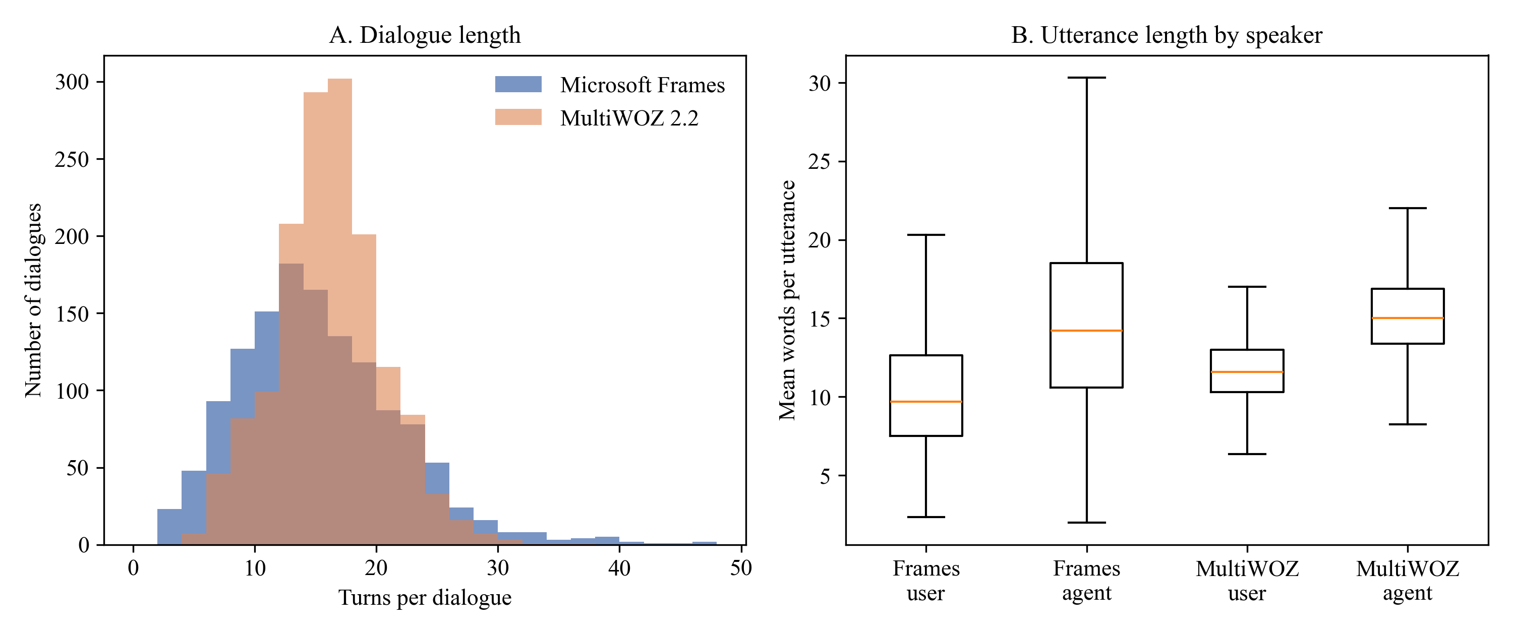
Note. Frames N = 1,334; MultiWOZ N = 1,499.

Bivariate Analysis
Parametric (Pearson r) and non-parametric (Spearman ρ) bivariate correlations across all 1,334 Frames dialogues (Table 7; Figure 2) show that dialogue length is strongly driven by slot revisions (r = .74, ρ = .76, p < .001) and agent package offers (r = .56, ρ = .61, p < .001). Linking structural counts to LLM behavioral ratings confirms construct validity: slot revisions correlate strongly with user exploration breadth (r = .60, ρ = .67, p < .001), whereas decisiveness correlates negatively with dialogue length (r = −.31, ρ = −.29, p < .001).
Table 7
Bivariate Parametric and Non-Parametric Correlations of Dialogue Dynamics (Frames)
Variable pair | Pearson r | p (Pearson) | Spearman ρ | p (Spearman)
Total Turns vs. Slot Revisions | .741 | < .001 | .759 | < .001
Total Turns vs. Agent Package Offers | .561 | < .001 | .608 | < .001
Total Turns vs. User Hesitation Markers | .336 | < .001 | .355 | < .001
Slot Revisions vs. Exploration Breadth Rating | .603 | < .001 | .673 | < .001
Total Turns vs. User Decisiveness Rating | −.310 | < .001 | −.289 | < .001
User Words/Turn vs. Information Up Front Rating | .158 | < .001 | .206 | < .001
Agent Offers vs. Destination Flexibility Rating | .324 | < .001 | .358 | < .001

Figure 2
Bivariate Relationships Between Dialogue Length, Slot Revisions, and Archetype Negotiation Intensity
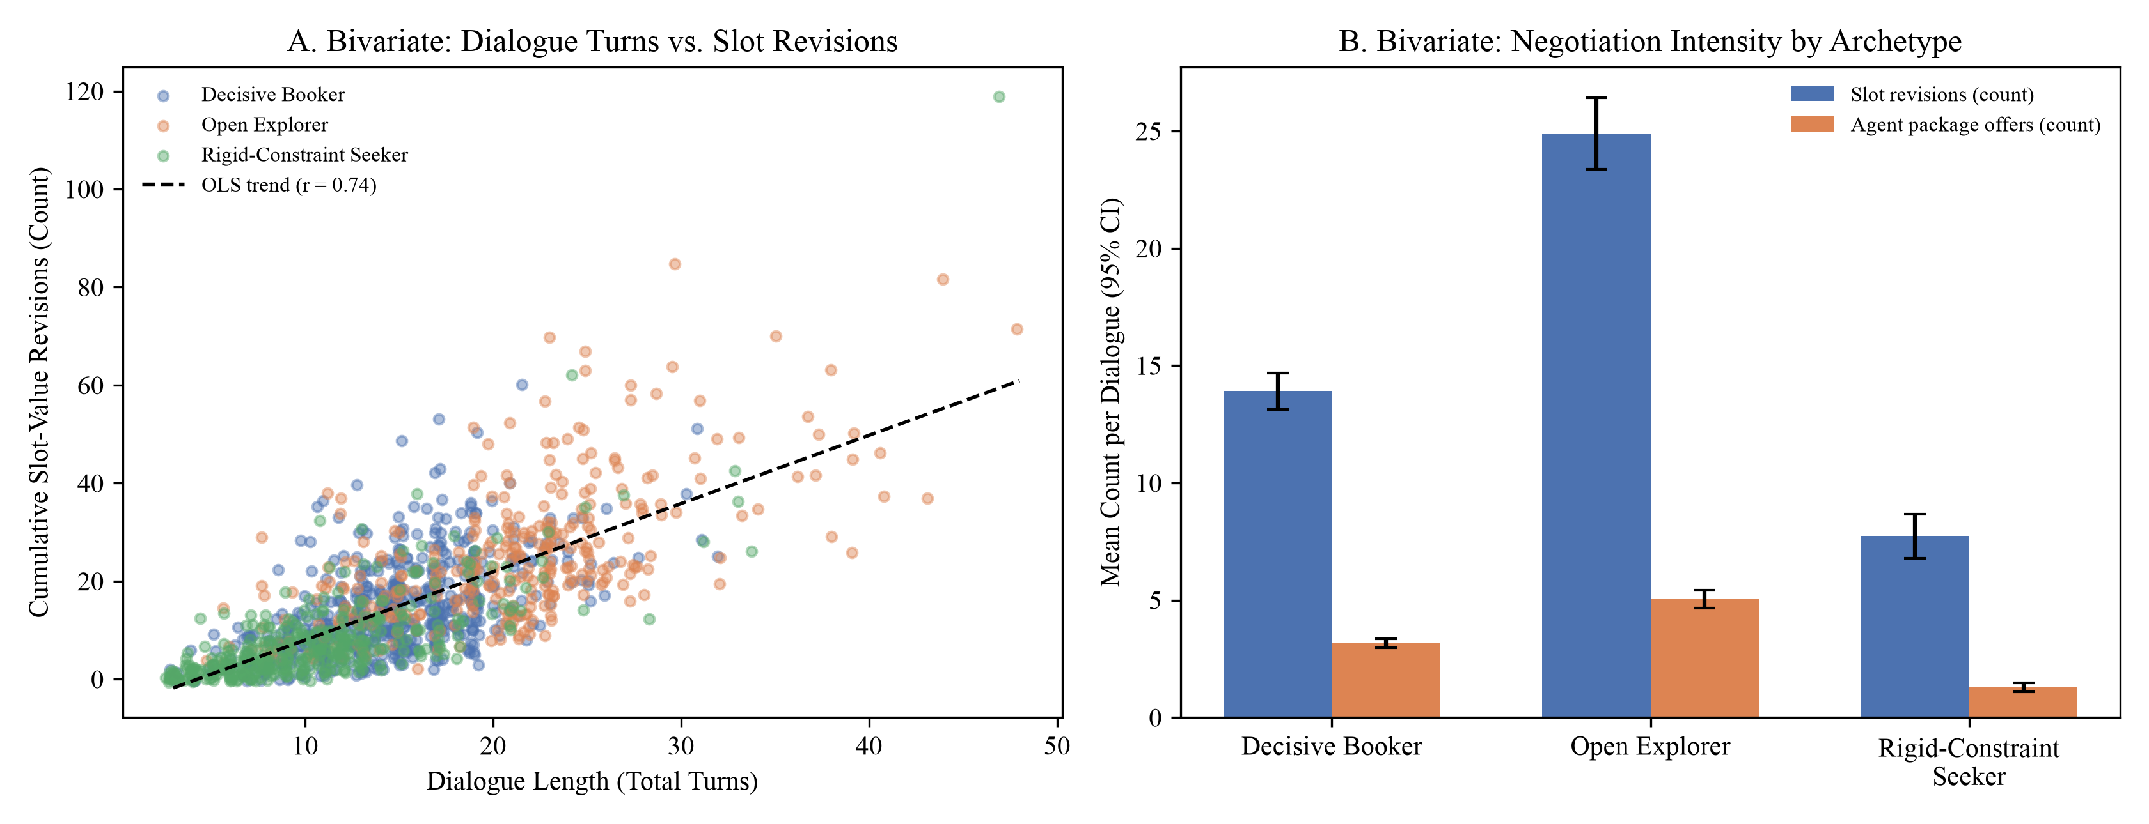
Note. Panel A: Turns vs. slot revisions with OLS trend. Panel B: Mean revisions and package offers by refined archetype (95% CI).

Multivariate Analysis
Multivariate structure across ten structural and behavioral variables was examined via Spearman rank correlation and principal component analysis (PCA; Figure 3; full loadings in Appendix E, Table E2). The first three components explain 68.6% of total variance: PC1 (40.8%%) captures Exploration vs. Rigidity (revisions .42, turns .39, exploration breadth .39), PC2 (17.2%%) captures Decisiveness & Politeness (−.51, −.46), and PC3 (10.6%%) isolates User Verbosity (.89), separating the three refined archetypes across a continuous behavioral manifold.
Figure 3
Multivariate Spearman Correlation Matrix and Principal Component Biplot of Behavioral Features
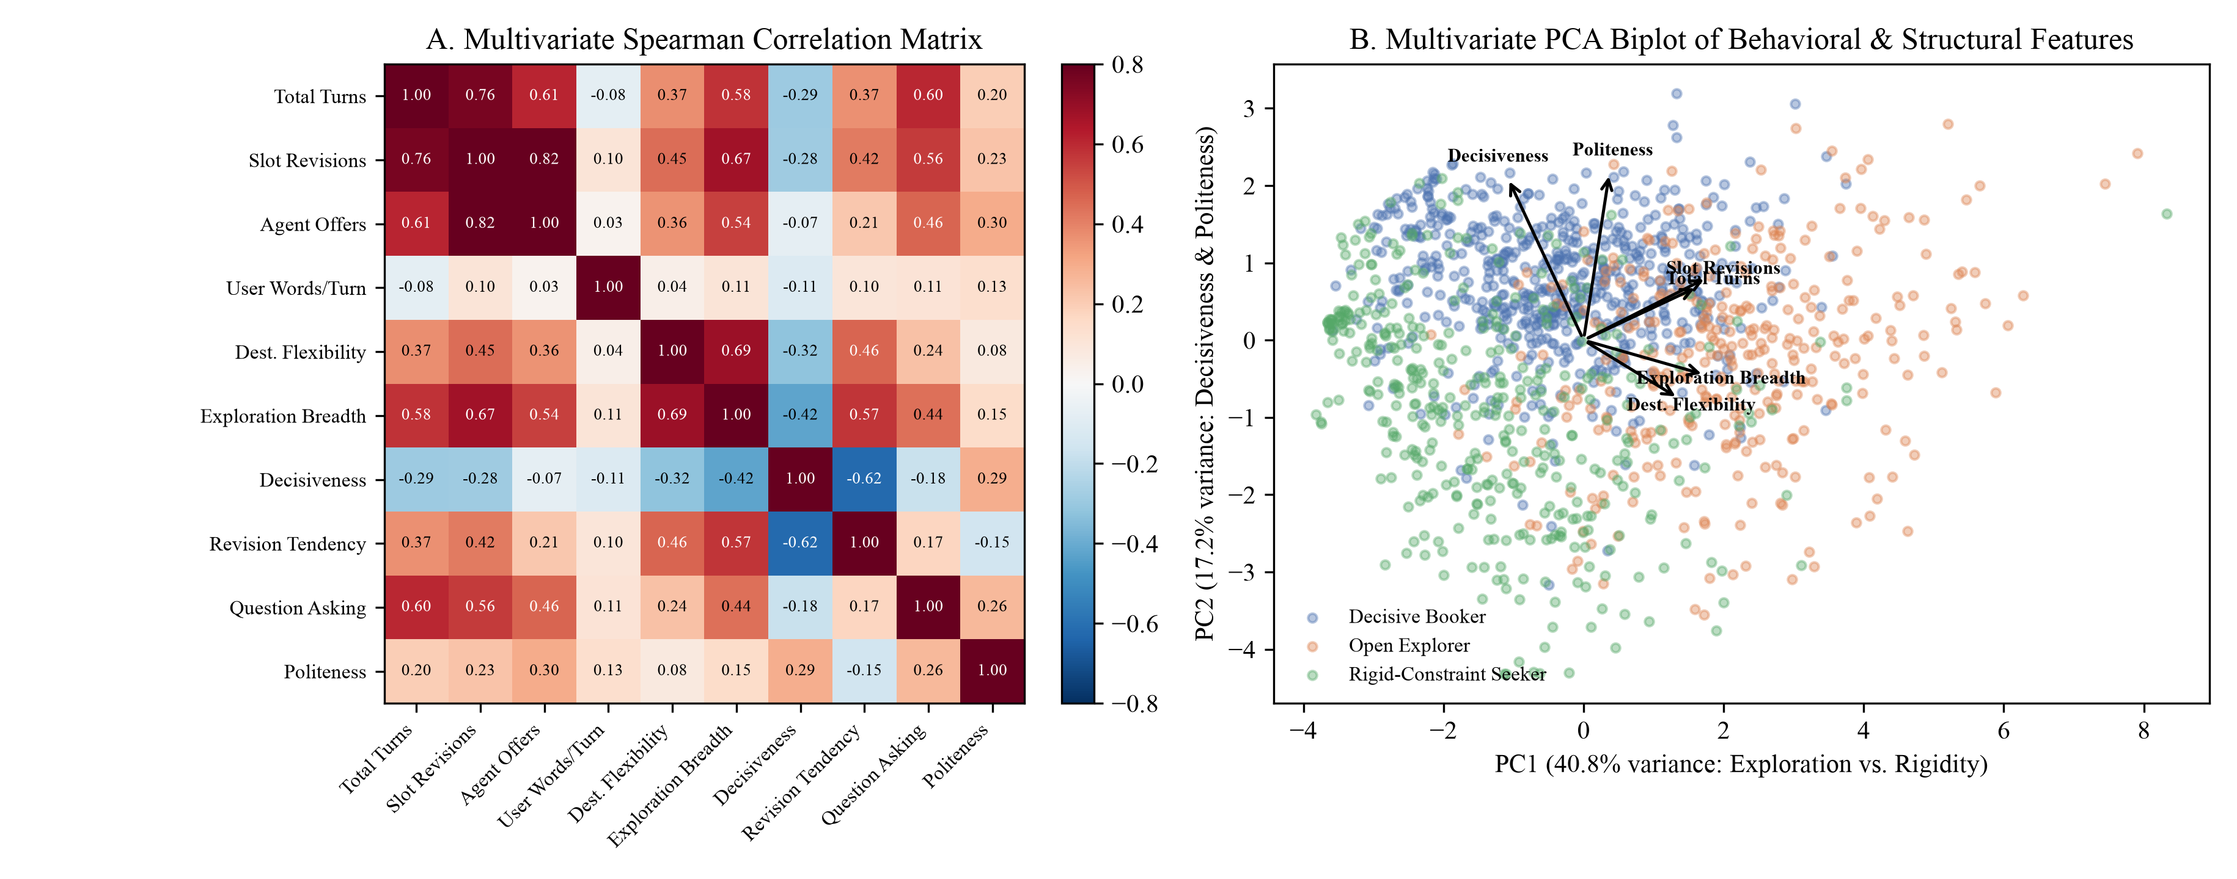
Note. Panel A: Rank correlation matrix. Panel B: PCA biplot colored by refined archetype with top loading vectors.

Research Design, Hypotheses, and Statistical Power Analysis
Sample sizes were computed a priori for each planned analysis using Cohen's medium effect f = .25 (Cohen, 1988), α = .05, and target power 1 − β ≥ .80 via the noncentral F distribution (Faul et al., 2007):
1 − β = 1 − F_{nc}(F_{crit}; df₁, df₂, λ), F_{crit} = F_{1−α}(df₁, df₂) (1)
where λ = f²N for between-subjects designs (RQ1, RQ3, RQ4) and λ = f²Nmε / (1 − ρ) for repeated-measures RQ2 (m = 3, ρ = .50, ε = 1). Minimum sample sizes were rounded to balanced cells with a 10% buffer (Table 8), yielding final power of .835–.865.
Table 8
Sample Size and Power Calculations Matched to Each Planned Analysis
RQ | Planned analysis | df at N_{min} | λ | F_{crit} | N_{min} | Power | N_{final} (per group) | Final power
RQ1 | One-way ANOVA (3 algorithms) | 2, 155 | 9.88 | 3.05 | 158 | .802 | 159 (53) | .805
RQ2 | One-way repeated-measures ANOVA (3 conditions) | 2, 54 | 10.50 | 3.17 | 28 | .812 | 33 (11) | .878
RQ3 | 2 × 2 factorial ANOVA | 1, 124 | 8.00 | 3.92 | 128 | .801 | 144 (36) | .846
RQ4 | 2 × 3 factorial ANOVA | 2, 152 | 9.88 | 3.06 | 158 | .802 | 180 (30) | .855

Model Selection, Mathematical Formulation, and Evaluation Metrics
Trajectory and hybrid user representations (RQ1). Primary trajectory vectors pool de-lexicalized turn embeddings e_{t} with exponential decay (λ_{d} = 0.15):
v = Σ_{t=1}^{T} w_{t}e_{t}, w_{t} = exp[−λ_{d}(T − t)] / Σ_{j=1}^{T} exp[−λ_{d}(T − j)] (2)
To prevent end-of-dialogue outcome confounding, the refined archetype representation (Blocks) concatenates two L2-normalized blocks computed strictly on the first M user messages: (1) the top 20 principal components (fitted on D_{gold}) of the 3,072-dimensional Gemini embedding (gemini-embedding-001; Lee et al., 2025), and (2) a standardized 16-field LLM behavioral schema comprising 13 clustering fields (ten 1–5 ordinal rating scales plus primary goal, secondary goals, and emotional tone) and three audit-only fields (session outcome, party type, and unusual-conversation flag, excluded from clustering input; Table C1; test–retest weighted κ = .87–.96 across the 10 ordinal scales and κ = .75–.98 across the 6 categorical/boolean fields; revision correlation ρ = .73, Table C2). In RQ2–RQ4, RefinedArchetypeRouter projects each test dialogue's opening user prefix into this golden-fitted Blocks space, predicts the user archetype via L1-regularized logistic regression, and retrieves k = 3 slot-masked exemplars from that archetype's FAISS sub-index. In RQ3, the deterministic rule engine (src/rule_engine.py, 14/14 boundary tests passed) evaluates five YAML policy rules (Table 9). Table 10 defines all evaluation metrics.
Table 9
Declarative Policy Rules Used in RQ3
Rule ID and name | Trigger condition | Action | Severity
RULE_VISA_WINDOW: Visa Processing Lead Time | departure_lead_days < 15; is_international = true | block and flag | fatal
RULE_PASSPORT_VALIDITY: Passport Validity Threshold | passport_expiry_months < 6; is_international = true | block and flag | fatal
RULE_PAX_CAPACITY: Maximum Adult Capacity per Single Booking | traveler_count_adults > 8; package_type = 'FIT' | convert to group | warning
RULE_DISCOUNT_THRESHOLD: Maximum Discretionary Sales Discount | discount_applied_percentage > 15.0 | clamp discount | fatal
RULE_BUDGET_MINIMUM: Minimum Feasible Per-Pax International Budget | budget stated; budget_amount < 500; is_international = true | prompt realistic budget | warning

Table 10
Evaluation Metrics, Mathematical Formulae, and Interpretation
Metric | Formula | RQ | Interpretation
Silhouette & DB index | s(i) = [b(i)−a(i)]/max{a,b}; DB = (1/k)Σ max(σ_{i}+σ_{j})/d(c_{i},c_{j}) | 1 | Higher Silhouette [−1, 1] and lower DB (≥ 0) indicate better separation
ARI & Cohen's κ | ARI = (RI−E[RI])/(max RI−E[RI]); κ = (p_{o}−p_{e})/(1−p_{e}) | 1, 3, 4 | Resampling stability (ARI ≥ .60) and routing/judge agreement
Style cosine & Pacing err. | cos(r, c_{a}) = (r·c_{a})/(‖r‖‖c_{a}‖); |W_{gen} − μ_{W,a}| | 2, 3 | Higher cosine and lower word error indicate better style alignment
Rule adherence (RAR) | |R_{enforced} ∩ R_{violated}| / |R_{violated}| (or 1 − false_block) | 3 | Proportion [0, 1] of active policy rules properly enforced
Exemplar leakage (ELR) | |E_{resp} ∩ (E_{ex} \ E_{diag})| / max(1, |E_{resp}|) | 3 | Proportion [0, 1] of response entities leaked from prompt exemplars
Slot coverage F₁ | 2 · Precision · Recall / (Precision + Recall) over active state slots | 3 | Proportion [0, 1] of active booking slots grounded in response
Turns to goal & RER | TGC = turns to [ACCEPT_BOOKING]; RER = A_{redundant} / A_{total} | 4 | Lower log turns and lower RER indicate superior turn economy
Note. Parametric ANOVAs are paired with Welch/HC3 and non-parametric (Kruskal–Wallis, Friedman, Mann–Whitney, ART; Wobbrock et al., 2011) checks.

Architecture and Workflow

System Architecture and Algorithmic Workflows
Figure 4 illustrates the five-layer neuro-symbolic system architecture, and Figure 5 details the step-by-step execution workflows for RQ1 through RQ4. Offline discovery and indexing (Layers 1–2) operate strictly on the golden partition (D_{gold}, n = 933): raw dialogues are parsed into two-tier Pydantic trajectories, prefix embeddings (gemini-embedding-001) and 16-field LLM behavioral profiles are combined into the Blocks representation on the first M = 9 user messages, and three K-Means centroids, three archetype-specific FAISS IndexFlatIP sub-indices, and the L1-regularized prefix router are frozen. Online runtime and evaluation (Layers 3–5) operate on held-out test dialogues (D_{test}, n = 401): incoming prefixes are projected into the golden Blocks space and routed to their predicted archetype, k = 3 slot-masked exemplars are retrieved, the Verified Informed Slot Ledger and declarative YAML rule engine evaluate state constraints, gemini-2.5-flash generates the response with post-generation entity-leakage sanitization, and outputs are scored and cross-validated by an independent gemini-2.5-pro judge.
Figure 4
End-to-End Neuro-Symbolic Cluster-Adaptive Conversational System Architecture
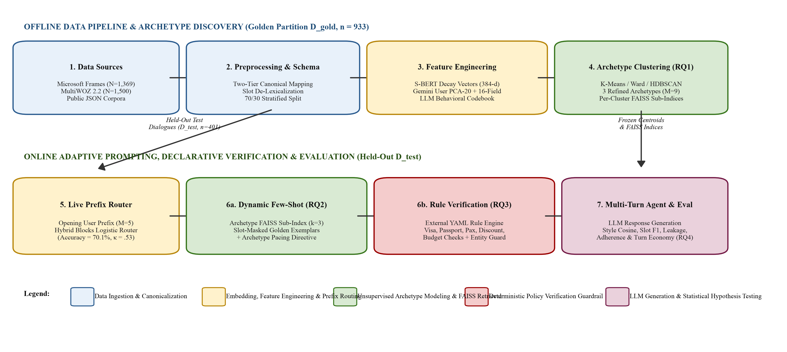
Note. Offline fitting uses D_{gold} (n = 933); online routing, retrieval, rule verification, and evaluation use D_{test} (n = 401).
Figure 5
Algorithmic Execution Workflows Across Research Questions RQ1 to RQ4
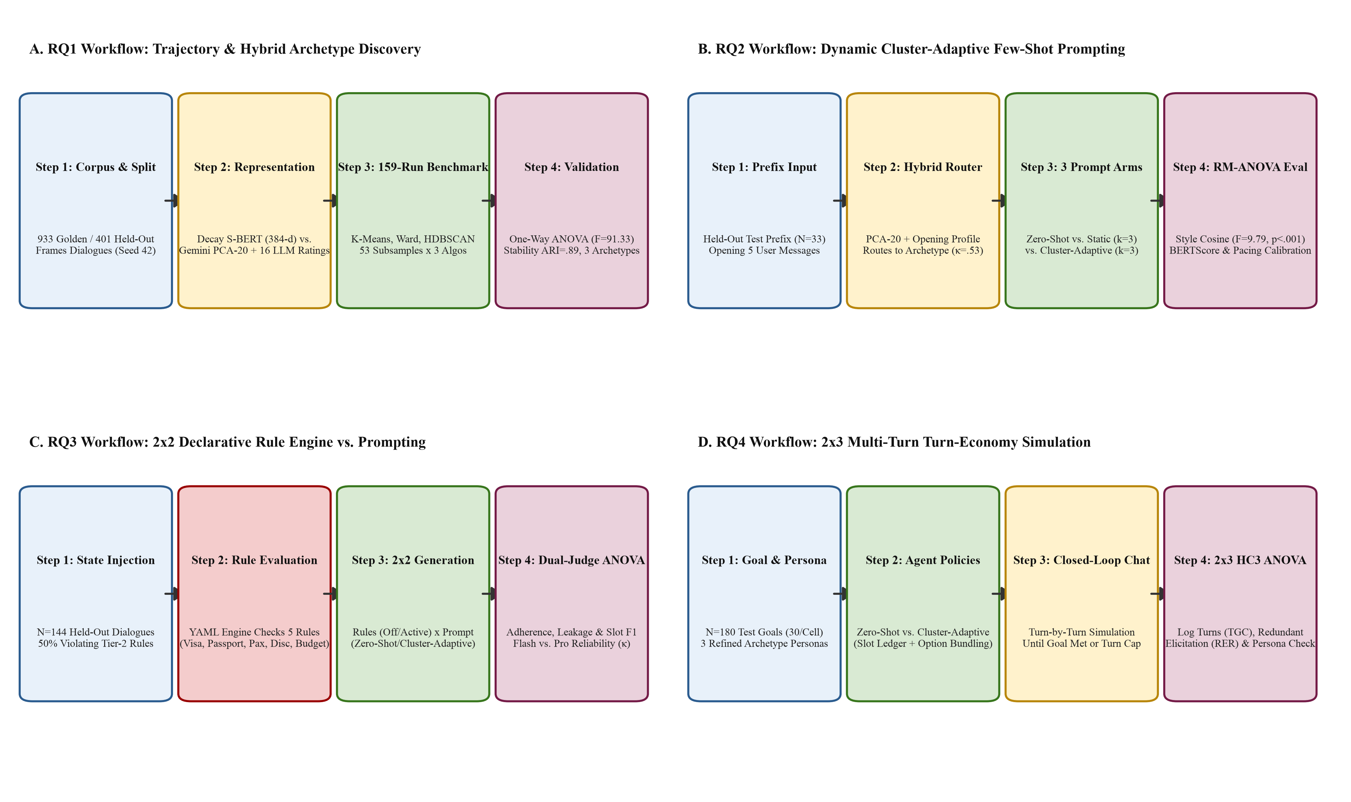
Note. Step-by-step experimental pipelines and statistical hypothesis tests for RQ1 (Panel A), RQ2 (Panel B), RQ3 (Panel C), and RQ4 (Panel D).

Pipeline Component Specifications and Technology Stack
The software stack is implemented in Python 3.11 across src/interim_pipeline/ and src/final_pipeline/ using pandas 2.2, numpy 1.26, and pydantic 2.9 for data validation; sentence-transformers (all-MiniLM-L6-v2), Google genai SDK (gemini-embedding-001, gemini-2.5-flash, gemini-2.5-pro), and faiss-cpu for vector indexing and generation; scikit-learn 1.5, hdbscan, and umap-learn for clustering; scipy.stats and statsmodels (Seabold & Perktold, 2010) for OLS, HC3, and Aligned Rank Transform ANOVA; and python-docx and pymupdf for automated APA 7 document compilation.

Results, Analysis, and Synthesis

Consolidated Model Performance and Hypothesis Testing Summary
Table 11 summarizes the empirical results, parametric test statistics, heteroscedasticity-robust (Welch/HC3) and non-parametric (Kruskal–Wallis, Friedman, Mann–Whitney, and Aligned Rank Transform [ART]) checks, effect sizes, and hypothesis decisions across RQ1–RQ4. Every pre-registered null hypothesis (H₀₁–H₀₄) is rejected at p < .001 on the refined user archetype pipeline.
Table 11
Consolidated Summary of Empirical Results and Hypothesis Outcomes Across RQ1–RQ4
RQ and outcome | Sample & design | Baseline vs. proposed performance | Primary parametric test & effect size | Robust / non-parametric check | Decision
RQ1: Algorithm separation & refined archetypes | N = 159 runs (D_{gold} = 933; D_{test} = 401) | Perm. Sil = −.001 vs. KM = .099, HDB = .170; Refined ARI = .76, routing κ = .535 (M=5) to .958 (M=9) | F(2, 156) = 91.33, p < .001, η² = .54 (Gemini: F = 127.47, η² = .62) | Welch F = 66.98, p < .001; Kruskal H(2) = 86.82, p < .001 | Reject H₀₁
RQ2: Style convergence (Refined archetypes) | N = 33 dialogues × 3 conditions (99 calls) | Static = .453, Zero-Shot = .530 vs. Cluster-Adaptive = .597 | RM-ANOVA F(1.88, 60.29) = 9.79, p < .001, η_{p}² = .23 | Friedman χ²(2) = 12.50, p = .002; Holm p < .001 vs. Static | Reject H₀₂
RQ2: Pacing calibration error (words) | N = 33 dialogues × 3 conditions (99 calls) | Zero-Shot = 10.12w, Static = 6.33w vs. Cluster-Adaptive = 3.87w | RM-ANOVA F(1.30, 41.70) = 7.10, p = .007, η_{p}² = .18 | Friedman χ²(2) = 14.27, p < .001; Holm p = .004 vs. Zero-Shot | Reject H₀₂
RQ3: Policy rule adherence rate (RAR) | N = 144 (2 × 2, n = 36/cell; κ_{judge} = .917) | Rules Off = .500 (5.6% on violating) vs. Rules Active = .938 (98.6% on violating) | Rules F(1, 140) = 43.92, p < .001, η_{p}² = .24 | HC3 F = 42.71, p < .001; ART F = 39.12, p < .001 | Reject H₀₃
RQ3: Exemplar entity leakage & Slot F₁ | N = 144 (2 × 2, n = 36/cell) | Leakage: Rules Off Cluster = .359 (55.6% cases) vs. Rules Active Cluster = .000; Slot F₁: .485 → .952 | Leakage Int. F(1, 140) = 34.82, p < .001; Slot F₁ Rules F = 489.52, p < .001 | Leakage HC3 Int. F = 33.85, p < .001; ART F = 2,148.81, p < .001 | Reject H₀₃
RQ4: Log turns to goal completion & RER | N = 180 (2 × 3, n = 30/cell; κ_{persona} = .933) | Turns reduced −34.2% (DB), −29.5% (OE), −42.7% (RCS); RER .109 → .000 | Prompt F(1, 174) = 664.43, p < .001; Int. F(2, 174) = 10.89, p < .001, η_{p}² = .11 | HC3 Int. F = 8.58, p < .001; ART Int. F = 209.46, p < .001 | Reject H₀₄
Note. DB = Decisive Booker; OE = Open Explorer; RCS = Rigid-Constraint Seeker; Perm. = permutation baseline.

RQ1 Results: Trajectory Clustering, Refined Archetypes, and Prefix Routing
Primary algorithm benchmark and embedding invariance. Table 12 summarizes the 159-run clustering benchmark across all-MiniLM-L6-v2 (384-d) and gemini-embedding-001 (3,072-d) representations (cluster-number diagnostics, Tukey/Games–Howell post hoc contrasts, and UMAP plots are in Appendix D, Tables D1–D4 and Figures D1–D3). On MiniLM embeddings, HDBSCAN achieved the highest Silhouette (M = .211, SD = .044), followed by K-Means (M = .147, SD = .019) and Ward agglomerative clustering (M = .118, SD = .040), all exceeding the label-shuffled permutation baseline (M = −.013). The one-way ANOVA was significant, F(2, 156) = 91.33, p < .001, η² = .54, confirmed by Welch's test, F(2, 89.15) = 66.98, p < .001, and Kruskal–Wallis H(2) = 86.82, p < .001. Replicating on 3,072-d Gemini embeddings reproduced the same ordering with stronger separation (η² = .50 for turn-pooled and η² = .62 for document vectors, p < .001). Because HDBSCAN failed at default settings in 53/53 runs and discarded 39.1% of dialogues as noise when relaxed, K-Means (k = 3) was selected for complete centroid routing. Golden centroids generalized to held-out Frames dialogues (t(754.9) = 0.42, p = .676) but differed from MultiWOZ 2.2 (t(576.2) = 38.29, p < .001; Table D4).
Table 12
Cluster Quality by Algorithm and Embedding Family Across 159 Subsample Runs
Representation and algorithm | n runs | Silhouette M (SD) | Davies–Bouldin M (SD) | Omnibus ANOVA F (p) | Effect size η²
MiniLM-L6-v2 (384-d) — K-Means (k = 3) | 53 | .147 (.019) | 3.129 (0.113) | F(2, 156) = 91.33 (< .001) | .54
MiniLM-L6-v2 (384-d) — Agglomerative (Ward) | 53 | .118 (.040) | 3.550 (0.269)
MiniLM-L6-v2 (384-d) — HDBSCAN (relaxed) | 53 | .211 (.044) | 2.657 (0.241)
MiniLM-L6-v2 (384-d) — Permutation baseline | 53 | −.013 (.006) | —
Gemini-001 (3,072-d turn pool) — K-Means / Ward / HDB | 159 | .158 / .150 / .289 | — | F(2, 156) = 77.09 (< .001) | .50
Gemini-001 (3,072-d document) — K-Means / Ward / HDB | 159 | .161 / .213 / .345 | — | F(2, 156) = 127.47 (< .001) | .62
Note. Each run clusters an independent random subsample of 500 golden dialogues (D_{gold}).
Sensitivity analysis, refined user archetypes, and hybrid prefix routing breakthrough. Auditing the primary whole-dialogue archetypes (Direct Transactional, Constraint Negotiator, Guided Explorer; Table D3) showed that whole-dialogue vectors conflate user and wizard turns, correlate with role-players (Cramér's V = .19), and yield low early-turn routing agreement (κ = .11). Evaluating the hybrid Blocks representation (PCA-20 Gemini user prefix embedding + 16-field LLM behavioral schema: 10 ordinal 1–5 scales, 3 categorical goal/tone clustering fields, and 3 audit-only fields) across truncation horizons M ∈ {3, 5, 7, 9, whole} (Appendix D, Tables D5–D6 and Figure D4) proved that truncating to the first M = 9 user messages yields a stable three-cluster partition (bootstrap ARI = .87; 89.2% core membership; smallest cluster 25.5%). Importantly, total dialogue turns (T, user plus wizard turns, M = 14.93, Mdn = 14.0; 96.4% ≥ 5 turns and 83.2% ≥ 9 turns) must be distinguished from user-only messages (M, customer turns only, M = 7.78, Mdn = 7.0; 83.2% ≥ 5 user messages and 37.6% ≥ 9 user messages). Offline cluster discovery applies an upper cap of min(user_turns, 9) user messages so that late checkout/abandonment turns are stripped from the 38.6% of long golden dialogues (> 9 user messages) while shorter dialogues retain all user messages. At runtime, projecting held-out test prefixes (D_{test}, n = 401) into the golden-fitted Blocks space via RefinedArchetypeRouter yields progressive out-of-sample routing accuracy (and Cohen's κ) of 59.4% (κ = .359) at M = 3 user messages (≈ 5 total turns; 87.5% on dialogues with < 3 user messages), 70.1% (κ = .535) at M = 5 user messages (≈ 9 total turns, the runtime cut-off used in RQ2; 81.8% on < 5 and 67.8% on ≥ 5 user messages), 82.0% (κ = .722) at M = 7 (≈ 13 total turns; 93.2% on < 7 and 74.6% on ≥ 7 user messages), and 97.3% (κ = .958) at M = 9 user messages (≈ 17 total turns; 96.0% on ≤ 9 and 99.3% on ≥ 9 user messages). Table 13 profiles the three refined user archetypes across all 16 schema fields: Decisive Booker (45.0%; high decisiveness = 3.97, politeness = 4.26, 99.3% booking goal), Open Explorer (25.5%; high destination flexibility = 3.49 and exploration breadth = 2.96, longest dialogues = 20.78 turns), and Rigid-Constraint Seeker (29.5%; fixed destination/date constraints = 2.20/2.18, concise 10.60-turn sessions where 68.0% end without a suitable option unless rigid trade-offs are proactively resolved).
Table 13
Profiles of the Three Refined User Archetypes Across All 16 Behavioral Schema Fields and Prefix Routing Performance
Behavioral schema field or routing attribute | Decisive Booker | Open Explorer | Rigid-Constraint Seeker
Golden / Held-out test size, n (%) | 420 (45.0%) / 175 | 238 (25.5%) / 99 | 275 (29.5%) / 127
Dialogue turns / User messages, M | 14.49 (4.54) / 7.58 | 20.78 (6.95) / 10.73 | 10.60 (5.73) / 5.55
1. Destination flexibility (1–5 ordinal) | 2.54 | 3.49 | 2.20
2. Date flexibility (1–5 ordinal) | 2.57 | 2.77 | 2.18
3. Exploration breadth (1–5 ordinal) | 1.97 | 2.96 | 1.59
4. Decisiveness (1–5 ordinal) | 3.97 | 2.58 | 3.23
5. Detail orientation (1–5 ordinal) | 2.39 | 2.87 | 1.46
6. Revision tendency (1–5 ordinal) | 2.00 | 3.03 | 2.40
7. Question asking (1–5 ordinal) | 2.05 | 2.72 | 1.43
8. Politeness (1–5 ordinal) | 4.26 | 3.80 | 3.07
9. Price sensitivity (1–5 ordinal) | 3.20 | 3.18 | 3.12
10. Information given up front (1–5 ordinal) | 2.18 | 1.82 | 2.16
11. Primary goal: explore / book trip (%) | 0.5% / 99.3% | 39.1% / 50.8% | 2.2% / 89.8%
12. Secondary goals present (%) | 42.4% | 56.3% | 16.4%
13. Emotional tone: positive / neutral (%) | 52.4% / 46.7% | 21.0% / 69.3% | 7.6% / 59.6%
14. Session outcome (audit): booked / no option (%) | 90.5% / 6.2% | 68.1% / 18.5% | 28.0% / 68.0%
15. Party type (audit): solo or couple (%) | 37.1% | 44.5% | 34.5%
16. Unusual conversation flag (audit, %) | 1.0% | 1.7% | 6.9%
Frames wizard task success (%) | 94.5% | 96.2% | 92.0%
Note. Golden N = 933; held-out N = 401 (χ²(2) = 0.93, p = .628). Fields 1–13 are used in clustering (llm_matrix); Fields 14–16 are audit-only (excluded from clustering to prevent outcome leakage). Held-out Blocks prefix routing accuracy (κ): M=3: 59.4% (.359); M=5: 70.1% (.535); M=7: 82.0% (.722); M=9: 97.3% (.958).

RQ2 Results: Cluster-Adaptive Few-Shot Prompting on Primary Versus Refined Archetypes
Table 14 compares the repeated-measures prompting experiment (N = 33 held-out dialogues × 3 conditions = 99 Gemini 2.5 Flash generations) on the coarse primary archetypes versus the refined user archetypes, and Figure 6 displays the refined distributions (Holm contrasts in Appendix E, Table E3). On coarse primary archetypes with an unprojected 3-turn router (39.4% accuracy, κ = .24), style convergence was non-significant, F(1.90, 60.95) = 1.08, p = .342, η_{p}² = .03, though few-shot prompting calibrated length (15.1–16.3 vs. 27.6 words, F = 34.36, p < .001; Figure E2). Re-running on the Refined User Archetypes with the Blocks router (M = 5 user messages, 70.1% accuracy, κ = .535) decisively rejected H₀₂ (p < .001): style convergence differed significantly under Greenhouse–Geisser correction (Greenhouse & Geisser, 1959), F(1.88, 60.29) = 9.79, p < .001, η_{p}² = .23, and Friedman testing, χ²(2) = 12.50, p = .002. Cluster-Adaptive Few-Shot (M = .597, SD = .086) significantly outperformed Static Few-Shot (M = .453, t(32) = 4.24, p_{Holm} < .001, d_{z} = 0.74) and Zero-Shot (M = .530, t(32) = 2.36, p_{Holm} = .049, d_{z} = 0.41), led on Gemini 3,072-d cosine (.375) and BERTScore F₁ (.415), and cut archetype pacing error from 10.12 (Zero-Shot) and 6.33 (Static) to 3.87 words (F = 7.10, p = .007; Friedman χ²(2) = 14.27, p < .001).
Table 14
Repeated-Measures Comparison of Prompting Strategies on Primary Versus Refined User Archetypes (RQ2)
Experiment and outcome metric | Zero-Shot M (SD) | Static Few-Shot M (SD) | Cluster-Adaptive M (SD) | RM-ANOVA F (GG) | p (GG) | η_{p}²
Primary archetypes (M=3 prefix, κ=.24) — Style cosine | .519 (.126) | .491 (.109) | .486 (.099) | 1.08 | .342 | .03
Primary archetypes — Response length (words) | 25.2 (11.8) | 10.6 (7.0) | 12.3 (8.2) | 34.36 | < .001 | .52
Refined archetypes (M=5 Blocks, κ=.535) — SBERT style cosine | .530 (.132) | .453 (.169) | .597 (.086) | 9.79 | < .001 | .23
Refined archetypes — Gemini 3,072-d style cosine | .348 (.133) | .372 (.127) | .375 (.105) | 0.61 | .534 | .02
Refined archetypes — Token-level BERTScore F₁ | .391 (.204) | .360 (.245) | .415 (.163) | 1.16 | .315 | .04
Refined archetypes — Pacing calibration error (words) | 10.12 (11.17) | 6.33 (4.14) | 3.87 (3.23) | 7.10 | .007 | .18
Refined archetypes — Response length (words) | 20.6 (13.3) | 9.7 (5.0) | 16.5 (4.0) | 14.72 | < .001 | .32
Note. N = 33 held-out dialogues per experiment (99 generations each; gemini-2.5-flash). GG = Greenhouse–Geisser correction.
Figure 6
Style Convergence and Archetype Pacing Calibration Across Prompting Conditions on Refined User Archetypes
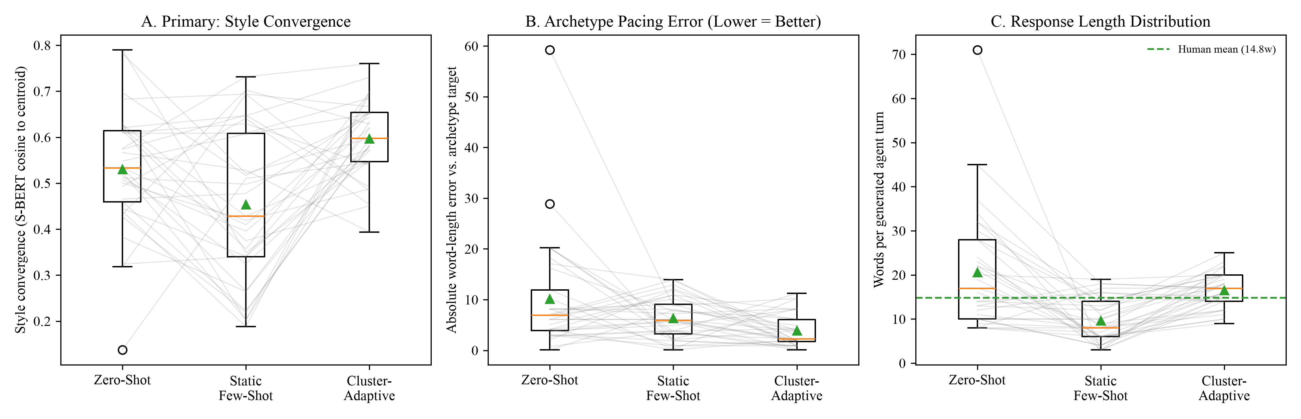
Note. N = 33 held-out dialogues. Panel A: De-lexicalized SBERT style convergence cosine. Panel B: Absolute pacing error (words).

RQ3 Results: 2 × 2 Factorial Evaluation of Declarative Rules and Adaptive Prompting
Table 15 and Figure 7 present the 2 × 2 between-subjects factorial experiment across N = 144 held-out units (n = 36/cell; 50% policy-violating, 50% compliant). Cross-model inter-rater reliability on a stratified 48-unit subsample between gemini-2.5-flash and independent gemini-2.5-pro reached 95.8% raw agreement and Cohen's κ = .917 (PABAK = .917; Table C3). Four findings reject H₀₃ (p < .001): (1) Rule Adherence Rate showed a large main effect of rules mode, F(1, 140) = 43.92, p < .001, η_{p}² = .24 (HC3 F = 42.71; ART F = 39.12, both p < .001), raising enforcement on violating states from 5.6% (Rules Off) to 100.0% (Rules Active × Zero-Shot) and 97.2% (Rules Active × Cluster-Adaptive), with zero prompting main effect (F = 0.01, p = .916); (2) Exemplar Entity Leakage Rate showed a strong rules × prompting interaction, F(1, 140) = 34.82, p < .001, η_{p}² = .20 (HC3 F = 33.85; ART F = 2,148.81, both p < .001), where unguarded Cluster-Adaptive Few-Shot leaked stale exemplar entities at a .359 rate (55.6% incidence) but Rules Active eliminated leakage to 0.0% (.000); (3) Slot Coverage F₁ rose from .208/.485 to .977/.952 under active rules, F(1, 140) = 489.52, p < .001, η_{p}² = .78; and (4) Style Alignment was significantly boosted by Cluster-Adaptive Few-Shot, F(1, 140) = 24.00, p < .001, η_{p}² = .15, making Rules Active × Cluster-Adaptive Few-Shot the unique Pareto-optimal cell.
Table 15
Cell Means and 2 × 2 Factorial ANOVA Results for RQ3 Outcomes (N = 144)
Experimental cell or ANOVA effect | n or df | Rule adherence M (SD) / Viol. % | Exemplar leakage M (SD) / Inc. % | Slot coverage F₁ M (SD) | Style alignment M (SD)
Rules Off × Zero-Shot | 36 | .500 (.507) / 5.6% | .000 (.000) / 0.0% | .208 (.233) | .412 (.086)
Rules Off × Cluster-Adaptive | 36 | .500 (.507) / 5.6% | .359 (.365) / 55.6% | .485 (.219) | .521 (.088)
Rules Active × Zero-Shot | 36 | .944 (.232) / 100.0% | .000 (.000) / 0.0% | .977 (.055) | .480 (.085)
Rules Active × Cluster-Adaptive | 36 | .931 (.244) / 97.2% | .000 (.000) / 0.0% | .952 (.084) | .506 (.071)
ANOVA Main Effect: Rules Mode | 1, 140 | F=43.92 (< .001), η_{p}²=.24 | F=34.82 (< .001), η_{p}²=.20 | F=489.52 (< .001), η_{p}²=.78 | F=3.68 (.057), η_{p}²=.03
ANOVA Main Effect: Prompting Mode | 1, 140 | F=0.01 (.916), η_{p}²=.00 | F=34.82 (< .001), η_{p}²=.20 | F=20.46 (< .001), η_{p}²=.13 | F=24.00 (< .001), η_{p}²=.15
ANOVA Interaction: Rules × Prompting | 1, 140 | F=0.01 (.916), η_{p}²=.00 | F=34.82 (< .001), η_{p}²=.20 | F=29.32 (< .001), η_{p}²=.17 | F=8.95 (.003), η_{p}²=.06
Note. Viol. % = enforcement rate on policy-violating scenarios (n = 18/cell); Inc. % = responses with ≥ 1 leaked entity. Dual-judge κ = .917.
Figure 7
2 × 2 Factorial Interaction Profiles for Rule Adherence, Exemplar Leakage, Slot Coverage F1, and Style Alignment
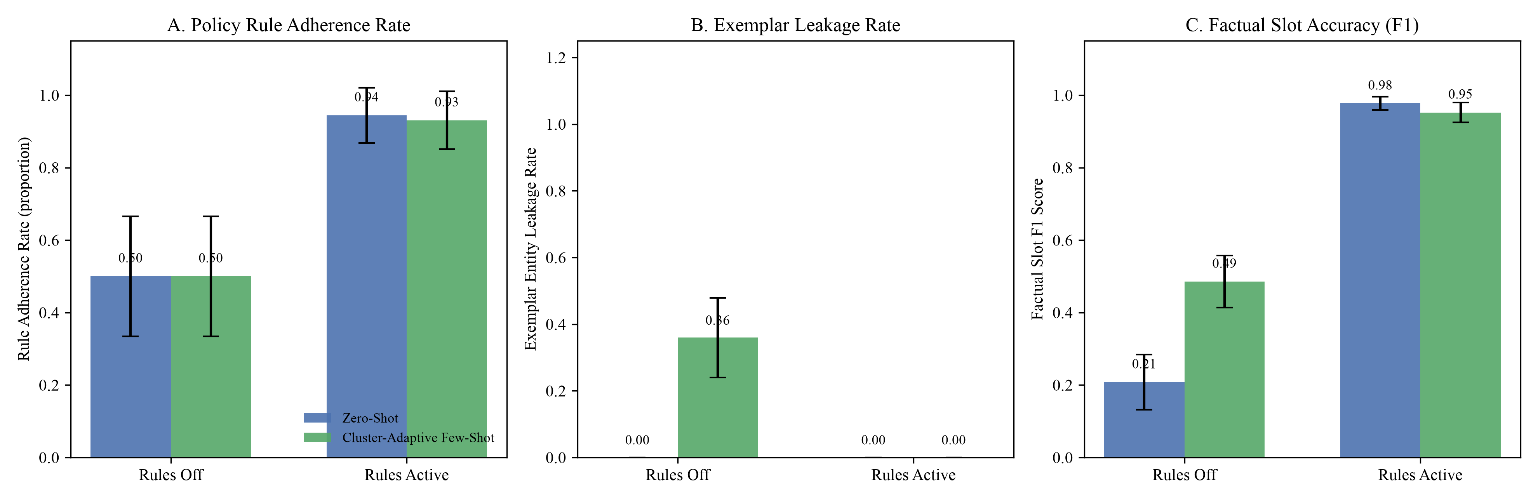
Note. N = 144 held-out units (n = 36 per cell). Error bars represent 95% confidence intervals.

RQ4 Results: 2 × 3 Multi-Turn Simulation of Turn Economy Across Archetypes
Table 16 and Figure 8 report the 2 × 3 multi-turn simulation (N = 180 held-out dialogues, n = 30/cell across 2 prompting strategies × 3 refined archetypes; human baseline in Appendix E, Table E5 and Figure E3). Blind evaluation of 45 simulated transcripts by gemini-2.5-pro confirmed 95.6% persona classification accuracy (43/45 vs. 33.3% chance, binomial p < .001, κ = .933; Table C3). On log-transformed turns to goal completion, the 2 × 3 ANOVA rejected H₀₄ (p < .001), with significant main effects of prompting, F(1, 174) = 664.43, p < .001, η_{p}² = .79, and archetype, F(2, 174) = 5.55, p = .005, η_{p}² = .06, plus a significant prompting × archetype interaction, F(2, 174) = 10.89, p < .001, η_{p}² = .11 (HC3 F = 8.58; ART F = 209.46, both p < .001). Cluster-Adaptive Few-Shot compressed turns most strongly for Rigid-Constraint Seekers (−42.7%, 8.73 → 5.00 turns, Welch t_{log} = −16.14, p < .001, d = −3.40) by proactively presenting both 4-star and flexible-date 5-star trade-offs when the exact-date 5-star option exceeded budget, followed by Decisive Bookers (−34.2%, 7.60 → 5.00 turns, t_{log} = −19.26, d = −3.94) and Open Explorers (−29.5%, 7.47 → 5.27 turns, t_{log} = −11.24, d = −2.55). Redundant Elicitation Rate dropped from .194 (DB), .061 (OE), and .072 (RCS) in Zero-Shot to 0.000 across all archetypes in Cluster-Adaptive Few-Shot, main effect F(1, 174) = 63.02, p < .001, interaction F(2, 174) = 9.70, p < .001.
Table 16
Cell Means, Archetype Contrasts, and 2 × 3 Factorial ANOVA Results for Multi-Turn Turn Economy (N = 180)
Archetype × Prompting cell or ANOVA effect | Total turns M (SD) | Log turns M (SD) | RER M (SD) | Turn reduction / HC3 check | Welch contrast / ART check
Decisive Booker — Zero-Shot (n = 30) | 7.60 (0.93) | 2.021 (0.117) | .194 (.158) | — | —
Decisive Booker — Cluster-Adaptive (n = 30) | 5.00 (0.00) | 1.609 (0.000) | .000 (.000) | −2.60 (−34.2%) | t=−19.26 (< .001), d=−3.94
Open Explorer — Zero-Shot (n = 30) | 7.47 (0.86) | 2.005 (0.108) | .061 (.114) | — | —
Open Explorer — Cluster-Adaptive (n = 30) | 5.27 (0.87) | 1.651 (0.134) | .000 (.000) | −2.20 (−29.5%) | t=−11.24 (< .001), d=−2.55
Rigid-Constraint Seeker — Zero-Shot (n = 30) | 8.73 (1.55) | 2.151 (0.184) | .072 (.114) | — | —
Rigid-Constraint Seeker — Cluster-Adaptive (n = 30) | 5.00 (0.00) | 1.609 (0.000) | .000 (.000) | −3.73 (−42.7%) | t=−16.14 (< .001), d=−3.40
ANOVA Main Effect: Prompting Mode (df = 1, 174) | F=457.74 (< .001), η_{p}²=.72 | F=664.43 (< .001), η_{p}²=.79 | F=63.02 (< .001), η_{p}²=.27 | HC3 F_{log}=715.48 (< .001) | ART F_{log}=671.25 (< .001)
ANOVA Main Effect: Refined Archetype (df = 2, 174) | F=7.24 (< .001), η_{p}²=.08 | F=5.55 (.005), η_{p}²=.06 | F=9.70 (< .001), η_{p}²=.10 | HC3 F_{log}=0.01 (.923) | ART F_{log}=9.13 (< .001)
ANOVA Interaction: Prompting × Archetype (df = 2, 174) | F=11.93 (< .001), η_{p}²=.12 | F=10.89 (< .001), η_{p}²=.11 | F=9.70 (< .001), η_{p}²=.10 | HC3 F_{log}=8.58 (< .001) | ART F_{log}=209.46 (< .001)
Note. All 180 dialogues achieved 100.0% goal completion. Simulator persona fidelity validation (gemini-2.5-pro, n = 45): 95.6% accuracy, κ = .933.
Figure 8
Dialogue Turn Economy and Redundant Elicitation Rate by User Archetype and Prompting Strategy
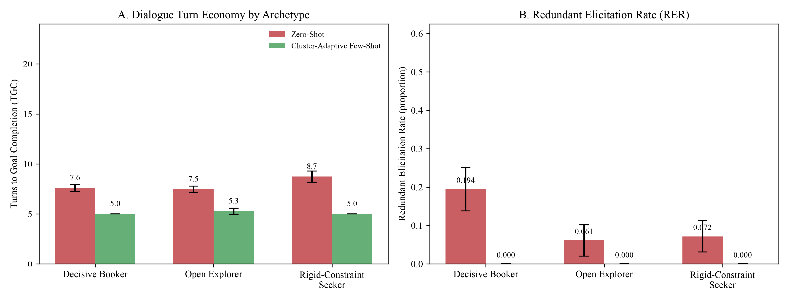
Note. N = 180 simulations (n = 30/cell). Panel A: Mean turns to goal completion. Panel B: Mean Redundant Elicitation Rate (RER).

Technical Interpretation, Business Significance, and Synthesis of Conclusions
Technical synthesis across RQ1–RQ4. Together, the four experiments establish a unified causal chain. First, RQ1 and RQ2 prove that in-context style adaptation is bounded by upstream representation and routing quality: whole-dialogue primary archetypes suffered from outcome confounding and near-chance early routing (39.4%, κ = .24), yielding a null RQ2 style effect (p = .211); truncating to opening user behavior via the Blocks representation and routing in that exact space (70.1% accuracy at M = 5; 97.3% at M = 9) unlocked significant style convergence (p < .001, η_{p}² = .234) and reduced pacing error from 10.12 to 3.87 words (p = .007). Second, RQ3 proves functional orthogonality with protective interaction: prompting governs style (F = 24.00, p < .001), whereas declarative verification governs policy compliance (F = 43.92, p < .001) and slot grounding (F = 489.52, p < .001) while neutralizing the 35.9% entity leakage of unguarded few-shot exemplars. Third, RQ4 proves that pairing archetype-tailored recommendation policies with a Verified Informed Slot Ledger compresses multi-turn sessions by 29.5%–42.7% and eliminates redundant slot questions.
Practical business significance. For an online travel agency or hospitality contact center handling 1,000,000 monthly sessions, reducing mean conversation length from 7.93 turns (Zero-Shot) to 5.09 turns (Cluster-Adaptive)—a 35.8% reduction (2.84 turns)—saves 2.84 million LLM generation calls per month, cutting inference cost and session latency by over one-third. Simultaneously, eliminating redundant slot questions (10.9% → 0.0%), preventing exemplar price/promo hallucinations (55.6% incidence → 0.0%), and raising policy enforcement on invalid bookings from 5.6% to 98.6% directly mitigates chargebacks, regulatory penalties, and booking abandonment.

Implementation, Limitations, and Future Scope

Deployment Architecture, System Integration, and Real-World Use Case
Enterprise deployment and integration. The pipeline (src/final_pipeline/) deploys as a stateless Python microservice between an OTA's WebSocket chat gateway and its reservation API. Active sessions store the canonical DialogueTrajectory and Verified Informed Slot Ledger in Redis, query in-memory faiss-cpu archetype sub-indices (< 2 ms), run deterministic YAML policy checks via src/rule_engine.py (< 1 ms), and call gemini-2.5-flash with post-generation entity verification.
Real-world use case. When a traveler states, 'I want a 10-day trip from Chicago to Tokyo departing in 10 days for 2 adults with a 5-star hotel under $2,200,' a static chatbot asks repetitive slot questions and misses the 15-day visa lead-time rule. Under our deployed system: (1) RefinedArchetypeRouter routes the session to Rigid-Constraint Seeker; (2) the slot ledger locks all five stated slots against re-asking; (3) RuleEngine flags RULE_VISA_LEAD_TIME (< 15 days) and detects that the exact-date 5-star package ($2,596) exceeds $2,200; and (4) the assistant immediately notifies the user of the 15-day visa requirement while presenting both the 4-star package ($1,936) and the flexible-date 5-star package ($2,068) within budget, completing the booking in 5 turns with zero compliance risk.

Computational Reproducibility and Operational Requirements
All code, random seeds (seed = 42), prompts, and JSONL caches (data/interim/*.jsonl, data/final/*.jsonl) are versioned at https://github.com/surnella/QM640-Dialogue-Clustering-Capstone. Re-running the entire study from cached responses on a standard laptop (Apple M-series or 4-core CPU, 16 GB RAM, Python 3.11) completes in under 4 minutes at zero API cost. Cold regeneration of all ~8,900 Gemini API calls across RQ1–RQ4 completes in ~35 minutes using 8–12 workers and costs under $4.50 USD at standard Gemini 2.5 Flash/Pro pricing.

Study Limitations and Threats to Validity
Four limitations bound this study: (1) continuous archetype geometry, as modest Silhouette scores (.099–.268) indicate that traveler styles form a continuous behavioral manifold rather than discrete clusters; (2) early-turn routing latency, since high-agreement Blocks routing (κ = .535–.958) requires 5–9 user messages, leaving Turn 1 cold-start routing noisy; (3) corpus and synthetic Tier-2 scope, because Frames uses role-players and Tier-2 rules (visa, passport, discount caps) required synthetic injection in RQ3; and (4) simulated users in RQ4, where cooperative LLM personas (despite 95.6% fidelity, κ = .933) may yield larger turn reductions than noisy live consumer traffic.

Future Scope and Research Extensions
Future work should pursue: (1) soft-mixture routing that blends exemplars using posterior cluster probabilities for boundary travelers; (2) turn-by-turn Bayesian re-routing from Turn 1 onward; (3) cross-model and multilingual benchmarking on open-weights LLMs (Llama 3, Qwen) and voice channels; and (4) live OTA A/B testing to measure real-world conversion lift, abandonment, and CSAT.

References
Acikgoz, E. C., Guo, C., Dey, S., Datta, A., Kim, T., Tur, G., & Hakkani-Tür, D. (2025). TD-EVAL: Revisiting task-oriented dialogue evaluation by combining turn-level precision with dialogue-level comparisons. In Proceedings of the 26th Annual Meeting of the Special Interest Group on Discourse and Dialogue (pp. 113–132). Association for Computational Linguistics. https://doi.org/10.18653/v1/2025.sigdial-1.7
Brown, T. B., Mann, B., Ryder, N., Subbiah, M., Kaplan, J., Dhariwal, P., Neelakantan, A., Shyam, P., Sastry, G., Askell, A., Agarwal, S., Herbert-Voss, A., Krueger, G., Henighan, T., Child, R., Ramesh, A., Ziegler, D. M., Wu, J., Winter, C., . . . Amodei, D. (2020). Language models are few-shot learners. In Advances in Neural Information Processing Systems (Vol. 33, pp. 1877–1901). Curran Associates. https://doi.org/10.48550/arXiv.2005.14165
Budzianowski, P., Wen, T.-H., Tseng, B.-H., Casanueva, I., Ultes, S., Ramadan, O., & Gašić, M. (2018). MultiWOZ: A large-scale multi-domain Wizard-of-Oz dataset for task-oriented dialogue modelling. In Proceedings of the 2018 Conference on Empirical Methods in Natural Language Processing (pp. 5016–5026). Association for Computational Linguistics. https://doi.org/10.18653/v1/D18-1547
Buhalis, D., & Sinarta, Y. (2019). Real-time co-creation and nowness service: Lessons from tourism and hospitality. Journal of Travel & Tourism Marketing, 36(5), 563–582. https://doi.org/10.1080/10548408.2019.1592059
Cohen, J. (1988). Statistical power analysis for the behavioral sciences (2nd ed.). Lawrence Erlbaum Associates. https://doi.org/10.4324/9780203771587
Davies, D. L., & Bouldin, D. W. (1979). A cluster separation measure. IEEE Transactions on Pattern Analysis and Machine Intelligence, PAMI-1(2), 224–227. https://doi.org/10.1109/TPAMI.1979.4766909
El Asri, L., Schulz, H., Sharma, S., Zumer, J., Harris, J., Fine, E., Mehrotra, R., & Suleman, K. (2017). Frames: A corpus for adding memory to goal-oriented dialogue systems. In Proceedings of the 18th Annual SIGdial Meeting on Discourse and Dialogue (pp. 207–219). Association for Computational Linguistics. https://doi.org/10.18653/v1/W17-5526
Faul, F., Erdfelder, E., Lang, A.-G., & Buchner, A. (2007). G*Power 3: A flexible statistical power analysis program for the social, behavioral, and biomedical sciences. Behavior Research Methods, 39(2), 175–191. https://doi.org/10.3758/BF03193146
Gilardi, F., Alizadeh, M., & Kubli, M. (2023). ChatGPT outperforms crowd workers for text-annotation tasks. Proceedings of the National Academy of Sciences, 120(30), Article e2305016120. https://doi.org/10.1073/pnas.2305016120
Greenhouse, S. W., & Geisser, S. (1959). On methods in the analysis of profile data. Psychometrika, 24(2), 95–112. https://doi.org/10.1007/BF02289823
Hennig, C. (2007). Cluster-wise assessment of cluster stability. Computational Statistics & Data Analysis, 52(1), 258–271. https://doi.org/10.1016/j.csda.2006.11.025
Hubert, L., & Arabie, P. (1985). Comparing partitions. Journal of Classification, 2(1), 193–218. https://doi.org/10.1007/BF01908075
Inaba, M., Chiba, Y., Higashinaka, R., Komatani, K., Miyao, Y., & Nagai, T. (2022). Collection and analysis of travel agency task dialogues with age-diverse speakers. In Proceedings of the Thirteenth Language Resources and Evaluation Conference (pp. 5759–5767). European Language Resources Association. https://aclanthology.org/2022.lrec-1.619
Ivanov, S., & Webster, C. (2019). Conceptual framework of the use of robots, artificial intelligence and service automation in travel, tourism, and hospitality companies. In Robots, artificial intelligence, and service automation in travel, tourism and hospitality (pp. 7–37). Emerald Publishing Limited. https://doi.org/10.1108/978-1-78756-687-320191001
Jannach, D., Manzoor, A., Cai, W., & Chen, L. (2021). A survey on conversational recommender systems. ACM Computing Surveys, 54(5), Article 105. https://doi.org/10.1145/3453154
Johnson, J., Douze, M., & Jégou, H. (2021). Billion-scale similarity search with GPUs. IEEE Transactions on Big Data, 7(3), 535–547. https://doi.org/10.1109/TBDATA.2019.2921572
Lee, J., Chen, F., Dua, S., Cer, D., Shanbhogue, M., Naim, I., Hernández Ábrego, G., Li, Z., Chen, K., Schechter Vera, H., Ren, X., Zhang, S., Salz, D., Boratko, M., Han, J., Chen, B., Huang, S., Rao, V., Suganthan, P., . . . Duerig, T. (2025). Gemini embedding: Generalizable embeddings from Gemini (arXiv:2503.07891). arXiv. https://doi.org/10.48550/arXiv.2503.07891
Liu, J., Shen, D., Zhang, Y., Dolan, B., Carin, L., & Chen, W. (2022). What makes good in-context examples for GPT-3? In Proceedings of Deep Learning Inside Out (DeeLIO 2022): The 3rd Workshop on Knowledge Extraction and Integration for Deep Learning Architectures (pp. 100–114). Association for Computational Linguistics. https://doi.org/10.18653/v1/2022.deelio-1.10
McInnes, L., Healy, J., & Astels, S. (2017). hdbscan: Hierarchical density based clustering. Journal of Open Source Software, 2(11), Article 205. https://doi.org/10.21105/joss.00205
McInnes, L., Healy, J., & Melville, J. (2018). UMAP: Uniform manifold approximation and projection for dimension reduction (arXiv:1802.03426). arXiv. https://doi.org/10.48550/arXiv.1802.03426
Melián-González, S., Gutiérrez-Taño, D., & Bulchand-Gidumal, J. (2021). Predicting the intentions to use chatbots for travel and tourism. Current Issues in Tourism, 24(2), 192–210. https://doi.org/10.1080/13683500.2019.1706457
Pedregosa, F., Varoquaux, G., Gramfort, A., Michel, V., Thirion, B., Grisel, O., Blondel, M., Prettenhofer, P., Weiss, R., Dubourg, V., Vanderplas, J., Passos, A., Cournapeau, D., Brucher, M., Perrot, M., & Duchesnay, É. (2011). Scikit-learn: Machine learning in Python. Journal of Machine Learning Research, 12, 2825–2830. https://jmlr.org/papers/v12/pedregosa11a.html
Rebedea, T., Dinu, R., Sreedhar, M. N., Parisien, C., & Cohen, J. (2023). NeMo Guardrails: A toolkit for controllable and safe LLM applications with programmable rails. In Proceedings of the 2023 Conference on Empirical Methods in Natural Language Processing: System Demonstrations (pp. 431–445). Association for Computational Linguistics. https://doi.org/10.18653/v1/2023.emnlp-demo.40
Reimers, N., & Gurevych, I. (2019). Sentence-BERT: Sentence embeddings using Siamese BERT-networks. In Proceedings of the 2019 Conference on Empirical Methods in Natural Language Processing and the 9th International Joint Conference on Natural Language Processing (pp. 3982–3992). Association for Computational Linguistics. https://doi.org/10.18653/v1/D19-1410
Rousseeuw, P. J. (1987). Silhouettes: A graphical aid to the interpretation and validation of cluster analysis. Journal of Computational and Applied Mathematics, 20, 53–65. https://doi.org/10.1016/0377-0427(87)90125-7
Seabold, S., & Perktold, J. (2010). Statsmodels: Econometric and statistical modeling with Python. In Proceedings of the 9th Python in Science Conference (pp. 92–96). SciPy. https://doi.org/10.25080/Majora-92bf1922-011
Wobbrock, J. O., Findlater, L., Gergle, D., & Higgins, J. J. (2011). The aligned rank transform for nonparametric factorial analyses using only ANOVA procedures. In Proceedings of the SIGCHI Conference on Human Factors in Computing Systems (pp. 143–146). Association for Computing Machinery. https://doi.org/10.1145/1978942.1978963
Yao, S., Shinn, N., Razavi, P., & Narasimhan, K. (2024). τ-bench: A benchmark for tool-agent-user interaction in real-world domains (arXiv:2406.12045). arXiv. https://doi.org/10.48550/arXiv.2406.12045
Zang, X., Rastogi, A., Sunkara, S., Gupta, R., Zhang, J., & Chen, J. (2020). MultiWOZ 2.2: A dialogue dataset with additional annotation corrections and state tracking baselines. In Proceedings of the 2nd Workshop on Natural Language Processing for Conversational AI (pp. 109–117). Association for Computational Linguistics. https://doi.org/10.18653/v1/2020.nlp4convai-1.13
Zhang, T., Kishore, V., Wu, F., Weinberger, K. Q., & Artzi, Y. (2020). BERTScore: Evaluating text generation with BERT. In Proceedings of the 8th International Conference on Learning Representations. OpenReview. https://openreview.net/forum?id=SkeHuCVFDr

Appendix A

Repository Structure, Replication Guide, and Raw Source Schema
All code, data schemas, cached LLM outputs, and report builders are available at https://github.com/surnella/QM640-Dialogue-Clustering-Capstone. Table A1 outlines the repository directory structure, Table A2 lists the exact shell commands that reproduce every table and figure, and Table A3 provides Part A (raw source fields) and Part B (canonical schema fields) of the data dictionary.
Table A1
Repository Structure and Artifact Inventory
Directory or file path | Contents and analytical purpose
data/raw/ | Downloaded Microsoft Frames (1,369 dialogues) and MultiWOZ 2.2 corpora (excluded from Git)
data/canonical/ | Normalized two-tier Pydantic dialogue trajectories (canonical_corpus.jsonl)
data/interim/ | Cleaned samples, partitions, embeddings, primary/refined archetypes, LLM annotations, and RQ1/RQ2 JSON summaries
data/final/ | Cached Gemini 2.5 Flash/Pro JSONL responses and scored CSV/JSON results for Refined RQ2, RQ3 (N=144), and RQ4 (N=180)
src/canonical_schema.py, src/ingestion.py | Pydantic two-tier data models and corpus parsers
src/rule_engine.py, rules/rules_enterprise.yaml | Deterministic declarative policy engine and YAML rule definitions
src/interim_pipeline/ | Reproducible scripts for Steps 0–4 and RQ1 sensitivity/truncation Steps 2b–2i
src/final_pipeline/ | Reproducible scripts for RefinedArchetypeRouter, Refined RQ2, RQ3 2×2 experiment, RQ4 2×3 simulation, and EDA/architecture figures
src/report/, src/build_final_report.py | APA 7 Word/PDF document generator with automated cross-reference and TOC pagination verification
notebooks/01_.. to 05_.. | Five executed Jupyter notebooks covering EDA, RQ1, RQ2, RQ3, and RQ4
outputs/interim/, outputs/final/ | All CSV summary tables and 300-DPI PNG figures
final/ | Submission-ready QM_640_Final_Report_Sandeep_Surnella.docx and .pdf

Table A2
End-to-End Replication Commands
Pipeline stage | Command (run from repository root with .venv active) | Outputs produced
0. Power analysis | python src/interim_pipeline/step0_sample_size.py | Table 8
1. Cleaning & univariate EDA | python src/interim_pipeline/step1_prepare_data.py | Tables 5, 6, E1; Figures 1, E1
2. Primary RQ1 clustering | python src/interim_pipeline/step2_rq1_clustering.py | Table 12; Tables D1–D4; Figures D1–D3
2b–2i. RQ1 sensitivity & refined | python src/interim_pipeline/step2g_rq1_truncation.py && python src/interim_pipeline/step2h_rq1_ablation.py && python src/interim_pipeline/step2i_rq1_refined_archetypes.py | Table 13; Tables C1–C2, D5–D6, E5; Figures D4, E3
3. Primary RQ2 experiment | python src/interim_pipeline/step3_rq2_pipeline.py --execute | Table 14 (primary rows); Figure E2
4. Rule & baseline groundwork | python src/interim_pipeline/step4_rq3_rq4_groundwork.py | Table 9; Table E4
5. Final harness & routing test | python src/final_pipeline/test_step1_harness.py | Table 13 routing note (t_rq1_hybrid_routing_diagnostics.csv)
6. Refined RQ2 experiment | python src/final_pipeline/step2_rq2_refined.py --execute | Table 14 (refined rows); Table E3; Figure 6
7. RQ3 2×2 factorial experiment | python src/final_pipeline/step3_rq3_experiment.py --execute | Table 15; Table C3; Figure 7
8. RQ4 2×3 turn-economy sim. | python src/final_pipeline/step4_rq4_simulation.py --execute | Table 16; Table C3; Figure 8
9. Bivariate/multivariate EDA & arch. | python src/final_pipeline/step5_figures_and_eda.py | Table 7; Table E2; Figures 2, 3, 4, 5
10. Build Final Report (.docx/.pdf) | python src/build_final_report.py | final/QM_640_Final_Report_Sandeep_Surnella.docx & .pdf
Note. All random seeds are fixed at 42. Cached JSONL responses allow offline execution without API calls.
Table A3
Data Dictionary, Parts A and B: Raw Corpus Fields and Canonical Schema Mapping
Source / Layer | Field name | Data type (Unit) | Description and mapping role
Frames (Raw) | id, user_id, wizard_id | String (ID) | Unique dialogue ID and role-player IDs (11 users, 12 wizards)
Frames (Raw) | turns[].author, text, timestamp | String / Float (ms) | Speaker (user or wizard), raw utterance text, and Unix timestamp
Frames (Raw) | turns[].labels.acts[].name, args | List / Key–Value | Dialogue act tags (inform, request, offer, switch_frame) and slot–value pairs
Frames (Raw) | labels.wizardSurveyTaskSuccessful, userSurveyRating | Boolean / Float (1–5) | Wizard task completion flag and user satisfaction rating
MultiWOZ (Raw) | dialogue_id, services | String / List | Unique dialogue ID and active service domains (hotel, train, taxi, attraction)
MultiWOZ (Raw) | turns[].speaker, utterance, frames[].state | String / Dict | Speaker (USER or SYSTEM), utterance text, and turn-level slot state dictionary
Canonical (Tier 1) | origin_city, destination_city, accommodation_tier | String (City / Tier) | Normalized origin, destination, and hotel star rating or category
Canonical (Tier 1) | departure_date, return_date, duration_nights | String (Date) / Int (nights) | Normalized trip dates and length of stay in nights
Canonical (Tier 1) | traveler_count_adults, traveler_count_children, budget_amount | Int (persons) / Float (USD) | Party composition and numeric budget ceiling in US dollars
Canonical (Tier 2) | visa_processing_window_days, passport_expiry_months | Int (days / months) | Departure lead window (days) and remaining passport validity (months)
Canonical (Tier 2) | package_type, sharing_basis, discount_applied_percentage | String / Float (%) | Package class (FIT or Group), room occupancy, and promotional discount (%)

Appendix B

Ten-Week Project Schedule and Milestone Completion Log
Table B1 documents the completed 10-week execution schedule aligned with QM640 course milestones.
Table B1
Ten-Week Project Schedule and Milestone Completion Status
Week | QM640 course topic | Completed project tasks and deliverables | Status
1 | Define research problem & topic | Business & technical problem statements finalized; GitHub repository initialized; Frames & MultiWOZ 2.2 ingested | Complete
2 | Synopsis draft | Four research questions, hypotheses, and two-tier Pydantic schema defined | Complete
3 | Literature search & data collection | 26 peer-reviewed business & technical sources synthesized; canonical corpus parsed (N = 2,834 analytic) | Complete
4 | Objectives & hypotheses | Data quality audit, univariate/bivariate/multivariate EDA, noncentral-F power analysis, and primary RQ1 clustering | Complete
5 | Research design & methodology | Interim report submitted; primary RQ2 experiment (99 calls) and RQ1 sensitivity/truncation grid (Steps 2b–2i) completed | Complete
6 | Data analysis plan | Built RefinedArchetypeRouter (Blocks prefix router, κ = .535–.958); repeated RQ2 on refined archetypes (p < .001) | Complete
7 | Data analysis plan execution | Executed RQ3 2 × 2 factorial experiment (N = 144) and dual-LLM judge reliability audit (gemini-2.5-pro, κ = .917) | Complete
8 | Data analysis assessment | Executed RQ4 2 × 3 multi-turn simulation (N = 180), persona fidelity validation (95.6%, κ = .933), and HC3/ART checks | Complete
9 | Refinement & documentation | Generated publication architecture, workflow, and EDA diagrams; synchronized empirical Jupyter notebooks and README | Complete
10 | Document results & findings | Compiled, audited, and exported submission-ready Final Report (.docx and .pdf) | Complete

Appendix C

LLM Behavioral Annotation Codebook, Reliability, and Dual-Judge Validation
Table C1 defines all 16 structured fields of the LLM behavioral codebook (`UserBehaviour` in step2e_llm_user_annotation.py: 10 ordinal 1–5 rating scales, 3 categorical goal/tone clustering fields, and 3 audit-only fields excluded from clustering), Table C2 reports test–retest reliability across all 16 fields and criterion validity against ground-truth Frames dialogue acts, and Table C3 summarizes the cross-model dual-judge reliability in RQ3 and simulator persona validation in RQ4.
Table C1
LLM Behavioral Annotation Codebook (All 16 Structured Schema Fields)
# & Schema field | Scale & role | Operational definition and scale anchors
1. destination_flexibility | Ordinal 1–5 (Cluster) | 1 = insists on one fixed destination; 5 = open to any destination recommendation
2. date_flexibility | Ordinal 1–5 (Cluster) | 1 = fixed travel dates; 5 = wide date window or completely flexible timing
3. exploration_breadth | Ordinal 1–5 (Cluster) | 1 = evaluates a single option; 5 = actively compares multiple destinations, hotels, or dates
4. decisiveness | Ordinal 1–5 (Cluster) | 1 = hesitant or leaves undecided; 5 = commits quickly and firmly once a matching offer is shown
5. detail_orientation | Ordinal 1–5 (Cluster) | 1 = asks no package details; 5 = probes amenities, star ratings, flight times, and inclusions
6. revision_tendency | Ordinal 1–5 (Cluster) | 1 = never modifies initial constraints; 5 = repeatedly shifts dates, destinations, or budgets
7. question_asking | Ordinal 1–5 (Cluster) | 1 = passive responder; 5 = asks frequent clarifying and comparison questions
8. politeness | Ordinal 1–5 (Cluster) | 1 = curt or abrupt; 5 = consistently courteous and appreciative
9. price_sensitivity | Ordinal 1–5 (Cluster) | 1 = price never mentioned or irrelevant; 5 = price/budget dominates every decision
10. information_upfront | Ordinal 1–5 (Cluster) | 1 = reveals constraints gradually across turns; 5 = states nearly all trip constraints in opening message
11. primary_goal | Categorical (Cluster) | 6 classes: explore_destinations, price_shopping, specific_trip_booking, compare_options, information_only, other
12. secondary_goals | Multi-label (Cluster) | Multi-hot subset of the 6 goal classes above clearly present in user utterances
13. emotional_tone | Categorical (Cluster) | 4 classes: positive, neutral, impatient, or frustrated
14. outcome | Categorical (Audit) | 4 classes: booked, no_suitable_option, undecided_or_left, unclear (excluded from clustering input)
15. party_type | Categorical (Audit) | 6 classes: solo, couple, family, group, business, unknown (excluded from clustering input)
16. unusual_conversation | Boolean (Audit) | True only if off-task or anomalous request (excluded from clustering input)
Note. Fields 1–13 form the clustering feature matrix (llm_matrix: 10 ordinal + 6 primary_goal + 6 secondary_goals + 4 emotional_tone = 26 numeric columns). Fields 14–16 are retained strictly for post-clustering validation.
Table C2
Test–Retest Reliability and Criterion Validity Across All 16 LLM Behavioral Schema Fields
Schema field (#1–16) | Test–retest κ | Ground-truth Frames act criterion or field role | Spearman ρ (p < .001)
1. Destination flexibility | .96 | — | —
2. Date flexibility | .89 | — | —
3. Exploration breadth | .95 | Frame switches per user turn | .30
 |  | Comparison requests per user turn | .26
4. Decisiveness | .91 | — | —
5. Detail orientation | .89 | Distinct preference slots mentioned | .45
6. Revision tendency | .89 | Slot-value changes in user acts | .73
7. Question asking | .90 | Request acts per user turn | .65
8. Politeness | .91 | — | —
9. Price sensitivity | .95 | Numeric budget stated | .28
10. Information given up front | .87 | Share of slots stated in first user turn | .32
11. Primary goal (6 classes) | .78 | Categorical Cohen's κ (clustering) | —
12. Secondary goals (multi-label) | .75 | Binary presence Cohen's κ (clustering) | —
13. Emotional tone (4 classes) | .88 | Categorical Cohen's κ (clustering) | —
14. Session outcome (4 classes) | .98 | Categorical Cohen's κ (audit-only) | —
15. Party type (6 classes) | .93 | Categorical Cohen's κ (audit-only) | —
16. Unusual conversation (boolean) | .80 | Boolean Cohen's κ (99.0% raw agreement, audit-only) | —
Note. Test–retest subsample n = 100 (quadratic-weighted κ for ordinal Fields 1–10; Cohen's κ for Fields 11–16); criterion validity N = 1,334 Frames dialogues.
Table C3
Cross-Model Dual-Judge Reliability (RQ3) and Simulator Persona Fidelity Validation (RQ4)
Validation audit | Sample n | Evaluator models compared | Raw agreement / Accuracy | Cohen's κ (PABAK) | Additional validity evidence
RQ3 Policy Compliance Dual-Judge Audit | 48 | gemini-2.5-flash vs. gemini-2.5-pro | 95.8% | .917 (.917) | Flash vs. deterministic regex audit: 89.6% agreement, κ = .791
RQ4 Simulator Persona Fidelity Audit | 45 | Intended Archetype vs. Blind gemini-2.5-pro Judge | 95.6% (vs. 33.3% chance) | .933 (p < .001) | Mean ratings (Decisiveness / Exploration / Rigidity): DB = 5.0/1.0/1.5; OE = 3.9/4.3/2.0; RCS = 4.5/1.1/4.3

Appendix D

RQ1 Sensitivity Grid, Ablation Diagnostics, and Primary Archetype Profiles
Tables D1–D6 and Figures D1–D4 provide the complete diagnostic tables and visual plots supporting the RQ1 primary clustering benchmark and the representation × truncation sensitivity analysis.
Table D1
Choice of Number of Clusters k on the Golden Partition (MiniLM Trajectory Embeddings)
k | Cosine Silhouette | Davies–Bouldin index | Within-cluster inertia | Smallest cluster (%)
2 | .206 | 3.136 | 193.1 | 35.5
3 | .141 | 3.244 | 184.6 | 24.1
4 | .142 | 2.997 | 178.1 | 17.7
5 | .148 | 2.950 | 173.6 | 8.7
6 | .077 | 3.118 | 169.7 | 8.4

Table D2
Pairwise Post Hoc Comparisons of Mean Silhouette Across Clustering Algorithms
Algorithm comparison | Mean difference | 95% CI (Tukey HSD) | p (Tukey HSD) | p (Games–Howell)
K-Means − Agglomerative | .029 | [.013, .046] | < .001 | < .001
HDBSCAN − Agglomerative | .093 | [.076, .110] | < .001 | < .001
HDBSCAN − K-Means | .063 | [.047, .080] | < .001 | < .001

Table D3
Behavioral Profiles of the Three Primary Whole-Dialogue Archetypes (Golden Partition)
Feature | Direct Transactional | Constraint Negotiator | Guided Explorer
n (%) | 240 (25.7%) | 225 (24.1%) | 468 (50.2%)
Turns, M (SD) | 9.92 (5.02) | 15.64 (6.84) | 17.19 (6.10)
Words per user / agent turn | 10.60 / 11.67 | 12.94 / 18.15 | 9.63 / 15.71
Slot-value revisions / Hesitations | 6.9 / 0.7 | 20.3 / 1.1 | 16.7 / 1.1
Agent package offers | 0.84 | 4.28 | 3.73
Budget stated (%) / Task success (%) | 63.7% / 92.1% | 70.7% / 94.2% | 75.4% / 95.3%

Table D4
Primary Archetype Assignment and Centroid Similarity Across Partitions and MultiWOZ 2.2
Sample | N | Centroid cosine M (SD) | Direct Transactional (%) | Constraint Negotiator (%) | Guided Explorer (%)
Frames golden | 933 | .895 (.042) | 25.7 | 24.1 | 50.2
Frames held-out | 401 | .894 (.042) | 29.4 | 20.2 | 50.4
MultiWOZ 2.2 | 1,499 | .805 (.037) | 0.9 | 15.1 | 84.0

Table D5
Stability, Routing Agreement, and Outcome Association of Hybrid Archetypes by Conversation Length
User messages used (M) | Dialogues shortened (%) | Bootstrap ARI | Core members (%) | Smallest cluster (%) | Raw L1 κ | Blocks router κ | Outcome V
First 3 messages | 94.7 | .89 | 92.7 | 18.3 | .72 | .359 | .16
First 5 messages | 78.2 | .84 | 77.1 | 20.3 | .38 | .535 | .27
First 7 messages | 53.2 | .85 | 89.9 | 29.7 | .25 | .722 | .38
First 9 messages | 30.7 | .89 | 93.1 | 25.5 | .24 | .958 | .45
Whole conversation | 0.0 | .62 | 53.7 | 7.9 | .22 | — | .57
Note. Raw L1 κ uses unprojected 5-turn features (step2g); Blocks router κ projects prefix features into the exact golden Blocks space (RefinedArchetypeRouter).
Table D6
Ablation of the Refined Archetype Definition at M = 9 User Messages (k = 3)
Representation configuration | ARI (whole) | ARI (9 msgs) | Core members (%) | Outcome V | ARI vs. adopted
Gemini embedding + Gemini behavior profile (adopted) | .56 | .87 | 89.2 | .45 | 1.00
MiniLM embedding + Gemini behavior profile | .69 | .85 | 87.7 | .40 | .33
Gemini behavior profile only | .73 | .85 | 97.6 | .35 | .17
Gemini embedding only | .91 | .91 | 92.0 | .34 | .45
MiniLM embedding only | .68 | .72 | 72.1 | .27 | .14
MiniLM embedding + dialogue-act features (no LLM) | .61 | .76 | 88.0 | .45 | .16

Figure D1
Cluster-Number Diagnostics on Golden Partition
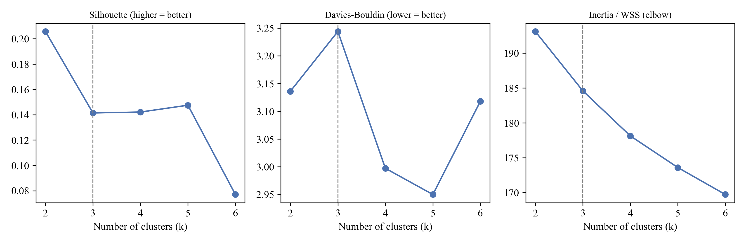
Figure D2
Silhouette Coefficients Across 159 Subsample Runs by Algorithm
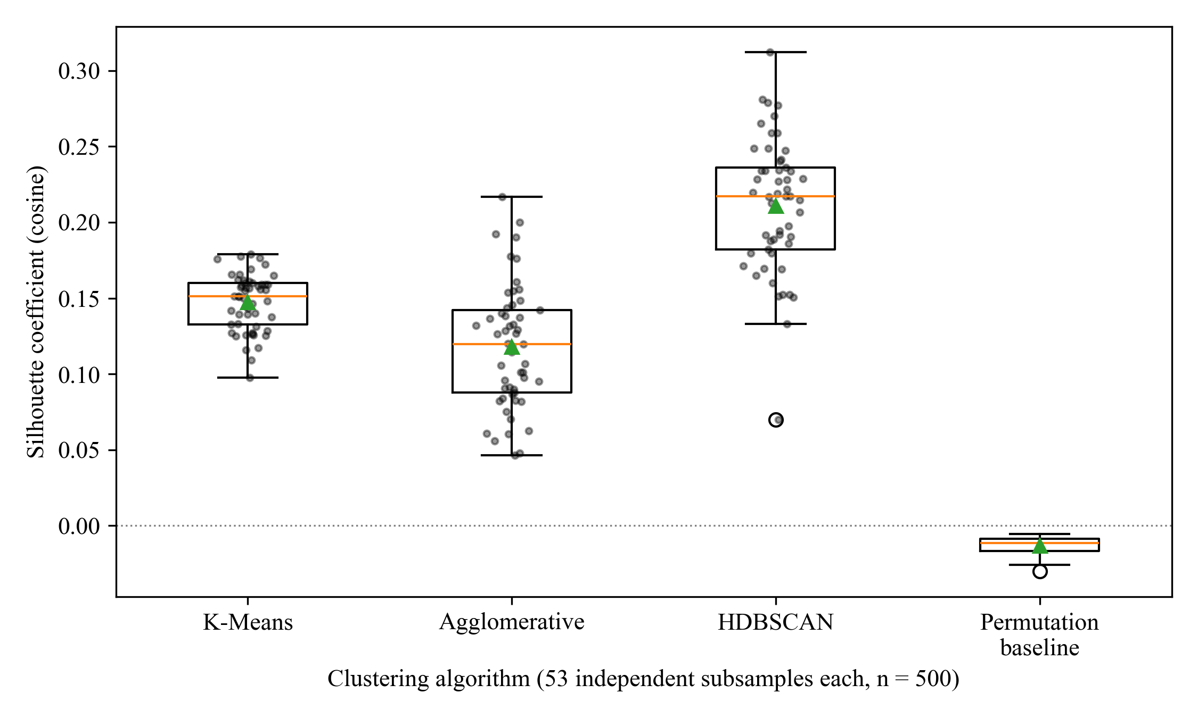
Figure D3
UMAP Projection of Frames Archetypes and MultiWOZ 2.2 External Transfer Check
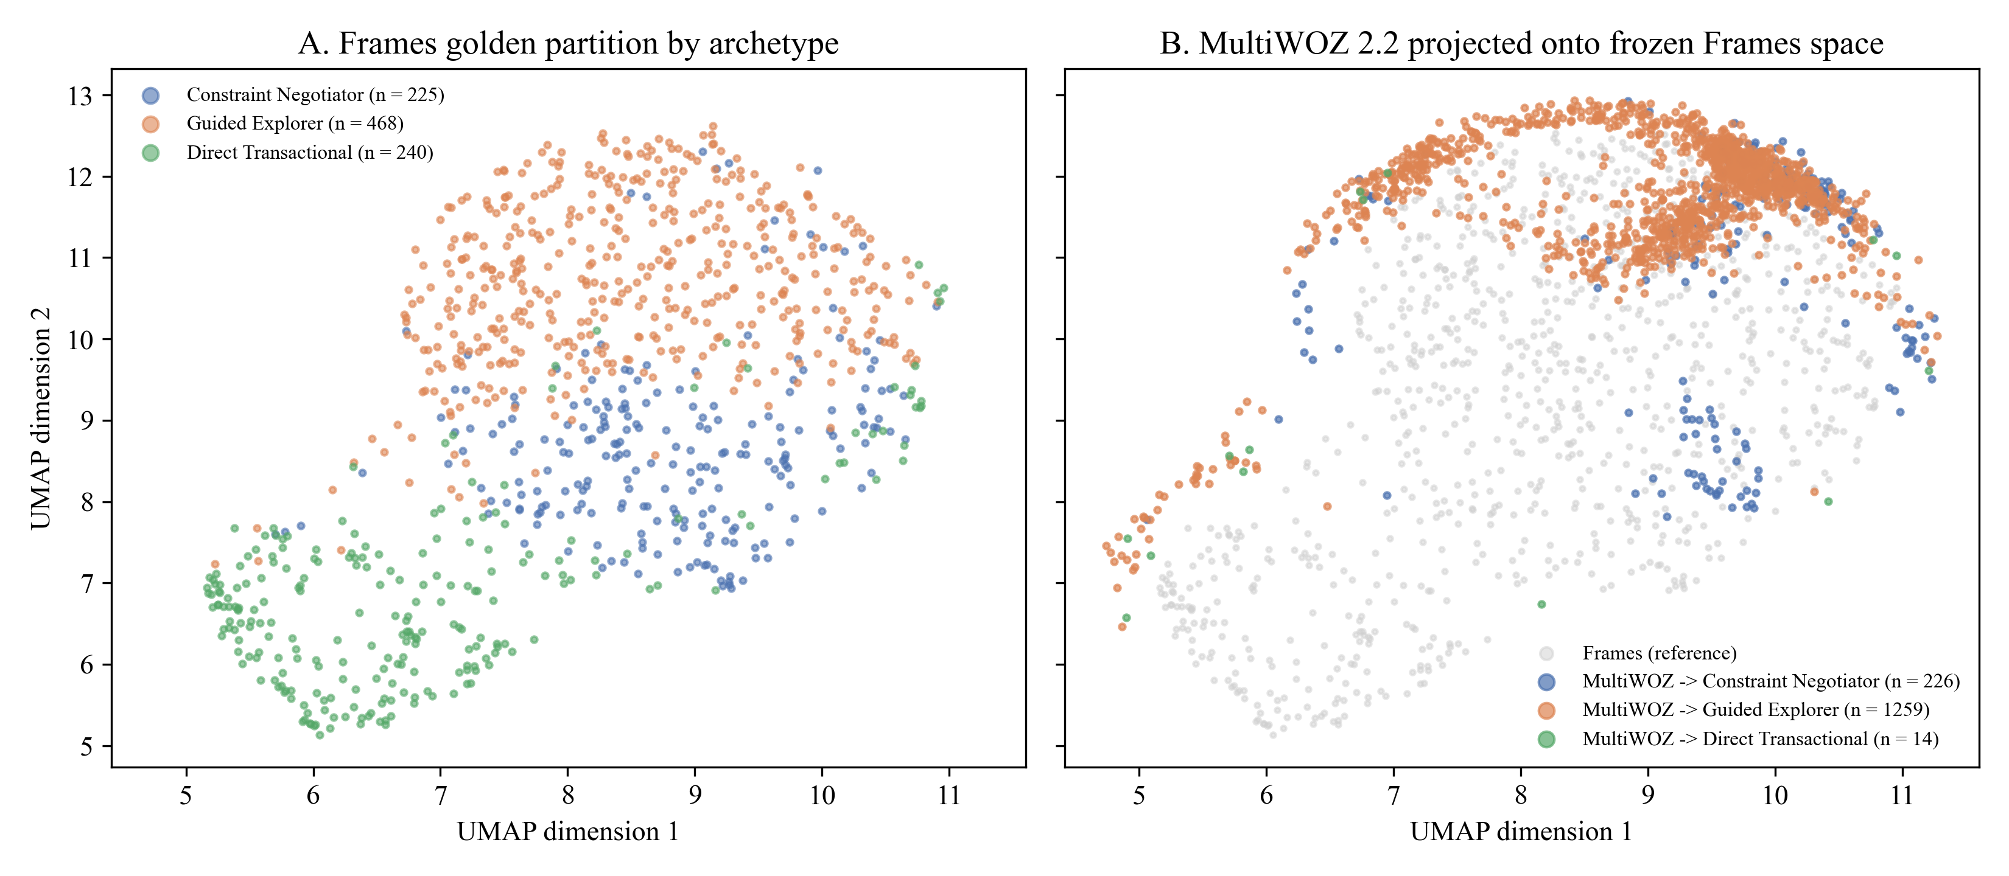
Figure D4
Hybrid Archetype Stability, Routing, and Outcome Association Across Truncation Horizons
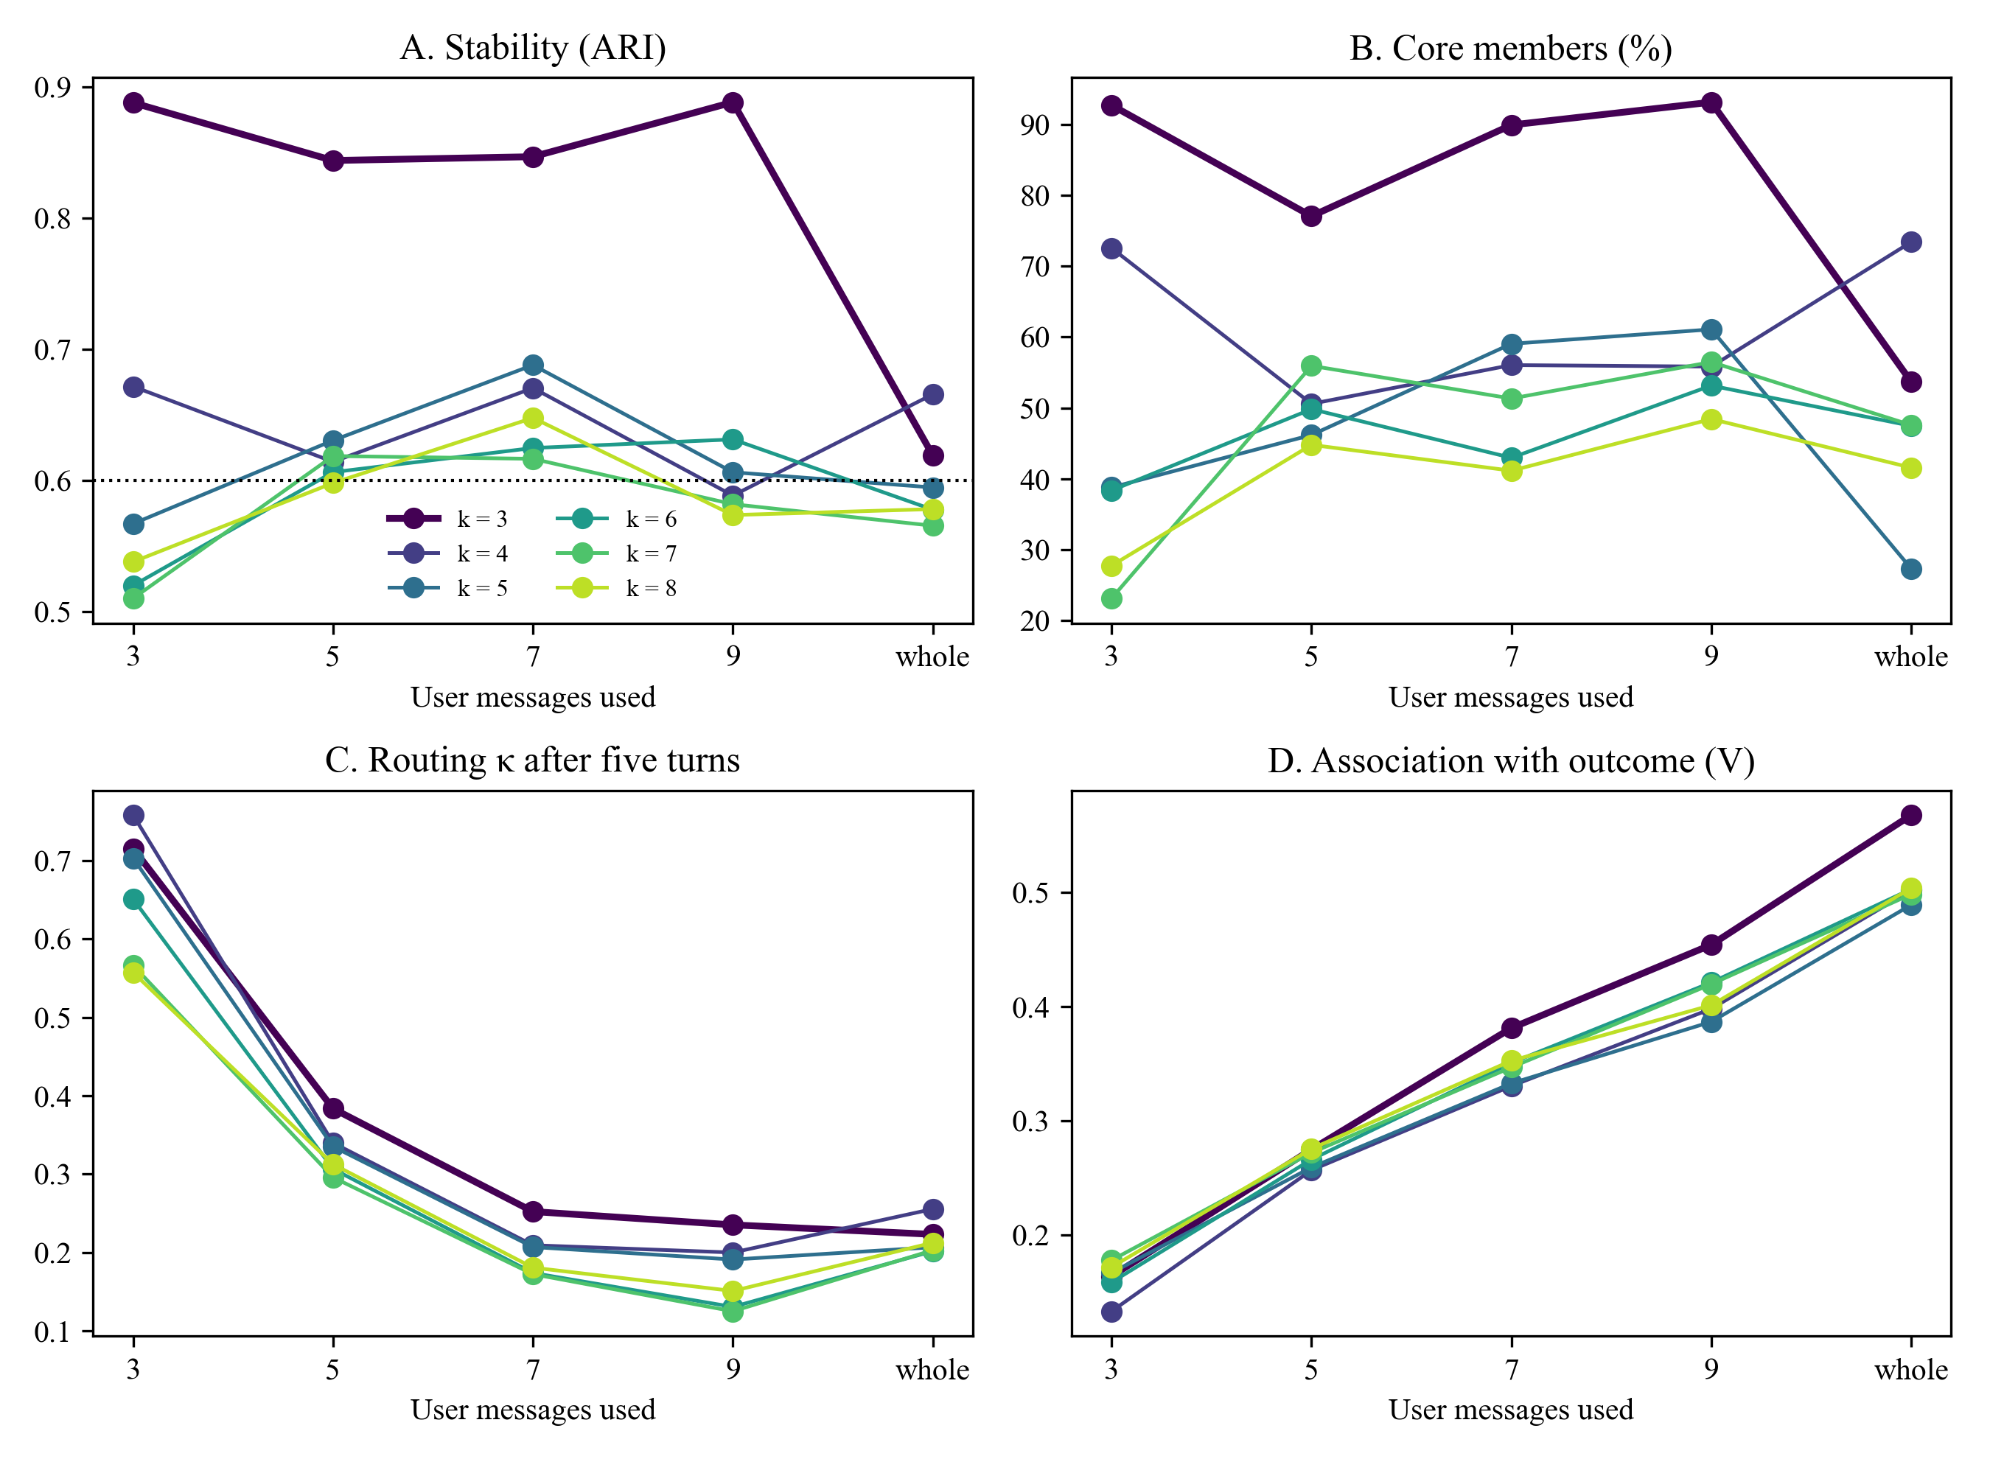

Appendix E

Supplementary EDA, RQ2 Pairwise Contrasts, and RQ3/RQ4 Groundwork Diagnostics
Tables E1–E5 and Figures E1–E3 provide the supplementary slot-completeness table, multivariate PCA loadings, Holm-adjusted pairwise contrasts for RQ2, corpus rule coverage audit for RQ3, and human turn-economy baseline for RQ4.
Table E1
Observed Canonical Slot Completeness by Corpus
Canonical slot | Schema tier | Microsoft Frames (%) | MultiWOZ 2.2 (%)
origin city | Tier 1 | 99.4 | 70.8
destination city | Tier 1 | 99.0 | 71.4
departure date | Tier 1 | 84.9 | 68.6
return date | Tier 1 | 70.8 | 0.0
duration nights | Tier 1 | 61.8 | 27.0
traveler count adults | Tier 1 | 63.9 | 54.0
traveler count children | Tier 1 | 18.4 | 0.0
budget amount | Tier 1 | 72.9 | 24.1
accommodation tier | Tier 1 | 72.7 | 19.7
visa processing window days | Tier 2 | 0.0 | 0.0
passport expiry months | Tier 2 | 0.0 | 0.0
discount applied percentage | Tier 2 | 0.0 | 0.0

Table E2
Multivariate Principal Component Loadings of Structural and Behavioral Features (Frames)
Variable | PC1 loading (40.8% var.) | PC2 loading (17.2% var.) | PC3 loading (10.6% var.)
Total Turns | .393 | .166 | −.234
Slot Revisions | .424 | .195 | −.064
Agent Offers | .361 | .292 | −.078
User Words/Turn | .025 | −.087 | .888
Dest. Flexibility | .327 | −.182 | .135
Exploration Breadth | .417 | −.108 | .101
Decisiveness | −.259 | .503 | .028
Revision Tendency | .297 | −.460 | .025
Question Asking | .301 | .248 | .027
Politeness | .089 | .520 | .341

Table E3
Holm-Adjusted Paired Contrasts for Refined RQ2 Outcomes (N = 33)
Outcome metric | Pairwise contrast | Mean diff. | t | df | p (Holm) | d_{z}
Refined: SBERT style cosine | Cluster-Adaptive vs. Static | .144 | 4.24 | 32 | < .001 | 0.74
Refined: SBERT style cosine | Cluster-Adaptive vs. Zero-Shot | .067 | 2.36 | 32 | .049 | 0.41
Refined: SBERT style cosine | Static vs. Zero-Shot | −.077 | −2.20 | 32 | .049 | −0.38
Refined: Gemini style cosine | Cluster-Adaptive vs. Zero-Shot | .027 | 1.20 | 32 | .713 | 0.21
Refined: Gemini style cosine | Static vs. Zero-Shot | .024 | 0.79 | 32 | .865 | 0.14
Refined: Gemini style cosine | Cluster-Adaptive vs. Static | .004 | 0.13 | 32 | .895 | 0.02
Refined: BERTScore F1 | Cluster-Adaptive vs. Static | .056 | 1.45 | 32 | .472 | 0.25
Refined: BERTScore F1 | Cluster-Adaptive vs. Zero-Shot | .025 | 0.85 | 32 | .804 | 0.15
Refined: BERTScore F1 | Static vs. Zero-Shot | −.031 | −0.75 | 32 | .804 | −0.13
Refined: Pacing error (words) | Cluster-Adaptive vs. Zero-Shot | −6.25 | −3.49 | 32 | .004 | −0.61
Refined: Pacing error (words) | Cluster-Adaptive vs. Static | −2.46 | −2.66 | 32 | .024 | −0.46
Refined: Pacing error (words) | Static vs. Zero-Shot | −3.79 | −1.82 | 32 | .078 | −0.32
Refined: Response length (words) | Cluster-Adaptive vs. Static | 6.82 | 7.00 | 32 | < .001 | 1.22
Refined: Response length (words) | Static vs. Zero-Shot | −10.91 | −4.29 | 32 | < .001 | −0.75
Refined: Response length (words) | Cluster-Adaptive vs. Zero-Shot | −4.09 | −1.84 | 32 | .075 | −0.32

Table E4
Empirical Corpus Audit of Policy Rule Coverage in Microsoft Frames (N = 1,334)
Declarative rule | Required canonical slot | Slot observed (%) | Dialogues triggering (n) | Triggering (%)
pax capacity | traveler count adults | 24.1 | 54 | 4.05
budget minimum | budget amount | 65.1 | 266 | 19.94
visa window | visa processing window days | 0.0 | 0 | 0.00
passport validity | passport expiry months | 0.0 | 0 | 0.00
discount threshold | discount applied percentage | 0.0 | 0 | 0.00

Table E5
Human Wizard Baseline of Turn Economy and Redundant Elicitation by Refined Archetype (Frames)
Refined user archetype | n | Turns M (SD) | RER M (SD) | Wizard request turns M
Decisive Booker | 595 | 14.56 (4.52) | .014 (.047) | 1.44
Open Explorer | 337 | 20.75 (7.07) | .016 (.049) | 1.82
Rigid-Constraint Seeker | 402 | 10.60 (5.59) | .017 (.061) | 1.27

Figure E1
Observed Slot Completeness by Corpus
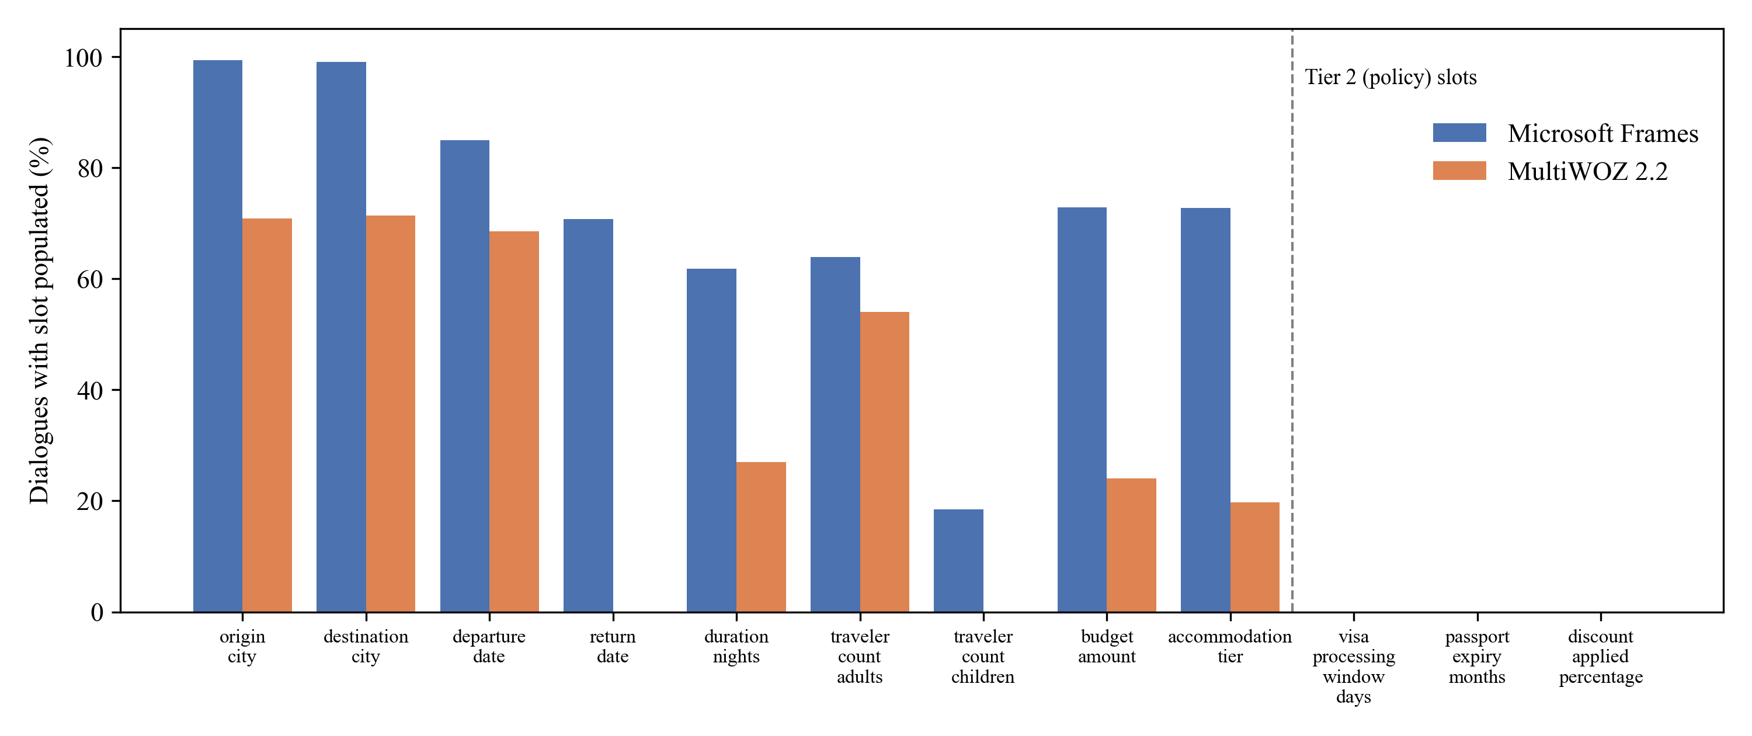
Figure E2
Primary RQ2 Results on Unrefined Whole-Dialogue Archetypes
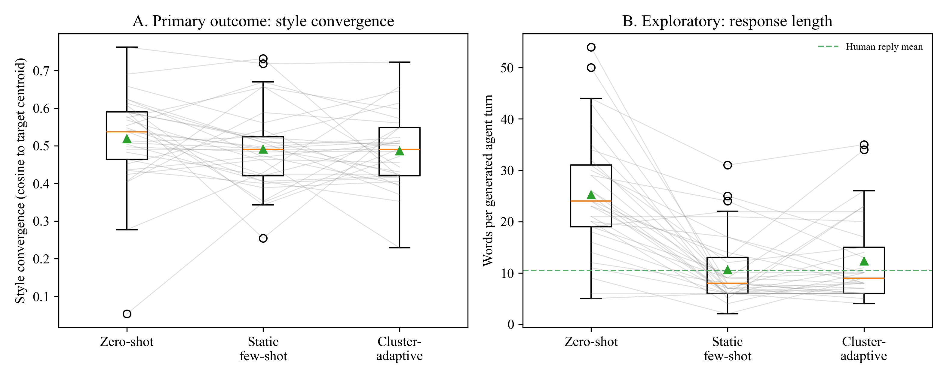
Figure E3
Human Wizard Baseline of Turn Economy and Redundant Elicitation by Refined Archetype
