Cluster-Adaptive Prompting for Multi-Turn Travel and Tourism Conversational Systems
Interim Report

Surnella Sandeep
Department of Data Analytics, Walsh College
QM640: Data Analytics Capstone
Mr. Smitraj Raut
October 27, 2026

Contents
Cluster-Adaptive Prompting for Multi-Turn Travel and Tourism Conversational Systems 4
Background and Problem Domain 4
Literature Review and Synthesis 4
Problem Statement and Variables 6
Purpose and Objectives 7
Interim Progress Summary 7
Scope, Research Questions, and Feasibility 8
Inclusions 8
Explicit Exclusions 8
Keeping the Cross-Corpus, Multi-Method Plan Manageable 9
Research Questions and Hypotheses 9
Feasibility 10
Methodology 11
Research Design and Partitioning 11
Randomization and Leakage Controls 11
Sample Size Determination 11
Data 14
Data Sources 14
Data Quality: Missing Values, Outliers, and Duplicates 15
Dataset Limitations 15
Preprocessing and the Two-Tier Canonical Schema 17
Data Dictionary 18
Ethical Considerations 20
Reproducibility 21
Exploratory Data Analysis 21
Analytical Approach and Interim Results 23
RQ1: Trajectory Clustering (Complete) 23
RQ2: Cluster-Adaptive Few-Shot Prompting (Complete) 30
RQ3: Rules Versus Prompting Ablation (Groundwork Complete) 36
RQ4: Turn Economy Across Archetypes (Groundwork Complete) 39
Discussion 41
Findings Mapped to the Research Questions 41
Limitations and Threats to Validity 42
Practical Recommendations 43
Remaining Work 43
References 44
Appendix A 48
Appendix B 49
Appendix C 50

Cluster-Adaptive Prompting for Multi-Turn Travel and Tourism Conversational Systems
Conversational artificial intelligence (AI) agents are now widely used in travel and tourism to support destination discovery, itinerary planning, and booking (Jannach et al., 2021). Travelers differ in how they converse: some state every constraint in the first message, some revise budgets and dates repeatedly, and others rely on the agent to lead the search (Inaba et al., 2022). Most production travel assistants, however, use one static prompt for every user. The result is repetitive clarification questions, mismatched pacing, and abandoned sessions. This interim report documents the progress of a quantitative capstone study that tests whether conversation archetypes learned from historical dialogues can be used to adapt a large language model (LLM) agent's style through in-context examples, while a separate rule engine protects factual accuracy and business policy.

Background and Problem Domain
Designers usually adapt an LLM agent's style through prompt engineering, for example, by inserting example dialogues into the prompt. Prompt-only adaptation creates two risks (Rebedea et al., 2023). First, the model can copy stale details from the examples, such as earlier prices, dates, or destinations, into the current conversation. Second, style instructions compete with business constraints, so the agent may propose an itinerary that violates passport, visa, capacity, or discount policies. This study therefore separates the two concerns: archetype-matched examples steer style, and a declarative rule engine outside the prompt checks policy.

Literature Review and Synthesis

Task-Oriented Dialogue Corpora
MultiWOZ (Budzianowski et al., 2018) is the standard multi-domain benchmark for task-oriented dialogue, and MultiWOZ 2.2 (Zang et al., 2020) corrected state annotations and introduced a schema-guided slot ontology. MultiWOZ, however, covers restaurant, hotel, attraction, train, and taxi services in one city and contains no flights or package negotiation. The Microsoft Frames corpus (El Asri et al., 2017) was designed for exactly that setting: users negotiate flight-and-hotel vacation packages under a budget and compare several candidate offers (frames) before deciding. Frames is therefore the primary corpus in this study, and MultiWOZ 2.2 serves only as an external comparison.

Dialogue Representation and Clustering
Sentence-BERT (Reimers & Gurevych, 2019) produces sentence embeddings whose cosine distances reflect semantic similarity, which makes whole-dialogue representations possible without task-specific training. Partitioning methods (K-Means), hierarchical methods (Ward agglomerative clustering), and density-based methods (HDBSCAN; McInnes et al., 2017) make different assumptions about cluster shape, so they should be compared rather than chosen a priori. Cluster quality is usually judged with the Silhouette coefficient (Rousseeuw, 1987) and the Davies–Bouldin index (Davies & Bouldin, 1979), and UMAP (McInnes et al., 2018) is commonly used to inspect the resulting structure visually. Implementations in scikit-learn (Pedregosa et al., 2011) make the comparison reproducible.

In-Context Exemplar Selection
Brown et al. (2020) showed that LLMs can perform new tasks from a few in-context examples, and Liu et al. (2022) showed that examples retrieved by embedding similarity outperform randomly chosen ones. Exact inner-product search libraries such as FAISS (Johnson et al., 2021) make such retrieval fast. These studies evaluate single-turn tasks and measure accuracy, not conversational style, and they retrieve from one global pool rather than from behaviorally defined sub-pools.

Policy Compliance and Evaluation
NeMo Guardrails (Rebedea et al., 2023) moves safety and policy logic into programmable rails outside the model. τ-bench (Yao et al., 2024) evaluates agents against explicit domain policies and shows that policy adherence must be measured separately from task success. TD-EVAL (Acikgoz et al., 2025) argues that dialogue-level similarity metrics such as BERTScore (Zhang et al., 2020) must be complemented by turn-level checks of factual consistency and policy compliance.

Synthesis and Research Gaps
Taken together, the literature supplies a suitable corpus (Frames), a representation method (Sentence-BERT), a retrieval mechanism (similarity-based exemplar selection), and an evaluation stance (separate measures of style, factual accuracy, and policy). Three gaps remain. First, no reviewed study derives conversation archetypes from whole-dialogue trajectories and uses them to select in-context examples. Second, studies that steer style do not measure whether the examples leak stale facts, and studies that enforce policy do not adapt style. Third, the turn-economy effect of style adaptation across different user archetypes has not been tested. Appendix C compares the closest studies with the present design.

Problem Statement and Variables
Travel conversational agents lack a data-driven way to recognize a user's conversation archetype and adapt their style to it, and prompt-based style steering can introduce factual leakage and policy violations. The study measures how four independent variables—clustering algorithm (RQ1), in-context conditioning strategy (RQ2), rule-engine mode (RQ3), and conditioning strategy crossed with user archetype (RQ4)—affect cluster separation, style convergence, slot accuracy, exemplar leakage, rule adherence, and turn economy. Every variable is defined operationally in the data dictionary (Tables 5 to 7).

Purpose and Objectives
The purpose of this quantitative study is to
1. discover and interpret conversation archetypes in human travel dialogues and identify the clustering algorithm that separates them best (RQ1);
2. measure whether archetype-matched in-context examples move an LLM agent's responses toward the target archetype's style more than zero-shot or static examples do (RQ2);
3. isolate, in a 2 × 2 experiment, the effects of a declarative rule engine and of cluster-adaptive prompting on slot accuracy, exemplar leakage, and rule adherence (RQ3); and
4. estimate whether cluster-adaptive prompting changes turn economy differently across archetypes (RQ4).

Interim Progress Summary
By Week 4 the data pipeline, quality audit, exploratory analysis, and power analysis were complete. RQ1 was completed end to end with real data. RQ2 was also completed: the repeated-measures experiment was run with 99 LLM generations, and archetype-matched examples did not improve style convergence beyond zero-shot or static examples, although few-shot prompting of either kind brought response length close to the human level. For RQ3 and RQ4 the groundwork was completed: the rule engine was verified, the corpus was audited for policy-relevant information, and a human baseline for turn economy was measured. Results from earlier drafts that relied on placeholder values have been removed; every number in this report comes from the reproducible pipeline described in Appendix A.

Scope, Research Questions, and Feasibility

Inclusions
The study includes English-language, multi-turn, human–human travel dialogues from two public corpora: all 1,369 Microsoft Frames dialogues and a 1,500-dialogue sample of MultiWOZ 2.2 dialogues that involve at least one travel service (hotel, train, taxi, or attraction). Dialogues must contain at least three turns. Archetypes are learned only from the Frames golden partition, and all experiments use one embedding model (Sentence-BERT all-MiniLM-L6-v2), three clustering algorithms, and one LLM family (Gemini Flash).

Explicit Exclusions
The following are outside the scope of this study:
1. Cross-corpus transfer. Archetypes are not trained on MultiWOZ, and no claim is made that Frames archetypes transfer to MultiWOZ or to other domains. MultiWOZ is used only as a frozen-centroid projection check, reported descriptively.
2. Proprietary, enterprise, or customer data of any kind, and any human-subject data collection.
3. Synthetic or LLM-augmented training dialogues. The only synthetic elements are the author-defined policy rules and the policy scenarios injected for RQ3, which are labeled as such.
4. Non-English dialogues, speech or voice channels, and dialogues with fewer than three turns.
5. MultiWOZ dialogues that involve only restaurant booking, which have no travel component.
6. Model fine-tuning, alternative embedding models, and alternative LLM providers, which are left as future sensitivity analyses.
7. Live deployment, real bookings, real prices, and user-satisfaction outcomes.

Keeping the Cross-Corpus, Multi-Method Plan Manageable
Four design decisions keep the four research questions feasible within one 10-week study. (a) One primary corpus: all learning, retrieval, and experiments use Frames; MultiWOZ adds a single descriptive projection and requires no additional modeling. (b) One shared pipeline: every research question reuses the same preprocessing, embeddings, frozen archetype centroids, and held-out partition, so later questions add only an experimental factor rather than a new method. (c) One shared test sample: the largest per-question sample (180 dialogues) fits inside the held-out partition, so no new data are needed. (d) Staged execution: RQ1 and RQ2 are complete, and RQ3 and RQ4 reuse the RQ2 generation code with one added factor each. Appendix B shows the resulting 10-week schedule.

Research Questions and Hypotheses
Table 1 states each research question with its hypotheses and the analysis that tests it.
Table 1
Research Questions, Hypotheses, and Planned Analyses
RQ | Research question | Hypotheses | Analysis
RQ1 | Which clustering algorithm (K-Means, agglomerative, HDBSCAN) gives the best separation of dialogue-trajectory embeddings, and which archetypes emerge? | H₀: mean Silhouette is equal across algorithms. H₁: at least one mean differs. | One-way ANOVA (Welch and Kruskal–Wallis as robustness checks); Tukey and Games–Howell post hoc
RQ2 | Does cluster-adaptive few-shot prompting increase style convergence relative to zero-shot and static few-shot prompting? | H₀: mean style cosine is equal across conditions. H₁: cluster-adaptive > static and zero-shot. | One-way repeated-measures ANOVA; Greenhouse–Geisser correction; Holm-adjusted paired contrasts
RQ3 | Do a declarative rule engine and cluster-adaptive prompting affect slot F1, exemplar leakage, and rule adherence? | H₀: no main or interaction effects. H₁: rules raise adherence and reduce leakage without lowering style convergence. | 2 × 2 between-subjects factorial ANOVA
RQ4 | Does cluster-adaptive prompting change turns to goal completion and redundant elicitation differently across archetypes? | H₀: no conditioning × archetype interaction. H₁: the reduction in turns differs by archetype. | 2 × 3 factorial ANOVA on log turns
Note. RQ = research question; ANOVA = analysis of variance. Significance level α = .05 for all tests.

Feasibility
Both corpora are freely downloadable, and the full pipeline (ingestion, embeddings, clustering, and pilot) runs on a laptop in under 15 minutes. The RQ2 experiment requires 99 LLM calls, and RQ3 and RQ4 together require fewer than 2,000 calls, which is within the free tier of the Gemini application programming interface. The main feasibility risk is API access; it is mitigated by caching every response so that interrupted runs resume, and by keeping the analysis code independent of the model call.

Methodology

Research Design and Partitioning
The study uses a quantitative design with one observational component (RQ1) and three controlled experiments (RQ2 to RQ4). After cleaning, the 1,334 analytic Frames dialogues were split once, with seed 42 and stratification on the task-success label, into a golden partition (D_{gold}, 70%, n = 933) and a held-out partition (D_{test}, 30%, n = 401). D_{gold} is used to fit clusters, compute archetype centroids, and build the exemplar retrieval pool, which contains the 879 golden dialogues that the wizard marked as successful. D_{test} is used only for evaluation.

Randomization and Leakage Controls
All random steps (partitioning, subsampling, test-sample selection, static exemplar choice, and rule-scenario injection) use a fixed seed so that results can be reproduced exactly. Four controls prevent leakage. First, D_{gold} and D_{test} share no dialogues, and centroids are frozen before any test dialogue is seen. Second, a test dialogue is routed using only the turns available at generation time, and the retrieval keys of the golden pool are built from the same number of opening turns, so neither side uses future turns. Third, entity values in exemplars are replaced with slot tokens (for example, [DST_CITY] or [NUM]) so that examples carry style rather than facts. Fourth, the human reply that follows the test prefix is used only as a reference for scoring and never appears in a prompt.

Sample Size Determination
Each sample size was computed for the exact test used later in the analysis, with a medium effect size f = .25 (Cohen, 1988), α = .05, and target power .80. Because no prior study reports effect sizes for these comparisons, Cohen's medium benchmark was used for all four questions. Power was computed exactly from the noncentral F distribution, and the results were checked against G*Power 3 (Faul et al., 2007).

General Formula
For an F test with numerator degrees of freedom df₁, denominator degrees of freedom df₂, and noncentrality parameter λ, power is
1 − β = 1 − F_{nc}(F_{crit}; df₁, df₂, λ), F_{crit} = F_{1−α}(df₁, df₂) (1)
where F_{nc} is the cumulative noncentral F distribution. For between-subjects designs λ = f²N. The smallest N that gives power ≥ .80 is N_{min}. N_{min} is then rounded up to a balanced design and, for experiments that call an LLM, increased by 10% to allow for failed or invalid generations.

RQ1: One-Way ANOVA With Three Algorithms
The unit of analysis is one clustering run on an independent random subsample of D_{gold}, and the outcome is that run's Silhouette coefficient. With k = 3 groups, df₁ = 2, df₂ = N − 3, and λ = f²N. At N = 158, λ = .0625 × 158 = 9.875, F_{crit}(2, 155) = 3.054, and power = .802; at N = 157, power falls below .80. Rounding up to a balanced design gives N = 159 runs (53 per algorithm; power = .805). No buffer is needed because clustering runs cannot fail.

RQ2: One-Way Repeated-Measures ANOVA With Three Conditions
Every sampled test dialogue is answered under all m = 3 prompting conditions, so the dialogue is the subject and the design is within-subjects. For a repeated-measures factor (Faul et al., 2007),
λ = f² · N · m · ε / (1 − ρ), df₁ = (m − 1)ε, df₂ = (N − 1)(m − 1)ε (2)
where ρ is the correlation among repeated measures and ε is the sphericity correction. With the conventional planning values ρ = .50 and ε = 1, N = 28 gives λ = .0625 × 28 × 3 / .50 = 10.5, F_{crit}(2, 54) = 3.168, and power = .812. Rounding to a multiple of three archetypes gives 30, and the 10% buffer gives N = 33 dialogues (11 per archetype; 99 scored responses; power = .878). If sphericity is violated, the Greenhouse–Geisser correction is applied; the buffer keeps power near .80 for ε down to about .80.

RQ3: 2 × 2 Between-Subjects Factorial ANOVA
Each test dialogue is randomly assigned to one of four cells (rules active or off × zero-shot or cluster-adaptive). Each main effect and the interaction has df₁ = 1, and df₂ = N − 4. At N = 128, λ = .0625 × 128 = 8.0, F_{crit}(1, 124) = 3.918, and power = .801. This is already balanced (32 per cell); the 10% buffer gives N = 144 (36 per cell; power = .846).

RQ4: 2 × 3 Factorial ANOVA
The design crosses conditioning (zero-shot or cluster-adaptive) with archetype (three levels). The test of interest is the interaction, with df₁ = (2 − 1)(3 − 1) = 2 and df₂ = N − 6. At N = 158, λ = .0625 × 158 = 9.875, F_{crit}(2, 152) = 3.056, and power = .802. Balancing to six cells gives 162, and the 10% buffer gives N = 180 (30 per cell; power = .855).

Summary and Minimax Decision
Table 2 summarizes the four calculations. The experiments draw their dialogues from the same held-out partition, and a dialogue may serve in more than one experiment but appears only once within an experiment. The binding requirement is therefore the largest experimental sample, max(33, 144, 180) = 180, which is smaller than |D_{test}| = 401. RQ1 draws its runs from D_{gold} (933 dialogues).
Table 2
Sample Size Calculations Matched to Each Planned Analysis
RQ | Planned analysis | df at N_{min} | λ | F_{crit} | N_{min} | Power | N_{final} (per group) | Final power
RQ1 | One-way ANOVA (3 algorithms) | 2, 155 | 9.88 | 3.05 | 158 | .802 | 159 (53) | .805
RQ2 | One-way repeated-measures ANOVA (3 conditions) | 2, 54 | 10.50 | 3.17 | 28 | .812 | 33 (11) | .878
RQ3 | 2 × 2 factorial ANOVA | 1, 124 | 8.00 | 3.92 | 128 | .801 | 144 (36) | .846
RQ4 | 2 × 3 factorial ANOVA | 2, 152 | 9.88 | 3.06 | 158 | .802 | 180 (30) | .855
Note. All calculations use f = .25 and α = .05. RQ1 units are clustering runs on subsamples of the golden partition; RQ2 units are test dialogues measured under three conditions (ρ = .50, ε = 1); RQ3 and RQ4 units are test dialogues. RQ2 to RQ4 include a 10% buffer for failed generations.

Data

Data Sources
Microsoft Frames (El Asri et al., 2017) contains 1,369 English Wizard-of-Oz dialogues in which a user role-player negotiates a flight-and-hotel package with a wizard who searches a database of fictional cities. Each turn carries dialogue-act annotations with slot–value arguments, and each dialogue carries a wizard-reported task-success label and a user satisfaction rating. The corpus is available from Microsoft Research (https://www.microsoft.com/en-us/research/project/frames-dataset/). MultiWOZ 2.2 (Zang et al., 2020) contains 10,438 dialogues with per-turn dialogue states and is available on GitHub (https://github.com/budzianowski/multiwoz). Both corpora were downloaded in full; the MultiWOZ sample was drawn with a fixed seed from dialogues that involve at least one travel service.

Data Quality: Missing Values, Outliers, and Duplicates
Table 3 reports the data-quality audit. No dialogue had a duplicate identifier or an empty utterance. One MultiWOZ dialogue duplicated another's full text and was removed. A total of 35 Frames dialogues had fewer than three turns and were excluded because they contain no negotiation trajectory. Turn-count outliers were flagged with the interquartile-range rule (Frames > 32.5 turns, n = 22; MultiWOZ > 27.0 turns, n = 13). They were retained because long negotiations are genuine behavior of interest; their influence is limited by the decay weighting in the embedding and by analyzing log-transformed turn counts. Missing slot values are not imputed: a slot that is never mentioned is treated as unobserved, which is the correct state for a dialogue-state tracker.
Table 3
Data-Quality Audit and Analytic Sample
Check | Microsoft Frames | MultiWOZ 2.2 sample
Dialogues downloaded or sampled | 1,369 | 1,500
Duplicate identifiers | 0 | 0
Duplicate full text (removed) | 0 | 1
Dialogues with an empty utterance | 0 | 0
Excluded: fewer than three turns | 35 | 0
Turn-count outliers (retained) | 22 (> 32.5) | 13 (> 27.0)
Missing task-success label | 0 | Not available
Missing user rating | 3 | Not available
Analytic sample | 1,334 | 1,499
Note. Outliers were identified as values above Q3 + 1.5 × IQR of the turn count. Restaurant-only MultiWOZ dialogues were excluded before sampling.

Dataset Limitations
Beyond access and ethics, the data have concrete coverage and completeness limits:
1. Role-play, not real customers. Frames dialogues were produced by 11 user role-players and 12 wizards following written scenarios. Archetypes may therefore partly reflect individual role-players' habits; this is tested in the RQ1 results.
2. Fictional geography and prices. Frames cities and prices are invented, so destination knowledge and price realism cannot be evaluated, and international travel must be assumed for policy checks.
3. Domain coverage. MultiWOZ covers one city, has no flights or package negotiation, and records price only as a category (cheap, moderate, expensive), so its budget information is not comparable to Frames.
4. Missing slot information. Table 4 shows that several Tier 1 slots are often absent. In Frames, children are mentioned in only 18.4% of dialogues and trip duration in 61.8%; MultiWOZ never records a return date or children.
5. Policy information absent. Neither corpus contains visa timing, passport validity, or discount information (0% for all three Tier 2 slots), so RQ3 must inject these conditions synthetically.
6. No demographics or outcome follow-up. Neither corpus records traveler age, nationality, or whether a booking was completed in reality; Frames timestamps record collection time only. Frames task-success labels are wizard-reported and highly imbalanced (94.2% successful).
7. Missing ratings. Frames has 3 dialogues without a user rating and none without a task-success label.
Table 4
Observed Slot Completeness by Corpus
Slot | Tier | Frames (%) | MultiWOZ 2.2 (%)
origin city | Tier 1 | 99.4 | 70.8
destination city | Tier 1 | 99.0 | 71.4
departure date | Tier 1 | 84.9 | 68.6
return date | Tier 1 | 70.8 | 0.0
duration nights | Tier 1 | 61.8 | 27.0
traveler count adults | Tier 1 | 63.9 | 54.0
traveler count children | Tier 1 | 18.4 | 0.0
budget amount | Tier 1 | 72.9 | 24.1
accommodation tier | Tier 1 | 72.7 | 19.7
visa processing window days | Tier 2 | 0.0 | 0.0
passport expiry months | Tier 2 | 0.0 | 0.0
discount applied percentage | Tier 2 | 0.0 | 0.0
Note. Percentage of dialogues in which the slot is mentioned at least once in the dialogue-act (Frames) or dialogue-state (MultiWOZ) annotations. MultiWOZ budget is the categorical price range. Frames N = 1,334; MultiWOZ N = 1,499.

Preprocessing and the Two-Tier Canonical Schema
Both corpora were parsed into one canonical dialogue format. Frames labels such as or_city and dst_city and MultiWOZ labels such as train-departure and train-destination were mapped to a two-tier schema. Tier 1 holds nine universal travel slots (origin, destination, departure and return dates, duration, adults, children, budget, and accommodation tier). Tier 2 holds policy slots (visa processing window, passport validity, package type, room sharing, and discount) that are used only by the rule engine. Speaker labels were made corpus-neutral (Frames wizard and MultiWOZ system both become AGENT), entity values were replaced with slot tokens, and numbers with [NUM].
Each turn t of a dialogue with T turns was embedded with Sentence-BERT as a 384-dimensional vector e_{t}. The dialogue trajectory vector is the decay-weighted mean
v = Σ_{t} w_{t}e_{t}, w_{t} = exp[−λ_{d}(T − t)] / Σ_{j} exp[−λ_{d}(T − j)] (3)
with λ_{d} = 0.15, followed by L2 normalization. The weighting emphasizes how a dialogue develops and closes while still including its opening. Structural features (turn counts, revisions, hesitations) are not part of the vector; they are used afterwards to interpret clusters, which keeps the clustering input purely textual.

Data Dictionary
The data dictionary has three parts: the raw fields used from each corpus (Table 5), the canonical schema produced by preprocessing (Table 6), and the analysis variables (Table 7).
Table 5
Data Dictionary, Part A: Raw Source Fields Used
Corpus | Field | Type | Description | Use
Frames | id | String | Unique dialogue identifier | Key
Frames | user_id, wizard_id | String | Role-player identifiers (11 users, 12 wizards) | Confound check
Frames | turns[].author | Category | user or wizard | Speaker tag
Frames | turns[].text | String | Utterance text | Embedding
Frames | turns[].timestamp | Float | Collection time (Unix ms) | Not used
Frames | turns[].labels.acts[].name | Category | Dialogue act (e.g., inform, request, offer, switch_frame) | Features, RER
Frames | turns[].labels.acts[].args[].key/val | String | Slot name and value (e.g., dst_city, budget) | Tier 1 slots
Frames | labels.wizardSurveyTaskSuccessful | Boolean | Wizard-reported task success | Stratify, pool
Frames | labels.userSurveyRating | Float | User satisfaction rating (1–5) | Descriptive
MultiWOZ | dialogue_id | String | Unique dialogue identifier | Key
MultiWOZ | services | List | Services involved (hotel, train, taxi, ...) | Inclusion
MultiWOZ | turns[].speaker | Category | USER or SYSTEM | Speaker tag
MultiWOZ | turns[].utterance | String | Utterance text | Embedding
MultiWOZ | turns[].frames[].state.slot_values | Map | Cumulative dialogue state per service | Tier 1 slots
Note. RER = redundant elicitation rate. Only the fields listed were read; all other fields were ignored.
Table 6
Data Dictionary, Part B: Canonical Schema Fields
Field | Type | Description
dialogue_id, source_dataset | String | Identifier and corpus of origin (frames or multiwoz)
total_turns, user_turns, wizard_turns | Integer | Turn counts
turns[].turn_id, speaker, utterance | Mixed | Ordered turns with corpus-neutral speaker and text
turns[].acts, slots_mentioned, revisions | List, map | Acts, slots informed, and slots whose value changed in the turn
Tier 1: origin_city, destination_city | String | Trip endpoints
Tier 1: departure_date, return_date, duration_nights | String, integer | Trip timing
Tier 1: traveler_count_adults, traveler_count_children | Integer | Party size
Tier 1: budget_amount, accommodation_tier | Float, string | Budget ceiling and hotel tier
Tier 2: visa_processing_window_days, passport_expiry_months | Integer | Policy timing (synthetic in RQ3)
Tier 2: package_type, sharing_basis, discount_applied_percentage | String, float | Package, room, and discount (synthetic in RQ3)
revisions_count | Integer | Number of slot-value changes across the dialogue
hesitation_markers_count | Integer | User hesitation phrases (e.g., "maybe," "not sure")
budget_specified | Boolean | Whether a numeric budget was stated
Note. Schema implemented as Pydantic models in src/canonical_schema.py.
Table 7
Data Dictionary, Part C: Analysis Variables
Variable | Role | Type | Operational definition | RQ
Clustering algorithm | IV | Nominal (3) | K-Means, Ward agglomerative, HDBSCAN | 1
Silhouette coefficient | DV | Continuous [−1, 1] | Cosine Silhouette of a clustering run | 1
Davies–Bouldin index | DV | Continuous ≥ 0 | Mean cluster similarity ratio (lower is better) | 1
Archetype | IV / moderator | Nominal (3) | Nearest frozen K-Means centroid (cosine) | 1, 4
Conditioning strategy | IV | Nominal (3) | Zero-shot, static few-shot, cluster-adaptive few-shot (k = 3 exemplars) | 2–4
Style convergence | DV | Continuous [−1, 1] | Cosine between response and target archetype's agent-style centroid | 2, 3
Gold similarity | DV | Continuous [−1, 1] | Cosine between response and the human reply | 2
Rule-engine mode | IV | Nominal (2) | Active or off | 3
Slot F1 | DV | Proportion | F1 of slot values in the response against the dialogue state | 3
Exemplar leakage rate | DV | Proportion | Entities in the response that occur in exemplars but not in the dialogue / all entities | 3
Rule adherence rate | DV | Proportion | 1 − (violating agent turns / agent turns) | 3
Turns to goal completion | DV | Count (log) | Turns until all required slots are filled and an offer is accepted | 4
Redundant elicitation rate | DV | Proportion | Agent requests for an already-informed slot / agent turns | 4
Note. IV = independent variable; DV = dependent variable. All cosine measures use de-lexicalized text and all-MiniLM-L6-v2 embeddings.

Ethical Considerations
Both corpora are public, were collected with consent by their original authors for research use, and contain no personal identifiers; role-players and wizards are identified only by codes. No new human data are collected. Only de-lexicalized public dialogue text is sent to the LLM. Because role-play data can embed stereotypes, archetypes are described only by conversational behavior (turns, revisions, offers), never by inferred demographics.

Reproducibility
All code, configuration, and result tables are in a public repository (https://github.com/surnella/QM640-Dialogue-Clustering-Capstone). Each pipeline step writes its tables and figures to disk, and this report is generated from those files, so rerunning the steps in Appendix A reproduces every number reported here.

Exploratory Data Analysis
Table 8 describes the analytic samples. Frames and MultiWOZ dialogues have similar mean lengths (M = 14.93 and 15.17 turns), but Frames lengths vary more (SD = 6.74 vs. 4.46) and have a longer right tail (Figure 1). The golden and held-out partitions are nearly identical in length, utterance length, and success rate, which confirms that the stratified split worked as intended.
Table 8
Descriptive Statistics of the Analytic Samples
Sample | N | Turns M (SD) | Mdn | Range | User words | Agent words | Task success (%)
Microsoft Frames | 1,334 | 14.93 (6.74) | 14 | 3–48 | 10.6 | 15.0 | 94.2
MultiWOZ 2.2 | 1,499 | 15.17 (4.46) | 16 | 4–36 | 11.7 | 15.1 | —
Frames golden partition | 933 | 14.95 (6.75) | 14 | 3–48 | 10.7 | 15.3 | 94.2
Frames held-out partition | 401 | 14.90 (6.71) | 14 | 3–43 | 10.4 | 14.5 | 94.3
Note. User and agent words are mean words per utterance. Task success is the wizard-reported label (not available in MultiWOZ).
Figure 1
Distribution of Dialogue Length by Corpus
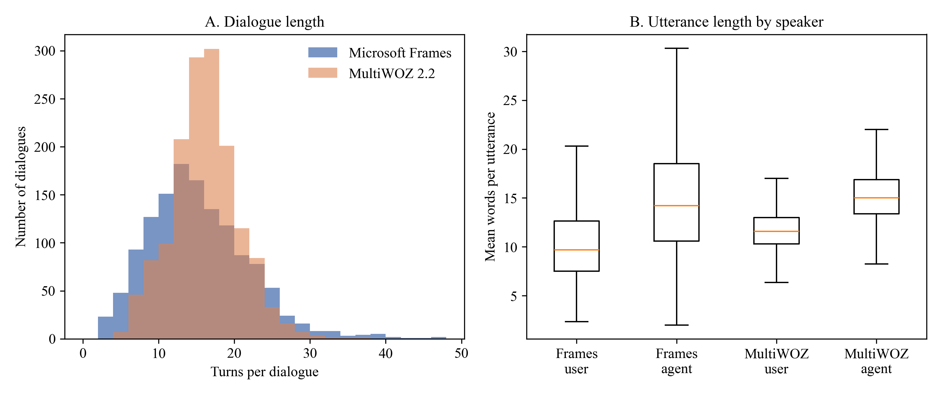
Note. Turn counts after cleaning. Frames N = 1,334; MultiWOZ N = 1,499.
Figure 2 visualizes the slot completeness reported in Table 4. Frames users state origin and destination in almost every dialogue and a budget in most, whereas MultiWOZ dialogues mention travel slots far less often and never mention return dates. Three insights shape the analysis. First, Frames is the only corpus with enough budget and package information for the negotiation behavior that the archetypes are meant to capture. Second, length differences between the corpora mean that any archetype tied to dialogue length will be distributed differently across corpora, which motivates treating MultiWOZ only as a descriptive check. Third, the absence of policy slots in both corpora confirms that RQ3 requires injected scenarios.
Figure 2
Slot Completeness by Corpus
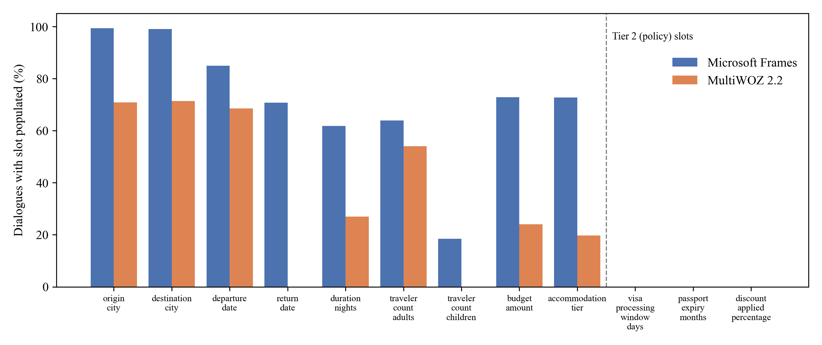
Note. Percentage of dialogues that mention each canonical slot at least once.

Analytical Approach and Interim Results
This section presents, for each research question, the method and features, the baseline, the assumptions and how each was tested, the metrics and validation, and the interim results. The four questions share one pipeline: (a) ingestion and canonicalization, (b) de-lexicalization and decay-weighted embedding, (c) archetype discovery on D_{gold} with frozen centroids, (d) FAISS exemplar indices per archetype, (e) prompt assembly and Gemini generation, (f) the declarative rule engine, and (g) statistical evaluation in SciPy and statsmodels (Seabold & Perktold, 2010).

RQ1: Trajectory Clustering (Complete)

Method, Features, and Baseline
The features are the 384-dimensional trajectory vectors from Equation 3. Each algorithm was applied to 53 independent random subsamples of 500 golden dialogues, drawn without replacement within each subsample, giving the 159 Silhouette scores required by the power analysis. K-Means used k = 3 with 10 initializations; Ward agglomerative clustering used k = 3; HDBSCAN chose the number of clusters itself, and its noise points were assigned to the nearest cluster centroid so that every dialogue receives an archetype. Two baselines were used: a permutation baseline, in which K-Means labels were shuffled within each subsample to give the Silhouette expected with no structure, and K-Means itself as the conventional reference method.

Assumptions and How They Were Tested
Independence of runs. Each run uses its own random subsample, so the runs are independent draws given the golden partition. Because subsamples share dialogues, the variability between runs is smaller than it would be across fully separate datasets; the comparison is therefore interpreted as a comparison of algorithms on this corpus.
Normality. Shapiro–Wilk tests did not reject normality for any algorithm (K-Means W = .965, p = .120; agglomerative W = .979, p = .477; HDBSCAN W = .980, p = .524). The assumption is met.
Homogeneity of variance. Levene's test was significant, W = 12.75, p < .001, because K-Means varies much less than the other algorithms. The assumption is not met, so Welch's ANOVA and Games–Howell comparisons are reported alongside the standard tests, and the Kruskal–Wallis test is reported as a distribution-free check.
Meaningful embedding geometry. The method assumes that cosine distance between trajectory vectors reflects conversational behavior. This was checked by testing whether clusters differ on behavioral features that were not used in clustering (turns, revisions, offers); Table 12 shows that they do.
Cross-corpus invariance. The synopsis assumed that Frames archetypes would apply to MultiWOZ. This was tested by projecting MultiWOZ onto the frozen centroids and is not supported (see the cross-corpus results below).

Metrics and Validation
The primary metric is the cosine Silhouette coefficient; the Davies–Bouldin index is secondary. Validation has three parts: (a) the choice of k was examined on the full golden partition, (b) frozen centroids were applied to D_{test} to check that assignments generalize within Frames, and (c) MultiWOZ was projected onto the same centroids as an external check.

Interim Results
Table 9 and Figure 3 show the diagnostics for k = 2 to 6. Silhouette is highest at k = 2 (.206) and nearly flat from k = 3 to 5 (.141 to .148); the Davies–Bouldin index and inertia show no clear elbow. Because RQ2 to RQ4 require archetypes that can be interpreted and that each contain enough exemplars, the pre-specified k = 3 was retained (smallest cluster 24.1% of dialogues); k = 2 is reported as a sensitivity result.
Table 9
Choice of the Number of Clusters (K-Means on the Golden Partition)
k | Silhouette | Davies–Bouldin | Inertia | Smallest cluster (%)
2 | .206 | 3.136 | 193.1 | 35.5
3 | .141 | 3.244 | 184.6 | 24.1
4 | .142 | 2.997 | 178.1 | 17.7
5 | .148 | 2.950 | 173.6 | 8.7
6 | .077 | 3.118 | 169.7 | 8.4
Note. N = 933 golden dialogues; cosine Silhouette.
Figure 3
Cluster-Number Diagnostics
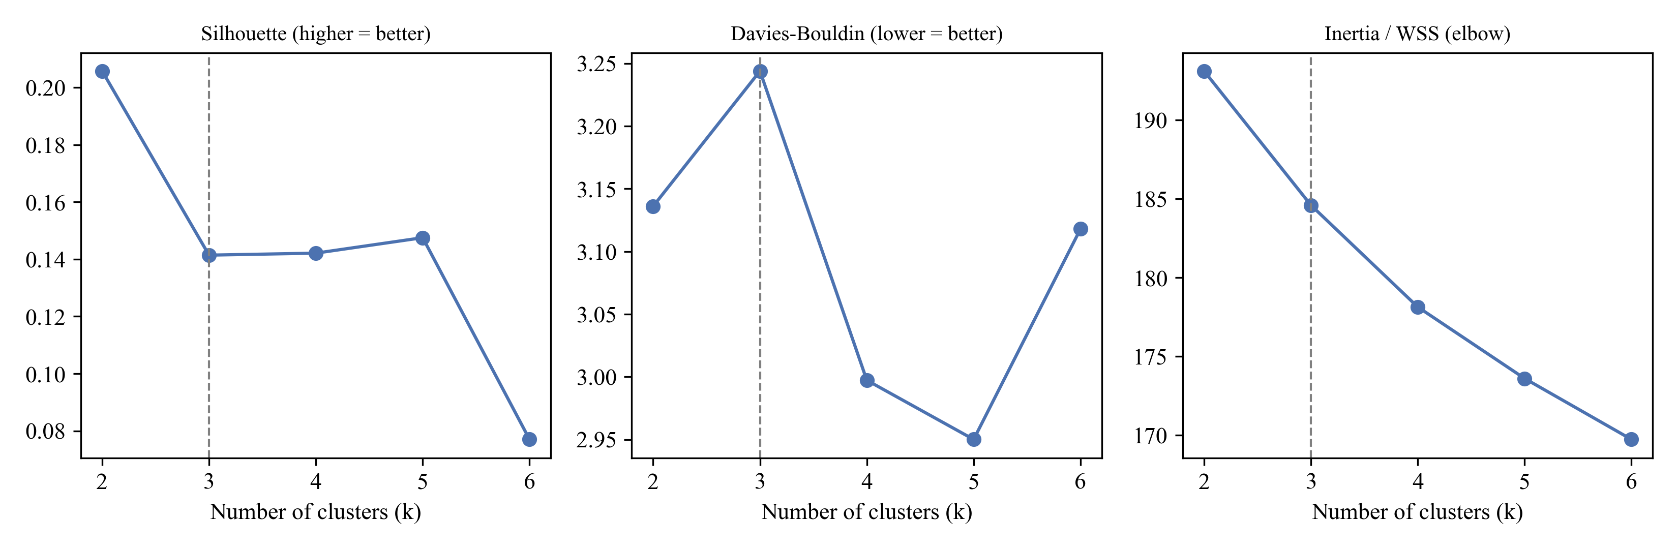
Note. The dashed line marks the pre-specified k = 3.
Table 10 and Figure 4 compare the algorithms. HDBSCAN produced the highest mean Silhouette (M = .211, SD = .044), followed by K-Means (M = .147, SD = .019) and agglomerative clustering (M = .118, SD = .040). All three far exceeded the permutation baseline (M = −.013, SD = .006). The one-way ANOVA was significant, F(2, 156) = 91.33, p < .001, η² = .54, and the result held under Welch's correction, F(2, 89.15) = 66.98, p < .001, and the Kruskal–Wallis test, H(2) = 86.82, p < .001. Every pairwise difference was significant under both Tukey and Games–Howell comparisons (Table 11). The null hypothesis is rejected.
Table 10
Cluster Quality by Algorithm
Algorithm | n runs | Silhouette M | Silhouette SD | Davies–Bouldin M | Davies–Bouldin SD
K-Means | 53 | .147 | .019 | 3.129 | 0.113
Agglomerative (Ward) | 53 | .118 | .040 | 3.550 | 0.269
HDBSCAN | 53 | .211 | .044 | 2.657 | 0.241
Permutation baseline | 53 | −.013 | .006 | — | —
Note. Each run clusters an independent random subsample of 500 golden dialogues. The permutation baseline shuffles K-Means labels within each subsample.
Table 11
Pairwise Comparisons of Mean Silhouette
Comparison | Mean difference | 95% CI (Tukey) | p (Tukey) | p (Games–Howell)
K-Means − Agglomerative | .029 | [.013, .046] | < .001 | < .001
HDBSCAN − Agglomerative | .093 | [.076, .110] | < .001 | < .001
HDBSCAN − K-Means | .063 | [.047, .080] | < .001 | < .001
Note. CI = confidence interval. Games–Howell comparisons do not assume equal variances.
Figure 4
Silhouette Coefficients by Algorithm
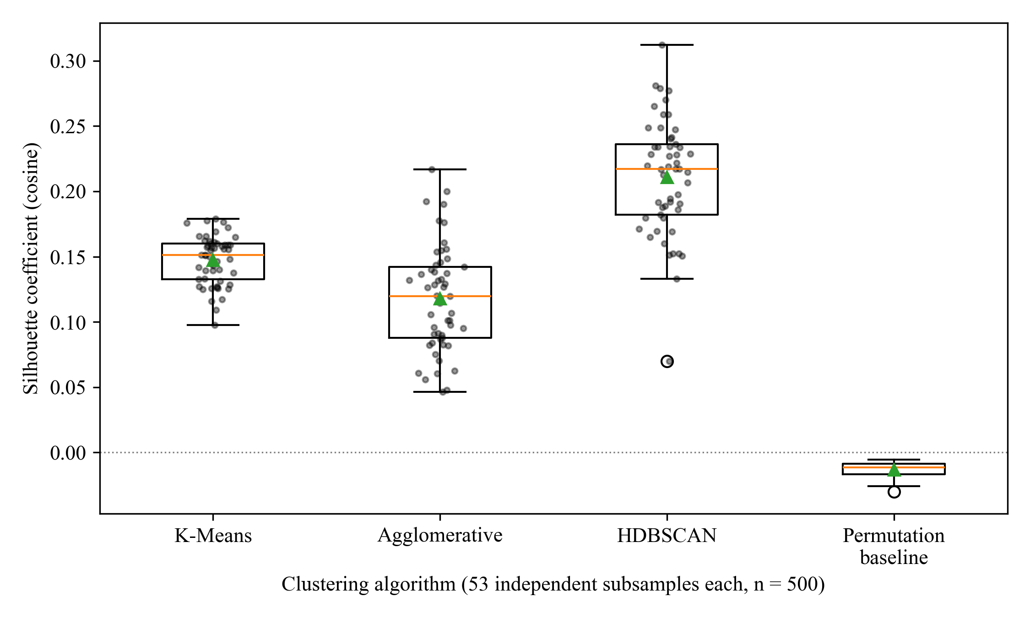
Note. Each point is one subsample run; triangles mark means. The permutation baseline shows the Silhouette expected with no structure.
Two qualifications matter for interpretation. First, HDBSCAN's advantage depends on its settings. With the commonly used minimum cluster size of 15 it found no clusters in 53 of 53 subsamples, so a minimum cluster size of 5 was used. Even then it labeled 39.1% of dialogues as noise on average (SD = 12.7%) and found between 2 and 6 clusters (most often 2), so its higher Silhouette partly reflects fewer clusters, consistent with Table 9. Second, all Silhouette values are below .25, which indicates weak structure: archetypes are tendencies on a continuum rather than sharply separated groups. Because prompt routing needs a stable number of archetypes and a centroid for every dialogue, K-Means with k = 3, the most stable method and the second best in separation, was used to define the archetypes.
Table 12 profiles the three K-Means archetypes on behavioral features that were not used for clustering. Names were assigned by a fixed rule: the cluster with the most slot-value revisions is the Constraint Negotiator, the longer of the remaining two is the Guided Explorer, and the shortest is the Direct Transactional archetype.
Table 12
Behavioral Profiles of the Three Archetypes (Golden Partition)
Feature | Direct Transactional | Constraint Negotiator | Guided Explorer
n (%) | 240 (25.7) | 225 (24.1) | 468 (50.2)
Turns, M (SD) | 9.92 (5.02) | 15.64 (6.84) | 17.19 (6.10)
Words per user utterance | 10.60 | 12.94 | 9.63
Words per agent utterance | 11.67 | 18.15 | 15.71
Slot-value revisions | 6.92 | 20.32 | 16.68
Hesitation markers | 0.67 | 1.15 | 1.15
Agent offers | 0.84 | 4.28 | 3.73
Budget stated (%) | 63.7 | 70.7 | 75.4
Task success (%) | 92.1 | 94.2 | 95.3
Note. Values are means per dialogue unless stated. Revisions count changes of a slot's value across user and agent acts.
Direct Transactional dialogues are short (9.9 turns), contain few revisions and almost no offers (0.84), and end quickly. Constraint Negotiators write the longest user and agent utterances and revise slot values most often (20.3 revisions), reflecting repeated trade-offs between dates, budget, and hotels. Guided Explorers form the largest group (50.2%); their dialogues are the longest (17.2 turns) but their user utterances are the shortest, which indicates an agent-led search through several offers. Task success is high in every archetype, so the archetypes differ in how users converse rather than in whether they succeed.
Two further checks were made. Archetype was associated with the Frames user role-player, χ²(20, N = 1,334) = 92.63, p < .001, Cramér's V = .19. The association is small to moderate, so individual role-player style contributes to the archetypes, and this is recorded as a limitation. Within Frames, the frozen centroids generalized to the held-out partition: mean centroid similarity did not differ between golden and held-out dialogues, t(754.9) = 0.42, p = .676, and the archetype distribution in D_{test} did not differ significantly from the golden proportions, χ²(2, N = 401) = 4.69, p = .096.
Table 13 and Figure 5 show the cross-corpus projection. MultiWOZ dialogues were markedly less similar to their nearest Frames centroid (M = .805) than held-out Frames dialogues were (M = .894), t(576.2) = 38.29, p < .001, and 84.0% of them fell into a single archetype. MultiWOZ occupies a separate region of the embedding space, so Frames archetypes do not transfer to it. This supports the decision to exclude cross-corpus transfer claims and to keep MultiWOZ as a descriptive check only.
Table 13
Archetype Assignment and Centroid Similarity Across Samples
Sample | N | Centroid similarity M (SD) | Direct Transactional (%) | Constraint Negotiator (%) | Guided Explorer (%)
Frames golden | 933 | .895 (.042) | 25.7 | 24.1 | 50.2
Frames held-out | 401 | .894 (.042) | 29.4 | 20.2 | 50.4
MultiWOZ 2.2 | 1,499 | .805 (.037) | 0.9 | 15.1 | 84.0
Note. Centroid similarity is the cosine between a dialogue vector and its nearest frozen centroid. Centroids were fitted on the golden partition only.
Figure 5
Archetypes in the Frames Embedding Space and Projection of MultiWOZ 2.2
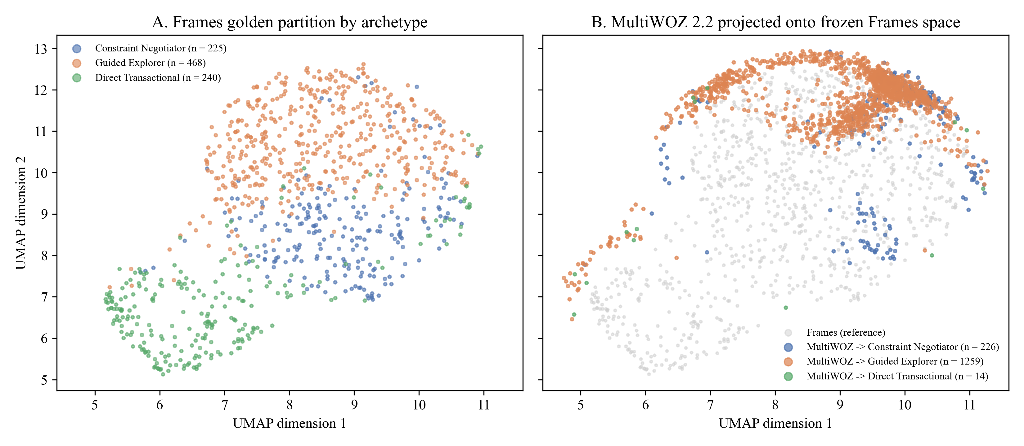
Note. Two-dimensional UMAP projection (McInnes et al., 2018) fitted on the golden partition; MultiWOZ dialogues were transformed into the same projection without refitting.

Interim Answer to RQ1
The algorithms differ significantly in cluster separation, with a large effect. HDBSCAN separates best but only after relaxing its settings, discarding a large share of dialogues as noise, and returning an unstable number of clusters; K-Means gives a stable three-archetype solution that generalizes to held-out Frames dialogues but not to MultiWOZ. Separation is weak in absolute terms. The three archetypes—Direct Transactional, Constraint Negotiator, and Guided Explorer—are therefore used as soft routing labels in RQ2 to RQ4.

RQ2: Cluster-Adaptive Few-Shot Prompting (Complete)

Method, Features, and Baseline
The experiment sampled 33 held-out dialogues, 11 per archetype, that open with a user–agent–user exchange. For each, the first three turns form the prefix, and the LLM (Gemini 2.5 Flash, temperature 0.2, internal reasoning disabled) generated the next agent turn under three conditions: zero-shot (instructions only), static few-shot (the same three randomly chosen golden exemplars for every dialogue), and cluster-adaptive few-shot. In the cluster-adaptive condition the prefix is embedded, routed to the nearest archetype centroid, and the three most similar golden dialogues are retrieved from that archetype's FAISS index. Exemplars are de-lexicalized and truncated to six turns. Zero-shot and static few-shot prompting are the baselines; an unclustered global nearest-neighbor retriever (Liu et al., 2022) was included as an additional comparison in the pilot. All 99 generations completed normally, so every dialogue contributed all three measurements (N = 33).

Assumptions and How They Were Tested
Sphericity. Mauchly's test was applied to the three conditions, with the Greenhouse–Geisser correction (Greenhouse & Geisser, 1959) available if it was significant. Sphericity held for style convergence, W = .95, χ²(2) = 1.59, p = .451, and for gold similarity, W = .97, p = .610; corrected results are nonetheless reported for consistency.
Normality of difference scores. Shapiro–Wilk tests on the three paired differences of style convergence gave p values from .003 to .616, so normality was violated for at least one difference. The Friedman test is therefore reported as a distribution-free check.
Valid style metric. The style score assumes that an agent turn written for an archetype is closer to that archetype's agent-style centroid. The pilot tested this on the real human replies (see below).
Correct routing. Cluster-adaptive prompting assumes that the prefix identifies the user's archetype. The pilot tested routing accuracy against the archetype of the full dialogue.
Exemplars carry style, not facts. De-lexicalization is assumed to remove factual content from exemplars; this is tested directly as exemplar leakage in RQ3.

Metrics and Validation
The primary outcome is style convergence, the cosine between the generated turn and the target archetype's agent-style centroid (the mean embedding of all golden agent utterances in that archetype). The secondary outcome is the cosine between the generated turn and the actual human reply. Response length in words was added as an exploratory measure after inspecting the generations. Effects are reported as partial η² and Cohen's d_{z} for Holm-adjusted paired contrasts. BERTScore (Zhang et al., 2020) is planned as a token-level check for the final report.

Pilot Results
The pilot ran every step except the LLM call on the exact experimental sample. Three results bear on the design. First, routing from a three-turn prefix was correct for 12 of 33 dialogues (36.4%), close to the 33.3% expected by chance: the opening turns do not yet reveal how a negotiation will unfold. Second, exemplar relevance differed by strategy (Table 14; Figure 6), F(1.11, 35.41) = 386.65, p < .001, partial η² = .92, after Greenhouse–Geisser correction. Both similarity-based strategies retrieved far more relevant exemplars than the static set, and global nearest-neighbor retrieval was slightly but significantly more relevant than cluster-adaptive retrieval (Table 15). Third, the style metric was valid but modest: human replies were closer to their own archetype's centroid (M = .508, SD = .126) than to the other centroids (M = .483, SD = .116), t(32) = 2.60, p = .014, d_{z} = .45, and the nearest centroid matched the archetype for 48.5% of replies.
Table 14
Pilot Exemplar Relevance by Retrieval Strategy
Strategy | Cosine to prefix M | SD | Exemplars from target archetype (%)
Static few-shot (fixed) | .578 | .057 | 33.3
Global k-NN (unclustered) | .840 | .054 | 36.4
Cluster-adaptive (routed sub-index) | .815 | .060 | 36.4
Note. N = 33 held-out dialogue prefixes; three exemplars per prefix. Relevance is the mean cosine between the prefix and the retrieval keys of the selected exemplars.
Table 15
Holm-Adjusted Paired Contrasts of Exemplar Relevance
Contrast | Mean difference | t | df | p (Holm) | d_{z}
Global k-NN vs. Static | .262 | 22.00 | 32 | < .001 | 3.83
Cluster-adaptive vs. Static | .237 | 18.18 | 32 | < .001 | 3.16
Cluster-adaptive vs. Global k-NN | −.024 | −6.93 | 32 | < .001 | −1.21
Note. Positive differences favor the first-named strategy.
Figure 6
RQ2 Pilot: Exemplar Relevance and Style-Metric Validity
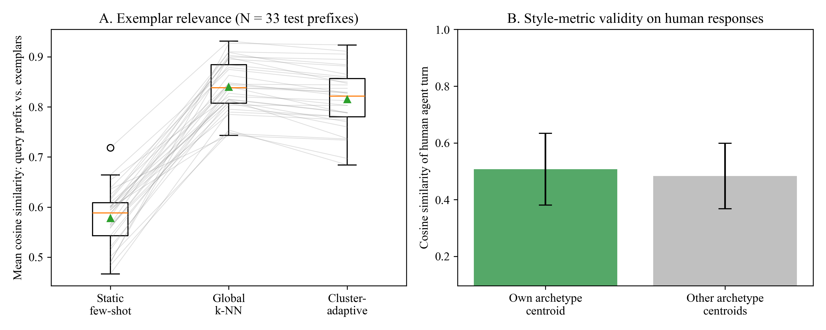
Note. Panel A: lines connect the three strategies for the same prefix. Panel B: cosine similarity of the human agent reply to its own versus the other archetype centroids; error bars show 1 SD.

Experimental Results
Table 16 and Figure 7 show the results. Style convergence did not differ by prompting condition, F(1.90, 60.95) = 1.08, p = .342, partial η² = .03, and the Friedman test agreed, χ²(2, N = 33) = 5.72, p = .057. Descriptively, zero-shot responses were slightly closer to the target centroid (M = .519) than static (M = .491) or cluster-adaptive responses (M = .486), the opposite of the hypothesized order, and no Holm-adjusted contrast was significant (Table 17). Similarity to the human reply also did not differ, F(1.94, 62.05) = 0.14, p = .861, partial η² = .00. The null hypothesis for RQ2 is therefore not rejected.
The exploratory length measure showed a large effect that the embedding-based metrics did not capture. Zero-shot responses averaged 25.2 words, whereas static and cluster-adaptive responses averaged 10.6 and 12.3 words, close to the human replies (M = 10.5, SD = 7.0), F(1.55, 49.50) = 34.36, p < .001, partial η² = .52 (Greenhouse–Geisser ε = .77). Both few-shot conditions were shorter than zero-shot (Holm p < .001 and < .001), but they did not differ from each other (Holm p = .196). In other words, any human examples move the model toward human pacing, but archetype-matched examples add nothing measurable beyond fixed examples.
Table 16
Generated Responses by Prompting Condition
Outcome | Zero-shot M (SD) | Static few-shot M (SD) | Cluster-adaptive M (SD) | F | p | η_{p}²
Style convergence (cosine) | .519 (.126) | .491 (.109) | .486 (.099) | 1.08 | .342 | .03
Similarity to human reply (cosine) | .317 (.195) | .325 (.223) | .333 (.221) | 0.14 | .861 | .00
Response length (words) | 25.2 (11.8) | 10.6 (7.0) | 12.3 (8.2) | 34.36 | < .001 | .52
Note. N = 33 held-out dialogues, each measured under all three conditions; gemini-2.5-flash. p values use the Greenhouse–Geisser correction. Response length is exploratory.
Table 17
Holm-Adjusted Paired Contrasts for the RQ2 Outcomes
Outcome | Contrast | Mean difference | t | df | p (Holm) | d_{z}
Style convergence | Cluster-Adaptive vs. Zero-shot | −.033 | −1.23 | 32 | .678 | −0.21
Style convergence | Static vs. Zero-shot | −.028 | −1.20 | 32 | .678 | −0.21
Style convergence | Cluster-Adaptive vs. Static | −.005 | −0.21 | 32 | .836 | −0.04
Similarity to human reply | Cluster-Adaptive vs. Zero-shot | .016 | 0.59 | 32 | > .999 | 0.10
Similarity to human reply | Static vs. Zero-shot | .008 | 0.26 | 32 | > .999 | 0.05
Similarity to human reply | Cluster-Adaptive vs. Static | .008 | 0.25 | 32 | > .999 | 0.04
Response length | Static vs. Zero-shot | −14.6 | −6.86 | 32 | < .001 | −1.19
Response length | Cluster-Adaptive vs. Zero-shot | −12.9 | −5.83 | 32 | < .001 | −1.02
Response length | Cluster-Adaptive vs. Static | 1.7 | 1.32 | 32 | .196 | 0.23
Note. Positive differences favor the first-named condition.
Figure 7
RQ2 Results: Style Convergence and Response Length by Prompting Condition
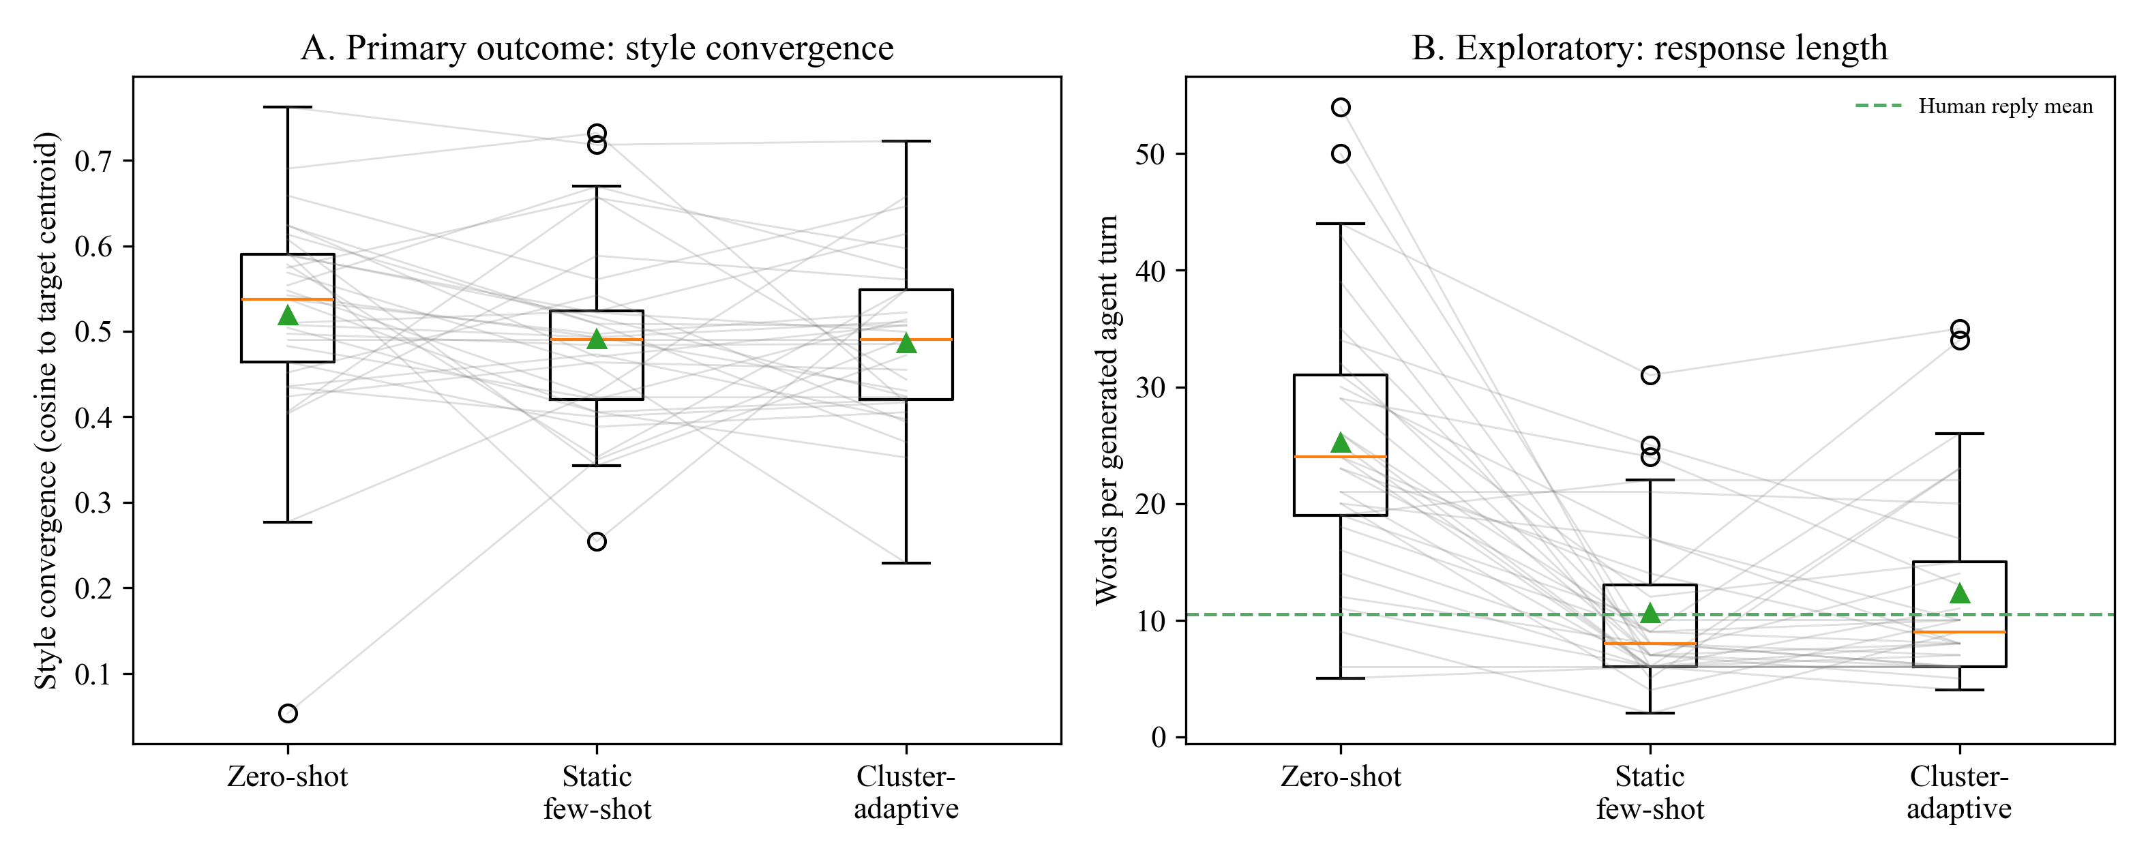
Note. Lines connect the three conditions for the same dialogue; triangles mark means. The dashed line in Panel B is the mean length of the human agent replies.

Interim Answer and Design Implications
Within this design, cluster-adaptive few-shot prompting did not increase style convergence relative to zero-shot or static few-shot prompting. The pilot points to two likely reasons. First, routing from three turns was close to chance (36.4%), so most dialogues received exemplars from the wrong archetype. Second, the archetypes are weakly separated and the style metric has only a modest effect even for human replies (d_{z} = .45), so the study had little room to detect a difference; the observed effect (f = 0.18) is below the medium effect assumed in the power analysis. The clear effect of examples on response length shows that few-shot prompting does change style, but along a dimension shared by all archetypes. The final report will add two sensitivity analyses: oracle routing, in which exemplars come from the dialogue's true archetype, and global nearest-neighbor retrieval as a fourth condition. The confirmatory test remains the three pre-specified conditions on which the power analysis is based.

RQ3: Rules Versus Prompting Ablation (Groundwork Complete)

Method, Features, and Baseline
RQ3 randomly assigns 144 held-out dialogues to the four cells of a 2 × 2 design (rule engine active or off × zero-shot or cluster-adaptive prompting). Because the corpora contain no policy information, each test dialogue state is augmented with seeded synthetic Tier 2 values, half of which violate at least one rule. When the rule engine is active, it evaluates the dialogue state before generation and adds any violations to the prompt as required actions; when it is off, the model sees only the dialogue. The baseline cell is zero-shot prompting with rules off. Table 18 lists the five author-defined rules, which are synthetic and do not represent any company's policy.
Table 18
Declarative Policy Rules Used in RQ3
Rule | Condition | Action | Severity
Visa Processing Lead Time | departure_lead_days < 15; is_international = true | block and flag | fatal
Passport Validity Threshold | passport_expiry_months < 6; is_international = true | block and flag | fatal
Maximum Adult Capacity per Single Booking | traveler_count_adults > 8; package_type = 'FIT' | convert to group | warning
Maximum Discretionary Sales Discount | discount_applied_percentage > 15.0 | clamp discount | fatal
Minimum Feasible Per-Pax International Budget | budget stated; budget_amount < 500; is_international = true | prompt realistic budget | warning
Note. Rules are stored in a YAML file and evaluated outside the LLM by src/rule_engine.py.

Assumptions and How They Will Be Tested
Deterministic rule evaluation. The engine must fire exactly the intended rules. All 14 of 14 boundary tests passed, including values exactly at each threshold (15 days, 6 months, 8 adults, 15.0%, and $500) and the domestic and group-package exemptions.
Decoupling. Rules are assumed to act independently of prompt style; this is the interaction term of the factorial ANOVA, so it is tested rather than assumed.
Residual normality and equal variances. Residuals will be checked with Shapiro–Wilk and Levene tests. Proportions near 0 or 1 are likely for rule adherence, so an aligned rank transform ANOVA or a logistic model will be used if the assumptions fail.
International travel. Frames cities are fictional, so all trips are treated as international when evaluating the visa, passport, and budget rules.

Metrics and Validation
Outcomes are slot F1 (slot values in the response compared with the dialogue state), exemplar leakage rate (entities in the response that occur in the exemplars but not in the current dialogue, divided by all entities in the response), and rule adherence rate (1 minus the share of agent turns that violate an active rule). Style convergence is also recorded to test whether rules reduce it.

Groundwork Results
Table 19 shows how much policy-relevant information the corpus contains. Only two rules can be checked from Frames annotations. A user-stated number of adults appears in 24.1% of dialogues and triggers the capacity rule in 54 (4.05%); a numeric budget appears in 65.1% and triggers the minimum-budget rule in 266 (19.94%). The visa, passport, and discount rules can never be triggered by the public data. This audit is the empirical basis for injecting synthetic Tier 2 scenarios.
Table 19
Corpus Audit of Rule Coverage in Frames
Rule | Required slot | Slot observed (%) | Dialogues triggering (n) | Triggering (%)
pax capacity | traveler count adults | 24.1 | 54 | 4.05
budget minimum | budget amount | 65.1 | 266 | 19.94
visa window | visa processing window days | 0.0 | 0 | 0.00
passport validity | passport expiry months | 0.0 | 0 | 0.00
discount threshold | discount applied percentage | 0.0 | 0 | 0.00
Note. N = 1,334 Frames dialogues. Only numeric values stated by the user were counted, so the adult and budget percentages are lower than the any-mention rates in Table 4.

Interim Answer
RQ3 is not yet answered. The rule engine is verified, the outcome definitions are fixed, and the audit shows that policy conditions must be injected. Execution follows RQ2 and reuses its generation code with the rule engine as an added factor.

RQ4: Turn Economy Across Archetypes (Groundwork Complete)

Method, Features, and Baseline
RQ4 uses 180 held-out dialogues, 30 per cell of a 2 × 3 design (zero-shot or cluster-adaptive prompting × three archetypes). For each dialogue, an LLM user simulator is given the dialogue's user goal (its Tier 1 slot values) and converses with the agent until the goal is met or 30 turns elapse. The zero-shot agent is the baseline, and the human Wizard-of-Oz dialogues provide a reference level of turn economy.

Assumptions and How They Will Be Tested
Log-normal turn counts. Turn counts are right-skewed, so they are analyzed on the log scale; residual normality will be checked with Shapiro–Wilk tests.
Equal variances. In the human baseline, Levene's test on log turns was significant, W = 24.81, p < .001. Heteroscedasticity-robust (HC3) standard errors will therefore be used for the factorial model.
Comparable goals. Turn counts are compared only within Frames, so the schema does not need to be invariant across corpora; MultiWOZ is not used in RQ4.
Archetype effect by construction. Archetypes partly reflect dialogue length, so a main effect of archetype on turns is expected and is not a finding. The tests of interest are the conditioning main effect and the conditioning × archetype interaction.

Metrics and Validation
Outcomes are turns to goal completion and the redundant elicitation rate (RER), defined as agent requests for a slot the user has already provided, divided by agent turns. Dialogues that reach 30 turns are recorded as incomplete and analyzed separately as a completion rate.

Groundwork Results
Table 20 and Figure 8 give the human baseline for all 1,334 Frames dialogues. Turn counts differed by archetype, H(2) = 325.25, p < .001, as expected by construction. Redundant elicitation was rare among human agents (M = .015, about one request in 65 agent turns) and did not differ by archetype, H(2) = 1.85, p = .397. The pooled standard deviation of turns within archetypes was 6.01. The near-zero human RER means that the synopsis expectation of reducing RER from .16 is not supported by the human data; RER will instead be compared between the two LLM agents, where redundant questions are more likely.
Table 20
Human Baseline of Turn Economy by Archetype (Frames)
Archetype | n | Turns M (SD) | RER M (SD) | Agent request turns M
Direct Transactional | 358 | 10.03 (5.05) | .021 (.071) | 1.28
Constraint Negotiator | 306 | 15.58 (6.68) | .016 (.045) | 1.32
Guided Explorer | 670 | 17.25 (6.16) | .012 (.041) | 1.67
Note. RER = redundant elicitation rate. Archetypes for held-out dialogues were assigned with the frozen centroids.
Figure 8
Human Baseline of Turn Economy and Redundant Elicitation by Archetype
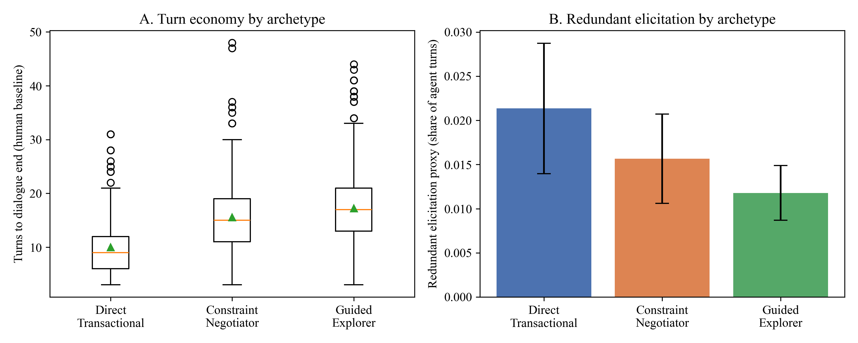
Note. Panel A: triangles mark means. Panel B: error bars show 95% confidence intervals.

Interim Answer
RQ4 is not yet answered. The baseline shows that archetypes differ strongly in length and that human agents rarely ask redundant questions, which sets realistic reference values for the simulated experiment.

Discussion

Findings Mapped to the Research Questions
Table 21 summarizes the status of each research question at the interim stage.
Table 21
Interim Status and Findings by Research Question
RQ | Status | Interim finding
RQ1 | Complete | Algorithms differ (η² = .54); HDBSCAN separates best but is unstable; K-Means gives three stable but weakly separated archetypes that do not transfer to MultiWOZ.
RQ2 | Complete | No effect on style convergence (partial η² = .03, p = .342); few-shot prompts roughly halve response length (partial η² = .52), but archetype matching adds nothing beyond static examples; early routing near chance (36.4%).
RQ3 | Groundwork | Rule engine verified (14/14 tests); three of five rules cannot be observed in public data.
RQ4 | Groundwork | Human baseline: archetypes differ in length; human RER near zero (.015).

Limitations and Threats to Validity
1. Internal validity: archetypes are weakly separated (Silhouette < .25), so routing errors will dilute any effect of archetype-matched prompting. The oracle-routing sensitivity condition addresses this.
2. Construct validity: archetypes are associated with individual role-players (Cramér's V = .19), and the style metric, although valid, has a modest effect size.
3. External validity: Frames is role-play with fictional cities, and the archetypes do not transfer to MultiWOZ; conclusions apply to vacation-package negotiation dialogues of this kind.
4. Statistical conclusion validity: RQ1 subsamples overlap, and power for RQ2 to RQ4 assumes a medium effect; the observed RQ2 style effect (f = .18) was smaller, so a small true effect cannot be ruled out.
5. Measurement: RQ3 policy scenarios are synthetic, and RQ4 relies on an LLM user simulator rather than real users.

Practical Recommendations
Even at the interim stage, the results support three recommendations for teams building travel assistants. First, cluster historical dialogues before designing personas, but treat clusters as soft tendencies and check them against role or agent identifiers, as Frames shows that apparent styles can reflect individual speakers. Second, do not route users to a persona from the first few turns; routing should be updated as the dialogue develops. Third, keep policy checks in a deterministic rule layer, because public dialogue data rarely contain the information needed to learn policy behavior from examples. The RQ2 results add a fourth: a few static in-context examples are enough to bring response length close to human agents, and archetype-matched examples should not be expected to add stylistic benefit unless routing is reliable. Whether cluster-adaptive prompting affects turn economy remains a hypothesis for RQ4, not a result.

Remaining Work
Weeks 5 and 6 cover the RQ2 sensitivity analyses (oracle routing and global nearest-neighbor examples) and the RQ3 scenario injection. Week 7 runs the RQ3 experiment, and Week 8 runs the RQ4 simulation and all robustness checks, completing the analysis. Weeks 9 and 10 are reserved for the final presentation and final report (Appendix B).

References
Acikgoz, E. C., Guo, C., Dey, S., Datta, A., Kim, T., Tur, G., & Hakkani-Tür, D. (2025). TD-EVAL: Revisiting task-oriented dialogue evaluation by combining turn-level precision with dialogue-level comparisons. In Proceedings of the 26th Annual Meeting of the Special Interest Group on Discourse and Dialogue (pp. 113–132). Association for Computational Linguistics. https://doi.org/10.18653/v1/2025.sigdial-1.7
Brown, T. B., Mann, B., Ryder, N., Subbiah, M., Kaplan, J., Dhariwal, P., Neelakantan, A., Shyam, P., Sastry, G., Askell, A., Agarwal, S., Herbert-Voss, A., Krueger, G., Henighan, T., Child, R., Ramesh, A., Ziegler, D. M., Wu, J., Winter, C., . . . Amodei, D. (2020). Language models are few-shot learners. In Advances in Neural Information Processing Systems (Vol. 33, pp. 1877–1901). Curran Associates. https://doi.org/10.48550/arXiv.2005.14165
Budzianowski, P., Wen, T.-H., Tseng, B.-H., Casanueva, I., Ultes, S., Ramadan, O., & Gašić, M. (2018). MultiWOZ: A large-scale multi-domain Wizard-of-Oz dataset for task-oriented dialogue modelling. In Proceedings of the 2018 Conference on Empirical Methods in Natural Language Processing (pp. 5016–5026). Association for Computational Linguistics. https://doi.org/10.18653/v1/D18-1547
Cohen, J. (1988). Statistical power analysis for the behavioral sciences (2nd ed.). Lawrence Erlbaum Associates. https://doi.org/10.4324/9780203771587
Davies, D. L., & Bouldin, D. W. (1979). A cluster separation measure. IEEE Transactions on Pattern Analysis and Machine Intelligence, PAMI-1(2), 224–227. https://doi.org/10.1109/TPAMI.1979.4766909
El Asri, L., Schulz, H., Sharma, S., Zumer, J., Harris, J., Fine, E., Mehrotra, R., & Suleman, K. (2017). Frames: A corpus for adding memory to goal-oriented dialogue systems. In Proceedings of the 18th Annual SIGdial Meeting on Discourse and Dialogue (pp. 207–219). Association for Computational Linguistics. https://doi.org/10.18653/v1/W17-5526
Faul, F., Erdfelder, E., Lang, A.-G., & Buchner, A. (2007). G*Power 3: A flexible statistical power analysis program for the social, behavioral, and biomedical sciences. Behavior Research Methods, 39(2), 175–191. https://doi.org/10.3758/BF03193146
Greenhouse, S. W., & Geisser, S. (1959). On methods in the analysis of profile data. Psychometrika, 24(2), 95–112. https://doi.org/10.1007/BF02289823
Inaba, M., Chiba, Y., Higashinaka, R., Komatani, K., Miyao, Y., & Nagai, T. (2022). Collection and analysis of travel agency task dialogues with age-diverse speakers. In Proceedings of the Thirteenth Language Resources and Evaluation Conference (pp. 5759–5767). European Language Resources Association. https://aclanthology.org/2022.lrec-1.619
Jannach, D., Manzoor, A., Cai, W., & Chen, L. (2021). A survey on conversational recommender systems. ACM Computing Surveys, 54(5), Article 105. https://doi.org/10.1145/3453154
Johnson, J., Douze, M., & Jégou, H. (2021). Billion-scale similarity search with GPUs. IEEE Transactions on Big Data, 7(3), 535–547. https://doi.org/10.1109/TBDATA.2019.2921572
Liu, J., Shen, D., Zhang, Y., Dolan, B., Carin, L., & Chen, W. (2022). What makes good in-context examples for GPT-3? In Proceedings of Deep Learning Inside Out (DeeLIO 2022): The 3rd Workshop on Knowledge Extraction and Integration for Deep Learning Architectures (pp. 100–114). Association for Computational Linguistics. https://doi.org/10.18653/v1/2022.deelio-1.10
McInnes, L., Healy, J., & Astels, S. (2017). hdbscan: Hierarchical density based clustering. Journal of Open Source Software, 2(11), Article 205. https://doi.org/10.21105/joss.00205
McInnes, L., Healy, J., & Melville, J. (2018). UMAP: Uniform manifold approximation and projection for dimension reduction (arXiv:1802.03426). arXiv. https://doi.org/10.48550/arXiv.1802.03426
Pedregosa, F., Varoquaux, G., Gramfort, A., Michel, V., Thirion, B., Grisel, O., Blondel, M., Prettenhofer, P., Weiss, R., Dubourg, V., Vanderplas, J., Passos, A., Cournapeau, D., Brucher, M., Perrot, M., & Duchesnay, É. (2011). Scikit-learn: Machine learning in Python. Journal of Machine Learning Research, 12, 2825–2830. https://jmlr.org/papers/v12/pedregosa11a.html
Rebedea, T., Dinu, R., Sreedhar, M. N., Parisien, C., & Cohen, J. (2023). NeMo Guardrails: A toolkit for controllable and safe LLM applications with programmable rails. In Proceedings of the 2023 Conference on Empirical Methods in Natural Language Processing: System Demonstrations (pp. 431–445). Association for Computational Linguistics. https://doi.org/10.18653/v1/2023.emnlp-demo.40
Reimers, N., & Gurevych, I. (2019). Sentence-BERT: Sentence embeddings using Siamese BERT-networks. In Proceedings of the 2019 Conference on Empirical Methods in Natural Language Processing and the 9th International Joint Conference on Natural Language Processing (pp. 3982–3992). Association for Computational Linguistics. https://doi.org/10.18653/v1/D19-1410
Rousseeuw, P. J. (1987). Silhouettes: A graphical aid to the interpretation and validation of cluster analysis. Journal of Computational and Applied Mathematics, 20, 53–65. https://doi.org/10.1016/0377-0427(87)90125-7
Seabold, S., & Perktold, J. (2010). Statsmodels: Econometric and statistical modeling with Python. In Proceedings of the 9th Python in Science Conference (pp. 92–96). SciPy. https://doi.org/10.25080/Majora-92bf1922-011
Yao, S., Shinn, N., Razavi, P., & Narasimhan, K. (2024). τ-bench: A benchmark for tool-agent-user interaction in real-world domains (arXiv:2406.12045). arXiv. https://doi.org/10.48550/arXiv.2406.12045
Zang, X., Rastogi, A., Sunkara, S., Gupta, R., Zhang, J., & Chen, J. (2020). MultiWOZ 2.2: A dialogue dataset with additional annotation corrections and state tracking baselines. In Proceedings of the 2nd Workshop on Natural Language Processing for Conversational AI (pp. 109–117). Association for Computational Linguistics. https://doi.org/10.18653/v1/2020.nlp4convai-1.13
Zhang, T., Kishore, V., Wu, F., Weinberger, K. Q., & Artzi, Y. (2020). BERTScore: Evaluating text generation with BERT. In Proceedings of the 8th International Conference on Learning Representations. OpenReview. https://openreview.net/forum?id=SkeHuCVFDr

Appendix A

Repository Structure and Replication Guide
All materials are available at https://github.com/surnella/QM640-Dialogue-Clustering-Capstone. Table A1 lists the parts of the repository used in this report, and Table A2 lists the commands that reproduce every table and figure.
Table A1
Repository Structure
Path | Contents
data/raw/ | Downloaded Frames and MultiWOZ 2.2 corpora
data/canonical/ | Canonical two-tier dialogue file
data/interim/ | Cleaned samples, embeddings, archetypes, prompts, and run summaries
src/ingestion.py, src/canonical_schema.py | Corpus parsers and Pydantic schema
src/rule_engine.py, rules/ | Declarative rule engine and YAML rule file
src/interim_pipeline/ | Reproducible analysis steps 0 to 4 (this report)
src/report/, src/build_interim_submission.py | APA report builder
outputs/interim/tables/, outputs/interim/figures/ | Result tables (CSV) and figures (PNG)
requirements.txt | Python dependencies

Table A2
Replication Commands
Step | Command (run from src/interim_pipeline/) | Produces
0 | python step0_sample_size.py | Table 2
1 | python step1_prepare_data.py | Tables 3, 4, and 8; Figures 1 and 2
2 | python step2_rq1_clustering.py | Tables 9 to 13; Figures 3 to 5
3 | python step3_rq2_pipeline.py | Tables 14 and 15; Figure 6; saved prompts
3 (execution) | python step3_rq2_pipeline.py --execute | Tables 16 and 17; Figure 7 (requires GEMINI_API_KEY)
4 | python step4_rq3_rq4_groundwork.py | Tables 18 to 20; Figure 8
Report | python src/build_interim_submission.py (from the repository root) | This document
Note. Python 3.11; all random steps use seed 42.

Appendix B

Ten-Week Project Schedule
Table B1 maps the project to the 10-week QM640 schedule. All analysis finishes in Week 8, and Weeks 9 and 10 are reserved for the presentation and final report.
Table B1
Ten-Week Schedule Aligned With the QM640 Course Topics
Week (dates) | Course topic | Project tasks and deliverables | Status
1 (Sep 27–Oct 3) | Define research problem and topic | Problem statement finalized; repository set up; Frames and MultiWOZ downloaded | Complete
2 (Oct 4–10) | Synopsis draft | Research questions and two-tier schema; synopsis draft (Oct 6) | Complete
3 (Oct 11–17) | Literature search and data collection | Synopsis final (Oct 13); ingestion, canonicalization, and embeddings | Complete
4 (Oct 18–24) | Objectives and hypotheses | Quality audit, EDA, power analysis, RQ1 clustering; RQ2 pilot; RQ3 and RQ4 groundwork; interim draft (Oct 20) | Complete
5 (Oct 25–31) | Research design and methodology | Interim report final (Oct 27); RQ2 generation run and analysis (complete) | In progress
6 (Nov 1–7) | Data analysis plan | RQ2 sensitivity analyses (oracle routing, global k-NN); RQ3 scenario injection; final report draft (Nov 3) | Planned
7 (Nov 8–14) | Data analysis plan execution | RQ3 2 × 2 experiment and analysis | Planned
8 (Nov 15–21) | Data analysis assessment | RQ4 simulation, 2 × 3 analysis, robustness checks; analysis complete | Planned
9 (Nov 22–28) | Refinement and documentation | Final presentation (Nov 27–28) | Planned
10 (Nov 29–Dec 5) | Document results and findings | Final report and repository release | Planned
Note. EDA = exploratory data analysis. No tasks are scheduled outside Weeks 1 to 10.

Appendix C

Comparison With Related Research
Table C1 compares the studies closest to this capstone and shows how the present design extends them.
Table C1
Related Research and Its Relationship to the Present Study
Study | Main contribution | Connection to this study | Gap addressed here
El Asri et al. (2017), Frames | 1,369 human–human vacation-package dialogues with frame tracking | Primary corpus for embeddings, archetypes, and exemplars | Does not cluster dialogues or use them for prompting
Zang et al. (2020), MultiWOZ 2.2 | Corrected multi-domain dialogue states and schema | External projection check and schema mapping | Focuses on slot tracking, not archetypes or prompting
Liu et al. (2022), KATE | Similarity-based in-context example selection beats random selection | Motivates retrieval; global nearest neighbor is a comparison | Single-turn tasks; no style or leakage measures
Rebedea et al. (2023), NeMo Guardrails | Programmable rails outside the LLM | Motivates the decoupled rule engine | Does not adapt style or test interaction with prompting
Yao et al. (2024), τ-bench | Agent evaluation against explicit domain policies | Supports measuring rule adherence separately | Tool-calling agents; no archetype adaptation
Acikgoz et al. (2025), TD-EVAL | Turn-level and dialogue-level evaluation | Supports combining similarity with turn-level checks | Evaluation framework only; no adaptive prompting
Note. The comparison describes relevance to this study and does not imply that the cited studies used the same data or metrics.

