Cluster-Adaptive Prompting for Multi-Turn Travel and Tourism Conversational Systems
Interim Report

Surnella Sandeep
Department of Data Analytics, Walsh College
QM640: Data Analytics Capstone
Mr. Smitraj Raut
October 27, 2026

GitHub repository: https://github.com/surnella/QM640-Dialogue-Clustering-Capstone
Contents
Cluster-Adaptive Prompting for Multi-Turn Travel and Tourism Conversational Systems 4
Background and Context 4
Problem Statement 4
Purpose of the Study 5
Interim Project Status 5
Scope and Objectives 6
Inclusions 6
Exclusions 6
Feasibility 6
Research Questions and Hypotheses 7
Literature Survey 7
Literature Review Approach 7
Thematic Review and Research Gaps 8
Data Description 9
Data Sources and Access 9
Dataset Overview 10
Data Dictionary 10
GitHub Data Availability Statement 13
Dataset Limitations 13
Analysis 14
Data Cleaning 14
Exploratory Data Analysis Results 15
Modeling 17
Research Design and Sample Size 17
Choice of Models With Justification 18
Features Included and Feature Engineering 22
Evaluation Metrics 23
Preliminary Results 24
RQ1: Clustering Algorithms and Primary Archetypes (Complete) 24
RQ1 Sensitivity Analysis: Refined Archetypes (Complete) 26
RQ2: Cluster-Adaptive Few-Shot Prompting (Complete) 29
RQ3: Rules Versus Prompting (Groundwork Complete) 31
RQ4: Turn Economy Across Archetypes (Groundwork Complete) 31
Interim Limitations and Risks 32
Next Steps 32
References 33
Appendix A 38
Appendix B 40
Appendix C 41
Appendix D 42
Appendix E 45

Cluster-Adaptive Prompting for Multi-Turn Travel and Tourism Conversational Systems

Background and Context
Conversational artificial intelligence (AI) agents are now widely used in travel and tourism to support destination discovery, itinerary planning, and booking (Jannach et al., 2021). Travelers differ in how they converse: some state every constraint in the first message, some revise budgets and dates repeatedly, and others rely on the agent to lead the search (Inaba et al., 2022). Most travel assistants, however, use one static prompt for every user, which produces repetitive clarification questions, mismatched pacing, and abandoned sessions.
Designers usually adapt a large language model (LLM) agent's style through prompt engineering, for example, by inserting example dialogues into the prompt. Prompt-only adaptation creates two risks (Rebedea et al., 2023): the model can copy stale details such as earlier prices, dates, or destinations from the examples, and style instructions compete with business constraints, so the agent may propose an itinerary that violates passport, visa, capacity, or discount policies. This study therefore separates the two concerns: conversation archetypes learned from historical dialogues select in-context examples that steer style, and a declarative rule engine outside the prompt checks policy.

Problem Statement
Travel conversational agents lack a data-driven way to recognize a user's conversation archetype and adapt their style to it, and prompt-based style steering can introduce factual leakage and policy violations. The study measures how four independent variables—clustering algorithm (RQ1), in-context conditioning strategy (RQ2), rule-engine mode (RQ3), and conditioning strategy crossed with user archetype (RQ4)—affect cluster separation, style convergence, slot accuracy, exemplar leakage, rule adherence, and turn economy.

Purpose of the Study
The purpose of this quantitative study is to
1. discover and interpret conversation archetypes in human travel dialogues and identify the clustering algorithm that separates them best (RQ1);
2. measure whether archetype-matched in-context examples move an LLM agent's responses toward the target archetype's style more than zero-shot or static examples do (RQ2);
3. isolate the effects of a declarative rule engine and of cluster-adaptive prompting on slot accuracy, exemplar leakage, and rule adherence (RQ3); and
4. estimate whether cluster-adaptive prompting changes turn economy differently across archetypes (RQ4).

Interim Project Status
• Completed: data ingestion, quality audit, cleaning, exploratory analysis, and power analysis; RQ1 end to end, including a sensitivity analysis that produced three refined archetypes (Decisive Booker, Open Explorer, and Rigid-Constraint Seeker); and the RQ2 experiment (99 LLM generations).
• In progress: groundwork for RQ3 and RQ4—the rule engine is verified, the corpus is audited for policy information, and a human baseline for turn economy is measured.
• Pending: repeating RQ2 with the refined archetypes, the RQ3 2 × 2 experiment, the RQ4 simulation, robustness checks, and the final report (Appendix B).

Scope and Objectives

Inclusions
The study includes English-language, multi-turn, human–human travel dialogues from two public corpora: all 1,369 Microsoft Frames dialogues and a 1,500-dialogue sample of MultiWOZ 2.2 dialogues that involve at least one travel service (hotel, train, taxi, or attraction), each with at least three turns. The pre-specified analyses use one embedding model (Sentence-BERT all-MiniLM-L6-v2), three clustering algorithms, and one LLM family (Gemini Flash); the RQ1 sensitivity analysis adds Gemini embeddings and LLM ratings of user behavior. Scope is contained by using Frames as the only corpus for learning, retrieval, and experiments, and by having every research question reuse one pipeline, one set of archetype assignments, and one held-out partition, so that each later question adds an experimental factor rather than a new method.

Exclusions
No claim is made that Frames archetypes transfer to MultiWOZ or other domains; MultiWOZ serves only as a descriptive projection check. Proprietary, enterprise, or customer data, new human-subject data, and synthetic training dialogues are excluded; the only synthetic elements are the author-defined policy rules and scenarios used in RQ3. Non-English, voice, restaurant-only, and sub-three-turn dialogues, model fine-tuning, other LLM providers, live deployment, real bookings, and user-satisfaction outcomes are also out of scope.

Feasibility
Both corpora are freely downloadable, and the core pipeline runs on a laptop in under 15 minutes. RQ2 required 99 LLM calls, the RQ1 sensitivity analysis 4,860 annotation calls, and RQ3 and RQ4 together need fewer than 2,000, all within the free tier of the Gemini application programming interface. Every response is cached so that interrupted runs resume.

Research Questions and Hypotheses
Table 1 states each research question with its hypotheses and the analysis that tests it.
Table 1
Research Questions, Hypotheses, and Planned Analyses
RQ | Research question | Hypotheses | Analysis
RQ1 | Which clustering algorithm (K-Means, agglomerative, HDBSCAN) gives the best separation of dialogue-trajectory embeddings, and which archetypes emerge? | H₀: mean Silhouette is equal across algorithms. H₁: at least one mean differs. | One-way ANOVA (Welch and Kruskal–Wallis as robustness checks); Tukey and Games–Howell post hoc
RQ2 | Does cluster-adaptive few-shot prompting increase style convergence relative to zero-shot and static few-shot prompting? | H₀: mean style cosine is equal across conditions. H₁: cluster-adaptive > static and zero-shot. | One-way repeated-measures ANOVA; Greenhouse–Geisser correction; Holm-adjusted paired contrasts
RQ3 | Do a declarative rule engine and cluster-adaptive prompting affect slot F1, exemplar leakage, and rule adherence? | H₀: no main or interaction effects. H₁: rules raise adherence and reduce leakage without lowering style convergence. | 2 × 2 between-subjects factorial ANOVA
RQ4 | Does cluster-adaptive prompting change turns to goal completion and redundant elicitation differently across archetypes? | H₀: no conditioning × archetype interaction. H₁: the reduction in turns differs by archetype. | 2 × 3 factorial ANOVA on log turns
Note. RQ = research question; ANOVA = analysis of variance. Significance level α = .05 for all tests.

Literature Survey

Literature Review Approach
Sources were located in the ACL Anthology, Google Scholar, and arXiv with combinations of the terms task-oriented dialogue corpus, dialogue clustering, sentence embeddings, in-context example selection, LLM guardrails, policy compliance, and LLM annotation. Peer-reviewed papers and widely cited preprints were retained when they supplied a corpus, method, or measure used in this study, and seminal statistical sources were added for each metric and test. Each source was mapped to the research questions it informs; the relevance matrix of the closest studies is in Appendix C.

Thematic Review and Research Gaps
Task-oriented dialogue corpora. MultiWOZ (Budzianowski et al., 2018) is the standard multi-domain benchmark, and MultiWOZ 2.2 (Zang et al., 2020) corrected its state annotations, but it covers local services in one city and contains no flights or package negotiation. Microsoft Frames (El Asri et al., 2017) was designed for exactly that setting: users negotiate flight-and-hotel packages under a budget and compare several offers before deciding. Frames is therefore the primary corpus, and MultiWOZ 2.2 is an external comparison.
Dialogue representation and clustering. Sentence-BERT (Reimers & Gurevych, 2019) yields embeddings whose cosine distances reflect semantic similarity, enabling whole-dialogue representations without task-specific training. K-Means, Ward agglomerative clustering, and HDBSCAN (McInnes et al., 2017) assume different cluster shapes and should be compared rather than chosen a priori; quality is judged with the Silhouette coefficient (Rousseeuw, 1987) and the Davies–Bouldin index (Davies & Bouldin, 1979), and stability with the adjusted Rand index under resampling (Hennig, 2007; Hubert & Arabie, 1985). UMAP (McInnes et al., 2018) and scikit-learn (Pedregosa et al., 2011) support inspection and reproducibility.
In-context exemplar selection. LLMs can perform new tasks from a few in-context examples (Brown et al., 2020), and examples retrieved by embedding similarity outperform random ones (Liu et al., 2022); FAISS (Johnson et al., 2021) makes such retrieval fast. These studies evaluate single-turn accuracy, not conversational style, and retrieve from one global pool rather than from behaviorally defined sub-pools. LLMs can also annotate text as reliably as trained crowd workers (Gilardi et al., 2023), which supports LLM ratings of user behavior.
Policy compliance and evaluation. NeMo Guardrails (Rebedea et al., 2023) moves policy logic into programmable rails outside the model, τ-bench (Yao et al., 2024) shows that policy adherence must be measured separately from task success, and TD-EVAL (Acikgoz et al., 2025) argues that dialogue-level similarity such as BERTScore (Zhang et al., 2020) must be complemented by turn-level checks of factual consistency and policy compliance.
Three gaps follow. No reviewed study derives conversation archetypes from dialogue trajectories and uses them to select in-context examples; studies that steer style do not measure whether examples leak stale facts, and studies that enforce policy do not adapt style; and the turn-economy effect of style adaptation across user archetypes has not been tested. RQ1 and RQ2 address the first gap, RQ3 the second, and RQ4 the third.

Data Description

Data Sources and Access
Microsoft Frames (El Asri et al., 2017) contains 1,369 English Wizard-of-Oz dialogues in which a user role-player negotiates a flight-and-hotel package with a wizard who searches a database of fictional cities; it is available from Microsoft Research at https://www.microsoft.com/en-us/research/project/frames-dataset/. MultiWOZ 2.2 (Zang et al., 2020) contains 10,438 dialogues with per-turn dialogue states and is available at https://github.com/budzianowski/multiwoz. Both corpora were downloaded in full and are public, were collected with consent for research use, and identify role-players only by codes, so no new human data are collected. Only public dialogue text with fictional cities is sent to the LLM, and archetypes are described only by conversational behavior, never by inferred demographics.

Dataset Overview
Table 2 summarizes the records, variables, time coverage, unit of analysis, and outcome variables.
Table 2
Dataset Overview
Attribute | Microsoft Frames (primary) | MultiWOZ 2.2 (comparison)
Records | 1,369 dialogues; 1,334 analytic (golden partition 933, held-out partition 401) | 10,438 dialogues; seeded sample of 1,500; 1,499 analytic
Variables used | Utterance text, speaker, dialogue acts with slot–value arguments, task-success label, user rating, role-player codes (Table 3) | Utterance text, speaker, services, per-turn dialogue state (Table 3)
Time period | Released 2017; timestamps record collection time only and are not analyzed | Released 2018 (version 2.2 in 2020); no timestamps
Unit of analysis | Dialogue; clustering run (RQ1 algorithm test); generated agent turn (RQ2) | Dialogue (descriptive projection only)
Target or outcome | No supervised target; outcomes are Silhouette (RQ1), style convergence (RQ2), slot F1, leakage, and adherence (RQ3), turns and redundant elicitation (RQ4) | Similarity to the nearest Frames centroid

Data Dictionary
The data dictionary has three parts: the raw source fields read from each corpus (Table 3), the canonical schema produced by preprocessing (Table 4), and the analysis variables with their roles and operational definitions (Table 5).
Table 3
Data Dictionary, Part A: Raw Source Fields Used
Corpus | Field | Type | Description | Use
Frames | id | String | Unique dialogue identifier | Key
Frames | user_id, wizard_id | String | Role-player identifiers (11 users, 12 wizards) | Confound check
Frames | turns[].author | Category | user or wizard | Speaker tag
Frames | turns[].text | String | Utterance text | Embedding
Frames | turns[].timestamp | Float | Collection time (Unix ms) | Not used
Frames | turns[].labels.acts[].name | Category | Dialogue act (e.g., inform, request, offer, switch_frame) | Features, RER
Frames | turns[].labels.acts[].args[].key/val | String | Slot name and value (e.g., dst_city, budget) | Tier 1 slots
Frames | labels.wizardSurveyTaskSuccessful | Boolean | Wizard-reported task success | Stratify, pool
Frames | labels.userSurveyRating | Float | User satisfaction rating (1–5) | Descriptive
MultiWOZ | dialogue_id | String | Unique dialogue identifier | Key
MultiWOZ | services | List | Services involved (hotel, train, taxi, ...) | Inclusion
MultiWOZ | turns[].speaker | Category | USER or SYSTEM | Speaker tag
MultiWOZ | turns[].utterance | String | Utterance text | Embedding
MultiWOZ | turns[].frames[].state.slot_values | Map | Cumulative dialogue state per service | Tier 1 slots
Note. RER = redundant elicitation rate. Only the fields listed were read; all other fields were ignored.
Table 4
Data Dictionary, Part B: Canonical Schema Fields
Field | Type | Description
dialogue_id, source_dataset | String | Identifier and corpus of origin (frames or multiwoz)
total_turns, user_turns, wizard_turns | Integer | Turn counts
turns[].turn_id, speaker, utterance | Mixed | Ordered turns with corpus-neutral speaker and text
turns[].acts, slots_mentioned, revisions | List, map | Acts, slots informed, and slots whose value changed in the turn
Tier 1: origin_city, destination_city | String | Trip endpoints
Tier 1: departure_date, return_date, duration_nights | String, integer | Trip timing
Tier 1: traveler_count_adults, traveler_count_children | Integer | Party size
Tier 1: budget_amount, accommodation_tier | Float, string | Budget ceiling and hotel tier
Tier 2: visa_processing_window_days, passport_expiry_months | Integer | Policy timing (synthetic in RQ3)
Tier 2: package_type, sharing_basis, discount_applied_percentage | String, float | Package, room, and discount (synthetic in RQ3)
revisions_count | Integer | Number of slot-value changes across the dialogue
hesitation_markers_count | Integer | User hesitation phrases (e.g., "maybe," "not sure")
budget_specified | Boolean | Whether a numeric budget was stated
Note. Schema implemented as Pydantic models in src/canonical_schema.py.
Table 5
Data Dictionary, Part C: Analysis Variables
Variable | Role | Type | Operational definition | RQ
Clustering algorithm | IV | Nominal (3) | K-Means, Ward agglomerative, HDBSCAN | 1
Silhouette coefficient | DV | Continuous [−1, 1] | Cosine Silhouette of a clustering run | 1
Davies–Bouldin index | DV | Continuous ≥ 0 | Mean cluster similarity ratio (lower is better) | 1
Archetype (primary) | IV / moderator | Nominal (3) | Nearest frozen K-Means centroid (cosine, MiniLM trajectory vectors) | 1, 2
Archetype (refined) | IV / moderator | Nominal (3) | K-Means on the Gemini embedding and LLM behavior profile of the first nine user messages | 1, 3, 4
Behavior rating | Feature | Ordinal (1–5) | Ten LLM ratings of user behavior (Appendix D) | 1
Conditioning strategy | IV | Nominal (3) | Zero-shot, static few-shot, cluster-adaptive few-shot (k = 3 exemplars) | 2–4
Style convergence | DV | Continuous [−1, 1] | Cosine between response and target archetype's agent-style centroid | 2, 3
Gold similarity | DV | Continuous [−1, 1] | Cosine between response and the human reply | 2
Rule-engine mode | IV | Nominal (2) | Active or off | 3
Slot F1 | DV | Proportion | F1 of slot values in the response against the dialogue state | 3
Exemplar leakage rate | DV | Proportion | Entities in the response that occur in exemplars but not in the dialogue / all entities | 3
Rule adherence rate | DV | Proportion | 1 − (violating agent turns / agent turns) | 3
Turns to goal completion | DV | Count (log) | Turns until all required slots are filled and an offer is accepted | 4
Redundant elicitation rate | DV | Proportion | Agent requests for an already-informed slot / agent turns | 4
Note. IV = independent variable; DV = dependent variable. All cosine measures use de-lexicalized text and all-MiniLM-L6-v2 embeddings.

GitHub Data Availability Statement
Code, configuration, processed data, and results are in the public repository (https://github.com/surnella/QM640-Dialogue-Clustering-Capstone). The raw corpora are not redistributed: data/raw/ is excluded from version control and is recreated by downloading Frames and MultiWOZ 2.2 from the sources above. Processed data (cleaned samples, partitions, archetype labels, LLM annotations, and saved prompts) are in data/interim/, result tables and figures in outputs/interim/, and the analysis code in src/interim_pipeline/. This report is generated from those files, so rerunning the steps in Appendix A reproduces every number.

Dataset Limitations
Frames dialogues were produced by 11 user role-players and 12 wizards following written scenarios, so archetypes may partly reflect individual habits, and its cities and prices are fictional. MultiWOZ covers one city without flights or package negotiation and records price only as a category. Several slots are often absent (Table E1): Frames mentions children in only 18.4% of dialogues and trip duration in 61.8%, MultiWOZ never records a return date, and neither corpus contains visa, passport, or discount information, so RQ3 must inject these conditions. Neither corpus records demographics or real booking outcomes; the Frames task-success label is wizard-reported and imbalanced (94.2% successful), and 3 dialogues lack a user rating.

Analysis

Data Cleaning
Table 6 is the cleaning log. Missing slot values are not imputed, because a slot that is never mentioned is correctly unobserved for a dialogue-state tracker, and turn-count outliers are retained because long negotiations are genuine behavior of interest.
Both corpora were parsed into one canonical format. Frames labels such as dst_city and MultiWOZ labels such as train-destination were mapped to a two-tier schema: Tier 1 holds nine universal travel slots (origin, destination, departure and return dates, duration, adults, children, budget, and accommodation tier), and Tier 2 holds policy slots (visa processing window, passport validity, package type, room sharing, and discount) used only by the rule engine. After cleaning, the 1,334 analytic Frames dialogues were split once (seed 42, stratified on task success) into a golden partition (D_{gold}, 70%, n = 933) used to fit clusters and build the exemplar pool, and a held-out partition (D_{test}, 30%, n = 401) used only for evaluation.
Table 6
Data Cleaning Log
Issue | Variables | Detection | Frames | MultiWOZ | Treatment and rationale
Duplicate identifiers | Dialogue ID | Uniqueness check | 0 | 0 | None needed
Duplicate full text | All utterances | Hash of the dialogue text | 0 | 1 | Removed; would double-weight one dialogue
Empty utterances | Utterance text | Length check | 0 | 0 | None needed
Fewer than three turns | Turns | Turn count | 35 | 0 | Excluded; no negotiation trajectory
Turn-count outliers | Turns | > Q3 + 1.5 × IQR | 22 (> 32.5) | 13 (> 27.0) | Retained; decay weighting and log turns limit influence
Missing slot values | Tier 1 and 2 slots | Slot never mentioned | See Figure 2 | See Figure 2 | Not imputed; unobserved is the correct state
Missing user rating | User rating | Null check | 3 | Not available | Retained; rating is descriptive only
Corpus-specific labels | Slots, speakers | Schema mapping | All | All | Mapped to one two-tier schema; speakers become USER or AGENT
Entity values in text | Utterance text | Slot values and numbers | All | All | Replaced with slot tokens so examples carry style, not facts
Analytic sample |  |  | 1,334 | 1,499
Note. IQR = interquartile range. Restaurant-only MultiWOZ dialogues were excluded before sampling. No dialogue lacked a task-success label (Frames).

Exploratory Data Analysis Results
Table 7 describes the analytic samples. Frames and MultiWOZ dialogues have similar mean lengths (M = 14.93 and 15.17 turns), but Frames lengths vary more (SD = 6.74 vs. 4.46) and have a longer right tail (Figure 1). The golden and held-out partitions are nearly identical in length, utterance length, and success rate, which confirms that the stratified split worked as intended.
Table 7
Descriptive Statistics of the Analytic Samples
Sample | N | Turns M (SD) | Mdn | Range | User words | Agent words | Task success (%)
Microsoft Frames | 1,334 | 14.93 (6.74) | 14 | 3–48 | 10.6 | 15.0 | 94.2
MultiWOZ 2.2 | 1,499 | 15.17 (4.46) | 16 | 4–36 | 11.7 | 15.1 | —
Frames golden partition | 933 | 14.95 (6.75) | 14 | 3–48 | 10.7 | 15.3 | 94.2
Frames held-out partition | 401 | 14.90 (6.71) | 14 | 3–43 | 10.4 | 14.5 | 94.3
Note. User and agent words are mean words per utterance. Task success is the wizard-reported label (not available in MultiWOZ).
Figure 1
Distribution of Dialogue Length by Corpus
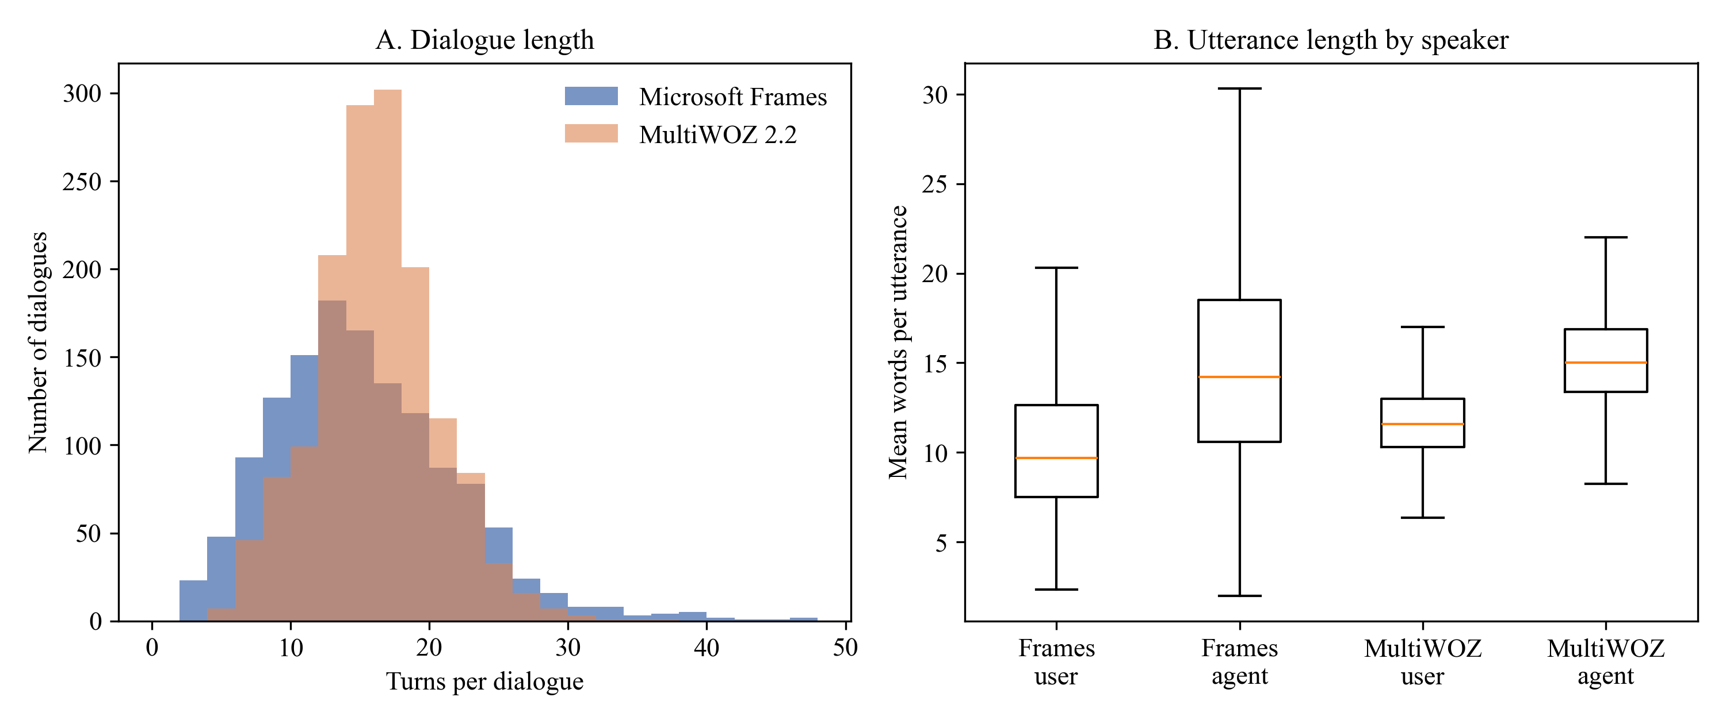
Note. Turn counts after cleaning. Frames N = 1,334; MultiWOZ N = 1,499.
Figure 2 compares slot completeness (exact percentages in Table E1). Frames users state origin, destination, and usually a budget; MultiWOZ dialogues mention travel slots far less often and never return dates. Thus only Frames carries the budget and package information that negotiation archetypes need; any length-linked archetype will be distributed differently across corpora, so MultiWOZ serves only as a descriptive check; and neither corpus has policy slots, so RQ3 requires injected scenarios.
Figure 2
Slot Completeness by Corpus
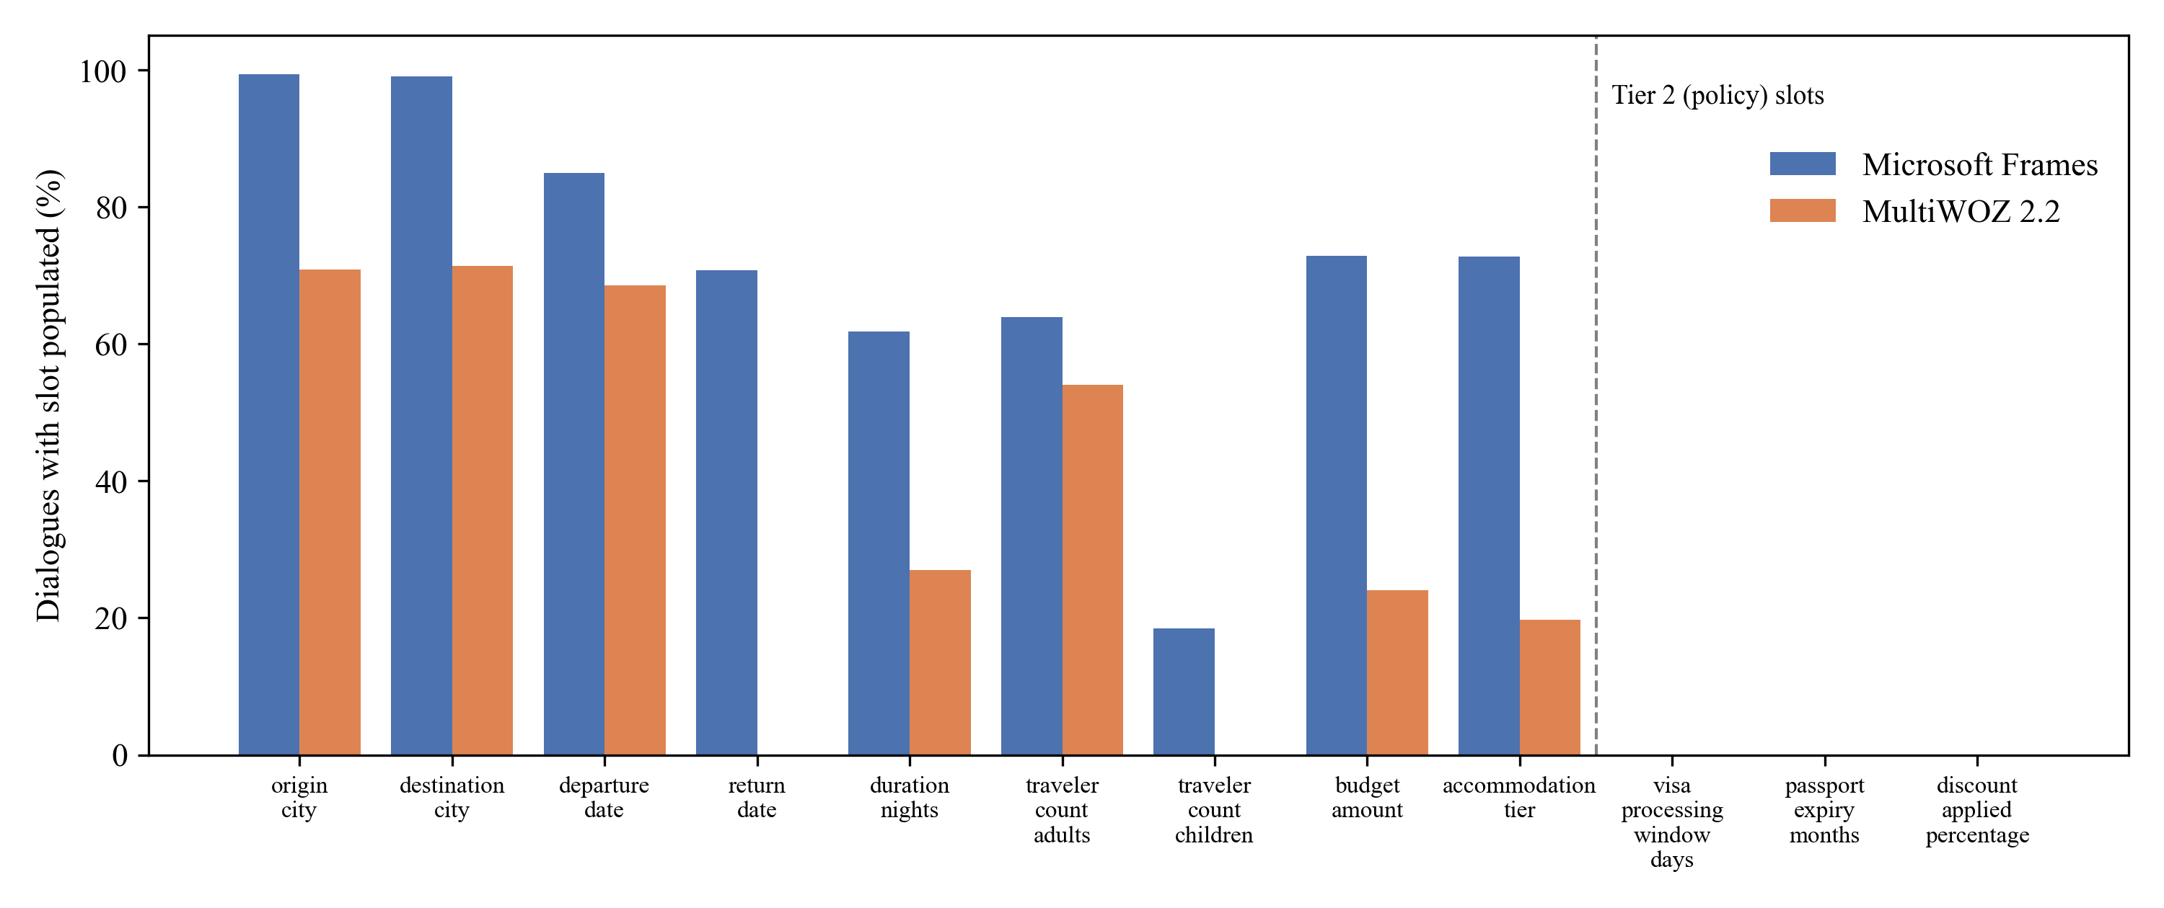
Note. Percentage of dialogues that mention each canonical slot at least once.

Modeling

Research Design and Sample Size
The study uses a quantitative design with one observational component (RQ1) and three controlled experiments (RQ2 to RQ4). All random steps use seed 42, and leakage is prevented by keeping the partitions disjoint, freezing centroids before any held-out dialogue is seen, routing and retrieving with only the turns available at generation time, and using the human reply only for scoring, never in a prompt.
Each sample size was computed for the exact test used later, with a medium effect f = .25 (Cohen, 1988), α = .05, and power .80, because no prior study reports effect sizes for these comparisons. Power was computed from the noncentral F distribution and checked against G*Power 3 (Faul et al., 2007):
1 − β = 1 − F_{nc}(F_{crit}; df₁, df₂, λ), F_{crit} = F_{1−α}(df₁, df₂) (1)
where F_{nc} is the cumulative noncentral F distribution and λ = f²N for between-subjects designs. The smallest N with power ≥ .80 (N_{min}) was rounded up to a balanced design and, for LLM experiments, increased by 10% for failed generations. Table 8 gives the computation (degrees of freedom, λ, F_{crit}, N_{min}, and power) for every research question. The experiments draw from the held-out partition, so the binding requirement is the largest experimental sample, 180 dialogues, which is smaller than |D_{test}| = 401.
Table 8
Sample Size Calculations Matched to Each Planned Analysis
RQ | Planned analysis | df at N_{min} | λ | F_{crit} | N_{min} | Power | N_{final} (per group) | Final power
RQ1 | One-way ANOVA (3 algorithms) | 2, 155 | 9.88 | 3.05 | 158 | .802 | 159 (53) | .805
RQ2 | One-way repeated-measures ANOVA (3 conditions) | 2, 54 | 10.50 | 3.17 | 28 | .812 | 33 (11) | .878
RQ3 | 2 × 2 factorial ANOVA | 1, 124 | 8.00 | 3.92 | 128 | .801 | 144 (36) | .846
RQ4 | 2 × 3 factorial ANOVA | 2, 152 | 9.88 | 3.06 | 158 | .802 | 180 (30) | .855
Note. All calculations use f = .25 and α = .05. RQ1 units are clustering runs on subsamples of the golden partition; RQ3 and RQ4 units are test dialogues. RQ2 units are test dialogues measured under m = 3 conditions, with λ = f²Nmε/(1 − ρ), ρ = .50, and ε = 1 (Faul et al., 2007). RQ2 to RQ4 include a 10% buffer for failed generations.

Choice of Models With Justification
No predictive model is trained. Each research question is answered with an unsupervised or experimental model and a statistical test matched to its design; baselines and assumptions are stated for each.

RQ1: Clustering Algorithms and Archetype Definition
K-Means (k = 3, 10 initializations), Ward agglomerative clustering (k = 3), and HDBSCAN, which chooses the number of clusters itself, were each applied to 53 independent random subsamples of 500 golden dialogues and compared with a one-way ANOVA on Silhouette. HDBSCAN noise points were assigned to the nearest centroid so that every dialogue receives an archetype. The baselines are a permutation baseline (K-Means labels shuffled within each subsample) and K-Means as the conventional reference.
Independence of runs. Each run uses its own subsample; because subsamples share dialogues, the test compares algorithms on this corpus rather than across datasets.
Normality. Shapiro–Wilk tests did not reject normality (K-Means W = .965, p = .120; agglomerative W = .979, p = .477; HDBSCAN W = .980, p = .524).
Homogeneity of variance. Levene's test was significant, W = 12.75, p < .001, so Welch's ANOVA, Games–Howell comparisons, and the Kruskal–Wallis test are reported as well.
Meaningful embedding geometry. Cosine distance is assumed to reflect conversational behavior; this was checked with behavioral features not used in clustering (Table 12).
Cross-corpus invariance. The synopsis assumed that Frames archetypes would apply to MultiWOZ; projection onto the frozen centroids did not support this.
A sensitivity analysis varied whose turns are represented (whole dialogue or user turns), how (MiniLM or Gemini embeddings, with or without an LLM behavior profile), and how much of the conversation (first 3, 5, 7, or 9 user messages, or all), under a selection rule fixed before results were inspected. Stability was the mean adjusted Rand index (ARI) between K-Means fits on two random 80% subsamples, repeated 50 times (Hennig, 2007). Eligible solutions had three to eight clusters, ARI ≥ .60, and a smallest cluster ≥ 5%; per length, the solution best predicted from the first five turns (Cohen's κ) was retained, and the most stable of these was adopted. The confirmatory RQ1 test is unchanged.
Valid behavior ratings. LLM ratings are assumed to measure user behavior; this was tested by re-annotation and by correlation with behaviors counted from the corpus annotations (see Features).

RQ2: Repeated-Measures Prompting Experiment
The experiment sampled 33 held-out dialogues, 11 per primary archetype (it was run before the sensitivity analysis). The first three turns form the prefix, and Gemini 2.5 Flash (temperature 0.2) generated the next agent turn under three conditions: zero-shot and static few-shot (three fixed random golden exemplars) as baselines, and cluster-adaptive few-shot, which routes the prefix to the nearest archetype centroid and retrieves the three most similar golden dialogues from that archetype's FAISS index; global nearest-neighbor retrieval (Liu et al., 2022) was compared in the pilot. A one-way repeated-measures ANOVA with Holm-adjusted contrasts tests the conditions; all 99 generations completed (N = 33).
Sphericity. Mauchly's test was not significant for style convergence, W = .95, χ²(2) = 1.59, p = .451, or gold similarity, W = .97, p = .610; Greenhouse–Geisser-corrected results (Greenhouse & Geisser, 1959) are reported for consistency.
Normality of difference scores. Shapiro–Wilk p values for the paired differences ranged from .003 to .616, so the Friedman test is reported as a distribution-free check.
Valid style metric and correct routing. The style score assumes that a turn written for an archetype is closer to its agent-style centroid, and routing assumes that the prefix identifies the archetype; the pilot tested both.
Exemplars carry style, not facts. De-lexicalization is assumed to remove factual content; this is tested as exemplar leakage in RQ3.

RQ3: Rules-by-Prompting Factorial Experiment
RQ3 randomly assigns 144 held-out dialogues to a 2 × 2 between-subjects design (rule engine active or off × zero-shot or cluster-adaptive prompting with the refined archetypes). Each dialogue state is augmented with seeded synthetic Tier 2 values, half of which violate at least one rule. When active, the engine evaluates the state before generation and adds violations to the prompt as required actions. The baseline cell is zero-shot prompting with rules off. Table 9 lists the five author-defined rules, which do not represent any company's policy.
Table 9
Declarative Policy Rules Used in RQ3
Rule | Condition | Action | Severity
Visa Processing Lead Time | departure_lead_days < 15; is_international = true | block and flag | fatal
Passport Validity Threshold | passport_expiry_months < 6; is_international = true | block and flag | fatal
Maximum Adult Capacity per Single Booking | traveler_count_adults > 8; package_type = 'FIT' | convert to group | warning
Maximum Discretionary Sales Discount | discount_applied_percentage > 15.0 | clamp discount | fatal
Minimum Feasible Per-Pax International Budget | budget stated; budget_amount < 500; is_international = true | prompt realistic budget | warning
Note. Rules are stored in a YAML file and evaluated outside the LLM by src/rule_engine.py.
Deterministic rule evaluation. All 14 of 14 boundary tests passed, including values exactly at each threshold and the domestic and group-package exemptions.
Decoupling. Rules are assumed to act independently of prompt style; this is the interaction term, so it is tested rather than assumed.
Residual normality and equal variances. Shapiro–Wilk and Levene tests will be applied; because adherence proportions are likely near 0 or 1, an aligned rank transform ANOVA or a logistic model will be used if they fail.
International travel. Frames cities are fictional, so all trips are treated as international for the visa, passport, and budget rules.

RQ4: Turn-Economy Simulation
RQ4 uses 180 held-out dialogues, 30 per cell of a 2 × 3 design (zero-shot or cluster-adaptive prompting × the three refined archetypes; the held-out partition contains 175, 99, and 127 dialogues of these archetypes). An LLM user simulator receives the dialogue's user goal and its archetype profile (Table 14) and converses with the agent until the goal is met or 30 turns elapse. The zero-shot agent is the baseline, and the human dialogues give a reference level. A 2 × 3 factorial ANOVA on log turns tests the interaction.
Log-normal turn counts. Turn counts are right-skewed and are analyzed on the log scale; residuals will be checked with Shapiro–Wilk tests.
Equal variances. In the human baseline, Levene's test on log turns was significant, W = 38.01, p < .001, so heteroscedasticity-robust (HC3) standard errors will be used.
Comparable goals. Turn counts are compared only within Frames, so the schema need not be invariant across corpora.
Archetype effect by construction. Archetypes partly reflect dialogue length, so an archetype main effect is expected and is not a finding; the tests of interest are the conditioning effect and the interaction.
Valid persona simulation. Simulated user turns will be annotated with the same codebook and tested for assignment to the intended archetype above chance.

Features Included and Feature Engineering
Trajectory vectors (primary archetypes, RQ2 routing). Each de-lexicalized turn t of a dialogue with T turns was embedded with Sentence-BERT as a 384-dimensional vector e_{t}, and the dialogue vector is the decay-weighted mean
v = Σ_{t} w_{t}e_{t}, w_{t} = exp[−λ_{d}(T − t)] / Σ_{j} exp[−λ_{d}(T − j)] (2)
with λ_{d} = 0.15 and L2 normalization, which emphasizes how a dialogue develops and closes. Structural features (turns, revisions, hesitations, offers) are excluded from the vector and used only to interpret clusters.
Hybrid features (refined archetypes). Two equally weighted blocks were combined, both computed on the same first M user messages: the first 20 principal components of the Gemini embedding (gemini-embedding-001; Lee et al., 2025), and an LLM behavior profile in which Gemini 2.5 Flash (temperature 0, JSON schema) rated each user on a 16-field codebook (Table D1) of ten 1–5 ratings, such as price sensitivity and revision tendency, plus goal and tone indicators. Re-annotating 100 random dialogues at temperature 0.7 gave quadratic-weighted κ from .87 to .96 for the ratings, and the ratings correlated with behaviors counted from the Frames acts, for example revision tendency with slot revisions (ρ = .73) and question asking with request rate (ρ = .65; Table D2).
Exemplar features (RQ2 to RQ4). Retrieval keys embed the same number of opening turns as the test prefix, so neither side uses future turns; exemplars are de-lexicalized and truncated to six turns.

Evaluation Metrics
Table 10 defines every outcome metric with its formula.
Table 10
Evaluation Metrics and Formulae
Metric | Formula | RQ | Interpretation
Silhouette | s(i) = [b(i) − a(i)] / max{a(i), b(i)}, averaged over i; a, b = mean cosine distance to own and nearest other cluster | 1 | −1 to 1; higher is better separated
Davies–Bouldin index | DB = (1/k) Σ_{i} max_{j≠i} (σ_{i} + σ_{j}) / d(c_{i}, c_{j}) | 1 | ≥ 0; lower is better
Adjusted Rand index | ARI = (RI − E[RI]) / (max RI − E[RI]) | 1 | 0 = chance agreement; 1 = identical partitions
Cohen's κ | κ = (p_{o} − p_{e}) / (1 − p_{e}) | 1 | Routing and rating agreement beyond chance
Cramér's V | V = √[χ² / (N(min(r, c) − 1))] | 1 | 0 to 1; association of archetype with a category
Style convergence | cos(r, c_{a}) = r · c_{a} / (‖r‖ ‖c_{a}‖); c_{a} = mean golden agent turn of archetype a | 2, 3 | Higher is closer to the target style
Gold similarity | cos(r, h); h = embedding of the human reply | 2 | Higher is closer to the human agent
Slot F1 | F₁ = 2PR / (P + R) over slot values | 3 | 0 to 1; higher is more accurate
Exemplar leakage rate | |E_{r} ∩ (E_{x} \ E_{d})| / |E_{r}|; entities in response, exemplars, dialogue | 3 | 0 to 1; lower is better
Rule adherence rate | 1 − V_{t} / A_{t}; violating and all agent turns | 3 | 0 to 1; higher is better
Turns to goal | Turns until all required slots are filled and an offer is accepted (log scale) | 4 | Lower is more economical
Redundant elicitation rate | R_{red} / A_{t}; requests for an already-informed slot over agent turns | 4 | 0 to 1; lower is better
Note. Cosine measures use de-lexicalized all-MiniLM-L6-v2 embeddings. ARI follows Hubert and Arabie (1985). BERTScore (Zhang et al., 2020) is planned as a token-level check for the final report.

Preliminary Results

RQ1: Clustering Algorithms and Primary Archetypes (Complete)
On the golden partition, Silhouette was nearly flat from k = 3 to 5 (.141 to .148), so the pre-specified k = 3 was retained (Table E2 and Figure E1).
Table 11 compares the algorithms. HDBSCAN produced the highest mean Silhouette (M = .211, SD = .044), followed by K-Means (M = .147, SD = .019) and agglomerative clustering (M = .118, SD = .040), and all three far exceeded the permutation baseline (M = −.013). The one-way ANOVA was significant, F(2, 156) = 91.33, p < .001, η² = .54, and held under Welch's correction, F(2, 89.15) = 66.98, p < .001, and the Kruskal–Wallis test, H(2) = 86.82, p < .001. Every pairwise difference was significant under Tukey and Games–Howell comparisons (Table E3; runs plotted in Figure E2). The null hypothesis is rejected.
Two qualifications matter. HDBSCAN's advantage depends on its settings: with the common minimum cluster size of 15 it found no clusters in 53 of 53 subsamples, and with a minimum of 5 it still labeled 39.1% of dialogues as noise and found 2 to 6 clusters (most often 2), so its higher Silhouette partly reflects fewer clusters. All Silhouette values are below .25, which indicates weak structure: archetypes are tendencies on a continuum. Because routing needs a stable number of archetypes and a centroid for every dialogue, K-Means with k = 3 defined the archetypes.
Table 11
Cluster Quality by Algorithm
Algorithm | n runs | Silhouette M | Silhouette SD | Davies–Bouldin M | Davies–Bouldin SD
K-Means | 53 | .147 | .019 | 3.129 | 0.113
Agglomerative (Ward) | 53 | .118 | .040 | 3.550 | 0.269
HDBSCAN | 53 | .211 | .044 | 2.657 | 0.241
Permutation baseline | 53 | −.013 | .006 | — | —
Note. Each run clusters an independent random subsample of 500 golden dialogues. The permutation baseline shuffles K-Means labels within each subsample.
Table 12 profiles the archetypes on features not used for clustering; names follow a fixed rule (most revisions = Constraint Negotiator; longer of the other two = Guided Explorer). Direct Transactional dialogues are short (9.9 turns) with almost no offers (0.84). Constraint Negotiators write the longest utterances and revise slot values most often (20.3). Guided Explorers form the largest group (50.2%) and have the longest dialogues (17.2 turns) but the shortest user utterances, indicating an agent-led search. Task success is high in every archetype, so they differ in how users converse rather than in whether they succeed.
Archetype was associated with the Frames user role-player, χ²(20, N = 1,334) = 92.63, p < .001, Cramér's V = .19, so individual role-player style contributes to the archetypes. The frozen centroids generalized within Frames: centroid similarity did not differ between golden and held-out dialogues, t(754.9) = 0.42, p = .676, and held-out proportions matched the golden ones, χ²(2, N = 401) = 4.69, p = .096. They did not transfer to MultiWOZ: MultiWOZ dialogues were far less similar to their nearest Frames centroid (M = .805 vs. .894), t(576.2) = 38.29, p < .001, and 84.0% fell into one archetype (Table E4 and the UMAP projection in Figure E3), which supports keeping MultiWOZ descriptive.
Table 12
Behavioral Profiles of the Three Primary Archetypes (Golden Partition)
Feature | Direct Transactional | Constraint Negotiator | Guided Explorer
n (%) | 240 (25.7) | 225 (24.1) | 468 (50.2)
Turns, M (SD) | 9.92 (5.02) | 15.64 (6.84) | 17.19 (6.10)
Words per user utterance | 10.60 | 12.94 | 9.63
Words per agent utterance | 11.67 | 18.15 | 15.71
Slot-value revisions | 6.92 | 20.32 | 16.68
Hesitation markers | 0.67 | 1.15 | 1.15
Agent offers | 0.84 | 4.28 | 3.73
Budget stated (%) | 63.7 | 70.7 | 75.4
Task success (%) | 92.1 | 94.2 | 95.3
Note. Values are means per dialogue unless stated. Revisions count changes of a slot's value across user and agent acts.
Interim answer. The algorithms differ significantly with a large effect. HDBSCAN separates best but only with relaxed settings, heavy noise, and an unstable number of clusters, whereas K-Means gives a stable three-archetype solution that generalizes to held-out Frames dialogues but not to MultiWOZ. The pre-specified answer to RQ1 is the three primary archetypes, which were used in RQ2.

RQ1 Sensitivity Analysis: Refined Archetypes (Complete)
Three diagnostics showed that the primary archetypes are a weak basis for routing: a router predicting the archetype from the first five turns reached only κ = .11 on held-out dialogues, the trajectory vectors mix user and agent behavior, and the archetypes are partly tied to role-players. With Gemini embeddings, the 159-run algorithm comparison reproduced the primary result with larger effects (η² = .50 for turn vectors and .62 for document vectors, both p < .001; Table D3), so the answer to RQ1 does not depend on the embedding model. Restricting MiniLM vectors to user turns raised three-cluster stability from ARI = .72 to .87 and lowered the role-player association from V = .19 to .12.
On whole conversations the hybrid representation was unstable (best eligible solution k = 4, ARI = .67) and largely reproduced how the dialogue ended (three-cluster association with the rated outcome V = .57), because late messages record the result of the search rather than the user's approach. Table 13 shows that truncating to the first M user messages solved this: three-cluster solutions were stable at every cut-off (ARI = .84 to .89), no solution with four or more clusters exceeded ARI = .69, and the outcome association rose with more messages (V = .16 at three to .45 at nine; all panels in Figure E4). The pre-declared rule selected the first nine user messages with k = 3 (ARI = .89; 93% core members that keep their archetype in at least 90% of 30 refits; smallest archetype 26%).
Table 13
Stability, Routing, and Outcome Association of Hybrid Archetypes by Conversation Length
User messages used | Dialogues shortened (%) | Stability ARI | Core members (%) | Smallest cluster (%) | Routing κ | Outcome V | Best ARI, k ≥ 4
3 | 94.7 | .89 | 92.7 | 18.3 | .72 | .16 | .67
5 | 78.2 | .84 | 77.1 | 20.3 | .38 | .27 | .63
7 | 53.2 | .85 | 89.9 | 29.7 | .25 | .38 | .69
9 | 30.7 | .89 | 93.1 | 25.5 | .24 | .45 | .63
Whole conversation | 0.0 | .62 | 53.7 | 7.9 | .22 | .57 | .67
Note. Values are for k = 3 on the golden partition (N = 933) unless stated. Stability is the mean ARI between K-Means fits on 50 pairs of random 80% subsamples; core members keep their archetype in at least 90% of 30 refits. Routing κ compares the archetype of held-out dialogues with a logistic-regression prediction from their first five turns. Outcome V is Cramér's V with the LLM-rated outcome of the whole conversation. The adopted solution uses nine messages. ARI = adjusted Rand index.
Table 14 profiles the refined archetypes; names follow a fixed rule (highest destination flexibility = Open Explorer; more decisive of the other two = Decisive Booker). Decisive Bookers (45.0%) are polite and decisive, pursue one specific trip (99%), and book in 90% of dialogues. Open Explorers (25.5%) are flexible about the destination, consider many alternatives, revise often, and have the longest dialogues (20.8 turns). Rigid-Constraint Seekers (29.5%) have a fixed destination and dates and ask few questions; their dialogues are short (10.6 turns) and end without a suitable option in 68% of cases. Frames task success does not distinguish them (Cramér's V = .08).
Table 14
Profiles of the Three Refined Archetypes (Golden Partition)
Feature | Decisive Booker | Open Explorer | Rigid-Constraint Seeker
n (%) | 420 (45.0) | 238 (25.5) | 275 (29.5)
Turns, M (SD) | 14.49 (4.54) | 20.78 (6.95) | 10.60 (5.73)
User messages, M | 7.58 | 10.73 | 5.55
Destination flexibility (1–5) | 2.54 | 3.49 | 2.20
Date flexibility (1–5) | 2.57 | 2.77 | 2.18
Exploration breadth (1–5) | 1.97 | 2.96 | 1.59
Decisiveness (1–5) | 3.97 | 2.58 | 3.23
Detail orientation (1–5) | 2.39 | 2.87 | 1.46
Revision tendency (1–5) | 2.00 | 3.03 | 2.40
Question asking (1–5) | 2.05 | 2.72 | 1.43
Politeness (1–5) | 4.26 | 3.80 | 3.07
Price sensitivity (1–5) | 3.20 | 3.18 | 3.12
Information given up front (1–5) | 2.18 | 1.82 | 2.16
Goal: explore destinations (%) | 0.5 | 39.1 | 2.2
Goal: book a specific trip (%) | 99.3 | 50.8 | 89.8
Outcome: booked (%) | 90.5 | 68.1 | 28.0
Outcome: no suitable option (%) | 6.2 | 18.5 | 68.0
Frames task success (%) | 94.5 | 96.2 | 92.0
Note. Ratings and goals are LLM annotations of the first nine user messages (the clustering input); outcomes are LLM annotations of the whole conversation and were not used for clustering.
The refined and primary archetypes overlap only partly (ARI = .20). On held-out dialogues the refined archetypes reproduced the golden proportions, χ²(2, N = 401) = 0.93, p = .628, and routing after five turns improved from κ = .11 to .24, which is still only fair. An ablation (Table E5) showed that truncation is the main driver of the gain: with the behavior profile, stability rose from ARI = .56 to .73 on whole conversations to .85 to .87 on nine messages; alternative representations agree only partly with the adopted labels (ARI = .14 to .45).
Decision. The primary archetypes remain the pre-specified answer to RQ1 and were used in RQ2. RQ3 and RQ4 use the refined archetypes because they are more stable, describe the user rather than the whole dialogue, and are recognized earlier; RQ2 will be repeated with them. They remain regions of a continuum (Silhouette only .033 above its permutation baseline) and partly capture whether a suitable package was available (outcome V = .45).

RQ2: Cluster-Adaptive Few-Shot Prompting (Complete)
The pilot ran every step except the LLM call on the experimental sample (Tables E6 and E7; Figure E5). Routing from a three-turn prefix was correct for 12 of 33 dialogues (36.4%), close to the 33.3% expected by chance. Similarity-based retrieval found far more relevant exemplars than the static set (partial η² = .92), with global retrieval slightly ahead of cluster-adaptive retrieval. The style metric was valid but modest: human replies were closer to their own archetype's centroid than to the others, t(32) = 2.60, p = .014, d_{z} = .45.
Table 15 shows the experimental results. Style convergence did not differ by condition, F(1.90, 60.95) = 1.08, p = .342, partial η² = .03, and the Friedman test agreed, χ²(2, N = 33) = 5.72, p = .057. Zero-shot responses were descriptively closest to the target centroid (M = .519), the opposite of the hypothesized order, no Holm-adjusted contrast was significant (Table E8; Figure E6), and similarity to the human reply did not differ either. The null hypothesis for RQ2 is not rejected.
The exploratory length measure showed a large effect: zero-shot responses averaged 25.2 words, whereas static and cluster-adaptive responses averaged 10.6 and 12.3 words, close to the human replies (M = 10.5), partial η² = .52; the two few-shot conditions did not differ from each other (Holm p = .196).
Table 15
Generated Responses by Prompting Condition
Outcome | Zero-shot M (SD) | Static few-shot M (SD) | Cluster-adaptive M (SD) | F | p | η_{p}²
Style convergence (cosine) | .519 (.126) | .491 (.109) | .486 (.099) | 1.08 | .342 | .03
Similarity to human reply (cosine) | .317 (.195) | .325 (.223) | .333 (.221) | 0.14 | .861 | .00
Response length (words) | 25.2 (11.8) | 10.6 (7.0) | 12.3 (8.2) | 34.36 | < .001 | .52
Note. N = 33 held-out dialogues, each measured under all three conditions; gemini-2.5-flash. p values use the Greenhouse–Geisser correction. Response length is exploratory.
Interim answer. Any human examples move the model toward human pacing, but archetype-matched examples add nothing measurable beyond fixed examples. Two likely reasons are near-chance routing, so most dialogues received exemplars from the wrong archetype, and weak archetype separation with a modest style metric; the observed effect (f = 0.18) is below the medium effect assumed in the power analysis.

RQ3: Rules Versus Prompting (Groundwork Complete)
The rule engine passed all 14 boundary tests. The corpus audit (Table E9) shows that only two rules can be checked from Frames annotations: a user-stated number of adults appears in 24.1% of dialogues and triggers the capacity rule in 54, and a numeric budget appears in 65.1% and triggers the minimum-budget rule in 266. The visa, passport, and discount rules can never be triggered by public data, which is the empirical basis for injecting synthetic scenarios. RQ3 is not yet answered.

RQ4: Turn Economy Across Archetypes (Groundwork Complete)
Table 16 gives the human baseline for all 1,334 Frames dialogues by refined archetype. Turn counts differed by archetype, H(2) = 433.22, p < .001, as expected by construction (distributions in Figure E7). Redundant elicitation was rare among human agents (M = .015, about one request in 66 agent turns) and did not differ by archetype, H(2) = 4.12, p = .128. The synopsis expectation of reducing RER from .16 is therefore not supported; RER will instead be compared between the two LLM agents.
Table 16
Human Baseline of Turn Economy by Refined Archetype (Frames)
Archetype | n | Turns M (SD) | RER M (SD) | Agent request turns M
Decisive Booker | 595 | 14.56 (4.52) | .014 (.047) | 1.44
Open Explorer | 337 | 20.75 (7.07) | .016 (.049) | 1.82
Rigid-Constraint Seeker | 402 | 10.60 (5.59) | .017 (.061) | 1.27
Note. RER = redundant elicitation rate. Archetypes for held-out dialogues were assigned with the K-Means model fitted on the golden partition.

Interim Limitations and Risks
Archetypes are weakly separated (primary Silhouette < .25; refined only .033 above the permutation baseline) and routing after five turns reaches only κ = .24, so routing errors dilute any effect of archetype-matched prompting. The primary archetypes are associated with role-players (V = .19) and the refined ones with the final outcome (V = .45), and other reasonable representations give partly different archetypes. The behavior ratings come from an LLM and were validated on whole conversations, RQ3 scenarios are synthetic, and RQ4 relies on a simulated user. Frames is role-play with fictional cities, so conclusions apply to vacation-package negotiation dialogues of this kind. The archetype definition was refined after the primary analysis (mitigated by a pre-declared rule and by reporting every configuration), and the observed RQ2 effect (f = .18) was smaller than the medium effect assumed for power.
Project risks are API quota limits (mitigated by caching every response), weak routing (refined archetypes and a global nearest-neighbor condition), an unrealistic simulator (persona check), and schedule slippage (analysis ends in Week 8, leaving Weeks 9 and 10 as buffer).

Next Steps
• Week 6: repeat RQ2 with the refined archetypes and global retrieval; prepare RQ3 scenarios.
• Week 7: run the RQ3 experiment (slot F1, exemplar leakage, rule adherence).
• Week 8: RQ4 simulation, persona and annotation-reliability checks, BERTScore, and robustness checks.
• Weeks 9 and 10: final presentation, final report, and repository release (Appendix B).

References
Acikgoz, E. C., Guo, C., Dey, S., Datta, A., Kim, T., Tur, G., & Hakkani-Tür, D. (2025). TD-EVAL: Revisiting task-oriented dialogue evaluation by combining turn-level precision with dialogue-level comparisons. In Proceedings of the 26th Annual Meeting of the Special Interest Group on Discourse and Dialogue (pp. 113–132). Association for Computational Linguistics. https://doi.org/10.18653/v1/2025.sigdial-1.7
Brown, T. B., Mann, B., Ryder, N., Subbiah, M., Kaplan, J., Dhariwal, P., Neelakantan, A., Shyam, P., Sastry, G., Askell, A., Agarwal, S., Herbert-Voss, A., Krueger, G., Henighan, T., Child, R., Ramesh, A., Ziegler, D. M., Wu, J., Winter, C., . . . Amodei, D. (2020). Language models are few-shot learners. In Advances in Neural Information Processing Systems (Vol. 33, pp. 1877–1901). Curran Associates. https://doi.org/10.48550/arXiv.2005.14165
Budzianowski, P., Wen, T.-H., Tseng, B.-H., Casanueva, I., Ultes, S., Ramadan, O., & Gašić, M. (2018). MultiWOZ: A large-scale multi-domain Wizard-of-Oz dataset for task-oriented dialogue modelling. In Proceedings of the 2018 Conference on Empirical Methods in Natural Language Processing (pp. 5016–5026). Association for Computational Linguistics. https://doi.org/10.18653/v1/D18-1547
Cohen, J. (1988). Statistical power analysis for the behavioral sciences (2nd ed.). Lawrence Erlbaum Associates. https://doi.org/10.4324/9780203771587
Davies, D. L., & Bouldin, D. W. (1979). A cluster separation measure. IEEE Transactions on Pattern Analysis and Machine Intelligence, PAMI-1(2), 224–227. https://doi.org/10.1109/TPAMI.1979.4766909
El Asri, L., Schulz, H., Sharma, S., Zumer, J., Harris, J., Fine, E., Mehrotra, R., & Suleman, K. (2017). Frames: A corpus for adding memory to goal-oriented dialogue systems. In Proceedings of the 18th Annual SIGdial Meeting on Discourse and Dialogue (pp. 207–219). Association for Computational Linguistics. https://doi.org/10.18653/v1/W17-5526
Faul, F., Erdfelder, E., Lang, A.-G., & Buchner, A. (2007). G*Power 3: A flexible statistical power analysis program for the social, behavioral, and biomedical sciences. Behavior Research Methods, 39(2), 175–191. https://doi.org/10.3758/BF03193146
Gilardi, F., Alizadeh, M., & Kubli, M. (2023). ChatGPT outperforms crowd workers for text-annotation tasks. Proceedings of the National Academy of Sciences, 120(30), Article e2305016120. https://doi.org/10.1073/pnas.2305016120
Greenhouse, S. W., & Geisser, S. (1959). On methods in the analysis of profile data. Psychometrika, 24(2), 95–112. https://doi.org/10.1007/BF02289823
Hennig, C. (2007). Cluster-wise assessment of cluster stability. Computational Statistics & Data Analysis, 52(1), 258–271. https://doi.org/10.1016/j.csda.2006.11.025
Hubert, L., & Arabie, P. (1985). Comparing partitions. Journal of Classification, 2(1), 193–218. https://doi.org/10.1007/BF01908075
Inaba, M., Chiba, Y., Higashinaka, R., Komatani, K., Miyao, Y., & Nagai, T. (2022). Collection and analysis of travel agency task dialogues with age-diverse speakers. In Proceedings of the Thirteenth Language Resources and Evaluation Conference (pp. 5759–5767). European Language Resources Association. https://aclanthology.org/2022.lrec-1.619
Jannach, D., Manzoor, A., Cai, W., & Chen, L. (2021). A survey on conversational recommender systems. ACM Computing Surveys, 54(5), Article 105. https://doi.org/10.1145/3453154
Johnson, J., Douze, M., & Jégou, H. (2021). Billion-scale similarity search with GPUs. IEEE Transactions on Big Data, 7(3), 535–547. https://doi.org/10.1109/TBDATA.2019.2921572
Lee, J., Chen, F., Dua, S., Cer, D., Shanbhogue, M., Naim, I., Hernández Ábrego, G., Li, Z., Chen, K., Schechter Vera, H., Ren, X., Zhang, S., Salz, D., Boratko, M., Han, J., Chen, B., Huang, S., Rao, V., Suganthan, P., . . . Duerig, T. (2025). Gemini embedding: Generalizable embeddings from Gemini (arXiv:2503.07891). arXiv. https://doi.org/10.48550/arXiv.2503.07891
Liu, J., Shen, D., Zhang, Y., Dolan, B., Carin, L., & Chen, W. (2022). What makes good in-context examples for GPT-3? In Proceedings of Deep Learning Inside Out (DeeLIO 2022): The 3rd Workshop on Knowledge Extraction and Integration for Deep Learning Architectures (pp. 100–114). Association for Computational Linguistics. https://doi.org/10.18653/v1/2022.deelio-1.10
McInnes, L., Healy, J., & Astels, S. (2017). hdbscan: Hierarchical density based clustering. Journal of Open Source Software, 2(11), Article 205. https://doi.org/10.21105/joss.00205
McInnes, L., Healy, J., & Melville, J. (2018). UMAP: Uniform manifold approximation and projection for dimension reduction (arXiv:1802.03426). arXiv. https://doi.org/10.48550/arXiv.1802.03426
Pedregosa, F., Varoquaux, G., Gramfort, A., Michel, V., Thirion, B., Grisel, O., Blondel, M., Prettenhofer, P., Weiss, R., Dubourg, V., Vanderplas, J., Passos, A., Cournapeau, D., Brucher, M., Perrot, M., & Duchesnay, É. (2011). Scikit-learn: Machine learning in Python. Journal of Machine Learning Research, 12, 2825–2830. https://jmlr.org/papers/v12/pedregosa11a.html
Rebedea, T., Dinu, R., Sreedhar, M. N., Parisien, C., & Cohen, J. (2023). NeMo Guardrails: A toolkit for controllable and safe LLM applications with programmable rails. In Proceedings of the 2023 Conference on Empirical Methods in Natural Language Processing: System Demonstrations (pp. 431–445). Association for Computational Linguistics. https://doi.org/10.18653/v1/2023.emnlp-demo.40
Reimers, N., & Gurevych, I. (2019). Sentence-BERT: Sentence embeddings using Siamese BERT-networks. In Proceedings of the 2019 Conference on Empirical Methods in Natural Language Processing and the 9th International Joint Conference on Natural Language Processing (pp. 3982–3992). Association for Computational Linguistics. https://doi.org/10.18653/v1/D19-1410
Rousseeuw, P. J. (1987). Silhouettes: A graphical aid to the interpretation and validation of cluster analysis. Journal of Computational and Applied Mathematics, 20, 53–65. https://doi.org/10.1016/0377-0427(87)90125-7
Seabold, S., & Perktold, J. (2010). Statsmodels: Econometric and statistical modeling with Python. In Proceedings of the 9th Python in Science Conference (pp. 92–96). SciPy. https://doi.org/10.25080/Majora-92bf1922-011
Yao, S., Shinn, N., Razavi, P., & Narasimhan, K. (2024). τ-bench: A benchmark for tool-agent-user interaction in real-world domains (arXiv:2406.12045). arXiv. https://doi.org/10.48550/arXiv.2406.12045
Zang, X., Rastogi, A., Sunkara, S., Gupta, R., Zhang, J., & Chen, J. (2020). MultiWOZ 2.2: A dialogue dataset with additional annotation corrections and state tracking baselines. In Proceedings of the 2nd Workshop on Natural Language Processing for Conversational AI (pp. 109–117). Association for Computational Linguistics. https://doi.org/10.18653/v1/2020.nlp4convai-1.13
Zhang, T., Kishore, V., Wu, F., Weinberger, K. Q., & Artzi, Y. (2020). BERTScore: Evaluating text generation with BERT. In Proceedings of the 8th International Conference on Learning Representations. OpenReview. https://openreview.net/forum?id=SkeHuCVFDr

Appendix A

Repository Structure and Replication Guide
All materials are available at https://github.com/surnella/QM640-Dialogue-Clustering-Capstone. Table A1 lists the parts of the repository used in this report, and Table A2 lists the commands that reproduce every table and figure.
Table A1
Repository Structure
Path | Contents
data/raw/ | Downloaded Frames and MultiWOZ 2.2 corpora
data/canonical/ | Canonical two-tier dialogue file
data/interim/ | Cleaned samples, embeddings, archetypes, LLM annotations, prompts, and run summaries
data/embeddings/gemini/ | Cached Gemini embeddings (regenerated by step 2c; not versioned)
src/ingestion.py, src/canonical_schema.py | Corpus parsers and Pydantic schema
src/rule_engine.py, rules/ | Declarative rule engine and YAML rule file
src/interim_pipeline/ | Reproducible analysis steps 0 to 4, including steps 2b to 2i (this report)
src/report/, src/build_interim_submission.py | APA report builder
outputs/interim/tables/, outputs/interim/figures/ | Result tables (CSV) and figures (PNG)
requirements.txt | Python dependencies

Table A2
Replication Commands
Step | Command (run from src/interim_pipeline/) | Produces
0 | python step0_sample_size.py | Table 8
1 | python step1_prepare_data.py | Tables 6, 7, and E1; Figures 1 and 2
2 | python step2_rq1_clustering.py | Tables 11, 12, and E2 to E4; Figures E1 to E3
2b | python step2b_rq1_representation.py --emb minilm | User-turn and dialogue-act representations
2c | python step2c_gemini_embeddings.py | Gemini embeddings (requires GEMINI_API_KEY)
2d | python step2d_rq1_gemini_algorithms.py | Table D3
2e | python step2e_llm_user_annotation.py (also --retest and --max-user-msgs 3, 5, 7, 9) | LLM behavior annotations (requires GEMINI_API_KEY)
2f | python step2f_rq1_llm_hybrid.py | Table D2; whole-conversation hybrid
2g | python step2g_rq1_truncation.py | Table 13; Figure E4; refined labels
2h | python step2h_rq1_ablation.py | Table E5
2i | python step2i_rq1_refined_archetypes.py | Tables 14 and 16; Figure E7
3 | python step3_rq2_pipeline.py | Tables E6 and E7; Figure E5; saved prompts
3 (execution) | python step3_rq2_pipeline.py --execute | Tables 15 and E8; Figure E6 (requires GEMINI_API_KEY)
4 | python step4_rq3_rq4_groundwork.py | Tables 9 and E9
Report | python src/build_interim_submission.py (from the repository root) | This document
Note. Python 3.11; all random steps use seed 42. LLM and embedding responses are cached, so steps 2c and 2e only call the API for missing items.

Appendix B

Ten-Week Project Schedule
Table B1 maps the project to the 10-week QM640 schedule. All analysis finishes in Week 8, and Weeks 9 and 10 are reserved for the presentation and final report.
Table B1
Ten-Week Schedule Aligned With the QM640 Course Topics
Week (dates) | Course topic | Project tasks and deliverables | Status
1 (Sep 27–Oct 3) | Define research problem and topic | Problem statement finalized; repository set up; Frames and MultiWOZ downloaded | Complete
2 (Oct 4–10) | Synopsis draft | Research questions and two-tier schema; synopsis draft (Oct 6) | Complete
3 (Oct 11–17) | Literature search and data collection | Synopsis final (Oct 13); ingestion, canonicalization, and embeddings | Complete
4 (Oct 18–24) | Objectives and hypotheses | Quality audit, EDA, power analysis, RQ1 clustering; RQ2 pilot; RQ3 and RQ4 groundwork; interim draft (Oct 20) | Complete
5 (Oct 25–31) | Research design and methodology | Interim report final (Oct 27); RQ2 generation run and analysis (complete); RQ1 sensitivity analysis of the archetype definition (complete) | In progress
6 (Nov 1–7) | Data analysis plan | RQ2 repeated with refined archetypes and global k-NN; RQ3 scenario injection; final report draft (Nov 3) | Planned
7 (Nov 8–14) | Data analysis plan execution | RQ3 2 × 2 experiment and analysis | Planned
8 (Nov 15–21) | Data analysis assessment | RQ4 simulation, 2 × 3 analysis, robustness checks; analysis complete | Planned
9 (Nov 22–28) | Refinement and documentation | Final presentation (Nov 27–28) | Planned
10 (Nov 29–Dec 5) | Document results and findings | Final report and repository release | Planned
Note. EDA = exploratory data analysis. No tasks are scheduled outside Weeks 1 to 10.

Appendix C

Comparison With Related Research
Table C1 compares the studies closest to this capstone and shows how the present design extends them.
Table C1
Related Research and Its Relationship to the Present Study
Study | Main contribution | Connection to this study | Gap addressed here
El Asri et al. (2017), Frames | 1,369 human–human vacation-package dialogues with frame tracking | Primary corpus for embeddings, archetypes, and exemplars | Does not cluster dialogues or use them for prompting
Zang et al. (2020), MultiWOZ 2.2 | Corrected multi-domain dialogue states and schema | External projection check and schema mapping | Focuses on slot tracking, not archetypes or prompting
Liu et al. (2022), KATE | Similarity-based in-context example selection beats random selection | Motivates retrieval; global nearest neighbor is a comparison | Single-turn tasks; no style or leakage measures
Rebedea et al. (2023), NeMo Guardrails | Programmable rails outside the LLM | Motivates the decoupled rule engine | Does not adapt style or test interaction with prompting
Yao et al. (2024), τ-bench | Agent evaluation against explicit domain policies | Supports measuring rule adherence separately | Tool-calling agents; no archetype adaptation
Acikgoz et al. (2025), TD-EVAL | Turn-level and dialogue-level evaluation | Supports combining similarity with turn-level checks | Evaluation framework only; no adaptive prompting
Note. The comparison describes relevance to this study and does not imply that the cited studies used the same data or metrics.

Appendix D

Behavior Annotation Codebook and Quality Checks
Table D1 gives the codebook used by the LLM to rate each Frames user in the RQ1 sensitivity analysis. The model read the conversation (whole or truncated after the M-th user message) and rated only the user, using the agent's messages as context. Table D2 reports the reliability and criterion validity of the ratings, and Table D3 repeats the RQ1 algorithm comparison with Gemini embeddings.
Table D1
LLM Behavior Annotation Codebook
Field | Type | Definition and scale anchors
Primary goal | Category | Main purpose: explore destinations, price shopping, book a specific trip, compare options, information only, or other
Secondary goals | Categories | Other purposes clearly present (same categories; may be empty)
Price sensitivity | 1–5 | 1 = price never matters; 5 = price dominates every decision
Destination flexibility | 1–5 | 1 = one fixed destination; 5 = open to anywhere
Date flexibility | 1–5 | 1 = fixed dates; 5 = fully flexible dates
Exploration breadth | 1–5 | 1 = considers a single option; 5 = considers many alternatives
Decisiveness | 1–5 | 1 = hesitant, cannot decide; 5 = decides quickly and firmly
Detail orientation | 1–5 | 1 = no interest in specifics; 5 = asks about many details
Information up front | 1–5 | 1 = reveals requirements bit by bit; 5 = states all requirements in the first message
Revision tendency | 1–5 | 1 = never changes requirements; 5 = changes them repeatedly
Question asking | 1–5 | 1 = asks no questions; 5 = asks many questions
Politeness | 1–5 | 1 = curt or rude; 5 = very polite
Emotional tone | Category | Positive, neutral, impatient, or frustrated
Outcome | Category | Booked, no suitable option, undecided or left, or unclear (not used for clustering)
Party type | Category | Solo, couple, family, group, business, or unknown (not used for clustering)
Unusual conversation | Yes/no | Off-task, nonsensical, or unlike a normal travel request
Note. Gemini 2.5 Flash, temperature 0, internal reasoning disabled, output constrained to a JSON schema with these fields. The instruction asked the model to base every rating on evidence in the user's messages and to use 3 for moderate or mixed behavior.
Table D2
Reliability and Criterion Validity of the LLM Behavior Ratings
Field | Re-annotation κ | Behavior counted from Frames acts | Spearman ρ
Destination flexibility | .96 | — | —
Date flexibility | .89 | — | —
Exploration breadth | .95 | Frame switches per user turn | .30
 |  | Comparison requests per user turn | .26
Decisiveness | .91 | — | —
Detail orientation | .89 | Distinct preference slots mentioned | .45
Revision tendency | .89 | Slot-value changes in user acts | .73
Question asking | .90 | Request acts per user turn | .65
Politeness | .91 | — | —
Price sensitivity | .95 | Budget stated | .28
Information given up front | .87 | Share of slots stated in the first user turn | .32
Primary goal | .78 | — | —
Emotional tone | .88 | — | —
Outcome | .98 | — | —
Party type | .93 | — | —
Note. Re-annotation: n = 100 random dialogues annotated a second time at temperature 0.7; quadratic-weighted κ for ratings and Cohen's κ for categories. Criterion validity: N = 1,334 dialogues; all ρ p < .001. Both checks use whole-conversation annotations.

Table D3
Algorithm Comparison Repeated With Gemini Embeddings
Representation | Algorithm | Silhouette M (SD) | ANOVA | η²
Decay-weighted turn vectors | K-Means | .158 (.012) | F(2, 156) = 77.09 | .50
 | Agglomerative | .150 (.062)
 | HDBSCAN | .289 (.093)
 | Permutation baseline | −.015 (.009)
Whole-dialogue document vectors | K-Means | .161 (.059) | F(2, 156) = 127.47 | .62
 | Agglomerative | .213 (.067)
 | HDBSCAN | .345 (.057)
 | Permutation baseline | −.019 (.012)
Note. Each algorithm was run on 53 random subsamples of 500 golden dialogues, as in Table 11, using gemini-embedding-001 vectors (3,072 dimensions). All ANOVAs p < .001; Welch and Kruskal–Wallis tests agreed.

Appendix E

Supplementary Tables and Figures
This appendix holds second-level material that supports the conclusions stated in the body. Each table and figure is summarized where it is cited in the body.

Data Description
Table E1
Observed Slot Completeness by Corpus
Slot | Tier | Frames (%) | MultiWOZ 2.2 (%)
origin city | Tier 1 | 99.4 | 70.8
destination city | Tier 1 | 99.0 | 71.4
departure date | Tier 1 | 84.9 | 68.6
return date | Tier 1 | 70.8 | 0.0
duration nights | Tier 1 | 61.8 | 27.0
traveler count adults | Tier 1 | 63.9 | 54.0
traveler count children | Tier 1 | 18.4 | 0.0
budget amount | Tier 1 | 72.9 | 24.1
accommodation tier | Tier 1 | 72.7 | 19.7
visa processing window days | Tier 2 | 0.0 | 0.0
passport expiry months | Tier 2 | 0.0 | 0.0
discount applied percentage | Tier 2 | 0.0 | 0.0
Note. Percentage of dialogues in which the slot is mentioned at least once in the dialogue-act (Frames) or dialogue-state (MultiWOZ) annotations. MultiWOZ budget is the categorical price range. Frames N = 1,334; MultiWOZ N = 1,499. Figure 2 in the body plots these values.

RQ1: Clustering Diagnostics
Table E2
Choice of the Number of Clusters (K-Means on the Golden Partition)
k | Silhouette | Davies–Bouldin | Inertia | Smallest cluster (%)
2 | .206 | 3.136 | 193.1 | 35.5
3 | .141 | 3.244 | 184.6 | 24.1
4 | .142 | 2.997 | 178.1 | 17.7
5 | .148 | 2.950 | 173.6 | 8.7
6 | .077 | 3.118 | 169.7 | 8.4
Note. N = 933 golden dialogues; cosine Silhouette.
Figure E1
Cluster-Number Diagnostics
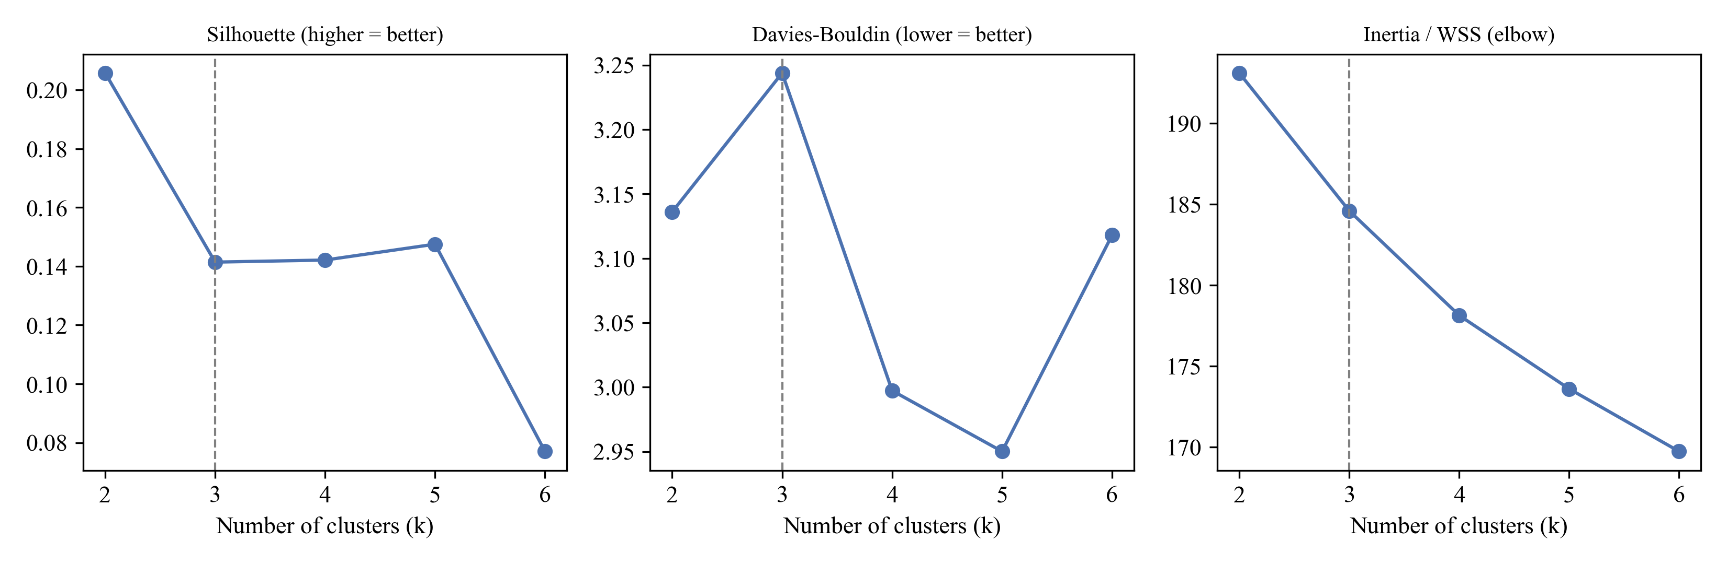
Note. The dashed line marks the pre-specified k = 3.
Figure E2
Silhouette Coefficients by Algorithm
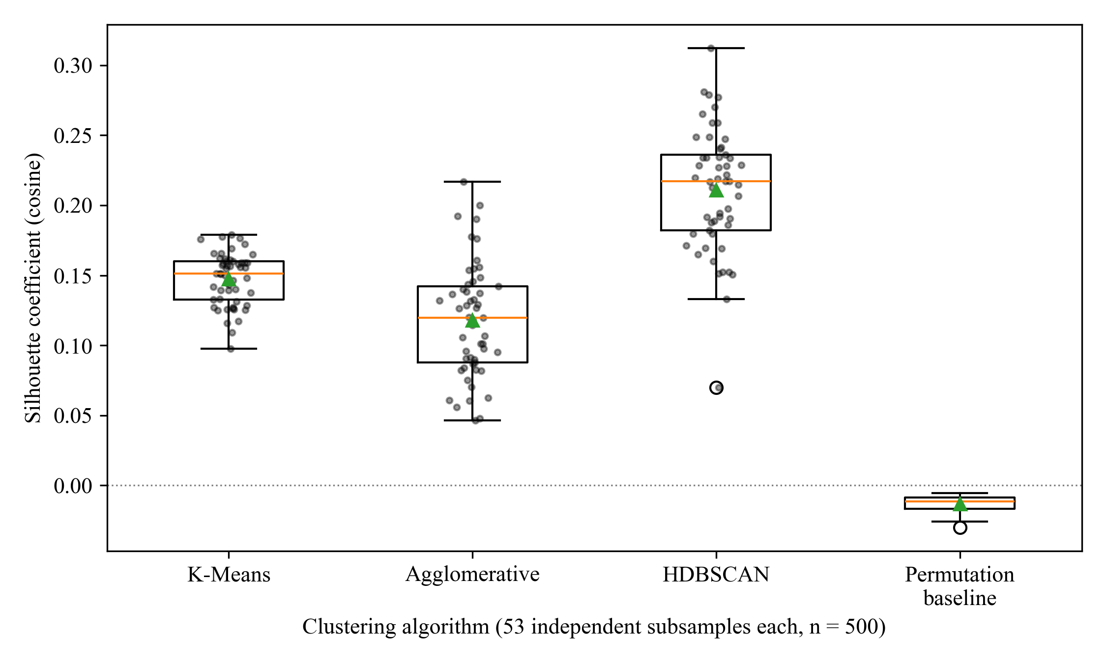
Note. Each point is one subsample run; triangles mark means. The permutation baseline shows the Silhouette expected with no structure.
Table E3
Pairwise Comparisons of Mean Silhouette
Comparison | Mean difference | 95% CI (Tukey) | p (Tukey) | p (Games–Howell)
K-Means − Agglomerative | .029 | [.013, .046] | < .001 | < .001
HDBSCAN − Agglomerative | .093 | [.076, .110] | < .001 | < .001
HDBSCAN − K-Means | .063 | [.047, .080] | < .001 | < .001
Note. CI = confidence interval. Games–Howell comparisons do not assume equal variances.
Table E4
Archetype Assignment and Centroid Similarity Across Samples
Sample | N | Centroid similarity M (SD) | Direct Transactional (%) | Constraint Negotiator (%) | Guided Explorer (%)
Frames golden | 933 | .895 (.042) | 25.7 | 24.1 | 50.2
Frames held-out | 401 | .894 (.042) | 29.4 | 20.2 | 50.4
MultiWOZ 2.2 | 1,499 | .805 (.037) | 0.9 | 15.1 | 84.0
Note. Centroid similarity is the cosine between a dialogue vector and its nearest frozen centroid. Centroids were fitted on the golden partition only.
Figure E3
Archetypes in the Frames Embedding Space and Projection of MultiWOZ 2.2
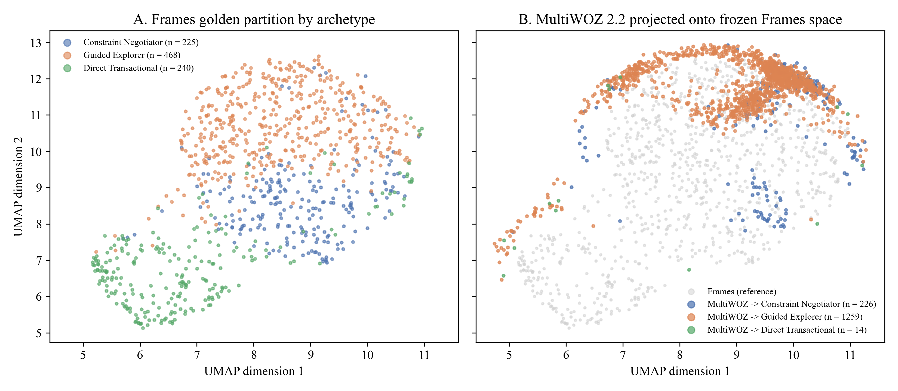
Note. Two-dimensional UMAP projection (McInnes et al., 2018) fitted on the golden partition; MultiWOZ dialogues were transformed into the same projection without refitting.
Figure E4
Hybrid Archetype Diagnostics by Conversation Length and Number of Clusters
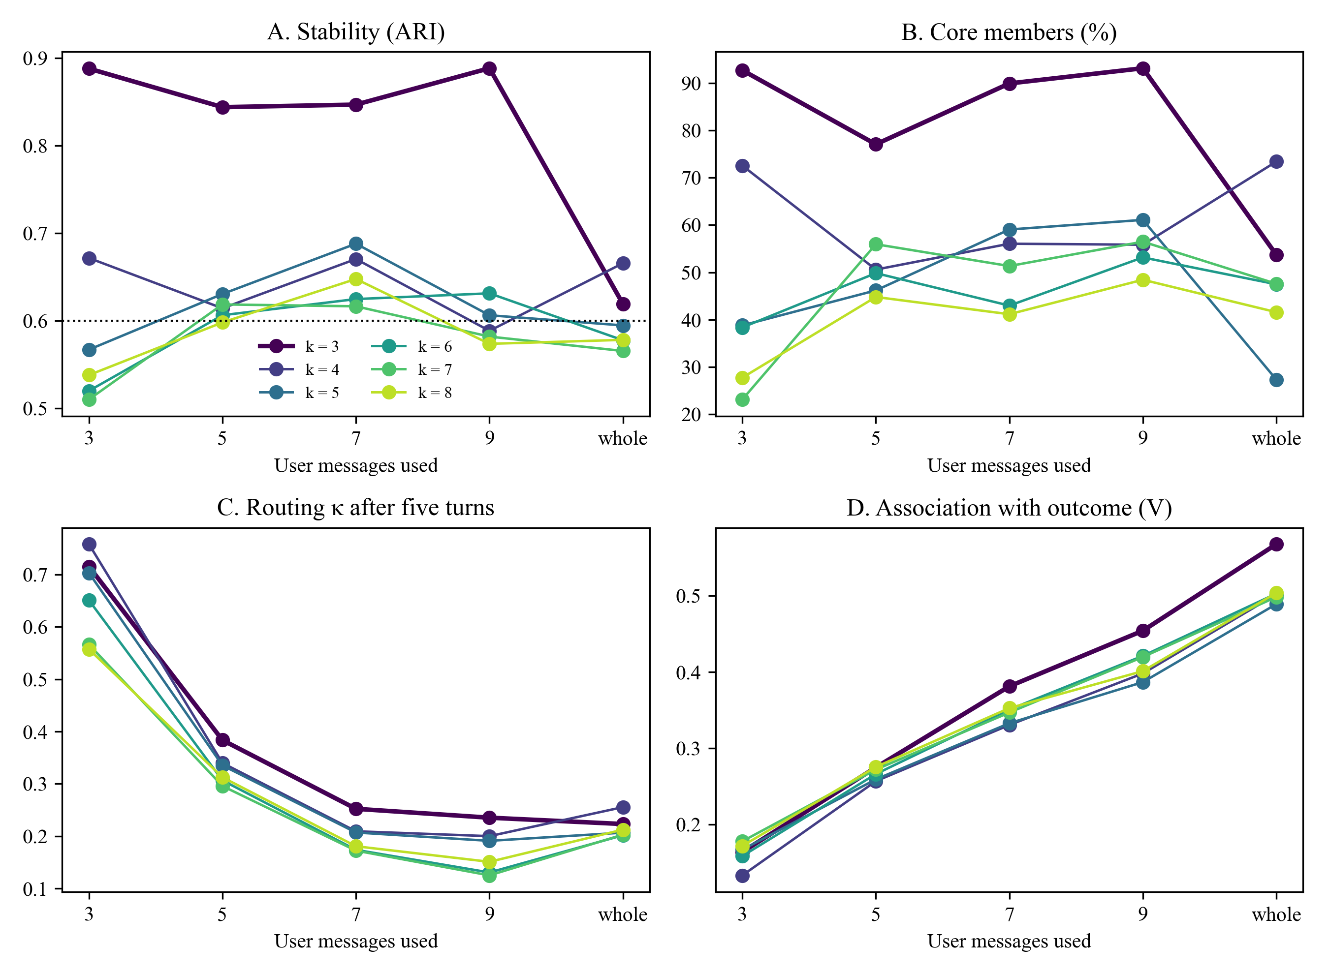
Note. Each line is one number of clusters (k). The dotted line in Panel A marks the stability threshold of .60. Panel C shows routing κ after five turns; Panel D shows Cramér's V between archetype and the rated outcome of the whole conversation.
Table E5
Ablation of the Refined Archetype Definition (Three Clusters)
Representation | Stability ARI (whole) | Stability ARI (9 messages) | Core members (%) | Outcome V | Routing κ | ARI with adopted labels
Gemini embedding + Gemini behavior profile (adopted) | .56 | .87 | 89.2 | .45 | .24 | 1.00
MiniLM embedding + Gemini behavior profile | .69 | .85 | 87.7 | .40 | .21 | .33
Gemini behavior profile only | .73 | .85 | 97.6 | .35 | .26 | .17
Gemini embedding only | .91 | .91 | 92.0 | .34 | .30 | .45
MiniLM embedding only | .68 | .72 | 72.1 | .27 | .32 | .14
MiniLM embedding + dialogue-act features | .61 | .76 | 88.0 | .45 | .25 | .16
Note. Core members, outcome V, routing κ, and agreement with the adopted labels refer to the nine-message version. Behavior profile = LLM ratings with goal and tone indicators; dialogue-act features are counted from the Frames annotations without an LLM. Bootstrap stability varies by about .03 between runs, which explains small differences from Table 13. ARI = adjusted Rand index.

RQ2: Pilot and Experimental Details
Table E6
Pilot Exemplar Relevance by Retrieval Strategy
Strategy | Cosine to prefix M | SD | Exemplars from target archetype (%)
Static few-shot (fixed) | .578 | .057 | 33.3
Global k-NN (unclustered) | .840 | .054 | 36.4
Cluster-adaptive (routed sub-index) | .815 | .060 | 36.4
Note. N = 33 held-out dialogue prefixes; three exemplars per prefix. Relevance is the mean cosine between the prefix and the retrieval keys of the selected exemplars.
Table E7
Holm-Adjusted Paired Contrasts of Exemplar Relevance
Contrast | Mean difference | t | df | p (Holm) | d_{z}
Global k-NN vs. Static | .262 | 22.00 | 32 | < .001 | 3.83
Cluster-adaptive vs. Static | .237 | 18.18 | 32 | < .001 | 3.16
Cluster-adaptive vs. Global k-NN | −.024 | −6.93 | 32 | < .001 | −1.21
Note. Positive differences favor the first-named strategy.
Figure E5
RQ2 Pilot: Exemplar Relevance and Style-Metric Validity
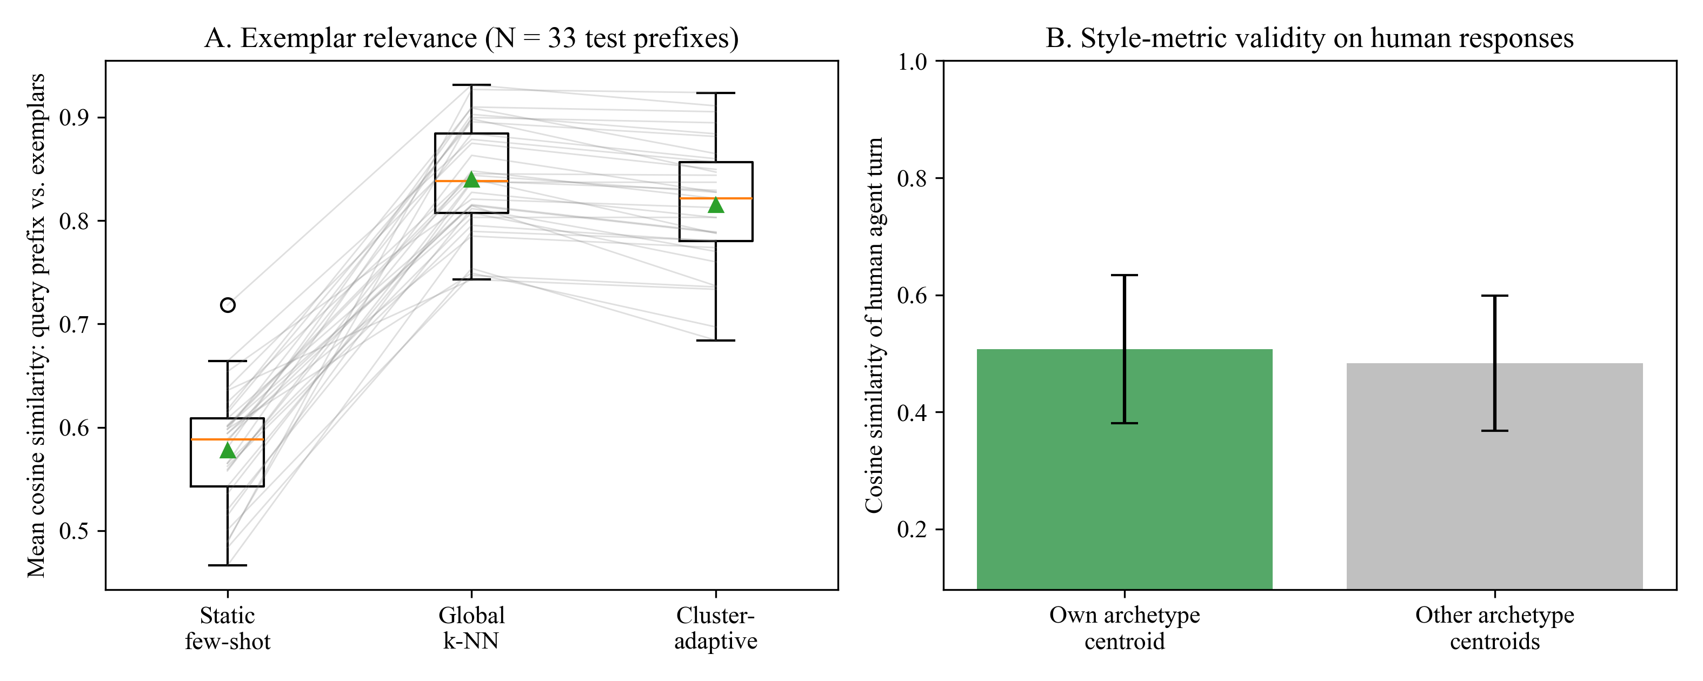
Note. Panel A: lines connect the three strategies for the same prefix. Panel B: cosine similarity of the human agent reply to its own versus the other archetype centroids; error bars show 1 SD. The nearest centroid matched the archetype for 48.5% of replies.
Table E8
Holm-Adjusted Paired Contrasts for the RQ2 Outcomes
Outcome | Contrast | Mean difference | t | df | p (Holm) | d_{z}
Style convergence | Cluster-Adaptive vs. Zero-shot | −.033 | −1.23 | 32 | .678 | −0.21
Style convergence | Static vs. Zero-shot | −.028 | −1.20 | 32 | .678 | −0.21
Style convergence | Cluster-Adaptive vs. Static | −.005 | −0.21 | 32 | .836 | −0.04
Similarity to human reply | Cluster-Adaptive vs. Zero-shot | .016 | 0.59 | 32 | > .999 | 0.10
Similarity to human reply | Static vs. Zero-shot | .008 | 0.26 | 32 | > .999 | 0.05
Similarity to human reply | Cluster-Adaptive vs. Static | .008 | 0.25 | 32 | > .999 | 0.04
Response length | Static vs. Zero-shot | −14.6 | −6.86 | 32 | < .001 | −1.19
Response length | Cluster-Adaptive vs. Zero-shot | −12.9 | −5.83 | 32 | < .001 | −1.02
Response length | Cluster-Adaptive vs. Static | 1.7 | 1.32 | 32 | .196 | 0.23
Note. Positive differences favor the first-named condition.
Figure E6
RQ2 Results: Style Convergence and Response Length by Prompting Condition
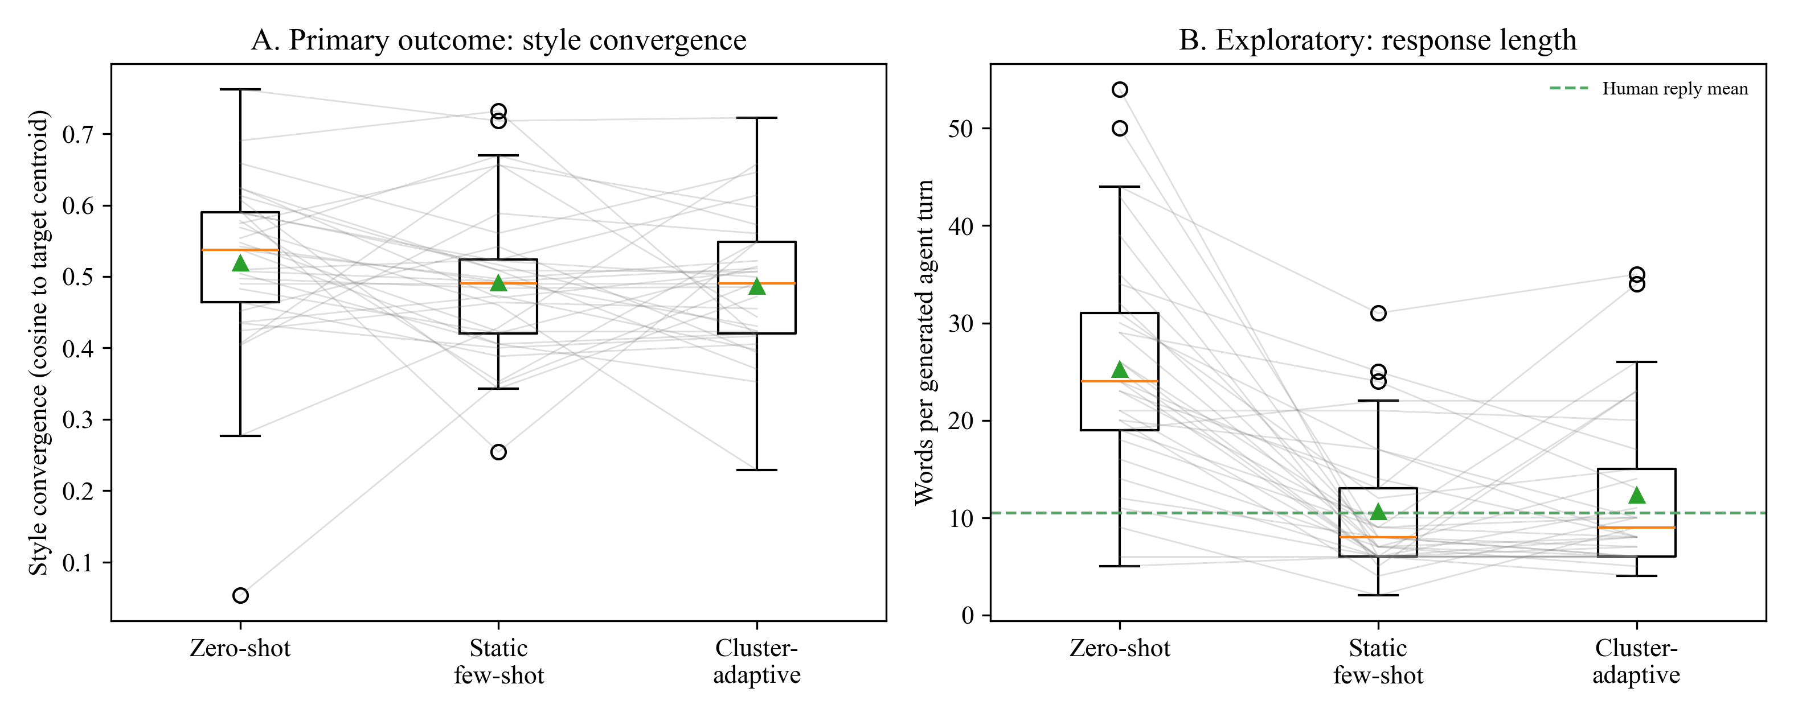
Note. Lines connect the three conditions for the same dialogue; triangles mark means. The dashed line in Panel B is the mean length of the human agent replies.

RQ3 and RQ4: Groundwork Details
Table E9
Corpus Audit of Rule Coverage in Frames
Rule | Required slot | Slot observed (%) | Dialogues triggering (n) | Triggering (%)
pax capacity | traveler count adults | 24.1 | 54 | 4.05
budget minimum | budget amount | 65.1 | 266 | 19.94
visa window | visa processing window days | 0.0 | 0 | 0.00
passport validity | passport expiry months | 0.0 | 0 | 0.00
discount threshold | discount applied percentage | 0.0 | 0 | 0.00
Note. N = 1,334 Frames dialogues. Only numeric values stated by the user were counted, so the adult and budget percentages are lower than the any-mention rates in Table E1.
Figure E7
Human Baseline of Turn Economy and Redundant Elicitation by Refined Archetype
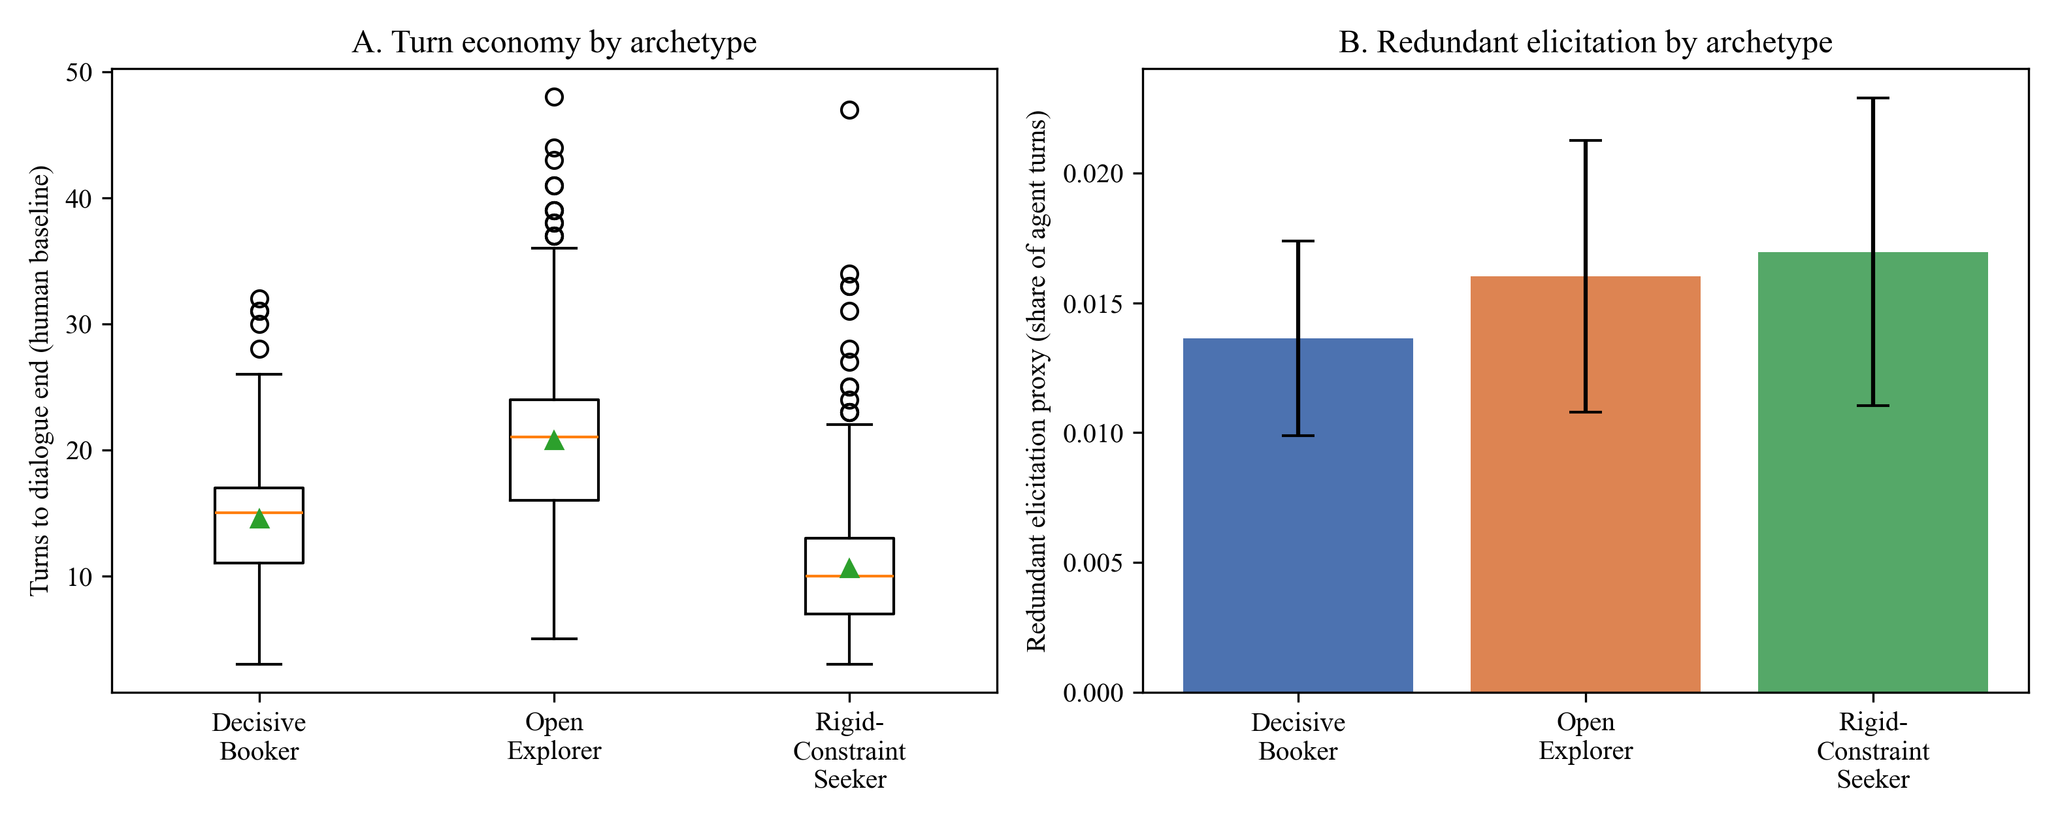
Note. Panel A: triangles mark means. Panel B: error bars show 95% confidence intervals.

