Introduction
For Human health blood glucose plays a vital role as it is related with cardiovascular disease, diabetes and other serious complications. Monitoring blood glucose is a must to keep our heart as well as us healthy.
Our focus in this study was to predict the future blood glucose levels using given nonlinear regression models that capture relationships between the given variables and blood glucose level output.
Dataset Description
The dataset consists of more than 2100 observations, each capturing blood glucose levels. The data reflects physiological or experimental measurements like blood glucose mean, insulin intake, carbohydrate intake, average heart rate, total steps, calories burned, making it suitable for building predictiive models.
The dataset has six input variables and one output variable:
X1:bg_mean - Average of all available past glucose readings
X2:insulin_sum – total insulin dose received
X3:carbs_sum-total carbohydrate intake over time window
X4:hr_mean-average heart rate over past few hours
X5:steps_sum-total steps taken during time period
X6:cals_sum- total calories burned over the time
Y:bg+1:00 – blood glucose reading in mmol/L one hour into the future

Task 1: Preliminary Data Analysis
Task 1.1: Data Preparation
The data was uploaded into the system and primary works like data cleaning, data exploration, handling missing values were performed to make it suitable for modeling.
To support further time series analysis, a new ’time’ column was added as the last column.
Task 1.2: Time Series Analysis
Time series plots were created for each variable by placing time series values along x-axis and their corresponding readings along y-axis.
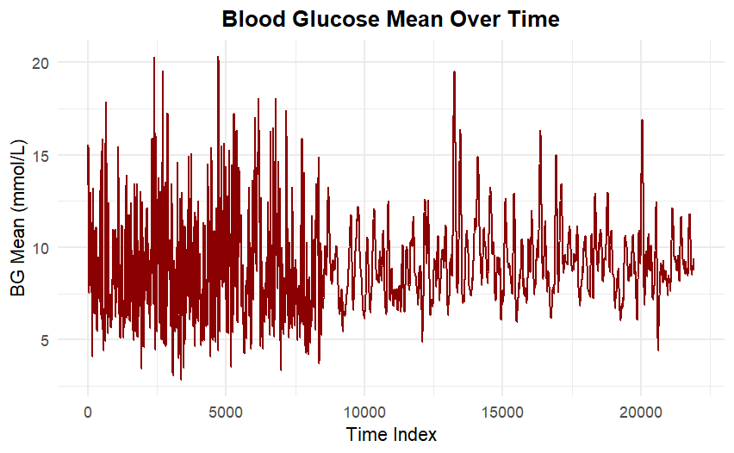

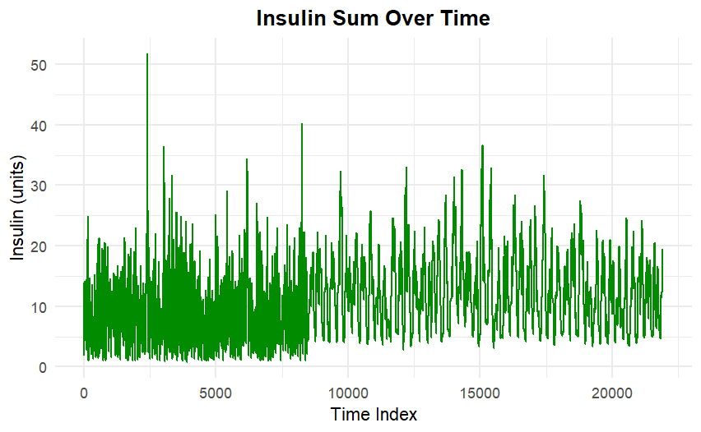

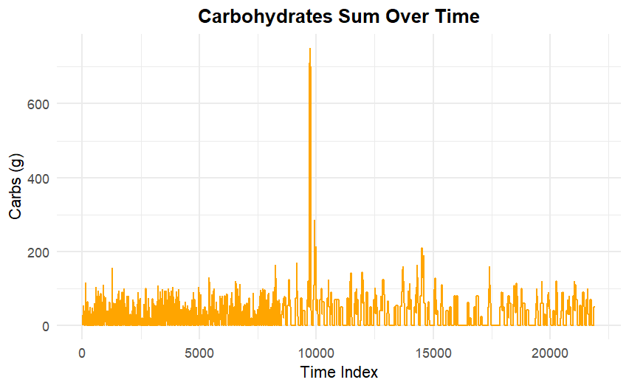

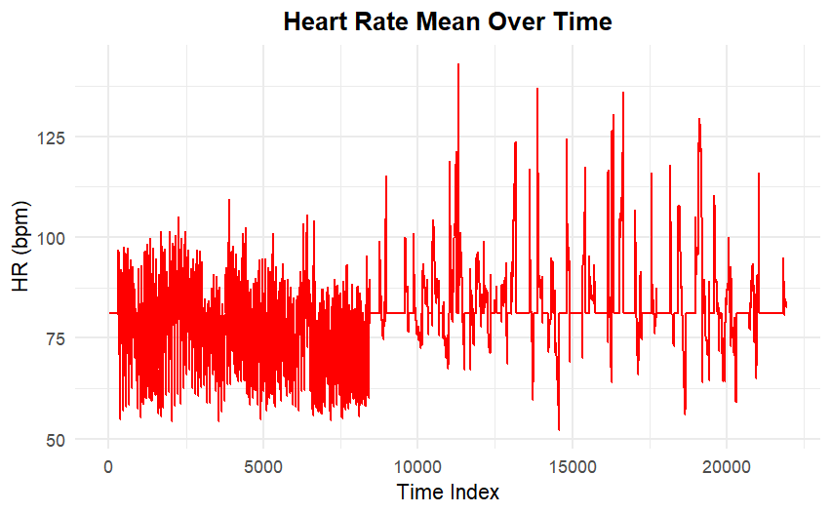

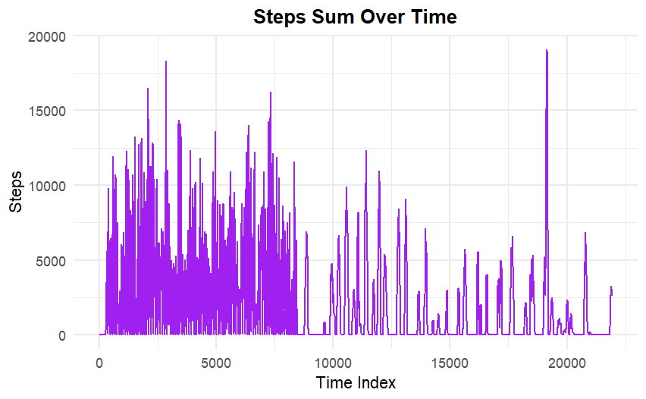

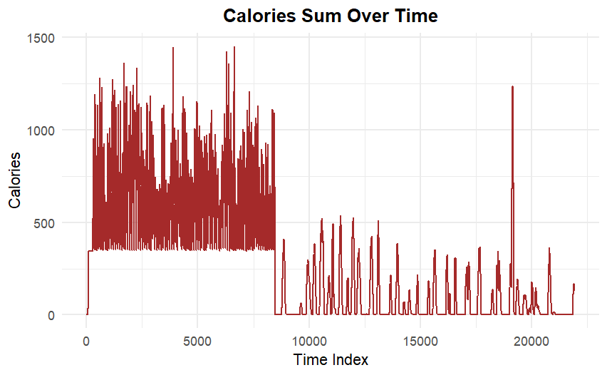

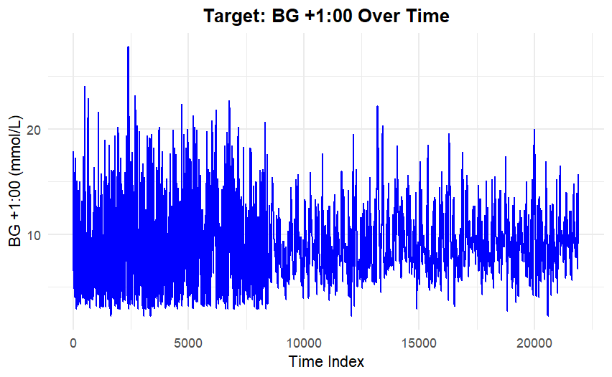

Fig 1: Time series plots of all input variables and one output variable
The time series plot highlights how each input variable varies over time. It shows during initial phase large fluctuations with frequent sharp spikes and drops. As time progresses fluctuations appear to be reduced slightly. Overall the plot is dominated by irregular fluctuations which suggests blood glucose levels are strongly influenced by physiological and behavioral factors rather than long-term temporal trends.

