**Serial No.:008 (ESTD-1929) Mobile:- +91 7278955534**

**+91 9432249475**

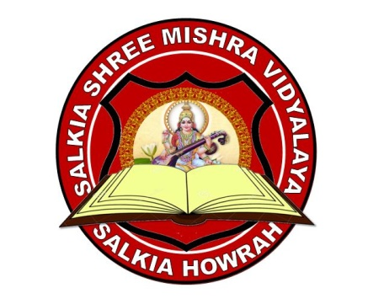

**(Co-Education High School)**

**(Recognized By W.B.B.S.E & Aided by Govt. of West Bengal)**

**(Under the auspices of Shree Mishra Education Welfare Society)**

**15, Govind Banerjee Lane, Salkia Howrah-711106**

**E-mail:-rajesh180873@gmail.com**

**School Index No: F1-112**

**CHARACTER CUM SCHOOL LEAVING CERTIFICATE**

**This is to Certify that Anirban Dutta Son/Daughter of Sri/Smt. Sagar Dutta has been a Compart Student of this school. She/He has Passed the Madhyamik Examination 2019 from West Bengal Board Of Secondary Education bearing Roll 1254A Number 12 with grade A So far as I know, he/she bears a good moral character. I wish him/her all success in life.**

**Medium of Instruction and medium of examination is Hindi/English**

**”With Thanks”**

**Issued on**.:**12/02/2020**

**Rajesh Kumar Mishra**

**Head of Institution**