DETAILED PROJECT REPORT
for setting up a
CUSTOM HIRING CENTRE (CHC) OF FARM MACHINERY
Credit Linked Subsidy Scheme for Rural Entrepreneurs – individual applicant, TFO Rs 29.57 lakh
under the FARM MECHANIZATION SCHEME 2026-27
Department of Agriculture, Government of West Bengal

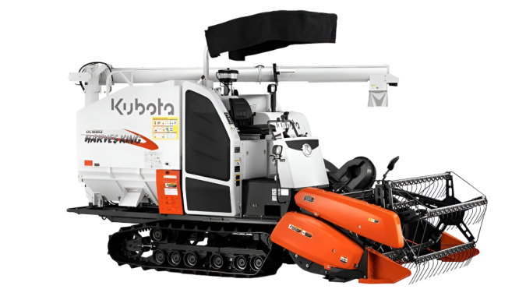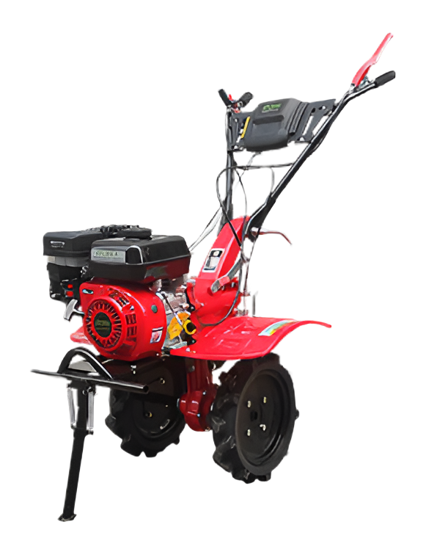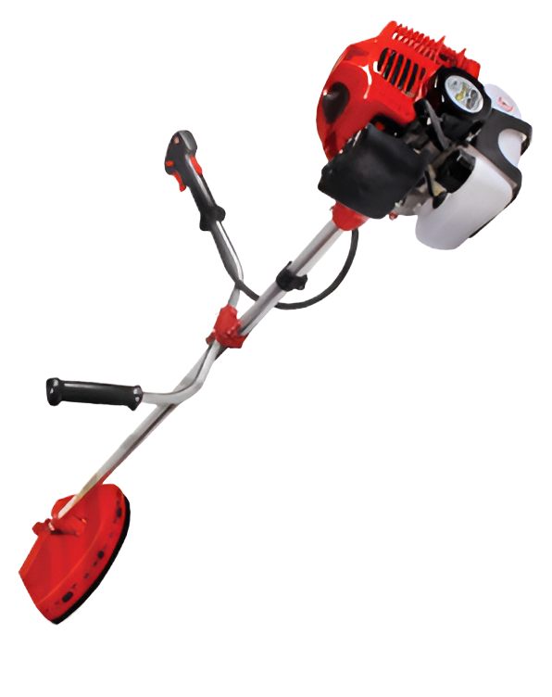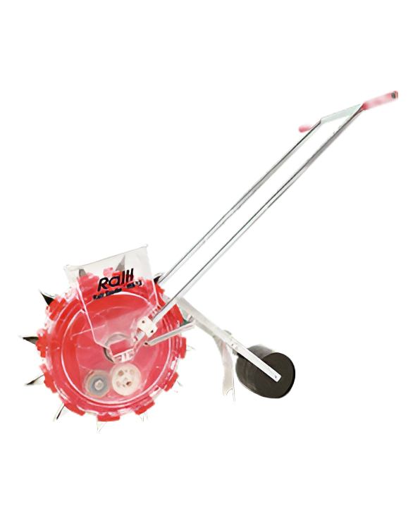

SUBMITTED BY
RAMPRASAD BISWAS
Individual applicant – farmer, Scheduled Caste (SC)
S/o Sudhir Biswas | Age: 60 years | Male
Vill. & P.O. Dakshin Durgapur, G.P. Deulbari Debipur, Block & P.S. Kultali, Dist. South 24 Parganas, PIN 743349
Mobile: 8116680624 | e-mail: surojit3136@gmail.com
Project site: own bastu land – Mouza Dakshin Durgapur, J.L. No. 37, Dag No. 317, G.P. Deulbari Debipur

PART A – MAIN REPORT

2. APPLICANT PROFILE

2.1 Details of the applicant
Particulars | Details
Name of the applicant | Ramprasad Biswas
Father's name | Sudhir Biswas
Applicant category | Individual – farmer (rural entrepreneur)
Age / gender | 60 years / Male
Social category | Scheduled Caste (SC)
Address | Vill. Dakshin Durgapur, P.O. Dakshin Durgapur, G.P. Deulbari Debipur, Block & P.S. Kultali, Dist. South 24 Parganas, West Bengal, PIN 743349
Mobile / e-mail | 8116680624 / surojit3136@gmail.com
Aadhaar No. | XXXX XXXX 7895 (masked)
Voter ID (EPIC) No. | WB/XX/XXX/XXX448 (masked)
PAN | XXXXXX147J (masked)
Bank account | State Bank of India, Kaikhali Branch – A/c No. XXXXXXX5724 (masked), IFSC SBIN0008785
Krishak Bandhu (Natun) / PM-KISAN registration No. | To be furnished – Krishak Bandhu (Natun) registration is required; PM-KISAN if any (Cl. XI(d)(i))
Occupation | Farmer; his wife is also a farmer. Neither of them is or was a Govt./semi-Govt. employee, a civic volunteer or contractual staff

2.2 Eligibility under FMS 2026-27 (CHC – individual applicant, Cl. XI(d) and XI(g))
Condition | Position of the applicant
Rural entrepreneur (farmer) registered under Krishak Bandhu (Natun); PM-KISAN registration if any (Cl. XI(d)(i)) | Farmer of Vill. Dakshin Durgapur, G.P. Deulbari Debipur; Krishak Bandhu (Natun) registration No. to be furnished (Section 2.1)
TFO from Rs 20.00 lakh up to the SMAM maximum; subsidy for an individual Rs 16.00 lakh or 40% of TFO, whichever is less (Cl. XI(d)(i), XI(e)(ii)) | TFO Rs 29.57 lakh; subsidy Rs 11,15,636 – below Rs 11,82,980 (40% of TFO)
Land in possession (own/leased/hired) of "commercial, bastu or viti" category; agricultural land not allowed (Cl. XI(d)(ii)) | Own bastu land, 2 decimal (Mouza Dakshin Durgapur, J.L. No. 37, Khatian No. 682, Dag No. 317)
Applicant aged 18–70 years at the time of application (Cl. XI(d)(iv)) | 60 years
Applicant (and spouse) not an employee or retired employee of Govt./statutory body/Govt. undertaking/Panchayat/municipality/local body/Govt.-aided institution, nor a civic volunteer or contractual staff (Cl. XI(d)(iii); Annexure-V, item iv) | Yes – the applicant and his wife are farmers; neither of them holds or held any Govt. job, nor is a civic volunteer or contractual staff
Applicant and spouse have not availed any benefit under FSSM/OTA-SFI/FMB/FMH/CHC during 2022-23 to 2025-26 (Cl. XI(d)(v)) | Yes – no benefit availed under any of these schemes during 2022-23 to 2025-26
At least four types of machinery/implements from Annexure-IV; at most two tractors (Cl. XI(g)(i), (iv)) | 4 types (one each); no tractor
Reservation: at least 22% of CHC benefits for Scheduled Caste and 7% for Scheduled Tribe applicants (Cl. XI(m)(iii)) | Applicant is Scheduled Caste (SC)

3. PROJECT AT A GLANCE

3.1 Summary of the project
Item | Details
Applicant | Sri Ramprasad Biswas, S/o Sudhir Biswas – individual farmer, 60 years, Scheduled Caste
Scheme / component | Credit Linked Subsidy Scheme for Rural Entrepreneurs to set up Custom Hiring Centres (CHC) of Farm Machinery – Farm Mechanization Scheme 2026-27 (Memo No. 780-AG-11030(11)/1/2024-NAB-SEC dated 05.08.2026); individual applicant; credit-linked back-ended capital subsidy; approval by the DLSC (TFO up to Rs 60 lakh)
Project site | Vill. Dakshin Durgapur, P.O. Dakshin Durgapur, G.P. Deulbari Debipur, Block & P.S. Kultali, Dist. South 24 Parganas, PIN 743349
Land | Mouza Dakshin Durgapur, J.L. No. 37, Khatian No. 682, Dag No. 317, 2 decimal, Bastu; own land of the applicant
Shed | Not ready – a new open machinery shed (mandatory, Cl. XI(e)(i)) will be built at the project site; latest estimate Rs 1,10,035, included in TFO
Machinery (4 types) | Combine harvester (self-propelled, track type), power weeder, brush cutter, hand seeding machine – one each
Total Financial Outlay (TFO) | Rs 29,57,450 (Rs 29.57 lakh) = machinery Rs 27,89,515 + shed Rs 1,10,035 + AMC Rs 41,900 + insurance (first year) Rs 16,000
Admissible Govt. subsidy (back-ended) | Rs 11,15,636 = 37.72% of TFO (40% of the cost of each machine, the shed, the AMC and the insurance, subject to the machine-wise ceilings of Annexure-IV; the combine harvester is held to its ceiling of Rs 10,00,000) – within the individual limit of Rs 16.00 lakh or 40% of TFO, whichever is less (Cl. XI(e)(ii)); released in two halves to the Subsidy Reserve Fund (Cl. XI(k))
Applicant's margin money | Rs 7,39,362 (25% of TFO – the minimum under Cl. XI(e)(v)), deposited with the bank before the subsidy is released
Bank term loan | Rs 11,02,452 with interest (the bank loan in the application) – repaid by the applicant; the bank also lends Rs 11,15,636 without interest against the subsidy (kept in the Subsidy Reserve Fund), so the total loan sanctioned is Rs 22,18,088 = TFO less margin (Annexure-IX; Section 9.3)
Financing bank | State Bank of India, Kaikhali Branch (IFSC SBIN0008785) – a commercial bank (Cl. XI(b)); interest assumed at 9% p.a. (the AIF lending-rate cap), 6% p.a. net after the 3% AIF interest subvention
AIF convergence | Yes – AIF benefit to be availed on the loan with interest: 3% p.a. interest subvention (Section 9.4)
Service area / crop | Deulbari Debipur G.P. first, then the other G.P.s of Kultali block listed in Section 6.1 – main crop paddy (Aman and Boro)
Implementation | CHC to be set up within 3 months of sanction or by 31 March 2027, whichever is earlier (Cl. XI(k)(xiii)); first full year of operation 2027-28 (Year I)
Area and bookings | About 158 ha in Year I rising to about 211 ha a year from Year IV; about 634 to 845 hire bookings a year
Employment | Combine operator and helper (seasonal, about 52 to 69 paid days each a year); the applicant runs the CHC himself

4. PROJECT OBJECTIVE & LOCAL NEED

4.1 Background and local need
Farm mechanization raises production and productivity, makes farm operations timely and reduces the cost of cultivation. In Kultali block of South 24 Parganas, in the Sundarbans area, paddy is the main crop and most farmers are small and marginal. They cannot buy costly machines such as a combine harvester, and at harvest time labour is scarce and expensive. As a result, harvesting is delayed and the crop is exposed to rain, cyclones and shattering losses.
To address this, Sri Ramprasad Biswas, a farmer of Vill. Dakshin Durgapur, proposes to establish a Custom Hiring Centre (CHC) of farm machinery on his own bastu land in the village, to hire out machines to local farmers at reasonable charges with preference to small and marginal farmers, as intended under Cl. XI(c) of the FMS 2026-27 guideline.
Paddy is grown in two seasons – Aman (kharif) and Boro (summer) – so the combine harvester has two harvest windows a year; pulses, oilseeds and vegetables give work for the small implements (Section 7.2).

4.2 Objectives of the project
Primary objectives
- To give a combine harvester and small farm implements on hire to farmers at village level, with priority to small and marginal farmers.
- To complete paddy harvesting on time and reduce crop losses.
- To reduce the cost of harvesting and the dependence on scarce labour.
- To create regular self-employment and income for the applicant, and seasonal jobs for local youth as operator and helper.
- To increase farm-power availability in Kultali block.
Secondary objectives
- To spread awareness among farmers about modern farm machinery.
- To help farmers get information on Government schemes for agriculture.

5. PROJECT SITE, LAND & SHED DETAILS

5.1 Project site and land
Particulars | Details
Location of the CHC | Vill. Dakshin Durgapur, P.O. Dakshin Durgapur, G.P. Deulbari Debipur, Block & P.S. Kultali, Dist. South 24 Parganas, PIN 743349
Mouza / J.L. No. | Dakshin Durgapur / 37
Khatian No. | 682
Plot (Dag) No. | 317
Area | 2 decimal
Classification of land | Bastu – eligible category under Cl. XI(d)(ii)
Possession | Own land of the applicant
Approach road | 8 ft wide

5.2 Machinery shed
Particulars | Details
Status | Not ready – a new shed will be constructed at the project site
Ownership / location | Own open shed – mandatory for a CHC (Cl. XI(e)(i)) – to be built by the applicant on his own project land
Type and size | Length: 30 ft Width: 20 ft Height: 12 ft - Covered area: 600 sq. ft.
Cost included in TFO | Rs 1,10,035 (latest estimate) = 3.72% of TFO – within the 5% limit for shed cost (Rs 1,47,873) and the 10% limit for ancillary cost (Cl. XI(e)(iv)); vetted plan and estimate enclosed (Cl. XI(f), item 10)
Subsidy on the shed | Rs 44,014 (40% of cost)
Construction | To be built and completed before the machinery is delivered and jointly inspected

The project site is the applicant's own bastu land in his home village, Dakshin Durgapur (G.P. Deulbari Debipur).

6. SERVICE AREA, MACHINERY DEMAND & BENEFICIARY FARMERS

6.1 Service area
The CHC is in Deulbari Debipur G.P. of Kultali block (BDO, Kultali). It will serve the farmers of Deulbari Debipur G.P. first, with preference to small and marginal farmers, and then farmers of the other areas listed in the application: Gopalganj, Gurguria Bhubaneswari, Jalaberia-I, Jalaberia-II, Maipith Baikunthapur, Merigunj-I, Merigunj-II and Kundakhali Godabar G.P.s and Kultali Municipality.
Particulars | Details
Primary service area | Deulbari Debipur G.P. – Vill. Dakshin Durgapur (CHC site and the applicant's village), Deulbari Debipur, Katamari, Madhabpur and Shyamnagar
Secondary service area | The other G.P.s and areas of Kultali block listed above, after local demand is met; machines may also go to nearby blocks, but not outside West Bengal (Cl. XI(k)(xv))
Main crop | Paddy – Aman (kharif) and Boro (summer)

6.2 Planned harvesting service (combine harvester)
Year | Capacity utilisation | Working hours | Working days (8 h/day) | Area harvested (ha) at 0.44 ha/hour
I (2027-28) | 60% | 360 | 45 | 158.4
II (2028-29) | 70% | 420 | 53 | 184.8
III (2029-30) | 75% | 450 | 56 | 198.0
IV–VII (2030-31 to 2033-34) | 80% | 480 | 60 | 211.2

Estimated field capacity of the combine harvester: 0.40 to 0.48 ha/hour. Area = hours × 0.44 ha/hour (average); at 0.40–0.48 ha/hour the area is 144–173 ha in Year I and 192–230 ha from Year IV. Bookings = area ÷ 0.25 ha; 75 days = Aman 50 + Boro 25.

6.3 Beneficiary farmers
Particulars | Year I | Year IV onward
Hire bookings – combine harvester (no.) | 634 | 845
Area harvested (ha) | 158 | 211
Farm families served (approx., indicative) | about 330 | about 440
Farmers using the small implements (no.) | about 80 | about 110

6.4 Proposed hire charges (Year I)
Machine | Hire charge | Equivalent
Combine harvester | Rs 3,600 per hour | About Rs 8,180 per ha (about Rs 1,100 per bigha) at 0.44 ha/hour (Rs 7,500–9,000 per ha at 0.48–0.40 ha/hour)
Power weeder | Rs 250 per hour | –
Brush cutter | Rs 150 per hour | –
Hand seeding machine | Rs 100 per day | –

Rates rise 3% a year; actual "reasonable charges" are fixed in consultation with the ADA (Block) and the Asstt. DA (Admn) of the sub-division (Annexure-V, item xiv) and shown on the signboard with contact details (Annexure-V, item xi).

7. PROPOSED MACHINERY & TECHNICAL JUSTIFICATION

7.1 Machinery proposed
Sl | Machine and Annexure-IV category | Make, model and dealer | Specification | Qty | Indicative price / cost (Rs)
1 | Combine Harvester – self-propelled, track type  (Annexure-IV item 19(g): Combine Harvester (Track type) > 6 feet cutter bar width) | Escorts Kubota Ltd.  Kubota DC-68G Harvesking Pro  Dealer: Bengal Agro Machinery Corporation, Purba Bardhaman | Self-propelled paddy combine harvester (track type); estimated field capacity 0.40–0.48 ha/hour | 1 | 26,68,356
2 | Power Weeder  (Annexure-IV item 6(c): Power Weeder, engine operated 5 BHP & below 7.5 BHP) | Ralli Agrotech Ltd.  Ralli RRT-100P  Dealer: Bharat Tractors, Nadia | 5.3 hp, 212 cc, petrol engine driven | 1 | 89,397
3 | Brush Cutter  (Annexure-IV item 46: Brush Cutter (electric/engine powered)) | Ralli Agrotech Ltd.  Ralli BC-52  Dealer: Bharat Tractors, Nadia | 52 cc, single cylinder, 2-stroke petrol engine | 1 | 21,367
4 | Hand Seeding Machine  (Annexure-IV item 35: Hand Seedling Machine) | Ralli Agrotech Ltd.  Ralli RS-12  Dealer: Bharat Tractors, Nadia | Manually operated | 1 | 10,395
 | Total cost of machinery (4 types) |  |  | 4 | 27,89,515
5 | Add: shed (Section 5.2) |  |  | 1 | 1,10,035
6 | Add: AMC – paid upfront to the dealer, 18 months (Section 8.3) |  |  | – | 41,900
7 | Add: insurance of the machinery – first year (Section 8.3) |  |  | – | 16,000
 | Total Financial Outlay (TFO) = machinery + shed + AMC + insurance |  |  |  | 29,57,450

7.2 Technical justification
Machine | Operation covered | Why it is needed and how it is sized
Combine harvester (Kubota DC-68G Harvesking Pro) | Reaping, threshing and cleaning of paddy in one pass (Aman and Boro) | Removes the harvest-labour bottleneck, so mature paddy is less exposed to rain, cyclones and shattering. Track type for soft, wet fields. One unit matches the 75-day window (600 hours at 8 h/day).
Power weeder (Ralli RRT-100P) | Weeding / inter-cultivation and light soil working in small plots | Cuts manual weeding labour and cost; 5.3 hp suits small plots; 150 hours a year at full use. Scope: vegetables and other upland crops in the service area.
Brush cutter (Ralli BC-52) | Cutting weeds and grass on bunds, field boundaries and channels; cutting fodder and crop residue | Low-cost and portable; keeps bunds and channels clean before sowing or transplanting; 150 hours a year at full use.
Hand seeding machine (Ralli RS-12) | Line sowing of seed at uniform spacing and depth | Saves seed and sowing labour over broadcasting; manual, no fuel; 50 days a year at full use. Scope: line sowing of pulses, oilseeds and vegetables in the service area.

Together the four machines cover sowing (hand seeding machine), weeding and light tillage (power weeder), harvesting and threshing (combine harvester) and cutting of weeds, fodder and crop residue (brush cutter) – the end-to-end use of farm machinery sought for a CHC (Cl. XI(c)(i), XI(g)(iv)).

8. OPERATING PLAN & EMPLOYMENT

8.1 Operating calendar (indicative)
Period | Combine harvester | Small implements
April - May | Boro paddy harvest (local and nearby blocks within West Bengal) | Brush cutter for small plots
June - October | Servicing under AMC; standby | Power weeder and hand seeder in kharif vegetables and line-sown crops
November - December | Aman paddy harvest - peak season | Brush cutter for small plots and bunds
January - March | Off-season overhaul under AMC | Power weeder and hand seeder in rabi vegetables

8.2 Staffing and employment
Position | No. | Engagement | Wage (Year I) | Paid days a year | Annual cost, Year I (Rs)
Combine operator (skilled) | 1 | Hired, seasonal | Rs 2,300/day | 52 (Year I) to 69 (Year IV on) | 1,19,600
Helper | 1 | Hired, seasonal | Rs 600/day | 52 (Year I) to 69 (Year IV on) | 31,200
Total paid staff | 2 |  |  |  | 1,50,800

Paid days = working days + 15% for travel and standby, rounded to whole days; wages rise 5% a year. The applicant manages the CHC himself and draws no salary; the small implements are operated by him or by local workers paid only for that work, within their running cost.

8.3 Maintenance and insurance
- Annual Maintenance Contract (AMC) with the dealer: Rs 73,900 for the first 30 months (Rs 29,560 a year in Years I–II and Rs 14,780 for the first 6 months of Year III); renewal at Rs 40,000 a year from month 31 (Rs 20,000 in Year III), rising 5% a year from Year V. Rs 41,900 of the AMC is included in the TFO and paid upfront to the dealer (it covers the Year I charge of Rs 29,560 and Rs 12,340 of Year II); the balance of Rs 32,000 and the renewals are paid from hire income.
- Repairs and spares (one row, apart from the AMC): worked out by the Indian Standard IS 9164:1979 (BIS) from the hours each machine works, so the cost rises as the machines get older. The AMC is part of this maintenance cost, so it is deducted and not counted twice (details under FA-2).
- Insurance of the machinery: Rs 16,000 for one year; renewed every year and taken at Rs 16,000 a year. The first year's premium (Rs 16,000) is included in the TFO and paid upfront; the renewals from Year II are paid from hire income.
- Pre-season servicing before each harvest; the machines are parked under the shed when not in use.

8.4 Display, records and use of the machines
- A permanent signboard at the CHC (name of the CHC and its proprietor, year of financing, subsidy, financing bank and credit received, hire rates and contact details), a metal plate on each machine, a money receipt or cash/credit memo to every user and a hire register (Cl. XI(k)(xvi)–(xviii); Annexure-V, items vii, xi and xiii).
- Machines are hired out to all farmers, small and marginal farmers first; they may go to nearby blocks or districts after local demand is met, but never outside West Bengal (Cl. XI(k)(xv)). The CHC will not be sold, leased or mortgaged within 6 years (Cl. XI(j)(iii), (vii)).

9. PROJECT COST, SUBSIDY & MEANS OF FINANCE

9.1 Total Financial Outlay (TFO)
Component (as in Cl. XI(e)(i)) | Included in TFO (Rs) | Remarks
Indicative cost of machinery (4 types – Section 7) | 27,89,515
Cost of shed (new open machinery shed, to be built – Section 5.2) | 1,10,035 | 3.72% of TFO – within the 5% limit for shed cost (Rs 1,47,873) and the 10% limit for ancillary cost (Cl. XI(e)(iv)); open shed is mandatory (Cl. XI(e)(i)); vetted plan and estimate enclosed (Cl. XI(f), item 10)
AMC | 41,900 | Included; paid upfront to the dealer – part of the AMC of Rs 73,900 for 30 months (covers the Year I charge of Rs 29,560 and Rs 12,340 of Year II); the balance of Rs 32,000 and the renewals are paid from hire income
Insurance | 16,000 | Included; comprehensive insurance of the machinery for the first year (Year I); renewals from Year II (Rs 16,000 a year) are paid from hire income
Total Financial Outlay (TFO) | 29,57,450 | Rs 29.57 lakh – within the CHC range of Rs 20.00 lakh to the SMAM maximum (Cl. XI(e)(ii)); assistance @40% of TFO subject to machine-wise ceilings (Cl. XI(e)(i)); shed + AMC + insurance Rs 1,67,935 = 5.68% of TFO, within the 10% limit for ancillary cost (Cl. XI(e)(iv))

9.2 Admissible subsidy (Annexure-IV)
Sl | Item | Price / cost (Rs) | 40% of cost (Rs) | Ceiling – Annexure-IV (Rs) | Admissible subsidy (Rs)
1 | Combine Harvester | 26,68,356 | 10,67,342 | 10,00,000 | 10,00,000
2 | Power Weeder | 89,397 | 35,758 | 60,000 | 35,758
3 | Brush Cutter | 21,367 | 8,546 | 20,000 | 8,546
4 | Hand Seeding Machine | 10,395 | 4,158 | 10,000 | 4,158
5 | New open machinery shed | 1,10,035 | 44,014 | – | 44,014
6 | AMC (paid upfront) | 41,900 | 16,760 | – | 16,760
7 | Insurance (first year) | 16,000 | 6,400 | – | 6,400
 | Total | 29,57,450 | – | – | 11,15,636

Each machine: 40% of cost or its Annexure-IV ceiling, whichever is less (rounded down to the rupee, as on the portal); the combine harvester is held to its ceiling of Rs 10,00,000. Total Rs 11,15,636 = 37.72% of TFO – within the individual limit of Rs 16.00 lakh or 40% of TFO (Rs 11,82,980), whichever is less, and above the minimum subsidy of Rs 8.00 lakh (Cl. V(3), XI(d)(i), XI(e)(ii)).

9.3 Means of finance
Sl | Source | Amount (Rs) | % of TFO
1 | Applicant's margin money (minimum 25% of TFO, Cl. XI(e)(v)) | 7,39,362 | 25.00%
2 | Total bank term loan sanctioned (TFO less margin, Cl. XIII(3)) – State Bank of India, Kaikhali Branch, under AIF (Section 9.4) | 22,18,088 | 75.00%
 | (a) loan without interest (Annexure-IX, item 7) – backed by the Govt. subsidy kept in the Subsidy Reserve Fund (SRF), locked in for 5 years | 11,15,636 | 37.72%
 | (b) loan with interest (Annexure-IX, item 8) – the bank loan in the application, repaid by the applicant (9% p.a. less 3% AIF subvention = 6% p.a. net) | 11,02,452 | 37.28%
 | Total = TFO | 29,57,450 | 100.00%

The subsidy goes to the Subsidy Reserve Fund in two halves – 50% (Rs 5,57,818) as advance after the loan is sanctioned and the margin money deposited, and 50% (Rs 5,57,818) after joint inspection and geo-tagging of the machines (Cl. XI(k)(vi), (x), (xi)). It stays locked in for 5 years and is adjusted after the loan with interest is repaid; interest is charged only on the loan with interest (Cl. XI(j)(ii), (iv); XIII(3), (5)).

9.4 Convergence with the Agriculture Infrastructure Fund (AIF)
- A Custom Hiring Centre with at least 4 farm machines/implements is an eligible project under AIF, and the FMS feasibility report records AIF convergence (Annexure-XIV, item 10); this CHC has 4 machines, including a combine harvester.
- AIF gives an interest subvention of 3% p.a. on loans up to Rs 2 crore for a maximum of 7 years, and credit-guarantee cover through CGTMSE for eligible borrowers.
- Repayment under AIF can be up to 7 years including a moratorium of up to 2 years; this project follows the FMS rule of one grace year and repayment within 5 years (Cl. XI(j)(ii); XIII(6)(e)) – 10 half-yearly instalments in Years II–VI (FA-4).

10. EXPECTED ANNUAL INCOME, EXPENDITURE & NET RETURN

10.1 Total Financial Outlay and expected annual return (Annexure-VIII, items 16 and 17)
Sl | Item | Amount (Rs) | Basis / where to verify
1 | Total Financial Outlay (TFO) | 29,57,450 | Machinery Rs 27,89,515 + new open shed Rs 1,10,035 + AMC Rs 41,900 + first-year insurance Rs 16,000 (Section 9.1)
2 | (a) Gross annual income (Year I) | 13,35,000 | Hire income in 2027-28 at 60% utilisation: combine Rs 12,96,000 + small implements Rs 39,000 (Section 10.2)
3 | (b) Total expenditure (Year I) | 6,92,224 | Operating costs: fuel and lubricants, operator and helper, shifting, small implements, repairs and spares, AMC, insurance, miscellaneous (Section 10.4); AMC and insurance at full cost, of which Rs 45,560 is already paid from the TFO (Section 10.3)
4 | (c) Net income (Year I) = (a) – (b) | 6,42,776 | Before interest Rs 66,147 (net of the 3% AIF subvention), depreciation Rs 4,29,431 and income tax (nil) (Section 10.3)

10.2 Hire income in Year I (2027-28, 60% utilisation)
Machine | Basis | Income (Rs)
Combine harvester | 360 hours × Rs 3,600 | 12,96,000
Power weeder | 90 hours × Rs 250 | 22,500
Brush cutter | 90 hours × Rs 150 | 13,500
Hand seeding machine | 30 days × Rs 100 | 3,000
Total |  | 13,35,000

10.3 Annual income, expenditure and net return
 | Particulars | Year I (2027-28) | Year IV (2030-31, 80%)
A | Gross hire income | 13,35,000 | 19,45,142
B | Operating expenditure (fuel and lubricants, operator and helper, shifting, small-implement running, repairs and spares, AMC, insurance, miscellaneous) | 6,92,224 | 11,48,359
C | Net operating income (A – B) | 6,42,776 | 7,96,783
D | Interest on bank loan (6% p.a. net, after 3% AIF subvention) | 66,147 | 36,381
E | Depreciation (non-cash) | 4,29,431 | 2,64,989
F | Net profit before tax | 1,47,198 | 4,95,413
G | Income tax (projected – nil after the rebate, FA-3) | 0 | 0
H | Net profit after tax | 1,47,198 | 4,95,413
I | Add: AMC and insurance paid upfront from TFO (included in B; no cash outflow in the year) | 45,560 | 0
J | Cash surplus (H + E + I) | 6,22,189 | 7,60,402
K | Loan principal repaid | 0 (grace year) | 2,20,490
L | Net cash after loan repayment | 6,22,189 | 5,39,912

For the application form (Annexure-VIII): item 13 – area of operation about 158 ha in Year I, rising to about 211 ha a year from Year IV; item 14 – combine harvester, power weeder, brush cutter and hand seeding machine; item 16 – TFO Rs 29,57,450; item 17 (Year I) – (a) gross annual income Rs 13,35,000, (b) total expenditure Rs 6,92,224, (c) net income Rs 6,42,776.

10.4 Operating expenditure, Year I (Rs)
Fuel and lubricants | Operator and helper | Shifting of combine | Small implements running | Repairs and spares | AMC | Insurance | Miscellaneous | Total
3,09,600 | 1,50,800 | 45,424 | 28,545 | 54,295 | 29,560 | 16,000 | 58,000 | 6,92,224

11. SWOT / RISK MANAGEMENT

11.1 SWOT analysis
 | Points
Strengths | 1. The applicant is a farmer of the same village and knows the local farmers and their needs.  2. Paddy is the main crop, so combine harvesting is in demand in both Aman and Boro seasons.  3. The admissible Govt. subsidy (37.72% of TFO) and the 3% AIF interest subvention reduce the debt burden; average DSCR 3.37 (FA-5).  4. Own bastu land at the project site for the CHC and its new shed.
Weaknesses | 1. Depends on a hired operator for the combine harvester.  2. Most of the income comes from one machine (the combine harvester) in two short harvest seasons.
Opportunities | 1. Shortage of farm labour at harvest time.  2. Two paddy seasons (Aman and Boro) give two harvest windows a year.
Threats | 1. Rise in diesel price.  2. Machine breakdown during the harvest season.  3. Operator not available.  4. Rain or cyclone shortening the harvest window.

11.2 Risk management
Risk | Mitigation
Rise in diesel price | Annual review of hire charges with the ADA (Block); fuel-efficient operation and route planning by village cluster.
Breakdown during the harvest season | AMC with the dealer (Rs 73,900 for 30 months – Rs 41,900 of it paid upfront from TFO – then renewal); 1-year warranty and 4-year after-sales service under the guideline (Cl. VIII(B)(i)); pre-season servicing; stock of fast-moving spares.
Operator not available | Written agreement with an experienced operator before each season; a back-up operator trained from local youth.
New to running a CHC | Supplier demonstration and training at delivery; guidance from the ADA; simple records (hire register, log book, money receipts).
Accident, damage or theft | Comprehensive insurance (Rs 16,000 a year; first year paid from TFO); parking under the shed; geo-tracking through the telematics kit (Cl. VIII(B)(w)).

PART B – FINANCIAL ANNEXURE

FA-1 Capacity and hire income (Rs)
Particulars | I  2027-28 | II  2028-29 | III  2029-30 | IV  2030-31 | V  2031-32 | VI  2032-33 | VII  2033-34 | Total
Capacity utilisation | 60% | 70% | 75% | 80% | 80% | 80% | 80% | –
Harvester working hours | 360 | 420 | 450 | 480 | 480 | 480 | 480 | 3,150
Hire charge per hour (Rs) | 3,600 | 3,708 | 3,819 | 3,934 | 4,052 | 4,173 | 4,299 | –
Harvester hire income | 12,96,000 | 15,57,360 | 17,18,550 | 18,88,320 | 19,44,960 | 20,03,040 | 20,63,520 | 1,24,71,750
Small implements hire income | 39,000 | 46,865 | 51,719 | 56,822 | 58,526 | 60,282 | 62,091 | 3,75,305
Total hire income | 13,35,000 | 16,04,225 | 17,70,269 | 19,45,142 | 20,03,486 | 20,63,322 | 21,25,611 | 1,28,47,055

Basis – combine harvester | Details | Small implement | Use at 100% capacity | Hire charge | Income at 100% (Rs)
Number of units | 1 | Power weeder | 150 hours | Rs 250 per hour | 37,500
Hours of operation a day | 8 | Brush cutter | 150 hours | Rs 150 per hour | 22,500
Harvest-season window | 75 days (Aman 50 + Boro 25) | Hand seeding machine | 50 days | Rs 100 per day | 5,000
Working hours at 100% capacity | 600 hours a year | Total |  |  | 65,000

Harvester income = working hours × hire charge per hour. Small-implement income = Rs 65,000 × utilisation × 1.03^(year – 1).

FA-2 Operating expenditure (Rs)
Particulars | I  2027-28 | II  2028-29 | III  2029-30 | IV  2030-31 | V  2031-32 | VI  2032-33 | VII  2033-34 | Total
Fuel and lubricants | 3,09,600 | 3,72,036 | 4,10,568 | 4,51,078 | 4,64,610 | 4,78,548 | 4,92,905 | 29,79,345
Operator and helper wages | 1,50,800 | 1,82,700 | 2,07,821 | 2,31,641 | 2,43,223 | 2,55,384 | 2,68,153 | 15,39,722
Harvester shifting charges | 45,424 | 52,635 | 60,238 | 65,147 | 67,102 | 69,115 | 71,188 | 4,30,849
Small implements running and fuel | 28,545 | 34,617 | 38,557 | 42,758 | 44,458 | 46,229 | 48,075 | 2,83,239
Repairs and spares (as per IS 9164) | 54,295 | 1,34,151 | 1,86,099 | 2,34,593 | 2,65,610 | 2,91,903 | 3,14,876 | 14,81,527
AMC (Rs 73,900 for 30 months, then renewal; Rs 41,900 paid from TFO) | 29,560 | 29,560 | 34,780 | 40,000 | 42,000 | 44,100 | 46,305 | 2,66,305
Insurance (Rs 16,000 a year; Year I paid from TFO) | 16,000 | 16,000 | 16,000 | 16,000 | 16,000 | 16,000 | 16,000 | 1,12,000
Miscellaneous expense (semi-fixed) | 58,000 | 60,900 | 63,945 | 67,142 | 70,499 | 74,024 | 77,726 | 4,72,236
Total operating expenditure | 6,92,224 | 8,82,599 | 10,18,008 | 11,48,359 | 12,13,502 | 12,75,303 | 13,35,228 | 75,65,223

Fuel – combine harvester | Details | Manpower (Year I) | No. | Wage | Paid days | Annual cost (Rs)
Fuel requirement per hour | 8 litres | Combine harvester operator | 1 | Rs 2,300/day | 52 | 1,19,600
Working hours at 100% capacity | 600 hours | Helper | 1 | Rs 600/day | 52 | 31,200
Fuel requirement at 100% capacity | 4,800 litres a year | Total | 2 |  |  | 1,50,800
Fuel cost at 100% capacity (Rs 100/litre) | Rs 4,80,000
Year I fuel (60%) + lubricants 7.5% | Rs 2,88,000 + Rs 21,600 = Rs 3,09,600

FA-3 Depreciation and income tax (Rs)
Book depreciation (WDV) | I  2027-28 | II  2028-29 | III  2029-30 | IV  2030-31 | V  2031-32 | VI  2032-33 | VII  2033-34 | Total
Machinery @ 15% | 4,18,427 | 3,55,663 | 3,02,314 | 2,56,967 | 2,18,422 | 1,85,658 | 1,57,810 | 18,95,261
Shed @ 10% | 11,004 | 9,903 | 8,913 | 8,022 | 7,219 | 6,497 | 5,848 | 57,406
Total depreciation for the year | 4,29,431 | 3,65,566 | 3,11,227 | 2,64,989 | 2,25,641 | 1,92,155 | 1,63,658 | 19,52,667
Closing value – machinery | 23,71,088 | 20,15,425 | 17,13,111 | 14,56,144 | 12,37,722 | 10,52,064 | 8,94,254 | –
Closing value – shed | 99,031 | 89,128 | 80,215 | 72,193 | 64,974 | 58,477 | 52,629 | –
Closing value – total | 24,70,119 | 21,04,553 | 17,93,326 | 15,28,337 | 13,02,696 | 11,10,541 | 9,46,883 | –

Income tax computation | I  2027-28 | II  2028-29 | III  2029-30 | IV  2030-31 | V  2031-32 | VI  2032-33 | VII  2033-34 | Total
Net profit before tax | 1,47,198 | 2,93,220 | 3,91,424 | 4,95,413 | 5,41,191 | 5,85,942 | 6,26,725 | 30,81,113
Add: depreciation as per books | 4,29,431 | 3,65,566 | 3,11,227 | 2,64,989 | 2,25,641 | 1,92,155 | 1,63,658 | 19,52,667
Add: AMC and insurance paid from TFO – 40% met by subsidy, not allowed for tax | 18,224 | 4,936 | 0 | 0 | 0 | 0 | 0 | 23,160
Less: tax depreciation – machinery (15% WDV on Rs 17,41,053) | 2,61,158 | 2,21,984 | 1,88,687 | 1,60,384 | 1,36,326 | 1,15,877 | 98,496 | 11,82,912
Less: tax depreciation – shed (10% WDV on Rs 66,021) | 6,602 | 5,942 | 5,348 | 4,813 | 4,332 | 3,898 | 3,509 | 34,444
Taxable profit (total income) | 3,27,093 | 4,35,796 | 5,08,616 | 5,95,205 | 6,26,174 | 6,58,322 | 6,88,378 | 38,39,584
Tax at new-regime slab rates (s. 202) | 0 | 1,790 | 5,431 | 9,760 | 11,309 | 12,916 | 14,419 | 55,625
Less: rebate u/s 156 (up to Rs 12 lakh) | 0 | 1,790 | 5,431 | 9,760 | 11,309 | 12,916 | 14,419 | 55,625
Income tax payable (incl. 4% cess) | 0 | 0 | 0 | 0 | 0 | 0 | 0 | 0

Opening value = cost in Year I, then the previous year-end value. Book depreciation is on the full cost of the machinery and the shed; the subsidy is shown as a capital grant in the balance sheet. For tax, depreciation is on cost net of subsidy, and the AMC and insurance paid from the TFO are allowed only for the 60% not met by the subsidy. Hire income of the CHC is business income, not agricultural income. For projection, the applicant is taken as a resident individual under the new tax regime (s. 202, Income-tax Act, 2025: nil up to Rs 4 lakh, 5% on Rs 4–8 lakh, 10% on Rs 8–12 lakh) with no other taxable income; as his total income stays below Rs 12 lakh in every year, the rebate under s. 156 (up to Rs 60,000) makes the tax nil. The actual tax will depend on his total income and the Income-tax law in force.
FA-4 Repayment of the loan with interest, with AIF interest subvention (Rs)
Year | Opening balance | Interest @ 9% | Less: AIF subvention @ 3% | Net interest @ 6% (paid by the applicant) | Principal | Closing balance
I (2027-28) | 11,02,452 | 99,221 | 33,074 | 66,147 | 0 (grace) | 11,02,452
II (2028-29) | 11,02,452 | 94,260 | 31,420 | 62,840 | 2,20,490 | 8,81,962
III (2029-30) | 8,81,962 | 74,416 | 24,806 | 49,610 | 2,20,490 | 6,61,472
IV (2030-31) | 6,61,472 | 54,571 | 18,190 | 36,381 | 2,20,490 | 4,40,982
V (2031-32) | 4,40,982 | 34,727 | 11,575 | 23,152 | 2,20,490 | 2,20,492
VI (2032-33) | 2,20,492 | 14,883 | 4,961 | 9,922 | 2,20,492 | 0
Total |  | 3,72,078 | 1,24,026 | 2,48,052 | 11,02,452
Interest assumed at 9% p.a. (the AIF lending-rate cap; the actual rate is set by the bank, Cl. XIII(6)(c)) on the reducing balance. The loan with interest (Rs 11,02,452) is repaid in 10 half-yearly instalments in Years II–VI (Rs 1,10,245 each, the last Rs 1,10,247) – one grace year, then repayment over 5 years and not earlier (Cl. XI(j)(ii), (vi); Annexure-V, item x). The 3% AIF subvention is claimed by the bank and passed on to the applicant, so he bears 6% p.a. – the figure used in Section 10.3 and FA-3. No interest is charged on the loan without interest (Rs 11,15,636), which is adjusted from the Subsidy Reserve Fund after the loan with interest is repaid (Cl. XIII(3), (5)).
FA-5 Debt service coverage ratio (DSCR) (Rs)
Debt service coverage | I  2027-28 | II  2028-29 | III  2029-30 | IV  2030-31 | V  2031-32 | VI  2032-33 | Total (I–VI)
Net profit after tax | 1,47,198 | 2,93,220 | 3,91,424 | 4,95,413 | 5,41,191 | 5,85,942 | 24,54,388
Add: depreciation (non-cash) | 4,29,431 | 3,65,566 | 3,11,227 | 2,64,989 | 2,25,641 | 1,92,155 | 17,89,009
Add: net interest on the bank loan | 66,147 | 62,840 | 49,610 | 36,381 | 23,152 | 9,922 | 2,48,052
Add: AMC and insurance paid from TFO (non-cash) | 45,560 | 12,340 | 0 | 0 | 0 | 0 | 57,900
(A) Cash available for debt service | 6,88,336 | 7,33,966 | 7,52,261 | 7,96,783 | 7,89,984 | 7,88,019 | 45,49,349
Net interest (6% p.a.) | 66,147 | 62,840 | 49,610 | 36,381 | 23,152 | 9,922 | 2,48,052
Principal repaid | 0 | 2,20,490 | 2,20,490 | 2,20,490 | 2,20,490 | 2,20,492 | 11,02,452
(B) Total debt service | 66,147 | 2,83,330 | 2,70,100 | 2,56,871 | 2,43,642 | 2,30,414 | 13,50,504
DSCR = (A) ÷ (B) | 10.41 | 2.59 | 2.79 | 3.10 | 3.24 | 3.42 | 3.37 (average)
DSCR = cash available for debt service (A) ÷ net interest and principal (B). Year I is the grace year (interest only). Average DSCR for Years I–VI = 3.37 (Years II–VI: 3.01) – comfortably above the 1.25–1.50 range that banks usually require; credit merit is a selection criterion for CHC (Cl. XI(i)(iv)).

