DETAILED PROJECT REPORT
for setting up a
CUSTOM HIRING CENTRE (CHC) OF FARM MACHINERY
Credit Linked Subsidy Scheme for Rural Entrepreneurs – individual applicant, TFO Rs 29.57 lakh
under the FARM MECHANIZATION SCHEME 2026-27
Department of Agriculture, Government of West Bengal

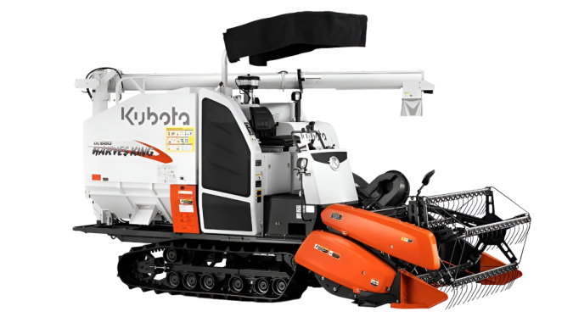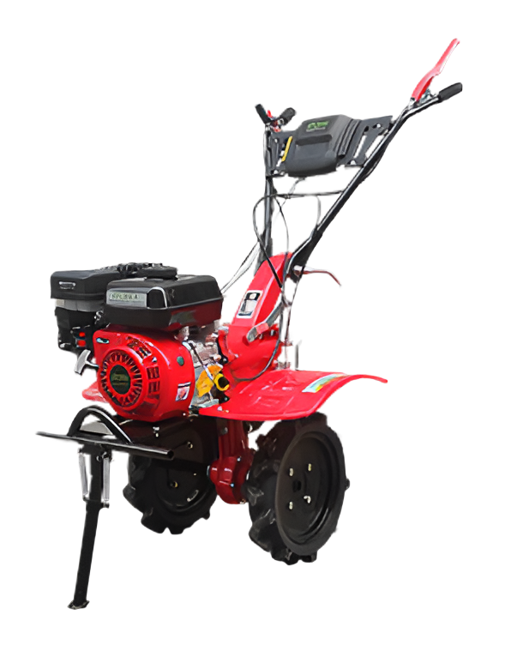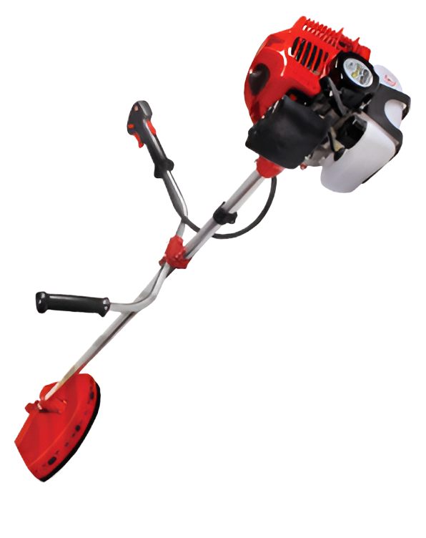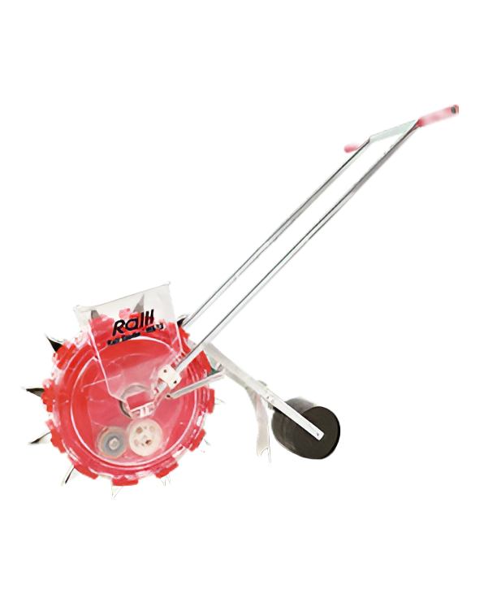

SUBMITTED BY
RAMPRASAD BISWAS
Individual applicant – farmer, Scheduled Caste (SC)
S/o Sudhir Biswas | Age: 63 years | Male
Vill. & P.O. Dakshin Durgapur, G.P. Deulbari Debipur, Block & P.S. Kultali, Dist. South 24 Parganas, PIN 743349
Mobile: 8116680624 | e-mail: surojit3136@gmail.com
Project site: own bastu land – Mouza Dakshin Durgapur, J.L. No. 37, Dag No. 317, G.P. Deulbari Debipur

2. APPLICANT PROFILE

2.1 Details of the applicant
Particulars | Details
Name of the applicant | Ramprasad Biswas
Father's name | Sudhir Biswas
Applicant category | Individual farmer (rural entrepreneur)
Age / gender | 63 years / Male
Social category | Scheduled Caste (SC)
Address | Vill. & P.O. Dakshin Durgapur, G.P. Deulbari Debipur, Block & P.S. Kultali, Dist. South 24 Parganas, West Bengal, PIN 743349
Mobile / e-mail | 8116680624 / surojit3136@gmail.com
Aadhaar No. | XXXX XXXX 7895 (masked)
Voter ID (EPIC) No. | WB/XX/XXX/XXX448 (masked)
PAN | XXXXXX147J (masked)
Bank account | State Bank of India, Kaikhali Branch – A/c No. XXXXXXX5724 (masked), IFSC SBIN0008785
Krishak Bandhu (Natun) | XXXXXXXX2348 (masked)
Occupation | Farmer

2.2 Eligibility (FMS 2026-27, Cl. XI)
Condition | Position of the applicant
Farmer registered under Krishak Bandhu (Natun) (Cl. XI(d)(i)) | Yes – Krishak Bandhu (Natun) ID XXXXXXXX2348 (masked)
TFO at least Rs 20 lakh; subsidy up to Rs 16 lakh or 40% of TFO, whichever is less (Cl. XI(e)(ii)) | TFO Rs 29,57,450; subsidy Rs 11,15,636 (limit Rs 11,82,980)
Land of commercial, bastu or viti class – own, leased or hired; not agricultural land (Cl. XI(d)(ii)) | Yes – own bastu land, 2 decimal
Age 18–70 years (Cl. XI(d)(iv)) | Yes – 63 years
Applicant and spouse are not serving or retired employees of any Govt. body, civic volunteers or contractual staff (Cl. XI(d)(iii)) | Yes – both are farmers
No benefit under FSSM, OTA-SFI, FMB/FMH or CHC in 2022-23 to 2025-26 – applicant and spouse (Cl. XI(d)(v)) | Yes – no benefit taken
At least 4 types of machines from Annexure-IV; at most 2 tractors (Cl. XI(g)) | Yes – 4 types; no tractor
At least 22% of CHC benefits go to SC and 7% to ST applicants (Cl. XI(m)(iii)) | Applicant is SC

3. PROJECT AT A GLANCE

3.1 Summary of the project
Item | Details
Applicant | Sri Ramprasad Biswas, S/o Sudhir Biswas – farmer, 63 years, Scheduled Caste
Constitution | Proprietorship (individual)
Experience in business | New venture – his first CHC; a farmer by occupation
Scheme / component | Credit Linked Subsidy Scheme for Rural Entrepreneurs to set up CHCs – FMS 2026-27
Project site | Vill. & P.O. Dakshin Durgapur, G.P. Deulbari Debipur, Block Kultali, Dist. South 24 Parganas, PIN 743349
Land | Own bastu land, 2 decimal – Mouza Dakshin Durgapur, J.L. No. 37, Khatian No. 682, Dag No. 317
Shed | New shed to be built – Rs 1,10,035, included in TFO
Machinery (4 types) | Combine harvester (track type), power weeder, brush cutter, hand seeding machine – one each
Service output (hours a year) | Combine: 750 hours a year at full capacity (75 days × 10 hours); 450 in Year I, 600 from Year IV. Power weeder and brush cutter: 150 hours each; seeder: 50 days (FA-1)
Working days | Combine: 75 days a year (Aman 50 + Boro 25), 10 hours a day; small implements in kharif and rabi
Hire charge (combine) | Rs 2,700 an hour in Year I (about Rs 820 a bigha), rising 3% a year; final rate set with the ADA
Total Financial Outlay (TFO) | Rs 29,57,450 = machinery Rs 27,89,515 + shed Rs 1,10,035 + AMC for 18 months Rs 41,900 + insurance for 1 year Rs 16,000
Admissible Govt. subsidy (back-ended) | Rs 11,15,636 (37.72% of TFO) – 40% of each item within the Annexure-IV ceilings (combine capped at Rs 10,00,000)
Applicant's margin money | Rs 7,39,362 (25% of TFO, the minimum)
Bank term loan | Rs 22,18,088 in all: Rs 11,02,452 with interest (repaid by the applicant) + Rs 11,15,636 without interest (covered by the subsidy)
Financing bank | State Bank of India, Kaikhali Branch (IFSC SBIN0008785); interest 9% p.a.
AIF convergence | Yes – 3% p.a. interest subvention (Section 9.4)
Service area / crop | Deulbari Debipur G.P. first, then other G.P.s of Kultali; paddy – Aman and Boro
Area and bookings | About 198 ha (792 bookings) in Year I, rising to 264 ha (1,056 bookings) from Year IV
Employment | Combine operator and helper (seasonal, 52–69 paid days a year of 10 hours); the applicant runs the CHC himself

4. PROJECT OBJECTIVE & LOCAL NEED

4.1 Background and local need
Farm machines make farm work timely, raise yields and cut costs. In Kultali block (Sundarbans area), paddy is the main crop and most farmers are small or marginal. They cannot buy costly machines like a combine harvester, and harvest labour is scarce and costly. So harvesting is delayed and crops are lost to rain, cyclones and shattering.
Sri Ramprasad Biswas, a farmer of Dakshin Durgapur, will set up a Custom Hiring Centre (CHC) on his own bastu land. He will hire out machines at reasonable rates, small and marginal farmers first.
Paddy is grown twice a year (Aman and Boro), so the combine has two harvest seasons. Pulses, oilseeds and vegetables give work to the small implements.
Mechanization through a CHC is needed in the area for:
- timely sowing, weeding and harvesting between two crops;
- higher yields and a lower cost of cultivation;
- less dependence on scarce labour, and less drudgery;
- fewer harvest losses and better quality produce;
- costly machines within reach of small and marginal farmers.

4.2 Objectives of the project
Primary objectives
- To hire out a combine harvester and small implements in the village, small and marginal farmers first.
- To complete paddy harvesting on time and reduce crop losses.
- To reduce the cost of harvesting and the dependence on scarce labour.
- To give the applicant a regular income, and local youth seasonal jobs.
- To increase farm-power availability in Kultali block.
Secondary objectives
- To spread awareness among farmers about modern farm machinery.
- To help farmers get information on Government schemes for agriculture.

5. PROJECT SITE, LAND & SHED DETAILS

5.1 Project site and land
Particulars | Details
Location of the CHC | Vill. & P.O. Dakshin Durgapur, G.P. Deulbari Debipur, Block & P.S. Kultali, Dist. South 24 Parganas, PIN 743349
Mouza / J.L. No. | Dakshin Durgapur / 37
Khatian No. | 682
Plot (Dag) No. | 317
Area | 2 decimal
Classification of land | Bastu
Possession | Own land of the applicant
Approach road | 8 ft wide

5.2 Machinery shed
Particulars | Details
Status | Not ready – a new shed will be built
Ownership / location | Own shed on his own land
Type and size | 30 ft long × 20 ft wide × 12 ft high; covered area 600 sq. ft.
Cost included in TFO | Rs 1,10,035 = 3.72% of TFO (limit 5% – Cl. XI(e)(iv));
Subsidy on the shed | Rs 44,014 (40% of cost)

The site is the applicant's own land in his home village.

6. SERVICE AREA, MACHINERY DEMAND & BENEFICIARY FARMERS

6.1 Service area
The CHC is in Deulbari Debipur G.P., Kultali block. It will serve this G.P. first, with small and marginal farmers first. It will then serve Gopalganj, Gurguria Bhubaneswari, Jalaberia-I, Jalaberia-II, Maipith Baikunthapur, Merigunj-I, Merigunj-II and Kundakhali Godabar G.P.s and Kultali Municipality.
Particulars | Details
Primary service area | Dakshin Durgapur (CHC site), Deulbari Debipur, Katamari, Madhabpur and Shyamnagar (Deulbari Debipur G.P.)
Secondary service area | The other areas above, after local demand is met
Main crop | Paddy – Aman (kharif) and Boro (summer)

6.2 Planned harvesting service (combine harvester)
Year | Capacity utilisation | Working hours | Working days (10 h/day) | Area harvested (ha) at 0.44 ha/hour
I (2027-28) | 60% | 450 | 45 | 198.0
II (2028-29) | 70% | 525 | 53 | 231.0
III (2029-30) | 75% | 563 | 56 | 247.7
IV–VII (2030-31 to 2033-34) | 80% | 600 | 60 | 264.0

Combine capacity: 0.40–0.48 ha/hour; 0.44 is used. Area = hours × 0.44 ha. One booking = 0.25 ha. 75 days (Aman 50 + Boro 25) × 10 hours a day = 750 hours at full capacity.

6.3 Beneficiary farmers
Particulars | Year I | Year IV onward
Hire bookings – combine harvester (no.) | 792 | 1,056
Area harvested (ha) | 198 | 264
Farm families served (approx., indicative) | about 410 | about 550
Farmers using the small implements (no.) | about 80 | about 110

6.4 Proposed hire charges (Year I)
Machine | Hire charge | Equivalent
Combine harvester | Rs 2,700 per hour | About Rs 6,140 per ha (Rs 820 per bigha)
Power weeder | Rs 250 per hour | –
Brush cutter | Rs 150 per hour | –
Hand seeding machine | Rs 100 per day | –

Rates rise 3% a year. Final rates are fixed with the ADA (Block) and Asstt. DA (Admn) and shown on the signboard.

7. PROPOSED MACHINERY & TECHNICAL JUSTIFICATION

7.1 Machinery proposed
Sl | Machine and Annexure-IV category | Make, model and dealer | Specification | Qty | Indicative price / cost (Rs)
1 | Combine Harvester – self-propelled, track type  (Annexure-IV item 19(g): track type, > 6 ft cutter bar) | Escorts Kubota Ltd.  Kubota DC-68G Harvesking Pro  Dealer: Bengal Agro Machinery Corporation, Purba Bardhaman | Track-type paddy combine; 0.40–0.48 ha/hour | 1 | 26,68,356
2 | Power Weeder  (Annexure-IV item 6(c): 5 to below 7.5 BHP) | Ralli Agrotech Ltd.  Ralli RRT-100P  Dealer: Bharat Tractors, Nadia | 5.3 hp, 212 cc petrol engine | 1 | 89,397
3 | Brush Cutter  (Annexure-IV item 46) | Ralli Agrotech Ltd.  Ralli BC-52  Dealer: Bharat Tractors, Nadia | 52 cc, 2-stroke petrol engine | 1 | 21,367
4 | Hand Seeding Machine  (Annexure-IV item 35) | Ralli Agrotech Ltd.  Ralli RS-12  Dealer: Bharat Tractors, Nadia | Manually operated | 1 | 10,395
 | Total cost of machinery (4 types) |  |  | 4 | 27,89,515
5 | Add: shed (Section 5.2) |  |  | 1 | 1,10,035
6 | Add: AMC for 18 months, paid upfront (Section 8.3) |  |  | – | 41,900
7 | Add: insurance, first year (Section 8.3) |  |  | – | 16,000
 | Total Financial Outlay (TFO) |  |  |  | 29,57,450

7.2 Technical justification
Machine | Operation covered | Why it is needed and how it is sized
Combine harvester (Kubota DC-68G Harvesking Pro) | Reaps, threshes and cleans paddy in one pass | Solves the harvest-labour shortage and cuts crop loss. Track type suits wet fields. One unit covers the 75-day season (750 hours at 10 hours a day).
Power weeder (Ralli RRT-100P) | Weeding and light tillage in small plots | Saves weeding labour and cost; for vegetables and upland crops; 150 hours a year at full use.
Brush cutter (Ralli BC-52) | Cuts weeds and grass on bunds and channels, and fodder and crop residue | Low-cost and portable; keeps bunds clean before sowing; 150 hours a year at full use.
Hand seeding machine (Ralli RS-12) | Line sowing at even spacing and depth | Saves seed and labour; manual, no fuel; for pulses, oilseeds and vegetables; 50 days a year at full use.

8. OPERATING PLAN & EMPLOYMENT

8.1 Operating calendar (indicative)
Period | Combine harvester | Small implements
April - May | Boro paddy harvest | Brush cutter for small plots
June - October | Servicing under AMC; standby | Power weeder and seeder – kharif crops
November - December | Aman paddy harvest - peak season | Brush cutter for small plots and bunds
January - March | Off-season overhaul under AMC | Power weeder and seeder – rabi vegetables

8.2 Staffing and employment
Position | No. | Engagement | Wage (Year I) | Paid days a year | Annual cost, Year I (Rs)
Combine operator (skilled) | 1 | Hired, seasonal | Rs 2,400/day (10 h) | 52 (Year I) to 69 (Year IV on) | 1,24,800
Helper | 1 | Hired, seasonal | Rs 600/day (10 h) | 52 (Year I) to 69 (Year IV on) | 31,200
Total paid staff | 2 |  |  |  | 1,56,000

The applicant runs the CHC and takes no salary. Small implements are run by him or by local workers paid per job.

8.3 Maintenance and insurance
- AMC: Rs 41,900 for the first 18 months, paid upfront from the TFO (Rs 27,933 in Year I, Rs 13,967 in Year II). After that it is renewed from hire income at Rs 40,000 a year, rising 5% a year from Year V.
- Repairs and spares follow IS 9164 (BIS), so the cost rises with the hours worked. The AMC is part of this cost and is not counted twice (FA-2).
- Insurance: Rs 16,000 a year. Year I is paid from the TFO; later years from hire income.
- Servicing before each harvest; machines are kept under the shed when idle.

8.4 Signboard, records and use of machines
- A signboard with the CHC name, owner, year of financing, subsidy, bank loan, hire rates and phone number; a metal plate on each machine; a receipt for every user; and a hire register.

9. PROJECT COST, SUBSIDY & MEANS OF FINANCE

9.1 Total Financial Outlay (TFO)
Component (as in Cl. XI(e)(i)) | Included in TFO (Rs) | Remarks
Indicative cost of machinery (4 types – Section 7) | 27,89,515
Shed, to be built (Section 5.2) | 1,10,035 | 3.72% of TFO (limit 5%)
AMC | 41,900 | For 18 months; paid upfront to the dealer
Insurance | 16,000 | First year, comprehensive
Total Financial Outlay (TFO) | 29,57,450 | Above the Rs 20 lakh minimum; shed + AMC + insurance = 5.68% of TFO (limit 10%)

9.2 Admissible subsidy (Annexure-IV)
Sl | Item | Price / cost (Rs) | 40% of cost (Rs) | Ceiling – Annexure-IV (Rs) | Admissible subsidy (Rs)
1 | Combine Harvester | 26,68,356 | 10,67,342 | 10,00,000 | 10,00,000
2 | Power Weeder | 89,397 | 35,758 | 60,000 | 35,758
3 | Brush Cutter | 21,367 | 8,546 | 20,000 | 8,546
4 | Hand Seeding Machine | 10,395 | 4,158 | 10,000 | 4,158
5 | New machinery shed | 1,10,035 | 44,014 | – | 44,014
6 | AMC (18 months, paid upfront) | 41,900 | 16,760 | – | 16,760
7 | Insurance (first year) | 16,000 | 6,400 | – | 6,400
 | Total | 29,57,450 | – | – | 11,15,636

Subsidy = 40% of cost or the Annexure-IV ceiling, whichever is less (combine capped at Rs 10,00,000). The total is within the individual limit (40% of TFO = Rs 11,82,980) and above the Rs 8 lakh minimum.

9.3 Means of finance
Sl | Source | Amount (Rs) | % of TFO
1 | Margin money (minimum 25%) | 7,39,362 | 25.00%
2 | Bank term loan – SBI, Kaikhali Branch (TFO less margin) | 22,18,088 | 75.00%
 | (a) Loan without interest – covered by the subsidy | 11,15,636
 | (b) Loan with interest – repaid by the applicant (6% net) | 11,02,452
 | Total = TFO | 29,57,450

The subsidy goes into the Subsidy Reserve Fund in two halves of Rs 5,57,818: after loan sanction and margin deposit, and after joint inspection and geo-tagging. It is locked in for 5 years, then set off against the loan without interest. Interest is charged only on the loan with interest.

9.4 Agriculture Infrastructure Fund (AIF)
- A CHC with at least 4 machines is eligible under AIF; this CHC has 4.
- AIF gives 3% p.a. interest subvention on loans up to Rs 2 crore for up to 7 years, plus CGTMSE credit guarantee.
- Repayment follows the FMS rule: 1 grace year, then 5 years in 10 half-yearly instalments (FA-4).

10. EXPECTED ANNUAL INCOME, EXPENDITURE & NET RETURN

10.1 TFO and expected annual return (Annexure-VIII)
Sl | Item | Amount (Rs) | Basis
1 | Total Financial Outlay (TFO) | 29,57,450 | Machinery + shed + AMC + insurance (Section 9.1)
2 | (a) Gross annual income (Year I) | 12,54,000 | Hire income at 60% use (Section 10.2)
3 | (b) Total expenditure (Year I) | 7,55,478 | Operating costs (Section 10.4)
4 | (c) Net income (Year I) = (a) – (b) | 4,98,522

10.2 Hire income in Year I (2027-28, 60% utilisation)
Machine | Basis | Income (Rs)
Combine harvester | 450 hours × Rs 2,700 | 12,15,000
Power weeder | 90 hours × Rs 250 | 22,500
Brush cutter | 90 hours × Rs 150 | 13,500
Hand seeding machine | 30 days × Rs 100 | 3,000
Total |  | 12,54,000

10.3 Annual income, expenditure and net return
 | Particulars | Year I (2027-28) | Year IV (2030-31, 80%)
A | Gross hire income | 12,54,000 | 18,26,822
B | Operating expenditure (Section 10.4) | 7,55,478 | 12,27,925
C | Net operating income (A – B) | 4,98,522 | 5,98,897
D | Interest on the loan (6% net) | 66,147 | 36,381
E | Depreciation (non-cash) | 4,29,431 | 2,64,989
F | Net profit before tax | 2,944 | 2,97,527
G | Income tax (nil – FA-3) | 0 | 0
H | Net profit after tax | 2,944 | 2,97,527
I | Add: AMC and insurance already paid from TFO | 43,933 | 0
J | Cash surplus (H + E + I) | 4,76,308 | 5,62,516
K | Loan principal repaid | 0 (grace year) | 2,20,490
L | Net cash after loan repayment | 4,76,308 | 3,42,026

For the application form (Annexure-VIII): area 198 ha in Year I and 264 ha from Year IV; TFO Rs 29,57,450; Year I income Rs 12,54,000, expenditure Rs 7,55,478, net income Rs 4,98,522.

10.4 Operating expenditure, Year I (Rs)
Fuel and lubricants | Operator and helper | Shifting of combine | Small implements running | Repairs and spares | AMC | Insurance | Miscellaneous | Total
3,87,000 | 1,56,000 | 47,500 | 28,545 | 57,500 | 27,933 | 16,000 | 35,000 | 7,55,478

11. SWOT / RISK MANAGEMENT

11.1 SWOT analysis
 | Points
Strengths | 1. A local farmer who knows the farmers and their needs.  2. Combine harvesting is in demand in both paddy seasons.  3. Subsidy and AIF subvention cut the debt burden;  4. Own land for the CHC and its shed.  5. Low hire rate (Rs 2,700 an hour, about Rs 820 a bigha) and 10-hour days, so more farmers are served.
Weaknesses | 1. Depends on a hired combine operator.  2. Most income comes from one machine in two short seasons.
Opportunities | 1. Shortage of farm labour at harvest time.  2. Two paddy seasons a year.
Threats | 1. Rise in diesel price.  2. Breakdown at harvest time.  3. Operator not available.  4. Rain or cyclone at harvest time.

11.2 Risk management
Risk | Mitigation
Rise in diesel price | Review hire rates each year with the ADA; plan routes to save fuel.
Breakdown during the harvest season | AMC for 18 months, then renewed; 1-year warranty and 4-year after-sales service.
Operator not available | Written agreement with an operator each season; a trained back-up from local youth.
New to running a CHC | Training by the supplier; guidance from the ADA; simple records.
Accident, damage or theft | Insurance (Rs 16,000 a year); parking under the shed; GPS tracking.

PART B – FINANCIAL ANNEXURE

FA-1 Capacity and hire income (Rs)
Particulars | I  2027-28 | II  2028-29 | III  2029-30 | IV  2030-31 | V  2031-32 | VI  2032-33 | VII  2033-34 | Total
Capacity utilisation | 60% | 70% | 75% | 80% | 80% | 80% | 80% | –
Harvester working hours | 450 | 525 | 563 | 600 | 600 | 600 | 600 | 3,938
Hire charge per hour (Rs) | 2,700 | 2,781 | 2,864 | 2,950 | 3,039 | 3,130 | 3,224 | –
Harvester hire income | 12,15,000 | 14,60,025 | 16,12,432 | 17,70,000 | 18,23,400 | 18,78,000 | 19,34,400 | 1,16,93,257
Small implements hire income | 39,000 | 46,865 | 51,719 | 56,822 | 58,526 | 60,282 | 62,091 | 3,75,305
Total hire income | 12,54,000 | 15,06,890 | 16,64,151 | 18,26,822 | 18,81,926 | 19,38,282 | 19,96,491 | 1,20,68,562

Basis – combine harvester | Details | Small implement | Use at 100% capacity | Hire charge | Income at 100% (Rs)
Number of units | 1 | Power weeder | 150 hours | Rs 250 per hour | 37,500
Hours of operation a day | 10 | Brush cutter | 150 hours | Rs 150 per hour | 22,500
Harvest-season window | 75 days (Aman 50 + Boro 25) | Hand seeding machine | 50 days | Rs 100 per day | 5,000
Working hours at 100% capacity | 750 hours a year | Total |  |  | 65,000

Working hours = 750 × utilisation (75 days × 10 hours). Harvester income = working hours × hire charge per hour (Rs 2,700 in Year I, +3% a year). Small-implement income = Rs 65,000 × utilisation × 1.03^(year – 1).

FA-2 Operating expenditure (Rs)
Particulars | I  2027-28 | II  2028-29 | III  2029-30 | IV  2030-31 | V  2031-32 | VI  2032-33 | VII  2033-34 | Total
Fuel and lubricants | 3,87,000 | 4,65,045 | 5,13,667 | 5,63,847 | 5,80,763 | 5,98,185 | 6,16,131 | 37,24,638
Operator and helper wages | 1,56,000 | 1,89,000 | 2,14,988 | 2,39,628 | 2,51,610 | 2,64,190 | 2,77,400 | 15,92,816
Harvester shifting charges | 47,500 | 55,088 | 63,017 | 68,124 | 70,169 | 72,274 | 74,442 | 4,50,614
Small implements running and fuel | 28,545 | 34,617 | 38,557 | 42,758 | 44,458 | 46,229 | 48,075 | 2,83,239
Repairs and spares (IS 9164, less AMC) | 57,500 | 1,23,877 | 1,70,310 | 2,17,051 | 2,44,707 | 2,68,280 | 2,88,992 | 13,70,717
AMC (Rs 41,900 for 18 months from TFO, then renewal) | 27,933 | 33,967 | 40,000 | 40,000 | 42,000 | 44,100 | 46,305 | 2,74,305
Insurance (Rs 16,000 a year; Year I paid from TFO) | 16,000 | 16,000 | 16,000 | 16,000 | 16,000 | 16,000 | 16,000 | 1,12,000
Miscellaneous expense (semi-fixed) | 35,000 | 36,750 | 38,588 | 40,517 | 42,543 | 44,670 | 46,903 | 2,84,971
Total operating expenditure | 7,55,478 | 9,54,344 | 10,95,127 | 12,27,925 | 12,92,250 | 13,53,928 | 14,14,248 | 80,93,300

Fuel – combine harvester | Details | Manpower (Year I) | No. | Wage | Paid days | Annual cost (Rs)
Fuel requirement per hour | 8 litres | Combine harvester operator | 1 | Rs 2,400/day | 52 | 1,24,800
Working hours at 100% capacity | 750 hours | Helper | 1 | Rs 600/day | 52 | 31,200
Fuel requirement at 100% capacity | 6,000 litres a year | Total | 2 |  |  | 1,56,000
Fuel cost at 100% capacity (Rs 100/litre) | Rs 6,00,000
Year I fuel (60%) + lubricants 7.5% | Rs 3,60,000 + Rs 27,000 = Rs 3,87,000

FA-3 Depreciation and income tax (Rs)
Book depreciation (WDV) | I  2027-28 | II  2028-29 | III  2029-30 | IV  2030-31 | V  2031-32 | VI  2032-33 | VII  2033-34 | Total
Machinery @ 15% | 4,18,427 | 3,55,663 | 3,02,314 | 2,56,967 | 2,18,422 | 1,85,658 | 1,57,810 | 18,95,261
Shed @ 10% | 11,004 | 9,903 | 8,913 | 8,022 | 7,219 | 6,497 | 5,848 | 57,406
Total depreciation for the year | 4,29,431 | 3,65,566 | 3,11,227 | 2,64,989 | 2,25,641 | 1,92,155 | 1,63,658 | 19,52,667
Closing value – machinery | 23,71,088 | 20,15,425 | 17,13,111 | 14,56,144 | 12,37,722 | 10,52,064 | 8,94,254 | –
Closing value – shed | 99,031 | 89,128 | 80,215 | 72,193 | 64,974 | 58,477 | 52,629 | –
Closing value – total | 24,70,119 | 21,04,553 | 17,93,326 | 15,28,337 | 13,02,696 | 11,10,541 | 9,46,883 | –

Income tax computation | I  2027-28 | II  2028-29 | III  2029-30 | IV  2030-31 | V  2031-32 | VI  2032-33 | VII  2033-34 | Total
Net profit before tax | 2,944 | 1,24,140 | 2,08,187 | 2,97,527 | 3,40,883 | 3,82,277 | 4,18,585 | 17,74,543
Add: depreciation as per books | 4,29,431 | 3,65,566 | 3,11,227 | 2,64,989 | 2,25,641 | 1,92,155 | 1,63,658 | 19,52,667
Add: AMC and insurance from TFO met by subsidy (40%) | 17,573 | 5,587 | 0 | 0 | 0 | 0 | 0 | 23,160
Less: tax depreciation – machinery (15% WDV on Rs 17,41,053) | 2,61,158 | 2,21,984 | 1,88,687 | 1,60,384 | 1,36,326 | 1,15,877 | 98,496 | 11,82,912
Less: tax depreciation – shed (10% WDV on Rs 66,021) | 6,602 | 5,942 | 5,348 | 4,813 | 4,332 | 3,898 | 3,509 | 34,444
Taxable profit (total income) | 1,82,188 | 2,67,367 | 3,25,379 | 3,97,319 | 4,25,866 | 4,54,657 | 4,80,238 | 25,33,014
Tax at new-regime slab rates (s. 202) | 0 | 0 | 0 | 0 | 1,293 | 2,733 | 4,012 | 8,038
Less: rebate u/s 156 (up to Rs 12 lakh) | 0 | 0 | 0 | 0 | 1,293 | 2,733 | 4,012 | 8,038
Income tax payable (incl. 4% cess) | 0 | 0 | 0 | 0 | 0 | 0 | 0 | 0

Book depreciation is on full cost; tax depreciation is on cost less subsidy. Hire income is business income. Tax uses the new regime (s. 202, Income-tax Act, 2025) and assumes no other income. Taxable income stays below Rs 12 lakh, so the s. 156 rebate makes the tax nil. Actual tax depends on his total income.

FA-4 Repayment of the loan with interest (Rs)
Year | Opening balance | Interest @ 9% | Less: AIF subvention @ 3% | Net interest @ 6% (paid by the applicant) | Principal | Closing balance
I (2027-28) | 11,02,452 | 99,221 | 33,074 | 66,147 | 0 (grace) | 11,02,452
II (2028-29) | 11,02,452 | 94,260 | 31,420 | 62,840 | 2,20,490 | 8,81,962
III (2029-30) | 8,81,962 | 74,416 | 24,806 | 49,610 | 2,20,490 | 6,61,472
IV (2030-31) | 6,61,472 | 54,571 | 18,190 | 36,381 | 2,20,490 | 4,40,982
V (2031-32) | 4,40,982 | 34,727 | 11,575 | 23,152 | 2,20,490 | 2,20,492
VI (2032-33) | 2,20,492 | 14,883 | 4,961 | 9,922 | 2,20,492 | 0
Total |  | 3,72,078 | 1,24,026 | 2,48,052 | 11,02,452
Interest assumed at 9% p.a. on the reducing balance; he pays 6% after the 3% AIF subvention. One grace year, then 10 half-yearly instalments of Rs 1,10,245 (last Rs 1,10,247); no early repayment (Cl. XI(j)). The loan without interest is set off from the Subsidy Reserve Fund after this loan is repaid.

FA-5 Debt service coverage ratio (DSCR) (Rs)
Debt service coverage | I  2027-28 | II  2028-29 | III  2029-30 | IV  2030-31 | V  2031-32 | VI  2032-33 | Total (I–VI)
Net profit after tax | 2,944 | 1,24,140 | 2,08,187 | 2,97,527 | 3,40,883 | 3,82,277 | 13,55,958
Add: depreciation | 4,29,431 | 3,65,566 | 3,11,227 | 2,64,989 | 2,25,641 | 1,92,155 | 17,89,009
Add: net interest | 66,147 | 62,840 | 49,610 | 36,381 | 23,152 | 9,922 | 2,48,052
Add: AMC and insurance from TFO | 43,933 | 13,967 | 0 | 0 | 0 | 0 | 57,900
(A) Cash available for debt service | 5,42,455 | 5,66,513 | 5,69,024 | 5,98,897 | 5,89,676 | 5,84,354 | 34,50,919
Net interest (6% p.a.) | 66,147 | 62,840 | 49,610 | 36,381 | 23,152 | 9,922 | 2,48,052
Principal repaid | 0 | 2,20,490 | 2,20,490 | 2,20,490 | 2,20,490 | 2,20,492 | 11,02,452
(B) Total debt service | 66,147 | 2,83,330 | 2,70,100 | 2,56,871 | 2,43,642 | 2,30,414 | 13,50,504
DSCR = (A) ÷ (B) | 8.20 | 2.00 | 2.11 | 2.33 | 2.42 | 2.54 | 2.56 (average)
DSCR = (A) ÷ (B). Year I is interest only. Average 2.56 (Years II–VI: 2.26; lowest 2.00) – above the 1.25–1.50 banks usually need.
FA-6 Projected profit and loss account (Rs)
Profit and loss account | I  2027-28 | II  2028-29 | III  2029-30 | IV  2030-31 | V  2031-32 | VI  2032-33 | VII  2033-34 | Total
Hire income – combine harvester | 12,15,000 | 14,60,025 | 16,12,432 | 17,70,000 | 18,23,400 | 18,78,000 | 19,34,400 | 1,16,93,257
Hire income – small implements | 39,000 | 46,865 | 51,719 | 56,822 | 58,526 | 60,282 | 62,091 | 3,75,305
(A) Total hire income | 12,54,000 | 15,06,890 | 16,64,151 | 18,26,822 | 18,81,926 | 19,38,282 | 19,96,491 | 1,20,68,562
(B) Operating expenditure (FA-2) | 7,55,478 | 9,54,344 | 10,95,127 | 12,27,925 | 12,92,250 | 13,53,928 | 14,14,248 | 80,93,300
(C) Operating profit (A – B) | 4,98,522 | 5,52,546 | 5,69,024 | 5,98,897 | 5,89,676 | 5,84,354 | 5,82,243 | 39,75,262
Interest, net of AIF subvention (FA-4) | 66,147 | 62,840 | 49,610 | 36,381 | 23,152 | 9,922 | 0 | 2,48,052
Depreciation (FA-3) | 4,29,431 | 3,65,566 | 3,11,227 | 2,64,989 | 2,25,641 | 1,92,155 | 1,63,658 | 19,52,667
(D) Net profit before tax | 2,944 | 1,24,140 | 2,08,187 | 2,97,527 | 3,40,883 | 3,82,277 | 4,18,585 | 17,74,543
Income tax (FA-3) | 0 | 0 | 0 | 0 | 0 | 0 | 0 | 0
(E) Net profit after tax | 2,944 | 1,24,140 | 2,08,187 | 2,97,527 | 3,40,883 | 3,82,277 | 4,18,585 | 17,74,543
Drawings by the owner (60% of E) | 1,766 | 74,484 | 1,24,912 | 1,78,516 | 2,04,530 | 2,29,366 | 2,51,151 | 10,64,725
Profit kept in the business | 1,178 | 49,656 | 83,275 | 1,19,011 | 1,36,353 | 1,52,911 | 1,67,434 | 7,09,818
Figures come from FA-1 to FA-4. The owner takes 60% of the profit after tax for his household; the rest stays in the business.
FA-7 Projected cash flow statement (Rs)
Cash flow | 0 (set-up)  2026-27 | I  2027-28 | II  2028-29 | III  2029-30 | IV  2030-31 | V  2031-32 | VI  2032-33 | VII  2033-34
Margin money (own capital) | 7,39,362 | 0 | 0 | 0 | 0 | 0 | 0 | 0
Loan with interest | 11,02,452 | 0 | 0 | 0 | 0 | 0 | 0 | 0
Loan without interest (against subsidy) | 11,15,636 | 0 | 0 | 0 | 0 | 0 | 0 | 0
Net profit after tax | 0 | 2,944 | 1,24,140 | 2,08,187 | 2,97,527 | 3,40,883 | 3,82,277 | 4,18,585
Add: depreciation | 0 | 4,29,431 | 3,65,566 | 3,11,227 | 2,64,989 | 2,25,641 | 1,92,155 | 1,63,658
Add: AMC and insurance from TFO | 0 | 43,933 | 13,967 | 0 | 0 | 0 | 0 | 0
(A) Total sources | 29,57,450 | 4,76,308 | 5,03,673 | 5,19,414 | 5,62,516 | 5,66,524 | 5,74,432 | 5,82,243
Purchase of assets (TFO) | 29,57,450 | 0 | 0 | 0 | 0 | 0 | 0 | 0
Loan repayment (FA-4) | 0 | 0 | 2,20,490 | 2,20,490 | 2,20,490 | 2,20,490 | 2,20,492 | 0
Drawings by the owner (FA-6) | 0 | 1,766 | 74,484 | 1,24,912 | 1,78,516 | 2,04,530 | 2,29,366 | 2,51,151
(B) Total uses | 29,57,450 | 1,766 | 2,94,974 | 3,45,402 | 3,99,006 | 4,25,020 | 4,49,858 | 2,51,151
(C) Net cash flow (A – B) | 0 | 4,74,542 | 2,08,699 | 1,74,012 | 1,63,510 | 1,41,504 | 1,24,574 | 3,31,092
Opening cash balance | 0 | 0 | 4,74,542 | 6,83,241 | 8,57,253 | 10,20,763 | 11,62,267 | 12,86,841
(D) Closing cash balance | 0 | 4,74,542 | 6,83,241 | 8,57,253 | 10,20,763 | 11,62,267 | 12,86,841 | 16,17,933
Year 0 = set-up (2026-27). The subsidy stays in the Subsidy Reserve Fund and is set off against the loan without interest in Year VI – no cash moves. Cash stays positive every year.
FA-8 Projected balance sheet (31 March) and ratios (Rs)
Balance sheet | 0 (set-up)  2026-27 | I  2027-28 | II  2028-29 | III  2029-30 | IV  2030-31 | V  2031-32 | VI  2032-33 | VII  2033-34
Owner's capital (margin + profit kept) | 7,39,362 | 7,40,540 | 7,90,196 | 8,73,471 | 9,92,482 | 11,28,835 | 12,81,746 | 14,49,180
Capital subsidy (Govt. grant) | 11,15,636 | 11,15,636 | 11,15,636 | 11,15,636 | 11,15,636 | 11,15,636 | 11,15,636 | 11,15,636
Loan with interest | 11,02,452 | 11,02,452 | 8,81,962 | 6,61,472 | 4,40,982 | 2,20,492 | 0 | 0
Loan without interest | 11,15,636 | 11,15,636 | 11,15,636 | 11,15,636 | 11,15,636 | 11,15,636 | 0 | 0
(A) Total liabilities | 40,73,086 | 40,74,264 | 39,03,430 | 37,66,215 | 36,64,736 | 35,80,599 | 23,97,382 | 25,64,816
Machinery and shed, net of depreciation (FA-3) | 28,99,550 | 24,70,119 | 21,04,553 | 17,93,326 | 15,28,337 | 13,02,696 | 11,10,541 | 9,46,883
Prepaid AMC and insurance | 57,900 | 13,967 | 0 | 0 | 0 | 0 | 0 | 0
Subsidy Reserve Fund (with the bank) | 11,15,636 | 11,15,636 | 11,15,636 | 11,15,636 | 11,15,636 | 11,15,636 | 0 | 0
Cash balance (FA-7) | 0 | 4,74,542 | 6,83,241 | 8,57,253 | 10,20,763 | 11,62,267 | 12,86,841 | 16,17,933
(B) Total assets | 40,73,086 | 40,74,264 | 39,03,430 | 37,66,215 | 36,64,736 | 35,80,599 | 23,97,382 | 25,64,816
Current ratio | – | 2.22 | 3.10 | 3.89 | 4.63 | 5.27 | – | –
Debt–equity ratio | 0.59 | 0.59 | 0.46 | 0.33 | 0.21 | 0.10 | 0.00 | 0.00
Fixed asset coverage ratio | 2.63 | 2.24 | 2.39 | 2.71 | 3.47 | 5.91 | – | –
DSCR (FA-5) | – | 8.20 | 2.00 | 2.11 | 2.33 | 2.42 | 2.54 | –
The loan without interest and the Subsidy Reserve Fund cancel out in Year VI. Current ratio = (cash + prepaid) ÷ next year's instalments; debt–equity = loan with interest ÷ (capital + subsidy); fixed asset coverage = net fixed assets ÷ loan with interest.
FA-9 Break-even analysis (Rs)
Break-even | I  2027-28 | II  2028-29 | III  2029-30 | IV  2030-31 | V  2031-32 | VI  2032-33 | VII  2033-34
Hire income | 12,54,000 | 15,06,890 | 16,64,151 | 18,26,822 | 18,81,926 | 19,38,282 | 19,96,491
Variable costs (fuel, wages, shifting, repairs, small implements) | 6,76,545 | 8,67,627 | 10,00,539 | 11,31,408 | 11,91,707 | 12,49,158 | 13,05,040
(A) Contribution | 5,77,455 | 6,39,263 | 6,63,612 | 6,95,414 | 6,90,219 | 6,89,124 | 6,91,451
Fixed costs – AMC, insurance, misc. | 78,933 | 86,717 | 94,588 | 96,517 | 1,00,543 | 1,04,770 | 1,09,208
Fixed costs – interest, depreciation | 4,95,578 | 4,28,406 | 3,60,837 | 3,01,370 | 2,48,793 | 2,02,077 | 1,63,658
(B) Total fixed costs | 5,74,511 | 5,15,123 | 4,55,425 | 3,97,887 | 3,49,336 | 3,06,847 | 2,72,866
Net profit before tax (A – B) | 2,944 | 1,24,140 | 2,08,187 | 2,97,527 | 3,40,883 | 3,82,277 | 4,18,585
Break-even (% of planned use) = B ÷ A | 99.5% | 80.6% | 68.6% | 57.2% | 50.6% | 44.5% | 39.5%
Planned use of capacity | 60% | 70% | 75% | 80% | 80% | 80% | 80%
Break-even (% of full capacity) | 59.7% | 56.4% | 51.5% | 45.8% | 40.5% | 35.6% | 31.6%
Cash break-even (% of full capacity) | 15.1% | 16.4% | 16.3% | 15.3% | 14.3% | 13.3% | 12.6%
Variable costs change with the hours worked; the rest are fixed. Break-even is 59.7% of capacity in Year I, a little below the 60% planned, so Year I shows a small profit. The CHC works above break-even every year, and by Year VII break-even falls to 31.6% against 80% planned. Cash break-even (without depreciation) is only 15.1% in Year I, so cash stays positive.

