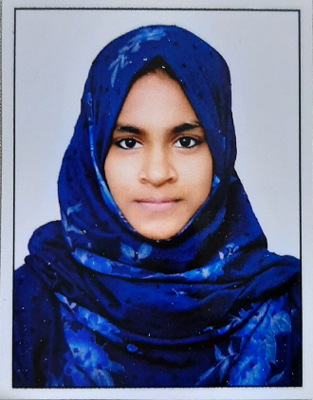  CONTACT:  PHONE: +91 7034989913  EMAIL: akmsuroorafathima@gmil.com  NATIONALITY: INDIAN  DOB: 23-05-2000  MARITAL STATUS: MARRIED  SKILLS  Technical Skills:  - Data Analysis  - Data Visualization  - Data modelling  - Web Development (Front-End)  - Programming  Soft Skills:  - Communication  - Emotional Intelligence  - Creativity  - Problem Solving  - Adaptability  - Team Leading  TECHNICAL TOOLS  Data Analysis:  - Python  - NumPy  - Pandas  - SQL  - Excel  - Google Sheet  - DAX - Data Analysis Expressions  - Power Query  Data visualization:  - Matplotlib  - Seaborn  - Microsoft Power BI  - Tableau  LANGUAGES:  - Malayalam (Native)  - English (Proficient | FATHIMA SUROORA  Aspiring Data Analyst  WORK EXPERIENCE :  FINQUEST - Bangalore February 2024 - Current  Data Associate  - Gathered data from diverse sources pertinent to specific projects.  - Systematically cleaned and refined data to enhance accuracy and usability.  - Organized and structured data proficiently utilizing Excel for streamlined analysis and accessibility.  Al-Falah English Medium School - Kerala November 2022 – December 2023  Computer Teacher  - Instructed students: Led engaging computer science classes, teaching essential skills in programming, software usage, and problem-solving.  - Managed classroom: Effectively maintained discipline, encouraged student participation, and provided constructive feedback on their progress.  INTERNSHIP:  Inmakes Infotech Pvt Ltd June – September 2022  Junior Python Developer – (Intern Trainee) Certificate  - contributed to Shopping Cart project, showcasing proficiency in Python and Django  development  - Orchestrated and executed multiple high-priority projects, ensuring seamless  coordination across cross-functional teams and consistently delivering results  ahead of schedule.  EDUCATION:  PGD Data Analytic and Machine Learning January-August 2023  Imarticus Bangalore Certificate  Batchelor of Computer Application 2017 – 2020  Calicut University Certificate  Higher Secondary Education in Commerce 2015 – 2017  Kerala Education Board Certificate  CERTIFICATIONS:  - 6-week online training on Data Science. Certificate  - Google Data Foundation Certificate  - Full Stack Web Development Udemy Certification Certificate  - Certified Penetration Tester. (2020-2021)\ Certificate  - ISO/IEC 27001 Information Security Associate Certificate  PROJECTS:  - Tesla Stock Price Prediction using Facebook Prophet Repository  - Pizza Sales Data analysis Report using SQL and Power BI Repository  - HR Employee Distribution Analysis project Repository  - McDonald’s Fast Food Case Study using Machine Learning Repository  - Phone Market Prediction System Repository  - Online Shopping Cart Using Python Django Repository  More About Me Click Here

