PING日報表

2022/09/19 15:45:14

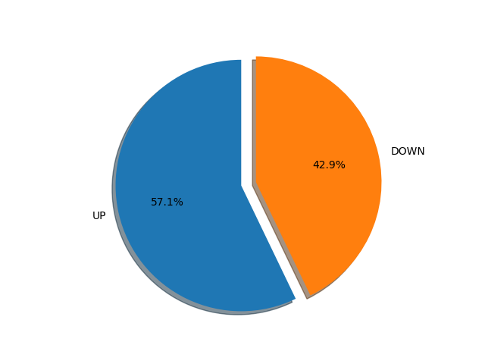

|  |  |
| --- | --- |
| UP | DOWN |

|  |  |
| --- | --- |
| 216.58.223.206 | 191.198.174.192 |
| wikipedia.org | 192.168.1.1 |
| 8.8.8.8 | 168.95.1.3 |
| 168.95.1.1 |  |

# 57% is up, 42% is down