Кнопка

Props

- Text
- State (enable | disable)
- Colors palette
- Handler
- Size (fixed | fill)
- Icon (before text | after text | both)
- Любые дополнительные пропсы, которые считаете нужными

Design
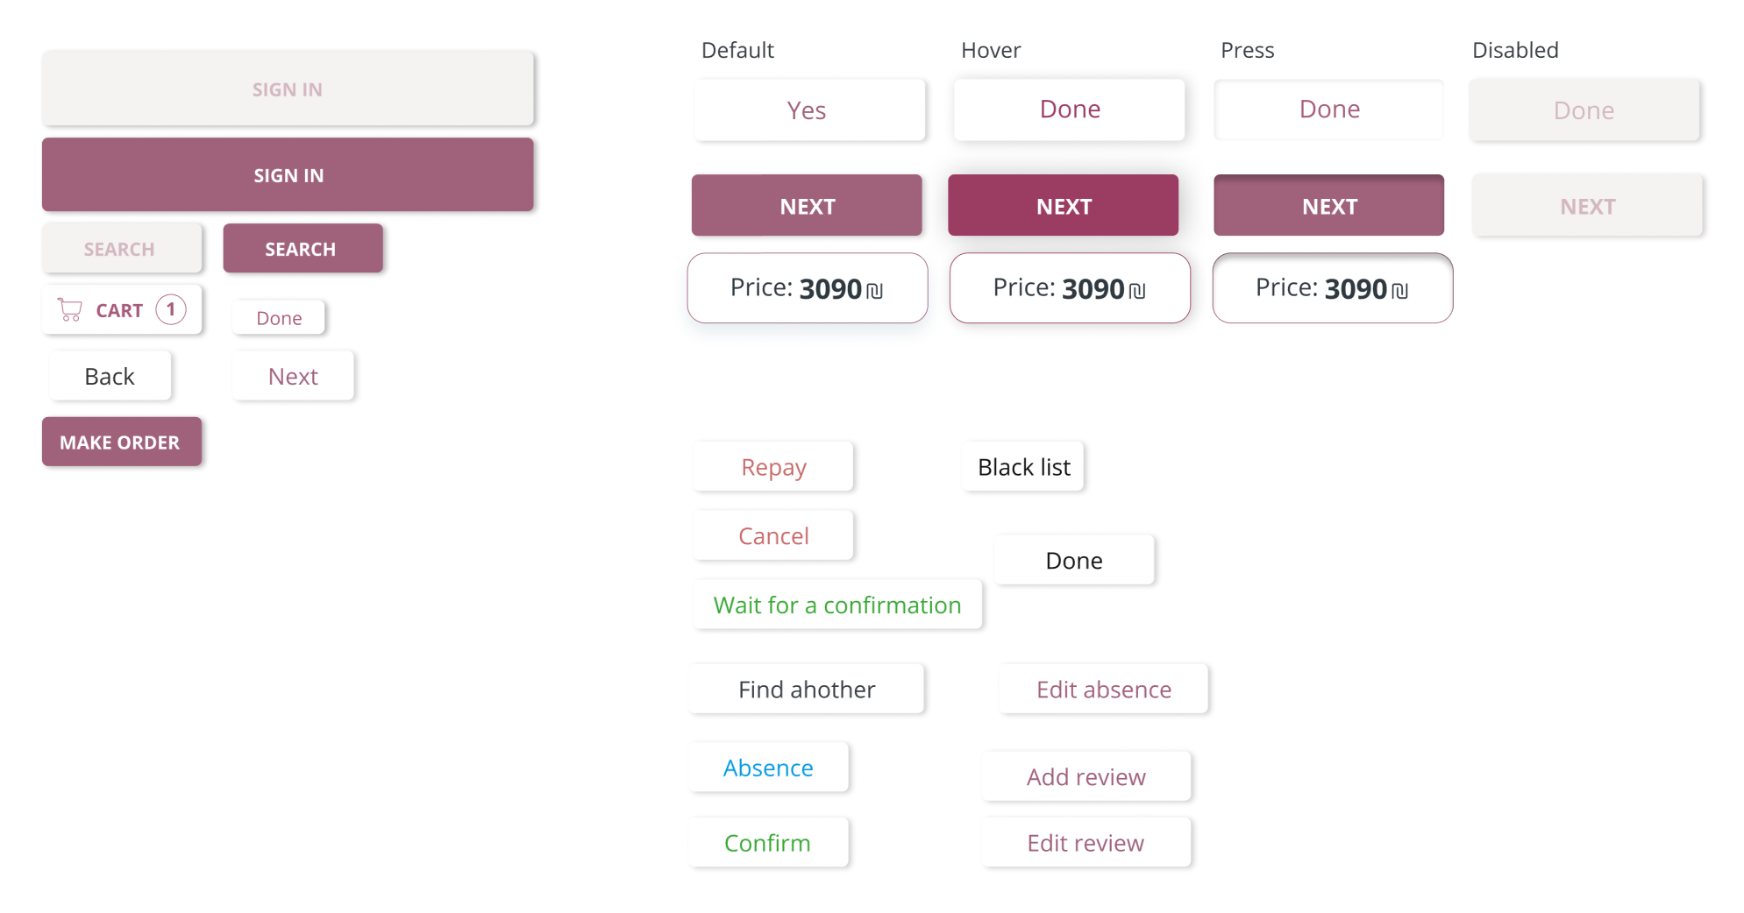

Css
background: #F5F2F2;
background: #A0627B;
background: #FFFFFF;
background: #A0627B;

box-shadow: 2px 1px 4px rgba(0, 0, 0, 0.3);
box-shadow: 0px 6.07407px 12.1481px rgba(46, 103, 140, 0.12);
box-shadow: 2px 1px 4px rgba(99, 93, 96, 0.3);
box-shadow: inset 0px 4px 4px rgba(0, 0, 0, 0.25);

border-radius: 4px;
border-radius: 12px;

border: 0.5px solid #A0627B;

font-family: 'Open Sans Hebrew';

font-style: normal;

font-weight: 400;
font-weight: 700;

font-size: 12px;
font-size: 16px;

line-height: 16px;
line-height: 22px;

color: rgba(160, 98, 123, 0.4);
color: #FFFFFF;
color: #2E3940;
color: #CA6A6A;
color: #37A834;
color: #383F43;
color: #029AE4;
color: #A0627B;
color: #131212;

Input

Design

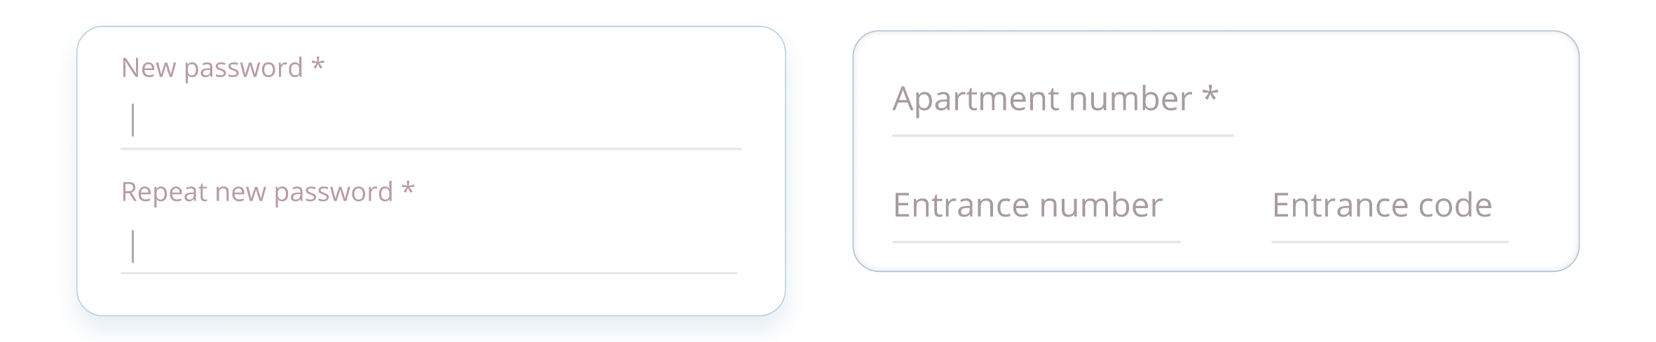

CSS

color: #B79BA6;
color: #A79CA0;

border: 1px solid #EDE4E8;
border: 0.5px solid #B7CEE8;

border-radius: 12px;

background: rgba(255, 255, 255, 0.01);

box-shadow: inset 0px -1px 0px #E9E3E5;

Card

Design

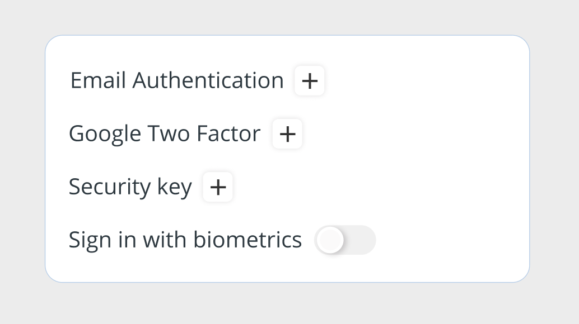

CSS

background: #FFFFFF;
border: 0.5px solid #B7CEE8;
border-radius: 12px;

Chip & ChipsGroup

Design

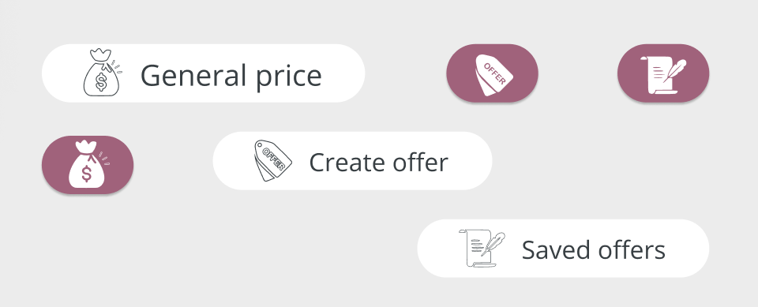
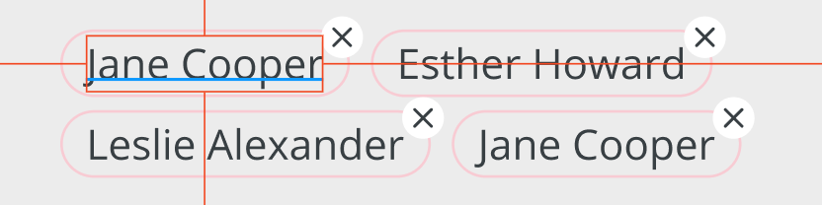

CSS

background: #FFFFFF;
background: #A0627B;

border-radius: 20px;

box-shadow: 0px 1px 1px rgba(0, 0, 0, 0.25);

border-radius: 20px;

Dialog

Design

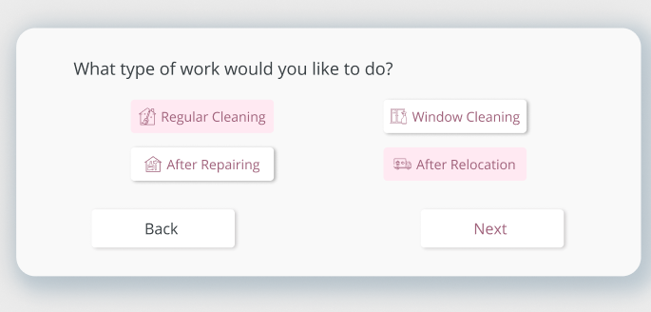

CSS

background: #F9F9F9;
box-shadow: 7px 7px 20px 10px rgba(46, 103, 140, 0.2), 0px 6px 60px rgba(0, 0, 0, 0.12);
border-radius: 20px;

