Nama : Aditia Surya Putra

Kelas : Flutter D

Soal 1

Sudah di commit di github

Soal 2

Build Code Competence 1

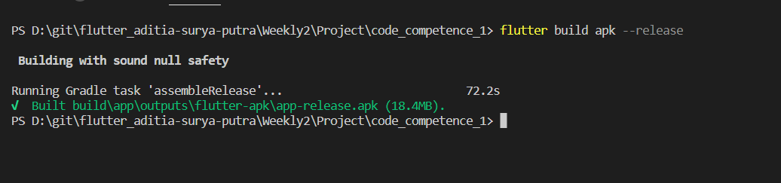

Build Code Competence 2

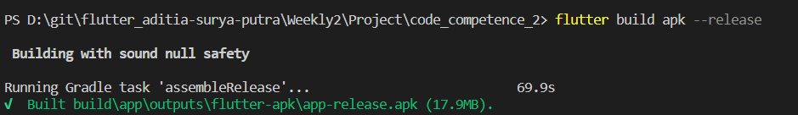

Soal 3

