|  |  |
| --- | --- |
| Exp. No.:8 | **Determination of transfer function of a physical system using frequency response and Bode’s asymptotes** |
| Date: |

**Aim**

To determine the transfer function of a physical system using frequency response and Bode’s asymptotes

**Introduction**

Bode plots were originally devised by Dr. Henrik Wayne Bode while he was working for Bell Labs in the 1930s. They are most used to analyze the stability of control systems, for example when designing and analyzing power supply feedback loops. The advantage of using Bode plot is that they provide a straightforward and common way of describing the frequency response of a linear time invariant system.

**Phase and gain margins**

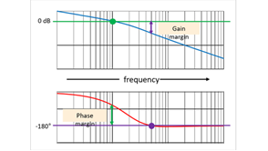

**Phase margin** is measured at the frequency where gain equals 0 dB. This is commonly referred to as the “crossover frequency”. Phase margin is a measure of the distance from the measured phase to a phase shift of -180°. In other words, how many degrees the phase must be decreased in order to reach -180°.

**Gain margin**, on the other hand, is measured at the frequency where the phase shift equals -180°. Gain margin indicates the distance, in dB, from the measured gain to a gain of 0 dB. These values, 0 dB and -180° are important because system instability occurs if these two values meet.

Gain and phase margins represent the distance from the points at which instability could occur. The greater the distance or margin the better, because higher gain and phase margins mean greater stability. A loop with

a gain margin of zero or even less would only be conditionally stable and could easily become unstable if gain changed. A typical goal for phase margin is to have at least 45 degrees, and even higher values might be desirable in more critical applications.

**Stable and unstable closed loop systems**

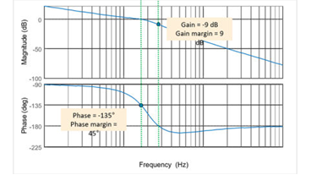

The measured phase at 0 dB is -135°, so the phase margin is 45°. The gain at -180° degrees is -9 dB, so the gain margin is 9 dB. Since phase margin is positive, this system is stable.

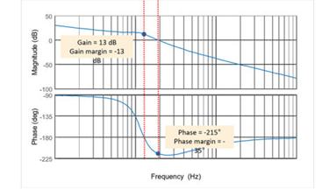

The measured gain is +13 dB when phase is -180°, so the gain margin is minus 13 dB. At a gain of 0 dB, the measured phase is minus 215°, so the phase margin is minus 35° at the gain crossover point. This system is unstable

**Procedure:**

Step1: Get the transfer function

Step2: Declare an array of gain values

Step3: Plot the Bode plot and find the phase margin and gain margin for all the gain.

**Matlab code**

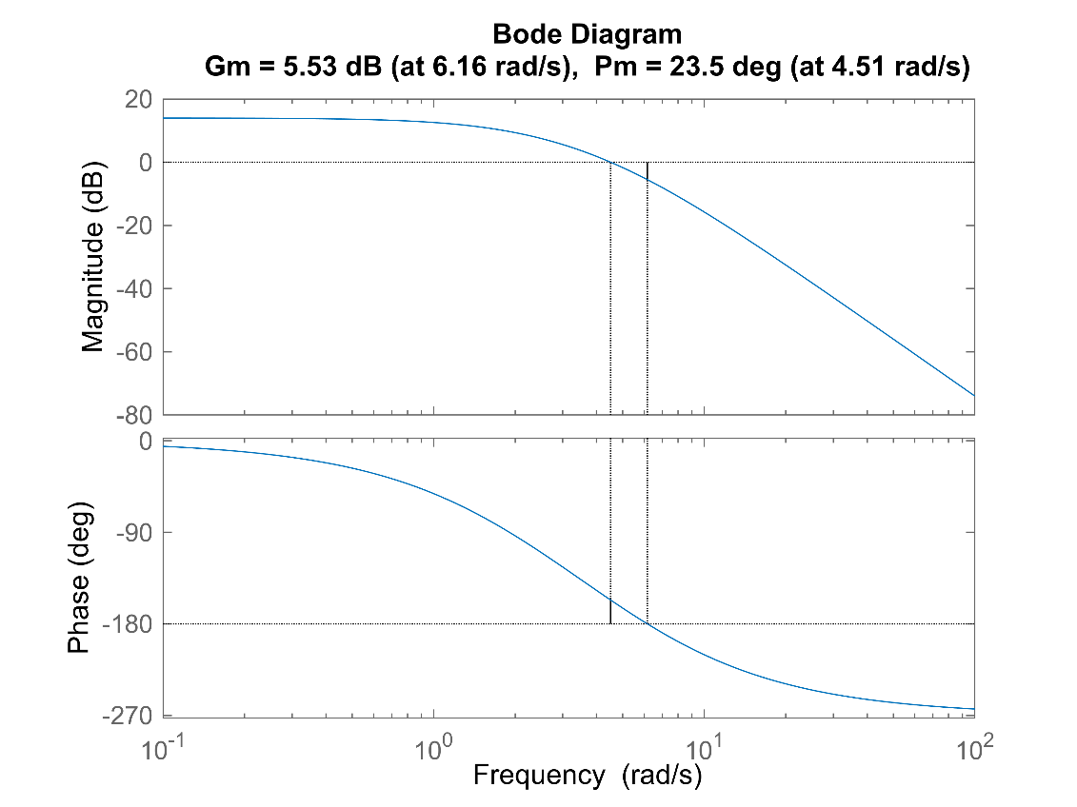

For Gain K = 5 Gain Margin Gm is : 1.89 and Phase Cross freq. Wcp : 4.51

Phase Margin is :23.50 and Gain crossover freq. Wgc: 6.16

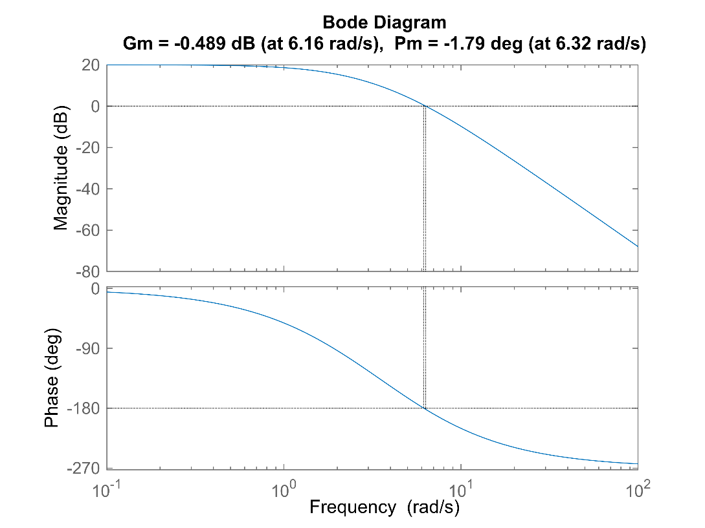

For Gain K = 10 Gain Margin Gm is : 0.95 and Phase Cross freq. Wcp : 6.32

Phase Margin is :-1.79 and Gain crossover freq Wgc: 6.16

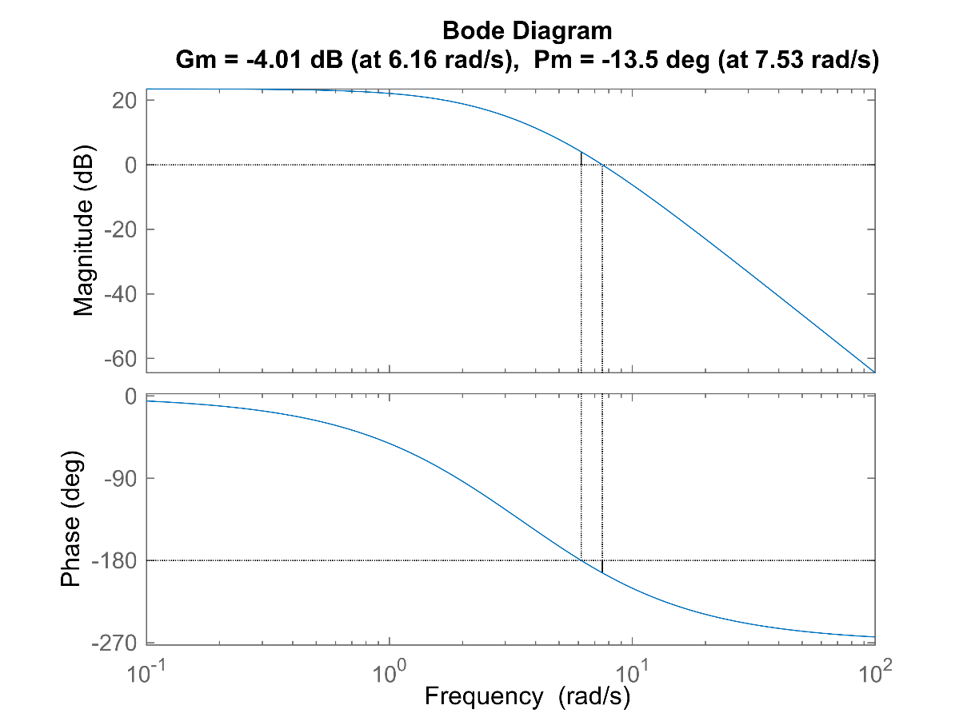

For Gain K = 15 Gain Margin Gm is : 0.63 and Phase Cross freq. Wcp : 7.53

Phase Margin is :-13.53 and Gain crossover freq Wgc: 6.16

**Bode Plot for Different Gain Values in Single Plot**



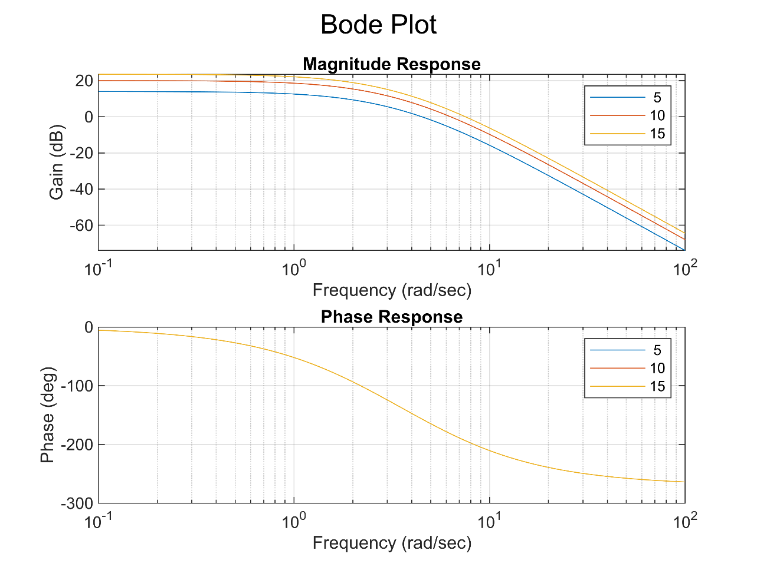

**Inference**

**Result**

Thus, the transferred function has been determined from frequency response and Bode’s asymptotes