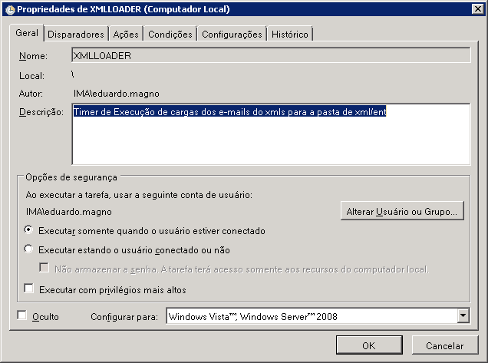
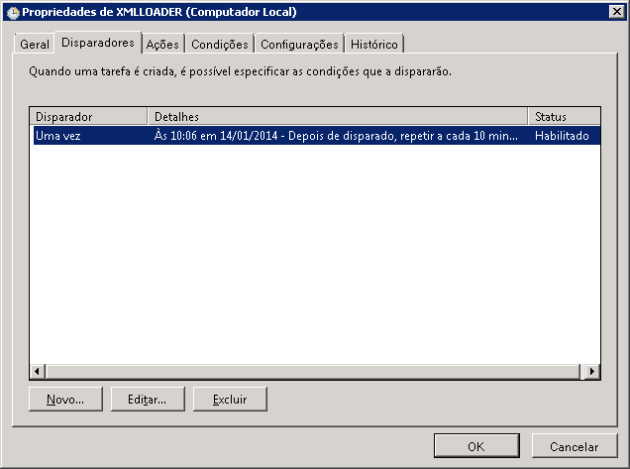

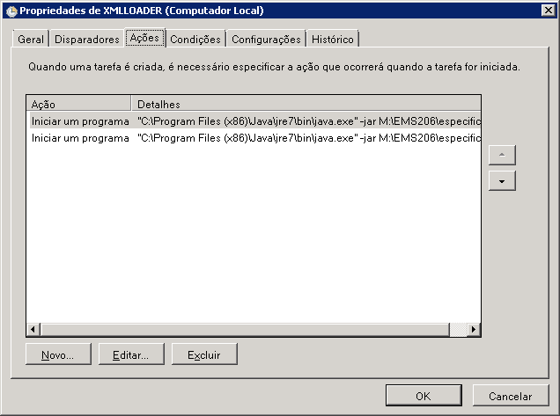
-jar M:\EMS206\especificos\xmlloader\ArqConf\Loader_IMA.jar M:\EMS206\especificos\xmlloader\ArqConf\arqCertif_ima.xml
-jar M:\EMS206\especificos\xmlloader\ArqConf\Loader_IMA_SSL.jar M:\EMS206\especificos\xmlloader\ArqConf\arqCertif_med.xml
