Table of Contents

Counter-measurement migration — working notes
Status: working notes (not the final report). Last updated 2026-07-01. Objective: consolidate the frontend (and reporting) needs served today by analysis_service + meter_service onto one or two common read services on the new ems_rust pipeline (aggregations for measurement data, hierarchy for identity) — so the frontend (and yggdrasil temporarily) call only those, not the ~15 services fanning out to analysis/meter. Stance — stepwise, not big-bang. Retiring the legacy ems-backend (.NET monolith) + downstream services is the end goal, not the immediate task. No wholesale replacement of any one system in a single step.

1. Context & mapping
emswt/main (old) | ems_rust (target)
sensor_measurements DB (raw) | S3 Iceberg raw_data
counter_measurements DB (logical) | S3 Iceberg logical_meter_data → rename logical_sensor_data (§5.5)
analysis_service (reads via @enity/counter-query) | aggregations Rust lambda (CQRS read, crates/services/aggregations)
meter_service (identity/hierarchy) | hierarchy service (hierarchy_new) + meter-identity
in-app + per-request compute | Spark/Glue rollup → DynamoDB measurements_aggregate + thin request-time compute
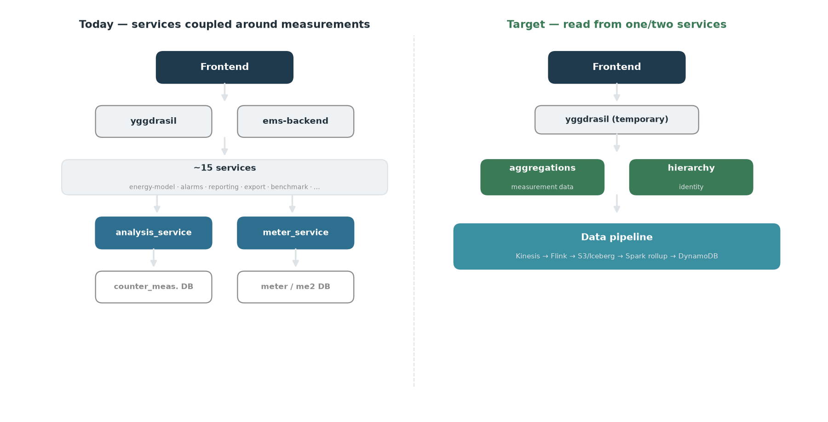
Current vs. target — the frontend fans out across ~15 services to analysis/meter today; the target reads from one or two common services on the pipeline.
Migration seam: @enity/counter-query has only 2 importers (analysis_service, counter-ingestion). Old read side = analysis_service; all endpoints are POST query-by-body (CQRS-read-shaped). It turns cumulative readings into consumption in-app (RunningTotal/RunningArea) then runs a 3-phase prep→data→compute pipeline.

2. Endpoints — analysis & meter (catalog + going-forward mapping)
The analysis_service request/response catalog, then the old→new mapping for both analysis and meter_service.
pass-through = straight DB read · processing = aggregation/computation. API defs: emswt/main/packages/analysis-client/src/api-endpoints/.
# | Endpoint (POST) | Request | Response | Class | Caller / note
1 | api/counters/reading-count | counterIds, intervals[] | per-counter counts | pass-through | missing-manual-readings (reminders). Not ingestion control
2 | api/counters/reading-bounds | counterIds | {first,last} | pass-through | energy-model-v2 uses .first (activation eligibility)
3 | api/counters/latest-reading | counterIds | {latest} | pass-through | yggdrasil meter-list + import-export (“Latest Reading” col) — frontend-facing
4 | api/meter-data/filter-query | meterFilter,interval,resolution? | per-meter series | processing | resolve meters → delta+time-weighted rollup → compute
5 | api/meter-data/details-query | meterDetails,… | = #4 | processing | #4 without meter resolution
6 | api/meter-data/filter-groupby | meterFilter,groupBy[] | nested groups[] | processing | rollup + hierarchy group-agg
7 | api/meter-data/details-groupby | meterDetails,groupBy[] | = #6 | processing | #6 without meter resolution
8 | api/meter-data/aggregate | aggregations{interval,resolution} | aggregations{} | processing | sum/avg/min/max over interval
9 | api/meter-data/values | requests[{interval,resolution}] | per-meter values | processing (richest) | full compute pipeline — §5
10 | api/key-values/sum | keys | sum | processing — likely out of domain | uses auxDataLayer; confirm & exclude
11 | legacy/consumption/query | legacy body | series | legacy | raw-URL; caller ems-backend/Web. Confirm traffic via enity_analysis_legacy_consumption_count
12 | legacy/zoom/query | legacy body | zoomed series | legacy | raw-URL; callers benchmark,co2-value,ems-backend/Web. Confirm via enity_analysis_legacy_zoom_count
3 pass-through, 8 processing (+1 aux to confirm).

2.1 Old endpoints → going forward (analysis + meter)
Where each old call lands in the target; per-consumer usage is in §9.2.
analysis:
Old call | Going forward
analysis aggregate / filter-query / filter-groupby / values (hour/day) | aggregations get_aggregations (rollup read)
the values compute layer (degree-days, cost, CO2, …) | get_aggregations + service-side compute (§5)
analysis reading-count / reading-bounds / latest-reading | columns already in the rollup (count, last_value/last_ts); add a first bound
analysis legacy/consumption|zoom | drop (legacy)
raw readings / datatilegnelse | aggregations get_measurements (Athena)
meter — most measurement-path meter calls disappear (hierarchy/identity is denormalized into the rollup, §7); new calls are hierarchy GET /query/{action} unless noted:
Old meter endpoint (client method) | Resolves | Going forward
meters/query/context (queryContext), meters/query (query), ids-from-filter (queryIds) | filter/context → meters | list_children / list_sensors / company_sensors for filter resolution; grouping/hierarchy itself is gone (rollup is keyed by node)
getMeterIdsFromHierarchy, hierarchyElementIds… | node ↔ meter ids | gone — hierarchy stamped into each sensor / rollup row
getMeterTypesByIds, counter-role | meter type / role | gone — resource + meter_type denormalized (§5.5/§7)
buildings/query (buildingQuery), fetchMeterDetails, /hierarchy/:id | buildings / meter details / subtree | get_node / list_children / get_sensor
building custom fields, tags (getTagsFrom…) | building metadata / tags | hierarchy node metadata (§7)
access (implicit in every read) | who may see what | effective_permission (§5.4 access filtering)
writes — insert-update-meter, …MetersHierarchyElements, updateCustomFieldsValue, updatePhysicalCounter, updateDatasource, addTagsToMeter | master-data CRUD | hierarchy /command — outside the measurement read scope

3. Already implemented in ems_rust
Spark/Glue rollup — infra/daq/data_pipeline/glue/measurements_aggregate.py (MeasurementsAggregateStack, daq acct 891377204778, hourly, LookbackDays default 1). Spec: .../specs/2026-06-07-measurements-rollup-view-design.md. - Source: all.logical_meter_data (event-sourced; resample_value where resample_method='time_proportional', dedup newest ingested_time). - Sink: DynamoDB measurements_aggregate (TTL 90d hourly / 730d daily; GSI by dimension energy|volume|other). - hour + day only; per (node, resource, granularity, period): sum, count, min, max, last_value, last_ts. - Hierarchy pre-aggregated at every ancestor level (company HN2# → leaf L#) → group-by is materialized.
Read API — measurements-aggregations-api (crates/services/aggregations), HTTP API GET /meterdata/query/{action}: get_aggregations (DynamoDB) · get_measurements (raw_data via Athena) · /openapi.json · /docs; ?format=html|json.
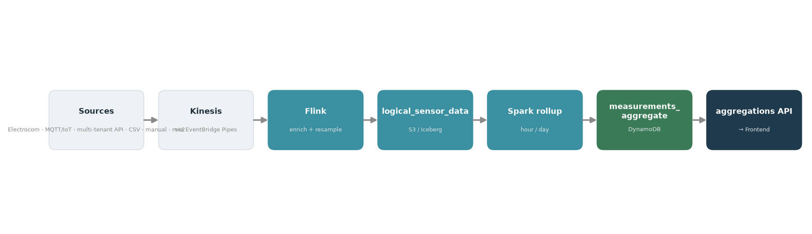
The data pipeline: sources → Kinesis → Flink (enrich + resample) → logical_sensor_data → Spark rollup → DynamoDB → aggregations API.

4. Coverage overlay — old endpoints vs the existing rollup
# | Endpoint | Covered? | Gap
1 | reading-count | ✅ count | consumer likely out of scope (§9)
2 | reading-bounds | 🟡 last yes; first not materialized | first needed only by energy-model-v2
3 | latest-reading | ✅ last_value/last_ts | frontend-facing
4/5 | filter/details-query | ✅ hour/day sum | off-grid resolutions (§6)
6/7 | filter/details-groupby | ✅ strong (hierarchy pre-agg) | off-grid resolutions
8 | aggregate | ✅ sum/min/max; avg=sum/count | arbitrary interval edges compose from stored hour/day periods
9 | values | 🟡 base sum only | compute layer — §5
11/12 | legacy | ✅ hour/day equiv | finer zoom
Takeaway: the rollup already collapses #1–#3 and the hour/day base of #4–#8/#11–#12 (incl. hierarchy grouping) into single-key DDB reads. Remaining work = the values compute layer (§5) + off-grid resolutions (§6).

5. Target compute model

5.1 Placement rule — denormalize, three lanes
Rule: do every join once in the pipeline (broadcast-join tiny reference tables) and write results as columns on measurements_aggregate; the read stays a single keyed DDB query. Read-time joins from S3/Iceberg (Athena) are seconds-slow, so nothing joins at read time. Denormalize as columns, not rows (row count unchanged); keep the 2–3 CO2 scopes as columns (co2_scope_*), cost in one base currency (convert at read) — cardinality stays flat.
Handler = analysis_service’s unit of computation for one derived metric — a “value key” such as energy, cost, co2, degree-days, active-hours. A handler produces that metric’s value series over the requested period through a 3-phase pipeline (declare prep/reference data → fetch counter data → compute), and handlers compose (e.g. the cost handler nests energy and multiplies by price). The values endpoint runs ~35 of them. The migration question is where each handler’s work belongs — materialised in the pipeline vs computed in the read service. The three lanes:
Lane | Handlers | Placement
A · Spark rollup | energy, flow, temp-in/out-avg, VWAT-numerator, computed-cooling, cooling-efficiency, hours, reading-count | Deterministic per-period aggregates. energy/flow/temperatures each come from their own sensor (a distinct daq_id; resource/meter_type assigned by meter-identity) — aggregate directly (temp avg = sum/count). computed-cooling / VWAT are cross-sensor (flow·Δtemp, Σ(flow·temp), combining the flow + temperature sensors of one physical device — same daq_id up to meterserial) → they aggregate a derived series from the formula step (§5.5), time-aligned after resample, not raw readings. Extra columns: temp Σ+count, Σ(flow·temp)+Σflow, flow·Δtemp
B · Flink stream | active-hours, standby (+fraction/ratio/per-hour), op-hours mask | Need finer-than-period (sub-hour) resolution → pre-aggregate in the stream into daily active_hours/standby_energy columns
C · Denormalized columns (broadcast join) | cost (energy×price), CO2 (energy×factor), degree-days / climate-correct (weather), key-ratio, energy-budget | Reference tables are tiny → broadcast-join once in Spark, write columns. Keys: weather on (location, date) (node location from meter-identity); factors on (resource/scope, validFrom). Mechanics in §5.3
Handlers suffixed *-old (degree-days-old, energy-dda-old, normal-degree-days-old, co2-old) + energy-guf are the legacy degree-day approach, superseded by model-based climate-correct — likely droppable (verify).
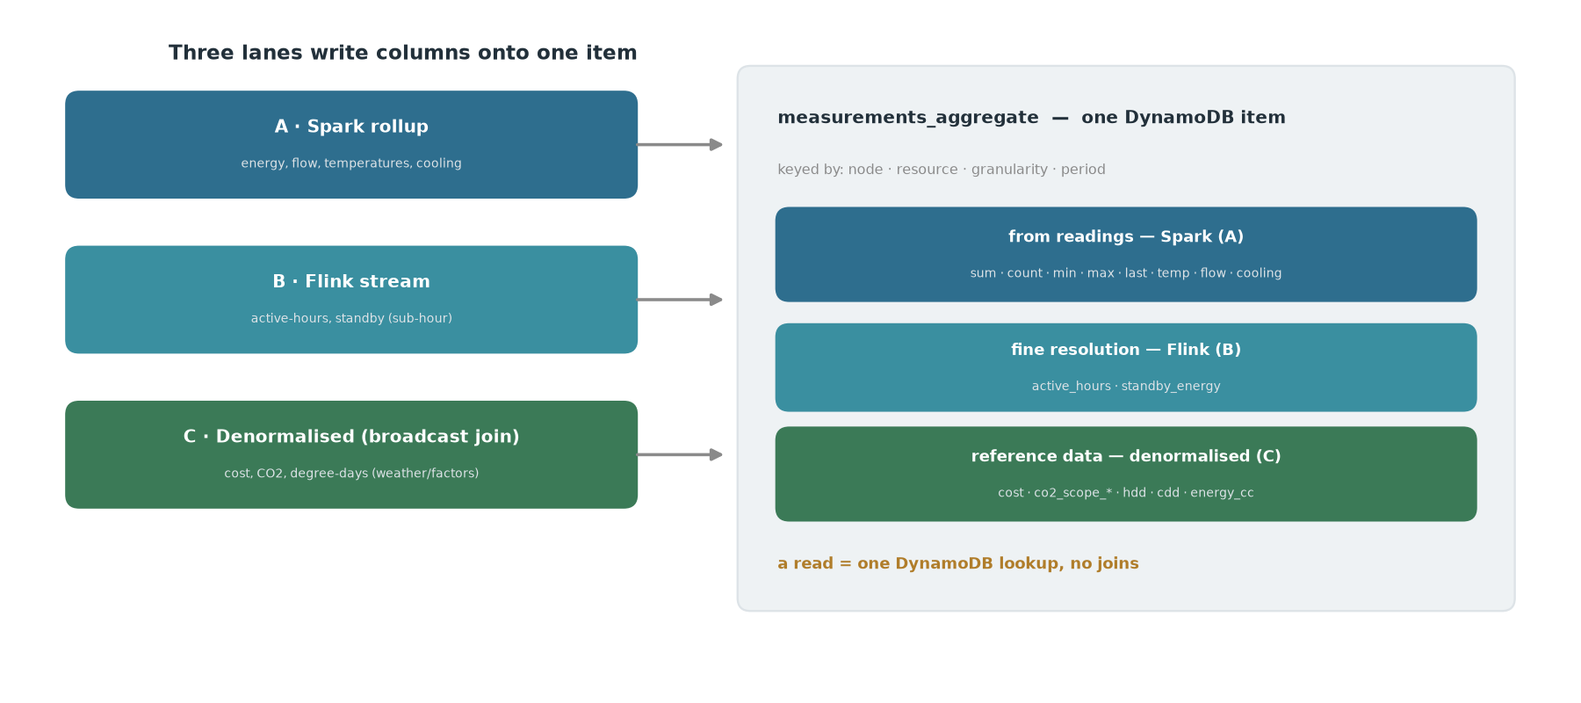
The three compute lanes each write columns onto one measurements_aggregate item; a read is a single DynamoDB lookup, no joins.

5.2 measurements_aggregate item shape (with §5.1 additions)
Keys unchanged: pk="HN2#<hn2>", sk="<path>#<resource>#<gran>#<period>", gsi1pk="HN2#<hn2>#<dimension>", gsi1sk="<path>#<gran>#<period>" — gran + period (the hour/day label) live in the sort key, not as stored attributes; the resource (electricity/water/heat) is stored in an attribute still misnamed purpose. Additions land as extra columns on the energy row (functions of that row’s sum + reference data) or new derived-resource rows (physically distinct series, different unit).
{
"pk": "HN2#2",
"sk": "HN2#2|HN3#9|HN4#456|L#10009#Electricity#d#2026-06-07",
"gsi1pk": "HN2#2#energy", "gsi1sk": "HN2#2|HN3#9|HN4#456|L#10009#d#2026-06-07",
"purpose": "Electricity", "unit": "kWh", // "purpose" attribute holds the resource (misnamed)
"sum": 123.4, "count": 24, "min": 0.1, "max": 9.7, "last_value": 90123.4, "last_ts": "2026-06-07T23:00:00Z",
"cost": 246.8, "cost_ccy": "DKK", // energy × price(period, tariff)
"co2_s1": 12.3, "co2_s2": 9.8, // energy × CO2 factor, per scope (columns)
"hdd": 4.2, "cdd": 0.0, // degree-days for this node's location/day (daily+ only)
"energy_cc": 118.9, // climate-corrected energy
"active_hours": 18.5, "standby_energy": 3.1, // Lane B
"updated_at": "2026-06-08T01:00:00Z", "ttl": 1783000000
}
Derived-resource rows (same schema) for flow+temperature meters: Cooling, FlowVolume, TempInAvg, TempOutAvg, VWAT; avg = sum/count.
Open schema decisions: (1) hdd/cdd repeat per resource row at a node — accept duplication (single-read) vs a DegreeDays row (adds a lookup); leaning accept. (2) item-size × row-count acceptable — gated on the §10.1 sizing.

5.3 Weather / CO2e / prices — realization
Own each as a small reference table; the Spark rollup broadcast-joins and writes columns (§5.1).
How the join works: the aggregate row already carries the node’s hierarchy + resource; add the node’s location (from meter-identity) and Spark broadcast-joins two in-memory tables — weather(location, date) → hdd, cdd, normal (from Weatherbit) and factors(resource/scope, validFrom) → price, co2 — with no shuffle, then computes and writes hdd / cdd / energy_cc / cost / co2_scope_*. hdd/cdd are per-location, so they sit on location-bearing nodes (building and below); cost/co2/energy_cc are additive (computed at the leaf with local weather, summed up the hierarchy).
Finalization uses existing machinery, no bespoke trigger for the common case: set LookbackDays ≥ 5 so the recent window is re-baked as forecast HDD/CDD (or restated factors) finalize; reads are ≤1 rollup-cycle stale. A (location, date) late-trigger (existing late_arrival_trigger/late_recomputation/backfill_trigger shape) is a fallback only for restatements older than the window. Prereq: location on meter-identity (lat/lon or weather-location id). Weather is greenfield in ems_rust (only in a spec).

5.4 Service-vs-data boundary — what stays in the read service
Everything that can be data is data (pipeline → logical_sensor_data + measurements_aggregate columns). The read service keeps only:
Stays in service | Why
Access / permission filtering | Per-user (writes/reads/blocked edges); rollup holds all nodes
Query orchestration / response shaping / validation | The CQRS surface
Request-param selection & scalar scaling | scope pick (co2_scope_*), currency, unit/display, budget scenario, tunable base-temp — select/scale over columns
Ratio / division metrics | VWAT, efficiency, key-ratio, per-hour — divide of two rolled-up sums (numerators pre-baked)
Resolution re-agg + interval edges | week/month/year from daily; intervals not aligned to the hour/day grid
Ad-hoc cross-node / cross-period comparison | benchmarking, this-vs-last
Transition “meter” grouping | meter → its logical_ids, until derived sensors cover it

5.5 Sensor & formula model; the meter hierarchy
No meter entity. The model is typed hierarchy nodes + sensors (S#<int>, attached via has_sensor), each with purpose (the resource — electricity/heat), meter_type (Counter|Gauge), unit, resample_minutes, and a formula (Identity/Zero/Expr; Expr refs other sensors’ computed S', + - * / abs, company-scoped, cycle-checked). A raw sensor reading carries only {daq_id, timestamp, value, unit} — everything else (logical_id, hierarchy hn2..hn9, resource, meter_type, resample) is assigned by meter-identity enrichment keyed on daq_id. The daq_id is structured protocol:schematype:customer:gatewayid:meterserial:sensorid; sensors on the same physical device share all but the final sensorid. So there is no “meter with counters”: each measurement (energy, flow, forward-temp, return-temp — and on modern meters many more: energy tariffs, production, per-phase, …) is an independent sensor with its own daq_id/logical_id, and the “same physical meter” grouping is just the shared daq_id prefix (up to meterserial). (The old TaellerNr 1/2/3/10/11 is a legacy convention, not a fixed structure — §10.2.) logical_meter_data is keyed per logical_id → rename logical_sensor_data; a “meter” during switchover = the set of sensors sharing that prefix.
Formula status: the system is implemented (AST + tested eval, parser, attach/set_formula, API, and formula is propagated into meter-identity) — but not applied to the time-series: the hierarchy evaluate reading-hook is a stub and the Flink/Glue pipeline has zero formula references. So no derived series exists yet. Build gap: a pipeline step running eval() per reading, resolving cross-sensor Refs (time-aligned sibling values); formula change → late-recompute. (Evaluate in the pipeline, never at read time.)
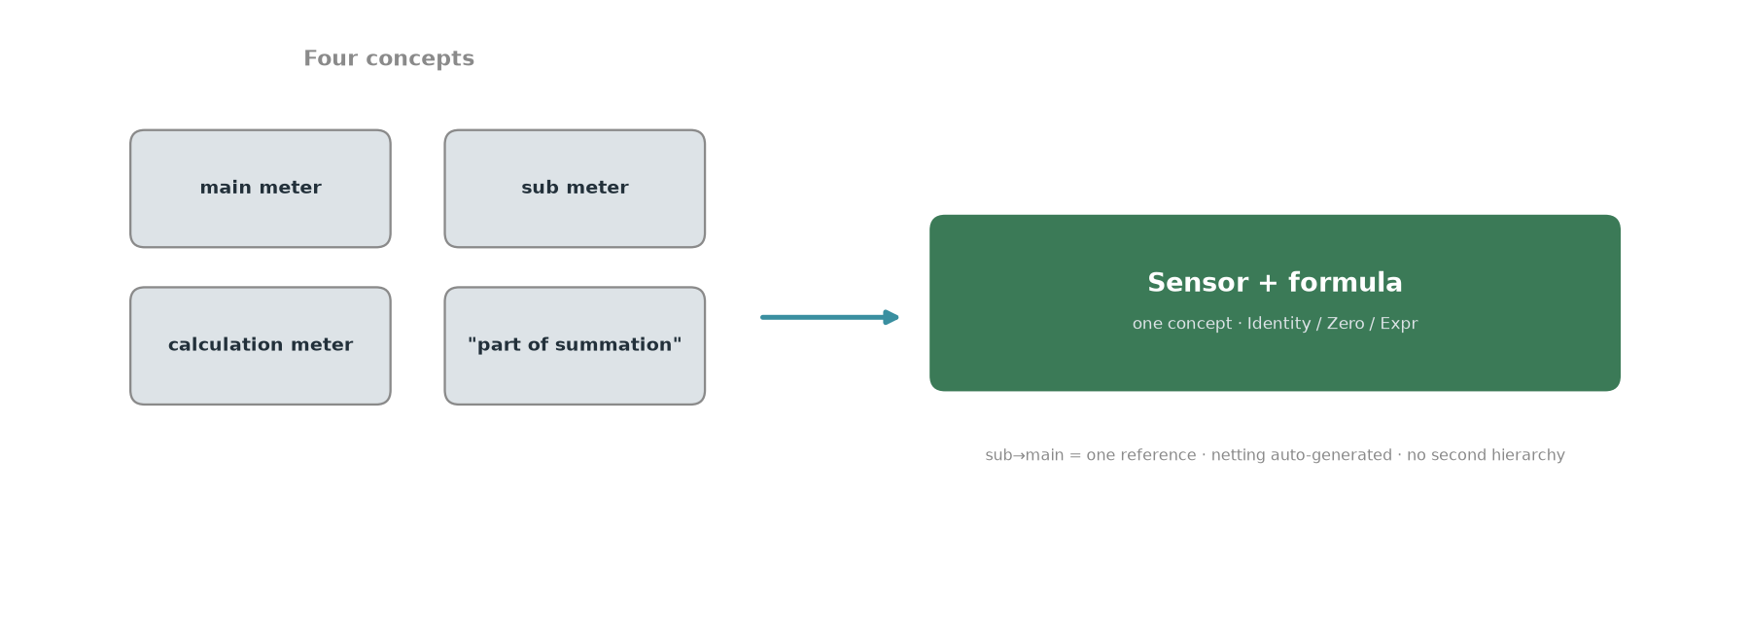
The four old meter concepts (main, sub, calculation, sum flag) collapse into one: a sensor with a formula.
Meter hierarchy = one relationship, not a parallel tree. The old main/sub tree exists only to avoid double-counting, and main/sub legitimately crosses buildings, so the netting relationship is independent of the location hierarchy. Represent it as one “part-of-main” reference per sub-meter (cross-node, company-scoped); the netting formula (main = self − Σ subs) is auto-generated and re-derived from it (add/remove a sub → parent updates; preserves the auto-maintenance the old summation flag gave for free). This is a per-sensor computation DAG, not a navigable second hierarchy — and it drops all the old machinery (separate meter tree, Part of summation flags, query-time summation contexts, area/context modes). Hand-authored Expr is reserved for genuine derived metrics (COP/ratios).
Old → new mapping: sub-meter = identity leaf; main = netting parent (auto-derived); calc meter (counter.formula over [meterId:counter] tokens; MeterBasedFormulaTranslator exists) = Expr; not-part-of-summation = Zero. All four old types collapse into the one formula/sensor concept.

6. Resolution strategy
- hour + day: materialized (done).
- week / month / year: compute in-service from the 730-point daily series (÷7 / ÷30) — do not materialize; not worth the DDB cost.
- 15-minute: deferred — a DDB storage-cost decision, gated on real frontend need.

7. Adjacent context: meter_service (identity plane)
A different bounded context — the identity/hierarchy/metadata registry (its own me2db + meter DB; reads no measurement DB). Owns meters/sensors/counters, buildings/hierarchy, tags, units, operational-hours, documents, custom fields, ownership. 15 consumers via @enity/meter-client. Role in the measurement path: resolve meterFilter → meters + hierarchy (the “which meters” behind “what values”).
Target: → hierarchy service + meter-identity, not the aggregations service. The measurement read path should read from meter-identity (identity/hierarchy is already denormalized into the data), never call a meter service at query time. Enrich meter-identity as a lean read projection (candidates: reading-type, operational-hours, location, tags, and the counter-role that replaces TaellerNr — primary / secondary / temperature — expressed as resource + meter_type, not a counter number; add an explicit primary marker only when a node has two energy sensors), fed by registry change events; per field decide stamped-at-write (point-in-time, like the hierarchy path) vs looked-up-at-read (current, e.g. tags) — getting it wrong silently rewrites history.
Building-level reference data → node metadata. The per-company schema already lets each company declare typed metadata fields on node types (a building carries lat/lon today). So building attributes the read side divides/joins by — area & heated-area, custom keys (from keyratio), operational-hours — belong as hierarchy node metadata, not separate services. This subsumes keyratio’s key-value storage into the hierarchy service (system keys = typed building fields; custom keys = company-declared fields, or a single custom_keys JSON map if they churn); the intensity ratio (consumption ÷ key-value) stays a read-time divide in aggregations (§5.4). Caveat — node metadata is current-only (updated in place, no valid-from history), while keyratio values are time-versioned: decide per key between current-value normalization (fine for area — rarely changes, often the intended basis) and historical accuracy (needs a small temporal side-table, or accept the simplification). Same point-in-time-vs-current call as the enrichment fields above.

8. Raw side: sensor_measurements / raw_data readers
The analytics/frontend path does not read raw (it’s all on logical). Consumer read of raw = the datatilegnelse view → get_measurements over raw_data via Athena. Direct raw readers are pipeline/quality (counter-ingestion transform, sensor-measurements-stat-manager, -missing-readings-manager, -management, -ingestion) → Flink/Glue. One outlier: ok-carwash-api reads raw via sensor-measurements-management (fetchAdjustedReadings) for per-car-wash consumption → MARKED FOR UPDATE: repoint to raw_data/Athena or the logical path.

9. Consumer classification (analysis/meter → common service)
Disposition = what happens to the service in the target end-state: - client — the service keeps existing as its own service, but is repointed to call the new common service(s) (aggregations / hierarchy) instead of analysis_service / meter_service. Its own logic is unchanged; it’s still a consumer, just of the new backend. (Here “client” means “a caller of the common service” — not the @enity/*-client HTTP libraries.) - subsumed — the service’s functionality is absorbed into the common service, and the separate service is retired. - eliminate / collapse — a thin intermediary whose callers are all entry points (yggdrasil / ems-backend); once those call the common service directly, it disappears — no separate service, nothing to repoint. Higher-value than client: it shrinks the middle tier instead of preserving it. (If it has real domain logic, it’s subsumed, not eliminated.) - out of scope — a different bounded context; not part of this consolidation (left as-is or handled elsewhere).
Repoint is a migration step, not the destination. “client/repoint” only stops a service reaching into analysis_service/meter_service internals — it reads the clean common API instead. If we stop there we’ve just relocated the hard coupling one layer down. The end-state for each consumer is one of: fold its measurement/identity logic into aggregations/hierarchy; re-home a genuinely separate domain (alarms, reporting/CSRD, ML) as its own clean bounded-context service the frontend calls as a peer (owns its data, loose coupling via events/APIs — not a middle-tier pass-through); or retire. The table below is the first move; the fold-in/re-home is the target.
Consumer | Uses | Disposition
yggdrasil | analysis (latest-reading + most) + meter | client (temporary frontend façade)
consumption-api | analysis aggregate/values; meter | subsumed (it is a consumption read API)
import-export | analysis latest-reading + query; meter | client (reporting)
energy-model-v2 | analysis reading-bounds.first + aggregate/values; meter | client (needs first bound)
alarm_runner | analysis filter-query; meter | client (alarms)
computed-benchmark | analysis filter-groupby/values | client (benchmarks)
report-runner | analysis filter-groupby/details-query; meter | client (reporting)
export | analysis aggregate; meter | client
energy-model-service (v1) | analysis filter-query/values; meter | client (verify legacy vs v2)
ok-carwash-api | analysis values; + raw (§8) | client
alarm-management | meter only | client (identity)
climate_reporting_service | meter; via yggdrasil | client
missing-manual-readings | analysis reading-count; meter | out of scope (manual-reading workflow)
energy-cost | meter only | out of scope (pricing; identity client)
back-office | counter-ingestion admin | out of scope (pipeline ops)
ems-backend/Web | analysis legacy endpoints | out of scope (legacy monolith)
Feasibility confirmed: every meter call = identity/hierarchy (→ hierarchy service); analysis calls concentrate on filter-query/filter-groupby/aggregate/values (→ aggregations, covered except the §5 compute layer). 1 subsumed, ~8 client, rest out of scope. The only real blocker to “frontend calls one service” is the §5 compute layer, not consumer breadth.
Alternative lens — collapse the middle tier (don’t just repoint). Most “client” services sit in a sandwich: frontend → yggdrasil / ems-backend → {service} → analysis/meter. A middle service that is (1) reached only via entry points (yggdrasil/ems-backend) and (2) a thin reshape over analysis+meter can be eliminated — the entry point calls the common service directly. This is the higher-value move: it shrinks the distributed monolith rather than preserving it. Deciding it needs both filters — the caller graph (all callers = entry points?) and a logic-depth check (thin reshape vs real domain logic). First pass (caller graph via client-pkg importers):
Middle service | Callers | Filter 1 (entry-only?) | Disposition
computed-benchmark | yggdrasil only | ✅ | collapse candidate — verify benchmark logic is thin / a query pattern
import-export | yggdrasil only | ✅ but 20k LOC import/export domain → fails filter 2 | stays client (repoint data-fetch only)
energy-model-v2 | analysis_service + ems-backend + yggdrasil | ❌ multi-caller | stays client (shared dep + real ML)
alarm-management | ems-backend + user_service + yggdrasil | ❌ multi-caller | stays client (alarms domain)
So client in the table above is the conservative disposition; several entries may become eliminate/subsumed once the full caller-graph + logic-depth pass is done (open §13).

9.1 Subsumability estimate (logic-depth pass)
Rough sizing + logic shape (src LOC excl. tests). “Subsume” = fold into the common aggregation service; otherwise it stays its own service and just repoints its measurement reads (client).
Service | LOC | Logic character | Subsume?
consumption-api | 4.7k | consumption read/reshape over analysis (+ some me2db, response schema) | Yes — easy-ish. It is a consumption read API = the common service. Its me2db reads are meter/hierarchy (Maaler/Firma/Energiform) → available from hierarchy + meter-identity (not a blocker); only real wrinkle is the response schema
computed-benchmark | 2.2k | benchmark calc (~200 LOC) + its own results DB | Yes — moderate. Port the calc; its DB → a rollup/materialized view or query pattern. (Only-via-yggdrasil → also an eliminate candidate)
ok-carwash-api | 1.3k | bespoke car-wash config + export builder | No — stays (product edge; small; repoint + §8 raw-read)
export | 2.4k | async export-job subsystem (queue/jobs/file gen, own db) | No — stays. Different concern (job orchestration); repoint data-fetch only
import-export | 20k | import/export domain (formats, mappings) | No — stays. Repoint data-fetch only
energy-cost | 6k | price-list / cost-factor registry (cost-factor-service, price-list-service) | Reference-data owner now; replace later. It owns the price/CO2-factor tables the pipeline broadcast-joins (§5.1 Lane C); cost-compute moves to the denormalized column. Since we plan to own prices (§5.1), the registry itself becomes a replace/retire candidate — move price/factor ownership into the new system, feed the pipeline directly, drop energy-cost (a later simplification). Its me2db reads are hierarchy/meter (available)
energy-model-v2 / -service | 5.6k / 4.4k | ML regression modeling | No — stays (distinct capability)
alarm_runner / alarm-management | 5.2k / 16.7k | alarm evaluation engine + config | No — stays (alarms domain)
report-runner | 9.2k | report generation (custom/KPI/week, templates, notifications) | No — stays (reporting domain)
climate_reporting_service | 6.9k | CSRD compliance (emission types/scopes/fields, exports) | No — stays (compliance domain)
Estimate: consumption-api (easy) and computed-benchmark (moderate) fold in now; the rest repoint first and then reach their end-state as their domains are rebuilt — measurement/identity logic folds into aggregations/hierarchy, genuine domains (alarms, reporting/CSRD, ML) re-home as clean bounded-context peers, energy-cost becomes a reference-data owner then retires. Repoint alone is not the goal — it breaks the analysis/meter coupling but, left there, just relocates it. The near-term consolidation is modest; the destination is a small set of context-owning services, loosely coupled, that the frontend composes from — not a fan-out of middle-tier services.
me2db reads are hierarchy + meter identity — not a migration blocker. The services that hit me2db directly (consumption-api, energy-cost, report-runner, climate_reporting_service) pull almost entirely hierarchy (Bygningselement, Firma, Adresse, recursive-hierarchy CTEs) and meter/sensor identity (Maaler, Taeller/FysiskTaeller, Energiform/EnergiHovedgruppe, Grundenhed/base-unit/meter-type) — exactly what the new hierarchy service + meter-identity already hold. So these direct me2db reads are repoint targets, not blockers: swap to the new identity/hierarchy source. The only residual is user/access/recipient data (Bruger, DataadgangBrugerFirma, profiles, contact-users — mostly report-runner for report distribution) + i18n (sprog). This isn’t a separate context either: the hierarchy service already owns users (U#<email> rows, access/block edges, Cognito provisioning). During switchover it needs a sync path — the ME2 monolith already CDC-streams all entity changes (users included) via the Me2Events table → me2-events Kafka topic (me2-event-stream); a consumer projecting user/hierarchy changes into hierarchy_new keeps the new system in sync until it becomes the source of truth.
keyratio (two services) — reference data, folds into hierarchy. keyratio-v3-service is the current key-value store (custom + system keys per building, time-versioned; keyratio_url); the older keyratio is keyratio_legacy_url, used only by the legacy benchmark service → old keyratio + benchmark retire together (same legacy pair as benchmark→computed-benchmark). Like energy-cost, keyratio is a reference-data owner, not a measurement consumer: its key-values become hierarchy node metadata (§7, area/heated-area/custom keys) and the intensity ratio a read-time divide (§5.4). So keyratio-v3’s storage is subsumed into hierarchy metadata rather than kept as a service; the only open question is the current-vs-time-versioned call for keys that change (§7).

9.2 Per-consumer endpoint usage & disposition
Old→new endpoint mapping (analysis + meter) is in §2.1.
Per-consumer (what each calls today on analysis/meter, and going forward). The frontend “Resource Insights” module (lis: Overblik / Analyse / Energimodel) is the primary consumer — served today via yggdrasil, calling get_aggregations going forward. climate_reporting_service consumes measurement data indirectly through yggdrasil (climateReporting*StatementQuery), hence no direct analysis calls.
Consumer | Old analysis calls | Old meter/other | Going forward | Disposition
Frontend — Resource Insights (via yggdrasil) | aggregate, values, groupby, filter-query | meter queryContext | get_aggregations + hierarchy /query; yggdrasil temporary façade | the target
yggdrasil (BFF) | all 8 (aggregate, filter/details-query, filter/details-groupby, values, latest-reading, keyValuesSum) | meter (all) | get_aggregations / get_measurements + hierarchy; temporary façade | client (façade)
consumption-api | aggregate, values | meter buildingQuery/tags/context | subsumed → get_aggregations | subsume
energy-model-service (v1) | filter-query, values | meter | get_aggregations + service compute | client (verify legacy)
energy-model-v2 | reading-bounds (.first) | meter | get_aggregations (+ first-bound) + hierarchy | client
computed-benchmark | filter-groupby | — | get_aggregations (grouped) | client / collapse
report-runner | details-query, filter-groupby | meter, me2 | get_aggregations + hierarchy | client
export | aggregate | meter queryContext/queryIds | get_aggregations + hierarchy | client
import-export | latest-reading | meter | get_aggregations (latest col) + hierarchy | client
ok-carwash-api | values | meter query/queryIds; raw | get_aggregations + get_measurements | client (+§8)
alarm_runner | filter-query | meter query | get_aggregations + hierarchy | client
missing-manual-readings | reading-count | meter | count from rollup; out of scope (manual workflow) | out of scope
climate_reporting_service | — (via yggdrasil climateReporting*StatementQuery) | meter queryContext | get_aggregations (consumption + co2_scope_*) + hierarchy | client
alarm-management | — | meter queryContext/queryIds | hierarchy /query (identity only) | client (identity)
energy-cost | — | meter query | reference-data owner (prices) → retire | out of scope
Net: everything going forward is aggregations (get_aggregations for the rollup, get_measurements for raw) + hierarchy /query — two services, two endpoint families. yggdrasil stays a temporary façade so the frontend cuts over without waiting for every consumer.

10. Verification plan
Before committing schema/pipeline changes, verify two models against the current system on real data.

10.1 Reference-data model (weather · CO2e · prices)
- Inventory + keys. Weather: choose the location key (Weatherbit lat/lon) and confirm every measuring sensor resolves to a location (add lat/lon or weather-location id to meter-identity). CO2e: enumerate factors + scopes (@enity/energy-cost-client), confirm scope count S and validFrom versioning. Prices: enumerate tariffs/currencies/versioning; confirm per-region/standard (denormalizable) vs per-tenant contract (cardinality risk).
- Linearity / join-once validity. Confirm cost & CO2 are pure energy × factor(t, scope) → safe to compute per leaf row and sum up the hierarchy. For degree-days/climate-correct, confirm base temp (fixed hdd@17?) and whether correction is a per-(location,day) join or a per-meter fitted model (the latter needs a stored model, not just a weather join).
- Sizing (open item). Compute M/N/R/L/S → measurements_aggregate row count + item-size delta from the new columns; confirm DDB storage/cost acceptable; confirm reference tables stay O(L×days)/O(S×validFrom).
- Finalization horizon. Confirm Weatherbit provisional→final horizon ≤ chosen LookbackDays (≥5); verify the recent window re-bakes each run. Decide whether factor/price restatements ever apply beyond the window (→ need the fallback (location/scope, date) trigger).
- Parity harness (the actual verify). For a sample of nodes/periods, compute cost / CO2 / degree-day-adjusted energy both ways — old analysis_service values vs the new Spark-denormalized columns — and diff within tolerance. Investigate mismatches (unit conversion, base-temp, scope selection). Iterate to parity.
- Temporal correctness. Verify point-in-time semantics: cost/CO2 use the factor valid at consumption time (not current); historical rows keep weather/factor as-of that day. Test a factor change and a hierarchy move; confirm history isn’t silently rewritten.

10.2 Meter-hierarchy extraction (sub→main + calc formulas)
- Extract raw relationships from me2db/meter DB: meter → parent_meter (main/sub forest), isPartOfCalcMeterSum (summation flag), counter.formula + CounterType.Formula (calc meters, [meterId:counterIndex] refs), meter→counters (TaellerNr) → logical_id/daq_id mapping — note 1/2/3/10/11 is a legacy convention, not universal: it’s primary/secondary consumption + fwd/return temp ([10,11] hardcoded as gauge/temperature in counter-ingestion), but modern meters report many measure types (energy tariffs, production, volume, temps — see the ECM-Bus config-matcher), so extract the actual TaellerNr set per meter rather than assuming five slots; in the new model each measure is its own sensor sharing a daq_id up to meterserial, meter_type from enrichment. Area → explicit meter-id lists.
- Audit calc-meter grammar. Parse all counter.formula; enumerate operators/functions; confirm they fit + - * / abs + refs. Flag anything richer (min/max/conditional/time) for handling or grammar extension.
- Audit summation modes. Quantify context (building) vs area (explicit list) vs arbitrary; count cross-building main/sub (legit → cross-node part-of refs); confirm no cross-company refs.
- Derive new-model artifacts. parent_meter → one part-of-main ref per sub → generated netting formula main = self − Σ(part-of-summation subs); calc meters → Expr (translate [meterId:counter] → sensor Refs via counter-index→resource); not-part-of-summation → Zero. Relationship is the source of truth; formula is generated.
- Diff harness (the actual verify). Per sample company: recompute node/company totals from the derived formulas (Σ computed S' over the subtree) vs current analysis_service summation output per context; diff within tolerance; investigate mismatches (double-counting, missing subs, translation errors, context edge cases). Can run offline using the model’s existing eval — independent of the pipeline formula-wiring (§5.5 gap).
- Cutover gate. Companies that pass → migrate mechanically; residual mismatches → interim dual-run keeping old semantics until resolved.

11. Later — user-friendly formula authoring
Users should not type formulas for the common cases. Instead, illustrate the company hierarchy tree and let them pick, generating the formula underneath:
- Sub-metering: pick a meter (possibly in another building) from the tree → added to the parent as a subtraction by default (creates the part-of-main ref → auto-netting).
- Combine two sensors as one: mark both as Zero (excluded from normal aggregation) and create a derived sensor with s1 + s2 — mirroring today’s behaviour.
- Formulas stay the substrate; tree-picking gestures compile to them. Raw Expr authoring is the power-user escape hatch. Decide + user-test this separately from adopting the engine — the redesign, not the engine, is the UX lever (the current main/sub/sum/calc model is what confuses users).

12. Path ahead — proposed sequencing
Stepwise, verify-before-build. After a shared verification phase, the two build tracks (data-denormalization and formula/hierarchy) are independent and run in parallel; consolidation/cutover comes last. Note: validation is per company; the cutover itself is a shared switch (multi-tenant pipeline/services — see Phase 3), so “company by company” applies to checking, not to running old and new side by side per tenant.
Track I — Ingestion completeness (parallel foundation; the pipeline must carry all measurements before the read side can replace analysis). Measurement sources still on the legacy eventlogger Kafka topics get redirected into the new Kinesis stream via EventBridge Pipes — the mechanism already live for me2-events. Per source: - Electrocom — write the data-pipeline parser (the hardest; python/ts reference code already exists to port). - Catch-all MQTT (mqtt-ext-broker / mqtt-emqx) — reroute through AWS IoT Core (native pipeline path) rather than a bespoke parser. - Brunata / Datahub / Aalborg Forsyning / Danfoss / Techem — move to the multi_tenant_api (API-based ingestion; no parser). - CSV — the new csv_parser. - Manual meter updates — arrive through the pipe (EventBridge Pipe → Kinesis). - Kinect — dead; decommissioned, nothing to migrate. - Exit: every active source lands in logical_sensor_data via the new pipeline → the legacy eventlogger/ingestion services can be retired.
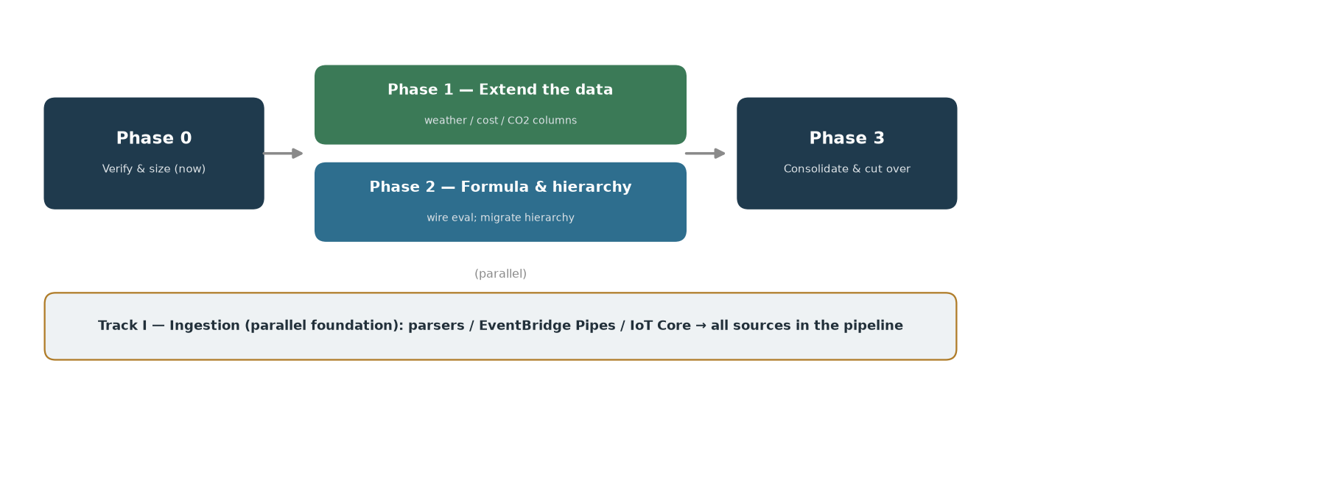
The phased path: verify & size first, then extend-the-data ∥ formula-and-hierarchy in parallel, then consolidate & cut over; ingestion runs as a parallel foundation track.
Phase 0 — Verify & size (now; read-only, parallel; these are the go/no-go gates). - Meter-hierarchy diff harness (§10.2) — run offline via the model’s eval (no pipeline dependency); validate sub→main + calc-formula derivation vs current summation, per company. → gates Phase 2. - Reference-data parity harness (§10.1) — old values vs new denormalized cost/CO2/degree-day columns. → gates Phase 1. - Data-volume sizing (M/N/R/L/S) — confirm the denormalized DDB item is affordable. - Frontend call pattern (values #9 vs aggregate/groupby) + legacy-endpoint traffic (metrics) — scope the real critical path. - Exit: derivation + parity within tolerance; sizing OK; critical path known.
Phase 1 — Extend the data (additive, low-risk; parallel with Phase 2; gated on §10.1 + sizing). Additive to the existing rollup — current reads untouched. - Add location to meter-identity; stand up the weather ref-table (Weatherbit) + broadcast-join into the rollup; LookbackDays ≥ 5. - Own price/CO2 factor ref-tables; broadcast-join cost/CO2 columns. - Add Lane A columns (temp/flow/cooling/VWAT-numerator). - Rename logical_meter_data → logical_sensor_data (sequence with column changes; S3Tables replace). - Exit: measurements_aggregate carries the denormalized columns; reads stay single-key.
Phase 2 — Formula & hierarchy (the hard prerequisite; parallel with Phase 1; gated on §10.2). - Wire formula eval into the pipeline (company-scoped, cycle-safe, cross-sensor refs) → derived-sensor rows. - Migrate the meter hierarchy: old parent_meter → part-of-main refs (auto-netting), calc meters → Expr; populate + validate company by company (offline diff harness §10.2) — the derivation is per-company data, so it can roll out and be checked one company at a time. - Add Lane B Flink columns (active-hours/standby). - Exit: cross-sensor physics + netting materialized; company-by-company parity.
Phase 3 — Consolidate & cut over (last). - Extend the aggregations service to the full analysis surface (filter/groupby/aggregate/values + service-side ratios/resolutions/access-filtering, §5.4). - Subsume consumption-api; collapse computed-benchmark; repoint → fold/re-home the client services (§9.1). - Cutover is a shared switch, not per tenant. The pipeline + services are multi-tenant, so once validation passes across companies, reads move to the new services globally — stageable by capability/endpoint (e.g. get_aggregations first), not by company. Per-tenant cutover would need dual ingestion (both pipelines fed) + per-tenant frontend routing; that’s a separate decision, not assumed here. Retire legacy endpoints once metrics show zero traffic. - Exit: frontend (via yggdrasil temporarily) reads only aggregations + hierarchy.
Cross-cutting (throughout switchover). - me2-events CDC sync → project user/hierarchy/access changes into hierarchy_new/meter-identity until cutover flips source-of-truth (§13 item 13). Treat as one transition-sync design, not user-specific. - Own prices → later; retire energy-cost (§9.1).
Recommended first move: the §10.2 meter-hierarchy diff harness — it validates the biggest thesis (formula derivation), runs offline with no pipeline dependency, and gates the largest build (Phase 2). Every expensive step downstream is gated on Phase 0.

13. Open questions
Decided: denormalize (no read-time joins); columns not rows; LookbackDays ≥ 5 for weather (trigger only as fallback); week/month in-service; formulas as the single substrate with auto-maintained netting; no parallel sensor hierarchy; one/two common services (aggregations + hierarchy) — feasibility confirmed (§9).
Open: 1. Data-volume sizing (§10.1.3) — M/N/R/L/S → confirm item-size/cost before schema-freeze. 2. meter-identity / node-metadata enrichment (§7) — which fields (reading-type, operational-hours, location, tags, counter-role, building keys?), each stamped-at-write vs read-time. Counter-role replaces the TaellerNr primary/secondary/temperature convention (consumers: meter_service, energy-model-v2, consumption-api, ok-carwash-api, report-runner) — expose as resource+meter_type. Building keys (area/heated-area/custom, from keyratio) → node metadata; same current-vs-time-versioned decision. 3. Wire formula eval into the pipeline (§5.5) — the prerequisite for cross-sensor physics in the data; run the §10.2 diff harness offline first. 4. Rename logical_meter_data → logical_sensor_data (S3Tables rename = replace + reload; sequence with column changes). 5. Extra columns — Lane A (temp Σ+count, Σ(flow·temp)+Σflow, flow·Δtemp) + Lane C (hdd,cdd,energy_cc,cost,co2_scope_*); Lane B daily (active_hours,standby_energy). 6. Meter-hierarchy migration (§10.2) — mechanical vs interim dual-run per company, gated on the diff harness. 7. User-facing model (§11) — auto-netting + unified concept vs formula authoring; user-test. 8. Verify legacy consumers — energy-model-service v1 vs v2; benchmark/co2-value vs computed-benchmark; ems-backend/Web legacy endpoints (traffic via the legacy_*_count metrics). 9. Confirm key-values/sum (#10) is aux → exclude. First-reading bound (#2) — rollup vs on-demand (only energy-model-v2). 10. ok-carwash-api (§8) — repoint raw read. 11. Frontend call pattern — does it hit values (#9) or mostly aggregate/groupby? Decides how much of §5 is on the critical path. 12. Middle-tier collapse (§9.1 done, first pass) — logic-depth estimate: only consumption-api (easy) + computed-benchmark (moderate, also eliminate candidate) are subsumable; the rest stay clients that repoint. import-export fails the thin-filter despite being only-via-yggdrasil. Remaining: confirm consumption-api’s me2db reads + computed-benchmark’s DB→rollup path; verify each “stays” service has no other thin-reshape endpoints worth folding. 13. User sync during switchover (§9.1) — hierarchy owns users, but while me2db is still authoritative, project user/access changes into hierarchy_new by consuming the existing me2-events CDC topic (Me2Events → me2-event-stream). Scope the consumer (which Me2Events entity types → hierarchy nodes/users/access edges) and the cutover point where the new system becomes source of truth. (Adjacent to counter-measurement scope — transition dependency.) 14. Cutover model (§12 Phase 3) — default is a shared switch: cut reads over globally, staged by capability/endpoint, once validation passes across companies. Per-tenant cutover (company-by-company live switch) is only viable with dual ingestion (old + new pipelines fed in parallel) + per-tenant frontend routing — decide whether that’s worth building, or whether a global/capability-staged cutover is accepted. Per-company validation is independent of this and stays either way.

