Database Security project

- Introduction
- Brief presentation of the designed model and its rules
The database stores and manages information about the world's football championships, the teams that compete in these championships, as well as the players on the teams. The purpose of creating this database is to be able to retain the history of each football season, played in all countries of the world, in order to not to lose the tradition of this sport loved by many international fans. Each championship can have a sponsor and is divided into several divisions, depending on the quality of the teams that compete in them. A championship has a number of stadiums where the teams that compete can hold games. Any division has associated referees who take part in the matches within the specific division. Football teams have several players in their composition, and each player has certain individual statistics obtained during the games (number of goals scored, number of assists, etc.). Each team is coached by a single coach, who in turn CANNOT coach multiple teams simultaneously, and each coach holds a license that allows him to coach at the highest level. Each team plays multiple games.
- Conceptual diagram
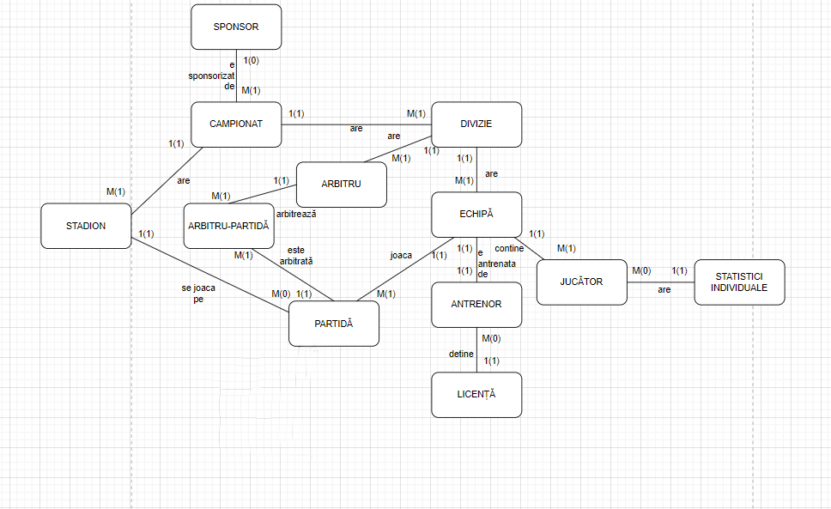
- Relational schemas
- Table creation (separate script)
- Presentation of the security rules to be applied to the model
- Data encryption
- Database activity Auditing
- Standard Auditing
- Audit Triggers
- Audit Policies
- Management of Database Users and Computational Resources
- Designing the identity management configuration in the database (process-user, entity-process, entity-user matrices)
- Implementing the identity management configuration in the database
- Privileges and Roles
- System and Object Privileges
- Privileges hierarchies
- Privileges on dependent objects
- Database Applications and Data Security
- Application Context
- SQL Injection
- Data Masking

