OOP Assignment

*19Z311 -Object Oriented Programming Laboratory*



**19Z308- Bharath S**

**19Z316- Gowtham S**

**19Z330 – Mahesh Boopathy M**

**19Z351- Surtik S**

**19Z360- Venkata Gowtham**

**Problem Statement:**

Developing a Java Program to track student performances of a entire class with the help of a pre-existing CSV file containing information about 60 students and their respective Name, Roll No., and marks in nine different subjects. The program has additional features such as creating new student with 9 marks, calculating CGPA, calculating subject average of entire class and calculation of CGPA differential between average marks and a particular student.

**Class Diagram:**

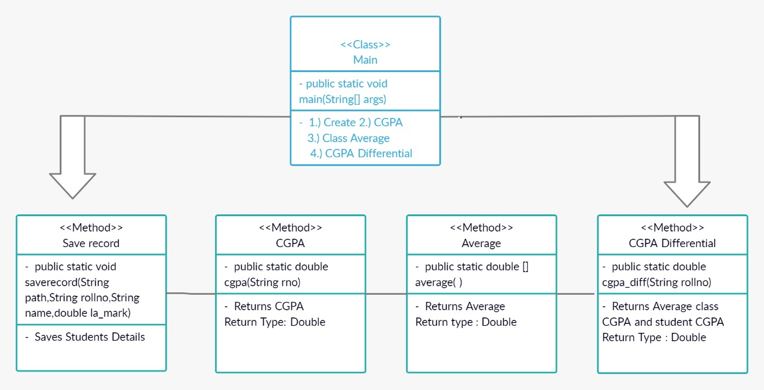

**Features available in the application:**

The Program presents 4 different options to the user once the program is run, They are prompted to input a choice from 1- 4, which would perform the features as below:

**1-Create:**

This takes input for a students RollNo, Name and marks in nine different subjects and appends all of it in the pre-existing CSV file

**2-CGPA:**

Takes a roll number input and calculates the cgpa of the corresponding person from the CSV file and displays it in the console for the user to see

**3-Average:**

Calculates the Average class marks in each and every subject and displays it to the user. This function also displays whichever subject the class is performing the best in and whichever subject the class is performing least well in.

**4-CGPA diff:**

Takes a roll number as input and calculate CGPA of the average class marks and hence we get average cgpa of the class, and it compares this average cgpa with the CGPA of a inputted student and prints the differential between the student and the average CGPA

**Challenges Faced:**

* Learning to read CSV file and access their values to perform calculations on the data and printing it was difficult, Also appending new data to the CSV file was challenging at first as it was a new topic, But it got easier over time.
* Co-operating and doing the project as a team was challenging as we had to design the code mostly over phone or through online meets which wasn’t nearly as efficient as coding together on a system.

**Contribution of Team Members:**

| Student | Function | Usage |
| --- | --- | --- |
| Bharath S | Create | Creates a new Student and appends it to the CSV file in a new line and correct format |
| Surtik S | CGPA | Calculates the CGPA of a student when their RollNo is given as input |
| John Gowtham | Average | This function was used to calculate class average in each subject and also output best performed subject and worst performed subject |
| Mahesh Boopathy | CGPA Differential | Calculates the CGPA differential between a given student and class average CGPA |
| Venkata Gowtham | Main() | Incorporates all the features and access all the functions with objects and gives the user the choices to select whichever feature they want to use |

**Annexure I: Code**

The link to the code in GitHub, and other related files to the project is given: <https://github.com/surtik48/Studentperformancetracker>

**Annexure II – Screenshots of output**

1. Create

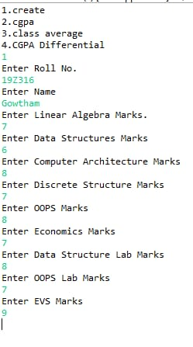

2. Calculating CGPA

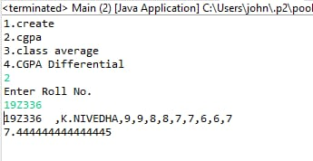

3. Calculating Average

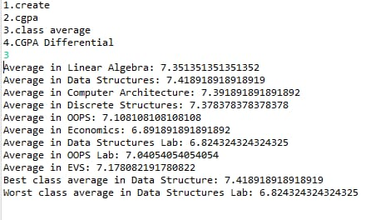

4. Calculation to differential CGPA with respect to class CGPA

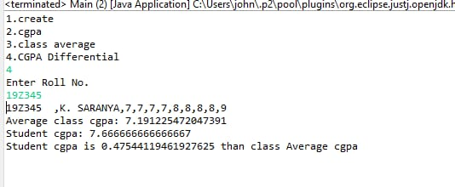

5. Exception for Roll No (Validates only for G2)

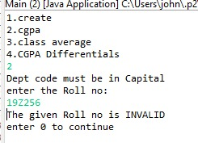

**References:**

For JAVA

* “Java: The Complete Reference” by Schildt H
* W3 Schools : https://www.w3schools.com/java/java_inheritance.asp
* Javapoint : <https://www.javatpoint.com/>

For handling CSV files:

* <https://www.geeksforgeeks.org/reading-csv-file-java-using-opencsv/>
* <https://www.tutorialspoint.com/how-to-read-the-data-from-a-csv-file-in-java>
* <https://mkyong.com/java/how-to-read-and-parse-csv-file-in-java/>

**Plagiarism Report:**

