**Balancing Food Need with Dietary Recommendation**

Caitlyn’s thesis addresses Food Need in pages 9-12. On page 11 she balances food availability with food availability with dietary recommendation and coverts servings to tonnes as following:

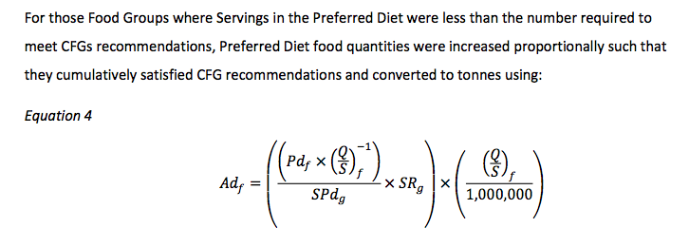

* Pdf  - **Kg** of food in the preferred diet
* SPdg – **Servings** of food in the preferred diet
* (Q/S) – **kg/serving** (the value is available as kg/serving but we need it as serving/kg thus we put it to the power of -1 to get the inverse)
* SRg – **Servings** of food in the preferred diet

I’ve visualized this equation in the context of the overall calculation of food need as such:

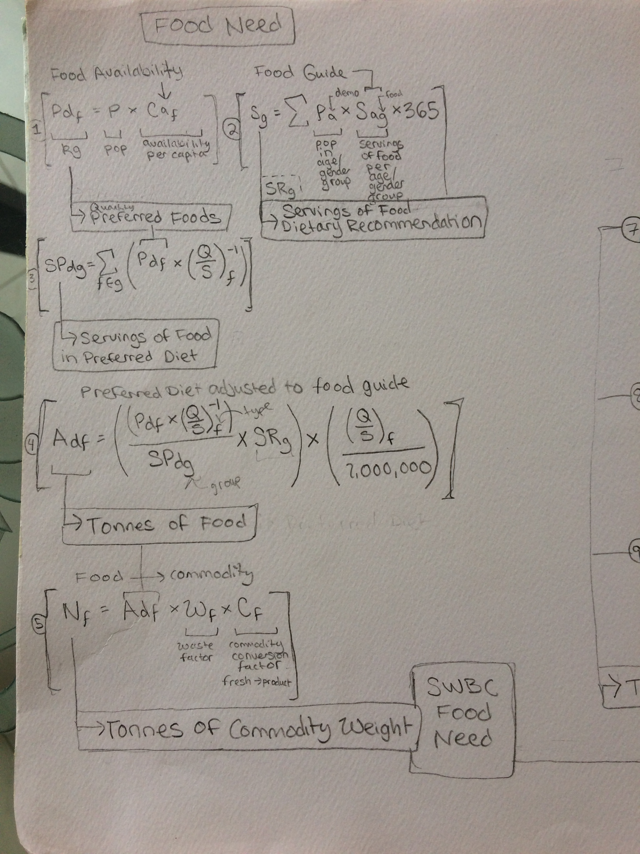

In this step we want to:

1. Find out how much more the dietary recommendation per food group per age group differs from the actual food availability.
2. When the recommendation exceeds the availability we want to adjust the food availability values up proportionally to this difference.
3. Availability of foods in kg must be converted to servings to compared to the recommendation, converted back to kg, then to tonnes.

Here is how I did it. First I converted all the availability data from **kg to servings** by multiplying by the reference value stored in a units table I made.

Then I downloaded the population data and made an excel file containing the dietary recommendation for each age group. I manually multiplied the recommendations by 365 to get the years recommendation per age group. Then I populated my population table with the yearly recommendations for each age year like so:

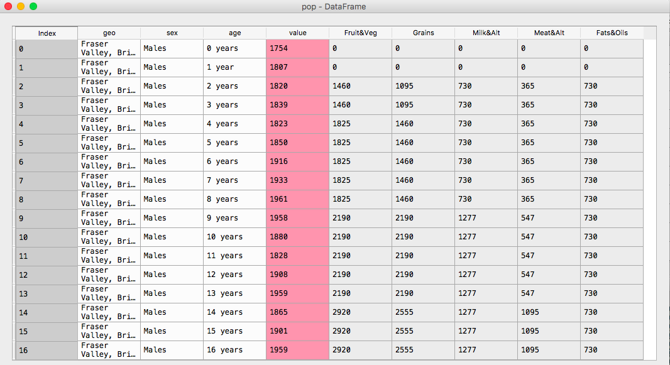

* Value –number of people in the age/region/gender group
* All other columns are the recommended yearly servings for each food group people in that age/region/gender group.

But we need to compare to the food availability, which is for the **average individual** in Canada. I **assumed a normal distribution** for the population data (I will need to verify this quickly using R). To find the total number of servings of each food group recommended in SWBC, for each food group I multiplied the value column by the recommended servings column and divided by total population of SWBC (the sum of the values column). This gave me the dietary recommendation by food group for the **average person in SWBC.**

In the code this looks like:

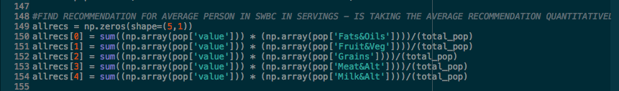

The result was then stored in a table called **allrecs,** a list of the dietary recommendations for the five food groups for the **average person on SWBC.**

Then I needed to find out what percent of the dietary recommendation was met by the food availability. I summed the values of available food in **servings** by group, giving me five values for the availability of the food in each group.

Then I divided the recommendation/availability to get the percent of the food group recommendation met by the food availability:

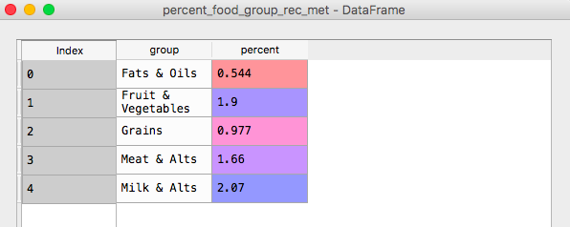

Ok. So we can see that the recommendation exceeds availability for Fruits & Vegetables, Meat & Alt, Milk & Alt. So all foods in these categories will need to be adjusted upwards.

So I just multiplied the **food availability in kg** by any percentage >1 that corresponds to that foods group. So the availability of all Fruits and Vegetables was multiplied by 1.9, etc.

I multiplied the balanced food in **kg** with 1000 to get **tonnes**.

I multiplied this by the **waste factor** and **commodity conversion** factor to get **food need** as a new value stored next to original availability in a table of all foods in SWBC.

I definitely did it differently than Caitlyn did in her thesis. I suspect the weakest part of my process has to do with taking the average recommendation in SWBC.

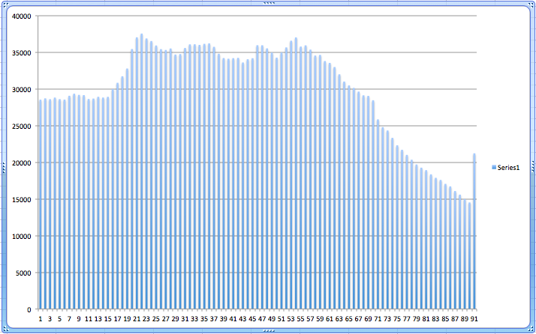

I made a histogram of the population of SWBC and the distribution looked normal enough for me to feel ok taking the average. A secondary check would be to run a Chi-square test.

I’m curious to hear about what you think of what I did. I tried to follow Caitlin’s logic but I don’t follow her formulas. I think the steps we took were similar but we executed them in a different order. Let me know what you think. I’m happy to recess and change things that do not produce the same results. Best,

-Rachel