**Yield Data Acquisition**

1. **CANSIM Table 001-0010 ("production"/"seeded area") (Statistics Canada, 2014)**



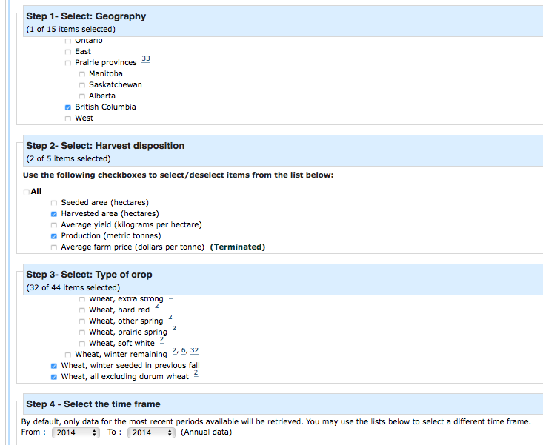

1. Download the file for database loading (as always)
2. Navigate to the downloaded file in your downloads folder. Open in, click Save As, save to the ‘m1.data’ folder and change file name to **cansim0010010.XXXX.csv** where XXXX is the digits of the year the population data is from.
3. Go to line _ in the code and change the ‘cansim00010010.XXXX.csv’ to match the exact name of the file in your working directory.
4. **CANSIM Table 001-0009 ("marketed production"/"cultivated area"), (Statistics Canada, 2014)**

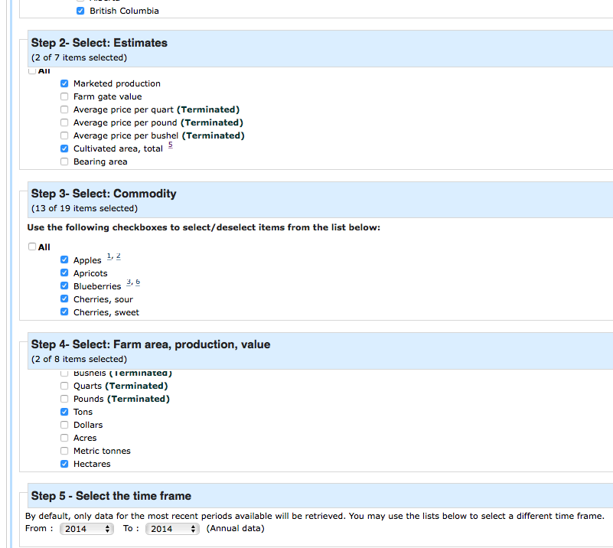

1. Download the file for database loading (as always)
2. Navigate to the downloaded file in your downloads folder. Open in, click Save As, save to the ‘m1.data’ folder and change file name to **cansim0010009.XXXX.csv** where XXXX is the digits of the year the population data is from.
3. Go to line _ in the code and change the ‘cansim00010009.XXXX.csv’ to match the exact name of the file in your working directory.
4. **CANSIM Table 001-0013 ("marketed production"/"seeded area"), (Statistics Canada, 2014)**

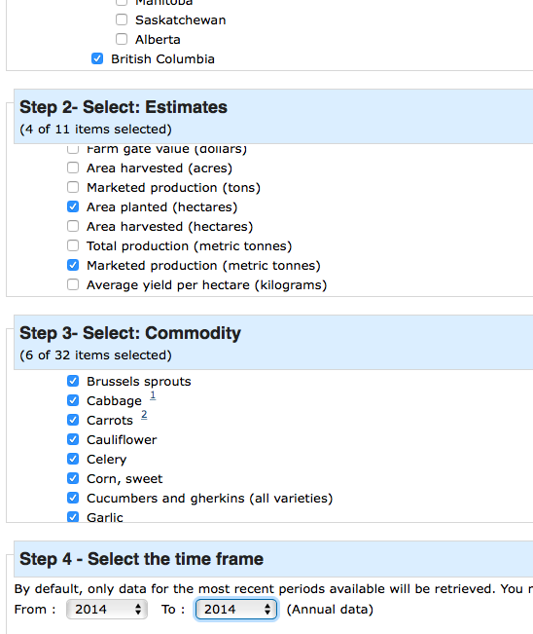

1. Download the file for database loading (as always)
2. Navigate to the downloaded file in your downloads folder. Open in, click Save As, save to the ‘m1.data’ folder and change file name to **cansim0010013.XXXX.csv** where XXXX is the digits of the year the population data is from.
3. Go to line _ in the code and change the ‘cansim00010013.XXXX.csv’ to match the exact name of the file in your working directory.
4. **CANSIM Table 001-0012 ("production, fresh and processed"/"area beds total"), (Statistics Canada, 2014)**
5. **CANSIM Table 001-0014 ("marketed production"/"seeded area"), (Statistics Canada, 2014)**
6. **CANSIM Table 001-0006, (Statistics Canada, 2014)**