LuckLotter - AI Retention Layer
  - Demo walkthrough and design notes - Phase 1 MVP
Table of Contents

This document is written to be read in two ways. Follow the Demo script top-to-bottom while driving the app, and hand the Design decisions and Edge cases sections to a reviewer who wants to know why it behaves the way it does. Every screenshot here is the real application against seeded data — none of it is a mockup.

1. What the product does
A café keeps a customer’s transactions in its till system and never looks at them again. LuckLotter reads that same POS data and answers one question the till cannot: which of my regulars have quietly stopped coming?
The engine does three things, in order:
- Learns each customer’s own visit rhythm from their transaction history.
- Flags a customer when they go quiet relative to that rhythm — not against a fixed number of days.
- Generates and sends a win-back offer, carrying a redemption code, and closes the flag by itself when the customer comes back.
The whole point is the word own. A daily regular missing for two weeks and a monthly regular missing for two weeks are not the same event, and a single “inactive after 30 days” setting cannot tell them apart.

The trigger, in one line
flag when days_since_last_visit
> clamp(avg_interval_days × sensitivity_multiplier,
min_threshold_days, max_threshold_days)
avg_interval_days is the customer’s learned cadence. The multiplier and the two clamps are the only things the business tunes. Both the threshold and the cadence are snapshotted onto each flag, so a flag stays explainable after the business later retunes its settings.

Stack
Layer | Choice
Backend | Spring Boot 3.3 / Java 21, Postgres 16, Flyway, JWT
Frontend | Angular 19 standalone components, served by nginx
Mail | SMTP, caught by a Mailpit container in the demo
Infra | Docker Compose; Coolify on a single VPS as the deploy target

2. Running the demo
Docker is the only prerequisite — no local JDK, Maven, or Node.
cp .env.example .env # set SEED_ENABLED=true before the first start
docker compose up --build
Dashboard | http://localhost:4200
API | http://localhost:8080
Offer inbox (Mailpit) | http://localhost:8025
Sign in with SEED_ADMIN_EMAIL / SEED_ADMIN_PASSWORD (defaults admin@lucklotter.test / demo-password-123).
The seed creates one business — Kaldi’s Coffee House — and a set of customers whose visit histories are built to exercise every path: customers who should flag, customers still on cadence, customers with no contact details, and customers with too little history to judge. Seeding is skipped entirely if any business already exists, so it can never touch real data.
Two things to know before you present. Offer emails are really sent over SMTP — the template, the transport, the status transitions and the failure-code mapping all execute. They are caught by Mailpit, so nothing can reach an actual person, which is what makes it safe to point at seeded customers. And nginx proxies /v1 from port 4200, so the browser only ever talks to one origin and the API needs no CORS configuration anywhere.

3. Demo script
Seven steps. Each one names what to say and what it actually proves.

Step 1 — Sign in
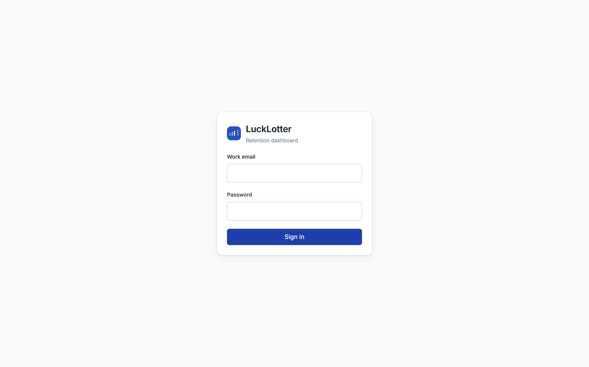
Login screen
Everything except login and /actuator/health sits behind the JWT filter — SecurityConfig is anyRequest().authenticated(), not a list of protected paths, so a new endpoint is private by default rather than public by accident.
JWT_SECRET comes from the environment with no fallback in committed config: a misconfigured deploy fails to boot rather than starting up signing tokens with a default everyone can read.

Step 2 — Overview: is this working?
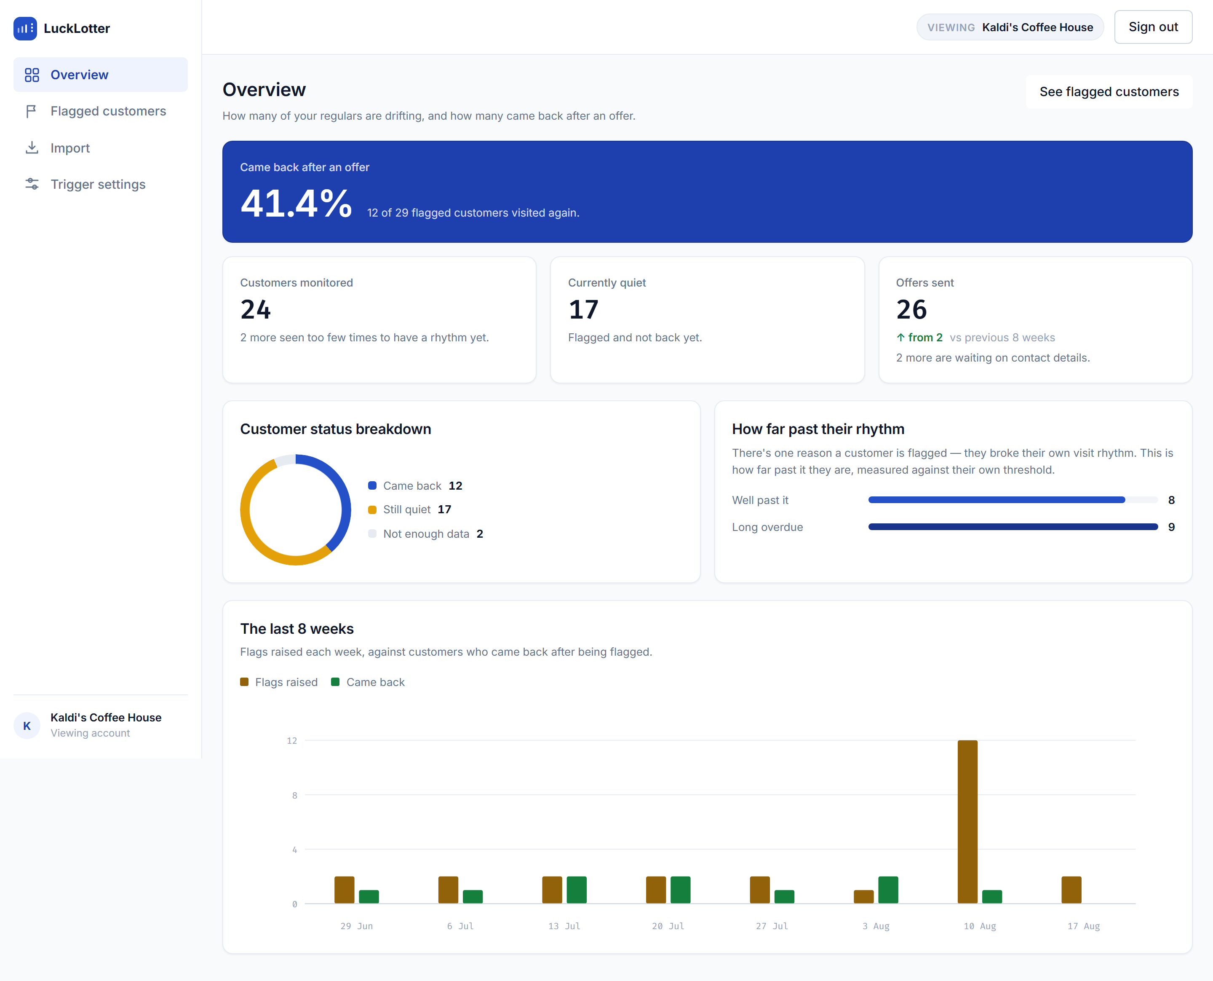
Overview dashboard
Say: “This is the number the owner cares about — of everyone we flagged, how many actually came back.”
Every figure on this page is a real aggregate from a single endpoint (GET /v1/stats/overview); nothing is reconstructed in the browser. Worth pointing at:
- Came back after an offer — the headline recovery rate, with the raw fraction beside it so a small denominator can’t hide behind a percentage.
- Customers monitored names, separately, how many were seen too few times to have a rhythm yet. Those customers are not failures and not flaggable — hiding them would overstate coverage.
- How far past their rhythm buckets the open flags by how badly the rhythm was broken. This is the panel that tells an owner whether sensitivity is set usefully.
- The last 8 weeks puts flags raised against customers who came back, so the two series can be read against each other rather than in separate charts.

Step 3 — The flag list: the evidence, per row
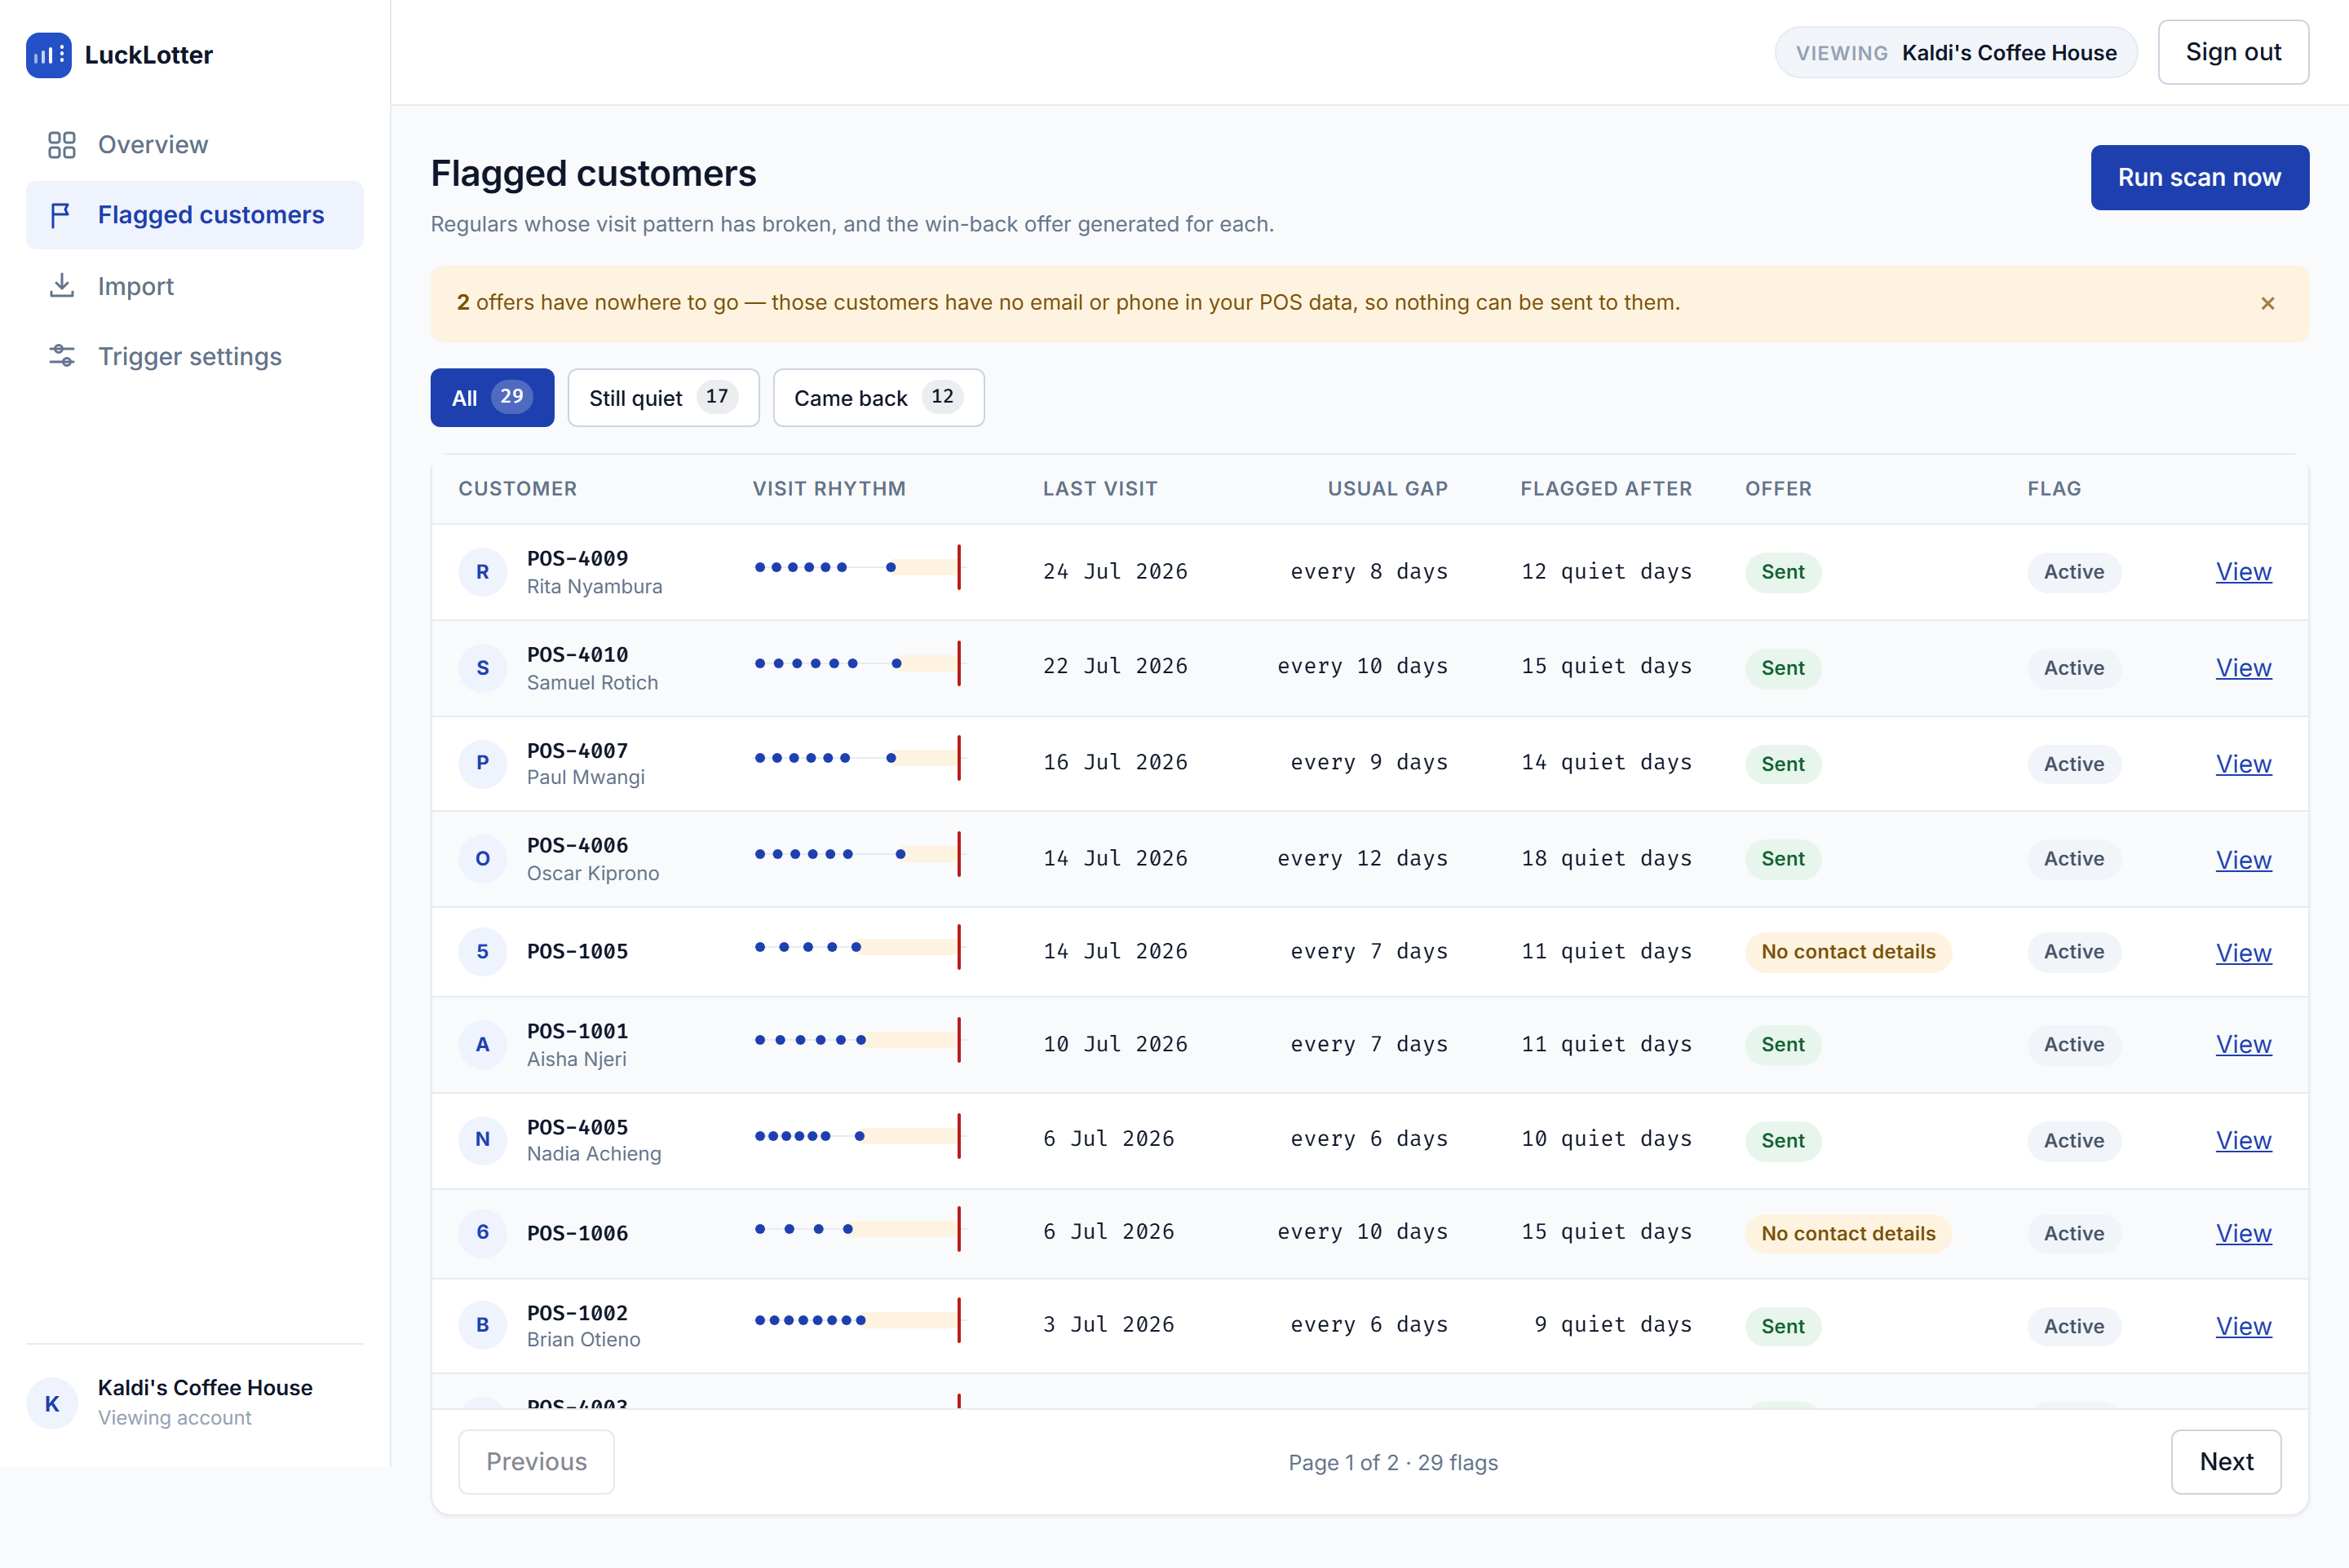
Flagged customers
Say: “Each row carries its own evidence. You never have to trust the flag — the reason is on the row.”
- The visit rhythm sparkline draws real recorded visits, the quiet stretch, and the moment the flag was raised. Twelve visits maximum, so a row stays a row.
- Usual gap and quiet days are the two numbers the trigger compared.
- The amber banner counts customers who were flagged but have no email or phone. That gap is deliberately visible — see Edge case 3.
- The filters (All / Still quiet / Came back) are counts, not just labels.
Press Run scan now, then press it again. The second run flags nobody. That is not the loop being careful — it is a partial unique index in Postgres enforcing at most one open flag per customer. See Edge case 5.

Step 4 — One flag in full
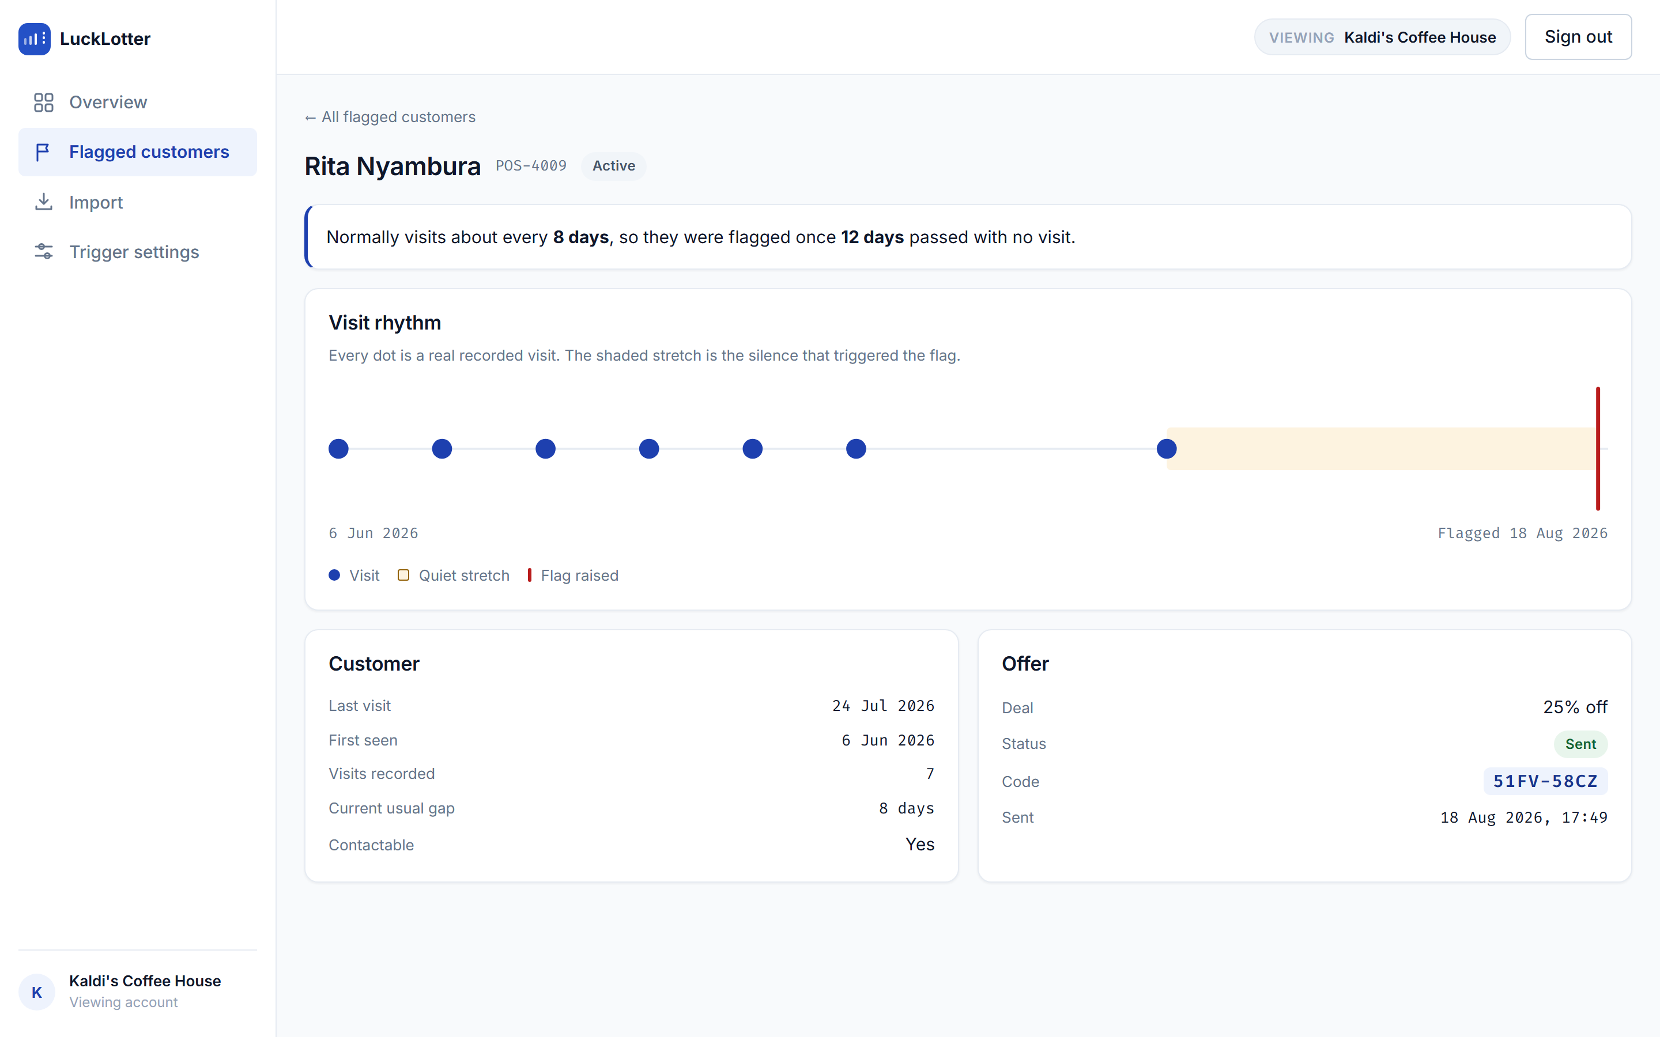
Flag detail, offer sent
Say: “This is the page that has to survive an owner asking why did you email my customer?”
It answers in plain language first — normally visits about every 8 days, so they were flagged once 12 days passed with no visit — and then shows the timeline as visual evidence for those same two numbers. The offer, its delivery state, and the redemption code the customer quotes at the counter sit underneath.
The customer’s name leads and the till reference sits beside it, because the reference is what the owner can actually look up in their own system.
…and the same page once they come back:
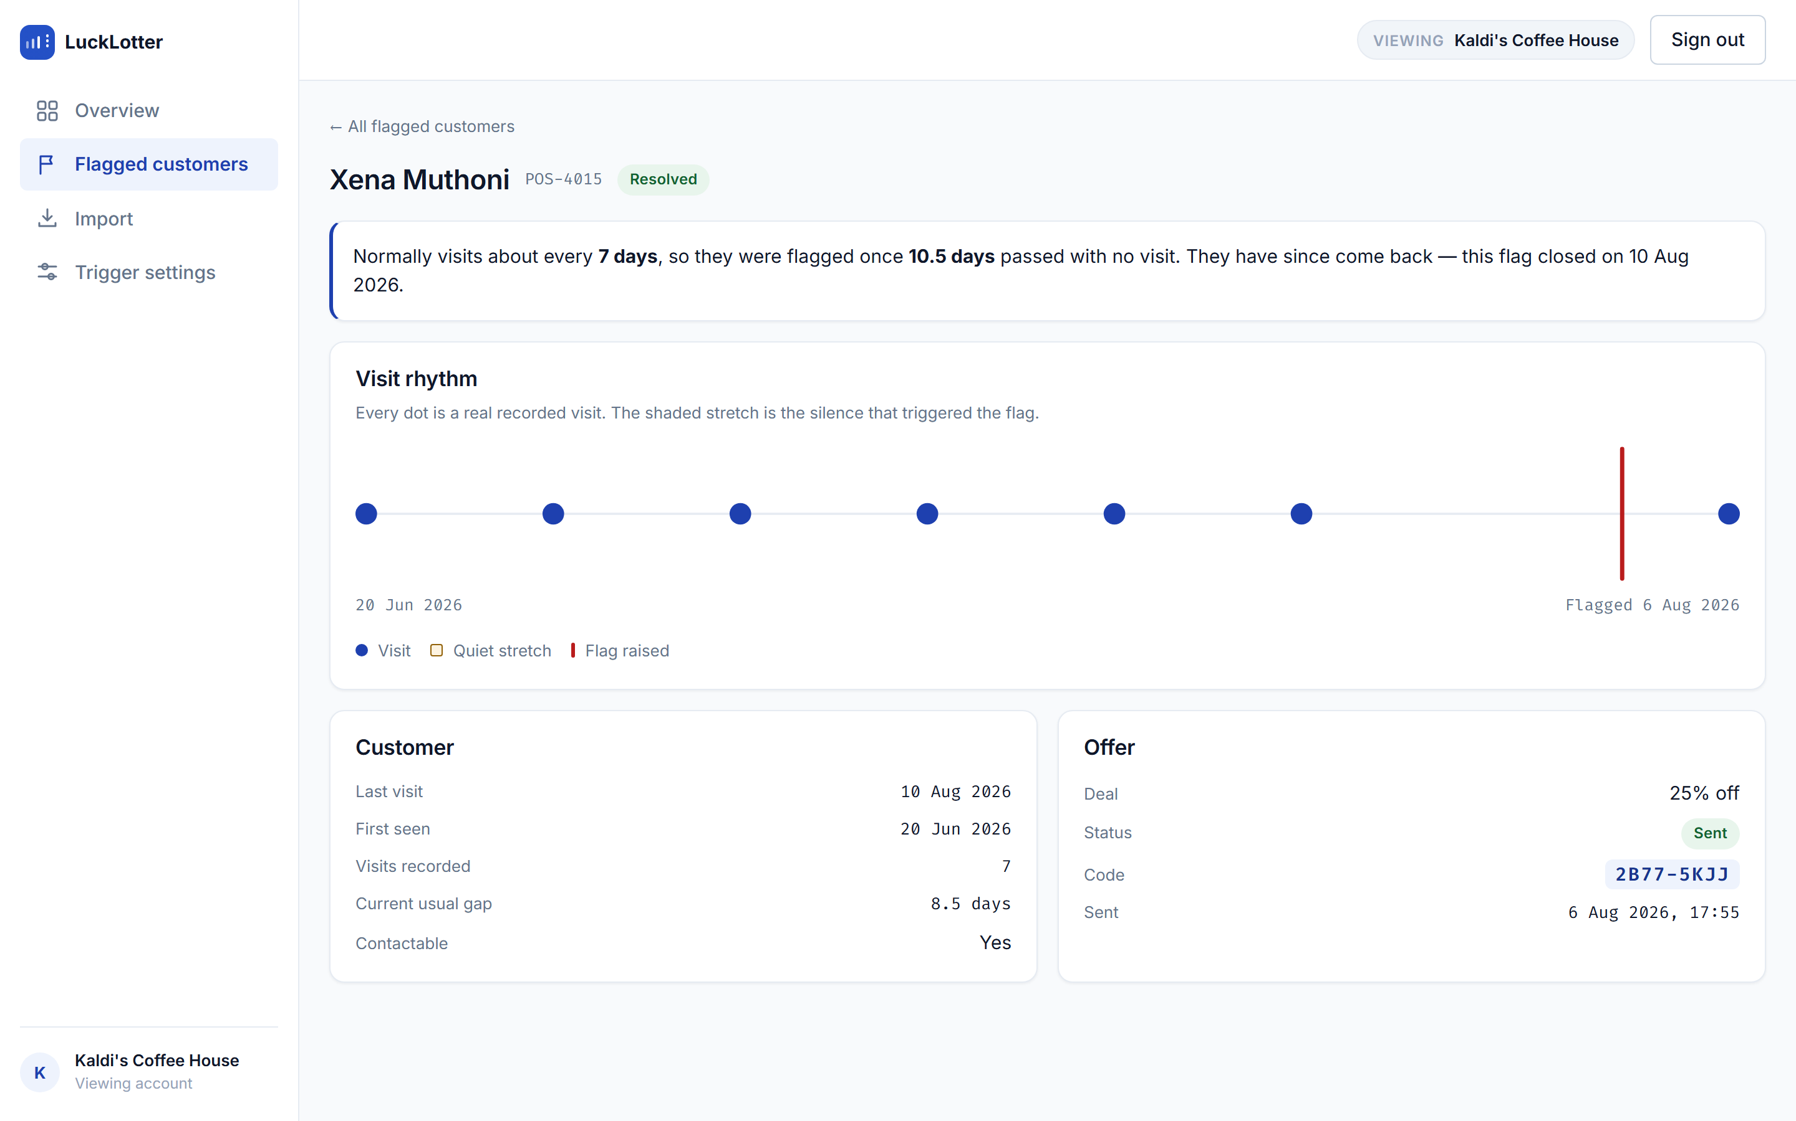
Flag detail, resolved
Note the last dot, sitting to the right of the flag marker — that is the return visit, and it closed the flag by itself. The explanation gains one sentence rather than changing into a different page. Nobody clicked anything: the flag was answered by a transaction arriving from the till.
The Came back filter on the list is the same set, counted:
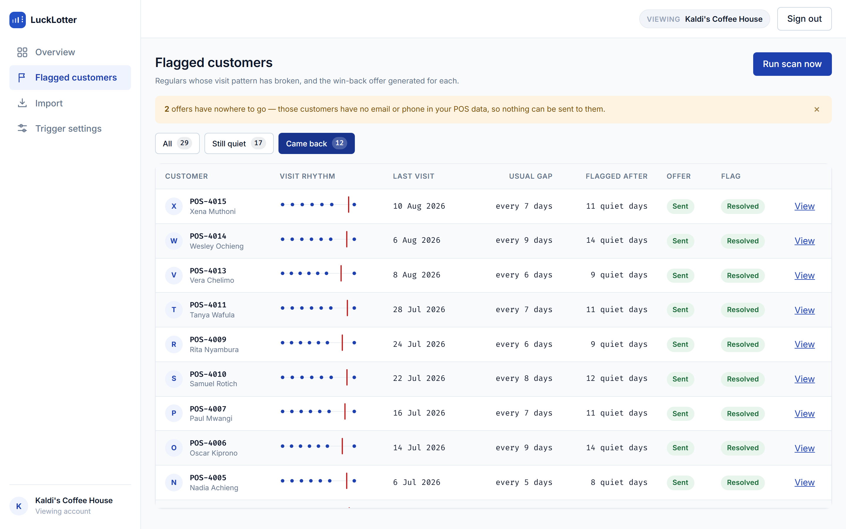
Flagged customers, came back

Step 5 — The offer that was really sent
Open http://localhost:8025 — the Mailpit inbox catching everything the app sends:
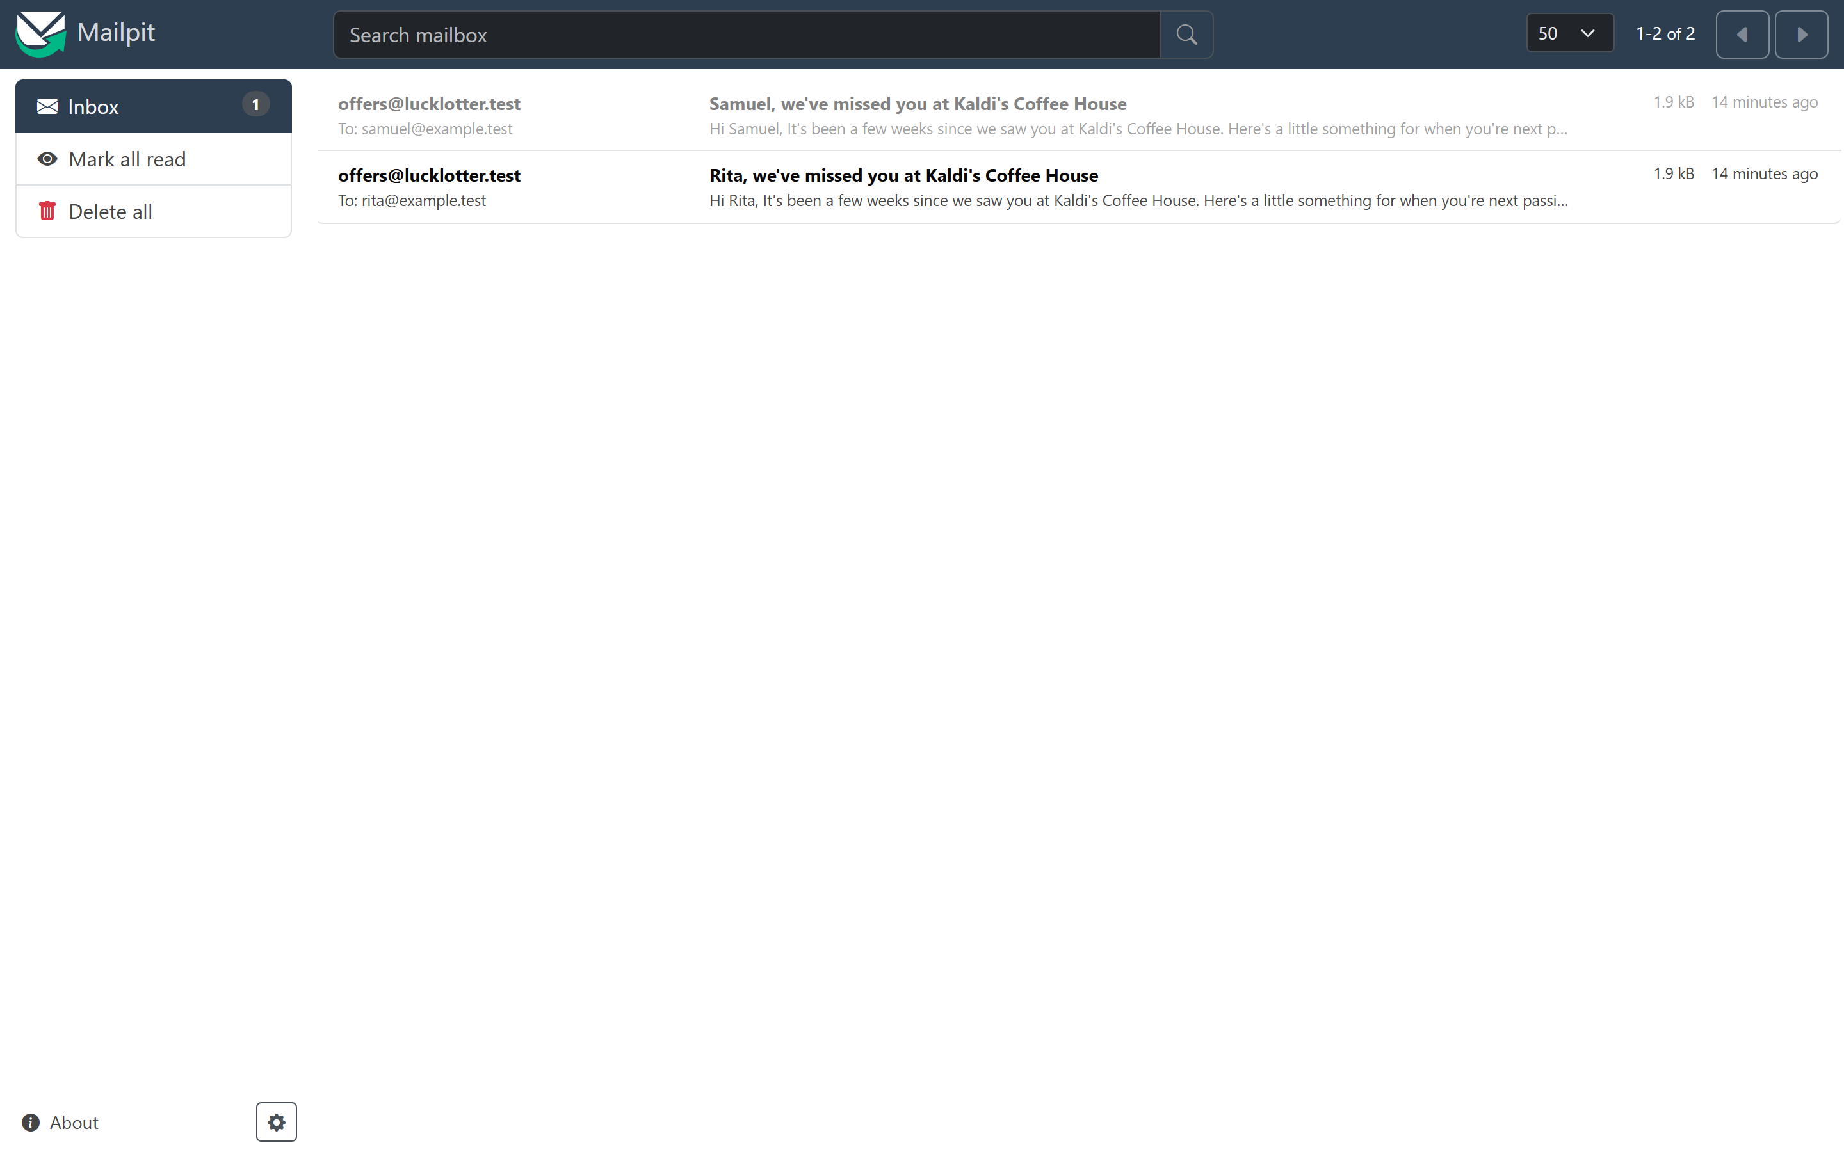
Offer inbox
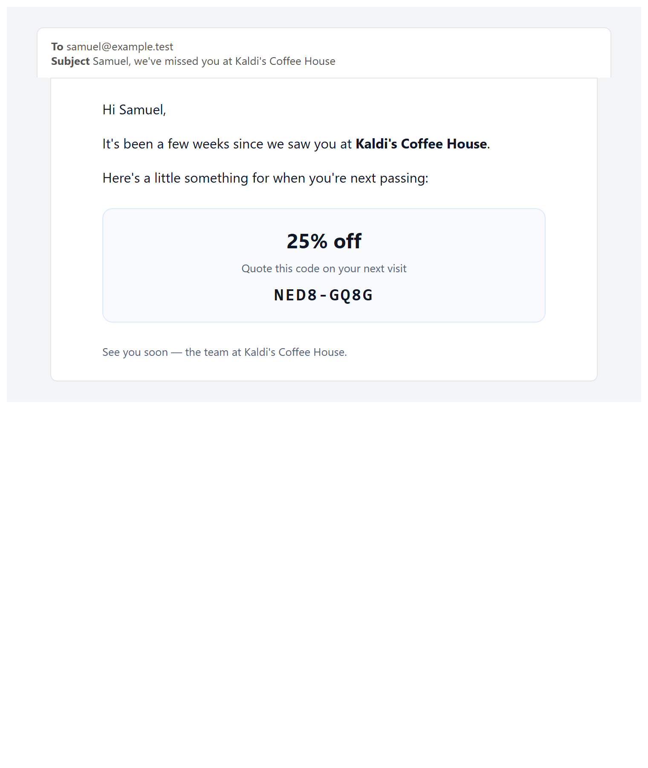
Offer email
The email is addressed by name, names the business, and carries the same redemption code shown on the flag detail page. Where the POS supplied a “usual order”, the copy uses it; where it didn’t, the sentence simply omits it rather than printing an empty slot.

Step 6 — Tuning the trigger
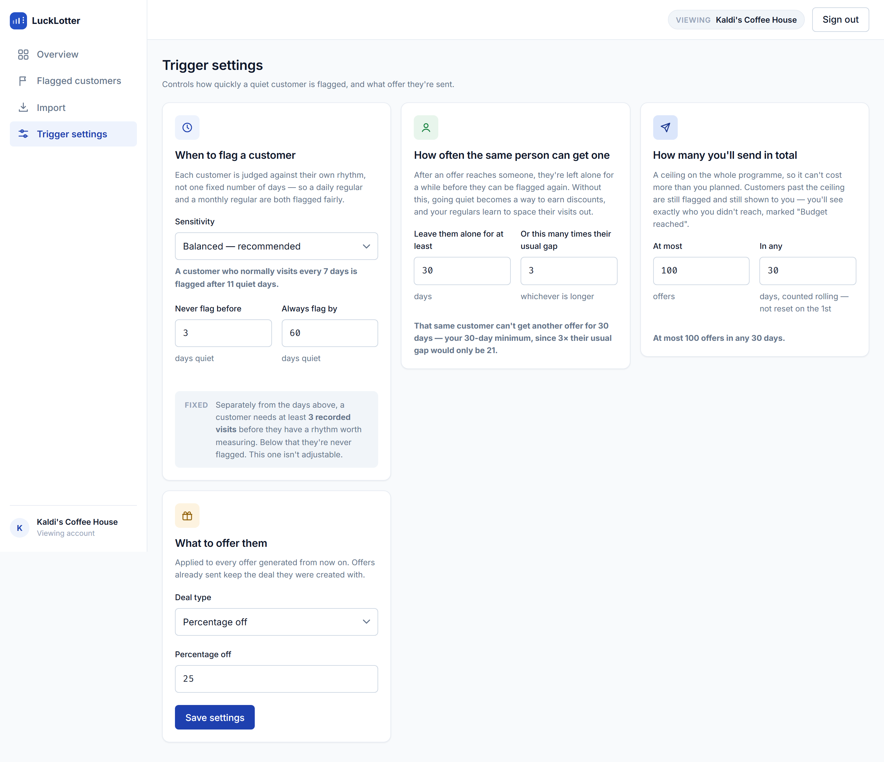
Trigger settings
Say: “The owner never sees the multiplier. They see what it does.”
Sensitivity is presented as named choices with a worked example that updates live — “a customer who normally visits every 7 days is flagged after 11 quiet days” — because 1.5 means nothing to a café owner. The same treatment is applied to the cooldown and the budget ceiling: each card states, in a sentence, what the numbers currently in the boxes will actually do.
The three cards are the three separate bounds the system needs, and they are deliberately not merged:
Card | Bounds
When to flag | how quickly a lapse is noticed
How often the same person can get one | what one customer can extract
How many you’ll send in total | what the programme can cost
The greyed fixed note explains the one constant that is not tunable: three visits before a customer has a rhythm worth measuring.

Step 7 — Importing a real POS export
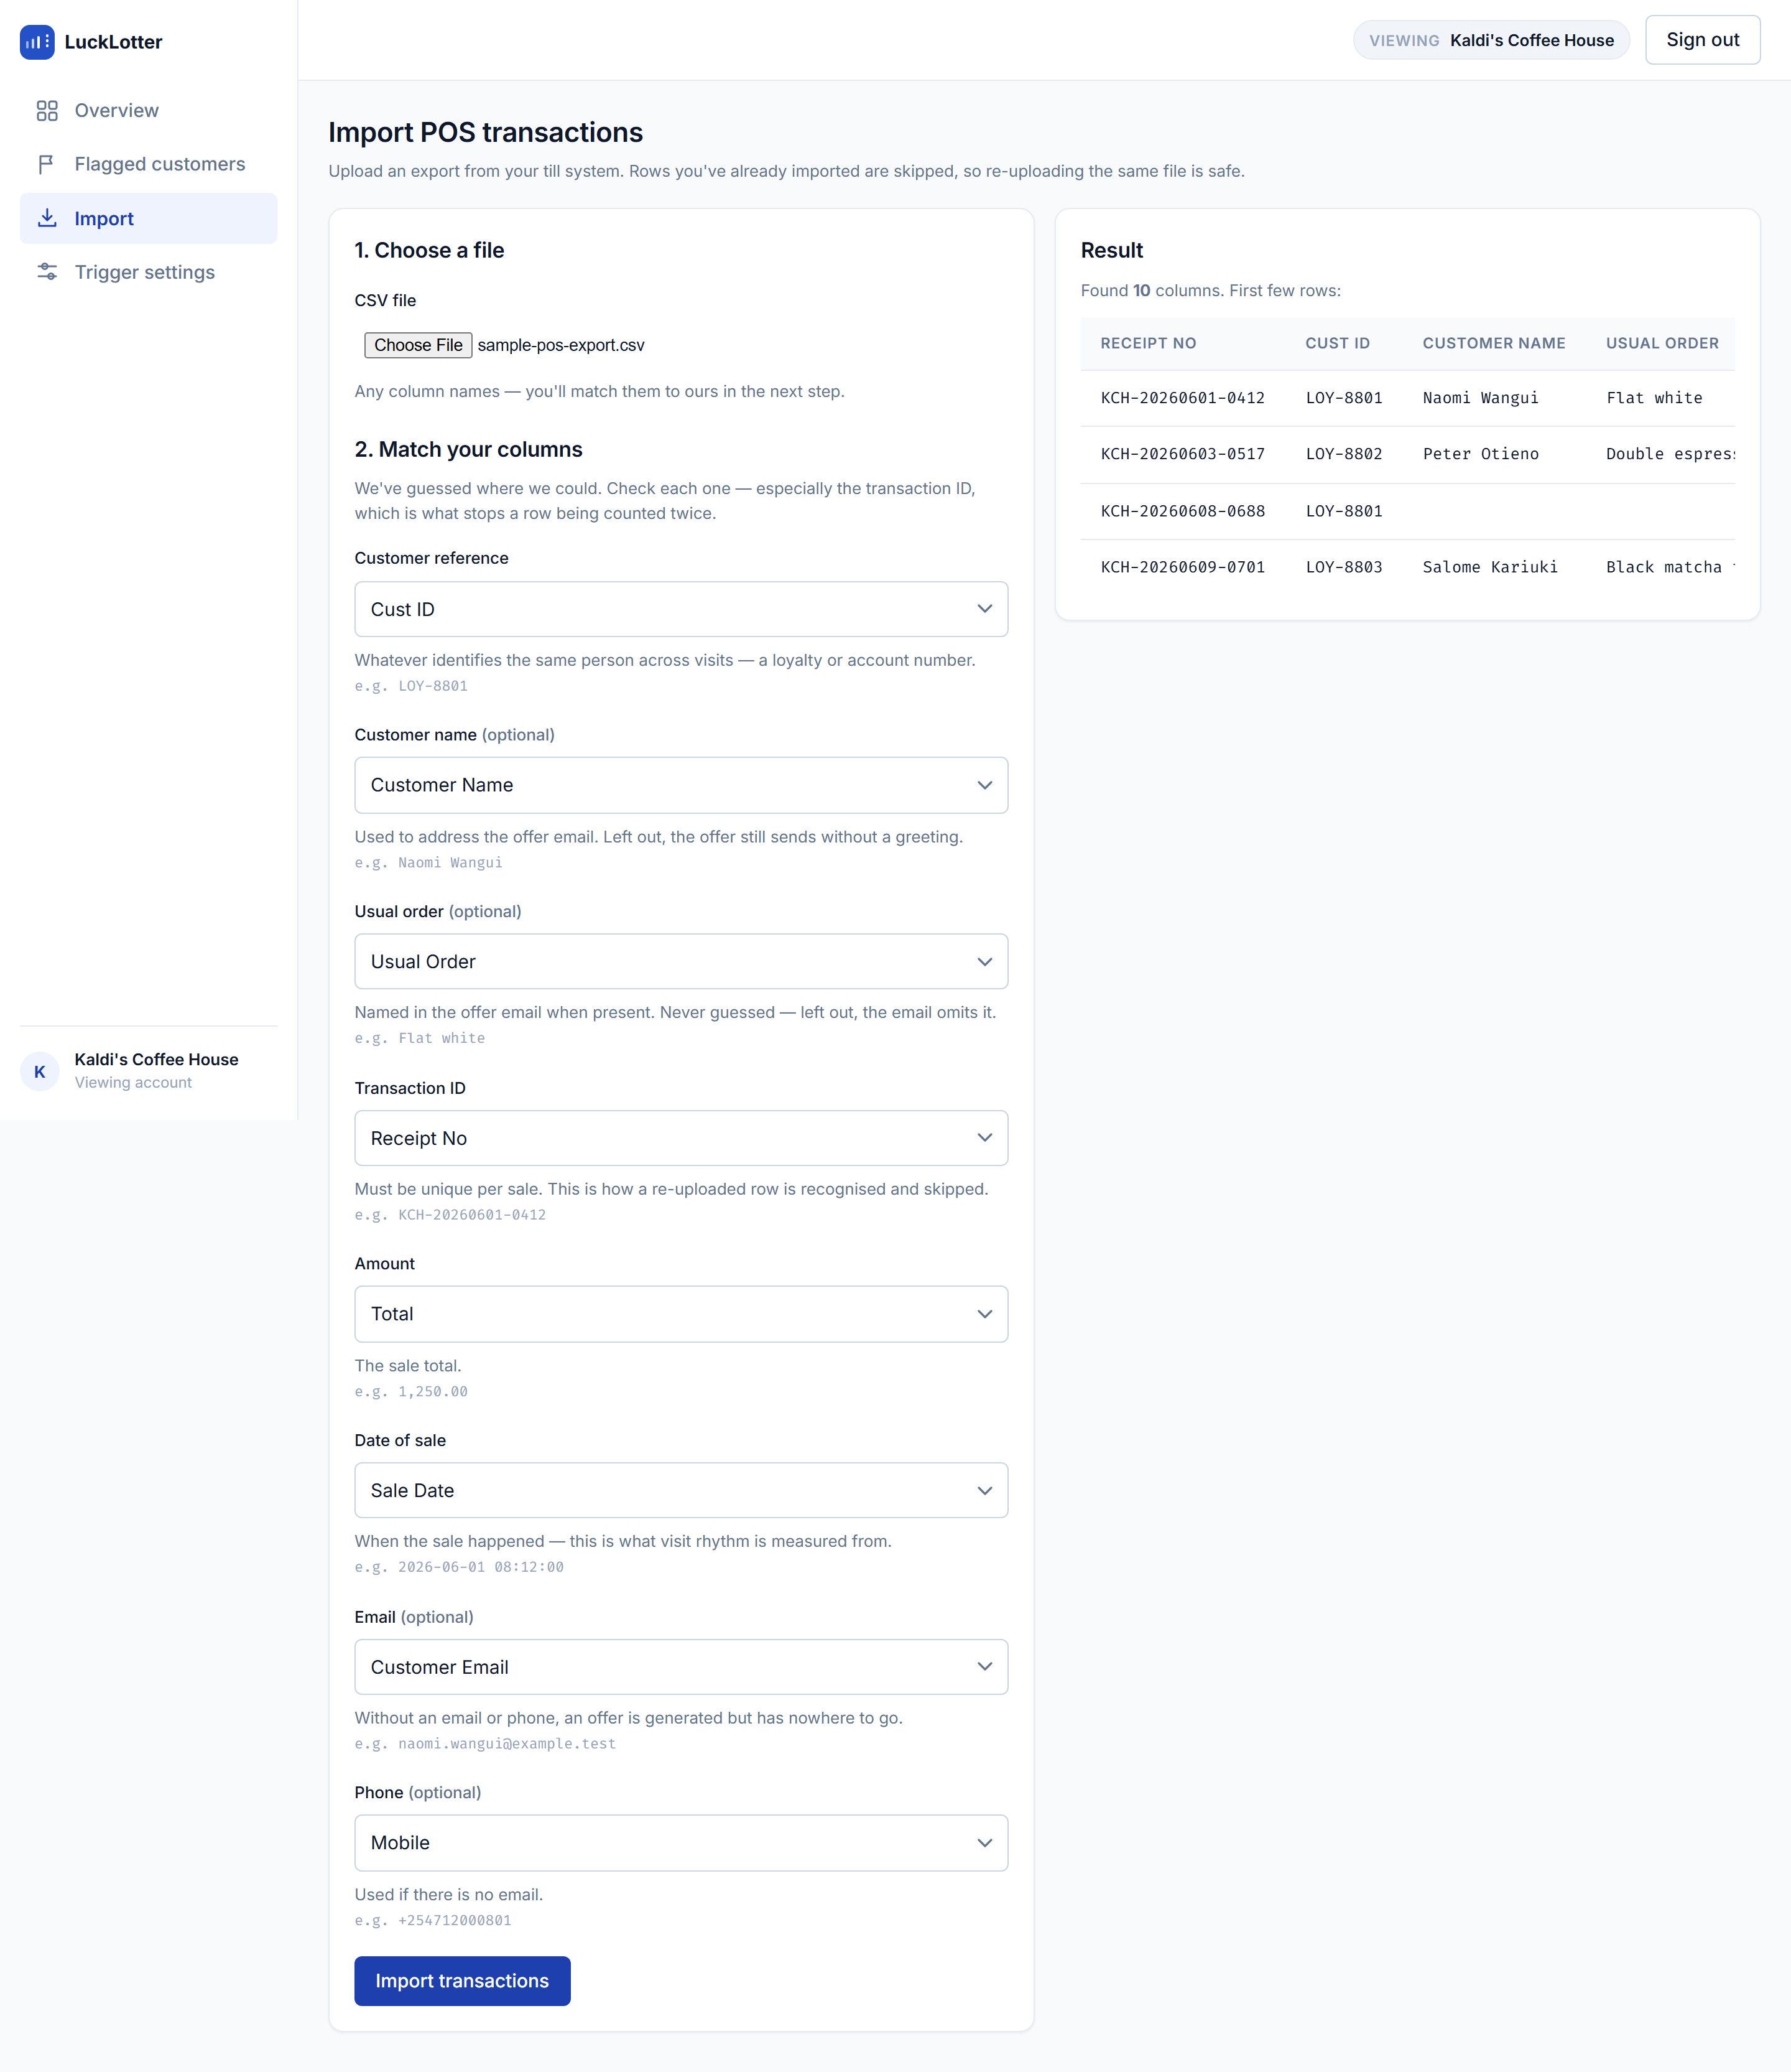
CSV column mapping
Say: “No two till vendors agree on column names, so we don’t guess silently.”
docs/sample-pos-export.csv uses a different vendor’s headers — Receipt No, Cust ID, Sale Date, Total. The importer reads the file server-side, returns its real headers and sample rows, pre-fills a mapping, and makes the admin confirm it. Each field shows a live sample value from their own file, so they can verify rather than trust.
The transaction-ID column gets its own warning, because guessing it wrong is the one mistake that breaks idempotency invisibly — and idempotency is what makes re-uploading the same export safe. Import the file twice: the second run reports 25 duplicates and imports nothing.

4. Design decisions worth defending

The interface explains itself in the domain’s language
No screen shows a raw enum, a raw multiplier, or a raw error code as the primary information. SENDER_UNAVAILABLE becomes “The mail service was unavailable. This will be retried.” — with the code kept in small print underneath, because that is what support will ask for. The sentence is a translation, not a replacement.

Sidebar, decided against an earlier call
The app originally used a top nav, on the reasoning that four destinations don’t earn a permanent ~240px column and the flag table wants the width. That cost is real and is now being paid. What changed is the judgement: a persistent left rail reads as an operations tool rather than a settings page, and it gives the tenant identity a fixed home instead of competing with navigation across the top.
The supplied mockups showed a sidebar and a top nav carrying the same four destinations. The duplicate was deliberately not implemented — two copies of the same navigation double where a user has to look and take back the vertical space the sidebar just spent. The top strip keeps only what is about the session: which business is on screen, and how to leave.

Tenant context is a control, not a subtitle
“Viewing Kaldi’s Coffee House” is a bordered chip next to Sign out — the control that changes it — rather than a caption under the product name. Every number on every screen is scoped to that business, so which business it is has to be a fact you cannot miss.

Success is a toast; failure is not
Saving settings raises an auto-dismissing toast. Save failures deliberately stay as inline banners: a message the admin has to act on should never clear itself on a timer. The toast host is mounted once in the shell as an always-present aria-live region, so the announcement is reliable rather than racing the element’s own insertion.

Responsive by degradation, not by hiding
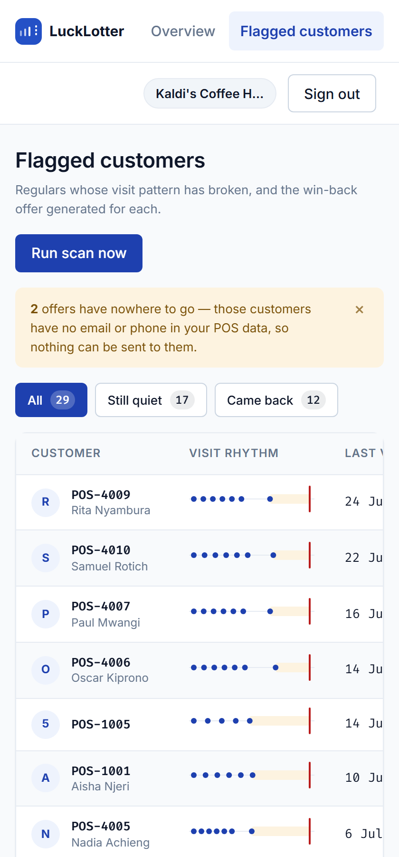
Flag list on a phone
At ≤900px the rail becomes a horizontal scroller — costing height rather than half the viewport — and the flag table scrolls sideways with the customer column readable. At ≤560px the tenant chip sheds its label but keeps the name. Nothing is removed at small sizes; it is re-laid-out.
On a tablet the rail moves to the top strip and the content takes the full width — the stat row and the two analysis panels keep their shape rather than being squeezed:
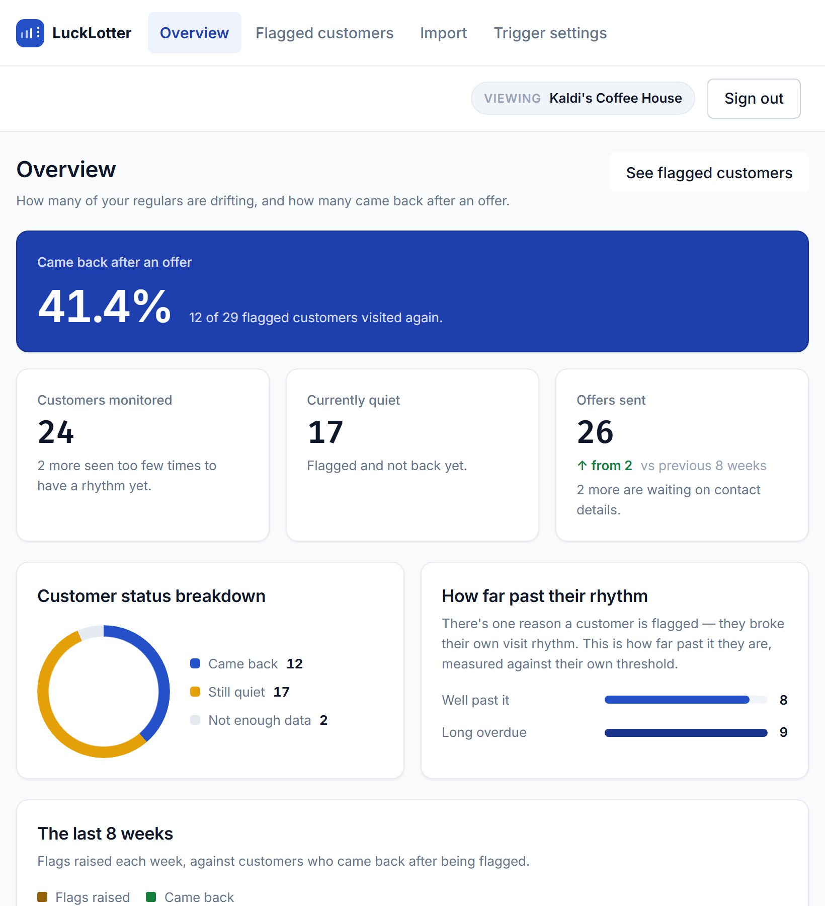
Overview on a tablet

The logo is the product’s own behaviour
An even rhythm, one beat missing, and a dashed marker where the gap was noticed. It is the only thing the system does, drawn at 28px.

5. Edge cases
This is the section most worth a reviewer’s attention. Each of these is a real decision with a real consequence, and each is enforced somewhere specific.
# | Situation | What happens | Enforced by
1 | Same POS transaction sent twice | No-op, reported as a duplicate | Unique (business_id, external_txn_id)
2 | One visit rung up as three receipts | Counted as one visit | MIN_VISIT_GAP = 6h
3 | Customer with no email or phone | Offer generated, marked NO_CONTACT | Offer.markNoContact()
4 | Mail server down | FAILED with a retriable code; flag survives | OfferSendService, REQUIRES_NEW
5 | Two scans overlapping | At most one open flag per customer | Partial unique index
6 | Backdated transaction imported | Does not close an open flag | IngestionService.resolveOpenFlag
7 | Customer lapsing on purpose | Cooldown, scaled to their own rhythm | Business.cooldownDaysFor
8 | Programme costs more than planned | SUPPRESSED_BUDGET, still visible | Row lock + rolling window count
9 | Too little history to judge | Never flagged, counted separately | MIN_TRANSACTIONS = 3
10 | Another business’s flag ID | 404, not 403 | findByIdAndBusinessId
11 | Third-party error text in logs | Scrubbed | Redact.scrub
12 | Unknown URL | 404, not 500 | NoResourceFoundException handler

1. The same transaction arrives twice
A POS integration retries. Replaying a transaction is a no-op, not a second visit — the ingest endpoint detects it and returns "duplicate": true without writing anything. If two identical requests race, the unique constraint catches the second and it answers 409, not 500.
This matters more than it sounds: a duplicated row would shorten the customer’s learned cadence, which drags their flag threshold down and wins them an offer sooner than their real rhythm justifies.

2. A split bill is one visit, not three
A POS export is a list of sales, not a list of trips to the counter. One visit routinely arrives as several rows — a split bill, items rung up separately, a till that exports line items.
Transactions within six hours of each other are collapsed into one visit before anything is measured, including the three-visit minimum. So three receipts from a customer’s first and only visit is still no cadence, rather than a very short one.
Six hours separates “paid in three goes at one counter” from “came back later in the day”, which is a real second visit and must survive. It is also a floor on the average, so the cadence can never round to zero.
This is both the commonest accident on honest data and the cheapest way to game the trigger on purpose.

3. A customer with no contact details
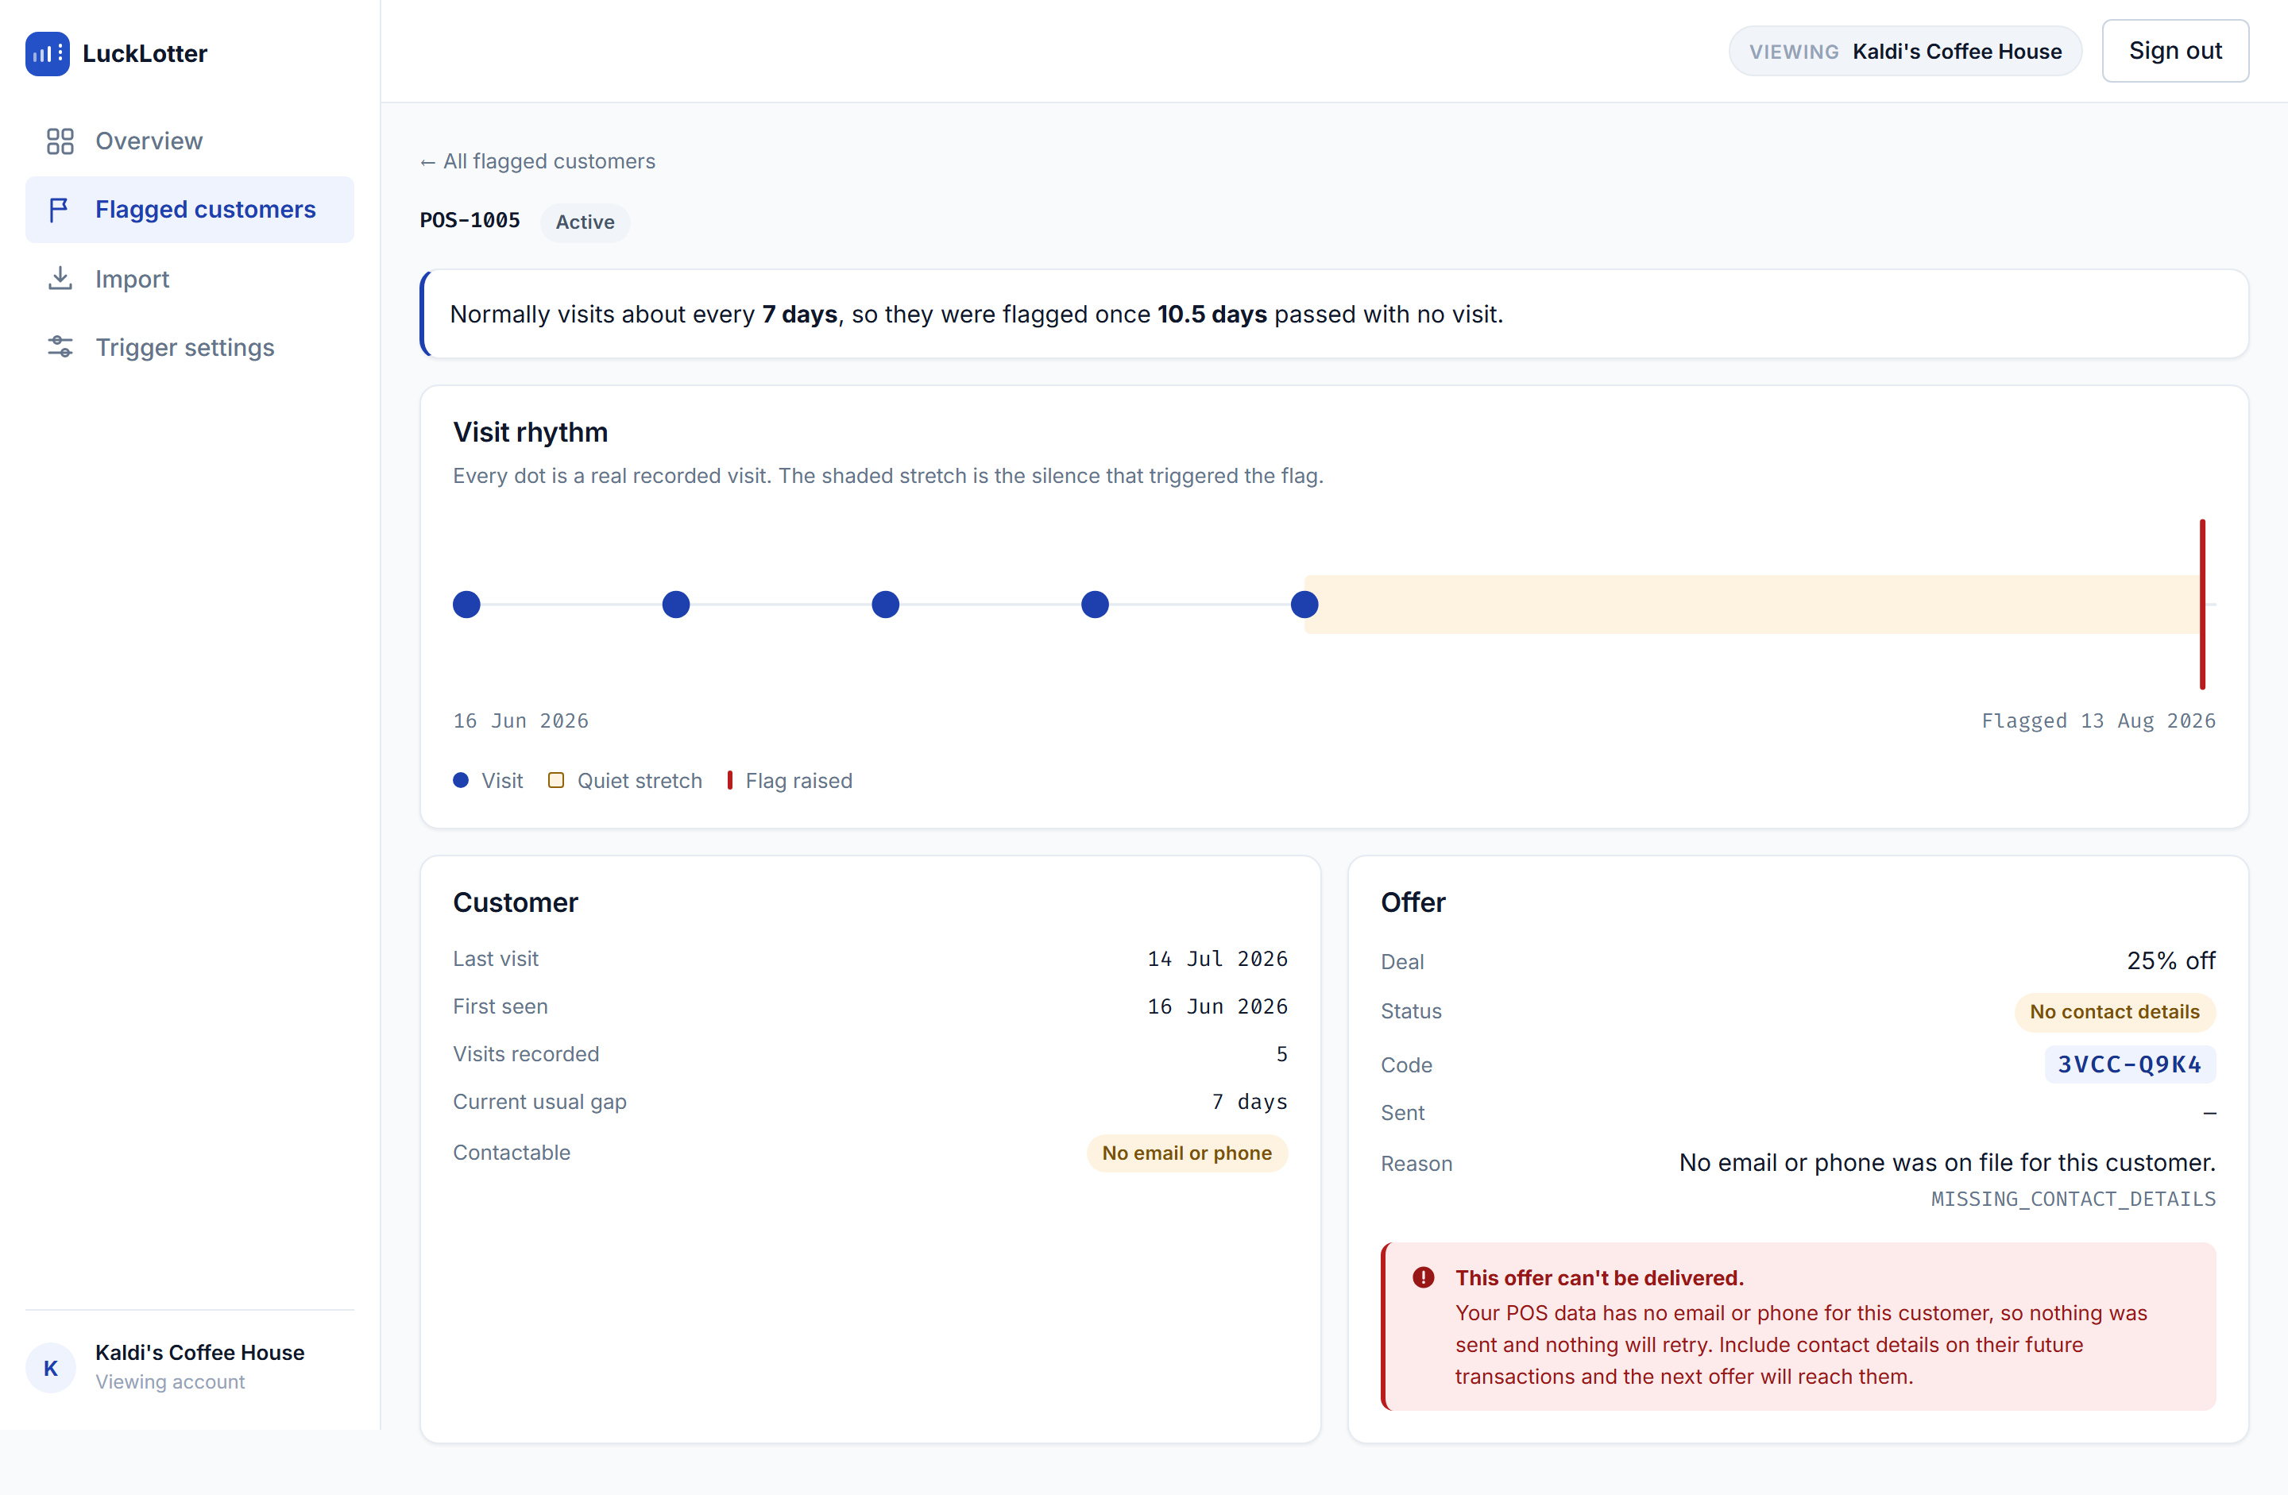
Flag detail, no contact details
The customer really did lapse, so the flag is real. But there is nothing to send to. The offer is still generated and still shown, marked NO_CONTACT — a fourth status that exists precisely so this customer is visibly un-contactable rather than sitting in PENDING forever.
NO_CONTACT is terminal and never retried: retrying would mean attempting to send to a customer with nothing to send to. The count is surfaced on the flag list as an amber banner, because it measures something the business can fix — how much of their POS data lacks contact details.

4. The mail server is down
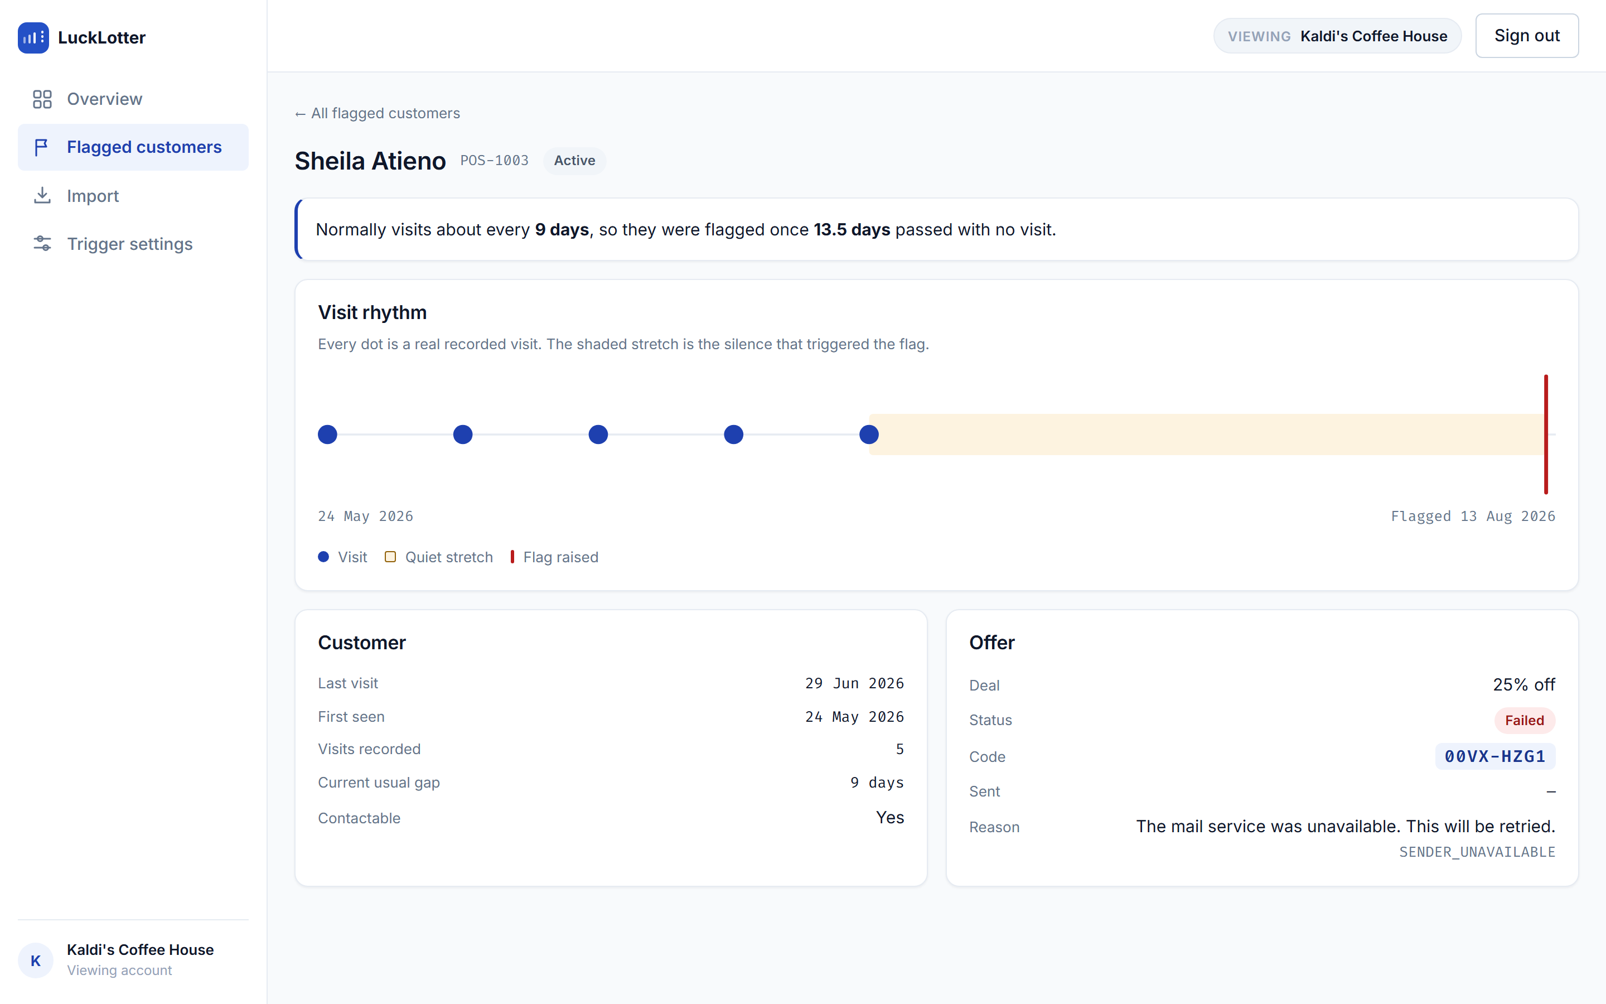
Flag detail, delivery failed
Sending happens outside the transaction that created the flag. A delivery failure records itself on the offer and must not undo the flag — the customer still lapsed whether or not the email got out.
Each attempt runs in its own transaction, so one customer’s failed delivery leaves the others sent. The provider’s diagnosis goes to the log only, correlated by offer ID, and is scrubbed on the way in: an SMTP rejection routinely quotes the recipient’s address back at us.
The stored failure_code is a bounded enum with a CHECK constraint behind it, never a provider error string. A freeform message is how a phone number ends up in a column that was never supposed to carry PII.

5. Two scans running at once
The scheduled 02:00 job and a manual Run scan now can overlap. Safety does not come from the loop:
- Each customer is flagged in its own transaction, so one customer hitting the “already flagged” constraint doesn’t roll back the whole sweep.
- The pre-check is a cheap optimisation. The thing that actually makes it safe is a partial unique index on active flags. When it fires, that is the constraint doing its job, not an error.
- One customer erroring cannot end the sweep; the scan counts it and continues.

6. A backdated transaction must not close a flag
Any new transaction resolving an open flag is right for live POS traffic and wrong for a historical CSV backfill. Importing a year of history for a customer who is currently lapsed would close their flag on the strength of a sale from months ago — reporting them as recovered when nobody has seen them. Worse, it would do it silently and in bulk: one import could clear a whole dashboard.
So only a transaction that moves the customer’s last-visit date forward can answer the flag. The same condition governs both, which is why they cannot drift apart.

7. The retention loop must not pay out indefinitely
A resolved flag makes a customer immediately re-flaggable. Without a cooldown, the cycle go quiet → collect a discount → return → go quiet again repeats forever, training regulars to space their visits out to harvest offers — the exact opposite of what the product is for.
The cooldown is scaled to the customer’s own rhythm, for the same reason the threshold is: a month of silence is a lapse for a weekly regular and unremarkable for someone who visits twice a year. A customer inside their cooldown is not a failure and not an anomaly, so it is logged at debug and counted as skipped.

8. The programme costs more than the owner planned
The cooldown bounds what one customer can extract. It says nothing about total spend, which is the number a business actually cares about — so there is a separate rolling ceiling on offers per window.
Two design choices here are worth pointing out:
- The flag is still created when the budget is spent. Hiding the customer because the money ran out would read as healthy retention rather than as exhausted spend. The offer is marked SUPPRESSED_BUDGET and stays on the dashboard, and the count of them is the evidence for raising the cap.
- The count-then-insert is guarded by a row lock on the business, taken before the count. Without it, two overlapping scans both read a count under the cap and both insert.
That lock was verified by removing it and watching all 16 concurrent callers get an offer against a cap of 5. A sequential test would have passed either way — which is the point.

9. Not enough history to judge
Two visits give one interval, which is not enough to call a rhythm. Below three visits a customer has no cadence and is never flagged — a fixed constant, not per-business config, with no exceptions in Phase 1.
These customers are not hidden. The overview counts them separately as “seen too few times to have a rhythm yet”, so coverage is never overstated.

10. Another business’s data
Every query takes businessId from the authenticated principal and filters on it — including the single-flag lookup. /v1/transactions treats the businessId in its payload as an assertion to check, never as an instruction to obey, and refuses a mismatch.
A flag belonging to another business reads as 404, not 403, so the API never confirms that someone else’s row exists.

11. Contact details must not reach the logs
Third-party error text is the leak nobody plans for. An SMTP rejection quotes the recipient; Postgres quotes the offending key in a constraint violation, and that key can be a customer’s external reference; a malformed-payload error quotes the payload, and an ingest payload carries contact details.
All of it goes through Redact.scrub / scrubStackTrace before it is logged — rendered and scrubbed rather than handed to the logger, which would otherwise print the message verbatim above the frames.

12. A mistyped URL
Spring raises NoResourceFoundException from the static-resource handler. Without an explicit case it falls through to the catch-all and a mistyped path answers 500 — telling the caller the server broke when the request was simply wrong, and putting routine 404s into the error log where a real fault becomes harder to see.

6. How this is verified
63 tests, 0 failures as of 18 August 2026.
Persistence tests run against real Postgres via Testcontainers with Flyway applied — never H2, because the partial unique index and the offer CHECK constraints are precisely what a substitute database would not enforce.
Suite | Covers
CadenceCalculatorTest | visit collapsing, the three-visit minimum, order-insensitivity
FlagCreationServiceTest | the seam where cooldown, budget and contactability meet
FlagCreationConcurrencyTest | the budget lock under 16 concurrent callers
IngestionBackdatingTest | backdated transactions not closing flags
OfferBudgetCeilingTest, OfferCooldownLookupTest | the rolling window and cooldown queries
RetentionFlagOfferMappingTest | the constraints that carry design decisions
RedactTest | that scrubbing actually removes contact details
ApiSecurityAndContractTest | auth, tenant scoping, status codes, validation shape
BusinessCooldownTest, CadenceRebuildServiceTest | threshold/cooldown arithmetic and bulk re-derivation
Run them with:
docker run --rm -v "$PWD/backend:/app" -v lucklotter_m2:/root/.m2 \
-v /var/run/docker.sock:/var/run/docker.sock \
-e TESTCONTAINERS_HOST_OVERRIDE=host.docker.internal \
-w /app maven:3.9-eclipse-temurin-21 mvn -B test

7. What is deliberately not built yet
Being straight about this is worth more than a longer feature list.
- A live mail provider. The SMTP path is real end to end, but it points at Mailpit. Switching over is MAIL_HOST / MAIL_PORT / MAIL_AUTH plus credentials.
- SMS. A phone-only customer lands at FAILED with a retriable code rather than a false SENT, so a sender added later picks those offers up without a migration.
- Redemption tracking. Offers carry a unique code; nothing marks one as used. That is Phase 2.
- A no-PII audit against a live POS feed. Scrubbing is in place and tested; it has never been run against data that actually carries emails and phone numbers.
- Gamification — the spin/voucher product — is Phase 2 and out of scope here.

One known limitation to name before someone finds it
The learned cadence is a mean over the customer’s whole history. A customer whose rhythm genuinely changed — weekly for a year, then monthly — reads as something in between, and will be flagged later than they should be. A trailing window would track a changing rhythm better. This is a known open question, not an oversight.

