**BCH 519**

**Week 10 – Homework**

**Suruchi Jaikumar Ahuja - 50170070**

**Exercise 1**

a)

a1) GO: 0006094

a2) biological processes

a3) Synonyms: glucose biosynthesis, glucose biosynthetic process

a4) Non inferred is_a parents of this term in ontology:

* Biosynthetic Process (GO : 0009058 )
* Glucose metabolic process ( GO : 0006006 )
* Hexose biosynthetic process ( GO : 0019319 )

a5) Number of gene product associations: 2182

a6) Mouse gene products: 76

a7) 12

a8) Mouse genes associated directly to ‘gluconeogenesis’:

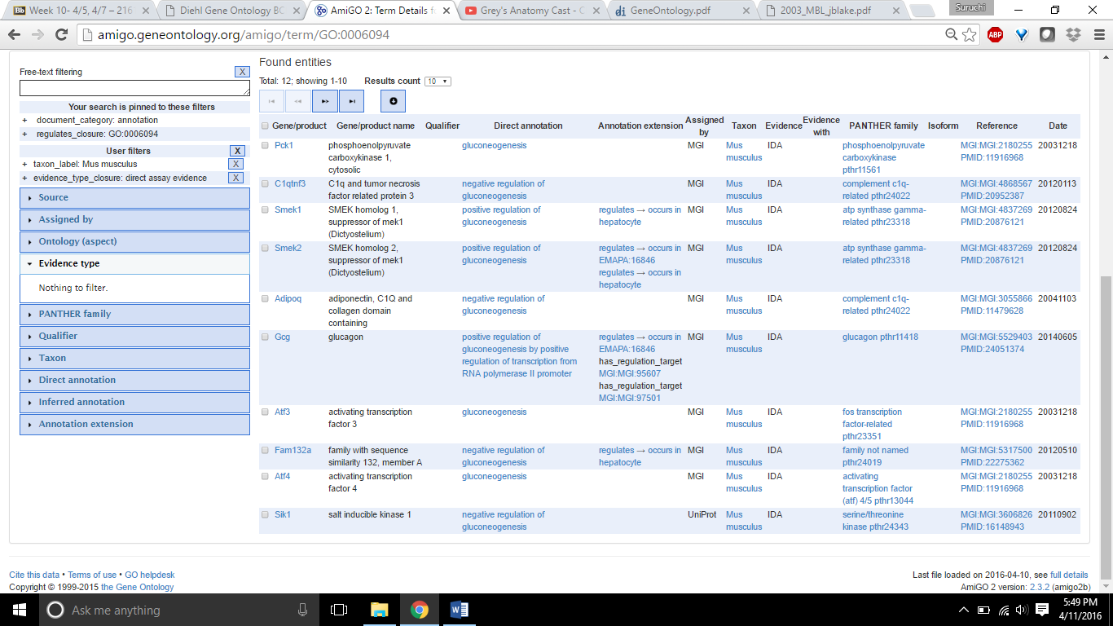

b)

b1) Peroxisome

b2) cellular_component

b3) Source: GOC:pm, [UniProtKB-KW:KW-0576](http://www.uniprot.org/keywords/KW-0576), [PMID:9302272](http://www.ncbi.nlm.nih.gov/pubmed/9302272)

b4) microbody (GO: 0042579)

b5) 7064

b6) 236

b7) 73

b8) 134

c)

c1) GO : 0033680

c2) molecular_function

c3) GO : 0008150

c4) 2 children :

GO : 0033681

GO : 0033682

c5) 27

c6) 8

d)

d1) 43

d2) 12

d3) 11 annotations

d4) 7

d5) 3

e)

e1) nef

e2) Human immunodeficiency virus type 1 ( BRU ISOLATE )

e3) Suppression by virus of host antigen processing and presentation of peptide antigen via MHC class 1

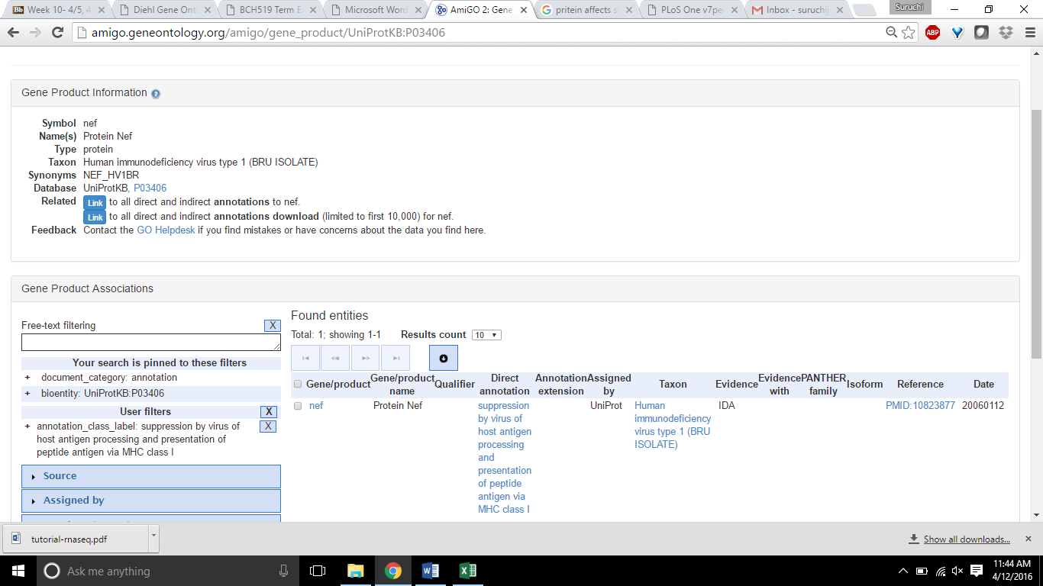

# e4) HIV-1 Nef protein binds to the cellular protein PACS-1 to downregulate class I major histocompatibility complexes.

# Also the CD4 and CD20 cellular protein.

**Exercise 2**

Upregulated genes

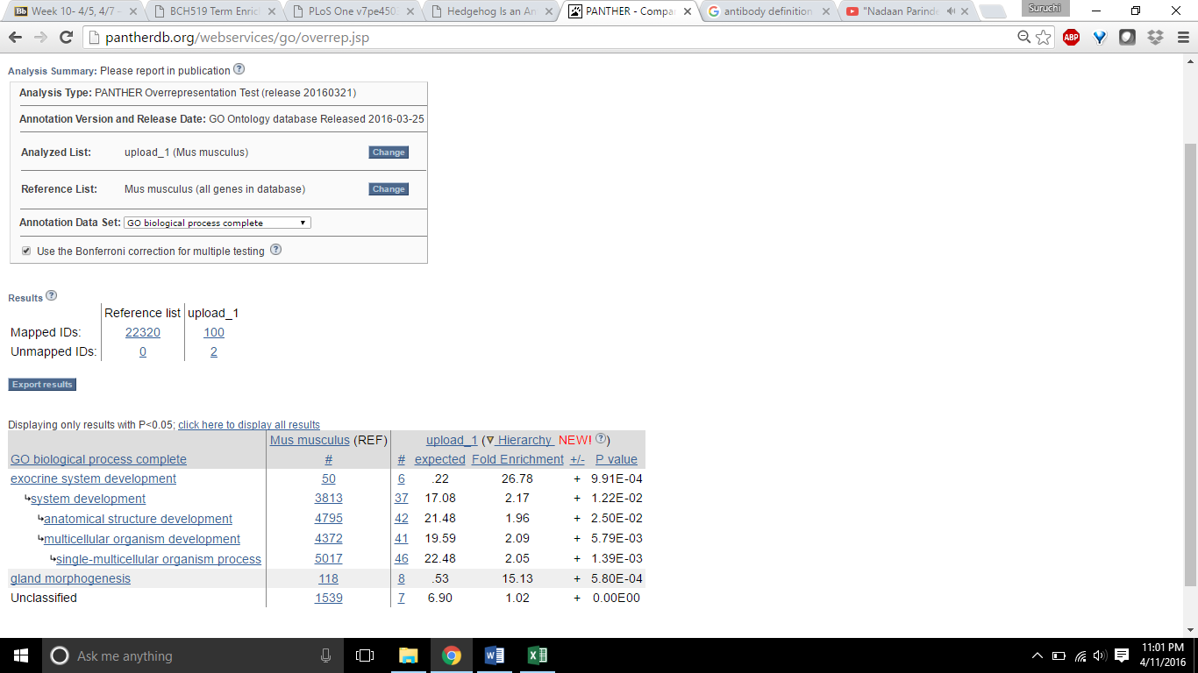

Downregulated Genes

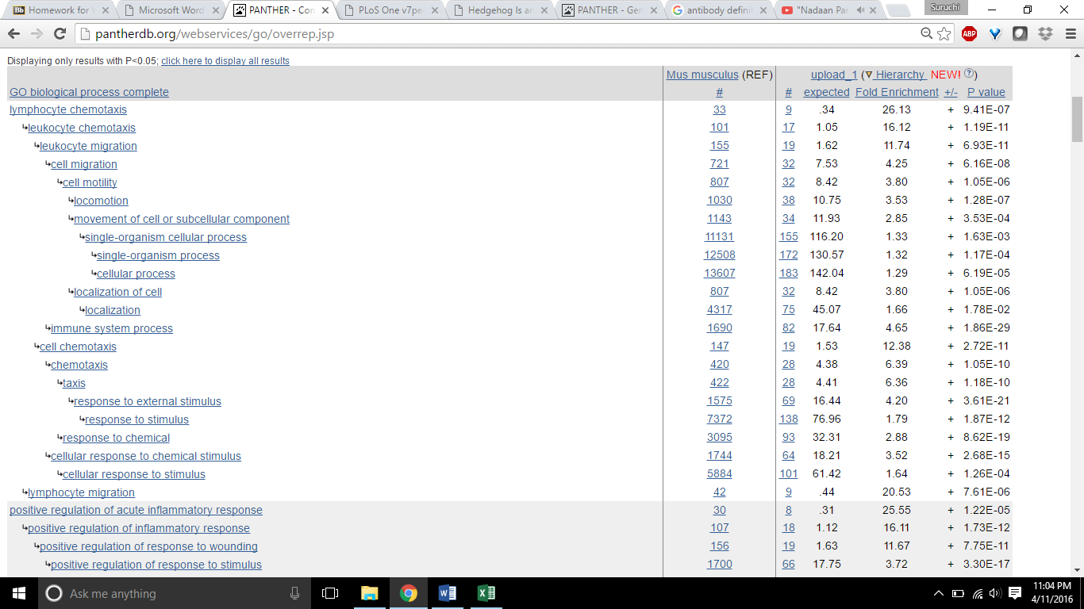

a) The gene enrichment analysis was done on both the upregulated and downregulated genes. The GO terms that were seen are biological process , the reference number, and the upload hierarchy which has the number, expected value, fold enrichment, the +/- value and P value. The terms in biological process for the upregulated and downregulated genes differ. The downregulated genes have a lot of sub-terms in the biological process and covers a wide range whereas the upregulated covers a smaller domain.

b) In the Figure 3 of the paper, there is genes upregulated by Hh, genes down regulated by Hh and also the genes upregulated by transition to culture. The percentage of genes associated with each of the 20 most overrepresented processes, which is identified by P value, were compared to the percentage of genes associated with the same process in the list of all mesenchymally enriched genes.

Whereas in the results obtained here there are genes upregulated and downregulated by Hh are similar, but they differ genes upregulated by transition by culture. The p value displayed are less than 0.005 for the results obtained.

**Exercise 3:**

The first 4 proteins are taken from Figure 3.

|  |  |  |  |  |
| --- | --- | --- | --- | --- |
| Symbol | GO term ID | Term name | Evidence Code | Reference Id |
| TET1 | TET1 Gene | Uncharacterized protein | IEA | [GO_REF:0000002](http://www.geneontology.org/cgi-bin/references.cgi#GO_REF:0000002) |
| TET1 | GO :0003677 | DNA binding | IEA |  |
| TET1 | GO : 0008270 | Zinc ion binding | IEA |  |
| AIDA | AIDA_Human  C1orf80 | Axin interactor, dorsalization-associated protein | IEA | [GO_REF:0000019](http://www.geneontology.org/cgi-bin/references.cgi#GO_REF:0000019) |
| AIDA | GO :0043496 | Regulation of protein homodimerization activity | IEA |  |
| CDM1 | AT1G6820 | Callose Defective Microspore 1 | IPI | [TAIR:locus:2199352](http://arabidopsis.org/servlets/TairObject?accession=locus:2199352) |
| AN4939.2 | Q5B3E1_EMENI | DNA damage response protein (Dap1) | IEA | [PAINT_REF:10281](http://www.geneontology.org/gene-associations/submission/paint/10281/%5bexample_id%5d.txt) |
| APOBEC4 | E2RD46_CANLF | Uncharacterized protein | IEA | [GO_REF:0000002](http://www.geneontology.org/cgi-bin/references.cgi#GO_REF:0000002) |

**Exercise 4:**

a) A GO style definition for “entosis” can be a non- apoptotic cell death pathway in mammary epithelial cells that have detached from the extra cellular matrix (ECM). It is a type of cell cannibalism.

b) Entosis can be identified in the metabolic process pathway of the biological process ontology, as it is a cellular catabolic process.

c) Although it had been proposed to create new, specific terms for each one of the subtypes of cell death, such as entosis the discussions with the experts of the APO-SYS consortium made it clear that research in the field for most of these terms is still quite preliminary and it is not clear whether they reflect real biological events or not. Hence the clarity of entosis being a real biological event is not well understood and so it is not yet to be a GO term.