

Predictive Modeling
Framework for Agricultural Yield
Forecasting And
Resource Optimization

A Universal, Machine Learning-Based Proposal for Agribusiness Performance Prediction

Suruthi D
11 November 2026

Contents

1. Executive Summary
2. Rationale for Predictive Modeling
3. Problem Formulation and Objectives
4. Overview of the Modeling Process (with workflow diagram)
5. Feature Identification and Selection
6. Proposed Model Training Process
7. Model Evaluation and Reliability
8. Simulation Study: Applying the Framework End to End in R
9. Universal Applicability Across Agribusiness Scenarios
10. Implementation Plan and Tools
11. Risks and Mitigation
12. Conclusion
Appendix A: Complete R Source Code
Appendix B: Additional R Outputs and Tuning Results
Appendix C: Session Information

1. Executive Summary
Agricultural output is shaped by weather, soil, crop genetics, management decisions and market conditions, and these factors interact in ways that simple averages or expert intuition cannot capture. This document proposes a complete predictive modeling framework that uses machine learning to forecast crop yield and related agribusiness performance metrics (revenue per hectare, input cost, harvest volume, supply-chain demand). The framework covers the full lifecycle: problem definition, data collection, feature selection, feature engineering, data splitting, model selection, validation, performance evaluation, deployment and monitoring.
To show that the framework works end to end, the document also includes a reproducible R simulation study (Section 8) in which the complete pipeline is run on a simulated multi-district, multi-season dataset, and a structured risks and mitigation plan (Section 11). The appendices contain the complete R source code, additional R outputs and the session information, so every result can be reproduced.
The framework is deliberately modular. Every stage is defined in terms of generic inputs and outputs, so the same pipeline can be applied to a different crop, region, farm size or even a different agribusiness target (such as livestock output or post-harvest losses) by changing the data and the feature library rather than the methodology.

2. Rationale for Predictive Modeling

2.1 Why forecast crop yield?
Yield is the central quantity in agribusiness planning. Accurate forecasts made weeks or months before harvest allow stakeholders to act early instead of reacting late:
- Farmers: decide on planting dates, seed variety, irrigation scheduling, fertilizer and pesticide timing.
- Agribusiness firms and cooperatives: plan procurement, storage, logistics, labour and processing capacity.
- Lenders and insurers: price credit and crop insurance more fairly and detect early signs of distress.
- Governments and planners: anticipate food-security risks, set support prices and manage imports and exports.

2.2 Why machine learning?
Traditional approaches such as regression on a few variables or historical averages assume simple, mostly linear relationships. In reality, yield responds non-linearly to rainfall (too little and too much are both harmful), has threshold effects (heat stress during flowering), and depends on interactions (fertilizer response depends on soil moisture and soil type). Machine learning models can learn these non-linear patterns and interactions directly from data, handle many correlated predictors, and improve as more seasons of data become available.

2.3 Resource optimization
Prediction is not the end goal; it is the input to decisions. A reliable yield model supports resource optimization in three ways: (1) what-if analysis, where predicted yield is compared under different fertilizer, irrigation or sowing scenarios; (2) targeted input use, where inputs are directed to fields with the highest predicted response, reducing cost and environmental load; and (3) risk-aware planning, where prediction intervals show the range of likely outcomes so that buffers (storage, credit, insurance) can be sized sensibly.

3. Problem Formulation and Objectives
The task is formulated as a supervised learning problem. For each unit of analysis (a field, farm, village or district in a given season), the model receives a vector of features X and predicts a target Y.
Element | Definition
Unit of analysis | Field-season, farm-season or district-season (chosen based on data granularity).
Primary target (Y) | Crop yield (tonnes or kg per hectare). This is a continuous variable, so the task is regression.
Secondary targets | Revenue per hectare, total production, input cost per hectare, or a class label such as low / normal / high yield (classification variant).
Forecast horizon | Pre-season (planning), in-season (mid-cycle update) and pre-harvest (final estimate). Features available at each point differ, so separate models or feature sets are used.
Success criteria | Error low enough to change decisions (for example, within 10% of the observed yield for most units), stable across seasons and regions, and better than a naive baseline.

4. Overview of the Modeling Process
The framework follows seven connected stages. Each stage produces a defined output that becomes the input of the next, and results of later stages (for example poor validation) can send the process back to earlier stages (for example more feature engineering).
Stage | Name | Key activities | Output
1 | Problem definition | Define target, unit, horizon, stakeholders and success metric. | Project specification
2 | Data collection and integration | Gather and join weather, soil, remote sensing, management and market data on a common key (location and season). | Raw integrated dataset
3 | Data cleaning and EDA | Handle missing values, outliers, units, duplicates; explore distributions, correlations and trends. | Clean analytical dataset
4 | Feature selection and engineering | Create agronomic features, encode categories, scale, reduce dimensionality and select informative variables. | Model-ready feature matrix
5 | Model training and selection | Split data, train baseline and candidate models, tune hyperparameters with cross-validation. | Shortlisted tuned models
6 | Evaluation and reliability checks | Test on held-out data, quantify uncertainty, run diagnostics and explainability. | Validated final model
7 | Deployment and monitoring | Serve predictions, track drift and accuracy, retrain on a schedule. | Operational forecasting system

Figure 1 shows the same stages as a workflow diagram. Data splitting is shown as its own step because it controls the honesty of every later result, and the dashed feedback loop shows that weak validation results send the work back to cleaning, features or model choice.
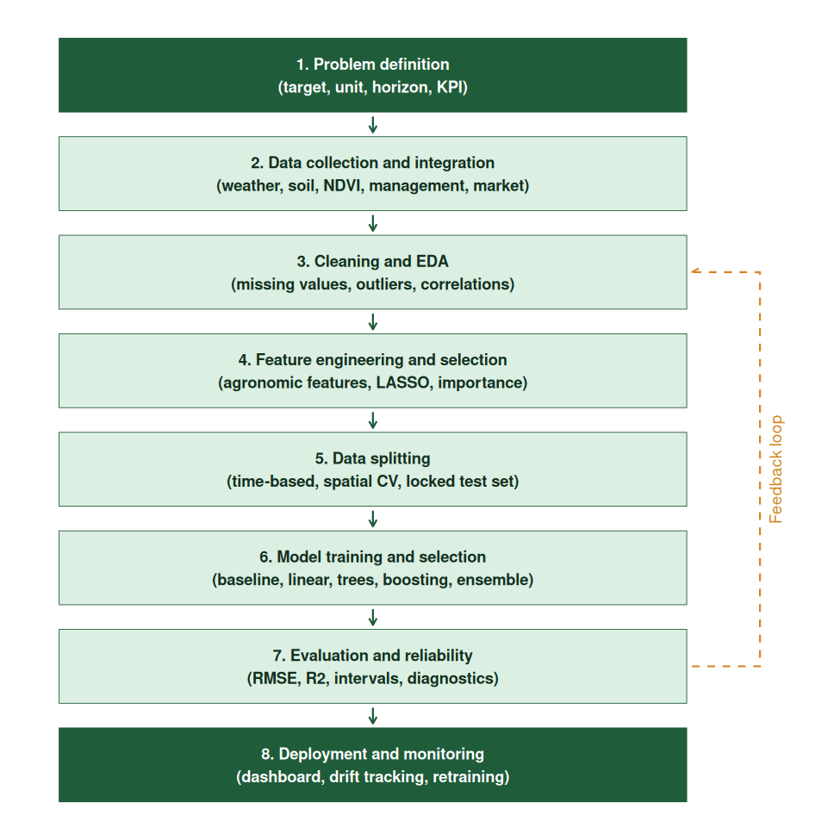
Figure 1: End-to-end predictive modeling workflow with feedback loop

5. Feature Identification and Selection

5.1 Candidate features and reasons for selection
Features are grouped into categories that correspond to the biological and economic drivers of yield. Each feature is included because there is an agronomic or business reason to expect it to influence yield, not merely because it is available.
Modern farms already collect most of these data streams automatically, as Figure 2 illustrates: satellites and drones supply vegetation indices, weather stations supply rainfall and temperature, in-field sensors supply soil moisture and soil health, and smart machinery and irrigation systems record management practices. These sources feed the feature categories listed in the table below, which is why the framework can be applied wherever such data is available.

Figure 2: Illustrative infographic of smart agriculture data sources (satellites, drones, weather stations, soil sensors, smart machinery)
Category | Example features | Reason for selection
Weather and climate | Rainfall (total and by growth stage), minimum and maximum temperature, humidity, solar radiation, wind speed, growing degree days, number of heat-stress days, dry-spell length, evapotranspiration. | Water and temperature are the strongest short-term drivers of crop growth; timing within the crop cycle matters as much as seasonal totals.
Soil | Soil type, pH, organic carbon, nitrogen, phosphorus, potassium, texture, water-holding capacity, salinity, drainage. | Soil determines nutrient supply and water availability, and explains yield differences between fields under the same weather.
Crop and genetics | Crop type, variety or hybrid, seed rate, maturity duration, sowing date, seed quality. | Varieties differ in yield potential and stress tolerance; sowing date sets the weather the crop will experience.
Management practices | Fertilizer type and dose, irrigation method and frequency, pesticide use, tillage, crop rotation, previous crop, planting density, labour and mechanization. | These are the controllable levers; including them lets the model support what-if and optimization analysis.
Remote sensing and sensors | NDVI, EVI, leaf area index, soil moisture from satellite, canopy temperature, drone imagery indices, IoT soil sensors. | Vegetation indices give a near real-time view of crop health and are strong in-season predictors.
Pest, disease and hazard | Pest incidence, disease alerts, flood and drought indicators, hail or cyclone events. | Biotic and extreme events cause sudden yield losses that weather averages miss.
Geography and farm structure | Latitude, longitude, elevation, irrigated area share, farm size, district or agro-climatic zone. | Captures spatial effects and infrastructure differences; allows the model to generalize across regions.
Economic and market | Input prices, crop price, credit access, subsidy, market distance, historical yield of previous seasons. | Economic conditions shape input use and therefore yield; lagged yield captures persistent farm-level productivity.

5.2 Feature selection methods
Starting with a wide feature set and then narrowing it improves accuracy, reduces overfitting and makes the model easier to explain. A combination of methods is proposed:
- Domain filtering: remove variables with no plausible causal link to the target or that will not be available at prediction time (preventing data leakage).
- Statistical filtering: drop near-constant variables, and for highly correlated groups (|r| above about 0.85) keep the most interpretable representative; check variance inflation factors for linear models.
- Embedded methods: use LASSO / Elastic Net coefficients and tree-based feature importance to rank variables during model fitting.
- Wrapper methods: recursive feature elimination (RFE) with cross-validation to find a compact subset that preserves performance.
- Permutation importance and SHAP: confirm that retained features genuinely contribute on unseen data, and that their effects are agronomically sensible.

6. Proposed Model Training Process

6.1 Data splitting
How the data is split is the most important decision for honest evaluation. Agricultural data is spatially and temporally correlated, so a purely random split gives over-optimistic results because neighbouring fields or adjacent seasons leak information into the test set.
Strategy | How it works | When to use
Time-based split | Train on earlier seasons, validate on a later season, test on the most recent season (for example train 2015-2021, validate 2022, test 2023). | Default for forecasting; mimics real deployment where the future is unseen.
Leave-one-season-out CV | Each season is held out in turn while the model trains on the rest. | Small datasets with few seasons; gives a stable estimate of year-to-year performance.
Spatial (grouped) CV | Entire regions, districts or farms are held out together. | To test whether the model generalizes to new locations, which is key for universal use.
Random split (70/15/15) | Random train, validation and test partition. | Only as a secondary check, when data has no strong time or space structure.

The test set is locked and used only once, after all modeling decisions are final. All preprocessing steps (imputation, scaling, encoding) are fitted on the training portion only and then applied to validation and test data, to prevent leakage.

6.2 Feature engineering
- Missing values: median or mode imputation for simple cases, k-nearest neighbour or model-based (MICE) imputation for important variables, plus a missing-indicator flag when missingness itself is informative.
- Outliers: detect with IQR or z-score rules, verify against agronomic limits (for example impossible yields), and treat by correction, capping (winsorizing) or removal with documentation.
- Agronomic derived features: growing degree days, cumulative rainfall per crop stage (sowing, vegetative, flowering, grain filling), number of days above a critical temperature, water-stress index, and fertilizer per hectare ratios.
- Temporal features: lagged yield, rolling means of rainfall and NDVI, seasonal trend, and year to capture technology improvement.
- Interaction terms: for example rainfall x soil water-holding capacity, fertilizer x irrigation; tree-based and neural models can learn these automatically, but explicit terms help linear models.
- Encoding and scaling: one-hot or target encoding for categorical variables (variety, soil type, district); standardization for distance-based and regularized models; log transformation for skewed targets.
- Dimensionality reduction: PCA for large sets of correlated spectral bands or weather series when interpretability of individual components is less critical.

6.3 Model selection
A tiered approach is used. First a simple baseline sets the minimum performance bar; then progressively more flexible algorithms are tested. A more complex model is adopted only if it improves cross-validated performance meaningfully.
Algorithm | Strengths | Limitations / best use
Baseline (historical mean, last-season yield) | Simple benchmark that every model must beat. | No explanatory power; used for comparison only.
Multiple linear regression, Ridge, LASSO, Elastic Net | Interpretable coefficients, fast, handles correlated features with regularization. | Misses non-linear effects; good first model and for small data.
Decision tree | Easy to visualize and explain rules such as thresholds of rainfall or temperature. | Unstable and prone to overfitting alone.
Random Forest | Robust to outliers and noise, captures non-linearity and interactions, provides importance scores, little tuning needed. | Cannot extrapolate beyond training range; large memory use.
Gradient boosting (XGBoost, LightGBM, CatBoost) | Typically the highest accuracy on tabular agricultural data; handles missing values and mixed feature types. | Needs careful tuning; can overfit small datasets.
Support Vector Regression | Effective on smaller datasets with kernel-based non-linearity. | Sensitive to scaling and kernel choice; slow on large data.
Neural networks (MLP) | Flexible function approximator for large, complex datasets. | Needs more data, less interpretable.
LSTM / CNN-LSTM and temporal models | Learn from weather time series and satellite image sequences within a season. | Data-hungry; use when high-frequency sequences are available.
Ensembles (stacking, averaging) | Combine the strengths of several models; usually more stable than any single one. | More complex to deploy and explain.
Mixed-effects / hierarchical models | Account for repeated measures from the same farm or region. | Useful when group structure is strong; can be combined with ML residual modeling.

6.4 Hyperparameter tuning and validation
- Cross-validation: k-fold (k = 5 or 10) for independent data; time-series (rolling-origin) or grouped k-fold when time or space structure exists.
- Tuning: grid search for small parameter spaces, random search or Bayesian optimization for larger ones (tree depth, number of trees, learning rate, regularization strength, minimum samples per leaf).
- Overfitting control: early stopping, regularization, limited tree depth, and comparison of training versus validation error.
- Nested cross-validation: used when comparing many algorithms with small data, to give an unbiased estimate of generalization error.
- Reproducibility: fixed random seeds, version-controlled code, and a documented pipeline (for example tidymodels in R or scikit-learn pipelines in Python).

7. Model Evaluation and Reliability

7.1 Performance metrics
Metric | Meaning | Why it is used
RMSE | Root mean squared error, in yield units. | Penalizes large misses, which are costly in planning.
MAE | Mean absolute error, in yield units. | Easy to explain to non-technical users (average miss).
MAPE / relative RMSE | Error as a percentage of the observed yield. | Allows comparison across crops with different yield scales.
R-squared (and adjusted R-squared) | Share of yield variation explained. | Overall explanatory power; adjusted version penalizes extra features.
Bias (mean error) | Average signed error. | Reveals systematic over- or under-prediction.
Skill score vs baseline | Improvement in error over the naive baseline. | Shows whether the model adds real value.
Accuracy, F1, ROC-AUC (classification variant) | Performance for low / normal / high yield classes. | Used when the decision depends on a category or an alert threshold.

7.2 Ensuring reliability
- Honest testing. Report performance on the locked test set and on spatial and temporal hold-outs, not on training data.
- Residual diagnostics. Plot residuals against predicted values, time and region to check for patterns, heteroscedasticity and systematic bias; the errors should look like random noise.
- Uncertainty quantification. Provide prediction intervals using quantile regression forests, conformal prediction or bootstrapping, and check calibration (a 90% interval should contain about 90% of outcomes).
- Stability analysis. Compare errors across seasons, crops, soil types and regions; investigate groups where performance drops, particularly in extreme years such as drought or flood.
- Sensitivity and robustness tests. Perturb inputs, remove features and add noise to see how predictions change; a reliable model should degrade gracefully.
- Explainability. Use SHAP values, partial dependence and permutation importance so that agronomists can verify that the model reacts sensibly (for example yield falls with prolonged heat stress).
- Leakage and data quality audit. Confirm that no feature contains information from after the prediction date and that data sources are consistently measured.
- Monitoring and retraining. After deployment, track error on newly observed harvests, detect data drift (changes in input distributions due to climate change or new practices) and retrain on a scheduled basis or when error exceeds a threshold.

8. Simulation Study: Applying the Framework End to End in R

8.1 Purpose and design
To demonstrate that the framework is practical, the complete pipeline was implemented and run in R (R Markdown on Posit Cloud, using the tidyverse, glmnet, ranger, xgboost and rpart packages) on a simulated agribusiness dataset. The data is synthetic and generated with a fixed random seed (42), so the numbers below show how the method behaves and should not be read as real-world yields. The dataset covers 60 districts over the seasons 2010 to 2023. Yield was generated from agronomically realistic relationships: a rainfall response that peaks at moderate rainfall and falls under drought or excess water, diminishing returns to fertilizer, penalties for heat-stress days and dry spells, benefits from soil organic matter and a favourable pH, a technology trend, district effects and random noise. Real-world messiness was injected on purpose: missing values in NDVI, soil pH and rainfall, 8 impossible yield values and 5 duplicate records.
After cleaning (845 records reduced to 832 by removing the duplicates and impossible yields) and creating lagged yield, the modeling dataset had 772 district-season records and 15 predictors. The code (Yield_Forecasting_Framework.Rmd) is fully reproducible and regenerates every table and figure in this section.

8.1.1 Implementation environment (Posit Cloud)
The framework was developed and executed in RStudio on Posit Cloud (project AGRI-4, R version 4.6.2). Figures 3a to 3d show the parts of the working session used in this study: the data viewer, the Environment pane, the Console and the project Files pane.

Data viewer
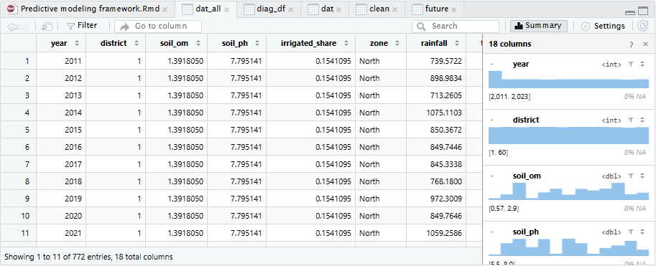
Figure 3a: Data viewer showing dat_all, the cleaned and imputed modeling dataset (772 entries, 18 columns)
The table opened in the data viewer is dat_all, the cleaned and imputed modeling dataset. It lists the season (2011 to 2023), district number, soil organic matter, soil pH, irrigated share, zone and rainfall for each district-season; for example, district 1 (North zone) appears for every season from 2011 onward. The summary panel on the right shows each variable's type and range (year 2011 to 2023, districts 1 to 60) with 0% missing values, which confirms that cleaning and imputation were completed.

Environment pane
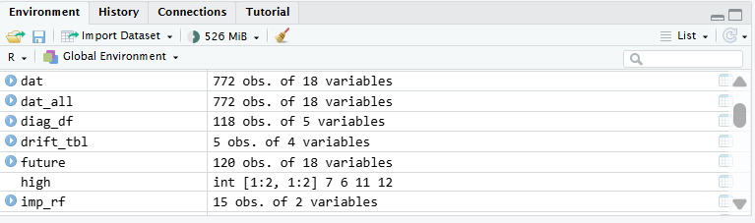
Figure 3b: Environment pane listing the objects created by the pipeline
The Environment pane shows the objects created by the pipeline: dat and dat_all (772 observations of 18 variables each, the engineered modeling dataset), diag_df (118 test-season predictions with residuals), drift_tbl (5 monitored variables), future (120 observations of simulated future seasons) and imp_rf (15 feature-importance values), using about 526 MiB of memory. These sizes match the counts reported in this section.

Console
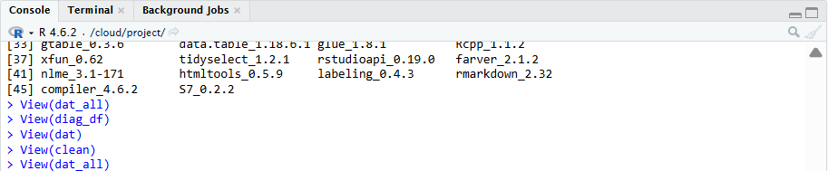
Figure 3c: Console showing the R version, loaded packages and the View() commands
The Console confirms that the session ran in R 4.6.2 from the project folder (/cloud/project) with the required packages loaded (the listing shows package versions such as rmarkdown 2.32 and tidyselect 1.2.1). The View() commands for dat_all, diag_df, dat and clean show the datasets being inspected step by step during the analysis.

Project files
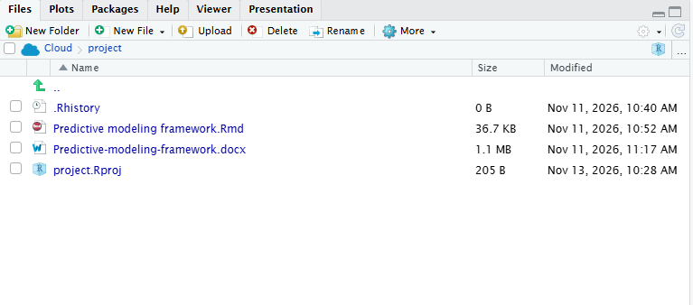
Figure 3d: Files pane with the R Markdown source, the knitted Word report and the project file
The Files pane contains the project files: the R Markdown source (Predictive modeling framework.Rmd), the knitted Word report and the R project file, which makes the work reproducible.
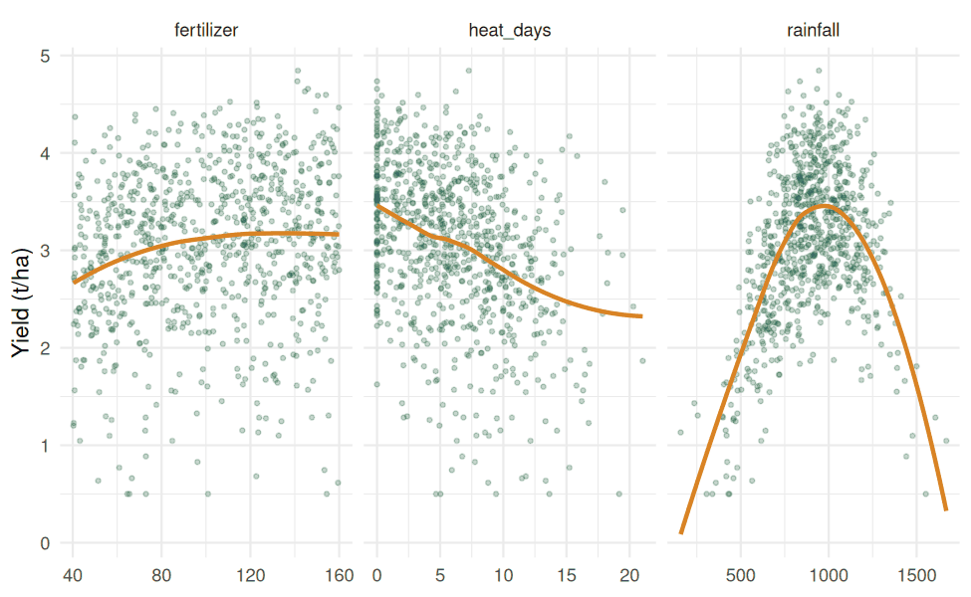
Figure 4: Simulated data shows a peaked rainfall response and diminishing returns to fertilizer (R output)

8.2 Pipeline steps applied
Pipeline step | What was done in the simulation
Cleaning | Exact duplicates were removed, and yields above a robust limit (median + 5 median absolute deviations) were treated as recording errors. Missing predictor values were filled with training-set medians only, so no information from validation or test data leaked into training.
Feature engineering | Created lagged yield (previous season, by district), rainfall x irrigated share, squared fertilizer (diminishing returns), heat x dry-spell stress and a time trend. Zone was one-hot encoded for the linear and boosting models.
Feature selection | Correlation filter (|r| above 0.85), variance inflation factors, LASSO coefficients, random forest permutation importance and XGBoost gain.
Data splitting (time-based) | Train: seasons 2011 to 2019 (534 records). Validation: 2020 to 2021 (120). Test: 2022 to 2023 (118), locked until the final evaluation. The first season was used only to build the lag feature.
Models compared | Eight models: baseline (last-season yield), linear regression, Ridge, LASSO, decision tree, Random Forest, XGBoost and an ensemble (RF + XGBoost + LASSO).
Tuning | Grid search on the validation seasons. Random Forest: mtry 8, minimum node size 3 (validation RMSE 0.466). XGBoost: depth 3, learning rate 0.08, 200 rounds (validation RMSE 0.406).
Validation | 5-fold cross-validation on the training data with folds grouped by season, then the validation set for model choice, and the locked test set for the final report.

8.3 Model comparison results
Model | CV RMSE | Val RMSE | Test RMSE | Test MAE | Test MAPE | Test R2
Baseline (last-season yield) | 0.967 | 1.029 | 1.088 | 0.822 | 33.8% | -0.70
Linear regression | 0.596 | 0.655 | 0.680 | 0.516 | 21.9% | 0.33
Ridge | 0.596 | 0.658 | 0.672 | 0.514 | 21.9% | 0.35
LASSO | 0.595 | 0.655 | 0.678 | 0.515 | 21.9% | 0.34
Decision tree | 0.584 | 0.546 | 0.576 | 0.457 | 16.4% | 0.52
Random Forest (tuned) | 0.449 | 0.466 | 0.474 | 0.357 | 13.0% | 0.68
XGBoost (tuned) | 0.403 | 0.406 | 0.410 | 0.308 | 11.3% | 0.76
Ensemble (RF + XGB + LASSO) | 0.442 | 0.467 | 0.467 | 0.352 | 13.7% | 0.69
RMSE and MAE are in tonnes per hectare. Lower error is better; higher R2 is better.
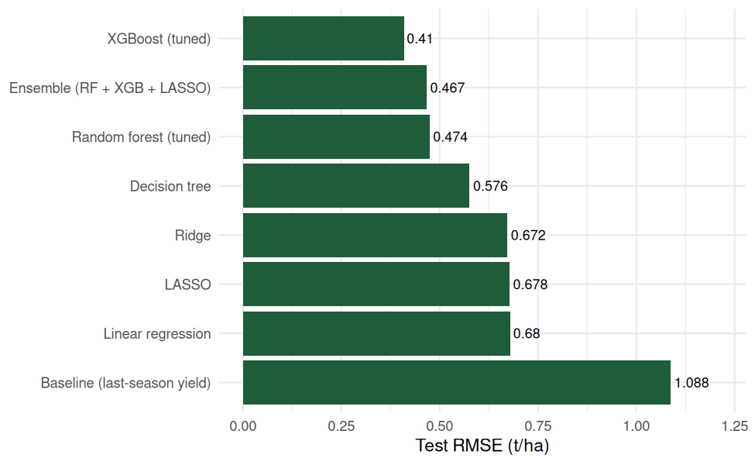
Figure 5: Test RMSE by model (R output)
XGBoost (tuned) had the lowest validation error, so it was selected using validation data (not test data). On the locked test seasons its RMSE of 0.410 t/ha is 62% lower than the naive last-season baseline (1.088 t/ha), and it explains 76% of the variation in unseen seasons (R2 = 0.76). A paired Wilcoxon test confirmed that the baseline errors are significantly larger than the model errors (p < 0.001), and a bootstrap 95% interval for the test RMSE was 0.337 to 0.487 t/ha. The baseline's negative R2 shows that repeating last season's yield is worse than predicting the average. The linear models (test R2 about 0.34) were clearly weaker than Random Forest and XGBoost (0.68 and 0.76), reflecting the non-linear rainfall and fertilizer effects. This agrees with the framework's guidance: start simple, but expect flexible tree-based models to win when relationships are non-linear.

8.4 Reliability checks
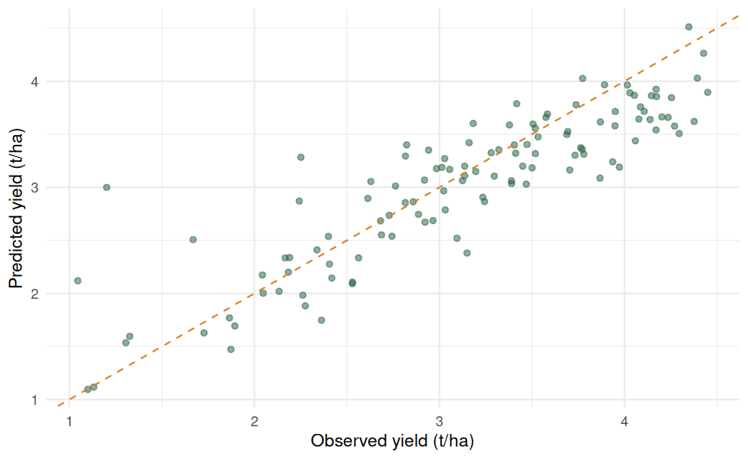
Figure 6: Predicted versus observed yield on the test seasons (R output)
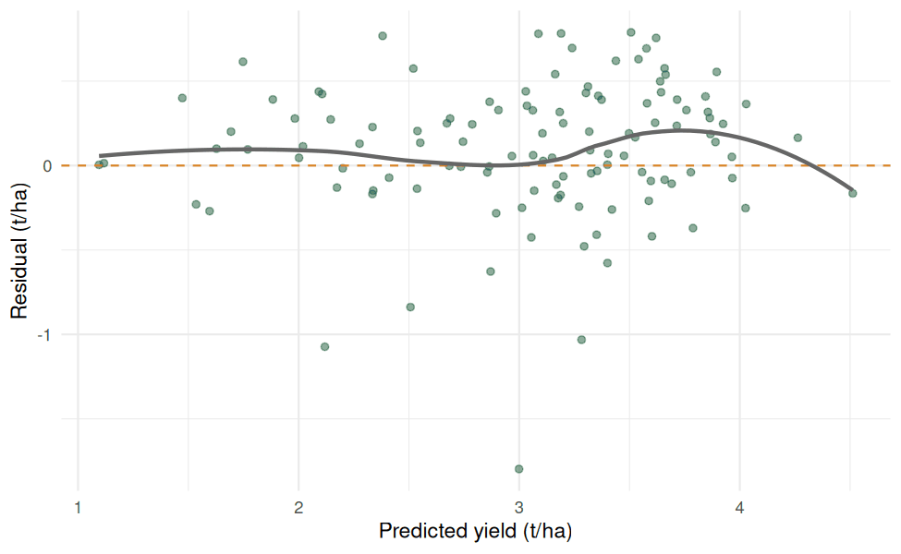
Figure 7: Residuals versus predicted values (R output)
- Residual diagnostics: points lie close to the 1:1 line. The test of residual spread against predicted yield showed no heteroscedasticity (correlation 0.07, p = 0.47). A Shapiro-Wilk test rejected perfect normality of residuals (p < 0.001), which is common and does not affect tree-based predictions, but it is why intervals are built with methods that do not assume normal errors. Mean bias was -0.10 t/ha, a small tendency to under-predict.
- Stability across seasons and zones: test RMSE was 0.467 t/ha in 2022 and 0.345 t/ha in 2023. By zone it ranged from 0.322 (East) and 0.336 (West) to 0.417 (South) and 0.502 (North), so the North zone would be flagged for closer review.
- Spatial generalization: when whole districts were held out (grouped cross-validation by district), RMSE was 0.440 t/ha, R2 0.69 and bias -0.02 t/ha. The model therefore predicts well for districts it has never seen, which supports the claim of universal applicability.
- Rolling-origin evaluation: training on all earlier seasons and forecasting the next gave RMSE of 0.425 (2018), 0.399 (2019), 0.381 (2020), 0.419 (2021), 0.424 (2022) and 0.300 (2023), so accuracy stayed stable over time (between 0.30 and 0.43 t/ha).
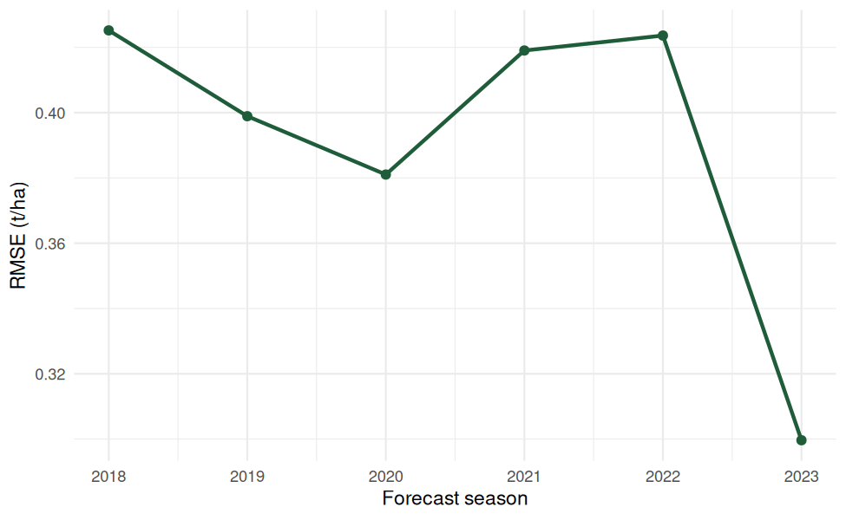
Figure 8: Rolling-origin forecast error by season (R output)
- Uncertainty: 90% prediction intervals were built two ways. A quantile regression forest covered 87.3% of observed test yields (mean width 1.81 t/ha), slightly below the 90% target. Split conformal prediction, calibrated on the validation seasons, covered 92.4% (width 1.46 t/ha), so it was both tighter and better calibrated. This shows why interval coverage must always be tested rather than assumed.
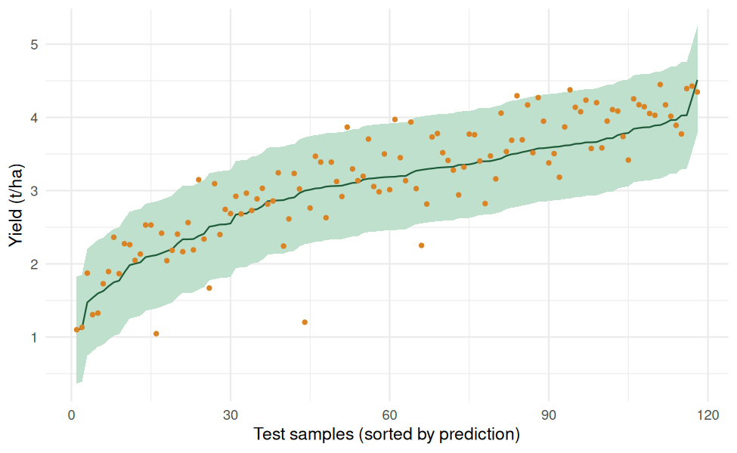
Figure 9: Conformal 90% prediction intervals with observed values on test samples (R output)

8.5 Feature importance and partial dependence
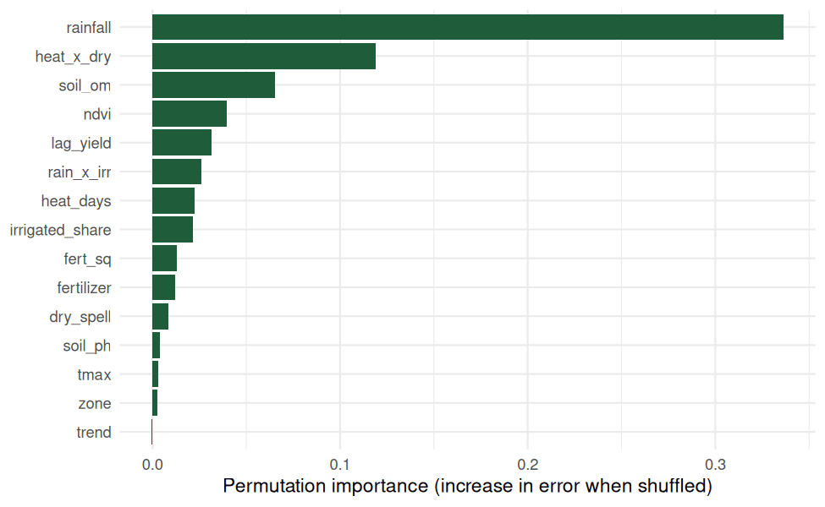
Figure 10: Random forest permutation importance (R output)
Permutation importance ranked rainfall first by a wide margin, followed by the heat x dry-spell stress interaction, soil organic matter, NDVI and lagged yield. This matches how the data was generated, where water availability and heat stress dominate yield, so the importance analysis recovers the true drivers and the engineered stress feature proved useful. Zone and the time trend contributed almost nothing, supporting their removal if a leaner model were needed.
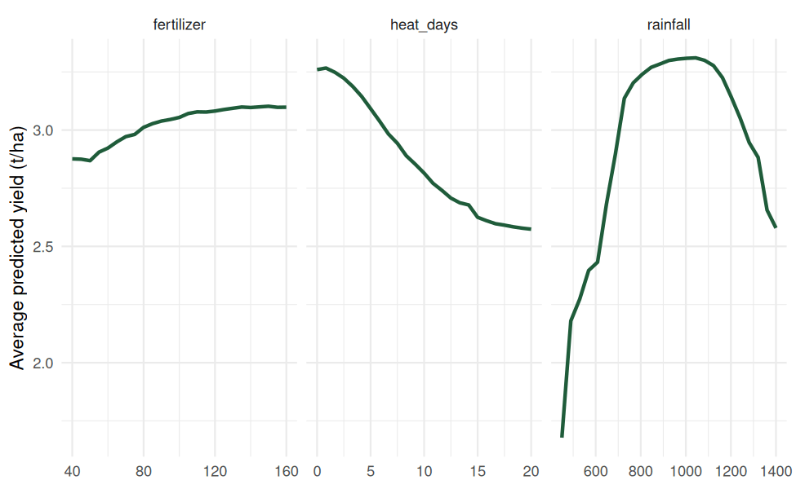
Figure 11: Partial dependence of predicted yield on fertilizer, heat days and rainfall (R output)
Partial dependence plots show the shape of each effect: predicted yield rises with fertilizer and then flattens (diminishing returns), falls steadily as the number of heat-stress days increases, and peaks at moderate rainfall (about 900 to 1,100 mm) before dropping sharply under drought and under excess rain. These are the agronomically expected patterns, which builds confidence that the model learned real relationships.

8.6 Scenario (what-if) simulation for resource optimization
After validation, the fitted model was used to simulate decisions. Holding other factors at typical values, fertilizer was varied from 40 to 160 kg/ha under three rainfall scenarios.
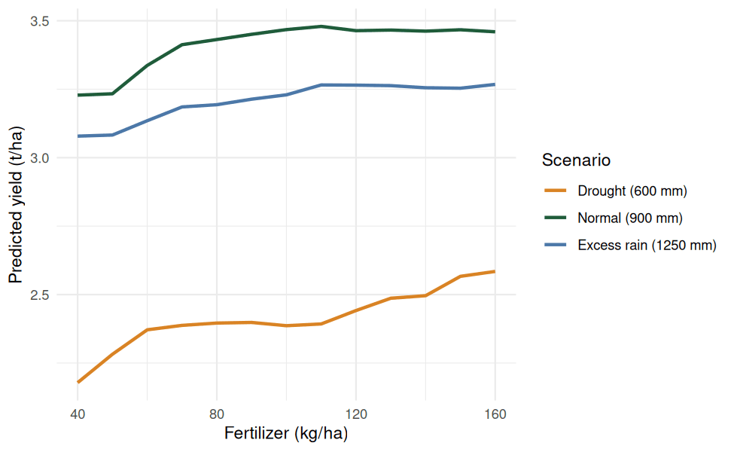
Figure 12: Model-predicted yield response to fertilizer under different rainfall scenarios (R output)
Rainfall scenario | Yield at 40 kg/ha | Yield at 100 kg/ha | Yield at 160 kg/ha
Normal (900 mm) | 3.23 | 3.47 | 3.46
Drought (600 mm) | 2.18 | 2.39 | 2.58
Excess rain (1250 mm) | 3.08 | 3.23 | 3.27
Values are predicted yield in t/ha.
The simulation gives practical insight. Under normal rainfall, raising fertilizer from 40 to 100 kg/ha adds about 0.24 t/ha, but going from 100 to 160 kg/ha adds nothing, so spending beyond roughly 100 kg/ha does not pay. A drought lowers yield by about 1.1 t/ha at the same fertilizer dose (3.47 versus 2.39 t/ha at 100 kg/ha), far more than any fertilizer increase can recover (about 0.4 t/ha from 40 to 160 kg/ha under drought). A decision-maker should therefore prioritize irrigation or drought-tolerant varieties in forecast-dry seasons and cap fertilizer near the point where the curve flattens. This is the resource-optimization use of the framework described in Section 2.3.

8.7 Classification variant: early-warning alert
Some decisions need a category rather than a number. The same features were used to classify each district-season as Low, Medium or High yield (tertiles of the training yield) with a random forest classifier. On the test seasons overall accuracy was 74.6% (88 of 118 correct). High and Low classes were identified well (F1 of 0.81 for both; recall 0.79 and 0.83), while the Medium class was hardest (F1 0.59), which is expected because it sits between the two extremes. For an early-warning system focused on the Low class, a recall of 83% means most poor-yield situations would be flagged in advance.
Class | Precision | Recall | F1 score
Low | 0.789 | 0.833 | 0.811
Medium | 0.588 | 0.588 | 0.588
High | 0.826 | 0.792 | 0.809

8.8 Drift monitoring and retraining trigger
To test monitoring, two future seasons (2024 and 2025) were simulated with a warmer, drier climate. Input drift was measured with the Kolmogorov-Smirnov test and the Population Stability Index (PSI; above 0.25 is a major shift). Rainfall (PSI 0.395) and maximum temperature (PSI 1.074) showed major shifts, NDVI a moderate shift (0.160), while heat days (0.024) and dry-spell length (0.093) were stable. Forecast error stayed below the alert threshold of 0.508 t/ha (125% of validation RMSE): RMSE was 0.400 in 2024 and 0.353 in 2025, so no retraining was triggered, although the model showed a small over-prediction bias of about 0.15 t/ha. This illustrates why both monitors are used: input drift is an early warning that can appear before accuracy actually falls, and the framework tracks both so retraining is triggered by evidence rather than by a fixed calendar alone.
Variable | PSI | Shift flag | KS test p-value
Rainfall | 0.395 | Major | < 0.001
Maximum temperature | 1.074 | Major | < 0.001
NDVI | 0.160 | Moderate | 0.445
Dry-spell length | 0.093 | Stable | 0.474
Heat days | 0.024 | Stable | 0.852

8.9 Same pipeline on three different scenarios
To test the universal applicability claim, the complete pipeline was wrapped in one function and run unchanged on three scenarios by changing only the data-generating parameters: a cereal crop (maize), a plantation crop with much larger yield scale (sugarcane), and a smallholder case with limited data (20 districts, 96 training records). Because yield scales differ, error is shown as RMSE as a percentage of mean yield (lower is better).
Scenario | Train rows | Baseline | LASSO | Random Forest | XGBoost | XGBoost R2
Cereal (maize), 60 districts | 534 | 34.6% | 21.5% | 15.6% | 13.6% | 0.74
Plantation (sugarcane), 60 districts | 534 | 27.9% | 13.9% | 12.2% | 10.2% | 0.67
Smallholder, limited data (20 districts) | 96 | 49.5% | 32.8% | 23.4% | 20.8% | 0.73
Relative test error (RMSE as % of mean yield).
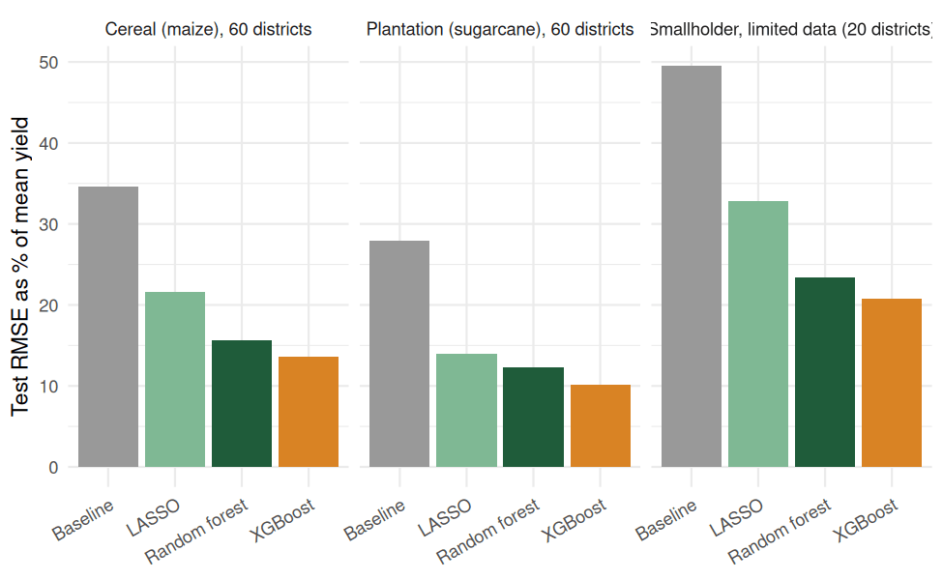
Figure 13: Relative test error by scenario and model (R output)
In all three scenarios the ranking of models was the same (baseline worst, then LASSO, Random Forest and XGBoost best) and XGBoost cut the relative error by between 58% and 64% compared with the baseline. Even with only 96 training records, the pipeline explained 73% of yield variation. The same code ran unchanged across crops and data sizes, which supports the claim that only the data and feature library change while the process stays the same.

8.10 Conclusions and limits of the simulation
- What the simulation shows: the pipeline runs end to end; the leakage-safe split and grouped cross-validation give honest estimates; XGBoost beat linear and baseline models by a wide margin on non-linear data; importance and partial dependence recover the true drivers; conformal intervals reached their target coverage; drift monitors work; and the framework transfers across crops and data sizes.
- What it does not show: the data is synthetic and cleaner than real farm records, so real-world accuracy will depend on data quality, sensor coverage and rare events. The slight under-coverage of the quantile forest and the weaker North zone are reminders that uncertainty and regional performance must be checked on every new dataset.
- Next step: replace the simulated dataset with real district or farm data. No change to the pipeline is needed, only the data source and feature list.

9. Universal Applicability Across Agribusiness Scenarios
The framework is designed so that its structure stays fixed while its content is replaced. The universal elements are: (a) a standard problem specification template (unit, target, horizon, success metric); (b) a feature library organized by driver category rather than by specific crop; (c) a leakage-safe splitting and preprocessing pipeline; (d) a tiered model comparison that lets the data decide the best algorithm; and (e) a common evaluation and monitoring protocol. Because the best algorithm is chosen empirically through cross-validation instead of assumed in advance, the same pipeline adapts to data-rich and data-poor settings.
Scenario | Target variable | Feature adaptations | Notes on adaptation
Cereal crops (rice, wheat, maize) | Yield per hectare | Rainfall and temperature by growth stage, NDVI, fertilizer dose. | Baseline use case.
Plantation and perennial crops (tea, coffee, coconut) | Annual production per tree or hectare | Tree age, pruning, multi-year lagged weather. | Longer lags; mixed-effects models for repeated measures.
Horticulture and vegetables | Harvest volume and quality grade | Greenhouse sensors, short cycles, market price. | Shorter horizon; frequent retraining.
Smallholder farms with limited data | Yield or income | Few variables, regional weather, survey data. | Regularized linear models, pooled data across regions, transfer learning.
Large commercial farms with precision agriculture | Field-zone yield | Drone, sensor and machinery data. | Boosting and deep learning on high-volume data.
Livestock and dairy | Milk or weight gain per animal | Feed, breed, health records, temperature-humidity index. | Same pipeline with animal-level units.
Supply chain and market planning | Demand, price or post-harvest loss | Storage conditions, transport time, price history. | Time-series and hybrid models; same evaluation protocol.
New region or new crop | Yield | Reuse feature categories; recalibrate with local data. | Transfer learning, spatial CV to test generalization.

To move to a new scenario, a practitioner replaces the data sources and target, re-runs the feature library and selection steps, and lets the cross-validation results determine which algorithm and settings are appropriate. Documentation templates for each stage keep the process consistent and auditable.

10. Implementation Plan and Tools
Phase | Activities | Indicative duration
Phase 1 | Define objectives, collect and integrate data, perform EDA. | Weeks 1-3
Phase 2 | Cleaning, feature engineering and selection. | Weeks 4-5
Phase 3 | Baseline and candidate model training, tuning and cross-validation. | Weeks 6-8
Phase 4 | Final evaluation, uncertainty analysis, explainability and reporting. | Weeks 9-10
Phase 5 | Deployment as a dashboard or API, monitoring and scheduled retraining. | Week 11 onward

Suggested tools: R (tidyverse, tidymodels, caret, ranger, xgboost, glmnet) or Python (pandas, scikit-learn, XGBoost, SHAP); GIS and remote-sensing tools for satellite indices; R Markdown or Jupyter for reproducible reporting; Git for version control; and Shiny or a web dashboard for presenting forecasts to decision-makers.

11. Risks and Mitigation
Every predictive system carries risks that can reduce accuracy, fairness or trust. The table below lists the main risks in this framework, rates their likelihood (L) and impact (I) as High, Medium or Low, and states how each is prevented or reduced, and how it will be detected if it occurs. These ratings are qualitative judgements and should be revisited when real data is available.
Risk | Description | L | I | Mitigation and monitoring
Poor data quality | Missing values, sensor faults, recording errors and inconsistent units reduce model accuracy. | H | H | Validation rules and range checks at ingestion; documented imputation and outlier treatment (fitted on training data only); data quality dashboard; source audits.
Data scarcity | Few seasons or farms give unstable models, especially for new crops or regions. | H | H | Start with regularized or simple models; pool data across regions; transfer learning; data augmentation; report wider uncertainty.
Data leakage | Future or target-related information enters training, giving falsely high accuracy. | M | H | Time-based and grouped splits; preprocessing fitted on training data only; feature availability check for each forecast date; locked test set.
Overfitting | Model memorizes noise and fails on new seasons. | M | H | Cross-validation, regularization, early stopping, limited tree depth, gap between training and validation error tracked, nested CV when comparing many models.
Climate change and drift | Weather patterns, varieties and practices change, so past relationships weaken. | H | H | Include recent seasons; monitor input distributions and rolling forecast error; scheduled retraining (for example each season); alert when error exceeds a threshold.
Extreme events | Rare droughts, floods or pest outbreaks are poorly represented in training data. | M | H | Add hazard indicators; use quantile or conformal intervals; scenario analysis; combine forecasts with expert judgement during extreme seasons.
Poorly calibrated uncertainty | Intervals can be too narrow, as seen in the simulation where the quantile forest covered 87.3% against a 90% target. | M | M | Conformal calibration on validation data (92.4% coverage in the simulation); coverage tracked on each new season; show intervals, not only point forecasts.
Spatial or group bias | Model performs worse for smallholders, small districts or less-sampled regions. | M | H | Report error by region and farm size; spatial cross-validation; reweighting or separate models for under-represented groups.
Low interpretability and trust | Users reject or misuse black-box forecasts. | M | M | SHAP and partial dependence plots; agronomist review of important features; plain-language reports with intervals.
Privacy and data security | Farm-level and financial data may be misused or exposed. | L | H | Consent and data-sharing agreements; anonymization or aggregation; access control and encryption; compliance with local data-protection rules.
Over-reliance on predictions | Decisions are taken blindly on model output, causing losses when it is wrong. | M | M | Position the model as decision support; human-in-the-loop review; documented limits of use; fallback to historical or expert estimates.
Operational and deployment failure | Late data feeds, broken pipelines or unavailable tools stop forecasts. | M | M | Automated pipeline tests; version control and reproducible environments; logging and alerts; backup manual process.

Overall, the highest-priority risks are data quality, data scarcity, leakage and drift because they affect every downstream result. The framework addresses them by design (clean, leakage-safe pipeline) and by process (monitoring, retraining and human oversight).

12. Conclusion
This document presented a structured, end-to-end predictive modeling framework for agricultural yield forecasting and resource optimization. It explains why machine learning is appropriate, identifies and justifies the features that drive yield, defines a leakage-safe training process (data splitting, feature engineering, model selection and validation), sets out a rigorous approach to evaluation and reliability, demonstrates the pipeline in a simulation study, and provides a risks and mitigation plan. Because every stage is written in terms of generic components, the framework can be reused across crops, regions, farm scales and other agribusiness metrics with only the data and feature library changing. Adopting this framework enables more accurate forecasts, better use of inputs and more resilient agribusiness decisions.

Appendix A: Complete R Source Code
This appendix lists the complete R code used in Section 8, in the order it is run (R Markdown file Yield_Forecasting_Framework.Rmd, executed in RStudio on Posit Cloud with R 4.6.2). Each block is labelled with its code chunk name. Running the file from top to bottom regenerates every table and figure in this report.
Code chunk: install
install.packages(c("tidyverse", "glmnet", "ranger", "xgboost", "rpart", "rpart.plot", "knitr"))

Setup and packages
Code chunk: packages
library(tidyverse) # dplyr, tidyr, ggplot2 ...
library(glmnet) # ridge / LASSO / elastic net
library(ranger) # fast random forest, quantile regression forest
library(xgboost) # gradient boosting
library(rpart) # decision trees
library(rpart.plot) # tree plots
library(knitr) # tables

set.seed(42)
theme_set(theme_minimal(base_size = 11))
green <- "#1F5C3A"; orange <- "#D98324"

Workflow diagram
Code chunk: workflow
steps <- c("1. Problem definition\n(target, unit, horizon, KPI)",
"2. Data collection and integration\n(weather, soil, NDVI, management, market)",
"3. Cleaning and EDA\n(missing values, outliers, correlations)",
"4. Feature engineering and selection\n(agronomic features, LASSO, importance)",
"5. Data splitting\n(time-based, spatial CV, locked test set)",
"6. Model training and selection\n(baseline, linear, trees, boosting, ensemble)",
"7. Evaluation and reliability\n(RMSE, R2, intervals, diagnostics)",
"8. Deployment and monitoring\n(dashboard, drift tracking, retraining)")
wf <- tibble(id = 1:8, label = steps, y = 9 - (1:8), ends = id %in% c(1, 8))

ggplot() +
geom_tile(data = wf, aes(x = 0, y = y, fill = ends), width = 6, height = 0.75, colour = green) +
geom_text(data = wf, aes(x = 0, y = y, label = label, colour = ends), size = 3.1, fontface = "bold") +
geom_segment(data = wf[-8, ], aes(x = 0, xend = 0, y = y - 0.42, yend = y - 0.58),
colour = green, arrow = arrow(length = unit(0.15, "cm"))) +
geom_path(data = tibble(x = c(3.05, 3.7, 3.7, 3.05), y = c(2, 2, 6, 6)), aes(x, y),
colour = orange, linetype = "dashed", arrow = arrow(length = unit(0.15, "cm"))) +
annotate("text", x = 3.85, y = 4, label = "Feedback loop", angle = 90, colour = orange, size = 3.2) +
scale_fill_manual(values = c("FALSE" = "#DCEFE3", "TRUE" = green), guide = "none") +
scale_colour_manual(values = c("FALSE" = "#12301f", "TRUE" = "white"), guide = "none") +
xlim(-3.2, 4.1) + theme_void()

Data simulation
Code chunk: simulator
zone_levels <- c("North", "South", "East", "West")

p_maize <- list(rain_mean = 900, rain_sd = 220, rain_opt = 950, rain_width = 450,
tmax_mean = 33, base = 1.2, rain_w = 1.6, fert_w = 1.1, yscale = 1, scale = 1)

sim_crop_data <- function(n_districts = 60, years = 2010:2023, p = p_maize, seed = 42) {
set.seed(seed)
districts <- tibble(
district = 1:n_districts,
dist_eff = rnorm(n_districts, 0, 0.25),
soil_om = runif(n_districts, 0.5, 3),
soil_ph = runif(n_districts, 5.5, 8),
irrigated_share = runif(n_districts, 0.1, 0.9),
zone = factor(sample(zone_levels, n_districts, replace = TRUE), levels = zone_levels)
)
crossing(year = years, district = 1:n_districts) %>%
left_join(districts, by = "district") %>%
mutate(
rainfall = rnorm(n(), p$rain_mean, p$rain_sd),
tmax = rnorm(n(), p$tmax_mean, 1.8),
dry_spell = pmax(0, rnorm(n(), 10, 5)),
heat_days = pmax(0, rnorm(n(), 6, 4) + (tmax - p$tmax_mean) * 1.5),
ndvi = pmin(0.9, pmax(0.2, 0.55 + 0.00018 * (rainfall - p$rain_mean) -
0.01 * heat_days + rnorm(n(), 0, 0.05))),
fertilizer = runif(n(), 40, 160),
rain_eff = pmax(1 - ((rainfall - p$rain_opt) / p$rain_width)^2, -0.5),
fert_eff = 1 - exp(-fertilizer / 70),
yield_t_ha = p$yscale * (p$base + p$rain_w * rain_eff * (0.6 + 0.4 * irrigated_share) +
p$fert_w * fert_eff + 0.25 * soil_om - 0.15 * abs(soil_ph - 6.8) -
0.045 * heat_days - 0.03 * dry_spell + 1.5 * (ndvi - 0.55) +
0.03 * (year - min(years)) + dist_eff +
0.45 * rain_eff * fert_eff + rnorm(n(), 0, 0.25)),
yield_t_ha = pmax(yield_t_ha, 0.5 * p$yscale)
) %>%
select(-rain_eff, -fert_eff, -dist_eff)
}
Code chunk: messify
messify <- function(df, seed = 1) {
set.seed(seed)
n <- nrow(df)
df$ndvi[sample(n, round(0.06 * n))] <- NA
df$soil_ph[sample(n, round(0.04 * n))] <- NA
df$rainfall[sample(n, round(0.03 * n))] <- NA
out <- sample(n, 8)
df$yield_t_ha[out] <- df$yield_t_ha[out] * 6 # impossible yield values
bind_rows(df, df[sample(n, 5), ]) # 5 duplicated records
}

raw <- sim_crop_data(60, 2010:2023, p_maize, seed = 42) %>% messify(seed = 1)
glimpse(raw)

Data cleaning
Code chunk: cleaning-audit
audit <- tibble(
Check = c("Rows", "Duplicate rows", "Missing values (all columns)", "Yields above robust limit (median + 5 MAD)"),
Count = c(nrow(raw), sum(duplicated(raw)), sum(is.na(raw)),
sum(raw$yield_t_ha > median(raw$yield_t_ha) + 5 * mad(raw$yield_t_ha)))
)
kable(audit, caption = "Data quality audit before cleaning")

missing_tbl <- tibble(Variable = names(raw), Missing = colSums(is.na(raw)),
Percent = round(100 * colSums(is.na(raw)) / nrow(raw), 1)) %>% filter(Missing > 0)
kable(missing_tbl, caption = "Missing values by variable")
Code chunk: cleaning
clean_data <- function(df) {
limit <- median(df$yield_t_ha, na.rm = TRUE) + 5 * mad(df$yield_t_ha, na.rm = TRUE)
df %>% distinct() %>% filter(!is.na(yield_t_ha), yield_t_ha > 0, yield_t_ha <= limit)
}
clean <- clean_data(raw)
cat("Rows before:", nrow(raw), " Rows after:", nrow(clean), "\n")

Exploratory data analysis
Code chunk: eda-summary
num_summary <- clean %>% select(yield_t_ha, rainfall, tmax, dry_spell, heat_days, ndvi, fertilizer) %>%
pivot_longer(everything(), names_to = "Variable") %>% group_by(Variable) %>%
summarise(Mean = mean(value, na.rm = TRUE), SD = sd(value, na.rm = TRUE),
Min = min(value, na.rm = TRUE), Median = median(value, na.rm = TRUE), Max = max(value, na.rm = TRUE))
kable(num_summary, digits = 2, caption = "Summary statistics of key variables")
Code chunk: eda-yield-dist
ggplot(clean, aes(yield_t_ha)) + geom_histogram(bins = 30, fill = green, colour = "white") +
labs(x = "Yield (t/ha)", y = "Count")
Code chunk: eda-trend
clean %>% group_by(year) %>% summarise(m = mean(yield_t_ha), s = sd(yield_t_ha)) %>%
ggplot(aes(year, m)) + geom_ribbon(aes(ymin = m - s, ymax = m + s), fill = "#BFE0CC") +
geom_line(colour = green, linewidth = 1) + geom_point(colour = green) +
labs(x = "Season", y = "Yield (t/ha)")
Code chunk: eda-relationships
clean %>% select(yield_t_ha, rainfall, fertilizer, heat_days) %>%
pivot_longer(-yield_t_ha, names_to = "Driver", values_to = "x") %>%
ggplot(aes(x, yield_t_ha)) + geom_point(alpha = .25, size = .8, colour = green) +
geom_smooth(method = "loess", se = FALSE, colour = orange) +
facet_wrap(~Driver, scales = "free_x") + labs(x = NULL, y = "Yield (t/ha)")
Code chunk: eda-zone
ggplot(clean, aes(zone, yield_t_ha, fill = zone)) + geom_boxplot(show.legend = FALSE) +
scale_fill_brewer(palette = "Greens") + labs(x = "Zone", y = "Yield (t/ha)")
Code chunk: eda-corr
cm <- cor(clean %>% select(yield_t_ha, rainfall, tmax, dry_spell, heat_days, ndvi, fertilizer,
irrigated_share, soil_om, soil_ph), use = "pairwise.complete.obs")
as.data.frame(as.table(cm)) %>%
ggplot(aes(Var1, Var2, fill = Freq)) + geom_tile() +
geom_text(aes(label = round(Freq, 2)), size = 2.5) +
scale_fill_gradient2(low = "#B2182B", mid = "white", high = green, limits = c(-1, 1), name = "r") +
labs(x = NULL, y = NULL) + theme(axis.text.x = element_text(angle = 45, hjust = 1))

Feature engineering
Code chunk: features
target <- "yield_t_ha"
num_feats <- c("rainfall", "tmax", "dry_spell", "heat_days", "ndvi", "fertilizer", "irrigated_share",
"soil_om", "soil_ph", "lag_yield", "rain_x_irr", "fert_sq", "heat_x_dry", "trend")
feats <- c(num_feats, "zone")

recompute <- function(d) d %>% mutate(rain_x_irr = rainfall * irrigated_share,
fert_sq = fertilizer^2 / 100,
heat_x_dry = heat_days * dry_spell)

engineer <- function(df) {
df %>% arrange(district, year) %>% group_by(district) %>%
mutate(lag_yield = lag(yield_t_ha)) %>% ungroup() %>%
recompute() %>% mutate(trend = year - 2010)
}

dat <- clean %>% engineer() %>% filter(!is.na(lag_yield))
cat("Modeling dataset:", nrow(dat), "rows,", length(feats), "predictors\n")

Data splitting
Code chunk: split
split_by_year <- function(d) {
yrs <- sort(unique(d$year)); n <- length(yrs)
list(train = d %>% filter(year <= yrs[n - 4]),
val = d %>% filter(year %in% yrs[(n - 3):(n - 2)]),
test = d %>% filter(year %in% yrs[(n - 1):n]))
}
get_medians <- function(d) d %>% summarise(across(all_of(num_feats), ~ median(.x, na.rm = TRUE)))
impute <- function(d, med) { for (v in num_feats) d[[v]][is.na(d[[v]])] <- med[[v]]; d }

sp <- split_by_year(dat)
med <- get_medians(sp$train)
sp <- lapply(sp, impute, med = med)
dat_all <- impute(dat, med) # imputed full data (used for spatial / rolling CV)

kable(tibble(Set = c("Train", "Validation", "Test"),
Seasons = sapply(sp, function(d) paste(range(d$year), collapse = " - ")),
Rows = sapply(sp, nrow)), caption = "Time-based data split")

Feature selection
Code chunk: collinearity
cm2 <- cor(sp$train[, num_feats]); diag(cm2) <- 0
high <- which(abs(cm2) > 0.85, arr.ind = TRUE)
high <- high[high[, 1] < high[, 2], , drop = FALSE]
if (nrow(high) > 0) {
kable(tibble(Feature_1 = rownames(cm2)[high[, 1]], Feature_2 = colnames(cm2)[high[, 2]],
Correlation = round(cm2[high], 2)), caption = "Feature pairs with |r| > 0.85")
} else cat("No feature pairs with |r| > 0.85\n")

vif_tbl <- tibble(Feature = num_feats, VIF = sapply(num_feats, function(v) {
r2 <- summary(lm(reformulate(setdiff(num_feats, v), v), data = sp$train))$r.squared
1 / (1 - r2) })) %>% arrange(desc(VIF))
kable(vif_tbl, digits = 2, caption = "Variance inflation factors (values above 10 signal strong multicollinearity)")
Code chunk: design-matrix
X <- function(d) model.matrix(~ . - 1, data = as.data.frame(d[, feats])) # one-hot encodes zone
season_fold <- function(d, k = 5) as.integer(factor(d$year)) %% k + 1
Code chunk: lasso
lasso_cv <- cv.glmnet(X(sp$train), sp$train[[target]], alpha = 1, foldid = season_fold(sp$train))
plot(lasso_cv)
co <- coef(lasso_cv, s = "lambda.min")
lasso_tbl <- tibble(Feature = rownames(co), Coefficient = as.numeric(co)) %>%
filter(Feature != "(Intercept)", Coefficient != 0) %>% arrange(desc(abs(Coefficient)))
kable(lasso_tbl, digits = 3, caption = "Features retained by LASSO at the best lambda")

Model functions
Code chunk: wrappers
rmse <- function(o, p) sqrt(mean((o - p)^2))
r2 <- function(o, p) 1 - sum((o - p)^2) / sum((o - mean(o))^2)
metrics <- function(o, p) tibble(RMSE = rmse(o, p), MAE = mean(abs(o - p)),
MAPE = 100 * mean(abs((o - p) / o)), R2 = r2(o, p), Bias = mean(p - o))

fp_base <- function(tr, te) te$lag_yield

fp_lm <- function(tr, te) {
m <- lm(yield_t_ha ~ ., data = as.data.frame(tr[, c(target, feats)]))
as.numeric(predict(m, as.data.frame(te[, feats])))
}

fp_glmnet <- function(alpha) function(tr, te) {
m <- cv.glmnet(X(tr), tr[[target]], alpha = alpha, foldid = season_fold(tr))
as.numeric(predict(m, X(te), s = "lambda.min"))
}

fp_tree <- function(tr, te) {
m <- rpart(yield_t_ha ~ ., data = as.data.frame(tr[, c(target, feats)]),
control = rpart.control(cp = 0.001, minsplit = 15))
m <- prune(m, cp = m$cptable[which.min(m$cptable[, "xerror"]), "CP"])
as.numeric(predict(m, as.data.frame(te[, feats])))
}

fp_rf <- function(tr, te, mtry = 5, min.node.size = 5) {
m <- ranger(yield_t_ha ~ ., data = as.data.frame(tr[, c(target, feats)]), num.trees = 500,
mtry = mtry, min.node.size = min.node.size, seed = 42)
predict(m, as.data.frame(te[, feats]))$predictions
}

fp_xgb <- function(tr, te, params = list(), nrounds = 400) {
p <- modifyList(list(objective = "reg:squarederror", eta = 0.05, max_depth = 4,
subsample = 0.8, colsample_bytree = 0.8, min_child_weight = 3), params)
set.seed(42)
m <- xgb.train(params = p, data = xgb.DMatrix(X(tr), label = tr[[target]]), nrounds = nrounds, verbose = 0)
predict(m, xgb.DMatrix(X(te)))
}

cv_rmse <- function(fp, d, k = 5) {
fold <- season_fold(d, k); pred <- numeric(nrow(d))
for (i in 1:k) { idx <- fold == i; pred[idx] <- fp(d[!idx, ], d[idx, ]) }
rmse(d[[target]], pred)
}

Hyperparameter tuning
Code chunk: tuning-rf
rf_grid <- expand.grid(mtry = c(3, 5, 8), min.node.size = c(3, 5, 10))
rf_grid$Val_RMSE <- mapply(function(m, n) rmse(sp$val[[target]], fp_rf(sp$train, sp$val, m, n)),
rf_grid$mtry, rf_grid$min.node.size)
rf_best <- rf_grid[which.min(rf_grid$Val_RMSE), ]
kable(rf_grid[order(rf_grid$Val_RMSE), ], digits = 3, row.names = FALSE, caption = "Random forest grid search")
Code chunk: tuning-xgb
xgb_grid <- expand.grid(max_depth = c(3, 4, 6), eta = c(0.03, 0.08), nrounds = c(200, 400))
xgb_grid$Val_RMSE <- mapply(function(d, e, n)
rmse(sp$val[[target]], fp_xgb(sp$train, sp$val, list(max_depth = d, eta = e), n)),
xgb_grid$max_depth, xgb_grid$eta, xgb_grid$nrounds)
xgb_best <- xgb_grid[which.min(xgb_grid$Val_RMSE), ]
kable(head(xgb_grid[order(xgb_grid$Val_RMSE), ], 6), digits = 3, row.names = FALSE,
caption = "XGBoost grid search (six best settings)")

fp_rf_tuned <- function(tr, te) fp_rf(tr, te, rf_best$mtry, rf_best$min.node.size)
fp_xgb_tuned <- function(tr, te) fp_xgb(tr, te, list(max_depth = xgb_best$max_depth, eta = xgb_best$eta), xgb_best$nrounds)
fp_ens <- function(tr, te) rowMeans(cbind(fp_rf_tuned(tr, te), fp_xgb_tuned(tr, te), fp_glmnet(1)(tr, te)))

Model comparison
Code chunk: comparison
models <- list(
"Baseline (last-season yield)" = fp_base,
"Linear regression" = fp_lm,
"Ridge" = fp_glmnet(0),
"LASSO" = fp_glmnet(1),
"Decision tree" = fp_tree,
"Random forest (tuned)" = fp_rf_tuned,
"XGBoost (tuned)" = fp_xgb_tuned,
"Ensemble (RF + XGB + LASSO)" = fp_ens
)

results <- bind_rows(lapply(names(models), function(nm) {
fp <- models[[nm]]
pv <- fp(sp$train, sp$val); pt <- fp(sp$train, sp$test)
tibble(Model = nm, CV_RMSE = cv_rmse(fp, sp$train), Val_RMSE = rmse(sp$val[[target]], pv),
Test_RMSE = rmse(sp$test[[target]], pt), Test_MAE = mean(abs(sp$test[[target]] - pt)),
Test_MAPE = 100 * mean(abs((sp$test[[target]] - pt) / sp$test[[target]])),
Test_R2 = r2(sp$test[[target]], pt))
}))
kable(results, digits = 3, caption = "Model comparison (RMSE and MAE in t/ha)")
Code chunk: comparison-plot
ggplot(results, aes(reorder(Model, -Test_RMSE), Test_RMSE)) +
geom_col(fill = green) + geom_text(aes(label = round(Test_RMSE, 3)), hjust = -0.1, size = 3) +
coord_flip() + expand_limits(y = max(results$Test_RMSE) * 1.12) + labs(x = NULL, y = "Test RMSE (t/ha)")
Code chunk: select-best
cand <- results %>% filter(!grepl("Baseline", Model))
best_name <- cand$Model[which.min(cand$Val_RMSE)] # chosen on validation data, not test data
best_fp <- models[[best_name]]
pred_test <- best_fp(sp$train, sp$test)
cat("Selected model (lowest validation RMSE):", best_name, "\n")
Code chunk: improvement
base_rmse <- results$Test_RMSE[grepl("Baseline", results$Model)]
best_rmse <- results$Test_RMSE[results$Model == best_name]
cat(sprintf("Baseline test RMSE: %.3f t/ha | %s test RMSE: %.3f t/ha | reduction: %.0f%%\n",
base_rmse, best_name, best_rmse, 100 * (1 - best_rmse / base_rmse)))

Diagnostics and reliability
Code chunk: diagnostics
diag_df <- tibble(obs = sp$test[[target]], pred = pred_test, resid = obs - pred,
year = sp$test$year, district = sp$test$district)
kable(metrics(diag_df$obs, diag_df$pred), digits = 3, caption = paste("Final test-set metrics:", best_name))
Code chunk: diag-plot1
ggplot(diag_df, aes(obs, pred)) + geom_point(alpha = .5, colour = green) +
geom_abline(slope = 1, intercept = 0, colour = orange, linetype = "dashed") +
labs(x = "Observed yield (t/ha)", y = "Predicted yield (t/ha)")
Code chunk: diag-plot2
ggplot(diag_df, aes(pred, resid)) + geom_point(alpha = .5, colour = green) +
geom_hline(yintercept = 0, colour = orange, linetype = "dashed") + geom_smooth(se = FALSE, colour = "grey40") +
labs(x = "Predicted yield (t/ha)", y = "Residual (t/ha)")
Code chunk: diag-plot3
ggplot(diag_df, aes(sample = resid)) + stat_qq(colour = green) + stat_qq_line(colour = orange) +
labs(x = "Theoretical quantiles", y = "Residual quantiles")
Code chunk: diag-tests
sw <- shapiro.test(diag_df$resid)
ct <- cor.test(abs(diag_df$resid), diag_df$pred)
kable(tibble(Test = c("Shapiro-Wilk (residual normality)", "Correlation of |residual| with prediction (heteroscedasticity)"),
Statistic = c(unname(sw$statistic), unname(ct$estimate)), P_value = c(sw$p.value, ct$p.value)),
digits = 3, caption = "Residual diagnostic tests (p > 0.05 suggests no violation)")
Code chunk: bootstrap
set.seed(42)
boot <- replicate(1000, { i <- sample(nrow(diag_df), replace = TRUE); rmse(diag_df$obs[i], diag_df$pred[i]) })
cat(sprintf("Test RMSE = %.3f t/ha, 95%% bootstrap interval: %.3f to %.3f\n",
rmse(diag_df$obs, diag_df$pred), quantile(boot, .025), quantile(boot, .975)))

wt <- wilcox.test(abs(sp$test[[target]] - sp$test$lag_yield), abs(diag_df$resid), paired = TRUE, alternative = "greater")
cat(sprintf("Paired Wilcoxon test (baseline errors larger than model errors): p = %.4g\n", wt$p.value))
Code chunk: stability
by_year <- diag_df %>% group_by(year) %>% summarise(RMSE = rmse(obs, pred), Rows = n())
kable(by_year, digits = 3, caption = "Test error by season")

by_zone <- sp$test %>% mutate(pred = pred_test) %>% group_by(zone) %>%
summarise(RMSE = rmse(yield_t_ha, pred), Rows = n())
kable(by_zone, digits = 3, caption = "Test error by zone (checks for regional bias)")
Code chunk: spatial-cv
fold_d <- as.integer(factor(dat_all$district)) %% 5 + 1
sp_pred <- numeric(nrow(dat_all))
for (i in 1:5) { idx <- fold_d == i; sp_pred[idx] <- best_fp(dat_all[!idx, ], dat_all[idx, ]) }
kable(metrics(dat_all[[target]], sp_pred), digits = 3,
caption = "Spatial cross-validation: whole districts held out (generalization to new locations)")
Code chunk: rolling
yrs <- sort(unique(dat_all$year)); origins <- tail(yrs, 6)
roll <- bind_rows(lapply(origins, function(y) {
tr <- dat_all %>% filter(year < y); te <- dat_all %>% filter(year == y)
tibble(Forecast_season = y, RMSE = rmse(te[[target]], best_fp(tr, te)), Training_rows = nrow(tr))
}))
kable(roll, digits = 3, caption = "Rolling-origin evaluation: train on all earlier seasons, forecast the next")
Code chunk: rolling-plot
ggplot(roll, aes(Forecast_season, RMSE)) + geom_line(colour = green, linewidth = 1) + geom_point(colour = green, size = 2) +
labs(x = "Forecast season", y = "RMSE (t/ha)")

Uncertainty quantification
Code chunk: intervals
qrf <- ranger(yield_t_ha ~ ., data = as.data.frame(sp$train[, c(target, feats)]), num.trees = 500, quantreg = TRUE,
mtry = rf_best$mtry, min.node.size = rf_best$min.node.size, seed = 42)
q <- predict(qrf, as.data.frame(sp$test[, feats]), type = "quantiles", quantiles = c(0.05, 0.5, 0.95))$predictions
cover_qrf <- mean(sp$test[[target]] >= q[, 1] & sp$test[[target]] <= q[, 3])

res_val <- abs(sp$val[[target]] - best_fp(sp$train, sp$val))
n_val <- length(res_val)
qhat <- quantile(res_val, min(1, ceiling((n_val + 1) * 0.90) / n_val))
cover_conf <- mean(abs(sp$test[[target]] - pred_test) <= qhat)

kable(tibble(Method = c("Quantile regression forest", "Split conformal prediction"),
Nominal = 0.90, Empirical_coverage = c(cover_qrf, cover_conf),
Mean_interval_width = c(mean(q[, 3] - q[, 1]), 2 * qhat)),
digits = 3, caption = "Coverage of 90% prediction intervals on the test seasons")
Code chunk: interval-plot
ord <- order(pred_test)
tibble(i = seq_along(ord), pred = pred_test[ord], obs = sp$test[[target]][ord]) %>%
ggplot(aes(i)) + geom_ribbon(aes(ymin = pred - qhat, ymax = pred + qhat), fill = "#BFE0CC") +
geom_line(aes(y = pred), colour = green) + geom_point(aes(y = obs), colour = orange, size = 1) +
labs(x = "Test samples (sorted by prediction)", y = "Yield (t/ha)")

Interpretability
Code chunk: rf-final
rf_final <- ranger(yield_t_ha ~ ., data = as.data.frame(sp$train[, c(target, feats)]), num.trees = 500,
mtry = rf_best$mtry, min.node.size = rf_best$min.node.size, importance = "permutation", seed = 42)
imp_rf <- tibble(Feature = names(rf_final$variable.importance), Importance = rf_final$variable.importance)
Code chunk: imp-rf-plot
ggplot(imp_rf, aes(reorder(Feature, Importance), Importance)) + geom_col(fill = green) + coord_flip() +
labs(x = NULL, y = "Permutation importance (increase in error when shuffled)")
Code chunk: xgb-imp
xgb_final <- xgb.train(params = list(objective = "reg:squarederror", eta = xgb_best$eta, max_depth = xgb_best$max_depth,
subsample = 0.8, colsample_bytree = 0.8, min_child_weight = 3),
data = xgb.DMatrix(X(sp$train), label = sp$train[[target]]), nrounds = xgb_best$nrounds, verbose = 0)
imp_xgb <- as.data.frame(xgb.importance(model = xgb_final))
ggplot(head(imp_xgb, 12), aes(reorder(Feature, Gain), Gain)) + geom_col(fill = orange) + coord_flip() +
labs(x = NULL, y = "Gain")
Code chunk: tree-plot
tree_fit <- rpart(yield_t_ha ~ ., data = as.data.frame(sp$train[, c(target, feats)]),
control = rpart.control(cp = 0.01, maxdepth = 4))
rpart.plot(tree_fit, type = 2, extra = 101, under = FALSE, cex = 0.7, box.palette = "Greens")
Code chunk: pdp
pred_rf <- function(d) predict(rf_final, as.data.frame(d[, feats]))$predictions
pdp <- function(var, grid) tibble(Variable = var, x = grid, y = sapply(grid, function(v) {
d <- sp$test; d[[var]] <- v; mean(pred_rf(recompute(d))) }))
bind_rows(pdp("rainfall", seq(450, 1400, length.out = 25)),
pdp("fertilizer", seq(40, 160, length.out = 25)),
pdp("heat_days", seq(0, 20, length.out = 25))) %>%
ggplot(aes(x, y)) + geom_line(colour = green, linewidth = 1) + facet_wrap(~Variable, scales = "free_x") +
labs(x = NULL, y = "Average predicted yield (t/ha)")

Scenario (what-if) analysis
Code chunk: whatif
base_row <- sp$test %>% summarise(across(all_of(num_feats), median)) %>% mutate(zone = factor("North", levels = zone_levels))
scen <- expand.grid(fertilizer = seq(40, 160, by = 10), rainfall = c(600, 900, 1250))
newd <- base_row[rep(1, nrow(scen)), ]
newd$fertilizer <- scen$fertilizer; newd$rainfall <- scen$rainfall
newd <- recompute(newd)
scen$pred <- pred_rf(newd)
scen$Scenario <- factor(scen$rainfall, levels = c(600, 900, 1250),
labels = c("Drought (600 mm)", "Normal (900 mm)", "Excess rain (1250 mm)"))
ggplot(scen, aes(fertilizer, pred, colour = Scenario)) + geom_line(linewidth = 1) +
scale_colour_manual(values = c(orange, green, "#4C78A8")) +
labs(x = "Fertilizer (kg/ha)", y = "Predicted yield (t/ha)")
Code chunk: whatif-table
wt_tbl <- scen %>% filter(fertilizer %in% c(40, 100, 160)) %>%
select(Scenario, fertilizer, pred) %>% pivot_wider(names_from = fertilizer, values_from = pred, names_prefix = "Fert_")
kable(wt_tbl, digits = 2, caption = "Predicted yield (t/ha) by scenario and fertilizer dose")

Classification variant
Code chunk: classification
cuts <- quantile(sp$train[[target]], c(1/3, 2/3))
to_class <- function(y) cut(y, breaks = c(-Inf, cuts, Inf), labels = c("Low", "Medium", "High"))
tr_c <- as.data.frame(sp$train[, feats]); tr_c$yield_class <- to_class(sp$train[[target]])
te_c <- as.data.frame(sp$test[, feats]); obs_c <- to_class(sp$test[[target]])

clf <- ranger(yield_class ~ ., data = tr_c, num.trees = 500, seed = 42)
pred_c <- predict(clf, te_c)$predictions
cm_tab <- table(Observed = obs_c, Predicted = pred_c)
kable(cm_tab, caption = "Confusion matrix on the test seasons")

recall <- diag(cm_tab) / rowSums(cm_tab); precision <- diag(cm_tab) / colSums(cm_tab)
f1 <- 2 * precision * recall / (precision + recall)
kable(tibble(Class = levels(obs_c), Precision = precision, Recall = recall, F1 = f1),
digits = 3, caption = sprintf("Class metrics (overall accuracy = %.3f)", sum(diag(cm_tab)) / sum(cm_tab)))

Drift monitoring
Code chunk: drift-data
p_future <- p_maize; p_future$tmax_mean <- p_maize$tmax_mean + 2; p_future$rain_mean <- p_maize$rain_mean - 120
future <- sim_crop_data(60, 2023:2025, p_future, seed = 42) %>% engineer() %>% filter(year >= 2024)

psi <- function(expected, actual, bins = 10) {
br <- unique(quantile(expected, probs = seq(0, 1, length.out = bins + 1), na.rm = TRUE))
br[1] <- -Inf; br[length(br)] <- Inf
e <- pmax(as.numeric(table(cut(expected, br))) / length(expected), 1e-4)
a <- pmax(as.numeric(table(cut(actual, br))) / length(actual), 1e-4)
sum((a - e) * log(a / e))
}
drift_vars <- c("rainfall", "tmax", "heat_days", "dry_spell", "ndvi")
drift_tbl <- tibble(Variable = drift_vars,
KS_p_value = sapply(drift_vars, function(v) ks.test(sp$train[[v]], future[[v]])$p.value),
PSI = sapply(drift_vars, function(v) psi(sp$train[[v]], future[[v]]))) %>%
mutate(Drift_flag = ifelse(PSI > 0.25, "Major shift", ifelse(PSI > 0.10, "Moderate shift", "Stable")))
kable(drift_tbl, digits = 4, caption = "Input drift between training seasons and future seasons (PSI > 0.25 = major shift)")
Code chunk: drift-error
thr <- 1.25 * results$Val_RMSE[results$Model == best_name]
fut_pred <- best_fp(sp$train, future)
mon <- future %>% mutate(pred = fut_pred) %>% group_by(year) %>%
summarise(RMSE = rmse(yield_t_ha, pred), Bias = mean(pred - yield_t_ha)) %>%
mutate(Alert_threshold = thr, Retrain = RMSE > Alert_threshold)
kable(mon, digits = 3, caption = "Forecast error monitoring (alert if RMSE exceeds 125% of validation RMSE)")

Same pipeline on different scenarios
Code chunk: universal
run_pipeline <- function(raw, label) {
d <- raw %>% clean_data() %>% engineer() %>% filter(!is.na(lag_yield))
s <- split_by_year(d); m <- get_medians(s$train); s <- lapply(s, impute, med = m)
mods <- list(Baseline = fp_base, LASSO = fp_glmnet(1),
"Random forest" = function(tr, te) fp_rf(tr, te, 5, 5), XGBoost = function(tr, te) fp_xgb(tr, te))
bind_rows(lapply(names(mods), function(nm) {
p <- mods[[nm]](s$train, s$test); o <- s$test[[target]]
tibble(Scenario = label, Model = nm, Train_rows = nrow(s$train), Test_RMSE = rmse(o, p),
Relative_error_pct = 100 * rmse(o, p) / mean(o), Test_R2 = r2(o, p))
}))
}

p_sugar <- list(rain_mean = 1200, rain_sd = 250, rain_opt = 1300, rain_width = 600, tmax_mean = 34,
base = 1.0, rain_w = 1.8, fert_w = 1.3, yscale = 15, scale = 1)
p_small <- list(rain_mean = 750, rain_sd = 260, rain_opt = 850, rain_width = 400, tmax_mean = 32,
base = 1.0, rain_w = 1.7, fert_w = 0.8, yscale = 1, scale = 1)

scenarios <- bind_rows(
run_pipeline(sim_crop_data(60, 2010:2023, p_maize, 42) %>% messify(1), "Cereal (maize), 60 districts"),
run_pipeline(sim_crop_data(60, 2010:2023, p_sugar, 7) %>% messify(2), "Plantation (sugarcane), 60 districts"),
run_pipeline(sim_crop_data(20, 2014:2023, p_small, 11) %>% messify(3), "Smallholder, limited data (20 districts)")
)
kable(scenarios, digits = 3, caption = "The same pipeline applied to three scenarios (Relative error = RMSE as % of mean yield)")
Code chunk: universal-plot
ggplot(scenarios, aes(Model, Relative_error_pct, fill = Model)) + geom_col(show.legend = FALSE) +
facet_wrap(~Scenario) + scale_fill_manual(values = c("grey60", "#7FB894", green, orange)) +
labs(x = NULL, y = "Test RMSE as % of mean yield") + theme(axis.text.x = element_text(angle = 30, hjust = 1))

Session information
Code chunk: session
sessionInfo()

Appendix B: Additional R Outputs and Tuning Results

B.1 Hyperparameter tuning results
Random Forest grid search on the validation seasons (best setting in the first row):
mtry | Minimum node size | Validation RMSE
8 | 3 | 0.466
8 | 5 | 0.468
8 | 10 | 0.470
5 | 3 | 0.484
5 | 5 | 0.487
5 | 10 | 0.489
3 | 3 | 0.517
3 | 5 | 0.519
3 | 10 | 0.524

XGBoost grid search, six best settings:
Max depth | Learning rate | Rounds | Validation RMSE
3 | 0.08 | 200 | 0.406
3 | 0.03 | 400 | 0.410
3 | 0.08 | 400 | 0.413
4 | 0.08 | 400 | 0.420
6 | 0.08 | 400 | 0.421
6 | 0.08 | 200 | 0.421

B.2 Test error by zone and rolling-origin results
Zone | Test RMSE (t/ha) | Records
North | 0.502 | 30
South | 0.417 | 42
East | 0.322 | 28
West | 0.336 | 18

Forecast season | RMSE (t/ha) | Training records
2018 | 0.425 | 414
2019 | 0.399 | 474
2020 | 0.381 | 534
2021 | 0.419 | 594
2022 | 0.424 | 654
2023 | 0.300 | 712

B.3 Exploratory data analysis and diagnostic charts
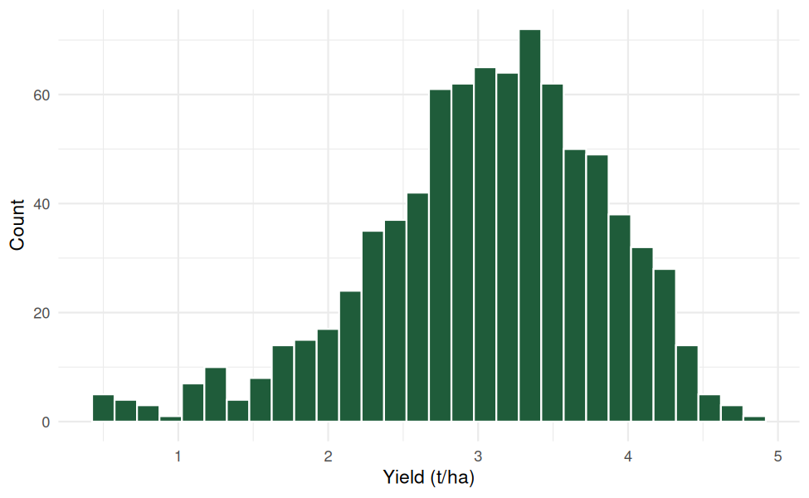
Figure B1: Distribution of simulated yield (R output)
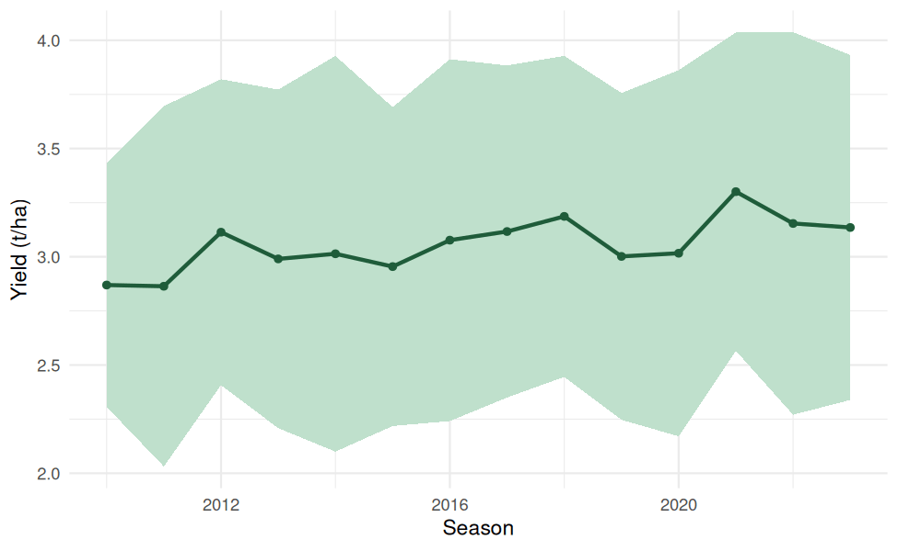
Figure B2: Mean yield by season with one standard deviation (R output)
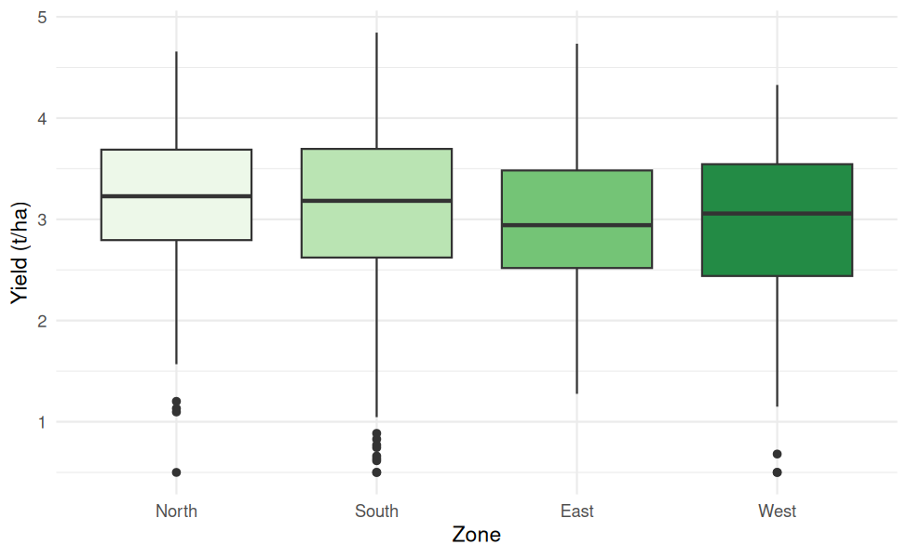
Figure B3: Yield by agro-climatic zone (R output)
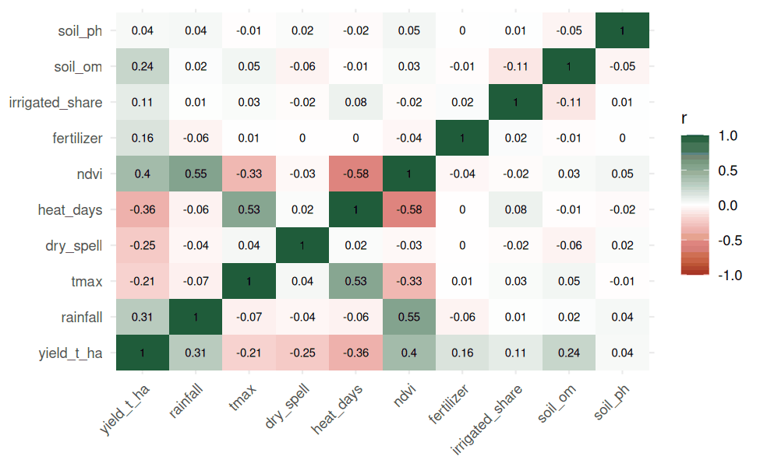
Figure B4: Correlation matrix of numeric variables (R output)
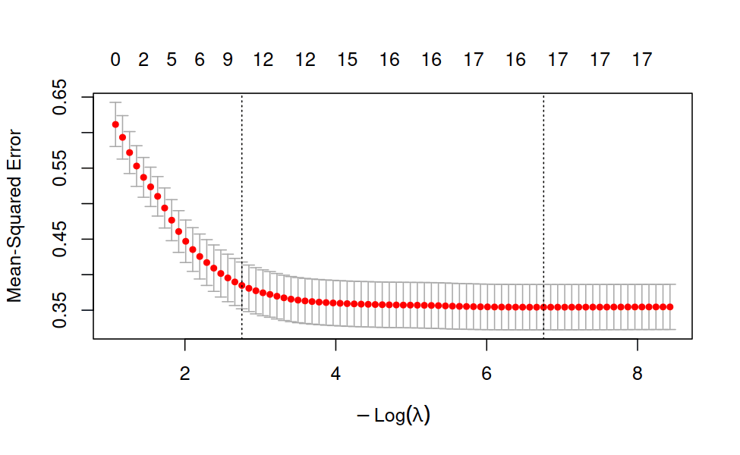
Figure B5: LASSO cross-validation curve, folds grouped by season (R output)
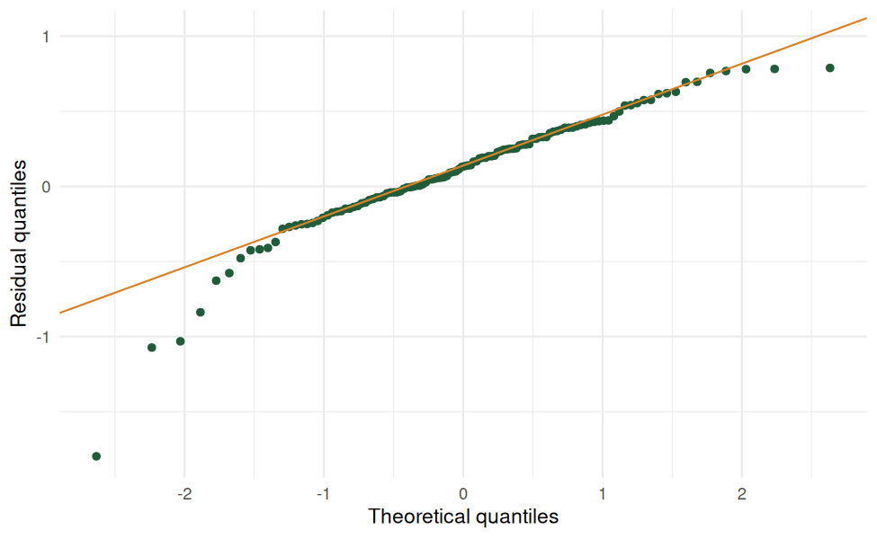
Figure B6: Normal Q-Q plot of test residuals (R output)
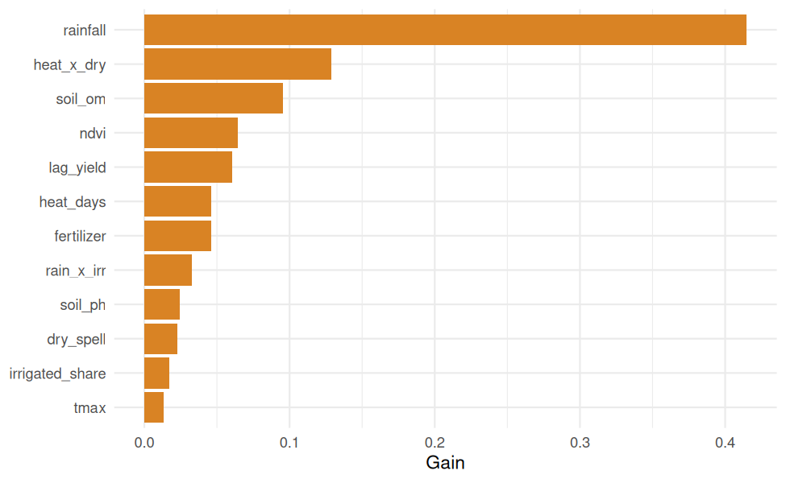
Figure B7: XGBoost feature importance by gain (R output)
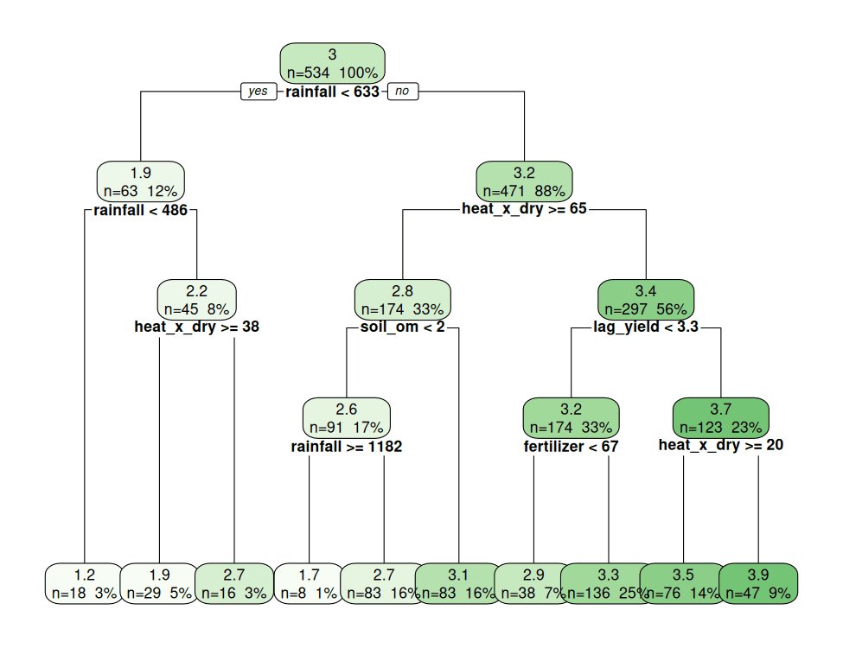Figure B8: Pruned decision tree showing interpretable yield rules (R output)

Appendix C: Session Information
The simulation was run in RStudio on Posit Cloud with the following software (output of sessionInfo()).
Item | Version | Used for
R | 4.6.2 (2026-10-29) | Statistical computing environment
Operating system | Ubuntu 24.04.5 LTS (x86_64) | Posit Cloud platform
tidyverse (dplyr 1.2.1, tidyr 1.3.2, ggplot2 4.0.3, tibble 3.3.1, purrr 1.2.2) | 2.0.0 | Data handling and charts
glmnet | 5.2 | Ridge and LASSO
ranger | 0.18.0 | Random Forest and quantile forest
xgboost | 3.2.1.1 | Gradient boosting
rpart / rpart.plot | 4.1.27 / 3.1.5 | Decision tree and tree plot
knitr / rmarkdown | 1.52 / 2.32 | Report generation
Random seed | 42 | Reproducibility

All results in this report can be reproduced by running Yield_Forecasting_Framework.Rmd in the same environment.

