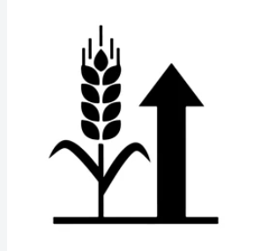

Agribusiness Data Analysis Planning

  - A Structured Plan for Collecting and Analyzing Public Agriculture Market Data

Suruthi D
03 November 2026

Table of Contents
1 Introduction 3
1.1 Purpose of This Document 3
1.2 Objectives 3
1.3 Scope of the Planned Study 3
2 Research Rationale 4
2.1 Why Agribusiness Forecasting Matters 4
2.2 Why Public Data? 4
2.3 Guiding Research Questions 4
3 Proposed Data Sources 4
3.1 Source Inventory 4
3.2 Source Evaluation Criteria 5
3.3 Data Collection Methods 5
4 Key Metrics and Indicators 6
4.1 Crop Production Metrics 6
4.2 Pricing Dynamics Metrics 6
4.3 Resource Utilization Metrics 7
4.4 Derived and Economic Indicators 7
5 Step-by-Step Analysis Plan 7
5.1 Stage 1: Define and Scope 7
5.2 Stage 2: Collect Data 7
5.3 Stage 3: Clean and Prepare 8
5.4 Stage 4: Explore the Data 9
5.5 Stage 5: Model and Forecast 9
5.6 Stage 6: Interpret and Communicate 9
5.7 Quality Assurance Checklist 9
6 Tools and Reproducibility 10
7 Project Timeline 10
7.1 Timeline Table 10
7.2 Timeline Chart 11
7.3 Milestone Review Points 11
8 Risks and Mitigation 12
9 Expected Outcomes and Business Value 12
10 Limitations 12
11 Conclusion 13
12 References and Data Portals 13
13 Screenshots of the RStudio Workflow 13
14 Appendix: Session Information 14

1 Introduction

1.1 Purpose of This Document
Agriculture is a data-rich but decision-poor sector. Farmers, traders, processors and policy makers must decide what to plant, when to sell and how much input to buy, often with little more than last season’s experience to guide them. Large volumes of free, public data on crop production, market prices, weather and input use exist, but they are scattered across many agencies, in different formats and with different levels of quality.
This document is a plan, not an analysis. It describes how publicly available agribusiness data will be identified, collected, cleaned, analyzed and interpreted in order to forecast agricultural market trends. It sets out the research rationale, the data sources, the key metrics, a step-by-step method, a realistic timeline and the risks that could affect delivery.

1.2 Objectives
- Identify reliable public data sources on agriculture market trends.
- Define the key indicators: crop yields, price dynamics and resource utilization.
- Design a repeatable workflow for collection, cleaning, analysis and interpretation.
- Build a realistic timeline with clear milestones.
- Explain how the results can support real agribusiness decisions.

1.3 Scope of the Planned Study
Element | Decision
Focus crops | Rice, wheat, maize and one pulse or oilseed (e.g., groundnut), chosen for data availability and market importance
Geography | India (national and state level, with Tamil Nadu as a detailed example); global series for context
Time horizon | Roughly 2000 to the latest available year for annual data; 5 to 10 years for daily or monthly market prices
Main question | Which factors drive price and yield movements, and how well can near-term prices be forecast?
Unit of analysis | Crop-state-year (annual) and crop-market-month (prices)

2 Research Rationale

2.1 Why Agribusiness Forecasting Matters
- Food security: Early warning of shortages or gluts helps governments plan buffer stocks, imports and exports.
- Farm income: Price risk is one of the largest risks a farmer faces. Knowing likely price direction supports better planting and selling decisions.
- Supply chain efficiency: Processors, warehouses and logistics firms can plan capacity and procurement when trends are anticipated.
- Climate risk: Rainfall variability and temperature extremes directly affect yield, so weather must be part of any serious agricultural analysis.
- Input cost management: Fertilizer and fuel prices change the economics of cultivation and can shift crop choices.

2.2 Why Public Data?
- Free and accessible: No licence cost, which suits a student or small-business context.
- Credible: Data published by statistical agencies and international organizations follows documented methods.
- Reproducible: Anyone can download the same files and verify the analysis.
- Long history: Many series run for decades, which is essential for seasonal and trend analysis.

2.3 Guiding Research Questions
- How have yield, area and production of the selected crops changed over time?
- What are the seasonal and long-term patterns in market prices?
- How strongly do rainfall, temperature and input costs relate to yield and price?
- Which simple forecasting approaches perform best for short-term price prediction?
- What practical recommendations follow for farmers, traders or planners?

3 Proposed Data Sources

3.1 Source Inventory
The table below lists the candidate sources. Each will be checked for coverage, update frequency, licence and format before it is adopted.
Candidate public data sources
Source | Data | Frequency | Format | Use
FAOSTAT (FAO) | Production, yield, area harvested, trade, producer prices by country | Annual | CSV, bulk download, API | Yield and production trends
Ministry of Agriculture & Farmers Welfare / Directorate of Economics and Statistics (India) | State and district crop area, production, yield; minimum support prices | Annual / seasonal | CSV, XLS, PDF reports | Regional yield and production
Agmarknet (via data.gov.in) | Daily mandi (market) arrivals and modal, minimum and maximum prices | Daily | CSV, API (key required) | Price dynamics
USDA Foreign Agricultural Service (PSD) and NASS | Global supply and demand balances; US crop statistics for benchmarking | Monthly / annual | CSV, XLS | Global context
World Bank Commodity Price Data (Pink Sheet) and World Development Indicators | Monthly global commodity prices; macro indicators | Monthly / annual | XLS, CSV, API | Global price drivers
India Meteorological Department (IMD) | Rainfall and temperature, monsoon summaries | Daily / monthly | CSV, gridded files | Weather drivers
NASA POWER / Open-Meteo | Gridded daily rainfall, temperature, solar radiation | Daily | CSV, JSON API | Weather drivers
FAO Fertilizer and input statistics; Fertiliser Association of India reports | Fertilizer consumption and prices; resource use | Annual | XLS, PDF | Resource utilization

3.2 Source Evaluation Criteria
Each source will be scored before use against five criteria:
- Relevance: Does it measure a planned metric directly?
- Coverage: Does it cover the chosen crops, regions and years?
- Timeliness: How recently is it updated?
- Quality: Is the methodology documented, and are there large gaps or revisions?
- Accessibility: Can it be downloaded or called through an API without cost?

3.3 Data Collection Methods
- Bulk downloads: FAOSTAT and World Bank files will be downloaded as CSV or Excel and stored unchanged in a data/raw/ folder.
- APIs: Weather data (NASA POWER, Open-Meteo) and, where allowed, market prices will be pulled with R packages such as httr and jsonlite.
- Manual download: Where portals require interactive selection (some state portals), files will be downloaded manually, and the download date and query settings recorded.
- Documentation: A data log will record for each file its source URL, access date, version, licence and any known limitations.

4 Key Metrics and Indicators

4.1 Crop Production Metrics
Crop production metrics
Metric | Definition | Why it matters
Yield | Output per unit area (e.g., tonnes per hectare) | Core measure of productivity
Area harvested | Land actually harvested (hectares) | Shows expansion or contraction of cultivation
Production | Total output (tonnes) | Drives market supply
Yield growth rate | Year-on-year or compound annual percentage change in yield | Indicates technology and management improvement
Yield variability | Coefficient of variation of yield over a rolling window | Proxy for production risk

4.2 Pricing Dynamics Metrics
Pricing dynamics metrics
Metric | Definition | Why it matters
Modal / average price | Typical market price in a period | Primary forecasting target
Price spread (max - min) | Range of prices within a market and period | Indicates market uncertainty
Month-on-month change | Percentage change from previous month | Captures short-term momentum
Seasonal index | Ratio of a month’s average price to the annual average | Reveals harvest-time price lows and lean-season highs
Price volatility | Standard deviation of log returns over a rolling window | Measures price risk
Price-to-MSP ratio | Market price divided by government minimum support price | Shows whether support prices are binding
Market arrivals | Quantity brought to market | Supply signal that often leads prices

4.3 Resource Utilization Metrics
Resource utilization metrics
Metric | Definition | Why it matters
Fertilizer use per hectare | Fertilizer consumed divided by cropped area | Intensity of input use
Irrigated area share | Irrigated area divided by total cropped area | Reduces dependence on monsoon
Rainfall (seasonal total) | Total rainfall during the crop season | Primary natural driver of yield
Rainfall deviation from normal | Percentage departure from the long-term average | Flags drought or excess rain years
Temperature extremes | Number of days above a heat threshold during key growth stages | Heat stress reduces yield
Input cost index | Index combining fertilizer, fuel and labour cost proxies | Affects profitability and supply response

4.4 Derived and Economic Indicators
- Gross margin proxy: price multiplied by yield minus an estimated input cost per hectare.
- Supply-demand balance: production plus imports minus exports and consumption (global data from USDA PSD).
- Lagged variables: previous season’s price and arrivals, used as predictors because farmers plant based on past prices.

5 Step-by-Step Analysis Plan
The workflow has six stages. Each stage ends with a checkpoint so that errors are found early.

5.1 Stage 1: Define and Scope
- Finalize crops, regions, years and the specific forecasting target (for example, next-month modal price of rice in selected markets).
- Write the research questions and success criteria (for example, forecast error below a benchmark naive model).
- Set up the project structure: data/raw, data/clean, scripts, outputs, docs.

5.2 Stage 2: Collect Data
- Download or request each approved source and save the untouched originals in data/raw/.
- Record every source in the data log (URL, date, licence, variables).
- Check file integrity: row counts, date ranges and variable names.
Example of the intended R approach (shown for illustration, not executed here):
library(tidyverse)
library(httr)
library(jsonlite)
# 1. Bulk CSV from FAOSTAT saved manually into data/raw/
fao <- read_csv("data/raw/faostat_crops.csv")
# 2. Daily weather from a public API (illustrative request)
resp <- GET("https://power.larc.nasa.gov/api/temporal/daily/point",
query = list(parameters = "PRECTOTCORR,T2M",
community = "AG",
latitude = 13.0, longitude = 80.2,
start = 20150101, end = 20241231,
format = "JSON"))
weather <- fromJSON(content(resp, "text"))

5.3 Stage 3: Clean and Prepare
Cleaning is expected to take the largest share of the effort, since data from different agencies rarely aligns.
- Standardize names and units: consistent crop names, tonnes versus quintals, hectares versus thousand hectares, financial year versus calendar year.
- Handle missing values: document the amount missing, then choose between removal, interpolation for short gaps in time series, or leaving as missing where imputation would mislead.
- Detect outliers: inspect with boxplots and rolling statistics; verify unusual prices against source notes before removing anything.
- Fix types and dates: convert text dates, create month and season variables.
- Harmonize geography: align state and market names across sources using a lookup table.
- Merge: join yield, price and weather tables at common keys (crop, region, year or month).
- Save: write cleaned files to data/clean/ and keep the cleaning script so every step is reproducible.
prices_clean <- prices_raw %>%
rename_with(tolower) %>%
mutate(date = as.Date(date, format = "%d/%m/%Y"),
modal_price = as.numeric(modal_price)) %>%
filter(!is.na(modal_price), modal_price > 0) %>%
group_by(commodity, market, month = floor_date(date, "month")) %>%
summarise(avg_modal = mean(modal_price), arrivals = sum(arrivals, na.rm = TRUE),
.groups = "drop")

5.4 Stage 4: Explore the Data
- Summary statistics for every metric by crop and region.
- Trend plots: yield and production over time; price series with moving averages.
- Seasonality: monthly price indices and seasonal decomposition (trend, seasonal, remainder).
- Relationships: correlation matrices and scatter plots of yield against rainfall, fertilizer use and irrigation; price against arrivals.
- Regional comparison: compare states or markets to find high and low performers.

5.5 Stage 5: Model and Forecast
A simple-to-complex approach will be used so that added complexity must justify itself.
Level | Method | Purpose
Baseline | Naive and seasonal naive forecast | Benchmark every other model must beat
Statistical | Linear and multiple regression of yield on rainfall, fertilizer, irrigation | Explain yield drivers
Time series | ETS and ARIMA (via the forecast package) | Short-term price forecasts
Extended | ARIMA with external regressors (rainfall, arrivals) | Test whether drivers improve forecasts
- Validation: hold out the most recent 12 months; use rolling-origin cross-validation for time series.
- Accuracy measures: MAE, RMSE and MAPE, always compared with the naive baseline.
- Diagnostics: check residuals for autocorrelation and non-constant variance.

5.6 Stage 6: Interpret and Communicate
- Translate statistics into plain language: what changed, by how much and why it matters.
- Distinguish correlation from causation, and state assumptions clearly.
- Present forecasts with prediction intervals, not single numbers.
- Provide decision-oriented recommendations, such as the best selling window or the crops most exposed to rainfall risk.
- Report limitations honestly (see the Risks and Limitations section).

5.7 Quality Assurance Checklist
- Every raw file is stored unchanged with source and date logged.
- Every cleaning step is scripted and can be rerun from scratch.
- Units and time periods are consistent across merged tables.
- Models are compared against a naive baseline.
- Results are checked against official published totals where possible.
- Charts have titles, labelled axes and units.

6 Tools and Reproducibility
Planned tools
Purpose | Tool
Programming and reporting | R and RStudio / Posit Cloud, R Markdown
Data wrangling | tidyverse (dplyr, tidyr, lubridate, readr)
Visualization | ggplot2
Time series forecasting | forecast, tseries
Data access | httr, jsonlite, readxl
Documentation | R Markdown, knitr (Word output)
Version control | Git and GitHub
Environment | renv or sessionInfo() recorded in the report
A GitHub repository will hold the scripts, data log, folder structure and README so that the analysis can be reproduced by anyone.

7 Project Timeline

7.1 Timeline Table
The plan assumes about four weeks (20 working days). A buffer is included because data access issues are the most common cause of delay.
Project timeline with milestones
Phase | Task | Days | Milestone
1. Scope and setup | Finalize crops, regions, questions; create project structure | Day 1 to Day 2 | Approved scope document
2. Source identification | Evaluate sources; build data log | Day 2 to Day 4 | Final source list with data log
3. Data collection | Download files; call APIs; verify integrity | Day 4 to Day 7 | All raw data stored
4. Cleaning and merging | Standardize, handle missing values, merge tables | Day 7 to Day 11 | Clean merged dataset
5. Exploration | Summary statistics, trends, seasonality, correlations | Day 11 to Day 14 | EDA charts and findings
6. Modelling and forecasting | Baseline, regression and ARIMA models; validation | Day 14 to Day 17 | Validated forecasts
7. Interpretation and report | Insights, recommendations, limitations, final write-up | Day 17 to Day 19 | Draft report complete
8. Buffer, review, submission | Proofreading, formatting, GitHub upload | Day 19 to Day 20 | Final submission

7.2 Timeline Chart
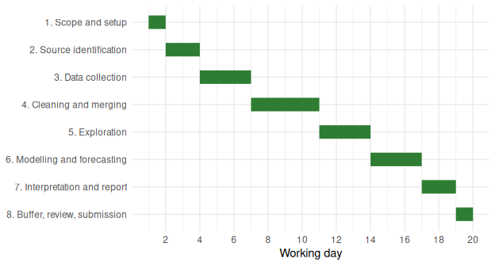
Planned schedule by phase (working days)

7.3 Milestone Review Points
- End of Week 1: scope fixed and sources confirmed. If a key source is unavailable, switch to the backup source.
- End of Week 2: clean dataset ready. No modelling starts before this point.
- End of Week 3: forecasts validated against the baseline.
- End of Week 4: final report reviewed and submitted.

8 Risks and Mitigation
Key risks and mitigation
Risk | Likelihood | Mitigation
Data unavailable or portal down | Medium | Identify a backup source for every metric; keep local copies of raw files
Inconsistent units or definitions across sources | High | Build unit and name lookup tables early; document every conversion
Large gaps in price data | Medium | Limit to markets with consistent reporting; use short-gap interpolation only
Overfitting with limited history | Medium | Start with simple models; use rolling validation and a naive benchmark
Structural breaks (policy changes, export bans, COVID-19) | High | Flag disruption periods; test models with and without them
Time overrun | Medium | Use the buffer days; cut optional extended models first

9 Expected Outcomes and Business Value
- A clean, documented, reproducible dataset combining yield, price and weather information.
- Descriptive insights into long-term productivity trends and seasonal price patterns.
- Short-term price forecasts with stated accuracy and uncertainty.
- Practical recommendations, for example the months when prices typically peak, or the crops most sensitive to rainfall shortfalls.
- A reusable template that can be rerun when new data is released.
Stakeholder | How they could use the results
Farmers and FPOs | Plan crop choice and timing of sales
Traders and processors | Plan procurement and storage
Policy makers | Anticipate shortages and calibrate support measures
Lenders and insurers | Assess price and yield risk

10 Limitations
- Public data may be delayed, revised or aggregated, which limits precision at farm level.
- Price data reflect market (mandi) prices, not necessarily what individual farmers receive.
- Statistical relationships do not prove cause and effect.
- Forecasts become less reliable for long horizons and during unexpected shocks such as policy changes or extreme weather.
- Findings for the selected crops and regions may not generalize to others.

11 Conclusion
This plan sets out a practical, realistic way to turn scattered public agriculture data into insight about market trends. It defines what will be measured (yield, price dynamics and resource use), where the data will come from, how it will be cleaned and analyzed, and when each step will be completed. By starting from a naive benchmark, documenting every step and building in a buffer for data problems, the approach keeps the project achievable within the available time while still producing results that matter to farmers, traders and planners. The next step is to execute Stage 1 and begin the source evaluation.

12 References and Data Portals
- Food and Agriculture Organization of the United Nations. FAOSTAT. fao.org/faostat
- Government of India. Open Government Data Platform (Agmarknet datasets). data.gov.in
- Directorate of Economics and Statistics, Ministry of Agriculture and Farmers Welfare, India. Agricultural Statistics. desagri.gov.in
- United States Department of Agriculture. Production, Supply and Distribution (PSD) Online and NASS Quick Stats. usda.gov
- World Bank. Commodity Markets (Pink Sheet) and World Development Indicators. worldbank.org
- India Meteorological Department. Rainfall and temperature data. imd.gov.in
- NASA. POWER Data Access Viewer. power.larc.nasa.gov
- Open-Meteo. Historical Weather API. open-meteo.com
Portal addresses and dataset availability should be re-checked before collection begins, as sites and access rules change.

13 Screenshots of the RStudio Workflow

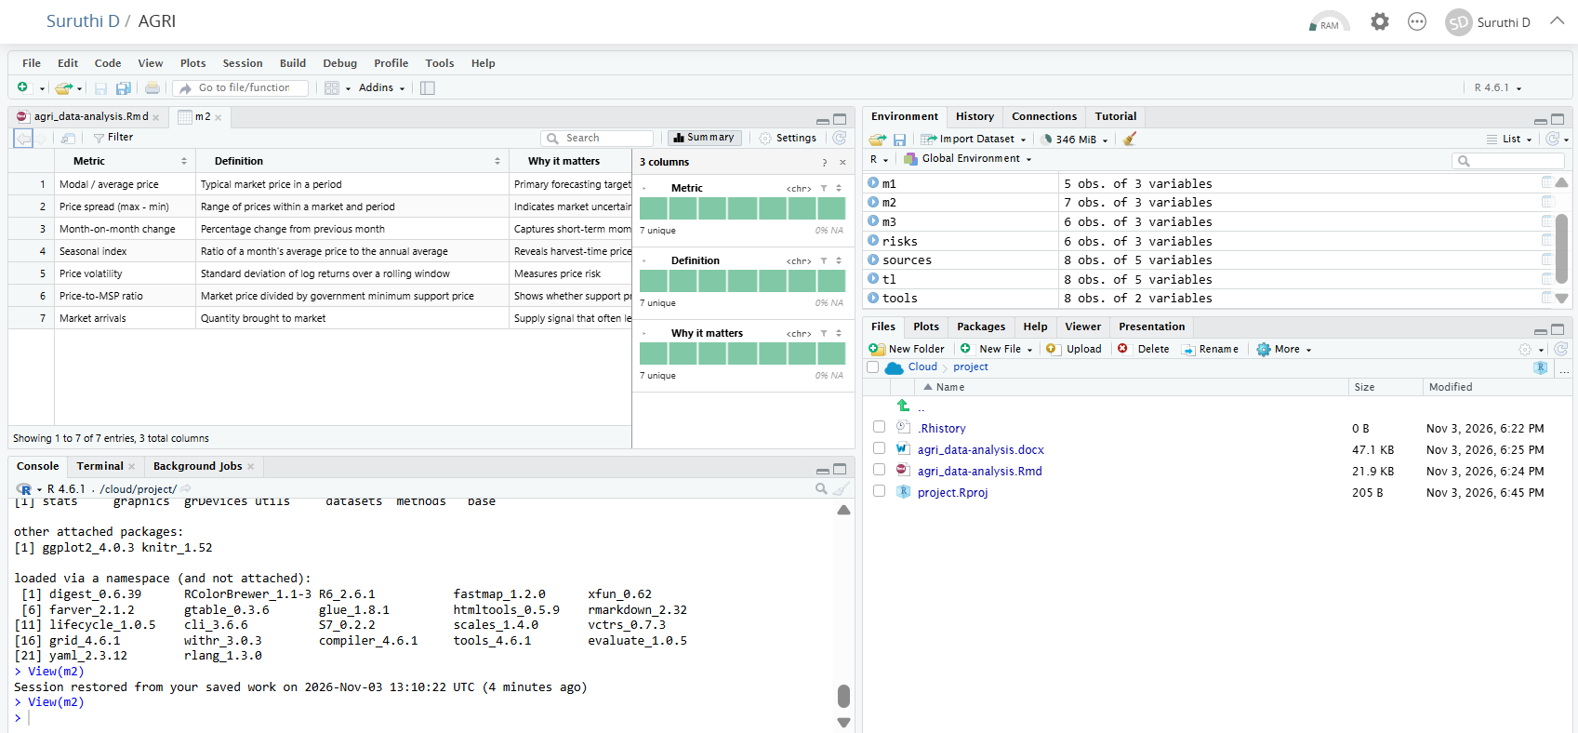
Fig: Project running in RStudio on Posit Cloud, showing the Rmd file, data objects and knitted output.

14 Appendix: Session Information
sessionInfo()
## R version 4.6.1 (2026-06-24)
## Platform: x86_64-pc-linux-gnu
## Running under: Ubuntu 24.04.5 LTS
##
## Matrix products: default
## BLAS: /usr/lib/x86_64-linux-gnu/openblas-pthread/libblas.so.3
## LAPACK: /usr/lib/x86_64-linux-gnu/openblas-pthread/libopenblasp-r0.3.26.so; LAPACK version 3.12.0
##
## locale:
## [1] LC_CTYPE=C.UTF-8 LC_NUMERIC=C LC_TIME=C.UTF-8
## [4] LC_COLLATE=C.UTF-8 LC_MONETARY=C.UTF-8 LC_MESSAGES=C.UTF-8
## [7] LC_PAPER=C.UTF-8 LC_NAME=C LC_ADDRESS=C
## [10] LC_TELEPHONE=C LC_MEASUREMENT=C.UTF-8 LC_IDENTIFICATION=C
##
## time zone: UTC
## tzcode source: system (glibc)
##
## attached base packages:
## [1] stats graphics grDevices utils datasets methods base
##
## other attached packages:
## [1] ggplot2_4.0.3 knitr_1.52
##
## loaded via a namespace (and not attached):
## [1] digest_0.6.39 RColorBrewer_1.1-3 R6_2.6.1 fastmap_1.2.0
## [5] xfun_0.62 farver_2.1.2 gtable_0.3.6 glue_1.8.1
## [9] htmltools_0.5.9 rmarkdown_2.32 lifecycle_1.0.5 cli_3.6.6
## [13] S7_0.2.2 scales_1.4.0 vctrs_0.7.3 grid_4.6.1
## [17] withr_3.0.3 compiler_4.6.1 tools_4.6.1 evaluate_1.0.5
## [21] yaml_2.3.12 rlang_1.3.0

