

Comprehensive Data Analysis Report

  - From Raw Data to Decisions: Cleaning, Visualization and Predictive Modeling in R
Suruthi D
30 October 2026

Table of Contents
1. Introduction and Objectives 3
1.1 The three projects at a glance 3
2. Methodology and Workflow 3
3. Part A: Data Preparation and Exploratory Analysis (Week 1) 4
3.1 Dataset overview 4
3.2 Missing values 6
3.3 Cleaning and imputation 8
3.4 Outlier detection 9
3.5 Transformation, scaling and encoding 11
3.6 Exploratory analysis of the cleaned data 13
4. Part B: Data Visualization and Insight Communication (Week 2) 16
4.1 Dataset overview 16
4.2 Choosing the right chart for each question 17
4.3 Visualizations and interpretation 17
4.4 Quantifying what the charts show 21
5. Part C: Statistical Analysis and Predictive Modeling (Week 3) 22
5.1 Dataset and rationale 22
5.2 Hidden missing values 23
5.3 Exploratory statistics and hypothesis tests 24
5.4 Modeling approach 27
5.5 Interpreting the logistic regression 28
5.6 Final evaluation on the held-out test set 30
5.7 Strengths and limitations of the model 32
6. Integrated Results 32
7. Discussion and Business Implications 33
8. Challenges Overcome and Lessons Learned 33
9. Recommendations and Future Directions 34
10. Conclusion and Limitations 34
11.Screenshots of the RStudio Workflow 35
Appendix 35

1. Introduction and Objectives
This report consolidates three weeks of work into one document that follows data through its full life cycle in R: from a messy raw table, to clear visual communication, to a validated predictive model. The objectives are to:
- Show how data is prepared: missing values, outliers, scaling and encoding (Week 1, msleep).
- Show how patterns are communicated: choosing the right chart for each question (Week 2, gapminder).
- Show how a model is built and judged: hypothesis tests, cross-validation, diagnostics and metrics (Week 3, Pima Indians Diabetes).
- Connect the three stages, explain what the results mean for decision-makers, and record the reasoning behind every decision so the workflow is reproducible.
The report is written for two audiences. Technical readers will find the annotated R code and diagnostics. Non-technical readers can follow the plain-language explanation that introduces each result and the “Hand-off” note that closes each part.

1.1 The three projects at a glance
Overview of the three projects
Stage | Dataset | Core question | Techniques
Week 1: Cleaning and EDA | msleep (ggplot2) | What must messy, mixed-type data go through before it can be trusted? | Missing values, IQR outliers, log/z-score/min-max, one-hot/ordinal/frequency encoding, correlations
Week 2: Visualization | gapminder | How have health and wealth changed, and where are the anomalies? | Histogram, scatter, line and bar charts; log scales; population weighting
Week 3: Modeling | Pima Indians Diabetes | Can routine clinical measurements predict diabetes? | Normality checks, t/Wilcoxon/chi-square tests, logistic regression, 10-fold CV, ROC

2. Methodology and Workflow
All three projects followed the same six-phase workflow. Using one process made the projects comparable and each one easy to audit.

Phase | What happened
1. Understand | Read documentation, inspect with str(), summary(), glimpse()
2. Prepare | Fix missing values, treat outliers, transform and encode variables
3. Explore | Descriptive statistics, correlations and charts
4. Model | Test hypotheses, fit a model, validate with cross-validation
5. Communicate | Interpret in plain language and state the business impact
6. Share | Version-control the code and outputs on GitHub
Reproducibility. Everything is written in R Markdown so that code, output and narrative live in one file. A fixed seed (set.seed(123)) is set wherever randomness is involved (data splitting and cross-validation), so a reviewer who reruns the file gets the same numbers. Repository links are in Appendix A.

3. Part A: Data Preparation and Exploratory Analysis (Week 1)

3.1 Dataset overview
The msleep dataset ships with the ggplot2 package. It is an updated version of the mammal sleep data of Allison and Cicchetti (1976) and holds sleep patterns, brain weight and body weight for 83 mammal species. It was chosen because it has missing values in both numeric and categorical columns, a mix of variable types, and strong outliers and skew (elephants versus mice), which makes normalisation and outlier handling meaningful rather than cosmetic.
data("msleep", package = "ggplot2")
ms_raw <- msleep # untouched copy for before/after comparisons
dim(ms_raw)
## [1] 83 11
ms_dictionary <- tibble(
Variable = c("name", "genus", "vore", "order", "conservation",
"sleep_total", "sleep_rem", "sleep_cycle", "awake",
"brainwt", "bodywt"),
Type = c(rep("Categorical", 5), rep("Numeric", 6)),
Description = c("Common name of the animal", "Genus", "Diet: carni, herbi, insecti, omni",
"Taxonomic order", "Conservation status (IUCN-style code)",
"Total sleep per day (hours)", "REM sleep per day (hours)",
"Length of sleep cycle (hours)", "Hours awake per day",
"Brain weight (kg)", "Body weight (kg)"))
kable(ms_dictionary, caption = "Data dictionary: msleep")
Data dictionary: msleep
Variable | Type | Description
name | Categorical | Common name of the animal
genus | Categorical | Genus
vore | Categorical | Diet: carni, herbi, insecti, omni
order | Categorical | Taxonomic order
conservation | Categorical | Conservation status (IUCN-style code)
sleep_total | Numeric | Total sleep per day (hours)
sleep_rem | Numeric | REM sleep per day (hours)
sleep_cycle | Numeric | Length of sleep cycle (hours)
awake | Numeric | Hours awake per day
brainwt | Numeric | Brain weight (kg)
bodywt | Numeric | Body weight (kg)
str(ms_raw)
## tibble [83 × 11] (S3: tbl_df/tbl/data.frame)
## $ name : chr [1:83] "Cheetah" "Owl monkey" "Mountain beaver" "Greater short-tailed shrew" ...
## $ genus : chr [1:83] "Acinonyx" "Aotus" "Aplodontia" "Blarina" ...
## $ vore : chr [1:83] "carni" "omni" "herbi" "omni" ...
## $ order : chr [1:83] "Carnivora" "Primates" "Rodentia" "Soricomorpha" ...
## $ conservation: chr [1:83] "lc" NA "nt" "lc" ...
## $ sleep_total : num [1:83] 12.1 17 14.4 14.9 4 14.4 8.7 7 10.1 3 ...
## $ sleep_rem : num [1:83] NA 1.8 2.4 2.3 0.7 2.2 1.4 NA 2.9 NA ...
## $ sleep_cycle : num [1:83] NA NA NA 0.133 0.667 ...
## $ awake : num [1:83] 11.9 7 9.6 9.1 20 9.6 15.3 17 13.9 21 ...
## $ brainwt : num [1:83] NA 0.0155 NA 0.00029 0.423 NA NA NA 0.07 0.0982 ...
## $ bodywt : num [1:83] 50 0.48 1.35 0.019 600 ...
summary(ms_raw)
## name genus vore order conservation
## Length :83 Length :83 Length :83 Length :83 Length :83
## N.unique :83 N.unique :77 N.unique : 4 N.unique :19 N.unique : 6
## N.blank : 0 N.blank : 0 N.blank : 0 N.blank : 0 N.blank : 0
## Min.nchar: 3 Min.nchar: 3 Min.nchar: 4 Min.nchar: 6 Min.nchar: 2
## Max.nchar:30 Max.nchar:13 Max.nchar: 7 Max.nchar:15 Max.nchar:12
## NAs : 7 NAs :29
##
## sleep_total sleep_rem sleep_cycle awake
## Min. : 1.90 Min. :0.100 Min. :0.1167 Min. : 4.10
## 1st Qu.: 7.85 1st Qu.:0.900 1st Qu.:0.1833 1st Qu.:10.25
## Median :10.10 Median :1.500 Median :0.3333 Median :13.90
## Mean :10.43 Mean :1.875 Mean :0.4396 Mean :13.57
## 3rd Qu.:13.75 3rd Qu.:2.400 3rd Qu.:0.5792 3rd Qu.:16.15
## Max. :19.90 Max. :6.600 Max. :1.5000 Max. :22.10
## NAs :22 NAs :51
## brainwt bodywt
## Min. :0.00014 Min. : 0.005
## 1st Qu.:0.00290 1st Qu.: 0.174
## Median :0.01240 Median : 1.670
## Mean :0.28158 Mean : 166.136
## 3rd Qu.:0.12550 3rd Qu.: 41.750
## Max. :5.71200 Max. :6654.000
## NAs :27

3.2 Missing values
Missingness was uneven across variables, so one rule for every column would have been a mistake.
ms_miss <- tibble(
variable = names(ms_raw),
n_missing = colSums(is.na(ms_raw)),
pct_missing = round(100 * n_missing / nrow(ms_raw), 1)
) %>% arrange(desc(n_missing))
kable(ms_miss, caption = "Missing values per variable in the raw data")
Missing values per variable in the raw data
variable | n_missing | pct_missing
sleep_cycle | 51 | 61.4
conservation | 29 | 34.9
brainwt | 27 | 32.5
sleep_rem | 22 | 26.5
vore | 7 | 8.4
name | 0 | 0.0
genus | 0 | 0.0
order | 0 | 0.0
sleep_total | 0 | 0.0
awake | 0 | 0.0
bodywt | 0 | 0.0
ggplot(ms_miss, aes(x = reorder(variable, pct_missing), y = pct_missing)) +
geom_col(fill = "steelblue") +
coord_flip() +
labs(x = NULL, y = "% missing")
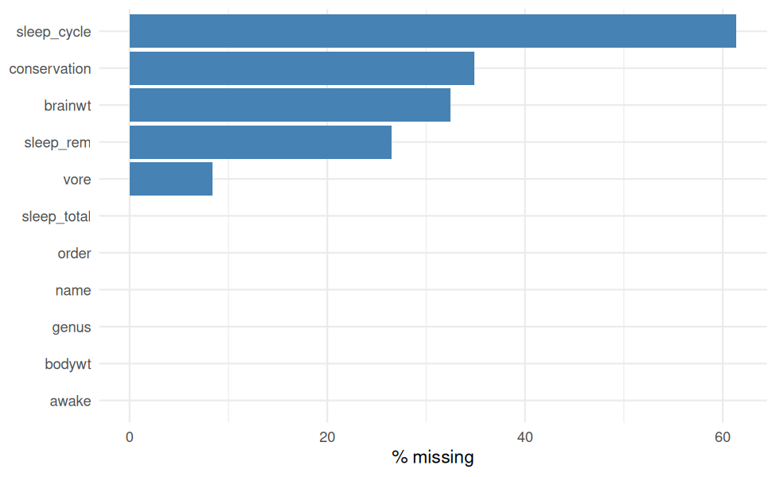
Percentage of missing values per variable (raw data)
The strategy depends on the variable type and how much is missing:
Situation | Strategy | Reason
Column with more than 50% missing | Drop the column | Imputing most of a column mostly invents data
Missing categorical value | Recode as an explicit "unknown" level | Missingness may itself be informative; avoids deleting rows
Missing numeric value | Median of the animal’s diet group (vore), falling back to the overall median | The median is robust to heavy skew; the group median keeps biological structure
Imputed numeric values | Add a logical flag column | Keeps the imputation transparent for later modelling

3.3 Cleaning and imputation
ms <- ms_raw %>%
mutate(across(where(is.character), str_trim)) %>%
mutate(across(c(order, genus, vore, conservation), as.factor))
# (a) Drop columns with too much missingness
threshold <- 0.5
high_miss <- names(which(colMeans(is.na(ms)) > threshold))
cat("Columns dropped (>", threshold * 100, "% missing):", high_miss, "\n")
## Columns dropped (> 50 % missing): sleep_cycle
ms <- ms %>% select(-all_of(high_miss))
# (b) Categorical NA -> explicit "unknown" level
ms <- ms %>%
mutate(across(c(vore, conservation),
~ factor(replace_na(as.character(.x), "unknown"))))
# (c) Numeric NA -> group median with overall-median fallback
impute_group_median <- function(x, g) {
out <- ave(x, g, FUN = function(v) { v[is.na(v)] <- median(v, na.rm = TRUE); v })
out[is.na(out)] <- median(x, na.rm = TRUE)
out
}
ms <- ms %>%
mutate(brainwt_imputed = is.na(brainwt),
sleep_rem_imputed = is.na(sleep_rem),
brainwt = impute_group_median(brainwt, vore),
sleep_rem = impute_group_median(sleep_rem, vore))
cat("Total remaining NA:", sum(is.na(ms)), "\n")
## Total remaining NA: 0
Sensitivity check: imputation should not distort the distributions much.
ms_check <- tibble(
variable = c("sleep_rem", "brainwt"),
mean_before = c(mean(ms_raw$sleep_rem, na.rm = TRUE), mean(ms_raw$brainwt, na.rm = TRUE)),
mean_after = c(mean(ms$sleep_rem), mean(ms$brainwt)),
sd_before = c(sd(ms_raw$sleep_rem, na.rm = TRUE), sd(ms_raw$brainwt, na.rm = TRUE)),
sd_after = c(sd(ms$sleep_rem), sd(ms$brainwt))
) %>% mutate(across(where(is.numeric), ~ round(.x, 4)))
kable(ms_check, caption = "Mean and SD before and after imputation")
Mean and SD before and after imputation
variable | mean_before | mean_after | sd_before | sd_after
sleep_rem | 1.8754 | 1.8102 | 1.2983 | 1.1528
brainwt | 0.2816 | 0.1974 | 0.9764 | 0.8090

3.4 Outlier detection
Outliers are flagged with the IQR rule: a value is an outlier if it lies below Q1 - 1.5 x IQR or above Q3 + 1.5 x IQR.
iqr_outliers <- function(x) {
q <- quantile(x, c(0.25, 0.75), na.rm = TRUE)
iqr <- q[2] - q[1]
x < q[1] - 1.5 * iqr | x > q[2] + 1.5 * iqr
}
ms_num_vars <- ms %>% select(where(is.numeric)) %>% names()
ms_outliers <- map_dfr(ms_num_vars, function(v) {
flag <- iqr_outliers(ms[[v]])
tibble(variable = v, n_outliers = sum(flag), pct_outliers = round(100 * mean(flag), 1))
})
kable(ms_outliers, caption = "Outliers per numeric variable (IQR rule)")
Outliers per numeric variable (IQR rule)
variable | n_outliers | pct_outliers
sleep_total | 0 | 0.0
sleep_rem | 3 | 3.6
awake | 0 | 0.0
brainwt | 16 | 19.3
bodywt | 11 | 13.3
ms %>%
select(all_of(ms_num_vars)) %>%
pivot_longer(everything(), names_to = "variable", values_to = "value") %>%
ggplot(aes(x = variable, y = value)) +
geom_boxplot(fill = "lightblue", outlier.colour = "firebrick") +
facet_wrap(~ variable, scales = "free") +
theme(axis.text.x = element_blank(), axis.title.x = element_blank())
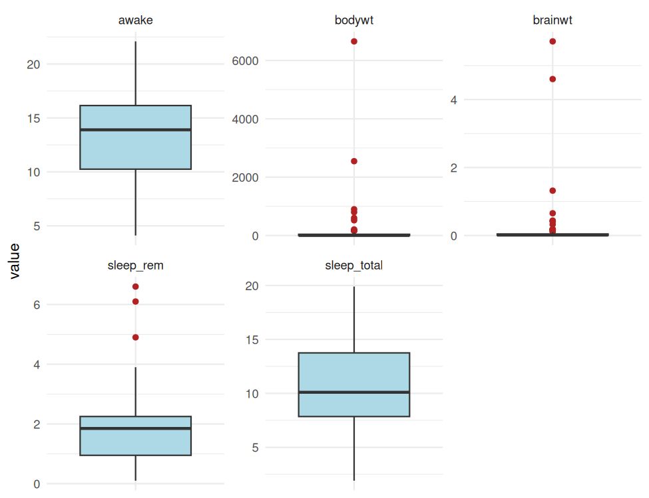
Boxplots of numeric variables (free scales) showing outliers
ms %>%
filter(iqr_outliers(bodywt)) %>%
select(name, bodywt, brainwt) %>%
arrange(desc(bodywt)) %>%
kable(caption = "Body-weight outliers")
Body-weight outliers
Name | bodywt | brainwt
African elephant | 6654.000 | 5.712000
Asian elephant | 2547.000 | 4.603000
Giraffe | 899.995 | 0.012285
Pilot whale | 800.000 | 0.044500
Cow | 600.000 | 0.423000
Horse | 521.000 | 0.655000
Brazilian tapir | 207.501 | 0.169000
Donkey | 187.000 | 0.419000
Bottle-nosed dolphin | 173.330 | 0.044500
Tiger | 162.564 | 0.044500
Lion | 161.499 | 0.044500
Decision: these are genuine biological measurements (large mammals), not data-entry errors, so deleting them would remove real information. They are flagged, and their influence is reduced with a log transformation instead.

3.5 Transformation, scaling and encoding
ms <- ms %>%
mutate(bodywt_outlier = iqr_outliers(bodywt),
brainwt_outlier = iqr_outliers(brainwt),
log_bodywt = log10(bodywt),
log_brainwt = log10(brainwt))
minmax <- function(x) (x - min(x)) / (max(x) - min(x))
scale_vars <- c("sleep_total", "sleep_rem", "awake", "log_brainwt", "log_bodywt")
ms_norm <- ms %>%
mutate(across(all_of(scale_vars),
list(z = ~ as.numeric(scale(.x)), mm = minmax)))
bind_rows(tibble(scale = "Original (kg)", value = ms$bodywt),
tibble(scale = "log10(kg)", value = ms$log_bodywt)) %>%
ggplot(aes(value)) +
geom_histogram(bins = 20, fill = "steelblue", colour = "white") +
facet_wrap(~ scale, scales = "free") +
labs(x = NULL, y = "Count")
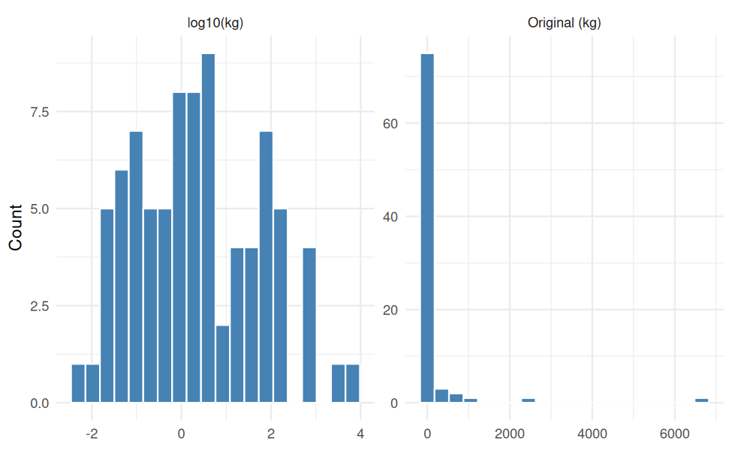
Body weight before and after log10 transformation
Three different encodings are used, each matched to the variable:
Variable | Encoding | Reason
vore (5 levels, no order) | One-hot (dummy) | No natural order between diets
conservation | Ordinal | Threat categories have a natural order of risk
order (many levels) | Frequency encoding | One-hot would add too many columns for 83 rows
onehot <- model.matrix(~ vore - 1, data = ms_norm)
colnames(onehot) <- paste0("vore_", levels(ms_norm$vore))
# "domesticated" and "unknown" are not points on the threat scale -> NA
threat_order <- c("lc", "cd", "nt", "vu", "en")
ms_enc <- bind_cols(ms_norm, as_tibble(onehot)) %>%
mutate(conservation_ord = match(as.character(conservation), threat_order),
order_freq = ave(rep(1, n()), order, FUN = sum) / n())
ms_enc %>%
select(name, vore, starts_with("vore_"), conservation, conservation_ord, order, order_freq) %>%
head(6) %>%
kable(digits = 3, caption = "First rows of the encoded variables")
First rows of the encoded variables
name | vore | vore_carni | vore_herbi | vore_insecti | vore_omni | vore_unknown | conservation | conservation_ord | order | order_freq
Cheetah | carni | 1 | 0 | 0 | 0 | 0 | lc | 1 | Carnivora | 0.145
Owl monkey | omni | 0 | 0 | 0 | 1 | 0 | unknown | NA | Primates | 0.145
Mountain beaver | herbi | 0 | 1 | 0 | 0 | 0 | nt | 3 | Rodentia | 0.265
Greater short-tailed shrew | omni | 0 | 0 | 0 | 1 | 0 | lc | 1 | Soricomorpha | 0.060
Cow | herbi | 0 | 1 | 0 | 0 | 0 | domesticated | NA | Artiodactyla | 0.072
Three-toed sloth | herbi | 0 | 1 | 0 | 0 | 0 | unknown | NA | Pilosa | 0.012
write_csv(ms_enc, "msleep_clean.csv")

3.6 Exploratory analysis of the cleaned data
ms_desc <- ms %>%
select(all_of(ms_num_vars)) %>%
pivot_longer(everything(), names_to = "variable") %>%
group_by(variable) %>%
summarise(n = n(), mean = mean(value), median = median(value), sd = sd(value),
min = min(value), max = max(value),
skewness = mean((value - mean(value))^3) / sd(value)^3,
.groups = "drop") %>%
mutate(across(where(is.numeric), ~ round(.x, 3)))
kable(ms_desc, caption = "Descriptive statistics of numeric variables")
Descriptive statistics of numeric variables
variable | n | mean | median | sd | min | max | skewness
awake | 83 | 13.567 | 13.900 | 4.452 | 4.100 | 22.100 | -0.051
bodywt | 83 | 166.136 | 1.670 | 786.840 | 0.005 | 6654.000 | 7.100
brainwt | 83 | 0.197 | 0.012 | 0.809 | 0.000 | 5.712 | 5.789
sleep_rem | 83 | 1.810 | 1.850 | 1.153 | 0.100 | 6.600 | 1.663
sleep_total | 83 | 10.434 | 10.100 | 4.450 | 1.900 | 19.900 | 0.052
ms_by_vore <- ms %>%
group_by(vore) %>%
summarise(n = n(),
mean_sleep = round(mean(sleep_total), 2),
median_sleep = round(median(sleep_total), 2),
mean_rem = round(mean(sleep_rem), 2),
.groups = "drop") %>%
arrange(desc(mean_sleep))
kable(ms_by_vore, caption = "Sleep by diet group")
Sleep by diet group
vore | n | mean_sleep | median_sleep | mean_rem
insecti | 5 | 14.94 | 18.1 | 3.42
omni | 20 | 10.93 | 9.9 | 1.95
carni | 19 | 10.38 | 10.4 | 2.13
unknown | 7 | 10.19 | 10.6 | 1.91
herbi | 32 | 9.51 | 10.3 | 1.26
ggplot(ms, aes(log_bodywt, sleep_total)) +
geom_point(aes(colour = vore), size = 2.5, alpha = 0.8) +
geom_smooth(method = "lm", formula = y ~ x, colour = "black") +
labs(x = "log10 body weight (kg)", y = "Total sleep (hours)", colour = "Diet")
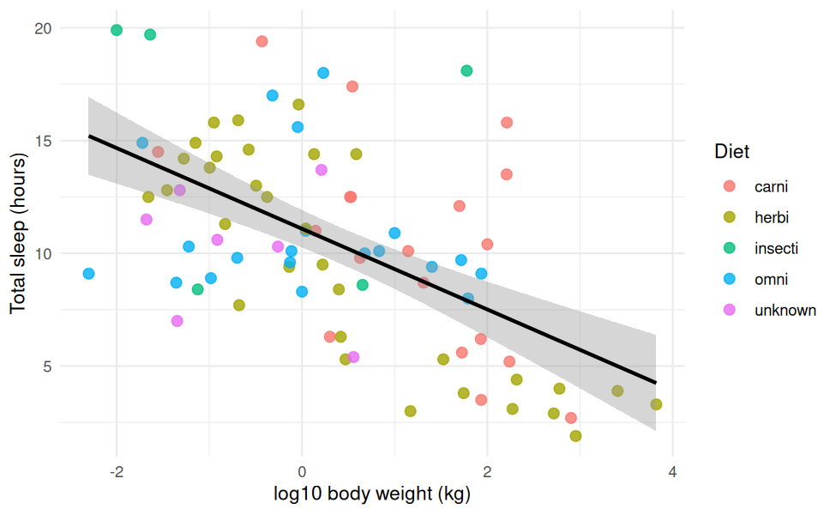
Total sleep versus log10 body weight, coloured by diet
cor_vars <- c("sleep_total", "sleep_rem", "awake", "log_brainwt", "log_bodywt")
ms_cmat <- cor(ms[cor_vars])
as.data.frame(as.table(ms_cmat)) %>%
ggplot(aes(Var1, Var2, fill = Freq)) +
geom_tile(colour = "white") +
geom_text(aes(label = round(Freq, 2))) +
scale_fill_gradient2(low = "firebrick", mid = "white", high = "steelblue", limits = c(-1, 1)) +
labs(x = NULL, y = NULL, fill = "r") +
theme(axis.text.x = element_text(angle = 30, hjust = 1))
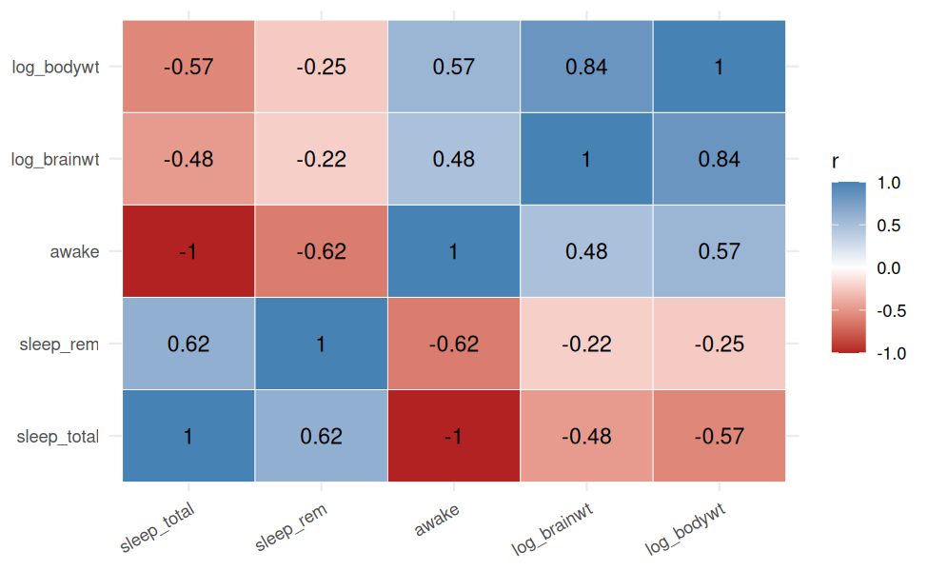
Correlation heatmap of the msleep numeric variables
Findings from Part A.
- The raw data had 136 missing cells; 0 remain after cleaning.
- Total sleep and log body weight have r = -0.57: larger animals tend to sleep less.
- log brain weight and log body weight are very highly correlated (r = 0.84), reflecting allometric scaling.
- awake equals 24 minus sleep_total (r = -1), so only one of the two should enter a model.
- The diet group with the highest average sleep is insecti, but group sizes are uneven, so this is preliminary.
Hand-off to Part B: a documented, fully populated dataset, and the habit of asking why a value is missing or extreme before deciding what to do with it.

4. Part B: Data Visualization and Insight Communication (Week 2)

4.1 Dataset overview
The gapminder dataset tracks 142 countries every five years from 1952 to 2007, giving 1704 rows. Unlike msleep, it is already clean, so the effort moves from repairing data to choosing the right chart for each question.
kable(tibble(
Variable = c("country", "continent", "year", "lifeExp", "pop", "gdpPercap"),
Type = c("Categorical", "Categorical", "Numeric", "Numeric", "Numeric", "Numeric"),
Description = c("Country name", "Continent", "Year (every 5 years)",
"Life expectancy at birth (years)", "Population",
"GDP per capita (inflation-adjusted US$)")),
caption = "Data dictionary: gapminder")
Data dictionary: gapminder
Variable | Type | Description
country | Categorical | Country name
continent | Categorical | Continent
year | Numeric | Year (every 5 years)
lifeExp | Numeric | Life expectancy at birth (years)
pop | Numeric | Population
gdpPercap | Numeric | GDP per capita (inflation-adjusted US$)
cat("Missing values:", sum(is.na(gapminder)), "\n")
## Missing values: 0
summary(gapminder)
## country continent year lifeExp
## Afghanistan: 12 Africa :624 Min. :1952 Min. :23.60
## Albania : 12 Americas:300 1st Qu.:1966 1st Qu.:48.20
## Algeria : 12 Asia :396 Median :1980 Median :60.71
## Angola : 12 Europe :360 Mean :1980 Mean :59.47
## Argentina : 12 Oceania : 24 3rd Qu.:1993 3rd Qu.:70.85
## Australia : 12 Max. :2007 Max. :82.60
## (Other) :1632
## pop gdpPercap
## Min. :6.001e+04 Min. : 241.2
## 1st Qu.:2.794e+06 1st Qu.: 1202.1
## Median :7.024e+06 Median : 3531.8
## Mean :2.960e+07 Mean : 7215.3
## 3rd Qu.:1.959e+07 3rd Qu.: 9325.5
## Max. :1.319e+09 Max. :113523.1
##
gap07 <- gapminder %>% filter(year == 2007)
gap07 %>%
group_by(continent) %>%
summarise(countries = n(),
mean_life = round(mean(lifeExp), 1),
median_gdp = round(median(gdpPercap)),
pop_millions = round(sum(as.numeric(pop)) / 1e6),
.groups = "drop") %>%
kable(caption = "2007 snapshot by continent")
2007 snapshot by continent
continent | countries | mean_life | median_gdp | pop_millions
Africa | 52 | 54.8 | 1452 | 930
Americas | 25 | 73.6 | 8948 | 899
Asia | 33 | 70.7 | 4471 | 3812
Europe | 30 | 77.6 | 28054 | 586
Oceania | 2 | 80.7 | 29810 | 25

4.2 Choosing the right chart for each question
Chart | Question it answers | Why it fits
Histogram | How is life expectancy distributed worldwide in 2007? | Shows shape, spread and any split into groups
Scatter (log x) | Does wealth relate to life expectancy? | Two continuous variables; the log scale handles the wide income range
Line | How has life expectancy changed over time by continent? | Time is the natural x-axis; lines show trend and gaps
Bar | Which continents have the highest GDP per capita? | Compares one summary value across categories

4.3 Visualizations and interpretation
ggplot(gap07, aes(lifeExp)) +
geom_histogram(bins = 20, fill = "steelblue", colour = "white") +
geom_vline(aes(xintercept = mean(lifeExp)), colour = "firebrick", linetype = "dashed") +
labs(x = "Life expectancy (years)", y = "Number of countries")
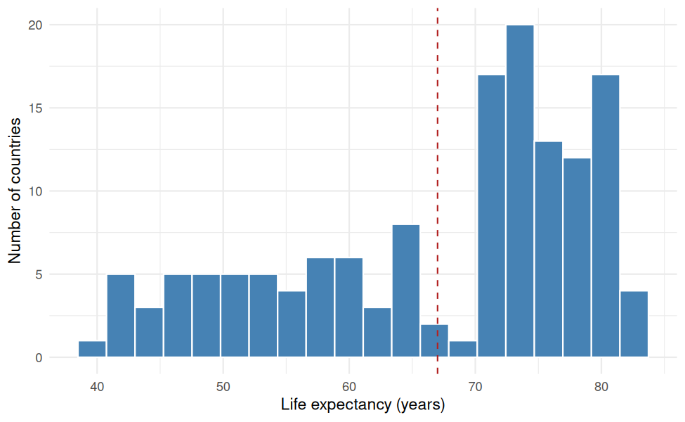
Distribution of life expectancy across countries, 2007
ggplot(gap07, aes(gdpPercap, lifeExp, colour = continent, size = pop)) +
geom_point(alpha = 0.7) +
scale_x_log10(labels = scales::dollar) +
scale_size(range = c(1, 12), guide = "none") +
labs(x = "GDP per capita (log scale)", y = "Life expectancy (years)", colour = "Continent")
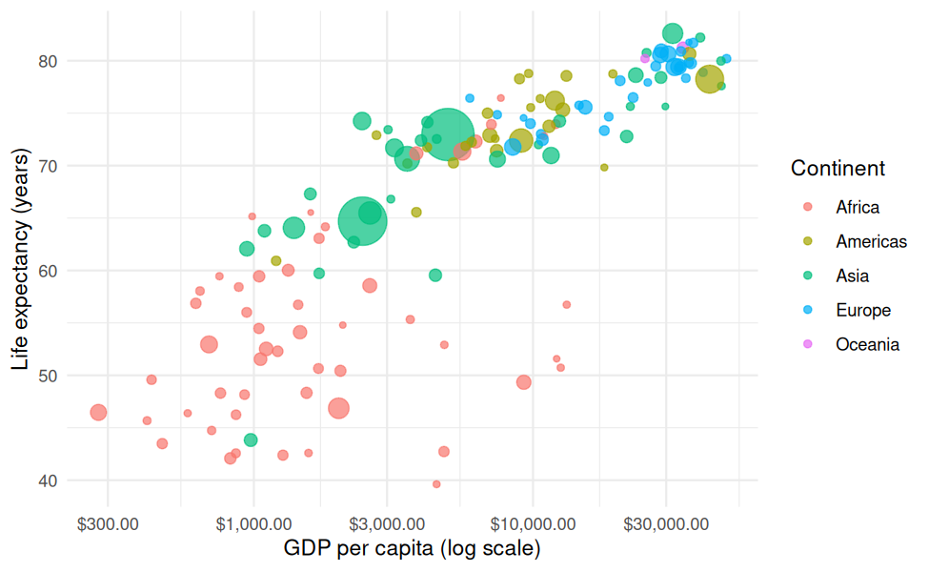
Life expectancy versus GDP per capita (log scale), 2007
life_cont <- gapminder %>%
group_by(continent, year) %>%
summarise(life = weighted.mean(lifeExp, pop), .groups = "drop")
ggplot(life_cont, aes(year, life, colour = continent)) +
geom_line(linewidth = 1.1) + geom_point() +
labs(x = NULL, y = "Life expectancy (years)", colour = "Continent")
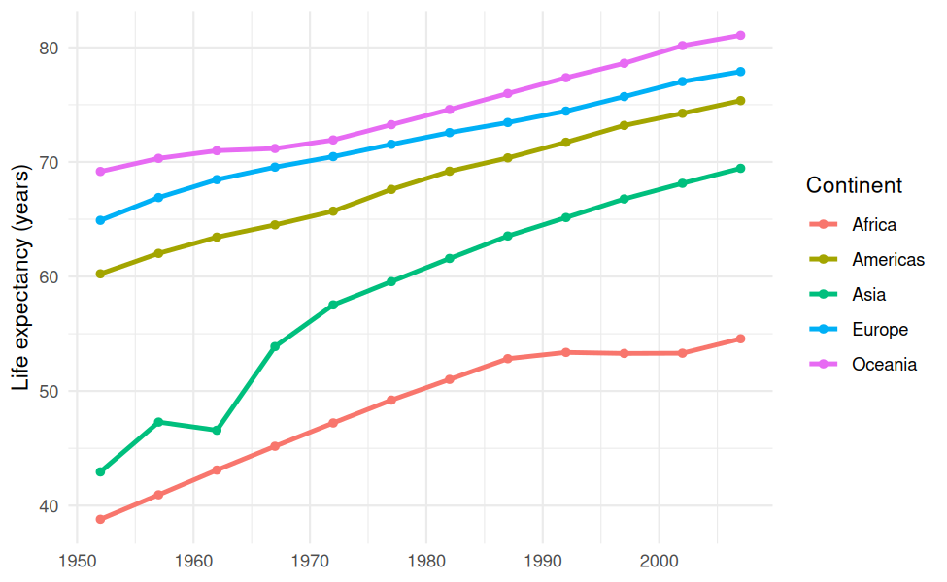
Population-weighted life expectancy by continent, 1952 to 2007
gap07 %>%
group_by(continent) %>%
summarise(gdp = mean(gdpPercap), .groups = "drop") %>%
ggplot(aes(reorder(continent, gdp), gdp)) +
geom_col(fill = "#1F3864") +
coord_flip() +
labs(x = NULL, y = "Mean GDP per capita (US$)")
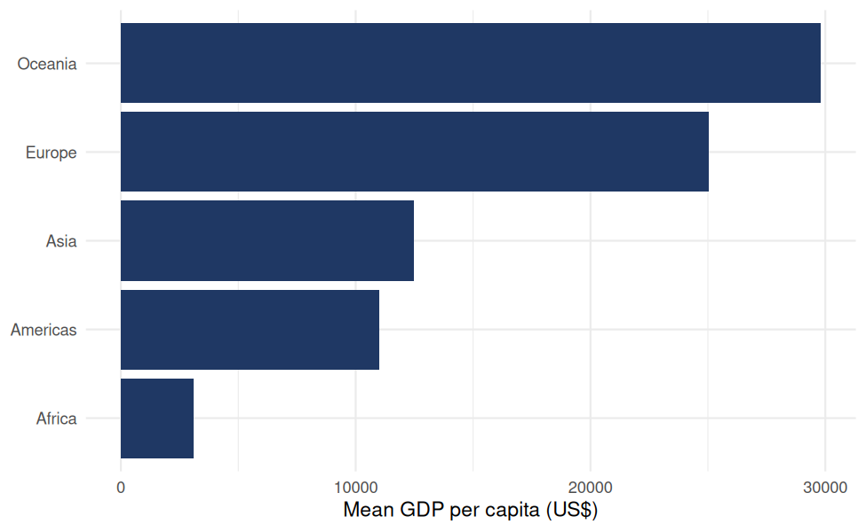
Mean GDP per capita by continent, 2007

4.4 Quantifying what the charts show
gains <- gapminder %>%
filter(year %in% c(1952, 2007)) %>%
group_by(continent, year) %>%
summarise(life = weighted.mean(lifeExp, pop), .groups = "drop") %>%
pivot_wider(names_from = year, values_from = life, names_prefix = "y") %>%
mutate(gain = y2007 - y1952) %>%
arrange(desc(gain)) %>%
mutate(across(where(is.numeric), ~ round(.x, 1)))
kable(gains, caption = "Life expectancy gain by continent, 1952 to 2007")
Life expectancy gain by continent, 1952 to 2007
continent | y1952 | y2007 | gain
Asia | 42.9 | 69.4 | 26.5
Africa | 38.8 | 54.6 | 15.8
Americas | 60.2 | 75.4 | 15.1
Europe | 64.9 | 77.9 | 13.0
Oceania | 69.2 | 81.1 | 11.9
changes <- gapminder %>%
arrange(country, year) %>%
group_by(country) %>%
mutate(change = lifeExp - lag(lifeExp)) %>%
ungroup() %>%
filter(!is.na(change))
worst <- changes %>% arrange(change) %>% slice(1)
Findings from Part B.
- Wealth and health. log10 GDP per capita and life expectancy have r = 0.81 in 2007, and income explains about 65% of the variation in life expectancy across countries. The curve flattens at high incomes: early gains in income are associated with the biggest health gains.
- Progress over time. Every continent improved. The largest gain was in Asia (26.5 years) and the smallest in Oceania (11.9 years).
- Anomalies. Despite the global trend, 102 country-periods show a decline. The largest single drop was Rwanda, which lost 20.4 years between 1987 and 1992. Averages hide events like this, which is why grouped and country-level views matter.
- Income does not tell the whole story. Countries with similar GDP per capita can differ by 10 or more years of life expectancy, which points to factors such as health policy and disease burden.
Hand-off to Part C: visual evidence that relationships can be non-linear, that averages conceal regional differences, and that distributions should be checked before any model assumes they are well behaved.

5. Part C: Statistical Analysis and Predictive Modeling (Week 3)

5.1 Dataset and rationale
The Pima Indians Diabetes dataset has 768 female patients and eight clinical predictors. It suits predictive modeling because the outcome is binary, the predictors are clinically meaningful, and the sample is large enough for cross-validation yet small enough to interpret.
pima <- pima_raw
pima$diabetes <- factor(pima$diabetes, levels = c("pos", "neg")) # "pos" first = event of interest
kable(tibble(
Variable = names(pima),
Description = c("Number of pregnancies", "Plasma glucose concentration",
"Diastolic blood pressure (mm Hg)", "Triceps skin-fold thickness (mm)",
"2-hour serum insulin (mu U/ml)", "Body mass index",
"Diabetes pedigree function", "Age (years)",
"Outcome: pos = diabetes, neg = no diabetes")),
caption = "Data dictionary: Pima Indians Diabetes")
Data dictionary: Pima Indians Diabetes
Variable | Description
pregnant | Number of pregnancies
glucose | Plasma glucose concentration
pressure | Diastolic blood pressure (mm Hg)
triceps | Triceps skin-fold thickness (mm)
insulin | 2-hour serum insulin (mu U/ml)
mass | Body mass index
pedigree | Diabetes pedigree function
age | Age (years)
diabetes | Outcome: pos = diabetes, neg = no diabetes
pima_balance <- tibble(class = names(table(pima$diabetes)),
n = as.integer(table(pima$diabetes)),
pct = round(100 * prop.table(table(pima$diabetes)), 1))
kable(pima_balance, caption = "Class balance of the outcome")
Class balance of the outcome
class | n | pct
pos | 268 | 34.9
neg | 500 | 65.1

5.2 Hidden missing values
A zero is physiologically impossible for glucose, blood pressure, skin-fold thickness, insulin and BMI. These zeros are disguised missing values, and the Week 1 lesson applies directly: ask what a value means before using it.
cols <- c("glucose", "pressure", "triceps", "insulin", "mass")
zero_tbl <- tibble(variable = cols,
n_zero = sapply(pima[cols], function(x) sum(x == 0)),
pct_zero = round(100 * n_zero / nrow(pima), 1)) %>%
arrange(desc(n_zero))
kable(zero_tbl, caption = "Impossible zero values per variable")
Impossible zero values per variable
variable | n_zero | pct_zero
insulin | 374 | 48.7
triceps | 227 | 29.6
pressure | 35 | 4.6
mass | 11 | 1.4
glucose | 5 | 0.7

Situation | Strategy | Reason
Impossible zero in a clinical measurement | Recode as NA | The value is missing, not zero
Remaining NA | Replace with the variable median | Robust to the skew seen in insulin and triceps
pima[cols] <- lapply(pima[cols], function(x) { x[x == 0] <- NA; x })
pima[cols] <- lapply(pima[cols], function(x) { x[is.na(x)] <- median(x, na.rm = TRUE); x })
cat("Total remaining NA:", sum(is.na(pima)), "\n")
## Total remaining NA: 0

5.3 Exploratory statistics and hypothesis tests
pima %>%
pivot_longer(-diabetes, names_to = "variable", values_to = "value") %>%
ggplot(aes(diabetes, value, fill = diabetes)) +
geom_boxplot(show.legend = FALSE) +
facet_wrap(~ variable, scales = "free_y") +
labs(x = NULL, y = NULL)
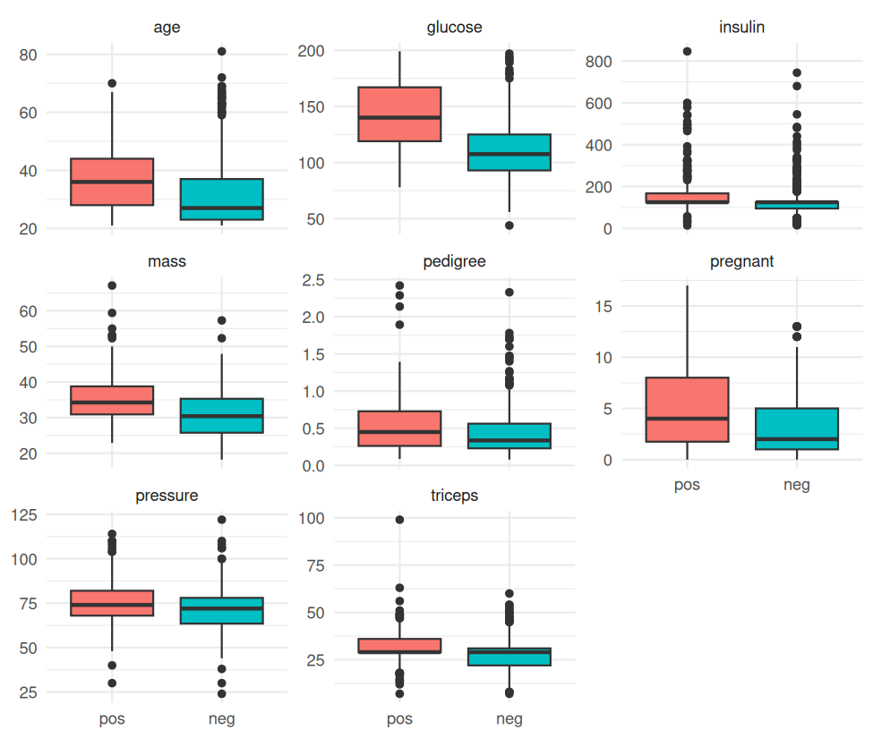
Predictors by diabetes status
Shapiro-Wilk tests check whether each predictor is normal, and non-parametric Wilcoxon tests are used so the conclusions do not depend on that assumption. Cohen’s d reports the size of the difference, not just whether it is detectable.
cohens_d <- function(x, g) {
x1 <- x[g == "pos"]; x0 <- x[g == "neg"]
sp <- sqrt(((length(x1) - 1) * var(x1) + (length(x0) - 1) * var(x0)) /
(length(x1) + length(x0) - 2))
(mean(x1) - mean(x0)) / sp
}
predictors <- setdiff(names(pima), "diabetes")
pima_tests <- map_dfr(predictors, function(v) {
tibble(variable = v,
mean_pos = round(mean(pima[[v]][pima$diabetes == "pos"]), 2),
mean_neg = round(mean(pima[[v]][pima$diabetes == "neg"]), 2),
shapiro_p = format.pval(shapiro.test(pima[[v]])$p.value, digits = 3, eps = 1e-4),
wilcox_p = format.pval(wilcox.test(pima[[v]] ~ pima$diabetes)$p.value, digits = 3, eps = 1e-4),
cohens_d = round(cohens_d(pima[[v]], pima$diabetes), 2))
}) %>% arrange(desc(abs(cohens_d)))
kable(pima_tests, caption = "Group comparison by diabetes status (sorted by effect size)")
Group comparison by diabetes status (sorted by effect size)
variable | mean_pos | mean_neg | shapiro_p | wilcox_p | cohens_d
glucose | 142.13 | 110.68 | <1e-04 | <1e-04 | 1.19
mass | 35.38 | 30.89 | <1e-04 | <1e-04 | 0.69
age | 37.07 | 31.19 | <1e-04 | <1e-04 | 0.51
pregnant | 4.87 | 3.30 | <1e-04 | <1e-04 | 0.48
triceps | 31.69 | 27.73 | <1e-04 | <1e-04 | 0.46
insulin | 164.70 | 127.79 | <1e-04 | <1e-04 | 0.44
pedigree | 0.55 | 0.43 | <1e-04 | <1e-04 | 0.37
pressure | 75.12 | 70.92 | <1e-04 | <1e-04 | 0.35
t.test(glucose ~ diabetes, data = pima)
##
## Welch Two Sample t-test
##
## data: glucose by diabetes
## t = 14.853, df = 469.08, p-value < 2.2e-16
## alternative hypothesis: true difference in means between group pos and group neg is not equal to 0
## 95 percent confidence interval:
## 27.28789 35.60931
## sample estimates:
## mean in group pos mean in group neg
## 142.1306 110.6820
age_group <- cut(pima$age, c(20, 30, 40, 50, 100), include.lowest = TRUE)
chisq.test(table(age_group, pima$diabetes))
##
## Pearson's Chi-squared test
##
## data: table(age_group, pima$diabetes)
## X-squared = 73.809, df = 3, p-value = 6.522e-16
A p-value below 0.05 means the observed difference would be unlikely if the two groups were really the same. A tiny p-value alone does not make an effect important, which is why the effect size column matters.
pima_cmat <- cor(pima[predictors])
as.data.frame(as.table(pima_cmat)) %>%
ggplot(aes(Var1, Var2, fill = Freq)) +
geom_tile(colour = "white") +
geom_text(aes(label = round(Freq, 2)), size = 3) +
scale_fill_gradient2(low = "firebrick", mid = "white", high = "steelblue", limits = c(-1, 1)) +
labs(x = NULL, y = NULL, fill = "r") +
theme(axis.text.x = element_text(angle = 30, hjust = 1))
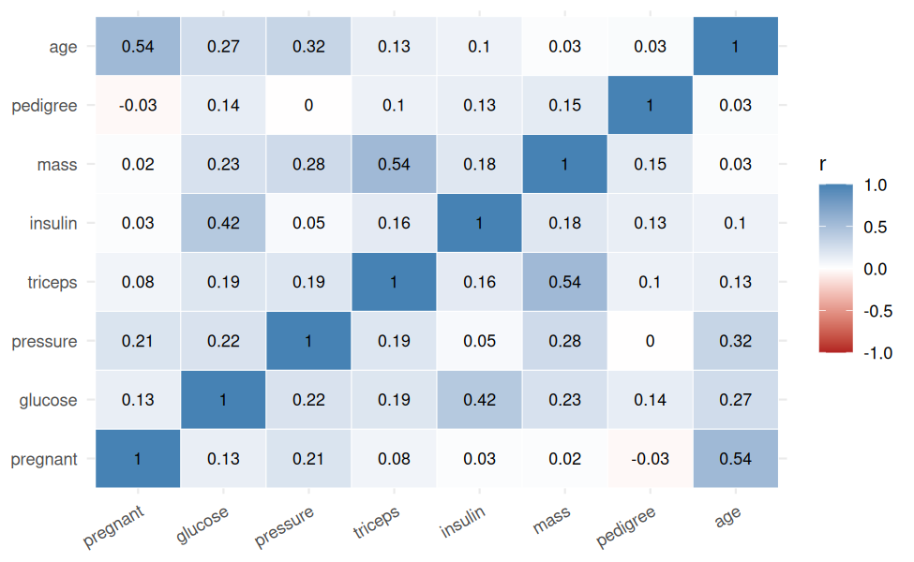
Correlation among predictors

5.4 Modeling approach
Decision | Choice | Reason
Validation | 80/20 train-test split, plus 10-fold cross-validation on the training set | The test set stays untouched until the final check; CV gives a stable estimate while tuning
Baseline model | Logistic regression | Interpretable: coefficients become odds ratios
Comparison model | Decision tree (rpart) | Can capture non-linear relationships that logistic regression cannot
Selection metric | ROC AUC | Not distorted by the 65/35 class imbalance
Scaling | Centre and scale inside the CV loop | Odds ratios become “per 1 SD increase”, comparable across predictors
set.seed(123)
idx <- createDataPartition(pima$diabetes, p = 0.8, list = FALSE)
train <- pima[idx, ]
test <- pima[-idx, ]
cat("Training rows:", nrow(train), "| Test rows:", nrow(test), "\n")
## Training rows: 615 | Test rows: 153
ctrl <- trainControl(method = "cv", number = 10, classProbs = TRUE,
summaryFunction = twoClassSummary, savePredictions = "final")
set.seed(123)
fit_glm <- train(diabetes ~ ., data = train, method = "glm", family = "binomial",
metric = "ROC", trControl = ctrl, preProcess = c("center", "scale"))
set.seed(123)
fit_tree <- train(diabetes ~ ., data = train, method = "rpart",
metric = "ROC", trControl = ctrl, tuneLength = 5)
cv_tbl <- bind_rows(
fit_glm$results %>% transmute(Model = "Logistic regression", ROC, Sens, Spec),
fit_tree$results %>% slice_max(ROC, n = 1, with_ties = FALSE) %>%
transmute(Model = "Decision tree (rpart)", ROC, Sens, Spec)
) %>% mutate(across(where(is.numeric), ~ round(.x, 3)))
kable(cv_tbl, caption = "10-fold cross-validation results (training data)")
10-fold cross-validation results (training data)
Model | ROC | Sens | Spec
Logistic regression | 0.842 | 0.577 | 0.875
Decision tree (rpart) | 0.790 | 0.614 | 0.812

5.5 Interpreting the logistic regression
m <- fit_glm$finalModel
or_tbl <- tibble(
predictor = names(coef(m))[-1],
odds_ratio = exp(-coef(m))[-1],
ci_low = exp(-confint.default(m))[-1, 2],
ci_high = exp(-confint.default(m))[-1, 1],
p_value = summary(m)$coefficients[-1, 4]
) %>%
arrange(desc(odds_ratio)) %>%
mutate(across(c(odds_ratio, ci_low, ci_high), ~ round(.x, 2)),
p_value = format.pval(p_value, digits = 3, eps = 1e-4))
kable(or_tbl, caption = "Odds ratios per 1 SD increase in each predictor (95% Wald CI)")
Odds ratios of diabetes per 1 SD increase in each predictor (95% Wald CI)
predictor | odds_ratio | ci_low | ci_high | p_value
glucose | 3.21 | 2.47 | 4.18 | < 1e-04
mass | 1.87 | 1.42 | 2.47 | < 1e-04
pregnant | 1.45 | 1.14 | 1.85 | 0.00223
pedigree | 1.37 | 1.10 | 1.69 | 0.00428
age | 1.24 | 0.96 | 1.60 | 0.09318
insulin | 0.97 | 0.78 | 1.20 | 0.78242
triceps | 0.96 | 0.75 | 1.24 | 0.77317
pressure | 0.88 | 0.70 | 1.12 | 0.29299
ggplot(or_tbl, aes(odds_ratio, reorder(predictor, odds_ratio))) +
geom_vline(xintercept = 1, linetype = "dashed", colour = "grey40") +
geom_pointrange(aes(xmin = ci_low, xmax = ci_high), colour = "steelblue") +
labs(x = "Odds ratio (per 1 SD)", y = NULL)
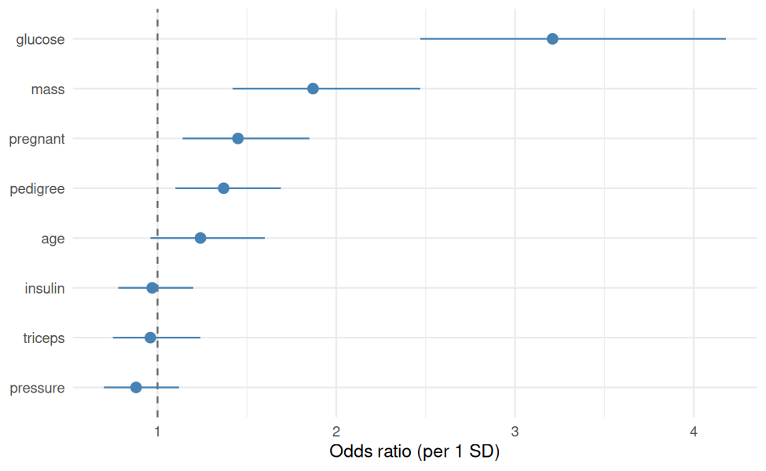
Odds ratios with 95% confidence intervals
An odds ratio above 1 means that a higher value of the predictor raises the odds of diabetes. A confidence interval that excludes 1 indicates a reliable effect.

5.6 Final evaluation on the held-out test set
prob <- predict(fit_glm, newdata = test, type = "prob")$pos
pred <- factor(ifelse(prob >= 0.5, "pos", "neg"), levels = c("pos", "neg"))
cm <- confusionMatrix(pred, test$diabetes, positive = "pos")
roc_obj <- roc(test$diabetes, prob, levels = c("neg", "pos"), direction = "<")
auc_val <- as.numeric(auc(roc_obj))
kable(as.data.frame.matrix(cm$table), caption = "Confusion matrix (rows = predicted, columns = actual)")
Confusion matrix (rows = predicted, columns = actual)
 | pos | neg
pos | 23 | 9
neg | 30 | 91
kable(tibble(
Metric = c("Accuracy", "Sensitivity", "Specificity", "Precision", "AUC"),
Result = round(c(cm$overall["Accuracy"], cm$byClass["Sensitivity"], cm$byClass["Specificity"],
cm$byClass["Pos Pred Value"], auc_val), 3),
Meaning = c("Share of all patients classified correctly",
"Share of true diabetics the model catches",
"Share of healthy patients correctly cleared",
"Share of predicted diabetics who truly have diabetes",
"Ability to rank a diabetic above a healthy patient (0.5 = chance, 1 = perfect)")),
caption = "Test-set performance of the logistic regression")
Test-set performance of the logistic regression
Metric | Result | Meaning
Accuracy | 0.745 | Share of all patients classified correctly
Sensitivity | 0.434 | Share of true diabetics the model catches
Specificity | 0.910 | Share of healthy patients correctly cleared
Precision | 0.719 | Share of predicted diabetics who truly have diabetes
AUC | 0.824 | Ability to rank a diabetic above a healthy patient (0.5 = chance, 1 = perfect)
plot(roc_obj, main = "ROC curve: logistic regression (test set)")
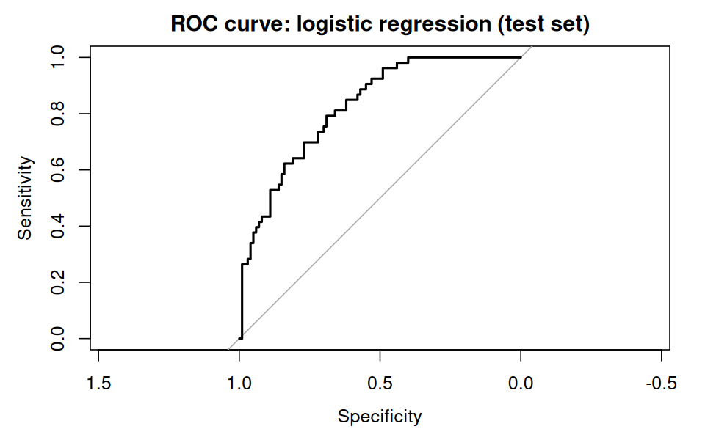
ROC curve on the test set
Threshold tuning. The default cut-off of 0.5 treats both kinds of error equally. In screening, missing a true case is usually costlier than a false alarm, so a lower threshold may be preferable.
thr_tbl <- map_dfr(c(0.3, 0.4, 0.5), function(t) {
p <- factor(ifelse(prob >= t, "pos", "neg"), levels = c("pos", "neg"))
cc <- confusionMatrix(p, test$diabetes, positive = "pos")
tibble(threshold = t,
accuracy = round(as.numeric(cc$overall["Accuracy"]), 3),
sensitivity = round(as.numeric(cc$byClass["Sensitivity"]), 3),
specificity = round(as.numeric(cc$byClass["Specificity"]), 3))
})
kable(thr_tbl, caption = "Effect of the classification threshold")
Effect of the classification threshold
threshold | accuracy | sensitivity | specificity
0.3 | 0.745 | 0.698 | 0.77
0.4 | 0.752 | 0.585 | 0.84
0.5 | 0.745 | 0.434 | 0.91
Findings from Part C.
- Class balance. 268 of 768 patients (34.9%) have diabetes, so accuracy alone would flatter a model that favours the majority class.
- Strongest group difference. glucose shows the largest effect size between diabetic and non-diabetic patients (Cohen’s d = 1.19).
- Strongest model predictor. glucose has the highest odds ratio per 1 SD increase (3.21).
- Model comparison. In cross-validation, Logistic regression achieved the higher AUC, so the simpler interpretable model is not necessarily the weaker one.
- Test-set result. The logistic regression reached an AUC of 0.824, sensitivity of 0.434 and specificity of 0.91 on data it had never seen.

5.7 Strengths and limitations of the model
- Strengths: transparent, fast, and its coefficients agree with clinical expectation (glucose and BMI as main risk signals).
- Limitations: it assumes a linear relationship between predictors and the log-odds; median imputation was applied before splitting the data, which lets a small amount of information leak from the test set; and the data comes from one specific population, so the model should not be applied elsewhere without external validation.

6. Integrated Results
The three projects are not independent exercises. Each one depended on the one before it.
Theme | Where it appeared | What it showed
Data quality drives results | Week 1 missing values; Week 3 hidden zeros | The same discipline was needed twice: ask what a value means before trusting it. Unchecked zeros would have distorted every later statistic.
Scale and skew matter | Week 1 log of body weight; Week 2 log of GDP; Week 3 normality checks | Skewed variables hide patterns and break assumptions; transformation revealed structure in all three datasets.
Visuals come before models | Week 2 curved income-health relationship | Looking first revealed non-linearity and motivated checking assumptions and comparing a tree against logistic regression.
Averages hide detail | Week 2 continent trends and country declines; Week 3 class balance | Grouped views and per-class metrics expose what a single summary number conceals.
Effect size beats p-value | Week 1 correlations; Week 3 Cohen’s d and odds ratios | Significance says an effect is detectable; effect size says whether it matters.

7. Discussion and Business Implications
- Health screening. A simple model built on routine measurements can help prioritise patients for follow-up testing. Its value is triage, helping limited clinical resources reach high-risk people first, not replacing diagnosis. The threshold table shows that the cut-off should be chosen from the cost of a missed case, not left at the default.
- Policy and investment. The wealth-health curve suggests that spending has the largest effect where baseline health is lowest, and the country-level declines show that income alone does not protect health outcomes, so targeted health programmes matter.
- Data governance. Preparation choices (what to impute, what to drop, what to keep as an outlier) silently shape every conclusion. Documenting them, as done in Part A, makes analyses reviewable and trustworthy.
- Communication. The same finding needs different framing for different readers: an odds ratio for a clinician, a trend line for a policy maker, a one-sentence takeaway for a manager.

8. Challenges Overcome and Lessons Learned
Challenge | How it was handled
Deciding how to treat missing data | Treated each variable separately: dropped a column that was mostly empty, group-median imputation for numerics, "unknown" for factors
Skewed and extreme values | Kept genuine extremes, flagged them, and used log transformations instead of deletion
Zeros hiding as real values in Pima | Used domain knowledge to recognise impossible values and recode them as missing
Choosing between models | Compared logistic regression with a decision tree under identical cross-validation folds
Explaining results to non-technical readers | Led each part with the question and closed it with a plain-language takeaway
Environment and reproducibility | Worked in Posit Cloud, fixed seeds, versioned everything on GitHub
Lessons learned
- Cleaning is analysis, not a chore: the most consequential decisions happen before any model is fitted.
- A chart is an argument. Axis, scale and title shape what the reader concludes.
- Accuracy is rarely the right headline metric. The cost of each kind of error should guide the choice.
- Keep the test set untouched until the end, and report effect sizes, not just p-values.
- Documenting the reasoning next to the code makes work reusable.

9. Recommendations and Future Directions
- Richer models: compare logistic regression with random forests and gradient boosting, and examine feature importance.
- Better imputation: use multiple imputation (e.g. mice) and, for the model, impute inside the cross-validation loop to remove leakage.
- Threshold tuning: choose the cut-off that matches the real cost of a missed diagnosis.
- Interactive communication: build a Shiny dashboard so stakeholders can explore the gapminder trends and model predictions.
- External validation: test the diabetes model on a different population before any real-world use.
- Automation: wrap the cleaning steps into reusable functions or a pipeline so new data is processed consistently.

10. Conclusion and Limitations
The report followed data through its full journey. In Week 1 messy data was cleaned and made trustworthy; in Week 2 it was made understandable through purposeful visualisation; in Week 3 it was turned into a validated predictive model. The recurring lesson is that a data-driven approach is only as strong as its weakest stage: careful preparation protects the model’s validity, clear visuals make findings usable, and honest evaluation prevents overconfidence. A data-driven approach does not remove judgment; it makes judgment visible and testable.
Limitations:
- The three datasets are public, small and unrelated, so the report demonstrates method rather than a single unified business case.
- Median imputation shrinks variance slightly and, for Pima, was applied before the train-test split.
- Correlation and prediction do not establish causation, and species and countries are not fully independent observations.

11.Screenshots of the RStudio Workflow
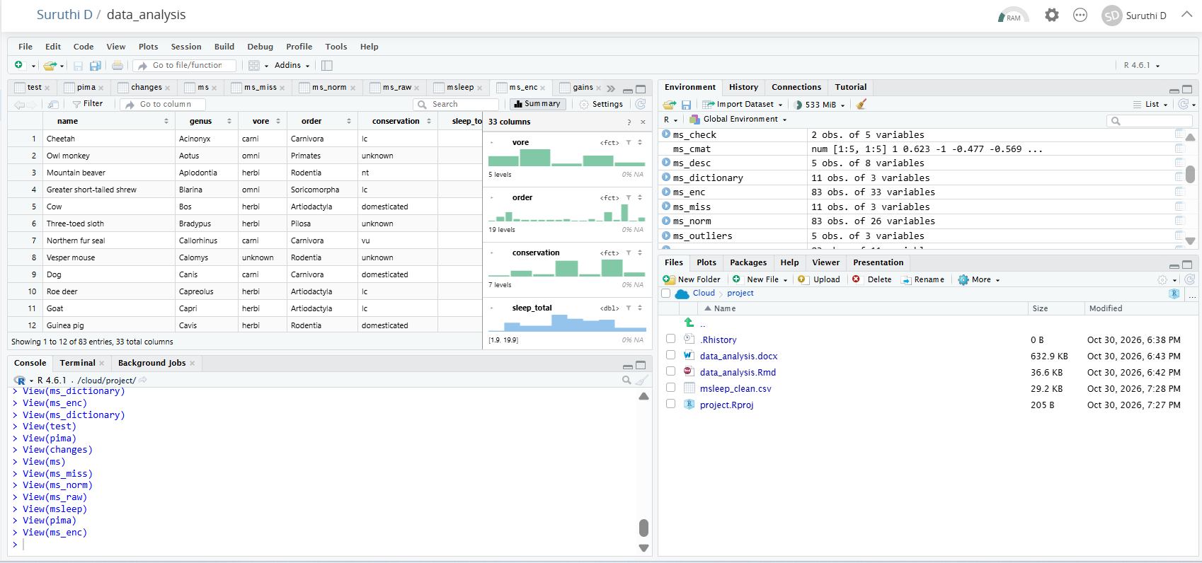

Appendix
A: Project Repositories
- Week 1, data cleaning: https://github.com/suruthi-1/r-data-cleaning-analysis
- Week 2, visualization: https://github.com/suruthi-1/r-data-visualization
- Week 3, predictive modeling: https://github.com/suruthi-1/r-statistical-modeling

B: Reproducibility
sessionInfo()
## R version 4.6.1 (2026-06-24)
## Platform: x86_64-pc-linux-gnu
## Running under: Ubuntu 24.04.5 LTS
##
## Matrix products: default
## BLAS: /usr/lib/x86_64-linux-gnu/openblas-pthread/libblas.so.3
## LAPACK: /usr/lib/x86_64-linux-gnu/openblas-pthread/libopenblasp-r0.3.26.so; LAPACK version 3.12.0
##
## locale:
## [1] LC_CTYPE=C.UTF-8 LC_NUMERIC=C LC_TIME=C.UTF-8
## [4] LC_COLLATE=C.UTF-8 LC_MONETARY=C.UTF-8 LC_MESSAGES=C.UTF-8
## [7] LC_PAPER=C.UTF-8 LC_NAME=C LC_ADDRESS=C
## [10] LC_TELEPHONE=C LC_MEASUREMENT=C.UTF-8 LC_IDENTIFICATION=C
##
## time zone: UTC
## tzcode source: system (glibc)
##
## attached base packages:
## [1] stats graphics grDevices utils datasets methods base
##
## other attached packages:
## [1] pROC_1.19.1 caret_7.0-1 lattice_0.22-9 gapminder_1.0.1
## [5] knitr_1.52 lubridate_1.9.5 forcats_1.0.1 stringr_1.6.0
## [9] dplyr_1.2.1 purrr_1.2.2 readr_2.2.0 tidyr_1.3.2
## [13] tibble_3.3.1 ggplot2_4.0.3 tidyverse_2.0.0
##
## loaded via a namespace (and not attached):
## [1] tidyselect_1.2.1 timeDate_4052.112 farver_2.1.2
## [4] S7_0.2.2 fastmap_1.2.0 digest_0.6.39
## [7] rpart_4.1.27 timechange_0.4.0 lifecycle_1.0.5
## [10] survival_3.8-6 magrittr_2.0.5 compiler_4.6.1
## [13] rlang_1.3.0 tools_4.6.1 yaml_2.3.12
## [16] data.table_1.18.6.1 labeling_0.4.3 bit_4.6.0
## [19] plyr_1.8.9 RColorBrewer_1.1-3 withr_3.0.3
## [22] nnet_7.3-20 grid_4.6.1 stats4_4.6.1
## [25] e1071_1.7-17 future_1.80.0 globals_0.20.0
## [28] scales_1.4.0 iterators_1.0.14 MASS_7.3-65
## [31] cli_3.6.6 rmarkdown_2.32 crayon_1.5.3
## [34] generics_0.1.4 otel_0.2.0 rstudioapi_0.19.0
## [37] future.apply_1.21.0 reshape2_1.4.5 tzdb_0.5.0
## [40] proxy_0.4-29 splines_4.6.1 parallel_4.6.1
## [43] vctrs_0.7.3 hardhat_1.4.3 Matrix_1.7-5
## [46] hms_1.1.4 bit64_4.8.6 listenv_1.1.0
## [49] foreach_1.5.2 gower_1.0.2 recipes_1.4.0
## [52] glue_1.8.1 parallelly_1.48.0 codetools_0.2-20
## [55] stringi_1.8.9 gtable_0.3.6 pillar_1.11.1
## [58] htmltools_0.5.9 ipred_0.9-16 lava_1.10
## [61] R6_2.6.1 vroom_1.7.1 evaluate_1.0.5
## [64] class_7.3-23 Rcpp_1.1.2 nlme_3.1-169
## [67] prodlim_2026.03.11 mgcv_1.9-4 xfun_0.62
## [70] pkgconfig_2.0.3 ModelMetrics_1.2.2.2

