

Data Cleaning and Preliminary Analysis in R
  - Case study: Mammal Sleep Dataset (msleep)
Suruthi D
25 October 2026

Table of Contents
1. Introduction and Objective 3
2. Dataset Overview 3
2.1 Source and rationale 3
2.2 Loading the data 3
2.3 Data dictionary 3
3. Initial Inspection 4
3.1 Structure 4
3.2 Summary statistics of the raw data 5
3.3 Missing values 6
3.4 Duplicates 7
4. Data Cleaning and Transformation 7
4.1 Type correction and text standardisation 7
4.2 Handling missing values 8
4.3 Outlier detection 10
4.4 Transformation and normalisation 12
4.5 Encoding categorical variables 13
4.6 Cleaned dataset 15
5. Exploratory Data Analysis 15
5.1 Structure and summary of the cleaned data 15
5.2 Descriptive statistics 16
5.3 Distributions 17
5.4 Relationships between variables 19
5.5 Correlation analysis 21
6.Key Insights 22
7. Conclusion and Limitations 23
8. Screenshots of the RStudio Workflow 24
Appendix: Reproducibility 24

1. Introduction and Objective
This report documents the data cleaning, preprocessing and preliminary analysis of a publicly available dataset using R.
The objectives are to:
- Select a dataset with missing values and a mix of categorical and numerical variables.
- Clean it: handle missing values, detect outliers, normalise numeric variables and encode categorical variables.
- Carry out exploratory data analysis (EDA) with str(), summary(), descriptive statistics, correlations and visualisations.
- Record the reasoning behind every decision so the workflow is reproducible.

2. Dataset Overview

2.1 Source and rationale
The msleep dataset ships with the ggplot2 package. It is an updated and expanded version of the mammal sleep data of Allison and Cicchetti (1976), and contains sleep patterns, brain weight and body weight for 83 mammal species. It was chosen because it has:
- Missing values in both numeric and categorical columns;
- A mix of variable types (character/categorical and numeric);
- Strong outliers and skew (e.g. elephants versus mice in body weight), which makes normalisation and outlier handling meaningful rather than cosmetic.

2.2 Loading the data
data("msleep", package = "ggplot2")
raw <- msleep # keep an untouched copy for before/after comparisons
dim(raw)
## [1] 83 11

2.3 Data dictionary
dictionary <- tibble(
Variable = c("name", "genus", "vore", "order", "conservation",
"sleep_total", "sleep_rem", "sleep_cycle", "awake",
"brainwt", "bodywt"),
Type = c(rep("Categorical", 5), rep("Numeric", 6)),
Description = c("Common name of the animal", "Genus", "Diet: carni, herbi, insecti, omni",
"Taxonomic order", "Conservation status (IUCN-style code)",
"Total sleep per day (hours)", "REM sleep per day (hours)",
"Length of sleep cycle (hours)", "Hours awake per day",
"Brain weight (kg)", "Body weight (kg)")
)
kable(dictionary)
Variable | Type | Description
name | Categorical | Common name of the animal
genus | Categorical | Genus
vore | Categorical | Diet: carni, herbi, insecti, omni
order | Categorical | Taxonomic order
conservation | Categorical | Conservation status (IUCN-style code)
sleep_total | Numeric | Total sleep per day (hours)
sleep_rem | Numeric | REM sleep per day (hours)
sleep_cycle | Numeric | Length of sleep cycle (hours)
awake | Numeric | Hours awake per day
brainwt | Numeric | Brain weight (kg)
bodywt | Numeric | Body weight (kg)

3. Initial Inspection

3.1 Structure
str(raw)
## tibble [83 × 11] (S3: tbl_df/tbl/data.frame)
## $ name : chr [1:83] "Cheetah" "Owl monkey" "Mountain beaver" "Greater short-tailed shrew" ...
## $ genus : chr [1:83] "Acinonyx" "Aotus" "Aplodontia" "Blarina" ...
## $ vore : chr [1:83] "carni" "omni" "herbi" "omni" ...
## $ order : chr [1:83] "Carnivora" "Primates" "Rodentia" "Soricomorpha" ...
## $ conservation: chr [1:83] "lc" NA "nt" "lc" ...
## $ sleep_total : num [1:83] 12.1 17 14.4 14.9 4 14.4 8.7 7 10.1 3 ...
## $ sleep_rem : num [1:83] NA 1.8 2.4 2.3 0.7 2.2 1.4 NA 2.9 NA ...
## $ sleep_cycle : num [1:83] NA NA NA 0.133 0.667 ...
## $ awake : num [1:83] 11.9 7 9.6 9.1 20 9.6 15.3 17 13.9 21 ...
## $ brainwt : num [1:83] NA 0.0155 NA 0.00029 0.423 NA NA NA 0.07 0.0982 ...
## $ bodywt : num [1:83] 50 0.48 1.35 0.019 600 ...
glimpse(raw)
## Rows: 83
## Columns: 11
## $ name <chr> "Cheetah", "Owl monkey", "Mountain beaver", "Greater shor…
## $ genus <chr> "Acinonyx", "Aotus", "Aplodontia", "Blarina", "Bos", "Bra…
## $ vore <chr> "carni", "omni", "herbi", "omni", "herbi", "herbi", "carn…
## $ order <chr> "Carnivora", "Primates", "Rodentia", "Soricomorpha", "Art…
## $ conservation <chr> "lc", NA, "nt", "lc", "domesticated", NA, "vu", NA, "dome…
## $ sleep_total <dbl> 12.1, 17.0, 14.4, 14.9, 4.0, 14.4, 8.7, 7.0, 10.1, 3.0, 5…
## $ sleep_rem <dbl> NA, 1.8, 2.4, 2.3, 0.7, 2.2, 1.4, NA, 2.9, NA, 0.6, 0.8, …
## $ sleep_cycle <dbl> NA, NA, NA, 0.1333333, 0.6666667, 0.7666667, 0.3833333, N…
## $ awake <dbl> 11.9, 7.0, 9.6, 9.1, 20.0, 9.6, 15.3, 17.0, 13.9, 21.0, 1…
## $ brainwt <dbl> NA, 0.01550, NA, 0.00029, 0.42300, NA, NA, NA, 0.07000, 0…
## $ bodywt <dbl> 50.000, 0.480, 1.350, 0.019, 600.000, 3.850, 20.490, 0.04…

3.2 Summary statistics of the raw data
summary(raw)
## name genus vore order conservation
## Length :83 Length :83 Length :83 Length :83 Length :83
## N.unique :83 N.unique :77 N.unique : 4 N.unique :19 N.unique : 6
## N.blank : 0 N.blank : 0 N.blank : 0 N.blank : 0 N.blank : 0
## Min.nchar: 3 Min.nchar: 3 Min.nchar: 4 Min.nchar: 6 Min.nchar: 2
## Max.nchar:30 Max.nchar:13 Max.nchar: 7 Max.nchar:15 Max.nchar:12
## NAs : 7 NAs :29
##
## sleep_total sleep_rem sleep_cycle awake
## Min. : 1.90 Min. :0.100 Min. :0.1167 Min. : 4.10
## 1st Qu.: 7.85 1st Qu.:0.900 1st Qu.:0.1833 1st Qu.:10.25
## Median :10.10 Median :1.500 Median :0.3333 Median :13.90
## Mean :10.43 Mean :1.875 Mean :0.4396 Mean :13.57
## 3rd Qu.:13.75 3rd Qu.:2.400 3rd Qu.:0.5792 3rd Qu.:16.15
## Max. :19.90 Max. :6.600 Max. :1.5000 Max. :22.10
## NAs :22 NAs :51
## brainwt bodywt
## Min. :0.00014 Min. : 0.005
## 1st Qu.:0.00290 1st Qu.: 0.174
## Median :0.01240 Median : 1.670
## Mean :0.28158 Mean : 166.136
## 3rd Qu.:0.12550 3rd Qu.: 41.750
## Max. :5.71200 Max. :6654.000
## NAs :27

3.3 Missing values
miss_tbl <- tibble(
variable = names(raw),
n_missing = colSums(is.na(raw)),
pct_missing = round(100 * n_missing / nrow(raw), 1)
) %>% arrange(desc(n_missing))
kable(miss_tbl, caption = "Missing values per variable in the raw data")
Missing values per variable in the raw data
variable | n_missing | pct_missing
sleep_cycle | 51 | 61.4
conservation | 29 | 34.9
brainwt | 27 | 32.5
sleep_rem | 22 | 26.5
vore | 7 | 8.4
name | 0 | 0.0
genus | 0 | 0.0
order | 0 | 0.0
sleep_total | 0 | 0.0
awake | 0 | 0.0
bodywt | 0 | 0.0
ggplot(miss_tbl, aes(x = reorder(variable, pct_missing), y = pct_missing)) +
geom_col(fill = "steelblue") +
coord_flip() +
labs(x = NULL, y = "% missing")
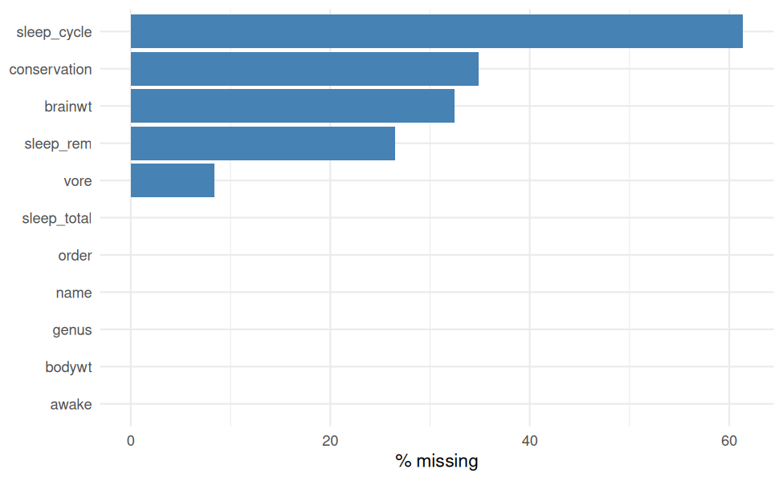
Percentage of missing values per variable (raw data)

3.4 Duplicates
cat("Duplicated rows:", sum(duplicated(raw)), "\n")
## Duplicated rows: 0
cat("Duplicated animal names:", sum(duplicated(raw$name)), "\n")
## Duplicated animal names: 0

4. Data Cleaning and Transformation

4.1 Type correction and text standardisation
Leading/trailing whitespace is trimmed from text columns, and categorical columns are converted to factors so that R treats them as discrete groups.
df <- raw %>%
mutate(across(where(is.character), str_trim)) %>%
mutate(across(c(order, genus, vore, conservation), as.factor))
str(df)
## tibble [83 × 11] (S3: tbl_df/tbl/data.frame)
## $ name : chr [1:83] "Cheetah" "Owl monkey" "Mountain beaver" "Greater short-tailed shrew" ...
## $ genus : Factor w/ 77 levels "Acinonyx","Aotus",..: 1 2 3 4 5 6 7 8 9 10 ...
## $ vore : Factor w/ 4 levels "carni","herbi",..: 1 4 2 4 2 2 1 NA 1 2 ...
## $ order : Factor w/ 19 levels "Afrosoricida",..: 3 15 17 19 2 14 3 17 3 2 ...
## $ conservation: Factor w/ 6 levels "cd","domesticated",..: 4 NA 5 4 2 NA 6 NA 2 4 ...
## $ sleep_total : num [1:83] 12.1 17 14.4 14.9 4 14.4 8.7 7 10.1 3 ...
## $ sleep_rem : num [1:83] NA 1.8 2.4 2.3 0.7 2.2 1.4 NA 2.9 NA ...
## $ sleep_cycle : num [1:83] NA NA NA 0.133 0.667 ...
## $ awake : num [1:83] 11.9 7 9.6 9.1 20 9.6 15.3 17 13.9 21 ...
## $ brainwt : num [1:83] NA 0.0155 NA 0.00029 0.423 NA NA NA 0.07 0.0982 ...
## $ bodywt : num [1:83] 50 0.48 1.35 0.019 600 ...

4.2 Handling missing values
The strategy depends on the variable type and how much is missing:
Situation | Strategy | Reason
Column with more than 50% missing | Drop the column | Imputing most of a column would mostly invent data
Missing categorical value | Recode as an explicit "unknown" level | Missingness may itself be informative; avoids deleting rows
Missing numeric value | Median of the animal’s diet group (vore), falling back to the overall median | Median is robust to the heavy skew seen in brain weight; group median keeps biological structure
Imputed numeric values | Add a logical flag column | Keeps imputation transparent for later modelling
# (a) Drop columns with too much missingness
threshold <- 0.5
high_miss <- names(which(colMeans(is.na(df)) > threshold))
cat("Columns dropped (>", threshold * 100, "% missing):", high_miss, "\n")
## Columns dropped (> 50 % missing): sleep_cycle
df <- df %>% select(-all_of(high_miss))
# (b) Categorical NA -> explicit "unknown" level
df <- df %>%
mutate(across(c(vore, conservation),
~ factor(replace_na(as.character(.x), "unknown"))))
# (c) Numeric NA -> group median with overall-median fallback
impute_group_median <- function(x, g) {
out <- ave(x, g, FUN = function(v) { v[is.na(v)] <- median(v, na.rm = TRUE); v })
out[is.na(out)] <- median(x, na.rm = TRUE)
out
}
df <- df %>%
mutate(brainwt_imputed = is.na(brainwt),
sleep_rem_imputed = is.na(sleep_rem),
brainwt = impute_group_median(brainwt, vore),
sleep_rem = impute_group_median(sleep_rem, vore))
# Verification: no missing values should remain
kable(tibble(variable = names(df), n_missing = colSums(is.na(df))) %>%
filter(n_missing > 0),
caption = "Remaining missing values (empty means none)")
Remaining missing values (empty means none)
variable | n_missing
cat("Total remaining NA:", sum(is.na(df)), "\n")
## Total remaining NA: 0
Sensitivity check: imputation should not distort the distributions much.
check <- tibble(
variable = c("sleep_rem", "brainwt"),
mean_before = c(mean(raw$sleep_rem, na.rm = TRUE), mean(raw$brainwt, na.rm = TRUE)),
mean_after = c(mean(df$sleep_rem), mean(df$brainwt)),
sd_before = c(sd(raw$sleep_rem, na.rm = TRUE), sd(raw$brainwt, na.rm = TRUE)),
sd_after = c(sd(df$sleep_rem), sd(df$brainwt))
) %>% mutate(across(where(is.numeric), ~ round(.x, 4)))
kable(check, caption = "Mean and SD before and after imputation")
Mean and SD before and after imputation
variable | mean_before | mean_after | sd_before | sd_after
sleep_rem | 1.8754 | 1.8102 | 1.2983 | 1.1528
brainwt | 0.2816 | 0.1974 | 0.9764 | 0.8090

4.3 Outlier detection
Outliers are detected with the IQR rule: a value is flagged if it lies below Q1 − 1.5·IQR or above Q3 + 1.5·IQR.
iqr_outliers <- function(x) {
q <- quantile(x, c(0.25, 0.75), na.rm = TRUE)
iqr <- q[2] - q[1]
x < q[1] - 1.5 * iqr | x > q[2] + 1.5 * iqr
}
num_vars <- df %>% select(where(is.numeric)) %>% names()
outlier_summary <- map_dfr(num_vars, function(v) {
flag <- iqr_outliers(df[[v]])
tibble(variable = v, n_outliers = sum(flag), pct_outliers = round(100 * mean(flag), 1))
})
kable(outlier_summary, caption = "Outliers per numeric variable (IQR rule)")
Outliers per numeric variable (IQR rule)
variable | n_outliers | pct_outliers
sleep_total | 0 | 0.0
sleep_rem | 3 | 3.6
awake | 0 | 0.0
brainwt | 16 | 19.3
bodywt | 11 | 13.3
df %>%
select(all_of(num_vars)) %>%
pivot_longer(everything(), names_to = "variable", values_to = "value") %>%
ggplot(aes(x = variable, y = value)) +
geom_boxplot(fill = "lightblue", outlier.colour = "firebrick") +
facet_wrap(~ variable, scales = "free") +
theme(axis.text.x = element_blank(), axis.title.x = element_blank())
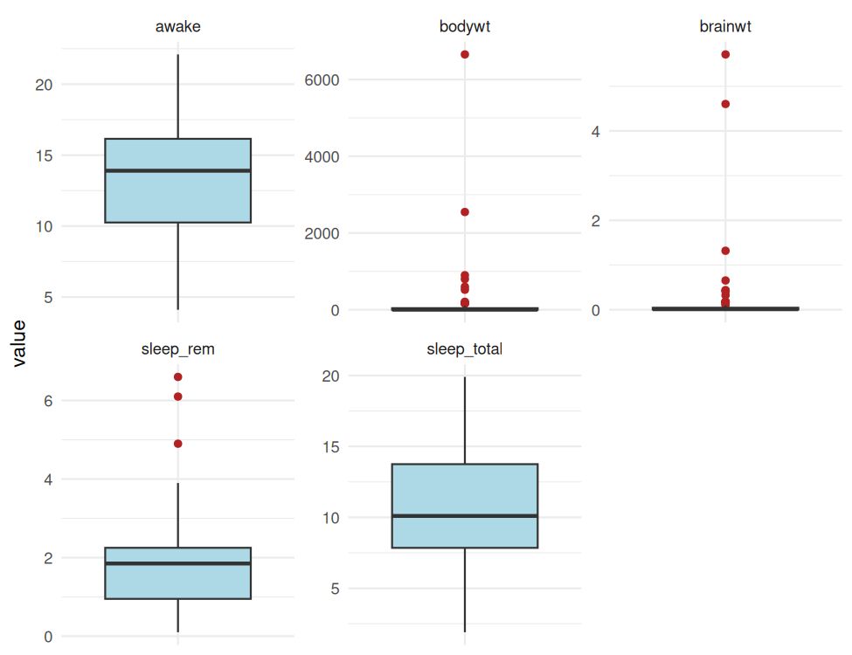
Boxplots of numeric variables (free scales) showing outliers
df %>%
filter(iqr_outliers(bodywt)) %>%
select(name, bodywt, brainwt) %>%
arrange(desc(bodywt)) %>%
kable(caption = "Body-weight outliers")
Body-weight outliers
name | bodywt | brainwt
African elephant | 6654.000 | 5.712000
Asian elephant | 2547.000 | 4.603000
Giraffe | 899.995 | 0.012285
Pilot whale | 800.000 | 0.044500
Cow | 600.000 | 0.423000
Horse | 521.000 | 0.655000
Brazilian tapir | 207.501 | 0.169000
Donkey | 187.000 | 0.419000
Bottle-nosed dolphin | 173.330 | 0.044500
Tiger | 162.564 | 0.044500
Lion | 161.499 | 0.044500
Decision: These outliers are genuine biological measurements (e.g. large mammals), not data-entry errors, so deleting them would remove real information. Instead they are flagged and their influence is reduced with a log transformation (Section 4.4).
df <- df %>% mutate(bodywt_outlier = iqr_outliers(bodywt),
brainwt_outlier = iqr_outliers(brainwt))

4.4 Transformation and normalisation

Log transformation (to fix skew)
df <- df %>% mutate(log_bodywt = log10(bodywt),
log_brainwt = log10(brainwt))
bind_rows(tibble(scale = "Original (kg)", value = df$bodywt),
tibble(scale = "log10(kg)", value = df$log_bodywt)) %>%
ggplot(aes(value)) +
geom_histogram(bins = 20, fill = "steelblue", colour = "white") +
facet_wrap(~ scale, scales = "free") +
labs(x = NULL, y = "Count")
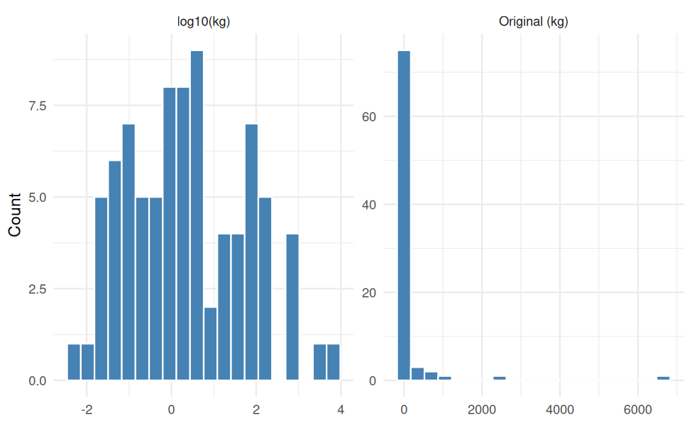
Body weight before and after log10 transformation

Z-score and min-max scaling
Z-score standardisation (mean 0, SD 1) suits methods sensitive to variance; min-max scaling (0 to 1) suits methods sensitive to range.
minmax <- function(x) (x - min(x)) / (max(x) - min(x))
scale_vars <- c("sleep_total", "sleep_rem", "awake", "log_brainwt", "log_bodywt")
df_norm <- df %>%
mutate(across(all_of(scale_vars),
list(z = ~ as.numeric(scale(.x)), mm = minmax)))
z_check <- sapply(select(df_norm, ends_with("_z")),
function(x) c(mean = mean(x), sd = sd(x)))
kable(round(z_check, 3), caption = "Z-scored variables: mean ~ 0, SD = 1")
Z-scored variables: mean ~ 0, SD = 1
 | sleep_total_z | sleep_rem_z | awake_z | log_brainwt_z | log_bodywt_z
mean | 0 | 0 | 0 | 0 | 0
sd | 1 | 1 | 1 | 1 | 1
mm_check <- sapply(select(df_norm, ends_with("_mm")),
function(x) c(min = min(x), max = max(x)))
kable(round(mm_check, 3), caption = "Min-max scaled variables: range 0 to 1")
Min-max scaled variables: range 0 to 1
 | sleep_total_mm | sleep_rem_mm | awake_mm | log_brainwt_mm | log_bodywt_mm
min | 0 | 0 | 0 | 0 | 0
max | 1 | 1 | 1 | 1 | 1

4.5 Encoding categorical variables
Three different encodings are used, each matched to the variable:
Variable | Encoding | Reason
vore (5 levels, no order) | One-hot (dummy) | No natural order between diets
conservation | Ordinal | Threat categories have a natural order of risk
order (many levels) | Frequency encoding | One-hot would add too many columns for 83 rows
# One-hot encoding for vore
onehot <- model.matrix(~ vore - 1, data = df_norm)
colnames(onehot) <- paste0("vore_", levels(df_norm$vore))
# Ordinal encoding for conservation (least to most threatened).
# "domesticated" and "unknown" are not points on the threat scale -> NA.
threat_order <- c("lc", "cd", "nt", "vu", "en")
df_enc <- bind_cols(df_norm, as_tibble(onehot)) %>%
mutate(conservation_ord = match(as.character(conservation), threat_order),
order_freq = ave(rep(1, n()), order, FUN = sum) / n())
df_enc %>%
select(name, vore, starts_with("vore_"), conservation, conservation_ord,
order, order_freq) %>%
head(8) %>%
kable(digits = 3, caption = "First rows of the encoded variables")
First rows of the encoded variables
name | vore | vore_carni | vore_herbi | vore_insecti | vore_omni | vore_unknown | conservation | conservation_ord | order | order_freq
Cheetah | carni | 1 | 0 | 0 | 0 | 0 | lc | 1 | Carnivora | 0.145
Owl monkey | omni | 0 | 0 | 0 | 1 | 0 | unknown | NA | Primates | 0.145
Mountain beaver | herbi | 0 | 1 | 0 | 0 | 0 | nt | 3 | Rodentia | 0.265
Greater short-tailed shrew | omni | 0 | 0 | 0 | 1 | 0 | lc | 1 | Soricomorpha | 0.060
Cow | herbi | 0 | 1 | 0 | 0 | 0 | domesticated | NA | Artiodactyla | 0.072
Three-toed sloth | herbi | 0 | 1 | 0 | 0 | 0 | unknown | NA | Pilosa | 0.012
Northern fur seal | carni | 1 | 0 | 0 | 0 | 0 | vu | 4 | Carnivora | 0.145
Vesper mouse | unknown | 0 | 0 | 0 | 0 | 1 | unknown | NA | Rodentia | 0.265

4.6 Cleaned dataset
dim(df_enc)
## [1] 83 33
write_csv(df_enc, "msleep_clean.csv")

5. Exploratory Data Analysis

5.1 Structure and summary of the cleaned data
str(df_enc %>% select(name, order, vore, conservation, all_of(num_vars)))
## tibble [83 × 9] (S3: tbl_df/tbl/data.frame)
## $ name : chr [1:83] "Cheetah" "Owl monkey" "Mountain beaver" "Greater short-tailed shrew" ...
## $ order : Factor w/ 19 levels "Afrosoricida",..: 3 15 17 19 2 14 3 17 3 2 ...
## $ vore : Factor w/ 5 levels "carni","herbi",..: 1 4 2 4 2 2 1 5 1 2 ...
## $ conservation: Factor w/ 7 levels "cd","domesticated",..: 4 6 5 4 2 6 7 6 2 4 ...
## $ sleep_total : num [1:83] 12.1 17 14.4 14.9 4 14.4 8.7 7 10.1 3 ...
## $ sleep_rem : num [1:83] 1.95 1.8 2.4 2.3 0.7 2.2 1.4 2 2.9 0.95 ...
## $ awake : num [1:83] 11.9 7 9.6 9.1 20 9.6 15.3 17 13.9 21 ...
## $ brainwt : num [1:83] 0.0445 0.0155 0.01229 0.00029 0.423 ...
## $ bodywt : num [1:83] 50 0.48 1.35 0.019 600 ...
summary(df_enc %>% select(vore, conservation, all_of(num_vars)))
## vore conservation sleep_total sleep_rem awake
## carni :19 cd : 2 Min. : 1.90 Min. :0.10 Min. : 4.10
## herbi :32 domesticated:10 1st Qu.: 7.85 1st Qu.:0.95 1st Qu.:10.25
## insecti: 5 en : 4 Median :10.10 Median :1.85 Median :13.90
## omni :20 lc :27 Mean :10.43 Mean :1.81 Mean :13.57
## unknown: 7 nt : 4 3rd Qu.:13.75 3rd Qu.:2.25 3rd Qu.:16.15
## unknown :29 Max. :19.90 Max. :6.60 Max. :22.10
## vu : 7
## brainwt bodywt
## Min. :0.00014 Min. : 0.005
## 1st Qu.:0.00560 1st Qu.: 0.174
## Median :0.01229 Median : 1.670
## Mean :0.19743 Mean : 166.136
## 3rd Qu.:0.04450 3rd Qu.: 41.750
## Max. :5.71200 Max. :6654.000
##

5.2 Descriptive statistics
desc <- df %>%
select(all_of(num_vars)) %>%
pivot_longer(everything(), names_to = "variable") %>%
group_by(variable) %>%
summarise(n = n(), mean = mean(value), median = median(value), sd = sd(value),
min = min(value), max = max(value),
skewness = mean((value - mean(value))^3) / sd(value)^3,
.groups = "drop") %>%
mutate(across(where(is.numeric), ~ round(.x, 3)))
kable(desc, caption = "Descriptive statistics of numeric variables")
Descriptive statistics of numeric variables
variable | n | mean | median | sd | min | max | skewness
awake | 83 | 13.567 | 13.900 | 4.452 | 4.100 | 22.100 | -0.051
bodywt | 83 | 166.136 | 1.670 | 786.840 | 0.005 | 6654.000 | 7.100
brainwt | 83 | 0.197 | 0.012 | 0.809 | 0.000 | 5.712 | 5.789
sleep_rem | 83 | 1.810 | 1.850 | 1.153 | 0.100 | 6.600 | 1.663
sleep_total | 83 | 10.434 | 10.100 | 4.450 | 1.900 | 19.900 | 0.052
by_vore <- df %>%
group_by(vore) %>%
summarise(n = n(),
mean_sleep = round(mean(sleep_total), 2),
median_sleep = round(median(sleep_total), 2),
mean_rem = round(mean(sleep_rem), 2),
.groups = "drop") %>%
arrange(desc(mean_sleep))
kable(by_vore, caption = "Sleep by diet group")
Sleep by diet group
vore | n | mean_sleep | median_sleep | mean_rem
insecti | 5 | 14.94 | 18.1 | 3.42
omni | 20 | 10.93 | 9.9 | 1.95
carni | 19 | 10.38 | 10.4 | 2.13
unknown | 7 | 10.19 | 10.6 | 1.91
herbi | 32 | 9.51 | 10.3 | 1.26

5.3 Distributions
ggplot(df, aes(sleep_total)) +
geom_histogram(bins = 15, fill = "steelblue", colour = "white") +
geom_vline(aes(xintercept = mean(sleep_total)), colour = "firebrick", linetype = "dashed") +
labs(x = "Total sleep (hours)", y = "Count")
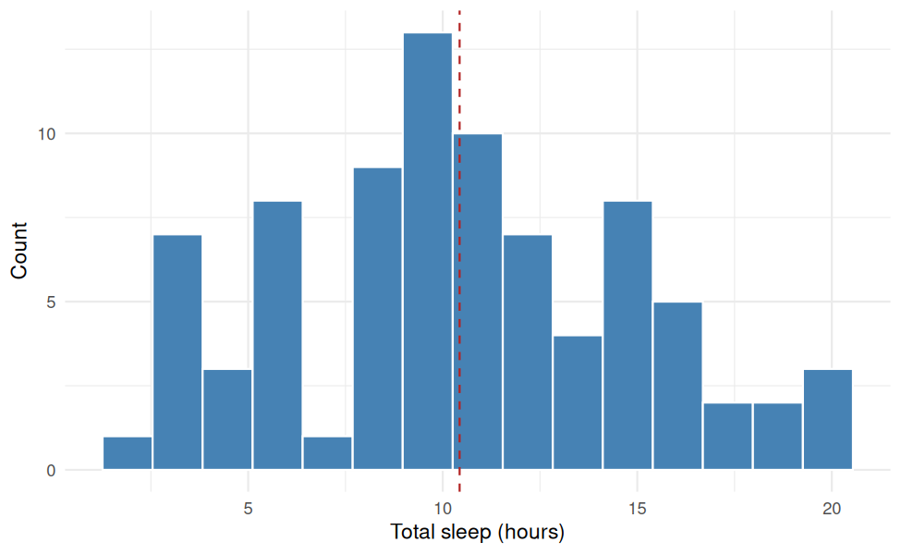
Distribution of total sleep (hours per day)
ggplot(df, aes(x = fct_infreq(vore), fill = vore)) +
geom_bar(show.legend = FALSE) +
labs(x = "Diet (vore)", y = "Number of species")
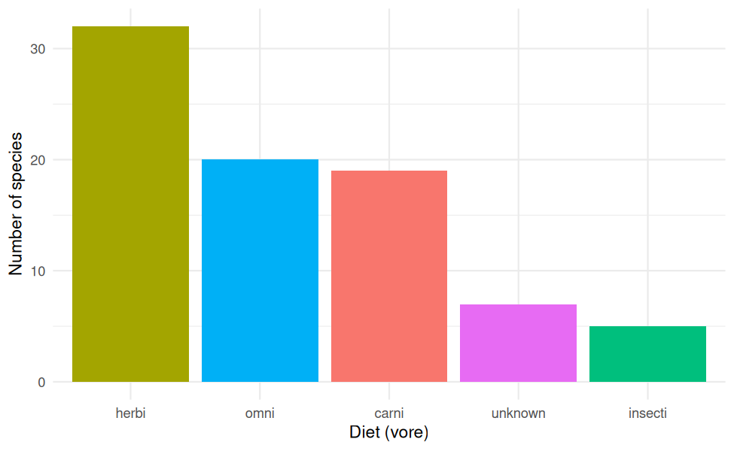
Number of species by diet
ggplot(df, aes(x = reorder(vore, sleep_total, median), y = sleep_total, fill = vore)) +
geom_boxplot(show.legend = FALSE) +
labs(x = "Diet (vore)", y = "Total sleep (hours)")
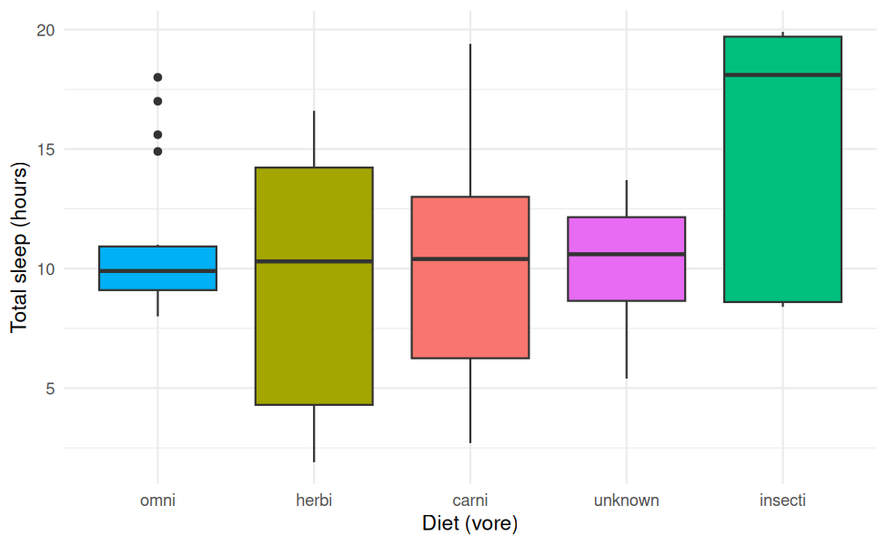
Total sleep by diet group

5.4 Relationships between variables
ggplot(df, aes(log_bodywt, sleep_total)) +
geom_point(aes(colour = vore), size = 2.5, alpha = 0.8) +
geom_smooth(method = "lm", formula = y ~ x, colour = "black") +
labs(x = "log10 body weight (kg)", y = "Total sleep (hours)", colour = "Diet")
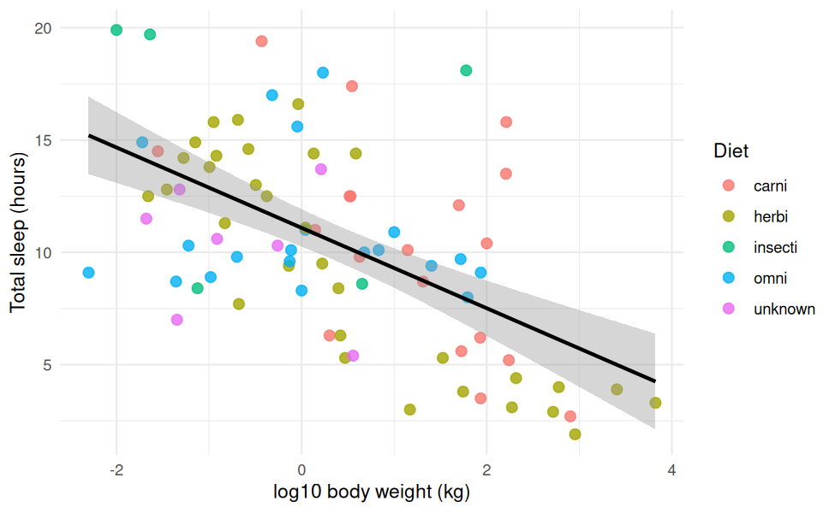
Total sleep versus log10 body weight, coloured by diet
ggplot(df, aes(log_bodywt, log_brainwt)) +
geom_point(aes(colour = vore), size = 2.5, alpha = 0.8) +
geom_smooth(method = "lm", formula = y ~ x, colour = "black") +
labs(x = "log10 body weight (kg)", y = "log10 brain weight (kg)", colour = "Diet")
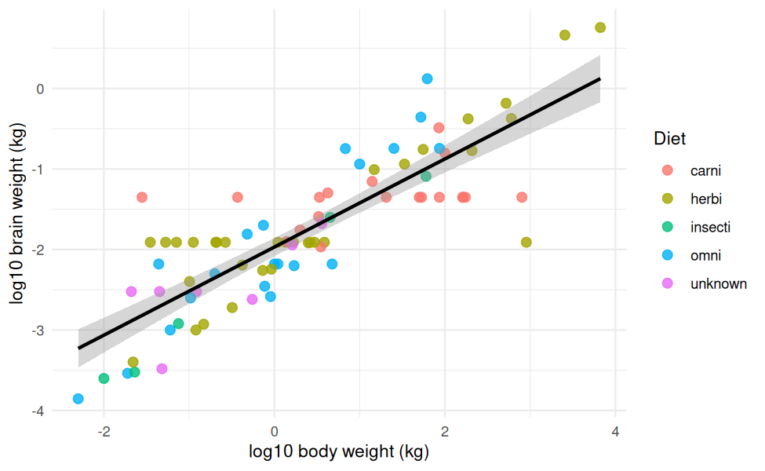
log10 brain weight versus log10 body weight

5.5 Correlation analysis
cor_vars <- c("sleep_total", "sleep_rem", "awake", "log_brainwt", "log_bodywt")
cmat <- cor(df[cor_vars])
kable(round(cmat, 2), caption = "Pearson correlation matrix")
Pearson correlation matrix
 | sleep_total | sleep_rem | awake | log_brainwt | log_bodywt
sleep_total | 1.00 | 0.62 | -1.00 | -0.48 | -0.57
sleep_rem | 0.62 | 1.00 | -0.62 | -0.22 | -0.25
awake | -1.00 | -0.62 | 1.00 | 0.48 | 0.57
log_brainwt | -0.48 | -0.22 | 0.48 | 1.00 | 0.84
log_bodywt | -0.57 | -0.25 | 0.57 | 0.84 | 1.00
as.data.frame(as.table(cmat)) %>%
ggplot(aes(Var1, Var2, fill = Freq)) +
geom_tile(colour = "white") +
geom_text(aes(label = round(Freq, 2))) +
scale_fill_gradient2(low = "firebrick", mid = "white", high = "steelblue",
limits = c(-1, 1)) +
labs(x = NULL, y = NULL, fill = "r") +
theme(axis.text.x = element_text(angle = 30, hjust = 1))
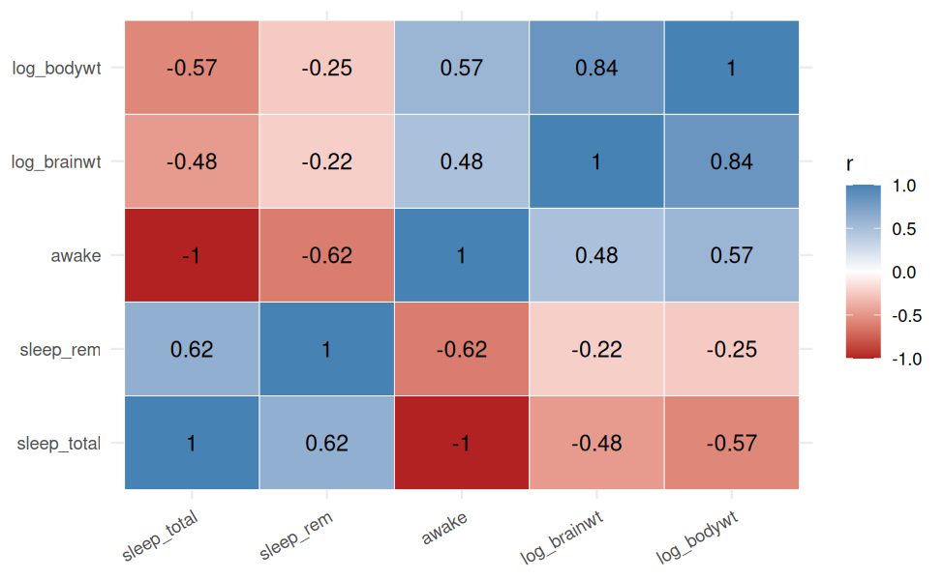
Correlation heatmap
top_pairs <- as.data.frame(as.table(cmat)) %>%
filter(as.character(Var1) < as.character(Var2)) %>%
mutate(Freq = round(Freq, 3)) %>%
arrange(desc(abs(Freq))) %>%
rename(Variable_1 = Var1, Variable_2 = Var2, r = Freq)
kable(top_pairs, caption = "Variable pairs ranked by absolute correlation")
Variable pairs ranked by absolute correlation
Variable_1 | Variable_2 | r
awake | sleep_total | -1.000
log_bodywt | log_brainwt | 0.838
sleep_rem | sleep_total | 0.623
awake | sleep_rem | -0.623
log_bodywt | sleep_total | -0.569
awake | log_bodywt | 0.569
log_brainwt | sleep_total | -0.477
awake | log_brainwt | 0.477
log_bodywt | sleep_rem | -0.251
log_brainwt | sleep_rem | -0.225

6.Key Insights

- Data quality:- The raw data had 136 missing cells. After cleaning 0 remain in the analysis columns.
- Skewness:- Body and brain weight are strongly right-skewed on the scale; the log10 transform makes them far more symmetric and suitable for correlation and regression.
- Sleep and body size:- The correlation between sleep and log body weight is -0.57, a negative relationship: larger animals tend to sleep less.
- Brain and body size:- Log brain weight and log body weight are highly correlated (r = 0.84) reflecting scaling.
- Sleep and REM:- Total sleep and REM sleep have r = 0.62.
- Redundancy:- Awake equals 24 minus sleep_total so the two are negatively correlated (r = -1); only one should be used in a model.
- Diet:-The diet group with the average sleep is insecti. Group sizes are uneven

7. Conclusion and Limitations
The dataset was cleaned through column removal, explicit-unknown recoding and group-median imputation; outliers were detected with the IQR rule and retained after log transformation; numeric variables were standardised and min-max scaled; and categorical variables were encoded with one-hot, ordinal and frequency methods.
Limitations:
- With only 83 species, group-level results (especially small diet groups) are unstable.
- Median imputation shrinks variance slightly; more advanced methods (e.g. multiple imputation with mice) could be tested.
- Correlation does not mean causation I think. Species are not observations because related species share ancestry.

Possible next steps: Regression of sleep, on body size and diet clustering of species and multiple imputation.
.

8. Screenshots of the RStudio Workflow

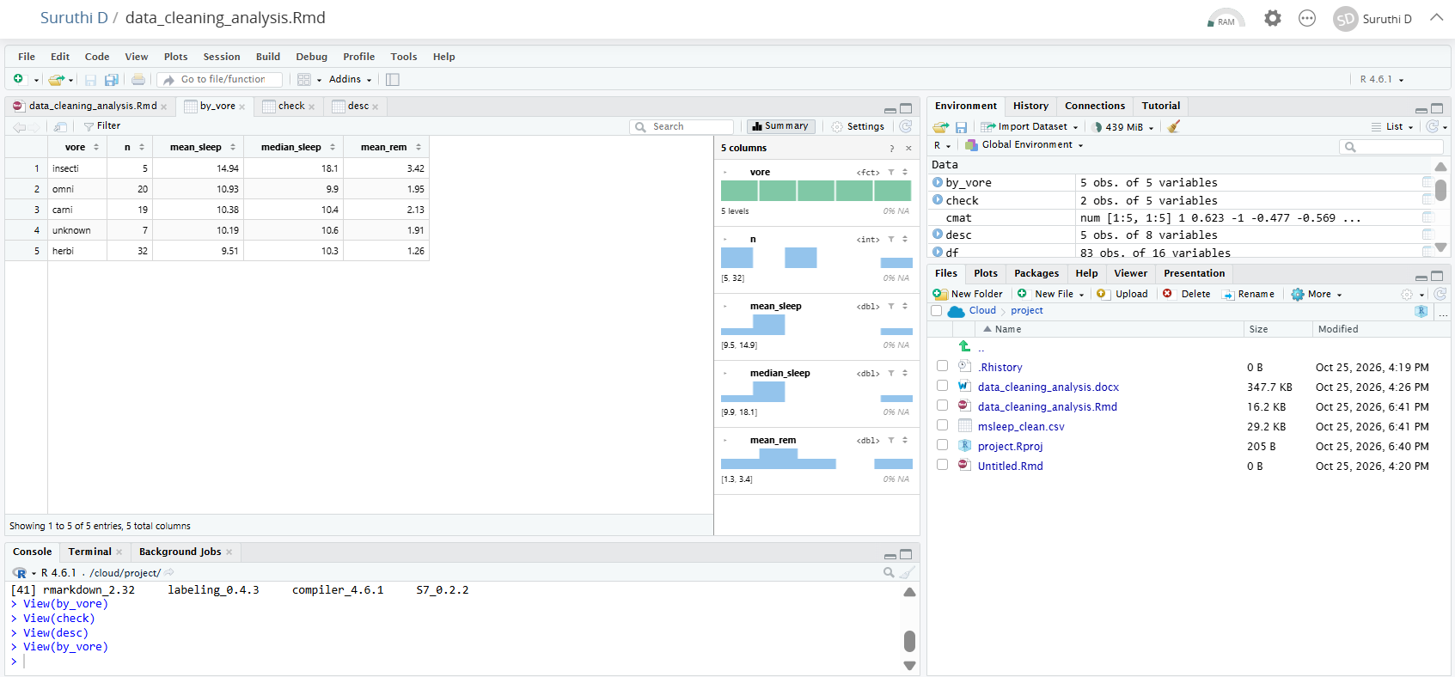

Appendix: Reproducibility
sessionInfo()
## R version 4.6.1 (2026-06-24)
## Platform: x86_64-pc-linux-gnu
## Running under: Ubuntu 24.04.5 LTS
##
## Matrix products: default
## BLAS: /usr/lib/x86_64-linux-gnu/openblas-pthread/libblas.so.3
## LAPACK: /usr/lib/x86_64-linux-gnu/openblas-pthread/libopenblasp-r0.3.26.so; LAPACK version 3.12.0
##
## locale:
## [1] LC_CTYPE=C.UTF-8 LC_NUMERIC=C LC_TIME=C.UTF-8
## [4] LC_COLLATE=C.UTF-8 LC_MONETARY=C.UTF-8 LC_MESSAGES=C.UTF-8
## [7] LC_PAPER=C.UTF-8 LC_NAME=C LC_ADDRESS=C
## [10] LC_TELEPHONE=C LC_MEASUREMENT=C.UTF-8 LC_IDENTIFICATION=C
##
## time zone: UTC
## tzcode source: system (glibc)
##
## attached base packages:
## [1] stats graphics grDevices utils datasets methods base
##
## other attached packages:
## [1] knitr_1.52 lubridate_1.9.5 forcats_1.0.1 stringr_1.6.0
## [5] dplyr_1.2.1 purrr_1.2.2 readr_2.2.0 tidyr_1.3.2
## [9] tibble_3.3.1 ggplot2_4.0.3 tidyverse_2.0.0
##
## loaded via a namespace (and not attached):
## [1] generics_0.1.4 stringi_1.8.9 lattice_0.22-9 hms_1.1.4
## [5] digest_0.6.39 magrittr_2.0.5 evaluate_1.0.5 grid_4.6.1
## [9] timechange_0.4.0 RColorBrewer_1.1-3 fastmap_1.2.0 Matrix_1.7-5
## [13] mgcv_1.9-4 scales_1.4.0 cli_3.6.6 rlang_1.3.0
## [17] crayon_1.5.3 bit64_4.8.6 splines_4.6.1 withr_3.0.3
## [21] yaml_2.3.12 otel_0.2.0 tools_4.6.1 parallel_4.6.1
## [25] tzdb_0.5.0 vctrs_0.7.3 R6_2.6.1 lifecycle_1.0.5
## [29] bit_4.6.0 vroom_1.7.1 pkgconfig_2.0.3 pillar_1.11.1
## [33] gtable_0.3.6 glue_1.8.1 xfun_0.62 tidyselect_1.2.1
## [37] rstudioapi_0.19.0 farver_2.1.2 htmltools_0.5.9 nlme_3.1-169
## [41] rmarkdown_2.32 labeling_0.4.3 compiler_4.6.1 S7_0.2.2

