

Statistical Analysis and Predictive Modeling using R

Pima Indians Diabetes
Suruthi D
28 October 2026

Table of Contents
1. Setup and packages 3
2. Dataset identification 3
3. Exploratory statistical analysis 4
3.1 Summary statistics and missing values 4
3.2 Target balance 6
3.3 Distributions 7
3.4 Normality checks 9
3.5 Correlation analysis 10
3.6 Hypothesis tests 12
4. Model building 14
4.1 Train / test split 14
4.2 Cross-validation setup 14
4.3 Model 1: Logistic regression 14
4.4 Model 2: Random forest (comparison model) 15
4.5 Cross-validated comparison 16
5. Evaluation on the held-out test set 18
5.1 Confusion matrix plot 19
5.2 ROC curves and AUC 21
6. Diagnostic analysis 21
6.1 Logistic regression: odds ratios 21
6.2 Multicollinearity (VIF, computed manually) 22
6.3 Residual diagnostics 22
6.4 Variable importance 25
7. Optimization and improvement 27
7.1 Threshold tuning (improving sensitivity) 27
7.2 Other ideas to try 27
8. Interpretation of Results 28
9. Key Insights & Key Features 28
10. Conclusion & Limitation 29
11.Screenshots of the RStudio Workflow 30
Appendix 31

1. Setup and packages
pkgs <- c("mlbench", "ggplot2", "dplyr", "tidyr", "caret",
"pROC", "corrplot", "randomForest")
for (p in pkgs) {
if (!requireNamespace(p, quietly = TRUE)) {
install.packages(p, repos = "https://cloud.r-project.org")
}
}
invisible(lapply(pkgs, library, character.only = TRUE))
set.seed(123)

2. Dataset identification
Dataset:
PimaIndiansDiabetes2 from the mlbench package (originally from the National Institute of Diabetes and Digestive and Kidney Diseases). It holds medical measurements for 768 women of Pima Indian heritage aged 21 or older. The target is diabetes (pos / neg).
Why this dataset:
This dataset was chosen because it has a clear binary outcome (diabetes yes/no) with eight clinical predictors, which suits both hypothesis testing and classification. It is a well-known public benchmark, small enough for 10-fold cross-validation, and it contains missing values (insulin 48.7%, triceps 29.6%), which makes the preprocessing decisions realistic.

df <- NULL
# Try 1: from the mlbench package
df <- tryCatch(mlbench::PimaIndiansDiabetes2, error = function(e) NULL)
# Try 2: download the raw data if the package version fails
if (is.null(df)) {
df <- tryCatch({
url <- "https://raw.githubusercontent.com/jbrownlee/Datasets/master/pima-indians-diabetes.data.csv"
d <- read.csv(url, header = FALSE)
names(d) <- c("pregnant", "glucose", "pressure", "triceps",
"insulin", "mass", "pedigree", "age", "diabetes")
d$diabetes <- factor(ifelse(d$diabetes == 1, "pos", "neg"),
levels = c("neg", "pos"))
cols <- c("glucose", "pressure", "triceps", "insulin", "mass")
d[cols] <- lapply(d[cols], function(x) ifelse(x == 0, NA, x))
d
}, error = function(e) NULL)
}
if (is.null(df)) stop("Dataset could not be loaded. Install mlbench and restart R.")
df <- as.data.frame(df)
dim(df)
## [1] 768 9
str(df)
## 'data.frame': 768 obs. of 9 variables:
## $ pregnant: int 6 1 8 1 0 5 3 10 2 8 ...
## $ glucose : int 148 85 183 89 137 116 78 115 197 125 ...
## $ pressure: int 72 66 64 66 40 74 50 NA 70 96 ...
## $ triceps : int 35 29 NA 23 35 NA 32 NA 45 NA ...
## $ insulin : int NA NA NA 94 168 NA 88 NA 543 NA ...
## $ mass : num 33.6 26.6 23.3 28.1 43.1 25.6 31 35.3 30.5 NA ...
## $ pedigree: num 0.627 0.351 0.672 0.167 2.288 ...
## $ age : int 50 31 32 21 33 30 26 29 53 54 ...
## $ diabetes: Factor w/ 2 levels "neg","pos": 2 1 2 1 2 1 2 1 2 2 ...
head(df)
## pregnant glucose pressure triceps insulin mass pedigree age diabetes
## 1 6 148 72 35 NA 33.6 0.627 50 pos
## 2 1 85 66 29 NA 26.6 0.351 31 neg
## 3 8 183 64 NA NA 23.3 0.672 32 pos
## 4 1 89 66 23 94 28.1 0.167 21 neg
## 5 0 137 40 35 168 43.1 2.288 33 pos
## 6 5 116 74 NA NA 25.6 0.201 30 neg

3. Exploratory statistical analysis

3.1 Summary statistics and missing values
summary(df)
## pregnant glucose pressure triceps
## Min. : 0.000 Min. : 44.0 Min. : 24.00 Min. : 7.00
## 1st Qu.: 1.000 1st Qu.: 99.0 1st Qu.: 64.00 1st Qu.:22.00
## Median : 3.000 Median :117.0 Median : 72.00 Median :29.00
## Mean : 3.845 Mean :121.7 Mean : 72.41 Mean :29.15
## 3rd Qu.: 6.000 3rd Qu.:141.0 3rd Qu.: 80.00 3rd Qu.:36.00
## Max. :17.000 Max. :199.0 Max. :122.00 Max. :99.00
## NAs :5 NAs :35 NAs :227
## insulin mass pedigree age diabetes
## Min. : 14.00 Min. :18.20 Min. :0.0780 Min. :21.00 neg:500
## 1st Qu.: 76.25 1st Qu.:27.50 1st Qu.:0.2437 1st Qu.:24.00 pos:268
## Median :125.00 Median :32.30 Median :0.3725 Median :29.00
## Mean :155.55 Mean :32.46 Mean :0.4719 Mean :33.24
## 3rd Qu.:190.00 3rd Qu.:36.60 3rd Qu.:0.6262 3rd Qu.:41.00
## Max. :846.00 Max. :67.10 Max. :2.4200 Max. :81.00
## NAs :374 NAs :11
colSums(is.na(df))
## pregnant glucose pressure triceps insulin mass pedigree age
## 0 5 35 227 374 11 0 0
## diabetes
## 0
round(colMeans(is.na(df)) * 100, 1) # % missing per column
## pregnant glucose pressure triceps insulin mass pedigree age
## 0.0 0.7 4.6 29.6 48.7 1.4 0.0 0.0
## diabetes
## 0.0
miss <- colSums(is.na(df))
barplot(miss, las = 2, col = "steelblue",
main = "Missing values per variable", ylab = "Count")
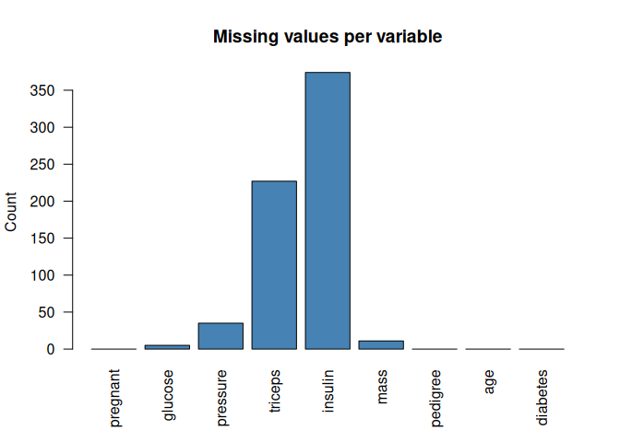

3.2 Target balance
table(df$diabetes)
##
## neg pos
## 500 268
round(prop.table(table(df$diabetes)), 3)
##
## neg pos
## 0.651 0.349
ggplot(df, aes(diabetes, fill = diabetes)) + geom_bar() +
labs(title = "Class distribution", x = "Diabetes", y = "Count") +
theme_minimal() + theme(legend.position = "none")
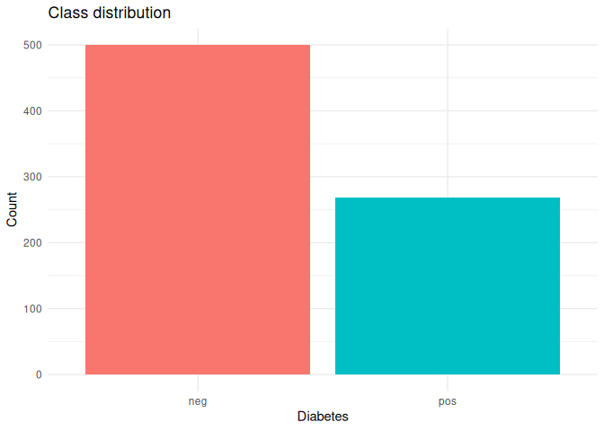

3.3 Distributions
long <- tidyr::pivot_longer(df, cols = -diabetes,
names_to = "variable", values_to = "value")
ggplot(long, aes(value, fill = diabetes)) +
geom_histogram(bins = 30, alpha = 0.7, position = "identity", na.rm = TRUE) +
facet_wrap(~variable, scales = "free") +
labs(title = "Distribution of predictors by diabetes status") +
theme_minimal()
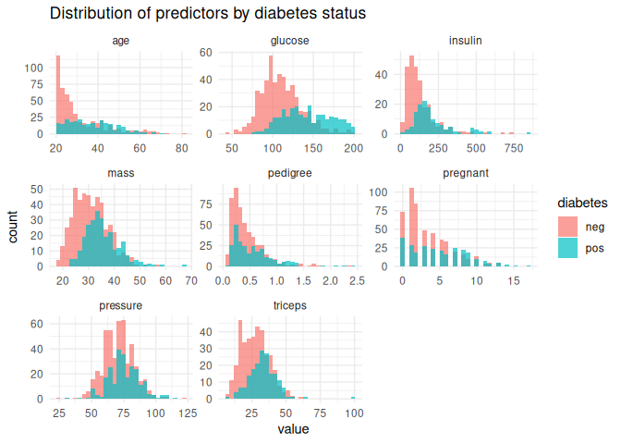
ggplot(long, aes(diabetes, value, fill = diabetes)) +
geom_boxplot(na.rm = TRUE) +
facet_wrap(~variable, scales = "free_y") +
theme_minimal() + theme(legend.position = "none")
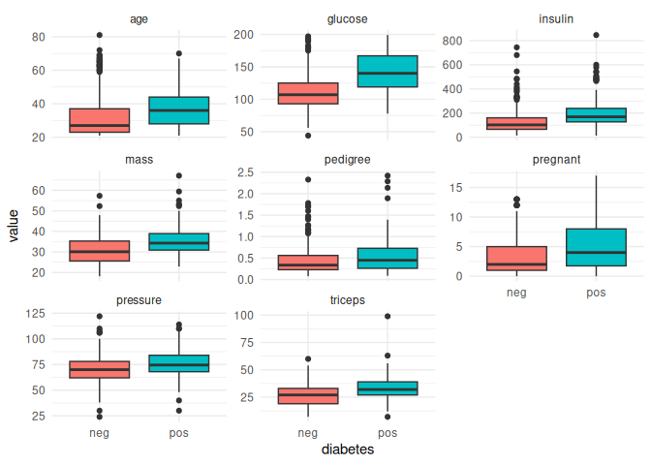

3.4 Normality checks
H0: the variable is normally distributed. H1: it is not.
num_vars <- setdiff(names(df), "diabetes")
normality <- sapply(num_vars, function(v) shapiro.test(na.omit(df[[v]]))$p.value)
round(normality, 6)
## pregnant glucose pressure triceps insulin mass pedigree age
## 0.0e+00 0.0e+00 9.5e-05 0.0e+00 0.0e+00 0.0e+00 0.0e+00 0.0e+00
par(mfrow = c(2, 4))
for (v in num_vars) {
qqnorm(df[[v]], main = paste("Q-Q plot:", v))
qqline(df[[v]], col = "red")
}
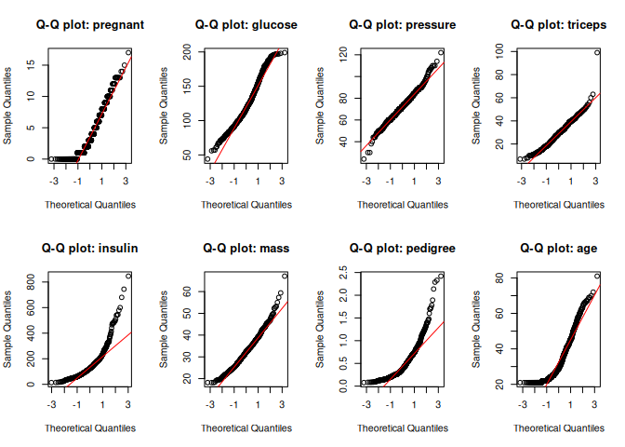
par(mfrow = c(1, 1))
Note: with n = 768 the Shapiro-Wilk test is very sensitive, so Q-Q plots should be read together with the p-values. Most variables are right-skewed, which supports using non-parametric tests alongside t-tests.

3.5 Correlation analysis
num_df <- df[, num_vars]
cor_mat <- cor(num_df, use = "pairwise.complete.obs", method = "spearman")
round(cor_mat, 2)
## pregnant glucose pressure triceps insulin mass pedigree age
## pregnant 1.00 0.13 0.19 0.09 0.13 0.00 -0.04 0.61
## glucose 0.13 1.00 0.25 0.23 0.66 0.23 0.09 0.28
## pressure 0.19 0.25 1.00 0.25 0.13 0.30 0.01 0.37
## triceps 0.09 0.23 0.25 1.00 0.25 0.69 0.07 0.23
## insulin 0.13 0.66 0.13 0.25 1.00 0.30 0.13 0.27
## mass 0.00 0.23 0.30 0.69 0.30 1.00 0.14 0.12
## pedigree -0.04 0.09 0.01 0.07 0.13 0.14 1.00 0.04
## age 0.61 0.28 0.37 0.23 0.27 0.12 0.04 1.00
corrplot(cor_mat, method = "color", type = "upper", addCoef.col = "black",
number.cex = 0.7, tl.col = "black")
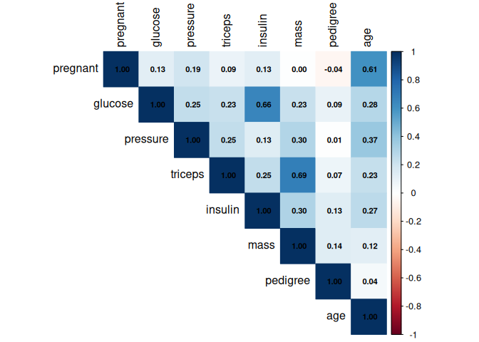
cor.test(df$glucose, df$insulin, method = "spearman", exact = FALSE)
##
## Spearman's rank correlation rho
##
## data: df$glucose and df$insulin
## S = 3451562, p-value < 2.2e-16
## alternative hypothesis: true rho is not equal to 0
## sample estimates:
## rho
## 0.6588133
cor.test(df$age, df$pregnant, method = "spearman", exact = FALSE)
##
## Spearman's rank correlation rho
##
## data: df$age and df$pregnant
## S = 29654123, p-value < 2.2e-16
## alternative hypothesis: true rho is not equal to 0
## sample estimates:
## rho
## 0.6072163

3.6 Hypothesis tests
Test 1: Is mean glucose different between diabetic and non-diabetic groups?
- H0: mean glucose (pos) = mean glucose (neg)
- H1: mean glucose (pos) is different from mean glucose (neg)
t.test(glucose ~ diabetes, data = df)
##
## Welch Two Sample t-test
##
## data: glucose by diabetes
## t = -14.884, df = 466.02, p-value < 2.2e-16
## alternative hypothesis: true difference in means between group neg and group pos is not equal to 0
## 95 percent confidence interval:
## -35.85757 -27.49380
## sample estimates:
## mean in group neg mean in group pos
## 110.6439 142.3195
wilcox.test(glucose ~ diabetes, data = df, exact = FALSE)
##
## Wilcoxon rank sum test with continuity correction
##
## data: glucose by diabetes
## W = 27394, p-value < 2.2e-16
## alternative hypothesis: true location shift is not equal to 0
Test 2: The same comparison for every predictor (Wilcoxon rank-sum)
wil <- sapply(num_vars, function(v) {
wilcox.test(df[[v]] ~ df$diabetes, exact = FALSE)$p.value
})
wil_tbl <- data.frame(variable = num_vars,
p_value = signif(wil, 3),
p_adj_bonferroni = signif(p.adjust(wil, "bonferroni"), 3))
wil_tbl[order(wil_tbl$p_value), ]
## variable p_value p_adj_bonferroni
## glucose glucose 1.31e-40 1.04e-39
## age age 1.14e-17 9.14e-17
## mass mass 1.82e-17 1.46e-16
## insulin insulin 7.48e-14 5.98e-13
## triceps triceps 6.96e-10 5.57e-09
## pregnant pregnant 3.75e-08 3.00e-07
## pedigree pedigree 1.20e-06 9.57e-06
## pressure pressure 1.63e-06 1.30e-05
Test 3: Is diabetes associated with age group? (Chi-square)
- H0: diabetes status is independent of age group
- H1: diabetes status depends on age group
age_group <- cut(df$age, breaks = c(20, 30, 40, 50, Inf),
labels = c("21-30", "31-40", "41-50", "51+"))
tab <- table(age_group, df$diabetes)
tab
##
## age_group neg pos
## 21-30 327 90
## 31-40 81 76
## 41-50 49 64
## 51+ 43 38
chisq.test(tab)
##
## Pearson's Chi-squared test
##
## data: tab
## X-squared = 73.809, df = 3, p-value = 6.522e-16
round(prop.table(tab, 1), 3)
##
## age_group neg pos
## 21-30 0.784 0.216
## 31-40 0.516 0.484
## 41-50 0.434 0.566
## 51+ 0.531 0.469
Test 4: Variance check (Levene / Brown-Forsythe style test) for glucose
gl <- df[!is.na(df$glucose), ]
gl$abs_dev <- abs(gl$glucose - ave(gl$glucose, gl$diabetes, FUN = median))
anova(lm(abs_dev ~ diabetes, data = gl))
## Analysis of Variance Table
##
## Response: abs_dev
## Df Sum Sq Mean Sq F value Pr(>F)
## diabetes 1 5896 5896.1 23.212 1.752e-06 ***
## Residuals 761 193307 254.0
## ---
## Signif. codes: 0 '***' 0.001 '**' 0.01 '*' 0.05 '.' 0.1 ' ' 1

4. Model building

4.1 Train / test split
Missing values are imputed inside the cross-validation folds (median imputation via preProcess), which avoids data leakage.
set.seed(123)
idx <- createDataPartition(df$diabetes, p = 0.8, list = FALSE)
train <- df[idx, ]
test <- df[-idx, ]
dim(train); dim(test)
## [1] 615 9
## [1] 153 9
round(prop.table(table(train$diabetes)), 3)
##
## neg pos
## 0.65 0.35
round(prop.table(table(test$diabetes)), 3)
##
## neg pos
## 0.654 0.346

4.2 Cross-validation setup
ctrl <- trainControl(method = "cv", number = 10,
classProbs = TRUE,
summaryFunction = twoClassSummary,
savePredictions = "final")
# NOTE: for twoClassSummary the first factor level ("neg") is treated as the
# event, so Sens/Spec in the CV table refer to "neg". ROC (AUC) is unaffected.

4.3 Model 1: Logistic regression
set.seed(123)
fit_glm <- train(diabetes ~ ., data = train,
method = "glm", family = "binomial",
metric = "ROC", trControl = ctrl,
preProcess = c("medianImpute", "center", "scale"),
na.action = na.pass)
fit_glm
## Generalized Linear Model
##
## 615 samples
## 8 predictor
## 2 classes: 'neg', 'pos'
##
## Pre-processing: median imputation (8), centered (8), scaled (8)
## Resampling: Cross-Validated (10 fold)
## Summary of sample sizes: 553, 553, 553, 554, 554, 554, ...
## Resampling results:
##
## ROC Sens Spec
## 0.8201569 0.875 0.5534632
summary(fit_glm$finalModel)
##
## Call:
## NULL
##
## Coefficients:
## Estimate Std. Error z value Pr(>|z|)
## (Intercept) -0.844330 0.107597 -7.847 4.26e-15 ***
## pregnant 0.351205 0.122110 2.876 0.00403 **
## glucose 1.142803 0.131644 8.681 < 2e-16 ***
## pressure -0.131260 0.116154 -1.130 0.25845
## triceps 0.005898 0.153431 0.038 0.96934
## insulin -0.091151 0.146012 -0.624 0.53245
## mass 0.596744 0.136116 4.384 1.16e-05 ***
## pedigree 0.266280 0.105474 2.525 0.01158 *
## age 0.149549 0.124342 1.203 0.22909
## ---
## Signif. codes: 0 '***' 0.001 '**' 0.01 '*' 0.05 '.' 0.1 ' ' 1
##
## (Dispersion parameter for binomial family taken to be 1)
##
## Null deviance: 796.05 on 614 degrees of freedom
## Residual deviance: 588.12 on 606 degrees of freedom
## AIC: 606.12
##
## Number of Fisher Scoring iterations: 5

4.4 Model 2: Random forest (comparison model)
set.seed(123)
fit_rf <- train(diabetes ~ ., data = train,
method = "rf", metric = "ROC", trControl = ctrl,
tuneGrid = expand.grid(mtry = c(2, 4)),
ntree = 200,
preProcess = c("medianImpute"),
na.action = na.pass)
fit_rf
## Random Forest
##
## 615 samples
## 8 predictor
## 2 classes: 'neg', 'pos'
##
## Pre-processing: median imputation (8)
## Resampling: Cross-Validated (10 fold)
## Summary of sample sizes: 553, 553, 553, 554, 554, 554, ...
## Resampling results across tuning parameters:
##
## mtry ROC Sens Spec
## 2 0.8132576 0.8425 0.5575758
## 4 0.8049297 0.8400 0.5666667
##
## ROC was used to select the optimal model using the largest value.
## The final value used for the model was mtry = 2.
plot(fit_rf)
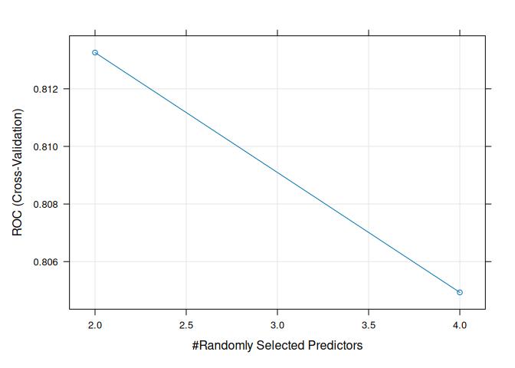

4.5 Cross-validated comparison
res <- resamples(list(Logistic = fit_glm, RandomForest = fit_rf))
summary(res)
##
## Call:
## summary.resamples(object = res)
##
## Models: Logistic, RandomForest
## Number of resamples: 10
##
## ROC
## Min. 1st Qu. Median Mean 3rd Qu. Max. NA's
## Logistic 0.7095238 0.8032062 0.8156926 0.8201569 0.8553571 0.9170455 0
## RandomForest 0.6916667 0.7772727 0.8413420 0.8132576 0.8553030 0.8738636 0
##
## Sens
## Min. 1st Qu. Median Mean 3rd Qu. Max. NA's
## Logistic 0.825 0.850 0.8750 0.8750 0.90000 0.925 0
## RandomForest 0.775 0.825 0.8375 0.8425 0.86875 0.925 0
##
## Spec
## Min. 1st Qu. Median Mean 3rd Qu. Max. NA's
## Logistic 0.3636364 0.4599567 0.5811688 0.5534632 0.612013 0.7727273 0
## RandomForest 0.2857143 0.5059524 0.5811688 0.5575758 0.612013 0.7727273 0
bwplot(res, metric = "ROC")
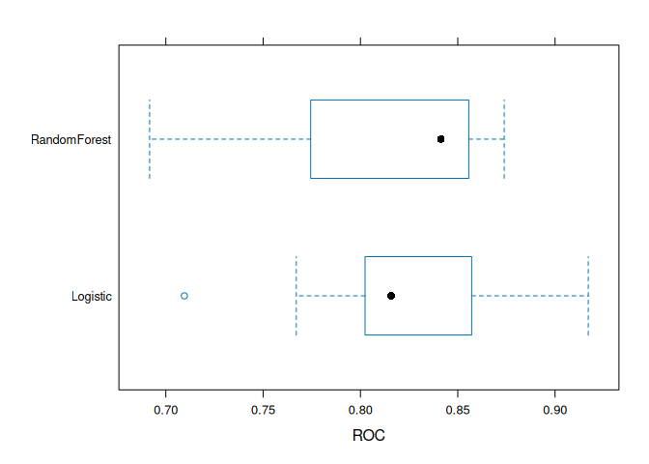

5. Evaluation on the held-out test set
pred_glm <- predict(fit_glm, newdata = test, na.action = na.pass)
prob_glm <- predict(fit_glm, newdata = test, type = "prob", na.action = na.pass)[, "pos"]
cm_glm <- confusionMatrix(pred_glm, test$diabetes, positive = "pos")
cm_glm
## Confusion Matrix and Statistics
##
## Reference
## Prediction neg pos
## neg 91 21
## pos 9 32
##
## Accuracy : 0.8039
## 95% CI : (0.7321, 0.8636)
## No Information Rate : 0.6536
## P-Value [Acc > NIR] : 3.3e-05
##
## Kappa : 0.5426
##
## Mcnemar's Test P-Value : 0.04461
##
## Sensitivity : 0.6038
## Specificity : 0.9100
## Pos Pred Value : 0.7805
## Neg Pred Value : 0.8125
## Prevalence : 0.3464
## Detection Rate : 0.2092
## Detection Prevalence : 0.2680
## Balanced Accuracy : 0.7569
##
## 'Positive' Class : pos
##
pred_rf <- predict(fit_rf, newdata = test, na.action = na.pass)
prob_rf <- predict(fit_rf, newdata = test, type = "prob", na.action = na.pass)[, "pos"]
cm_rf <- confusionMatrix(pred_rf, test$diabetes, positive = "pos")
cm_rf
## Confusion Matrix and Statistics
##
## Reference
## Prediction neg pos
## neg 89 18
## pos 11 35
##
## Accuracy : 0.8105
## 95% CI : (0.7393, 0.8692)
## No Information Rate : 0.6536
## P-Value [Acc > NIR] : 1.46e-05
##
## Kappa : 0.568
##
## Mcnemar's Test P-Value : 0.2652
##
## Sensitivity : 0.6604
## Specificity : 0.8900
## Pos Pred Value : 0.7609
## Neg Pred Value : 0.8318
## Prevalence : 0.3464
## Detection Rate : 0.2288
## Detection Prevalence : 0.3007
## Balanced Accuracy : 0.7752
##
## 'Positive' Class : pos
##
metrics <- data.frame(
Model = c("Logistic", "RandomForest"),
Accuracy = c(cm_glm$overall["Accuracy"], cm_rf$overall["Accuracy"]),
Sensitivity = c(cm_glm$byClass["Sensitivity"], cm_rf$byClass["Sensitivity"]),
Specificity = c(cm_glm$byClass["Specificity"], cm_rf$byClass["Specificity"]),
Precision = c(cm_glm$byClass["Precision"], cm_rf$byClass["Precision"]),
F1 = c(cm_glm$byClass["F1"], cm_rf$byClass["F1"])
)
metrics[, -1] <- round(metrics[, -1], 3)
metrics
## Model Accuracy Sensitivity Specificity Precision F1
## 1 Logistic 0.804 0.604 0.91 0.780 0.681
## 2 RandomForest 0.810 0.660 0.89 0.761 0.707

5.1 Confusion matrix plot
plot_cm <- function(cm, title) {
ggplot(as.data.frame(cm$table), aes(Reference, Prediction, fill = Freq)) +
geom_tile() + geom_text(aes(label = Freq), size = 6) +
scale_fill_gradient(low = "white", high = "steelblue") +
labs(title = title) + theme_minimal()
}
plot_cm(cm_glm, "Logistic regression: confusion matrix")
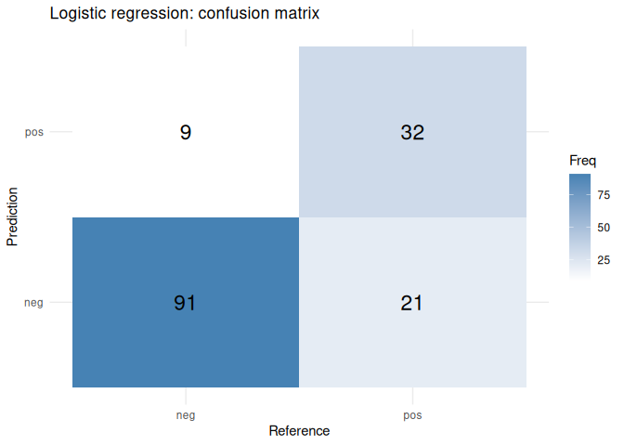
plot_cm(cm_rf, "Random forest: confusion matrix")
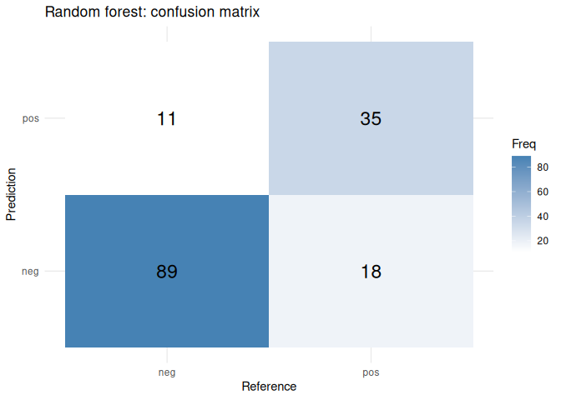

5.2 ROC curves and AUC
roc_glm <- roc(test$diabetes, prob_glm, levels = c("neg", "pos"), direction = "<")
roc_rf <- roc(test$diabetes, prob_rf, levels = c("neg", "pos"), direction = "<")
auc(roc_glm); auc(roc_rf)
## Area under the curve: 0.8904
## Area under the curve: 0.8863
plot(roc_glm, col = "blue", lwd = 2, main = "ROC curves (test set)")
plot(roc_rf, col = "darkgreen", lwd = 2, add = TRUE)
legend("bottomright",
legend = c(paste("Logistic AUC =", round(auc(roc_glm), 3)),
paste("RF AUC =", round(auc(roc_rf), 3))),
col = c("blue", "darkgreen"), lwd = 2)
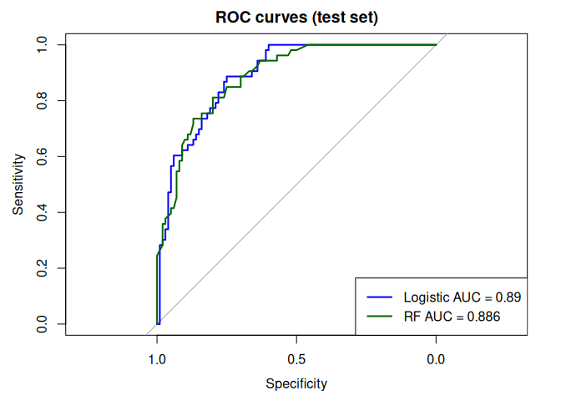

6. Diagnostic analysis

6.1 Logistic regression: odds ratios
Predictors were standardized, so each odds ratio is per 1 standard deviation increase.
glm_final <- fit_glm$finalModel
ci <- exp(confint.default(glm_final))
or_tbl <- data.frame(
term = names(coef(glm_final)),
odds_ratio = round(exp(coef(glm_final)), 3),
CI_low = round(ci[, 1], 3),
CI_high = round(ci[, 2], 3),
p_value = round(summary(glm_final)$coefficients[, 4], 4)
)
rownames(or_tbl) <- NULL
or_tbl
## term odds_ratio CI_low CI_high p_value
## 1 (Intercept) 0.430 0.348 0.531 0.0000
## 2 pregnant 1.421 1.118 1.805 0.0040
## 3 glucose 3.136 2.422 4.059 0.0000
## 4 pressure 0.877 0.698 1.101 0.2585
## 5 triceps 1.006 0.745 1.359 0.9693
## 6 insulin 0.913 0.686 1.215 0.5325
## 7 mass 1.816 1.391 2.372 0.0000
## 8 pedigree 1.305 1.061 1.605 0.0116
## 9 age 1.161 0.910 1.482 0.2291

6.2 Multicollinearity (VIF, computed manually)
X <- model.matrix(glm_final)[, -1]
vif_vals <- sapply(seq_len(ncol(X)), function(i) {
r2 <- summary(lm(X[, i] ~ X[, -i]))$r.squared
1 / (1 - r2)
})
names(vif_vals) <- colnames(X)
round(vif_vals, 2) # values above 5 suggest a problem
## pregnant glucose pressure triceps insulin mass pedigree age
## 1.46 1.35 1.23 1.48 1.23 1.62 1.05 1.66

6.3 Residual diagnostics
par(mfrow = c(2, 2))
plot(glm_final)
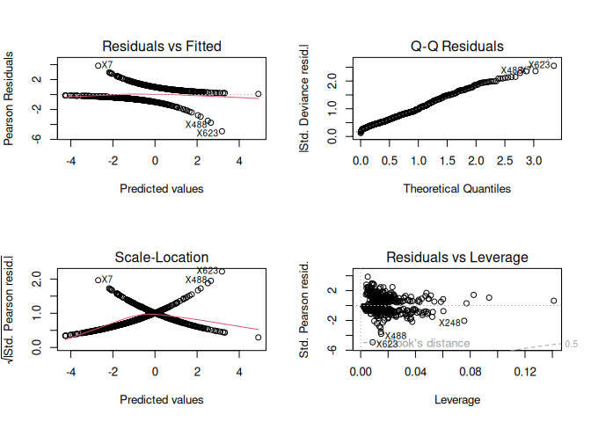
par(mfrow = c(1, 1))
res_df <- data.frame(fitted = fitted(glm_final),
dev_res = residuals(glm_final, type = "deviance"))
ggplot(res_df, aes(fitted, dev_res)) +
geom_point(alpha = 0.4) +
geom_smooth(method = "loess", formula = y ~ x, se = FALSE, colour = "red") +
labs(title = "Deviance residuals vs fitted probabilities",
x = "Fitted probability", y = "Deviance residual") +
theme_minimal()
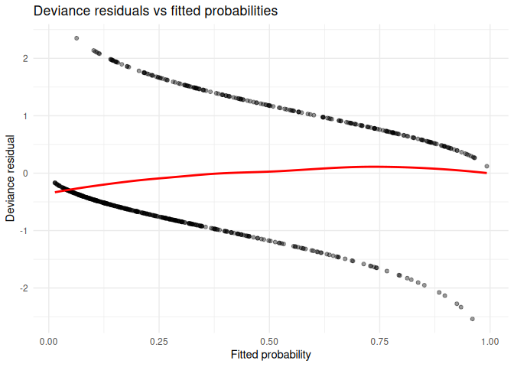
cd <- cooks.distance(glm_final)
plot(cd, type = "h", main = "Cook's distance", ylab = "Cook's D")
abline(h = 4 / length(cd), col = "red", lty = 2)
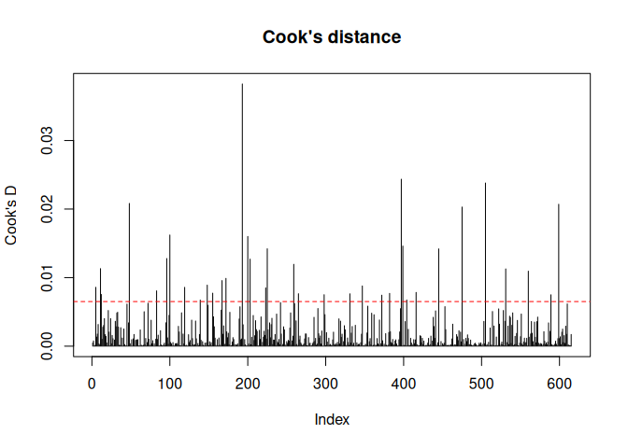
sum(cd > 4 / length(cd)) # number of potentially influential points
## [1] 36

6.4 Variable importance
plot(varImp(fit_glm), main = "Logistic regression: variable importance")
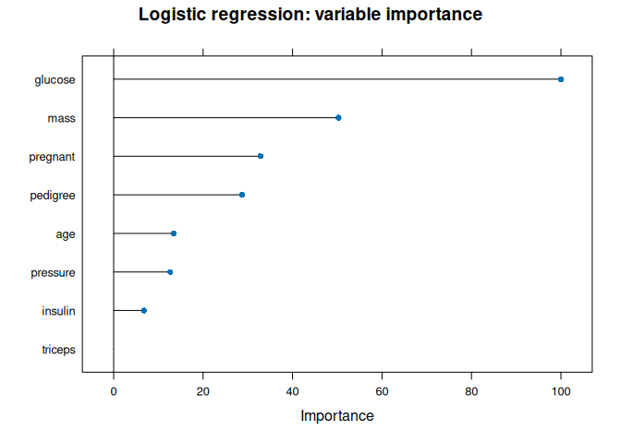
plot(varImp(fit_rf), main = "Random forest: variable importance")
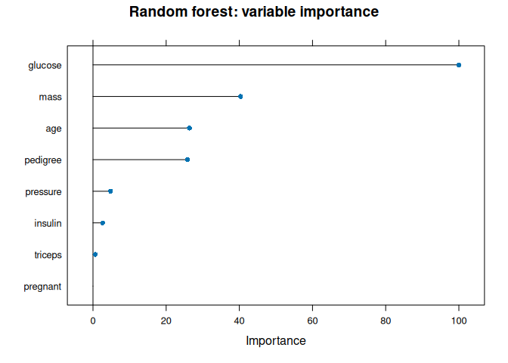

7. Optimization and improvement

7.1 Threshold tuning (improving sensitivity)
best <- coords(roc_glm, "best", best.method = "youden",
ret = c("threshold", "sensitivity", "specificity"))
best
## threshold sensitivity specificity
## 1 0.2702626 0.8867925 0.75
thr <- as.numeric(best[["threshold"]][1])
new_pred <- factor(ifelse(prob_glm >= thr, "pos", "neg"), levels = c("neg", "pos"))
confusionMatrix(new_pred, test$diabetes, positive = "pos")
## Confusion Matrix and Statistics
##
## Reference
## Prediction neg pos
## neg 75 6
## pos 25 47
##
## Accuracy : 0.7974
## 95% CI : (0.7249, 0.858)
## No Information Rate : 0.6536
## P-Value [Acc > NIR] : 7.169e-05
##
## Kappa : 0.5873
##
## Mcnemar's Test P-Value : 0.001225
##
## Sensitivity : 0.8868
## Specificity : 0.7500
## Pos Pred Value : 0.6528
## Neg Pred Value : 0.9259
## Prevalence : 0.3464
## Detection Rate : 0.3072
## Detection Prevalence : 0.4706
## Balanced Accuracy : 0.8184
##
## 'Positive' Class : pos
##

7.2 Other ideas to try
- Better imputation (kNN or mice) instead of median imputation
- Feature engineering (e.g. BMI categories, glucose x age interaction)
- Class balancing (SMOTE or down-sampling) and tuning with a recall-focused metric
- Other models: regularized logistic regression (glmnet), gradient boosting (xgboost), SVM
- Repeated cross-validation for more stable estimates

8. Interpretation of Results

Hypothesis tests:-
Mean glucose was higher in diabetic patients (142.3 vs 110.6; Welch t = -14.88, p < 2.2e-16). A variance test was significant (p = 1.75e-06), so the unequal-variance Welch test was appropriate. All eight predictors differed significantly between groups after Bonferroni correction, and diabetes prevalence was strongly related to age group (chi-square = 73.8, p = 6.5e-16), rising from 21.6% in the 21-30 group to 56.6% in the 41-50 group.
Correlations:-
The strongest relationships were mass-triceps (0.69), glucose-insulin (0.66) and age-pregnant (0.61). VIF values were all below 1.7, so multicollinearity is not a concern.
Model performance:-
Logistic regression and random forest performed very similarly (cross-validated AUC 0.820 vs 0.813; test AUC 0.890 vs 0.886; accuracy 0.804 vs 0.810). Both beat the 65.4% majority-class baseline. Because the test set has only 153 patients, the small differences between the models are not meaningful. Note that Sens/Spec in the cross-validation tables refer to the “neg” class, while the test-set confusion matrices use “pos” as the positive class.
Strengths and weaknesses:-
Specificity was high (0.91 and 0.89) but sensitivity was low (0.60 and 0.66), meaning about one third to 40% of diabetic patients were missed at the default 0.5 threshold. Lowering the threshold to 0.27 raised sensitivity to 0.887 (specificity 0.75, accuracy 0.797), which is preferable for screening.
Key predictors:-
In the logistic model, glucose had the largest effect (odds ratio 3.14 per standard deviation, 95% CI 2.42-4.06), followed by mass (1.82), pregnant (1.42) and pedigree (1.31). Pressure, triceps, insulin and age were not significant once the other variables were included.

9. Key Insights & Key Features
Insights
- Group differences: After Bonferroni correction, these predictors differed significantly between diabetic and non-diabetic patients: pregnant, glucose, pressure, triceps, insulin, mass, pedigree, age.
- Glucose: The Welch t-test for glucose gave p = <2e-16, so mean glucose differs between the two groups.
- Age and diabetes: The chi-square test of age group vs diabetes gave p = 6.52e-16.
- Model performance: On the test set, logistic regression reached an accuracy of 0.804 and AUC of 0.89; random forest reached an accuracy of 0.81 and AUC of 0.886.
- Baseline comparison: Always predicting the majority class would give an accuracy of 0.654, so the models should be judged against this number.
- Sensitivity vs specificity: Logistic regression detected 60.4% of diabetic cases (specificity 91%); random forest detected 66% (specificity 89%).
- Best model by AUC: logistic regression.
Features
The three most important predictors in the logistic regression model were glucose, mass and pregnant (see the variable importance plot in section 6.4). The table below summarizes all features used.
Feature | Description | Type
pregnant | Number of times pregnant | Numeric predictor
glucose | Plasma glucose concentration (2-hour oral glucose tolerance test) | Numeric predictor
pressure | Diastolic blood pressure (mm Hg) | Numeric predictor
triceps | Triceps skin fold thickness (mm) | Numeric predictor
insulin | 2-hour serum insulin (mu U/ml) | Numeric predictor
mass | Body mass index | Numeric predictor
pedigree | Diabetes pedigree function | Numeric predictor
age | Age in years | Numeric predictor
diabetes | Target: pos / neg | Binary target

10. Conclusion & Limitations
This project analysed the Pima Indians Diabetes dataset using hypothesis tests, correlation and normality analysis, and two classification models evaluated with 10-fold cross-validation and a held-out test set. The two models performed almost identically, with test AUC of 0.89 for logistic regression and 0.886 for random forest.
The hypothesis tests showed that all predictors differ between groups individually, while the multivariable model identified glucose, BMI, number of pregnancies and the pedigree function as independent predictors, with glucose by far the strongest. Both models performed comparably (test AUC about 0.89), so the simpler and more interpretable logistic regression is the preferable choice.

Limitations
The main limitations are the small sample size, median imputation of missing values, and moderate class imbalance. Future work could use multiple imputation, feature engineering, class balancing, threshold tuning (a threshold near 0.27 raised sensitivity from 0.60 to 0.89) and other algorithms such as gradient boosting.

11.Screenshots of the RStudio Workflow

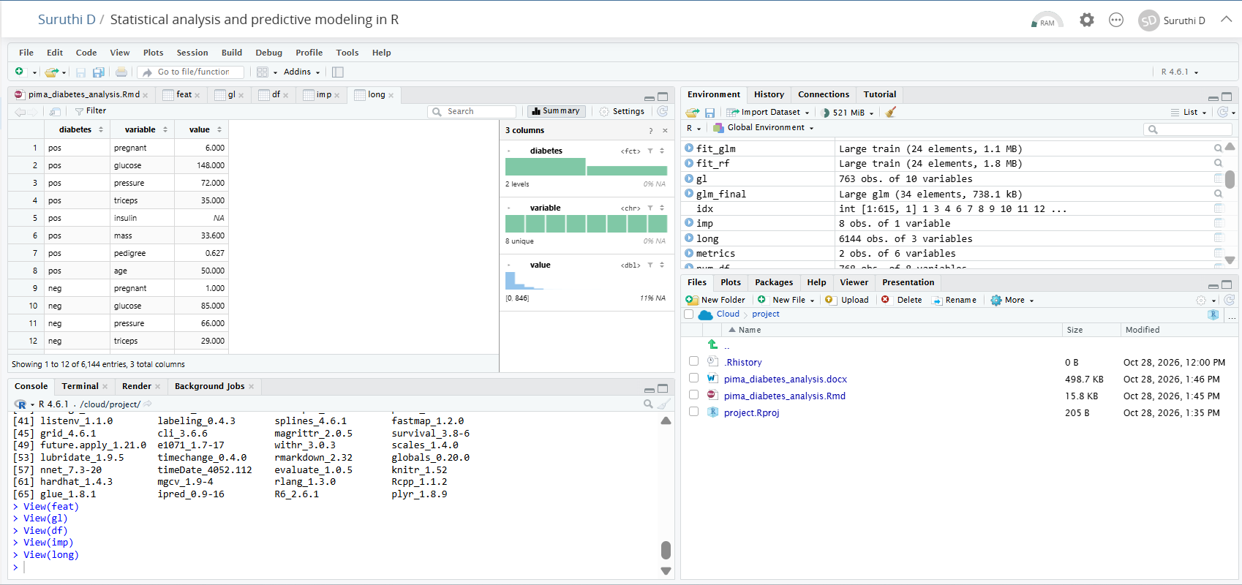
Fig: Project running in RStudio on Posit Cloud, showing the Rmd file, data objects and knitted output.

Appendix
A. Data dictionary and source
Dataset: PimaIndiansDiabetes2 (R package mlbench), 768 observations, 8 predictors and 1 binary target. Original source: National Institute of Diabetes and Digestive and Kidney Diseases.
B. Missing values per variable
data.frame(Missing = colSums(is.na(df)),
Percent = round(colMeans(is.na(df)) * 100, 1))
## Missing Percent
## pregnant 0 0.0
## glucose 5 0.7
## pressure 35 4.6
## triceps 227 29.6
## insulin 374 48.7
## mass 11 1.4
## pedigree 0 0.0
## age 0 0.0
## diabetes 0 0.0
C. Full odds ratio table
knitr::kable(or_tbl)
term | odds_ratio | CI_low | CI_high | p_value
(Intercept) | 0.430 | 0.348 | 0.531 | 0.0000
pregnant | 1.421 | 1.118 | 1.805 | 0.0040
glucose | 3.136 | 2.422 | 4.059 | 0.0000
pressure | 0.877 | 0.698 | 1.101 | 0.2585
triceps | 1.006 | 0.745 | 1.359 | 0.9693
insulin | 0.913 | 0.686 | 1.215 | 0.5325
mass | 1.816 | 1.391 | 2.372 | 0.0000
pedigree | 1.305 | 1.061 | 1.605 | 0.0116
age | 1.161 | 0.910 | 1.482 | 0.2291
D. Test-set performance table
knitr::kable(metrics)
Model | Accuracy | Sensitivity | Specificity | Precision | F1
Logistic | 0.804 | 0.604 | 0.91 | 0.780 | 0.681
RandomForest | 0.810 | 0.660 | 0.89 | 0.761 | 0.707
E. Session information
sessionInfo()
## R version 4.6.1 (2026-06-24)
## Platform: x86_64-pc-linux-gnu
## Running under: Ubuntu 24.04.5 LTS
##
## Matrix products: default
## BLAS: /usr/lib/x86_64-linux-gnu/openblas-pthread/libblas.so.3
## LAPACK: /usr/lib/x86_64-linux-gnu/openblas-pthread/libopenblasp-r0.3.26.so; LAPACK version 3.12.0
##
## locale:
## [1] LC_CTYPE=C.UTF-8 LC_NUMERIC=C LC_TIME=C.UTF-8
## [4] LC_COLLATE=C.UTF-8 LC_MONETARY=C.UTF-8 LC_MESSAGES=C.UTF-8
## [7] LC_PAPER=C.UTF-8 LC_NAME=C LC_ADDRESS=C
## [10] LC_TELEPHONE=C LC_MEASUREMENT=C.UTF-8 LC_IDENTIFICATION=C
##
## time zone: UTC
## tzcode source: system (glibc)
##
## attached base packages:
## [1] stats graphics grDevices utils datasets methods base
##
## other attached packages:
## [1] randomForest_4.7-1.2 corrplot_0.95 pROC_1.19.1
## [4] caret_7.0-1 lattice_0.22-9 tidyr_1.3.2
## [7] dplyr_1.2.1 ggplot2_4.0.3 mlbench_2.1-11
##
## loaded via a namespace (and not attached):
## [1] gtable_0.3.6 xfun_0.62 recipes_1.4.0
## [4] vctrs_0.7.3 tools_4.6.1 generics_0.1.4
## [7] stats4_4.6.1 parallel_4.6.1 proxy_0.4-29
## [10] tibble_3.3.1 pkgconfig_2.0.3 ModelMetrics_1.2.2.2
## [13] Matrix_1.7-5 data.table_1.18.6.1 RColorBrewer_1.1-3
## [16] S7_0.2.2 lifecycle_1.0.5 compiler_4.6.1
## [19] farver_2.1.2 stringr_1.6.0 codetools_0.2-20
## [22] htmltools_0.5.9 class_7.3-23 yaml_2.3.12
## [25] prodlim_2026.03.11 pillar_1.11.1 MASS_7.3-65
## [28] gower_1.0.2 iterators_1.0.14 rpart_4.1.27
## [31] foreach_1.5.2 nlme_3.1-169 parallelly_1.48.0
## [34] lava_1.10 tidyselect_1.2.1 digest_0.6.39
## [37] stringi_1.8.9 future_1.80.0 reshape2_1.4.5
## [40] purrr_1.2.2 listenv_1.1.0 labeling_0.4.3
## [43] splines_4.6.1 fastmap_1.2.0 grid_4.6.1
## [46] cli_3.6.6 magrittr_2.0.5 survival_3.8-6
## [49] e1071_1.7-17 future.apply_1.21.0 withr_3.0.3
## [52] scales_1.4.0 lubridate_1.9.5 timechange_0.4.0
## [55] rmarkdown_2.32 globals_0.20.0 nnet_7.3-20
## [58] timeDate_4052.112 evaluate_1.0.5 knitr_1.52
## [61] hardhat_1.4.3 mgcv_1.9-4 rlang_1.3.0
## [64] Rcpp_1.1.2 glue_1.8.1 ipred_0.9-16
## [67] R6_2.6.1 plyr_1.8.9

