**E-COMMERCE APPLICATION ON IBM CLOUD FOUNDRY**

730321104056: SURUTHI.R

PHASE 4 SUBMISSION DOCUMENT

**PROJECT: E-Commerce Application on IBM Cloud Foundry**

PHASE 4 Overview:

* Home Page:

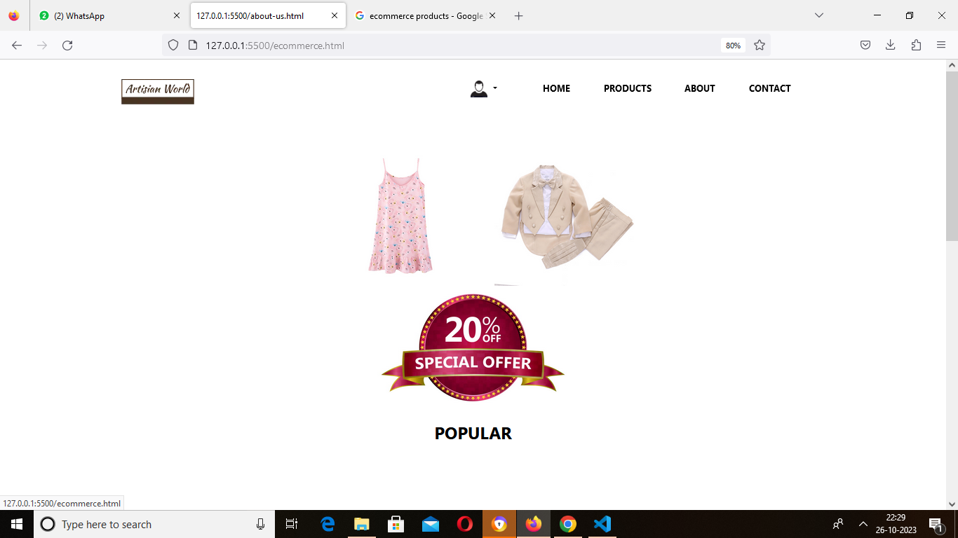

* Featured Products Page:

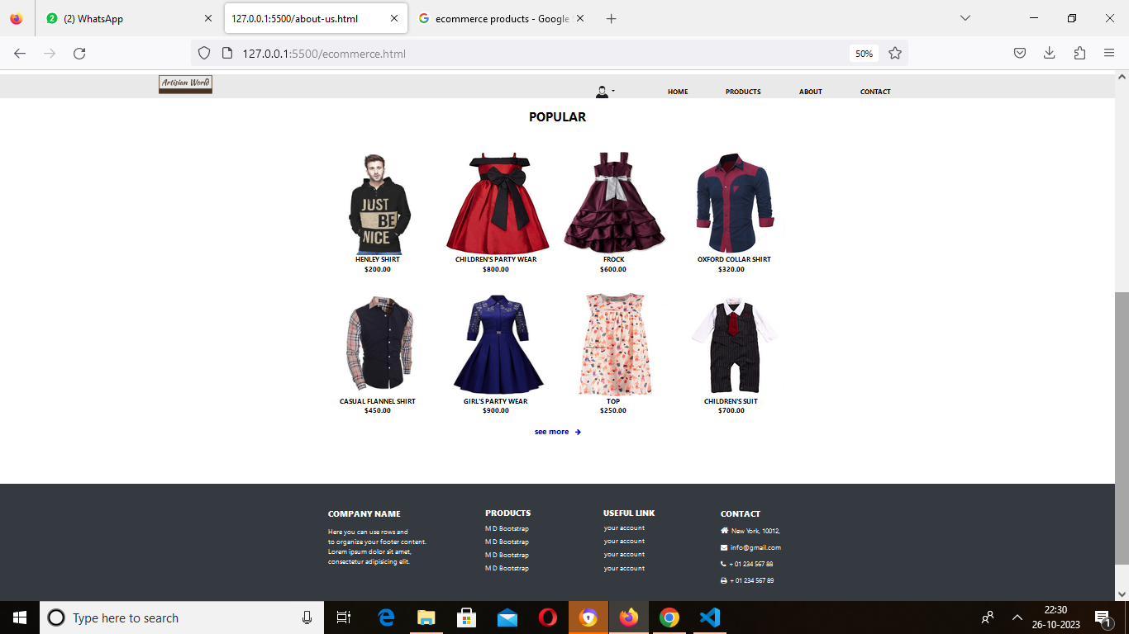

* All Products Page:

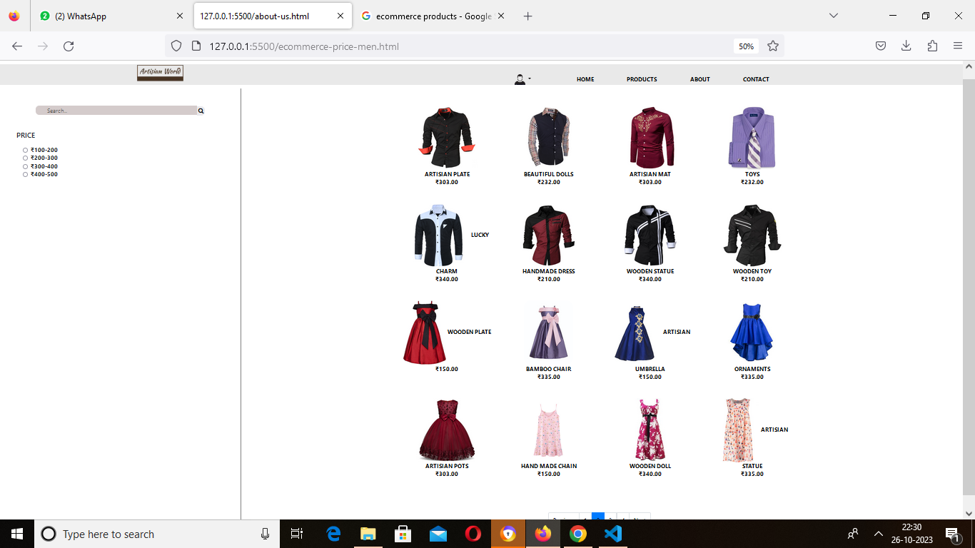

* Product Details Page:

