A PROJECT REPORT

On

**LOG SEGREGATOR AND ANALYSER FOR MANAGED INVESTMENTS**

Submitted in partial fulfillment of the

requirements for the degree of

**BACHELOR OF TECHNOLOGY**

In

**Information and Communication Technology**

Submitted by

**117014101 - Suruti.S**



**Under the Guidance of**

**Project Manager, Inx Tech Support**

**April 2017**

**Acknowledgement**

I would forever remain grateful tohonorable **Prof. R. Sethuraman, Vice Chancellor** for his encouragement in my academic life at SASTRA University.

I wish to express my profound gratitude to**Dr. S. Vaidhyasubramaniam, Dean - Planning & Development, Dr. S. Swaminathan, Director CeNTAB** and **Prof. G. Bhalachandran, Registrar** for their overwhelming support provided during my course span in SASTRA University.

I am extremely thankful to **Dr. K.S. Ravichandran, Associate Dean, Department of Information and Communication Technology** for providing me the opportunity to do this project and for all the academic help extended in my project.

I sincerely express my gratitude to my manager **Mr. Padmaraj Ramachandran** and my team mentor **Mr.** **Ramasubramanian Balasubramanian, iNAUTIX TECHNOLOGIES INDIA PVT LTD** for their assistance and guidance for the successful implementation of project in a systematic and professional manner. I also express my gratitude to my mentor **Mr. Manikandan Kathireson, iNAUTIX TECHNOLOGIES INDIA PVT LTD** for always guiding me in the right direction to complete my project.

I also thank all the **Teaching and Non-teaching staff,** and those who have directly or indirectly helped me by extending their moral support and encouragement for completion of this project.

I thank God Almighty and my parents for helping me procure such a challenging and interesting project, and in completing the same in due course without much difficulty.

**SYNOPSIS**

Logging is very crucial for smooth deployment and maintenance of any application. Logging is a process in which all the events that occur during application execution are recorded, which will be of extreme use in troubleshooting obscure problems, debugging and its corresponding maintenance. Typical logs include warnings, errors, transactional changes, relay messages. Logs save us valuable hours. The size of the logger files grow exponentially for frequently used applications.

Most of the log analysers lack artificial intelligence and they are not customized to any organization. This necessitates for the development of a customized log analyser which makes the log file easily interpretable so as to extract the necessary information. Logging helps the application developers know the status of the requests which make their application more user friendly. By looking through the logs, the developers can easily troubleshoot issues, if any which in turn makes the life of the developers and support team easier.

This system helps us derive the necessary log files, which will aid in bug fixing and easy maintenance of any application. This shall be done even for legacy systems. It assists the developer in tracking the bugs, even after years of deployment. A particular or generalized event/ information can be searched to gain meaningful insights from it. Logs can be classified based on its severity and prompt action has to be taken accordingly. The activities of each user is recorded which helps in deriving usage analysis of the system by a user. This data can be exported in multiple formats and delivered to the support team for their reference.

**TABLE OF CONTENTS**

|  |  |  |
| --- | --- | --- |
| **Chapter No.** | **TITLE** | **Page Number** |
| 1. | Introduction | 1 |
| 2. | Literature Review | 4 |
| 3. | System Configurations | 8 |
| 4. | System Analysis and Design | 9 |
| 5. | Implementation | 14 |
| 6. | Output Snapshots | 15 |
| 7. | Conclusion | 27 |
| 8. | References | 28 |

**INTRODUCTION**

**1.1 INTRODUCTION TO THE COMPANY – iNAUTIX**

**1.1.1 INTRODUCTION**

iNautix Technologies India Private Limited is a group company of Bank of New York Mellon - a leading financial services provider. iNautix provide technology development, business & technology operations and remote infrastructure management services for BNY Mellon and its subsidiaries. iNautix also develops and delivers comprehensive technology solutions and software development products for customers of BNY Mellon.

**1.1.2 FOUNDERS**

The Bank of New York Mellon was founded by Alexander Hamilton in 1784. Gerald Hassell is an American bank executive and is the Chairman and CEO of the Bank of New York Mellon from 2011. Suresh Kumar is the CEO of iNautix Technologies.

**1.1.3 ABOUT COMPANY**

             iNautix Technologies, established in the year 2000,provides technology solutions to BNY Mellon. As an innovation-focused company, iNautix specializes in providing insightful and new age technology solutions to help meet clients' business needs end-to-end. Since its inception in 2000, iNautix has maintained a relentless commitment to develop products and solutions that are designed to improve operational efficiencies, make planning more dynamic and realistic, monitoring and evaluation simple, risk-free and methodical, increase productivity, enhance delivery performance and ensure success for our clients.

* 1. **Background of the Project**

In the corporate world, each organization has as much as thousands of applications; these would have been typically written in numerous languages which in turn run in diversified platforms. Despite of these complications, if we are still able to maintain these applications and provide the user, the best experience it is because of logging. The process of making an entry in the log file is called logging. These logs generated during the execution of an application, can be recorded in multiple destinations such as a local disk, console, into other sockets or files. Analysis of these log files is necessary later during debugging or enhancement of the respective application.

Logging is crucial for a developer, who has to modify the application, to add new functionality, or modify the existing one, which has been developed years ago. The main components of logging are: Logger, Formatter, and Appender. The Logger captures the information with metadata that has to logged. Formatter formats the object. Appenders publish the log information into a variety of ConsoleAppender, FileAppender, RollingFileAppender, and SocketAppender.

A logger can be associated with different levels of severity such as fatal, error, warning, info, debug, trace in the descending order. So a logger if configured to warning level would log all levels above it. Logger has overhead associated with it, so developer has to be judicious on what is being logged. Log manager creates the logger and manages corresponding configuration files.

In this application, extraction of log files and corresponding analysis is done. In the corporate world, each organization has its datacenters in different geographical locations far from each other, in order to withstand any natural calamities. Each datacenter in turn has numerous severs associated with it. Each application runs in some hosts of the server, produces log files as the application is being executed.

Our application helps the developer and the support team to derive the relevant files from loads of log files by specifying the severity level and the keywords, which can be converted into pie charts, bar graphs, and text files for further debugging, and analysis. The developer can also add searches which are frequently used. It also displays the recently used queries. The developer can also search for any particular type of error on any application, it is termed as raw event searches . Thus this application can handle sparse searches and also dense searches.

This flexible modular application can handle complex queries by matching patterns and can be customized to organizational needs. This application can be invoked whenever necessary.

**2. SOFTWARE PROJECT PLAN**

**2.1 Existing System**

Splunk is a log analyser tool. It provides facilities like indexing, searching, visualizing, analyzing and reporting of log data. It also provides a way to identify and solve the bugs. But the system is not customised for any organization so it is dearth of any application specific filters.

**2.2 Proposed System**

In the proposed system, we are going to create a customized log analyser tool which can get rid of the complexity of maintaining the application specific logs. The system will be able to filter the logs in real time. The system receives the log files, generated during the user interaction with the application. The log files are analysed and the results are filtered in accordance to the user demand.

An application will be configured once initially. The process includes linking the application, with the servers which assists in running it and with the locations in which the log file will be stored.

Search is the primary way which enables user to navigate data. Search retrieves events from log file, use statistical commands to calculate metrics and generate reports, search for specific conditions within a rolling time window, identify patterns in your data, predict future trends, and so on. Searches can be saved as reports and used to power dashboard panels. The system supports various ways of searching, such as searching for a particular level of severity of error among multiple applications, or searching a single application for the presence of some keyword. It also allows you to save a frequently used search.

Alerts are triggered when conditions are met by search results for both historical and real-time searches. Alerts can be configured to trigger actions such as sending alert information to designated email addresses, posting alert information to an RSS feed, or running a custom script, such as one that posts an alert event to syslog.

Reports are saved searches and pivots. You can run reports on an ad hoc basis, schedule them to run on a regular interval, or set scheduled reports to generate alerts when the results of their runs meet particular conditions. You can add reports to dashboards as dashboard panels.

These results can be transformed into multiple formats which include excel, txt, JSON and can be sent to the support team members for further actions. The trend of the application usage can be visualized through various visual aids such as graph, pie chart, bar graph.

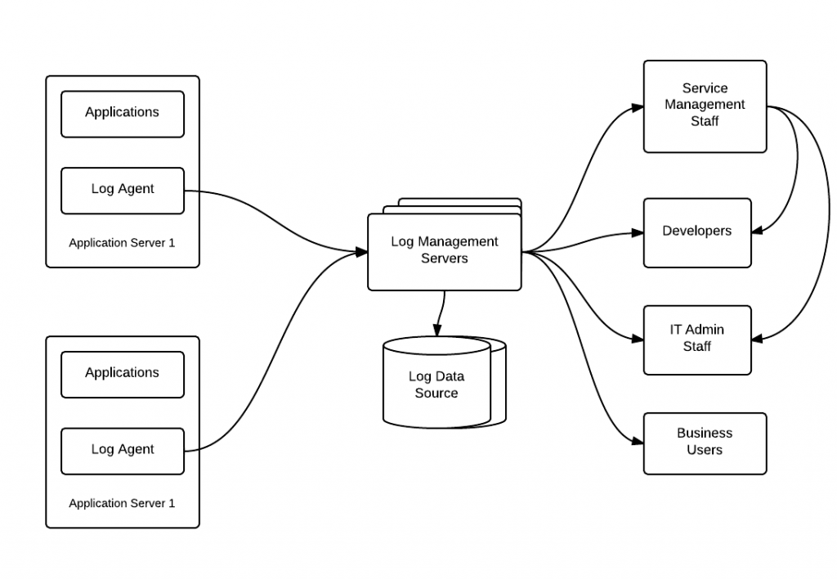  
Log agents assists us in the aggregation of log filesLog management server which processes the users request for the reports

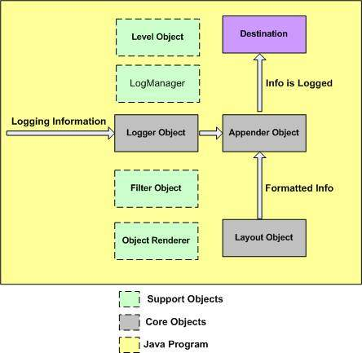

Java Logging Framework

**2.3 Modules**

1. Indexing
2. Searching
3. Generating reports

***2.3.1 Indexing***

The application indexes the incoming data. It generates numerous files which can be categorized into: Raw data, data in its compressed form; Indexes that point to these files and its metadata.

3

***2.3.2 Searching***

The keyword, which may be an application name, or the severity level of the log, is obtained from the user and it is searched in the log files.

***2.3.2 Reporting***

The results retrieved from the previous step are displayed in the user interface. This result can also be imported in multiple formats such as pdf,csv,excel.

**3. SOFTWARE REQUIREMENT SPECIFICATION**

**3.1 Functional Requirements**

The application’s functional requirements include the format of the input, functions that an application can do and the format of the output.

**3.1.1 Input**

The application gets the application name, for which the log file has to be searched, keyword(s) for segregation of those log files.

**3.1.2 Output**

The application upon receiving the application name, keyword to filter the log data, it displays the segregated logs and provides an option to import, as text files or csv.

* + 1. **Class Diagram**

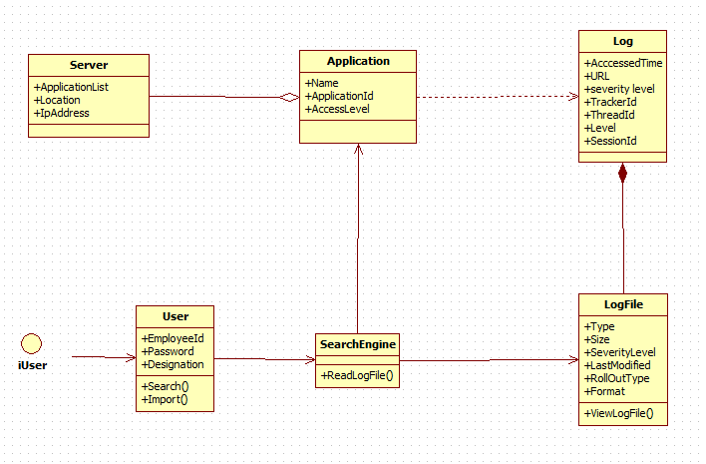

*Fig. no: 3.1.2 Class Diagram for user and system.*

**3.2 NON FUNCTIONAL REQUIREMENTS**

***3.2.1 Performance Requirements***

The key objective is to enable the user an instant access to loads of log file. It helps the developer and the support team to spot the errors and warnings if any and hence proceed with the following debugging.

***3.2.2 Interface Requirements***

The command prompt is used as an interface between the user and system where the user enters the initial key and the input file or text to be encrypted is given.

***3.2.3 Resource Requirements***

* Software Requirements:

Operating System - Windows,Linux

Front End - Web Application

Language - Java

System Type - 32, 64 bit Operating System

Memory - 8 GB RAM

Speed - 3 GHz

* Hardware Requirements:

Processor - Pentium IV or more

RAM - 512 Mb or more

Hard Disk - 50GB or Higher

Monitor - Display Panel (640 x 480)

***3.2.4 Security Requirements:***

The application needs a high level of security because it accesses critical data which includes tracker id, thread id.

***3.2.5 Quality and Reliability Requirements:***

Reliability is a vital requirement of this application as it assists in the further debugging of it.

**4. SYSTEM ANALYSIS**

**4.1 Use Case Diagram**

A use case diagram in the Unified Modeling Language (UML) is a type of behavioral diagram defined by and created from a use-case analysis. Its purpose is to present a graphical overview of the functionality provided by a system in terms of actors, their goals, and any dependencies between those use cases.

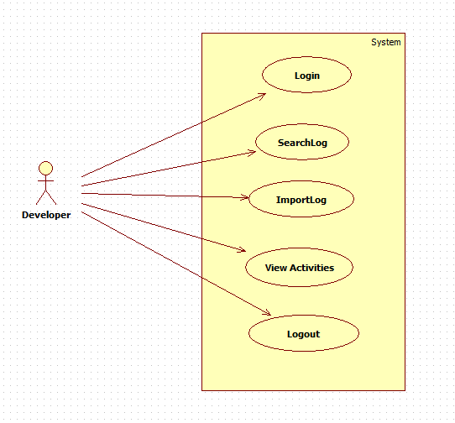

*Fig. no: 4.1.1 Use Case diagram*

**4.2 Dataflow Diagram**

A data-flow diagram (DFD) is a graphical representation of the “flow” of data through a system. DFDs aids us in keeping the development in an organized manner and also in decision making.

*Fig. no: 4.1.1 Dataflow diagram.*

**5. SYSTEM DESIGN**

**5.1 Front End Design**

***Maven Dependency***

Maven is a powerful tool that allows users to import dependencies into their software projects and also automatically manage transitive dependencies. In order to use Maven, it is necessary to explicitly add dependencies to the Maven pom.xml file. Once added to the Maven pom.xml file, dependencies will be automatically downloaded, updated, and have their sub-dependencies managed by Maven. The dependencies can be dynamically added and removed from the list and the version of the jar files can be modified at any time during the development of an application. This also ensures uniformity of the versions of files that every developer uses in their module of the same application, thus maintaining consistency

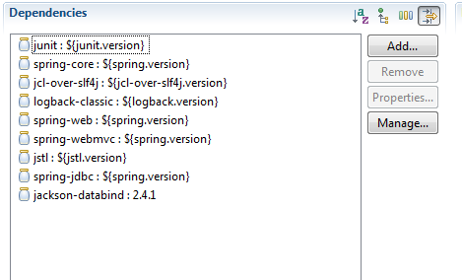

The above screenshot contains some of the core dependency injected and each one is responsible for importing some specific packages. For example, Jackson-databind will import the packages at run time which will convert list into JSON objects and vice versa.

**6. CODING**

**6.1 Sample Coding**

***POM.xml:***

<project xmlns="http://maven.apache.org/POM/4.0.0" xmlns:xsi="http://www.w3.org/2001/XMLSchema-instance"

xsi:schemaLocation="http://maven.apache.org/POM/4.0.0 http://maven.apache.org/maven-v4_0_0.xsd">

<modelVersion>4.0.0</modelVersion>

<groupId>ira.training.xeccq49</groupId>

<artifactId>SpringStudentRestWebService</artifactId>

<packaging>war</packaging>

<version>0.0.1-SNAPSHOT</version>

<name>LogAnalyser Maven Webapp</name>

<url>http://maven.apache.org</url>

<properties>

<jdk.version>1.7</jdk.version>

<spring.version>4.1.1.RELEASE</spring.version>

<jstl.version>1.2</jstl.version>

<junit.version>4.11</junit.version>

<logback.version>1.0.13</logback.version>

<jcl-over-slf4j.version>1.7.5</jcl-over-slf4j.version>

</properties>

<dependencies>

<!-- Unit Test -->

<dependency>

<groupId>junit</groupId>

<artifactId>junit</artifactId>

<version>${junit.version}</version>

</dependency>

<!-- Spring Core -->

<dependency>

<groupId>org.springframework</groupId>

<artifactId>spring-core</artifactId>

<version>${spring.version}</version>

<exclusions>

<exclusion>

<groupId>commons-logging</groupId>

<artifactId>commons-logging</artifactId>

</exclusion>

</exclusions>

</dependency>

<dependency>

<groupId>org.slf4j</groupId>

<artifactId>jcl-over-slf4j</artifactId>

<version>${jcl-over-slf4j.version}</version>

</dependency>

<dependency>

<groupId>ch.qos.logback</groupId>

<artifactId>logback-classic</artifactId>

<version>${logback.version}</version>

</dependency>

<dependency>

<groupId>org.springframework</groupId>

<artifactId>spring-web</artifactId>

<version>${spring.version}</version>

</dependency>

<dependency>

<groupId>org.springframework</groupId>

<artifactId>spring-webmvc</artifactId>

<version>${spring.version}</version>

</dependency>

<!-- jstl -->

<dependency>

<groupId>jstl</groupId>

<artifactId>jstl</artifactId>

<version>${jstl.version}</version>

</dependency>

<dependency>

<groupId>org.springframework</groupId>

<artifactId>spring-jdbc</artifactId>

<version>${spring.version}</version>

</dependency>

<!-- Jackson JSON Processor -->

<dependency>

<groupId>com.fasterxml.jackson.core</groupId>

<artifactId>jackson-databind</artifactId>

<version>2.4.1</version>

</dependency>

</dependencies>

<build>

<finalName>LogAnalyser</finalName>

</build>

</project>

spring-servlet.xml

beans xmlns=*"*[*http://www.springframework.org/schema/beans*](http://www.springframework.org/schema/beans)*"*

    xmlns:xsi=*"*[*http://www.w3.org/2001/XMLSchema-instance*](http://www.w3.org/2001/XMLSchema-instance)*"* xmlns:context=*"*[*http://www.springframework.org/schema/context*](http://www.springframework.org/schema/context)*"*

    xmlns:mvc=*"*[*http://www.springframework.org/schema/mvc*](http://www.springframework.org/schema/mvc)*"*

    xsi:schemaLocation=*"http://www.springframework.org/schema/beans http://www.springframework.org/schema/beans/spring-beans.xsd*

[*http://www.springframework.org/schema/context*](http://www.springframework.org/schema/context)[*http://www.springframework.org/schema/context/spring-context.xsd*](http://www.springframework.org/schema/context/spring-context.xsd)

[*http://www.springframework.org/schema/mvc*](http://www.springframework.org/schema/mvc)[*http://www.springframework.org/schema/mvc/spring-mvc.xsd*](http://www.springframework.org/schema/mvc/spring-mvc.xsd)*"*>

    <context:component-scan base-package=*"main.services"* />

    <mvc:annotation-driven />

     <mvc:default-servlet-handler/>

      <bean id=*"dataSource"* class=*"org.springframework.jdbc.datasource.DriverManagerDataSource"*>

              <property name=*"driverClassName"* value=*"org.apache.derby.jdbc.ClientDriver"* />

              <property name=*"url"* value=*"jdbc:derby://172.24.18.16:1527/book"* />

              <property name=*"username"* value=*"user"* />

              <property name=*"password"* value=*"pwd"* />

       </bean>

     <bean id=*"issuesDAO"* class=*"main.services.IssuesDAO"* />

</beans>

CHAPTER-7

**CONCLUSION**

**7.1 CONCLUSION**

Thus two models are developed using .Net framework. The models can be used to book travel tickets and provide seamless services for travel and notify the project current vacancy of any organization, and it can be availed by the registered employees. This system can be deployed to resolve employer issues as early as possible thereby improving customer satisfaction and product efficiency.

**7.2 FUTURE PLANS**

The further implementation of ASP.Net MVC is used to eliminate the dependencies and provide a user application for the employees with the help of Web-API.

CHAPTER-8

**REFERENCES**

<https://msdn.microsoft.com/en-us/library/aa309390(v=vs.71).aspx>

<https://www.coursera.org/learn/html-css-javascript>

<http://www.tutorialspoint.com/bootstrap/>

<http://www.tutorialspoint.com/angularjs/>

<http://www.tutorialspoint.com/jsp/>

<http://www.tutorialspoint.com/jquery/>